ANA 515 Assignment 1

Jeffin Wijaya

13/03/2022

## R Markdown

install.packages('tidyverse')  
install.packages('knitr')  
install.packages('bslib')

youthSummary = summary(youth)

## [1] "We have data about 100798 individuals killed by guns. Only 15687 are older than 65. The distribution of the remainder is shown below:"

# Guns death by age

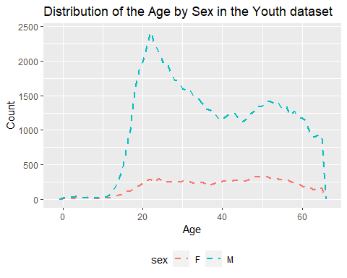

# Guns death by race

