Will Legg

02-23-2024

**REFLECTION PROMPT: Reflecting on this week in class, were you able to improve on what you said last week? Why or why not?** This week in class we were able to number our representations/plan and carry this numbering over to our solution solving process. This was something that we missed on the previous week. I felt that I was able to contribute an equal amount compared to the other members of the group and I was happy with my ability to stay active in our analysis and solving of the problem. We continued to split up work in the group so I got to write, draw, and propose ideas in my group which really helped me learn the material.

**What went well this week?** This week I felt it was easier to read and identify what we were looking to solve for in the problem. I think that this is because of our process in our four quadrants of not only finding facts/lacking/assumptions/representations but also identifying our plan of approach to solving the problem and the relevant equations. This allowed me to have a clear line of thinking of how I could approach and solve/conceptualize the problems.

**What area(s) could you improve on for next week related to in class and how might you work to improve those next week?** For next week I’d like to stay involved. I feel like some of the other members of the group are the main leaders of our actual plan and setting up equations. I think that when I can do some of the homework problems before work I have a much better understanding of material so it could help to attempt some of those problems to help get more exposure to the concepts we’ll see in class.

**What strategies might you try to improve next week when you return from Spring Break? Be specific and include supporting examples from this week’s classes.** Next week I’ll continue to stay involved by splitting up roles in our group as we have been and making sure that everyone in the group is on the same page in our group. I thought that everything went pretty smoothly in class this week but we did miss the justification of our assumptions that we started to work on after we were finished solving. Next week I’ll look to find time to justify our assumptions so I can gain a better understanding of our process.

**PASTE IMAGES OF YOUR TUESDAY WHITEBOARDS HERE:**

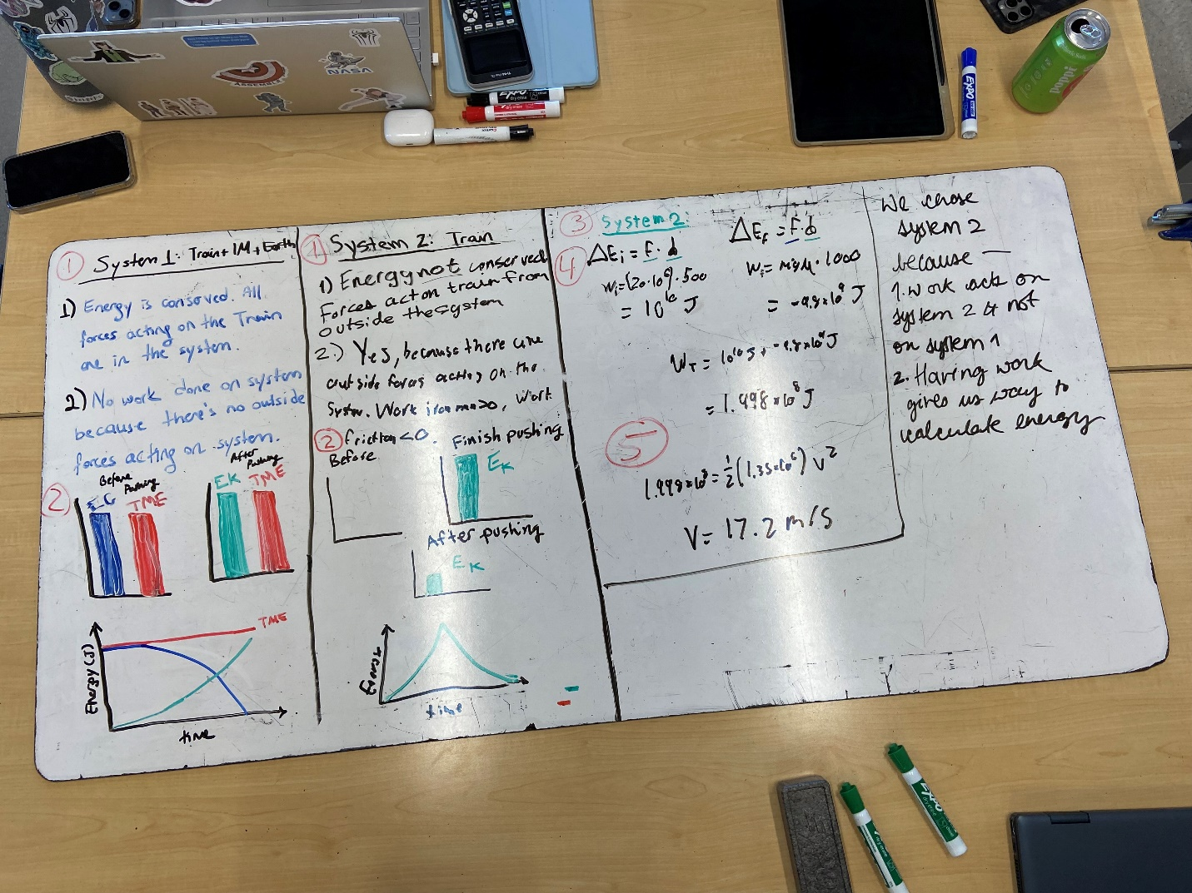

Thursday whiteboards:

