Following the lectures, one can find the Matrix A bei integrating the „Hütchen“-function for a point by using the derivative x_i – x_i-1 / h with h as stepsize.
Integrating from 0 to 1 will result in 2f/h.
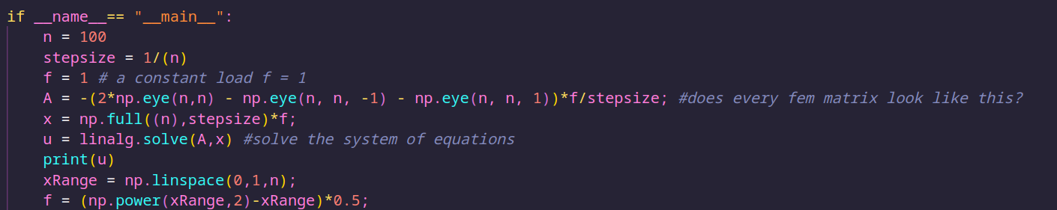

Plot the solutions
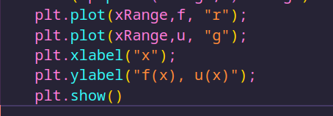
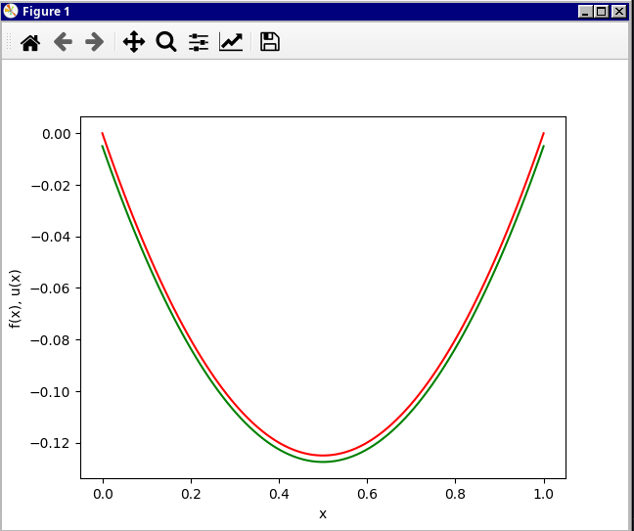

How could different boundary conditions be implemented?
I think based on different conditions the function u(x) would converge different than it does now.

