After a heated debate with a fellow student about whether Python has actually failed as a general language and is only sold to scientists through all the libraries and whether we should actually be learning a mathematical language, I decided to give old lady c++ a try .

CG and steepest Descent in C++

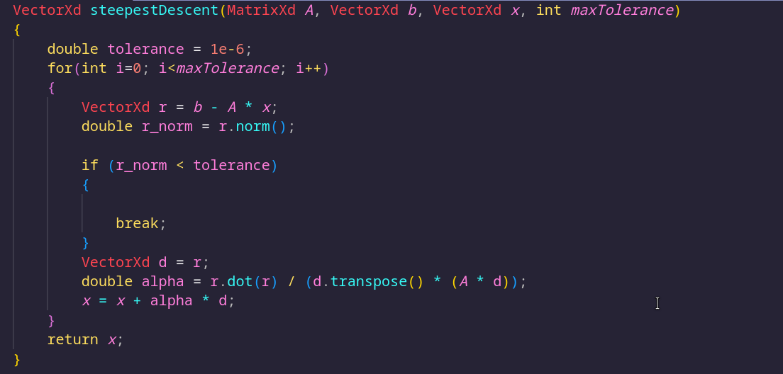

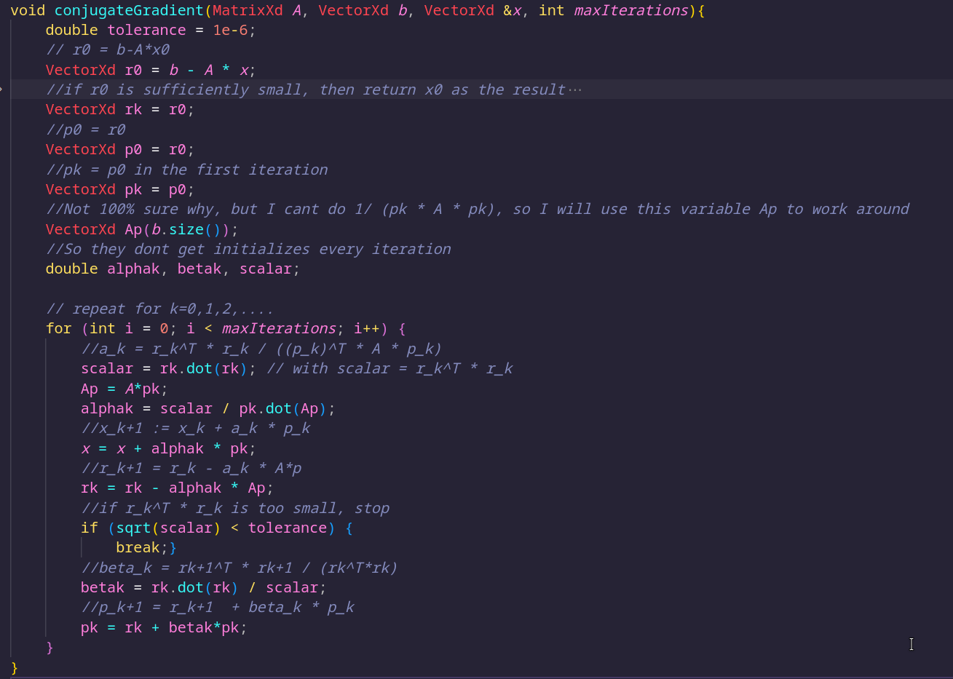

Applying the method to the test system

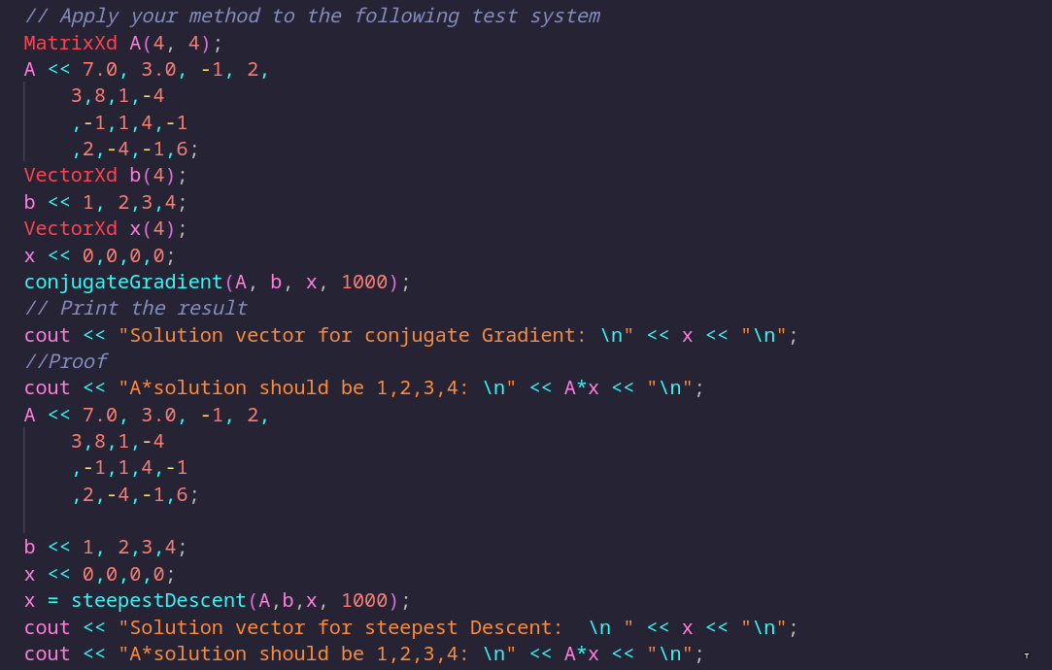
Output:

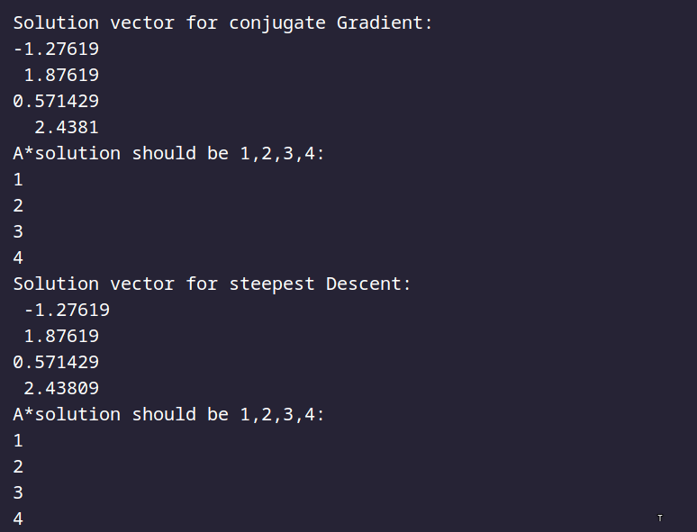

Perform benchmarks for matrices of different sizes

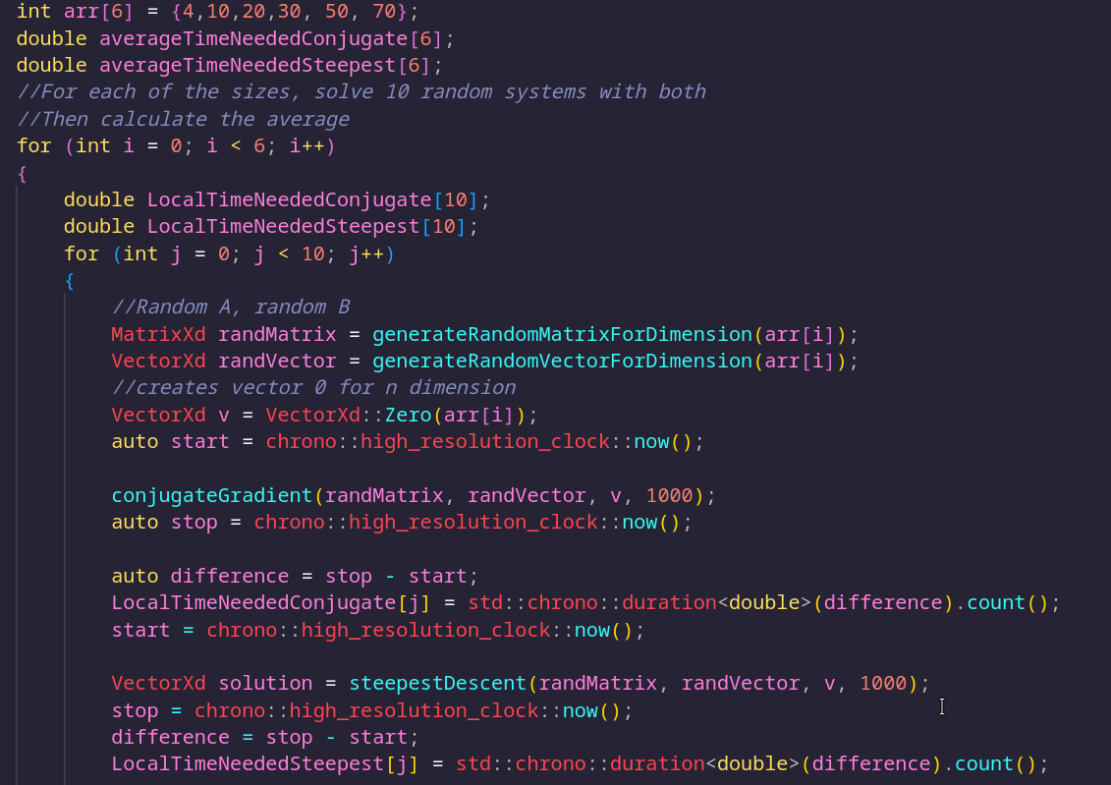
With helper functions to generate random matrices and vectors.

Visualize the benchmark
Since the last time I updated a bunch of linux stuff my Gnu plot is not working anymore, so I just wrote the average time for sizes into a csv file and plotted it in python:

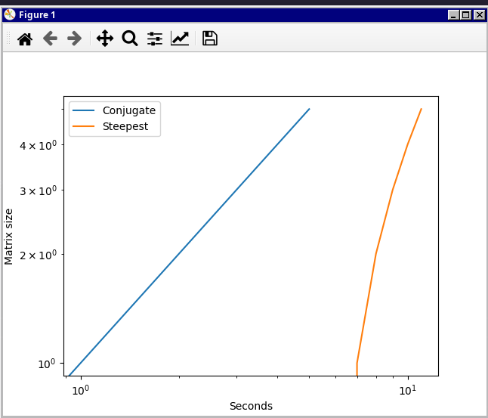
Comparisation with LU solvers
It’s hard to compare since I coded LU in python and this exercise in C++, but I think I can say with some information from the lectures that LU might be better for small matrices. The conjugate gradient method does not converge as quick as LU for poorly conditioned matrices.

Same goes for the steepest decent iteration, just that it is not as performant as the conjugate gradient method.

Are there any linear systems which cannot be solved using the algorithm?
The methods are not made for matrices that are positive-definite.

