Game Design Document

Snowpiercer

Based on the novel **Le Transperceneige**

**Philosophy**

“Snowpiercer” is a puzzle and managing game, that evokes feeling of loneliness and despair. However, through the game process player will find hope and understanding that any challenge is beatable.

**Feature set**

* Ambient frozen world with appropriate music and aesthetics, that underline key emotions the game is trying to evoke.
* Player is the one who creates the plotline: historical moments and decision points are written to your Diary.
* Manage the very limited resources to keep humanity alive, though there will be death anyway, but it’s on you to manage this number as low as possible.
* Unique train configuration for every level is to be assembled by player.
* Confrontation between the head and the tail is to be managed through the entire game.

**Setting**

After unsuccessful attempt to stop global warming in 2014, the world falls in new ice age. In only six months average temperature decreases to -119.6 °C, killing any lifeform in a few minutes. The remnants of humanity are surviving on the train, that is constantly moving through the continents.

Few years before conducting climate manipulations, a man called Wilford, the genius engineer, has predicted the apocalypse and has constructed the perpetual motion machine. His company, the Wilford Industries, has developed a train named as “Snowpiercer” and a circumnavigational transcontinental railway, on which the train was going moving on.

Wilford Industries started selling tickets for “the last chance of human survival”, as they call it. Thus, only the wealthy people can afford the continuation of their life. At the day of the boarding failed climate engineering outcomes were already noticeable. Crowds were watching how their last chance for surviving passing by unfairly and decided to change it.

They break through the gate, the majority was shot by the Snowpiercer guardians, but a few couple of dozens have boarded the train, which has departed a few minutes later. Thereby, there were two groups of people on the train: the rich at the head and the poor at the tail.

**Game development**

Development will be the common, like for other computer games:

* Designing
* Prototyping
* Iterating
* Further development (LD, ED, SFX, VFX, scripting)
* Iterating
* Polishing

Unity Engine will be used, because of its simplicity, huge community, availability and flexibility.



**Concept art**

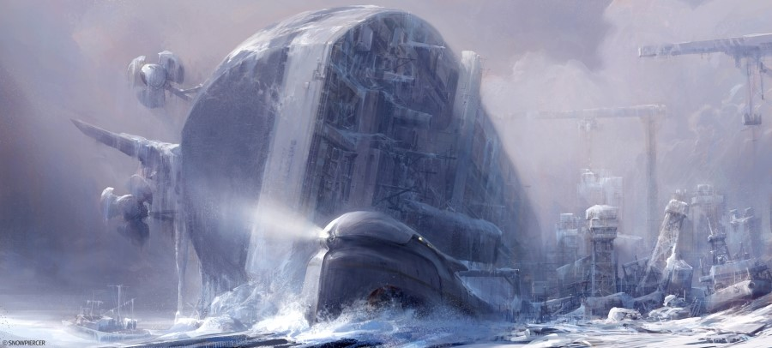

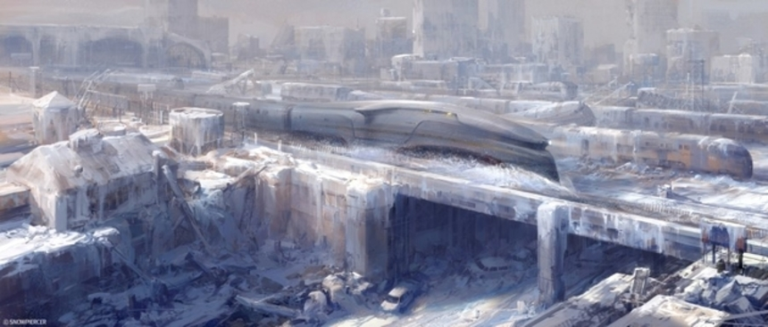

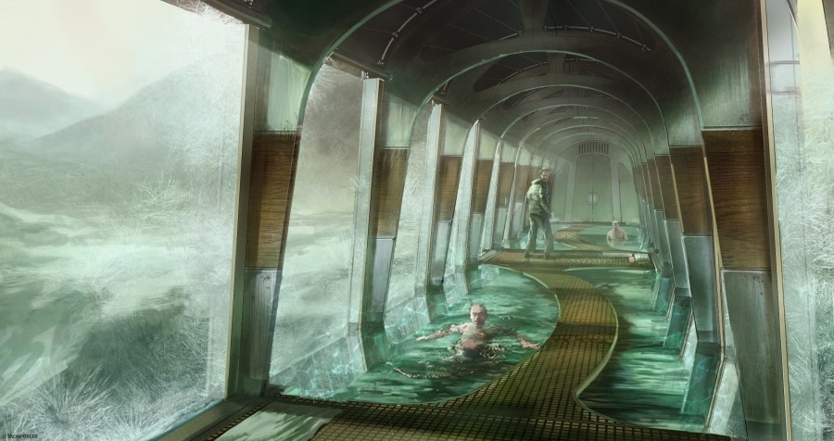

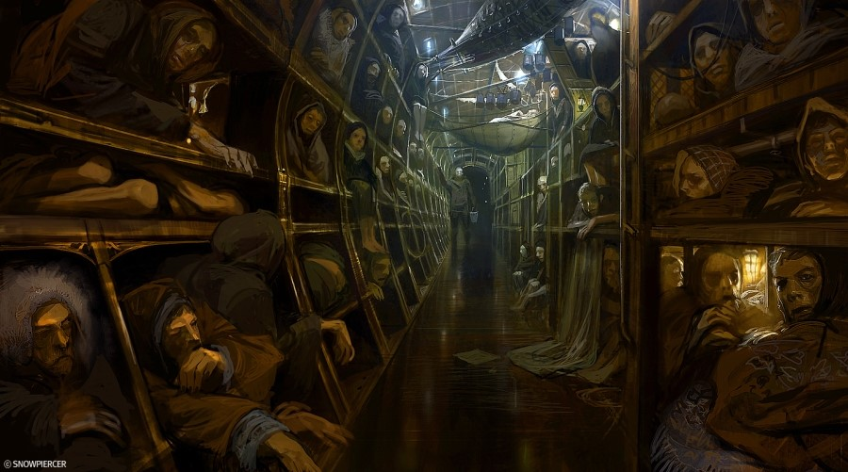

Source: <https://screenanarchy.com/2013/01/concept-art-for-bong-joon-hos-snowpiercer-reveals-icy-landscape.html>

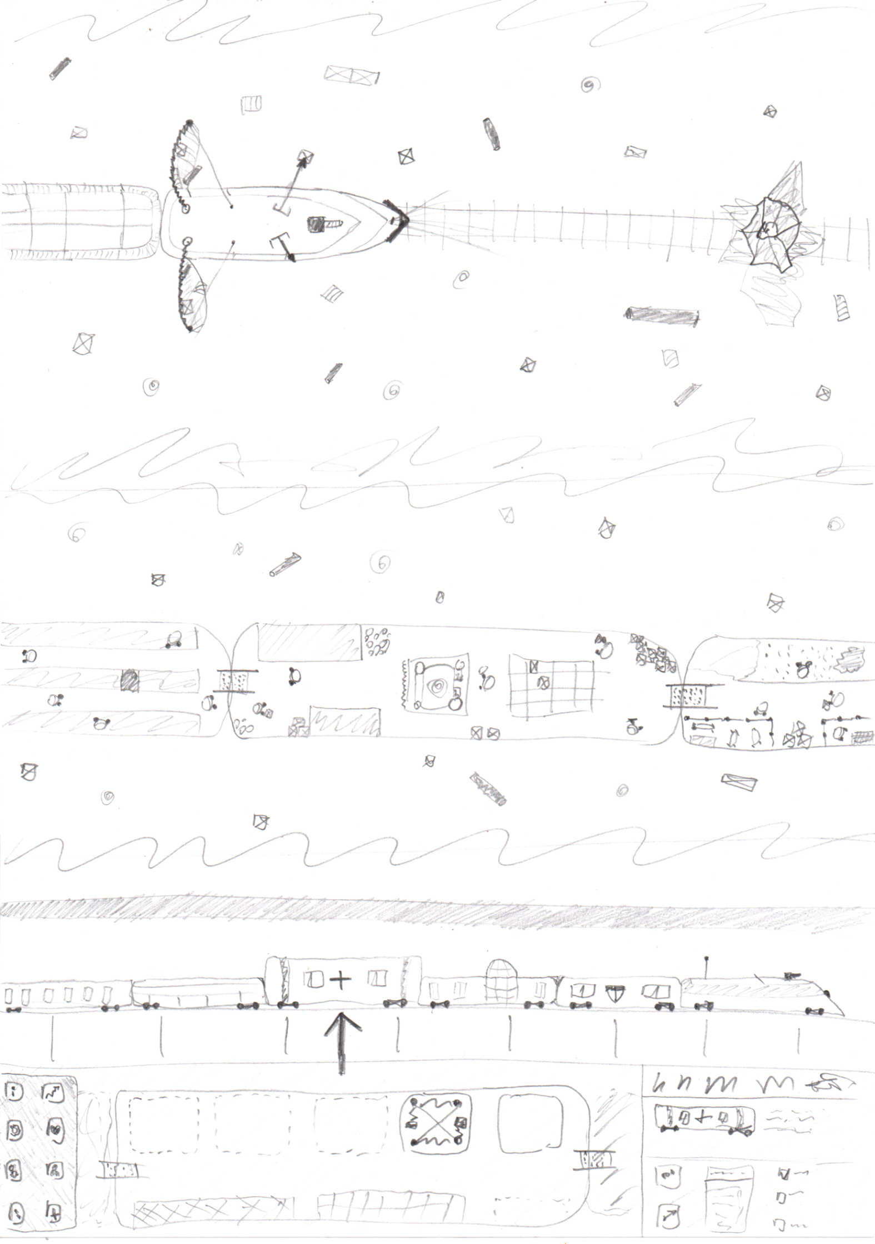

Resource gathering





Passengers managing



Car constructing



**Aesthetics**

*Visual*

On the levels top-down view will take place, but on stops the train will be viewed from the side. Cold colors will dominate on the screen to underline the loneliness and despair. Ice and snow will be represented in sharp shapes and white-blue colors. Crates and other stuff that can be found on the ground, will be much brighter and differentiate in form for player to notice in quicker.

*Audio*

Almost all players actions will be accompanied with sound to express movement. For players not to forget the climate outside the train, wind hauling and blizzard rumbling will be presented. Also, some tense music will be playing during the levels.

**Mechanics and systems**

Game starts when Snowpiercer is departing. Goal: get to Climate Engineering Tower on the other side of the Earth and launch Controlling Substance which parts are to be collected or crafted during the game. Player controls the train and lives in the head car.

The whole game process is divided into 2 parts: traversing from stop to stop (going through the level) and managing your cars and resources for next travelling (preparing for next level).

While playing the level, player can obtain resources with some special car instalments (e.g. grabbers, speargun, netgun) as well as tackle certain threats (avalanches, obstacles on rails etc.) and internal problems (rebellion, famine, car malfunction etc.).

While preparing for the next level, player can construct and deconstruct cars, upgrade them, install equipment.

*Processes*

There are two types of processes in the game: automatic and hand-by. The first are conducted without player’s assistance, while the second can only be handled by player.

Automatic processes: electricity production, resource gathering, obstacle tackling.

Hand-by: inner problem solving, cars and upgrades construction, upgrades instalment, items production.



*Electricity*

Perpetual motion machine installed in the head car and works mainly by converting train motion energy into electricity. Thus, train should move with speed not lower than certain, otherwise electricity will not be produced. This problem can be solved by installing batteries, which can allow train even to stop for a short period of time.

*Resources*

Resources play a key role in the game: you would construct cars, feed people and use items in purpose of the plot.

There are several types of them:

1. Materials
   1. wood
   2. plastic
   3. metal
   4. cloth
   5. ice
2. Items
   1. clothes
   2. electronics
   3. hand weapon
   4. fire weapon
   5. ammunition
   6. …
3. Food
   1. plants
   2. animals
   3. different cuisines: poor, common, luxury
   4. water
4. Special
   1. map fragments
   2. plot items
   3. car and item drawings



*Cars*

Cars are essential objects: now they are shelters to humanity. There are different types of cars:

1. Industrial
   1. Storage (storage for resources, has 3 levels of upgrades)
   2. Manufacturing (has rooms for manufacturing instalments (for items production) to be placed)
   3. Farm (to gain plants or animals)
   4. Defense (to make train more stable or to survive avalanches and other threats)
   5. Laboratory (to research new upgrades and instalments)
2. Residential (differ by Amenity points and room for passengers)
   1. Poor
   2. Luxury
3. Amenities (give Amenity points)
   1. Bar
   2. Club
   3. Pool
   4. …

At start, player is given certain number of cars (residential, storage, manufacturing, farm etc.).

Cars can be constructed only at stops and if certain amount of resources are available. Also, if needed, they can be deconstructed, and a few resources can be restored.

Train configuration can also be changed at stops for passengers to get to their destination quicker or to move certain cars from the group is restricted to enter them.

Any car can brake during the level if its durability points reach 0. In this case part of resources car was carrying will be lost and car can be repaired or deconstructed at a stop.

The majority of cars have level of upgrades and places for instalments. To upgrade cars player has to have these upgrades researched. This can be done in Lab or by collecting drawings.

*Resource gathering*

Resources can be obtained by special instalment placed on the head’s car roof (grabbers, speargun, netgun). These instalments also have levels, which define the cooldown and working speed.



*Obstacles and threats*

During the level player can come across obstacles (ice pile / debris on rails, broken part of rails etc.) and threats (avalanche), that can be tackled by special equipment (metal shield, repairing kit, balancing car, melting car) or passed as is, thus cars can be damaged.

*Passengers*

At start there are two types of passengers on board: poor at the tail and rich at the head. Passengers are represented in game, thus they can carry resources, work, rest, rebel etc.

These two groups have different characteristics:

Poor

* Works quicker and for longer period
* Not quite clever
* Eat a few, poor quality food
* Need a few amenity points
* Morale

Rich

* Works slower and for shorter period
* Quite clever
* Eat a lot, luxury food
* Need a lot amenity points
* Morale

Passengers can be restricted for entering certain cars. This tactic will help to give amenity points only to the rich.

*Morale*

If passenger needs (amenity points, food quantity and quality etc.) are not kept, morale points will decrease. When it is below a certain value, passengers’ productivity decreases, they can behave rebelliously (damaging all around) and even start a rival (trying to break through to the head car). From time to time insurgents will announce their requirements. If player agrees on them, rebels calm down, otherwise rival continues until they kill the player.

Player can order the rich to restrain the poor with weapon, which will decrease the morale of the seconds. However, the poor can steal this weapon for future rival.

Passengers can die from fatigue or famine. This will gradually decrease morale.

If group’s morale is at high level, a childbirth is possible.

*Merging passenger groups*

It is also possible for player to force both groups to merge into the “common passengers” with average stats for justice to arise. To do so, the poor and the rich have to be fed with common cuisine food and have the same luxury points. The merging process will start automatically, and will last for several levels. During the process, the rich’s morale will decrease, which can cause a rival.

If the poor’s morale is at low level, they can start riot for justice, requesting player to give them better quality food and more amenity points.

*Items production*

To manufacture items, instalments have to be built. When player orders production, batch size and workers can be selected, shift duration will be calculated automatically and if it exceeds worker’s work time, player will be notified and asked to choose whether to release the worker and end the production or to force them, which will decrease morale.

When player order items production, rested and fully operable passengers are searched for. For any order player can set up in which group search will be conducted. If no vacant passengers are found, player will be offered to force them up. In this case, the overall morale of the group is decreased.

*Plotline*

The destination point for “Snowpiercer” is the Climate Engineering Tower using which player has to fire up Controlling Substance to manage climate became normal. To do this, Controlling Substance has to be crafted at special car using unique resources and items, that can be found or crafted through the game process.