How to compile restroom finder

**AC Transit**

**1600 Franklin Str, Oakland, CA**

**7/27/2016**

Aidin Tajadod

In this document, I have tried to explain how to compile applications for both iOS and Android. There are few glitches that can make it hard to compile and push the application for distribution.

In this document , I will go through the details of the steps required to compile and push the application to the production. Because of the differences in the steps for each platform, I have separated them out.

iOS:

Please open the Xcode.

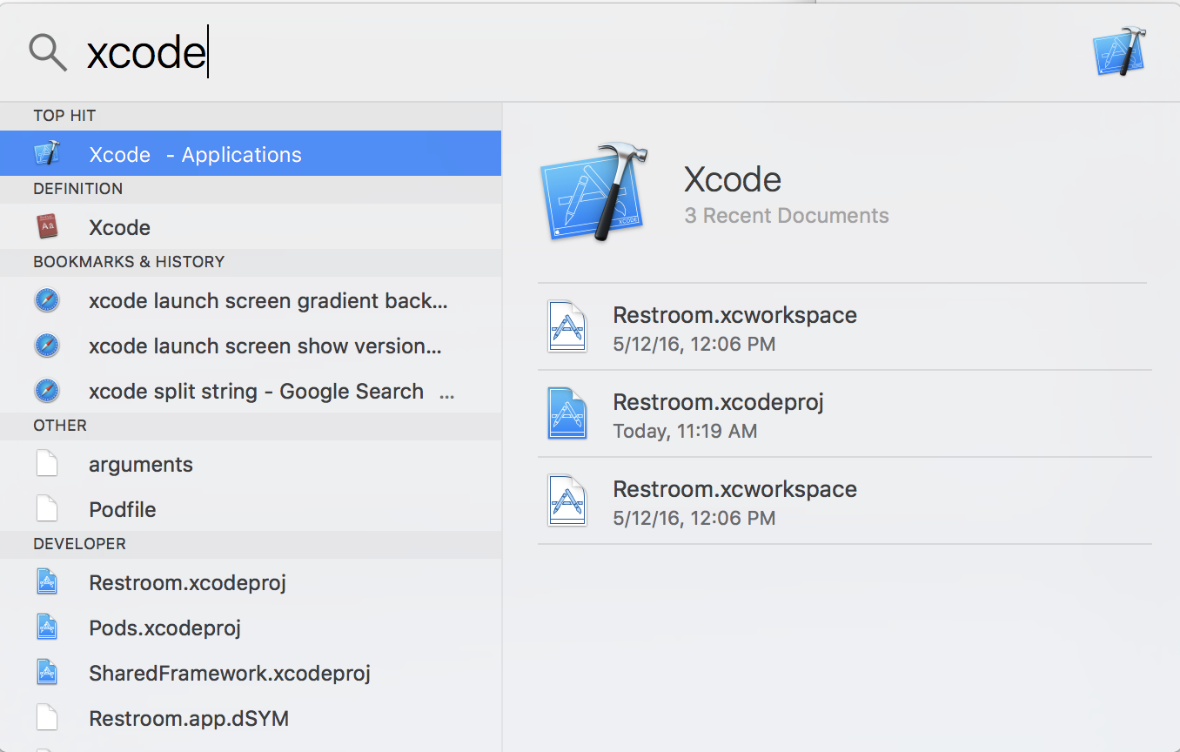

Open the restroom application from the Xcode startup windows.

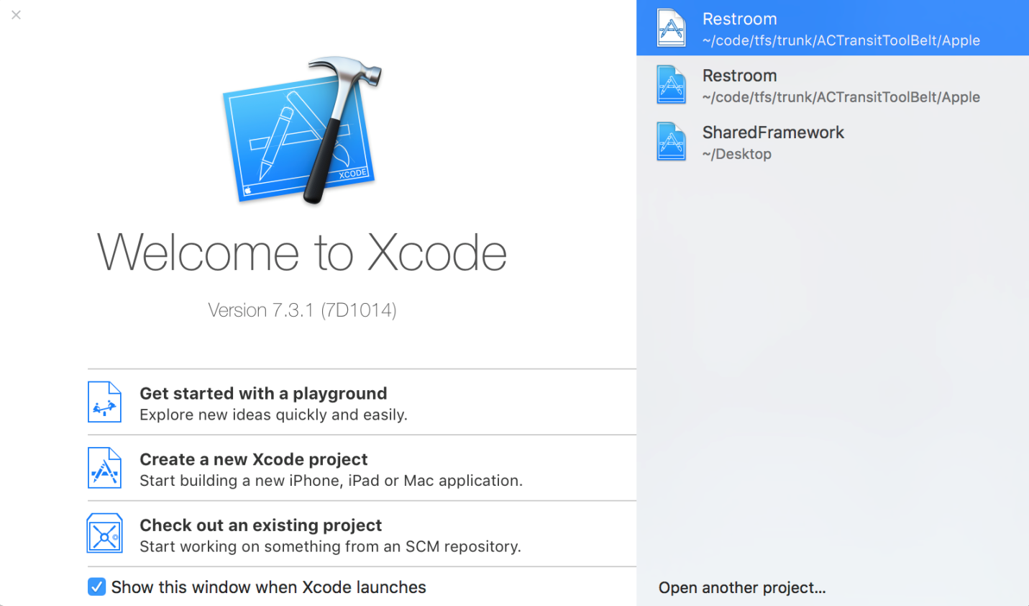

To test your application, from the top menu, select an emulator and run the application by pressing the Play icon.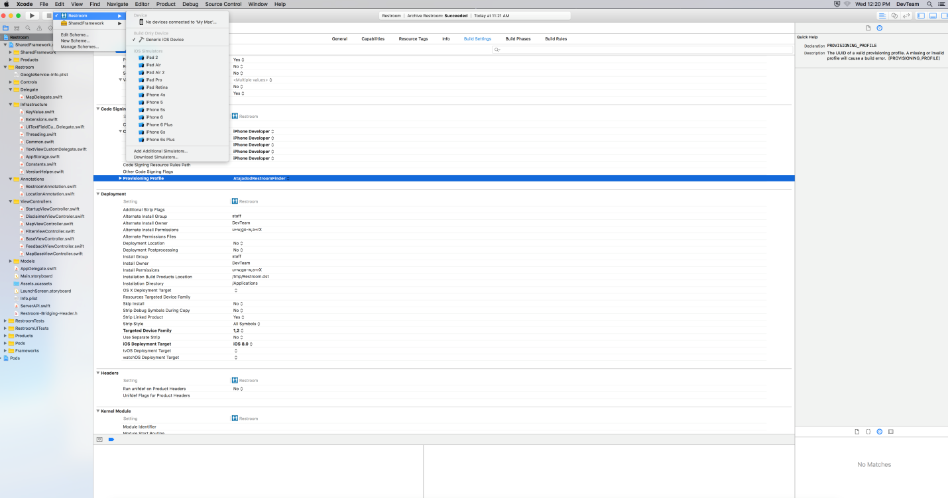

***Please note, when you want to compile the application for publishing, you need to set the device to be “Generic iOS Device”***

***Ready to publish:***

1. From the setting list, change the provisioning profile to AtajadodRestroomFinder, you can change this name or create your own from iTune console website.

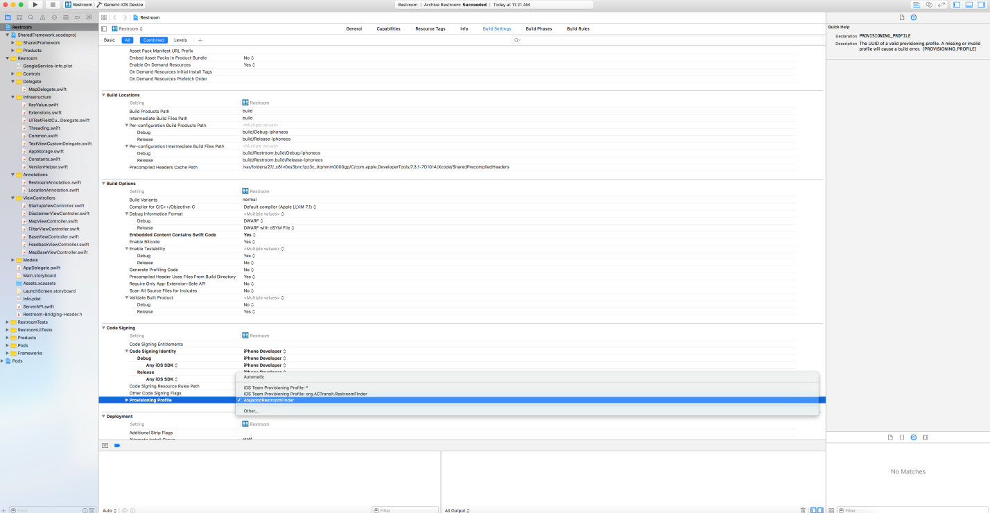

1. From the setting list, increase the version.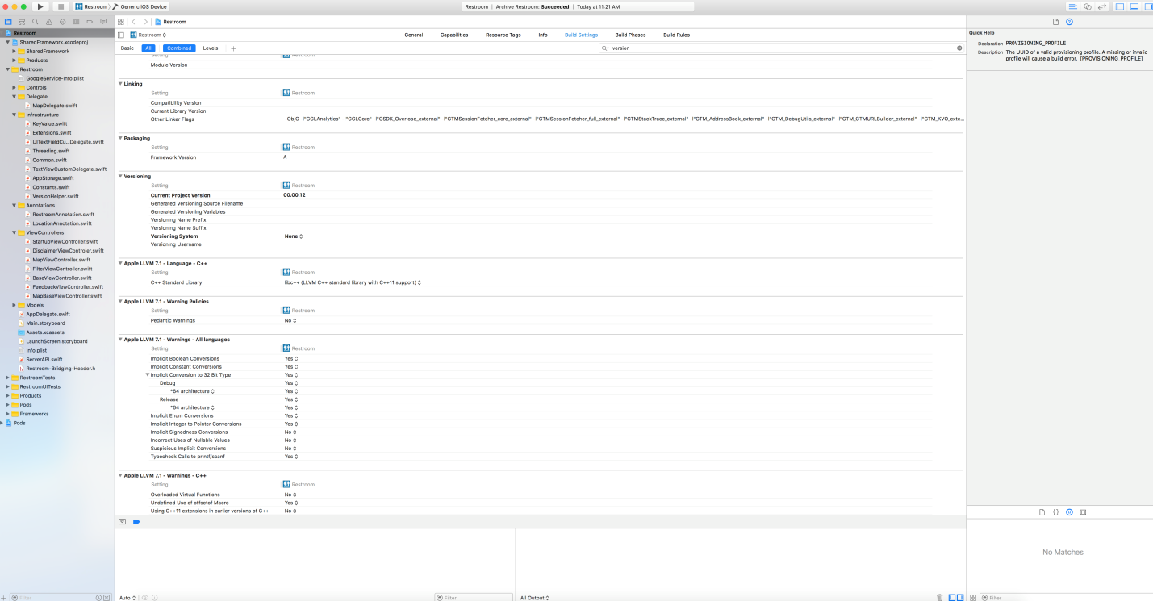
2. From the “Product” menu, select Clean.
3. From the “Product” menu, select “Archive”. Please note “Archive” will be disabled if “Clean” process is not completed or the device has not been set to “Generic iOS Device”. 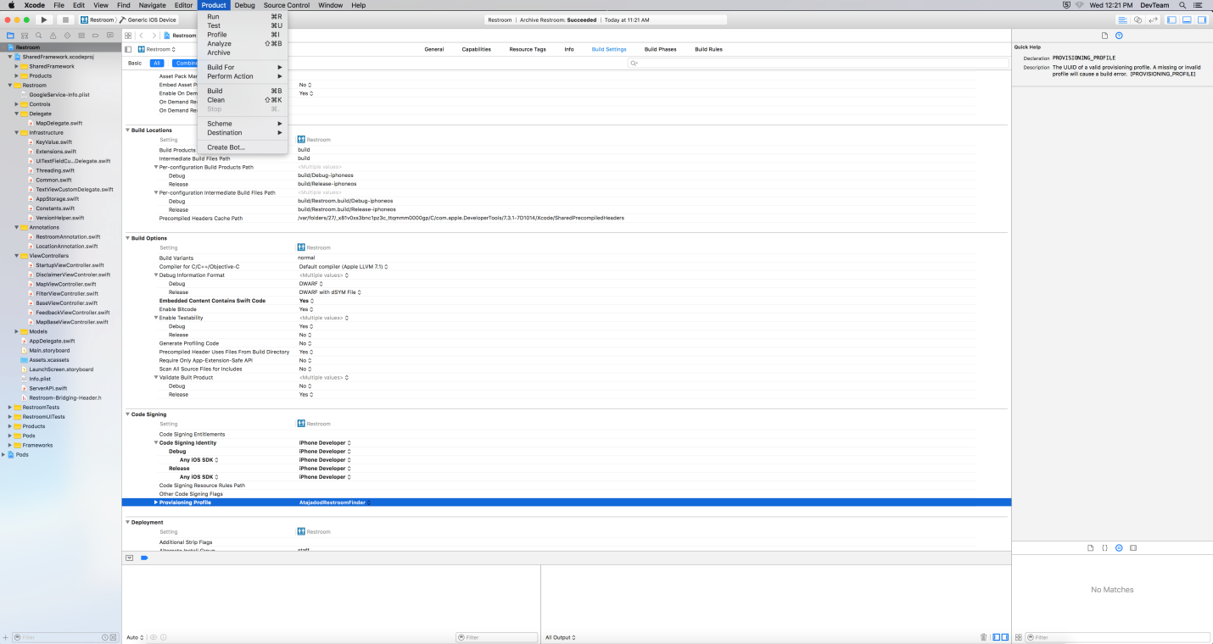
4. After the “Archive” process is done, Open “Organizer” windows from the “Window” menu.

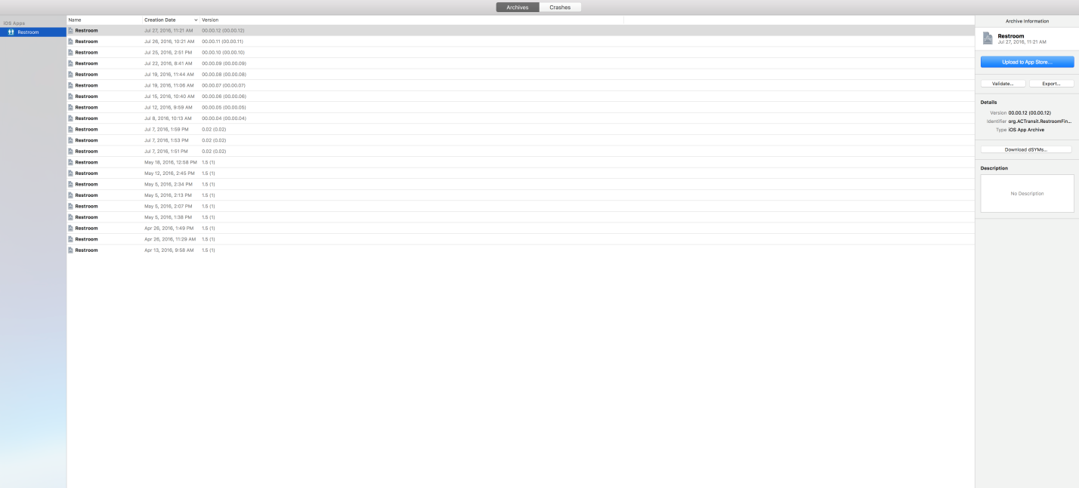

1. Select your build version and click the Export button on the right side of the page.
2. Follow the screens as shown in the pictures below to finish the process.

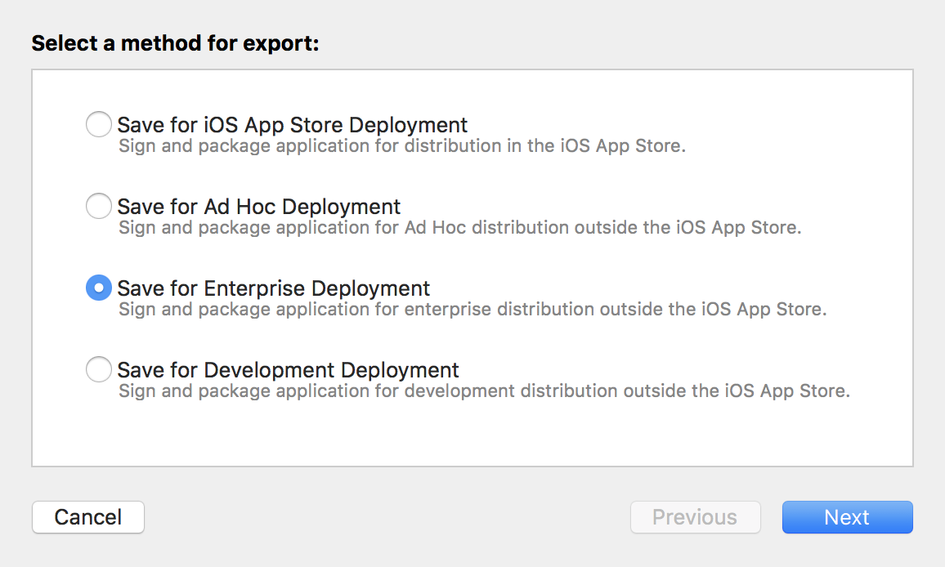

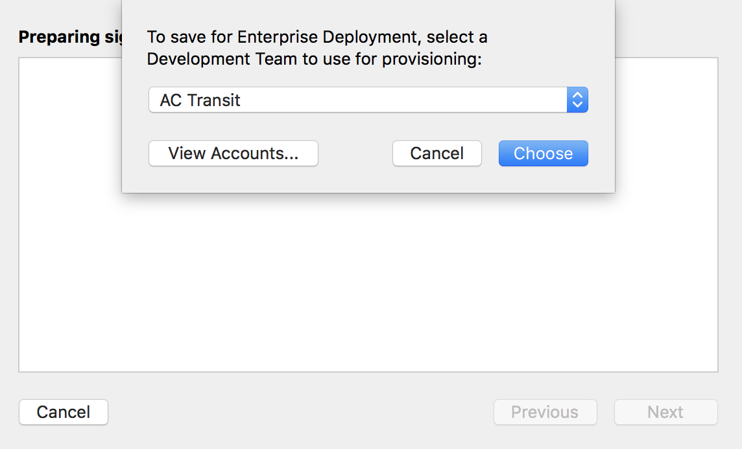

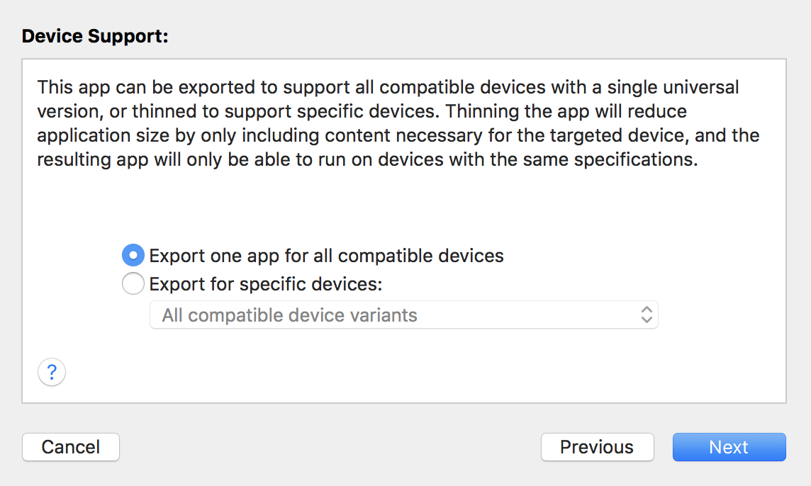

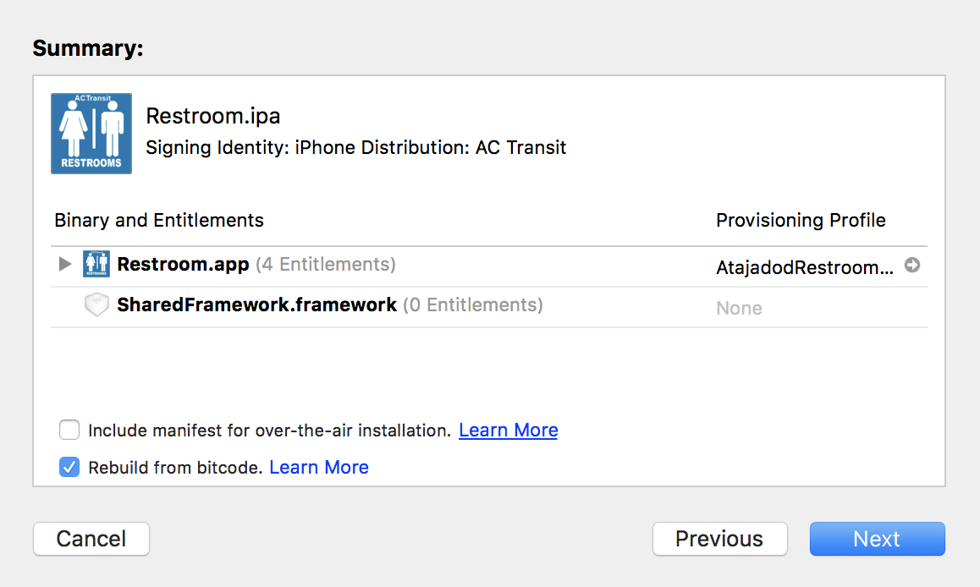

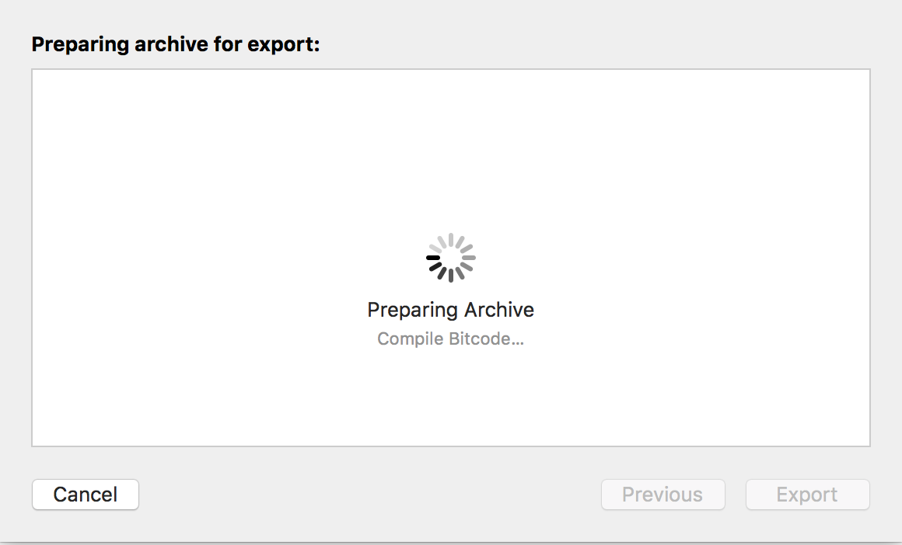

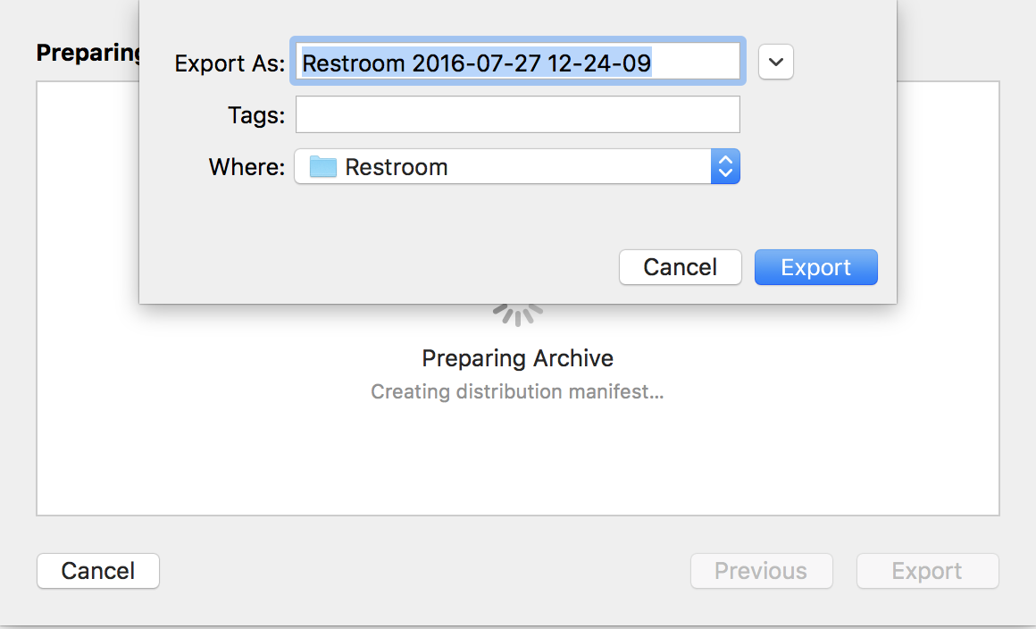

At this point, you can save the file and then push the file into the server. (make sure you push the ipa file and not the zip file that is created. Also make sure you change the file name to match with Restroom-release-[version].ipa

Android:

Please open Android Studio.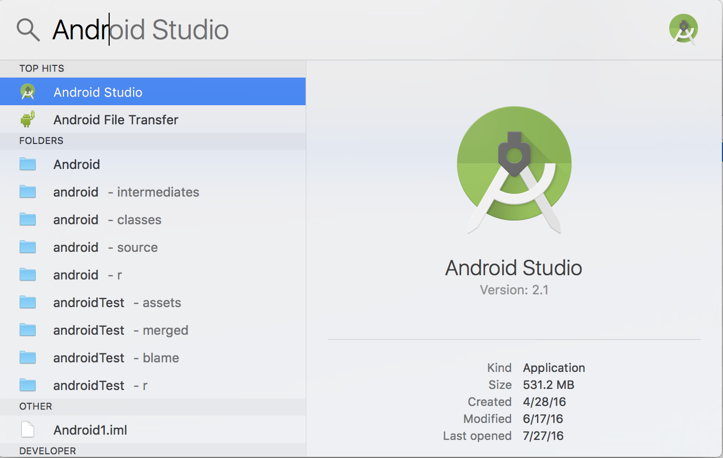

From the startup page, select the restroom finder app (First option).

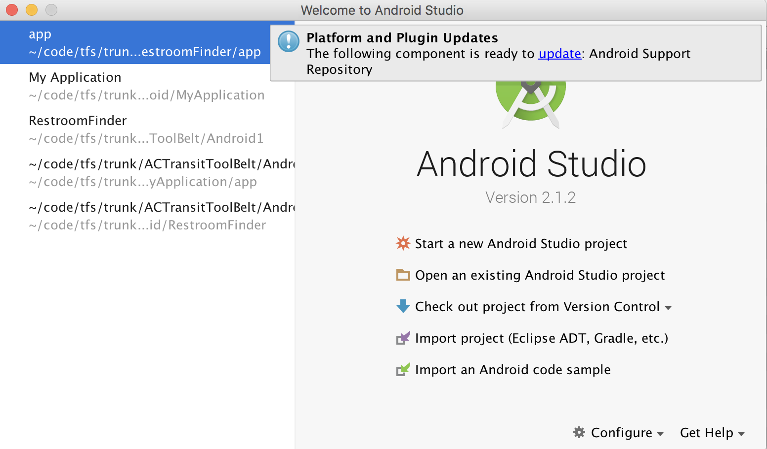

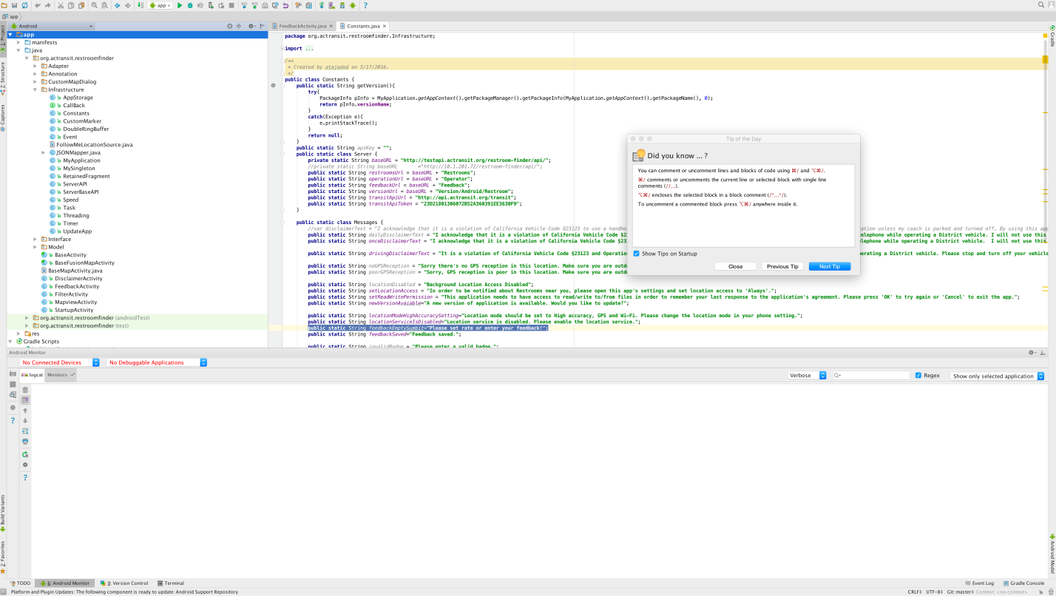

When you are ready to publish the application,

1. Open the build.gradle, module one.

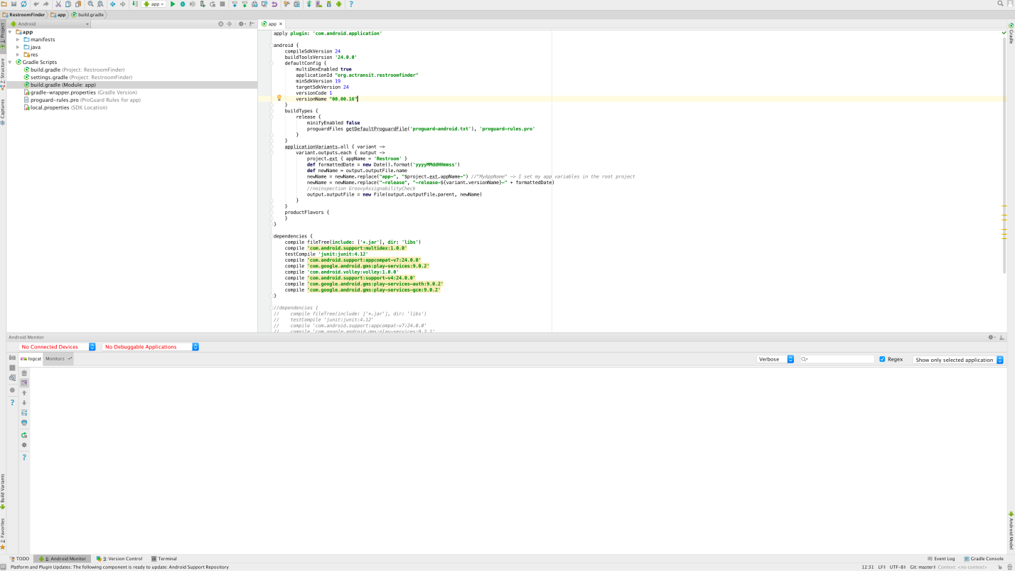

1. Increase the versionName. For example “00.00.17”
2. From the “Build” menu, first clean the project by clicking “Clean Project”

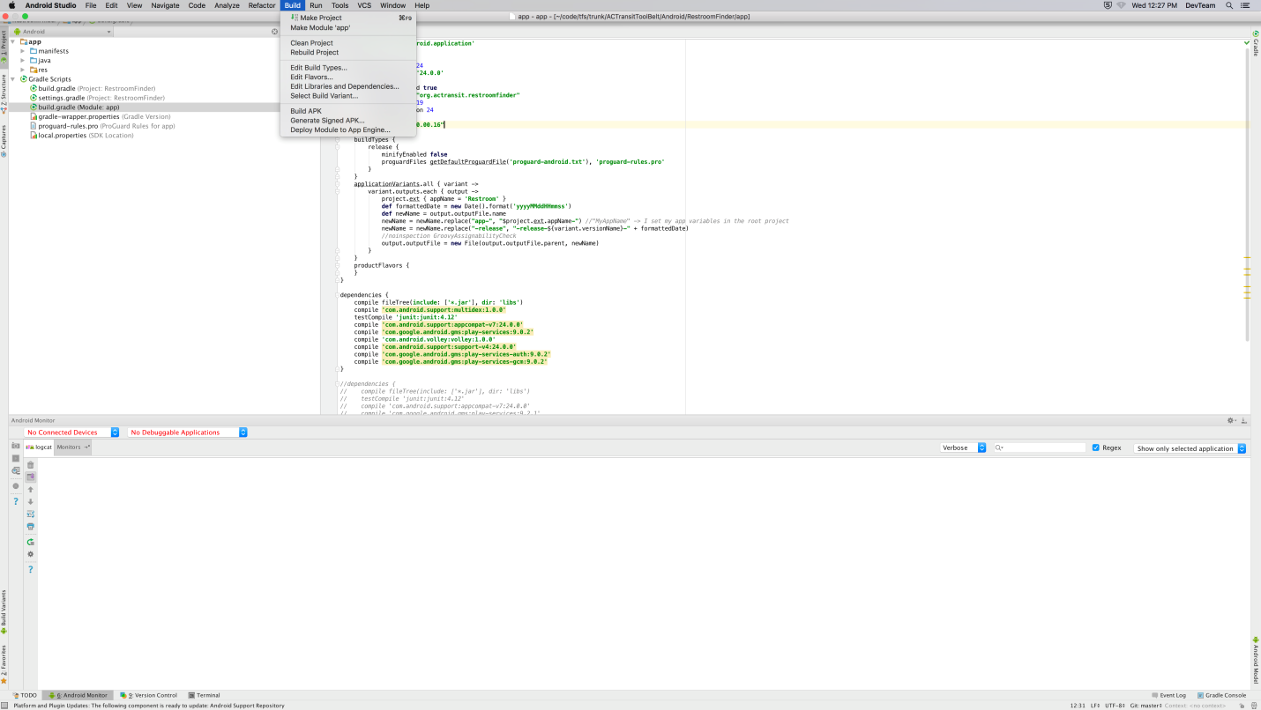

1. After the clean process is finished, from the “Build” menu select “Generate Signed APK…”

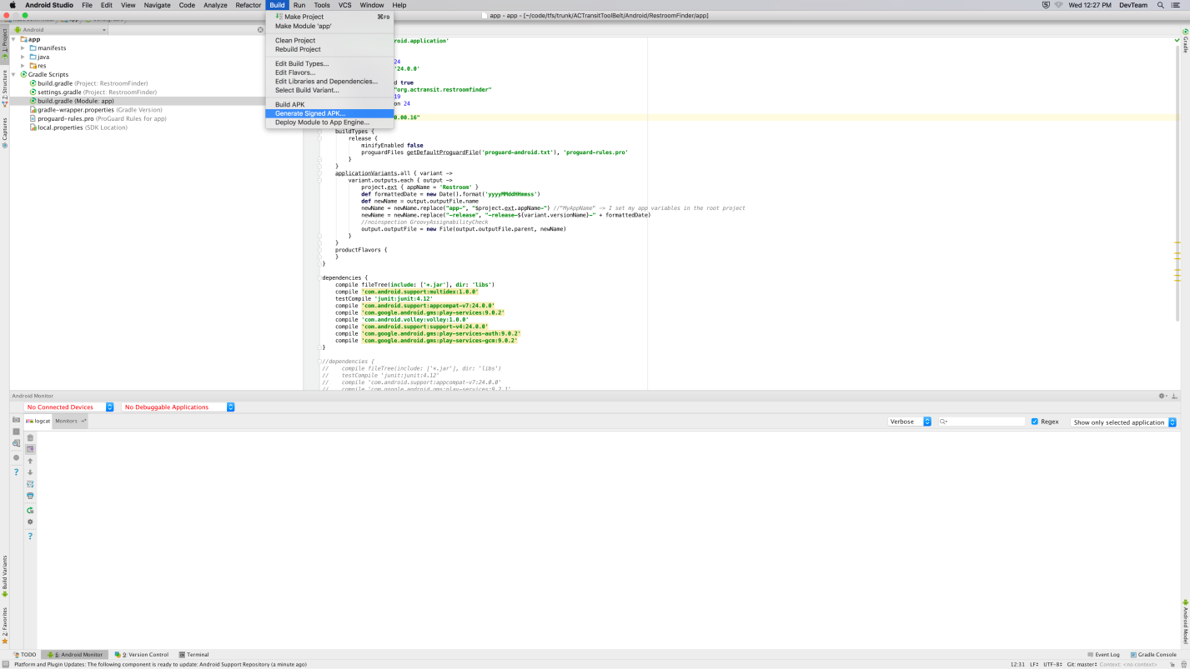

1. It may ask you to enter the password which has been set for this key, just for the first time. The password is “****”

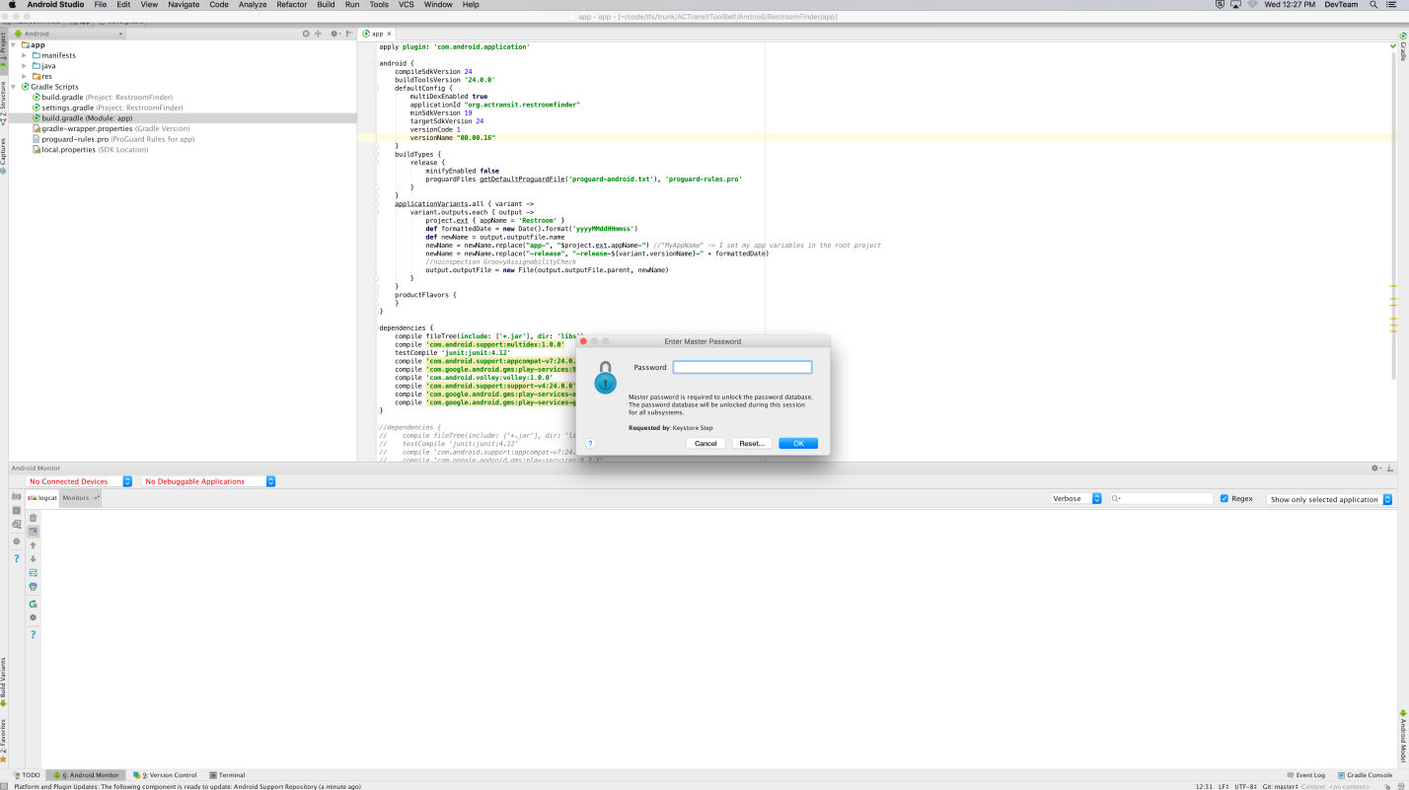

1. Follow the instructions to finish the process as shown in the pictures.

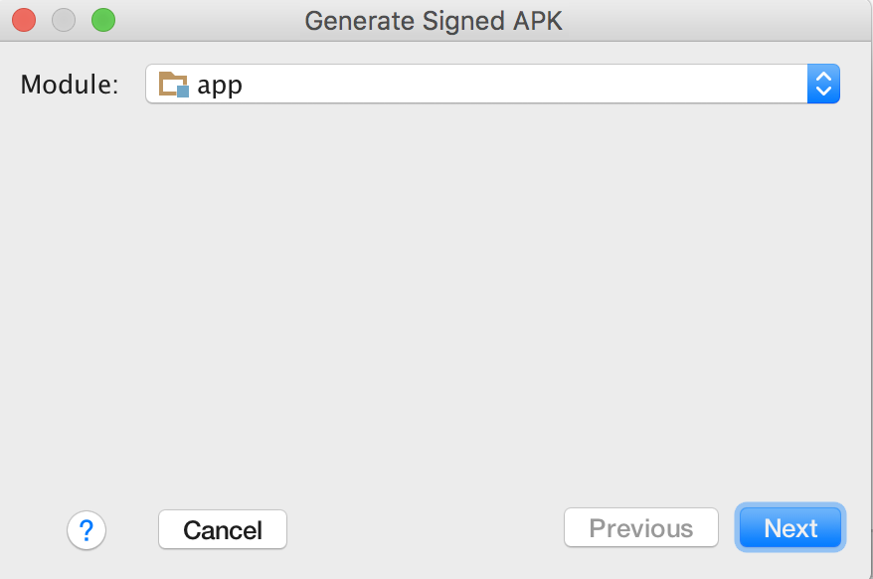

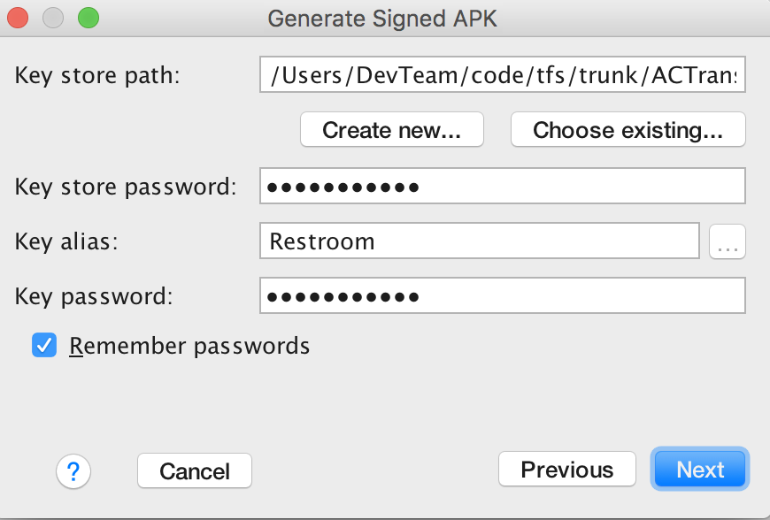

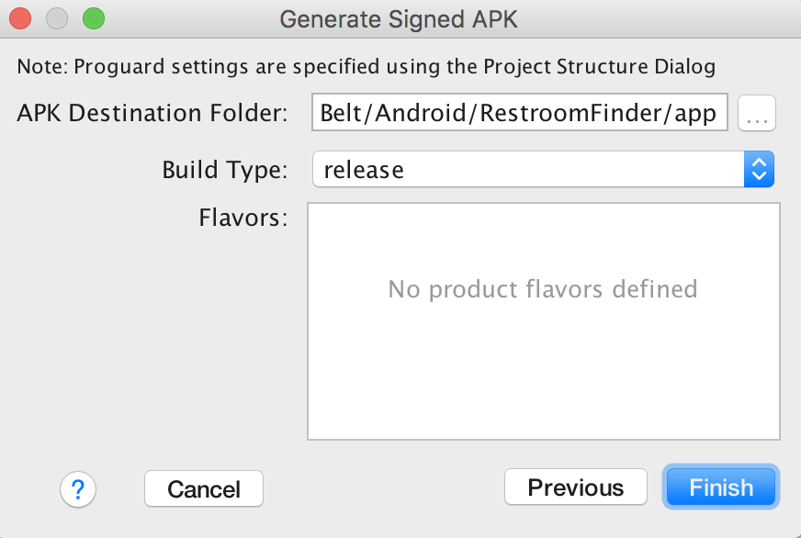

You can see a small windows on the top right on the screen. If you click on the “Reveal in Finder” link, you will be able to see the generated file. copy the apk file where is needs to go on the server.

