Training Application

**12/15/2015**

Trainee document

## Training and Apprentice Application Overview

The Training web application manages continuing education to meet safety and regulatory requirements, e.g., educating bus operators and mechanics. The application revolves around the student employee attending courses, tabulating apprentice work and assembling education results. With this information various reporting is achievable to manage course effectiveness and monitor education compliance to ultimately improve services.

Features of the application include creating courses and schedules, identifying instructors, registering participants and reporting student course results. Apprenticeships may also be established for on the job training. The apprentice programs pull work details from the central maintenance system and enables individual scoring and oversight.

**Course Attendance**

* **Course**

Course provides training in a particular field or skill.

* **Instructor**

A person who teaches people, drivers/mechanics or …, the skills they need for a particular field or course. This person usually is a district employee. However he/she could be a non-employee.

* **Non-Employee**

Represent a person who is not AC Transit employee. In most cases, Instructor or people who attend a class/course are district employees. In some cases, non-employees are eligible to attend a course or teach a class. In such cases, we need to enter their information as Non-Employee.

* **Course Schedule**

Date and time of a course being represented in details including start and end date of a course.

* **Topics**

List of Topics that are discussed in each course.

* **Course Enrollments**

List of enrolled people in each course for a given schedule.

* **Attendance**

The result of a course for each enrollee.

**Apprenticeship**

* **Apprentice Participants**

Participants are automatically added from the human resources system.

* **Participant Work Details**

Apprentice work hours are added from the central maintenance system.

* **Apprentice Oversight**

Participants scoring is managed through the training application with daily comments and overall scores.

## Home Page

This is the home page of the training application. From here you can access your class enrollments and see other available classes.

You can also view Reports, Training videos and this document. (Figure 1)

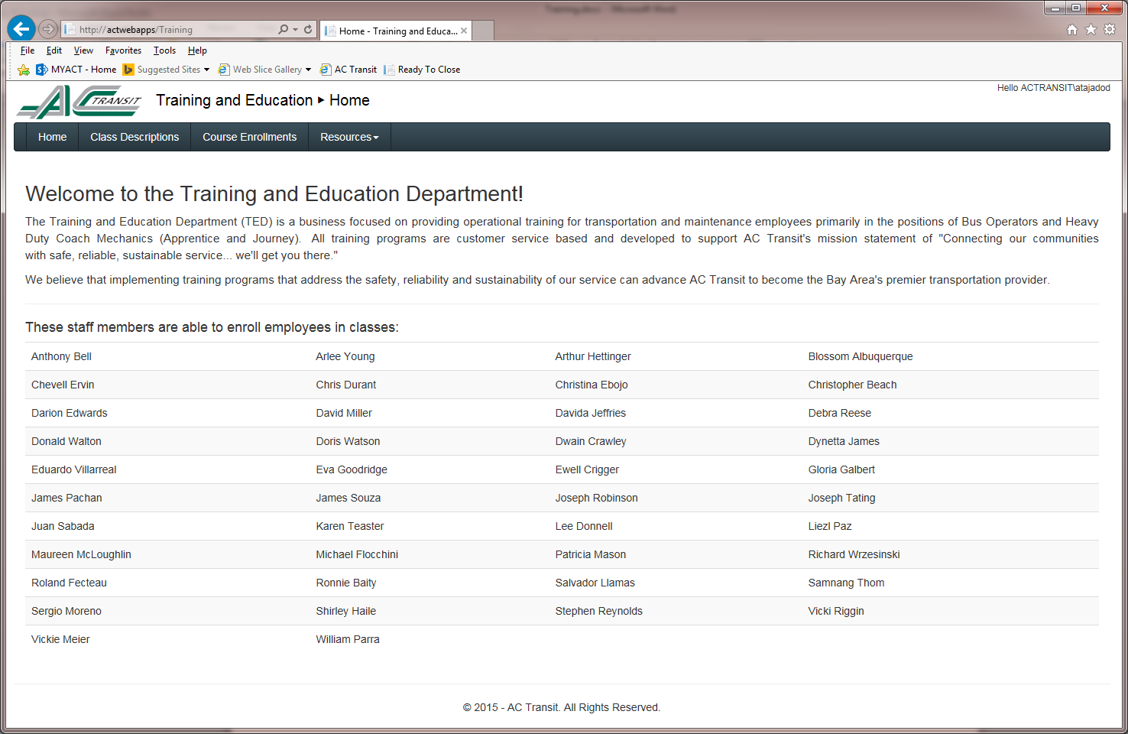

Figure : Home Page

## Class Description

In this page, you can see course descriptions. You can also filter the courses out by Transportation or Maintenance. (Figure 2)

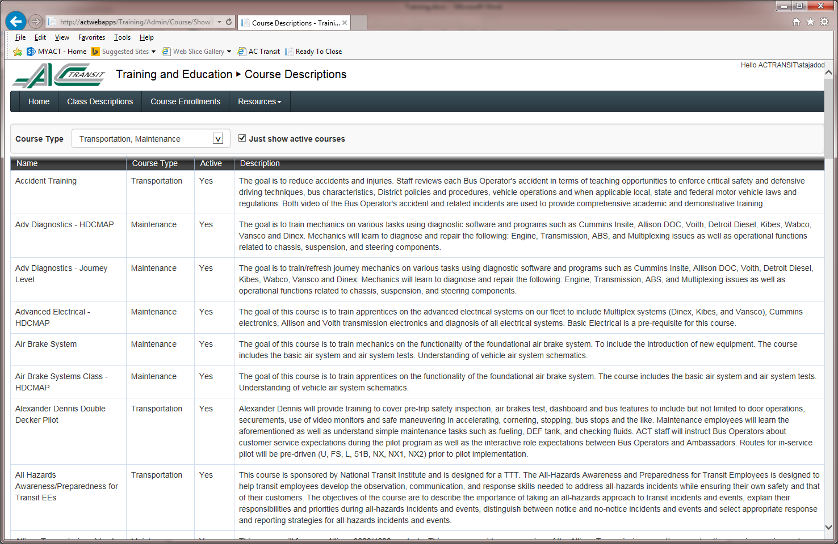

Figure : Class Description

## Course Enrollments

In this page, you can find your scheduled classes or find out about other past/future classes. Use the employee badge field with your badge number to see your enrolled courses. Make sure to press the “+” button on the left side of each course to access the details of the course. (Figure 3)

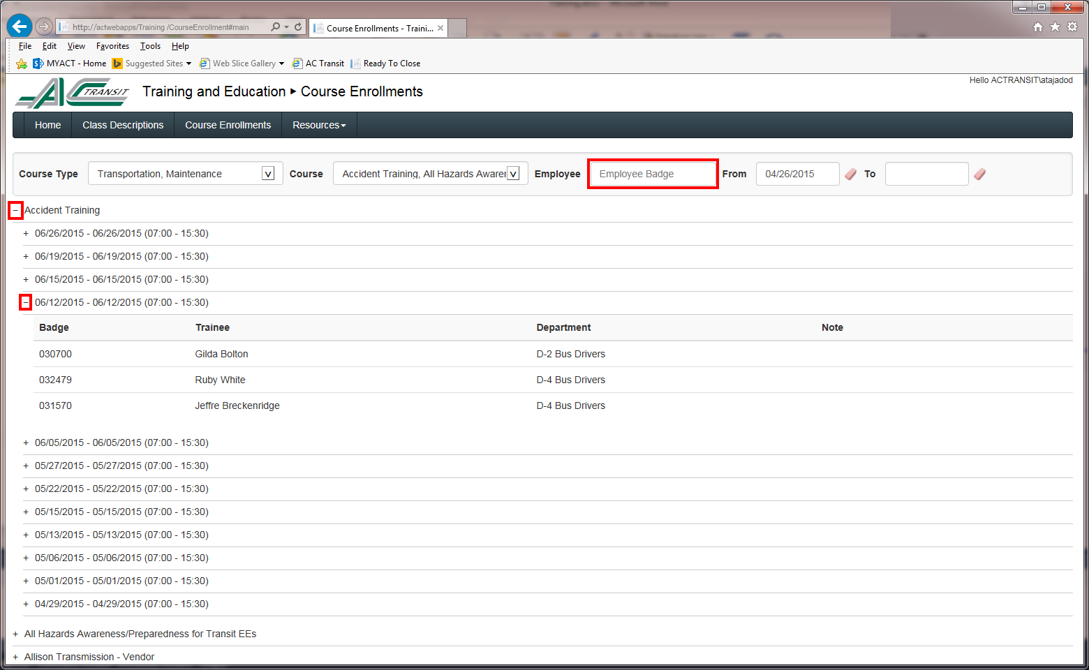

Figure : Course Enrollments

## Resources

From the Menu bar, expand Resources menu to access Reports, Training Video and this document. (Figure 4)

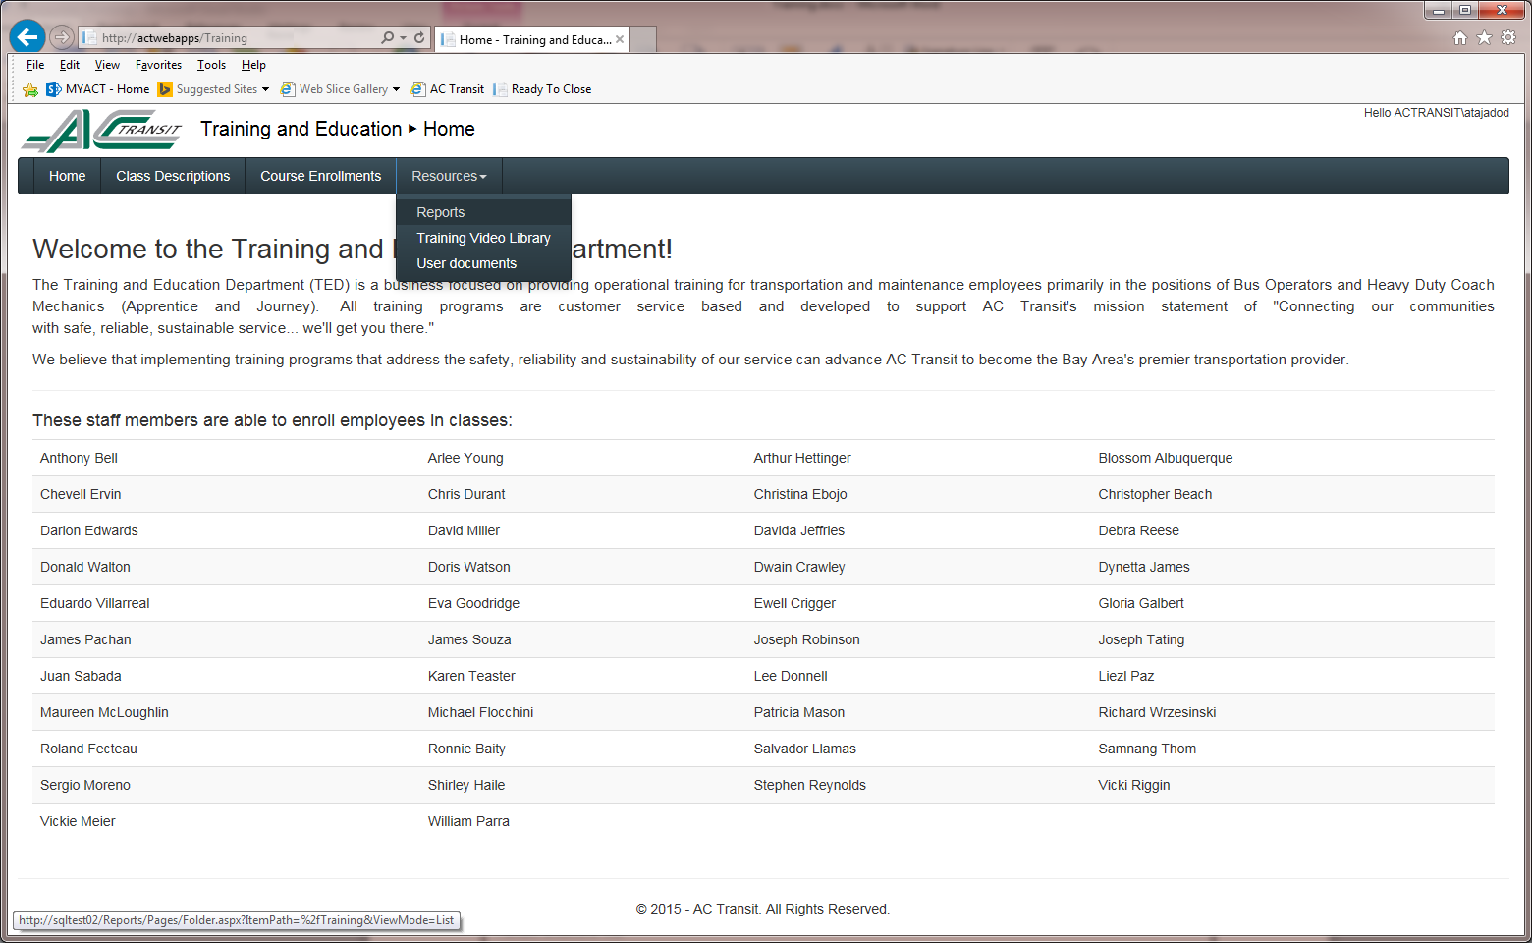

Figure : Resource menu

## Reports

From the menu bar, expand the Resources menu and click on the Reports link to see the Reports. (Figure 5)

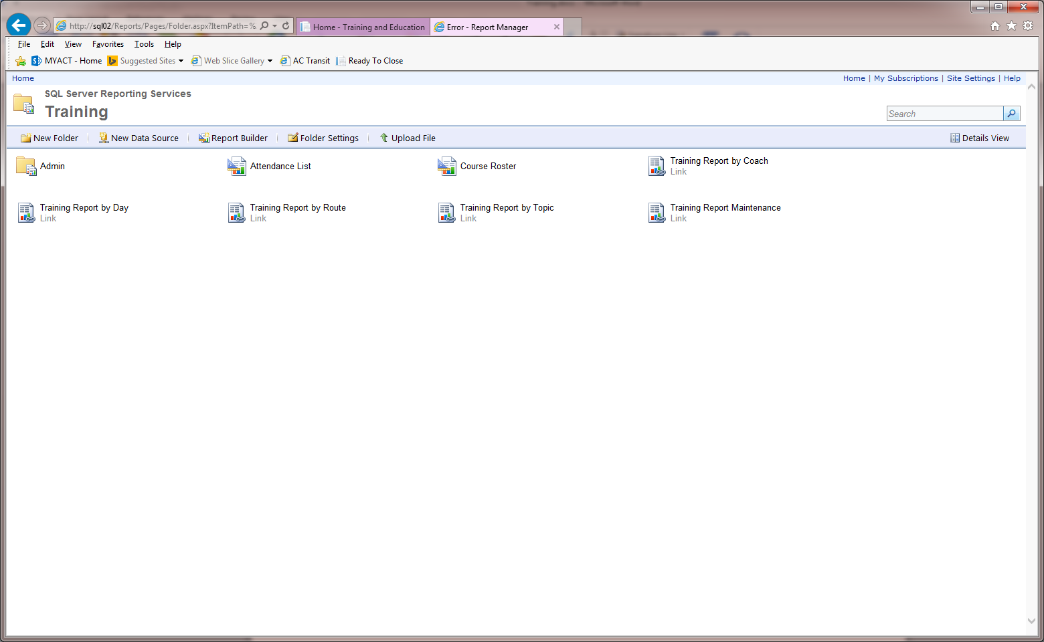

Figure : Reports

## Training Video Library

From the menu bar, expand the Resources menu and click on the “Training Video Library” link to see the “Training Video Library” page. (Figure 6)

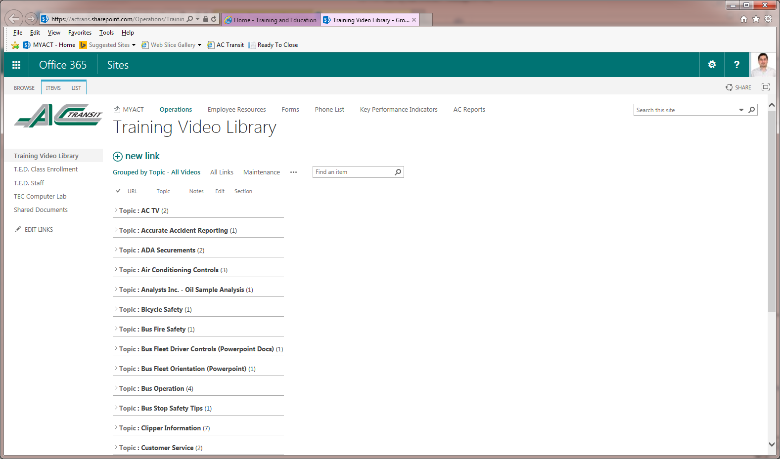

Figure : Training Video Library