Class04.R
anthonytruong
2026-01-16
x <- 1:50
plot(x)
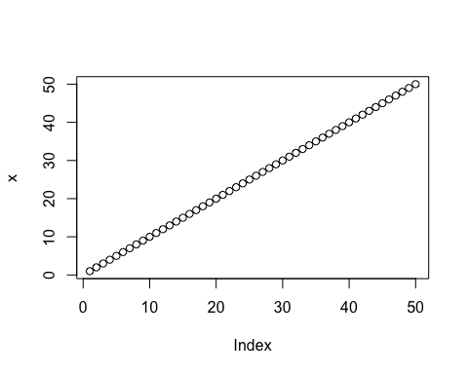
plot(x, sin(x),typ ="l", col = "blue", lwd = 3, xlab = "Is it lunch time yet?")
