EMA SERVICES PROJECT WALK THROUGH

Abdullah Qureshi, Kenneth Stroup, Saily Marudwar

Roosevelt University

CST 390/480 – Fall 2019

**Introduction**

This document has been created as a walk through to understand the flow of the project execution developed for the Department of Homeland Security – Emergency Management Agency. Currently, the EMA facility at Valparaiso, Indiana uses excel spreadsheet to keep log of their day to day activities – but it appears to be a bit cumbersome to type in everything manually. So, they want their system to be automated.

This Web Application would help the EMA center, to replace their manual management of excel spreadsheet and use this WebApp instead, to keep a log of their duties and equipment. It is designed keeping in mind that fine motor skills might be limited for the staff at EMA during the emergencies and stressful situations. Thus, ease of use was kept in mind while developing it. The main intention of this Web Application is to log the user duties or the activities they perform in the database and keeping a track of their activity time. Also, a user can track the equipment log which is used to perform their activities during the emergency situations.

# Project flow and execution

1. **Home Page:**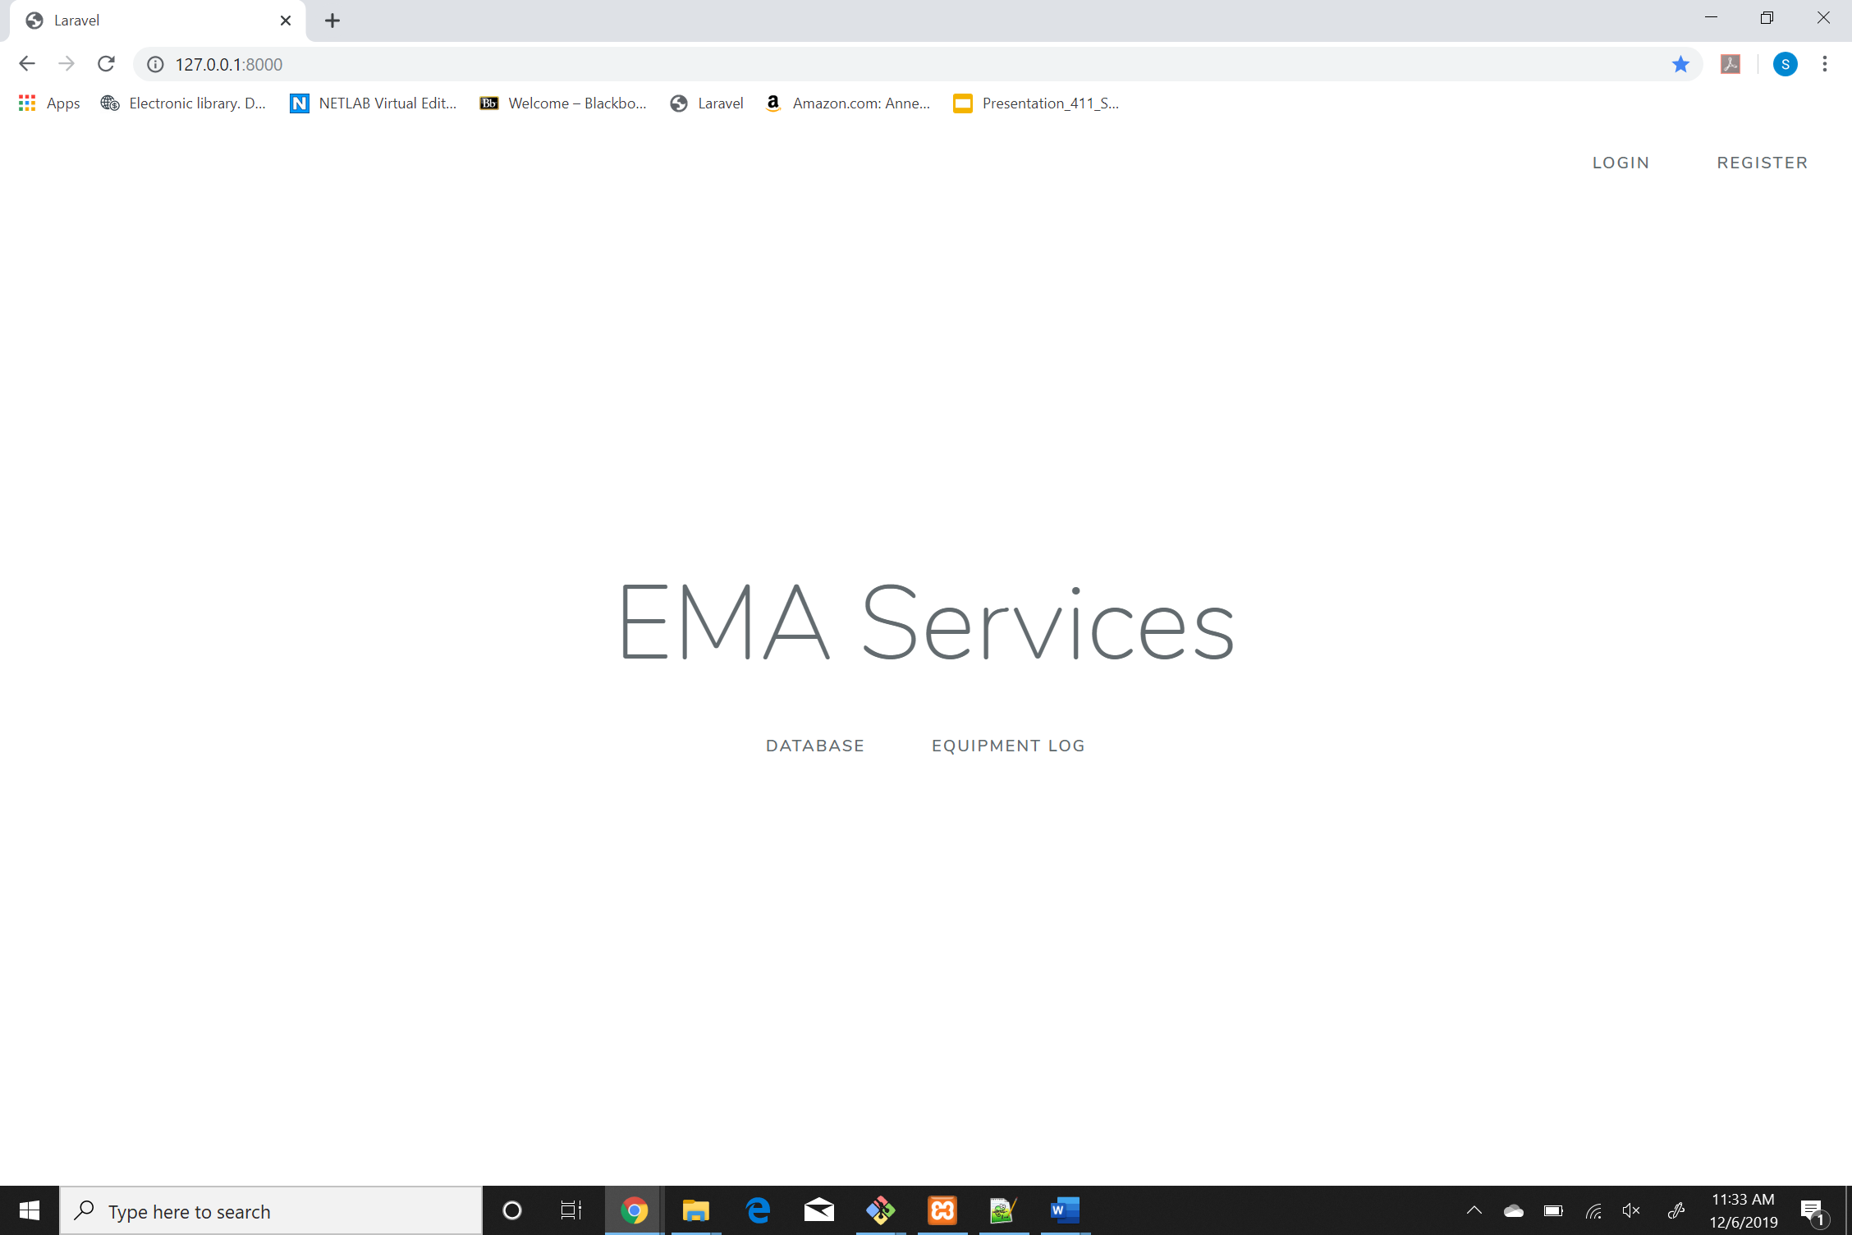

# Registration Page:

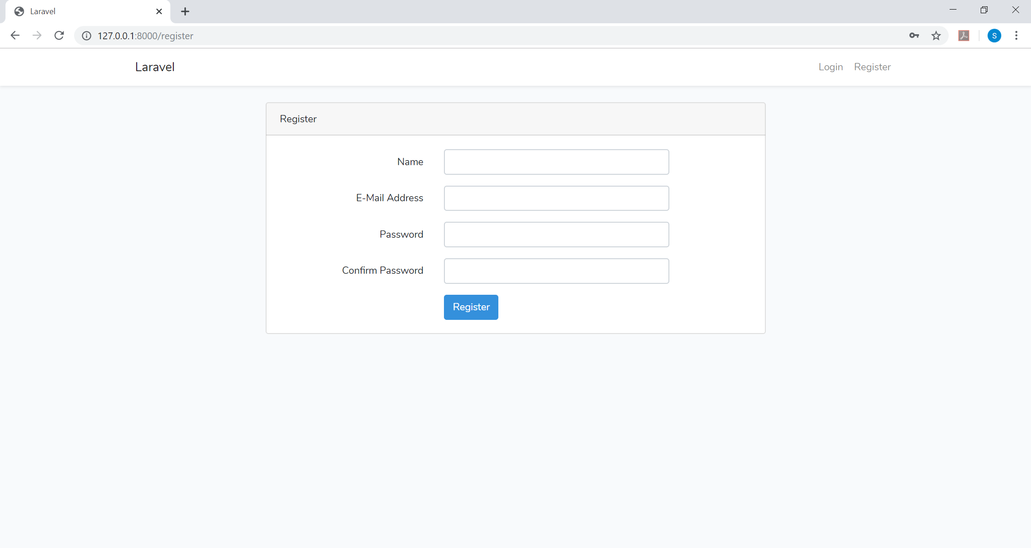

1. **Login Page:**

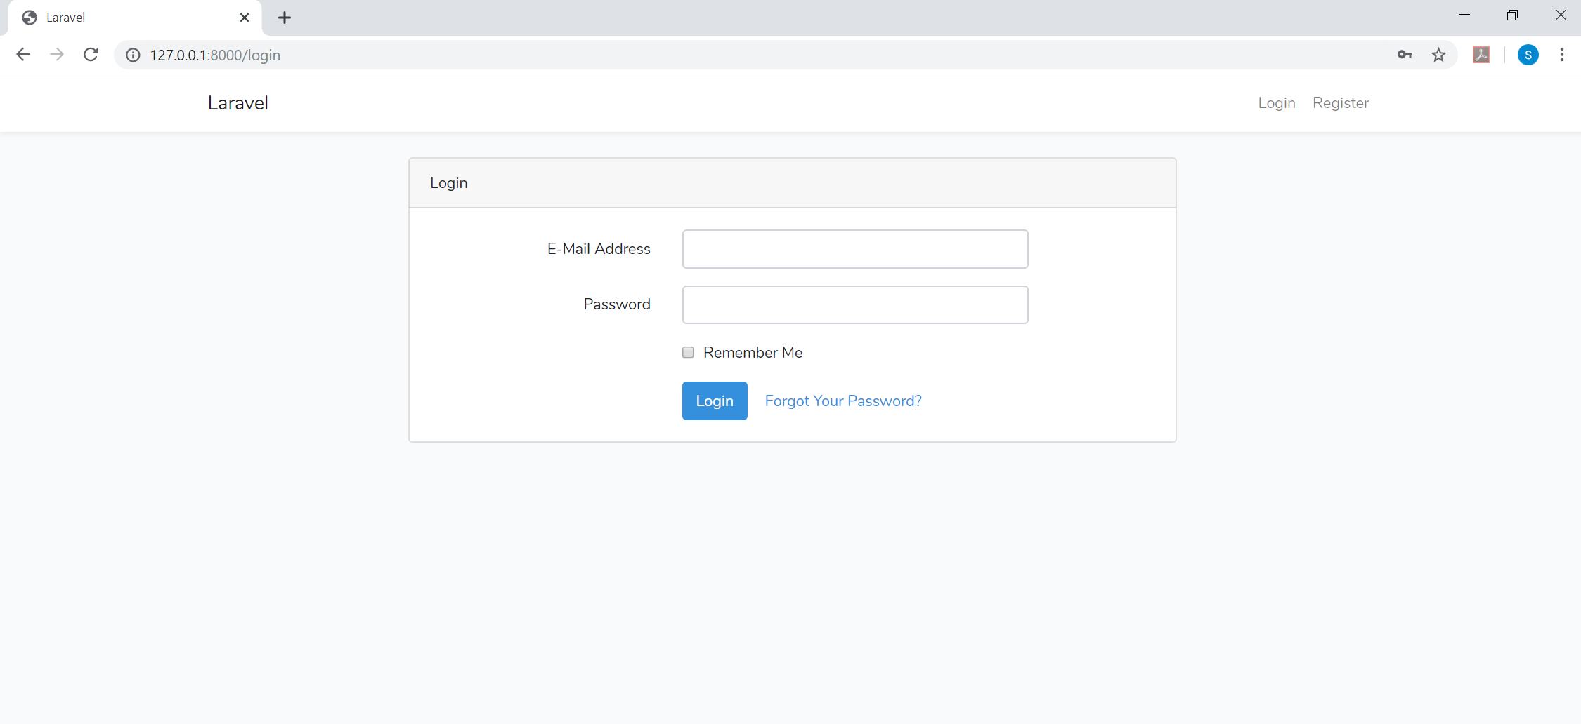

1. **Logging in as Admin:**

One can either login either as a normal user or as an Admin. Admin has access to Add/Update/Delete activities and equipment which the normal user cannot. Also, once logged in as an admin, the buttons on UI are in Red so as to remind the user of the special privileges that he as an Admin. After logging in as admin:

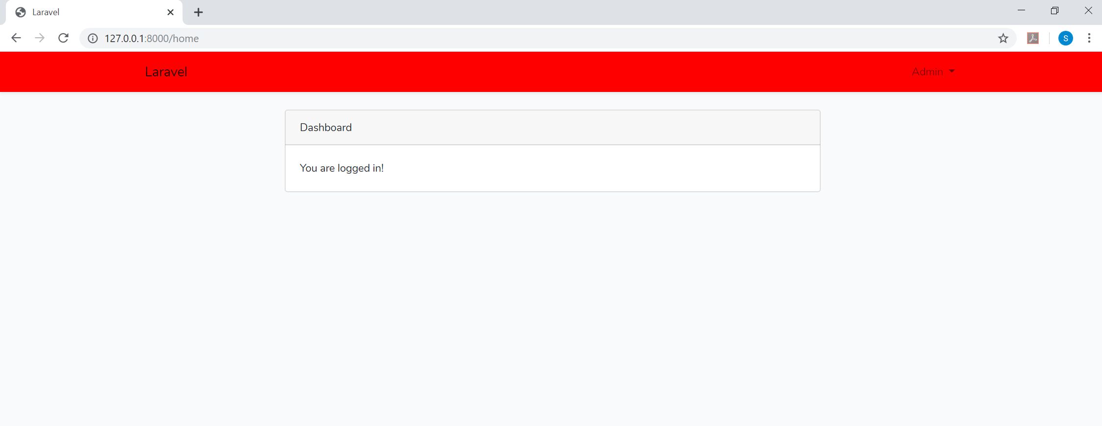

**Admin Home Page:**

Red buttons indicate that you are logged in as an Admin.

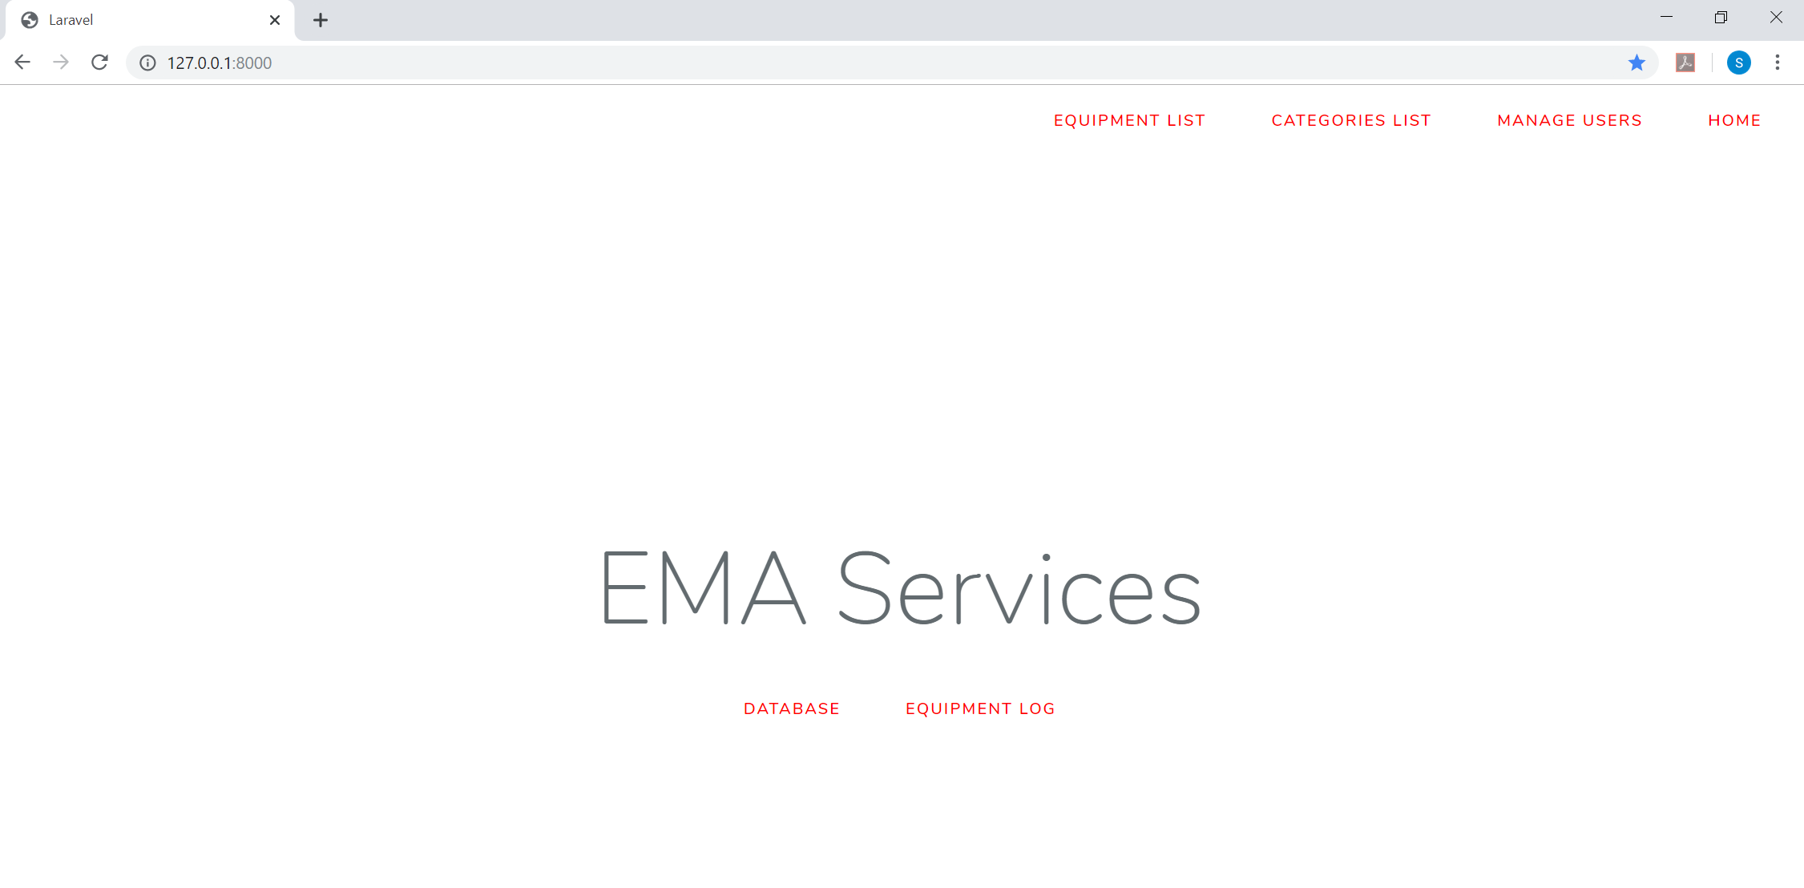

1. **Adding activities:**

A new category of activity can be added to the database from the homepage under the “CATEGORIES LIST” tab.



**Adding a new activity:**

By clicking on “Create New”, you can access the New Activity Entry page. Here the admin can enter any type of activity that are normally carried out at the EMA facility.

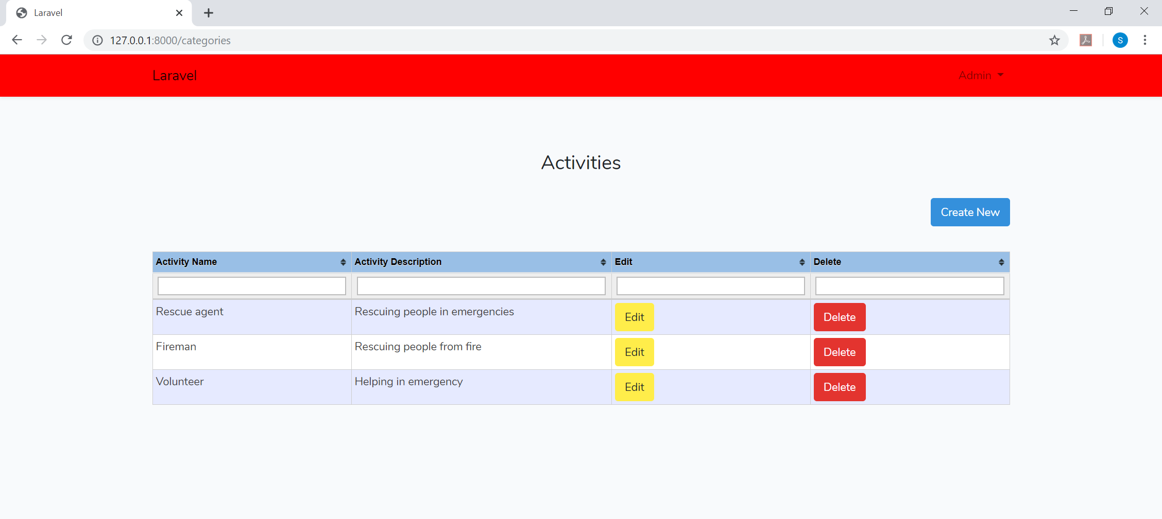

1. **New Activity Entry:**

Admin needs to enter the activity name and a brief description of the activity and hit submit. Here all possible activities that EMA team carries out can be entered.

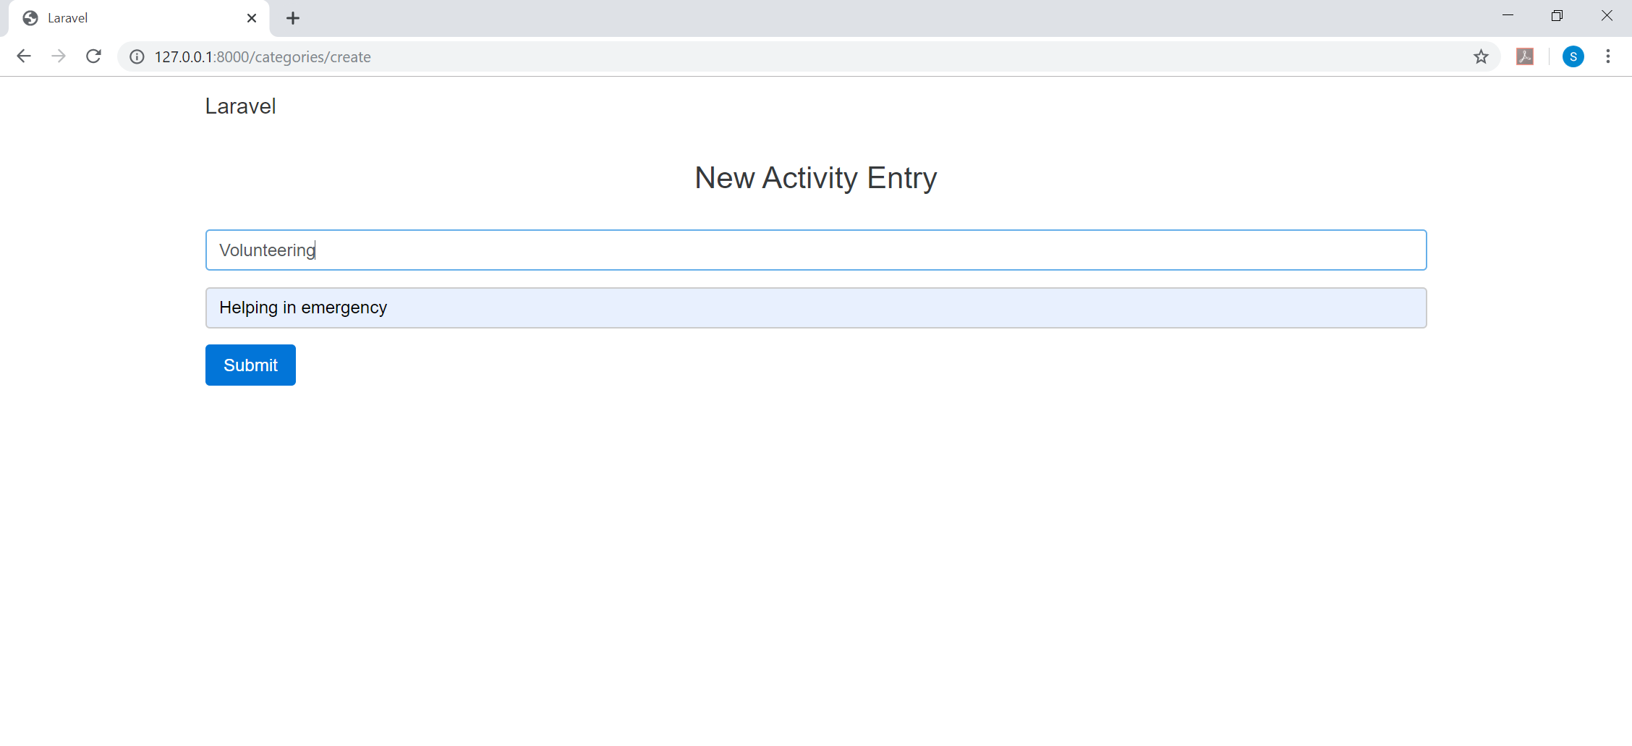

After entering the activities, the list of activities can be seen under the “CATEGORIES LIST”:

Admin can Edit or Delete these activities which would reflect immediately.

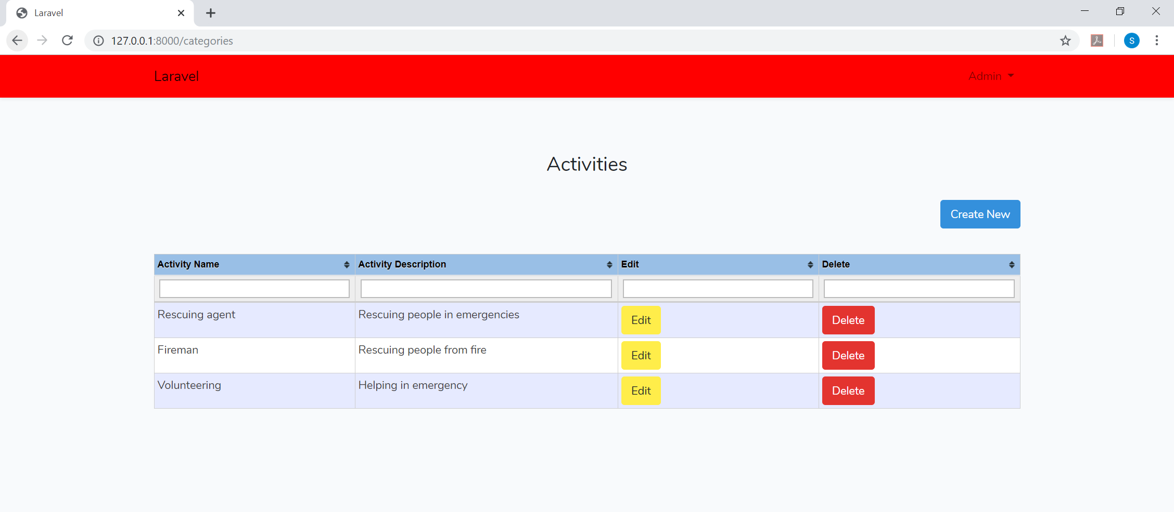

**Editing an activity:**



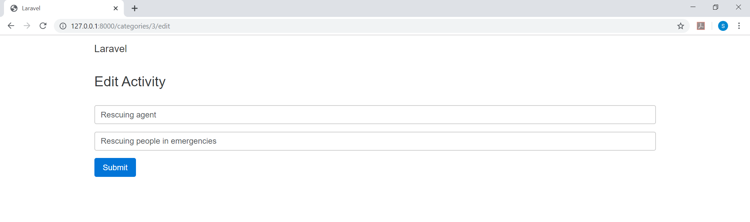

**Deleting an activity:**

Admin can delete an activity by clicking the Delete button and it would immediately update the Activities list:



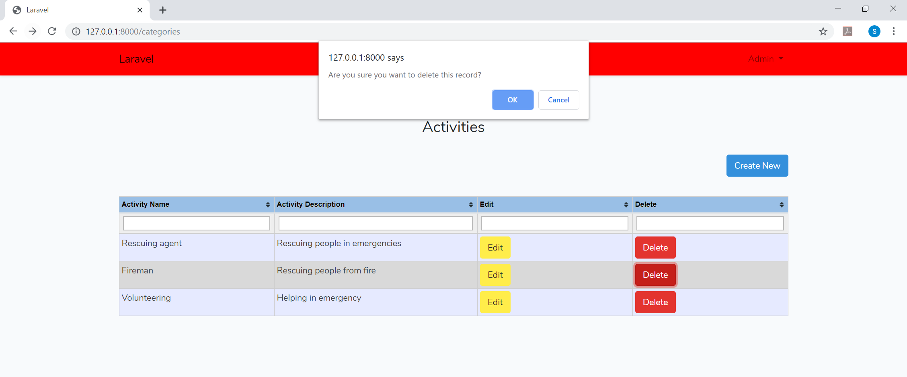

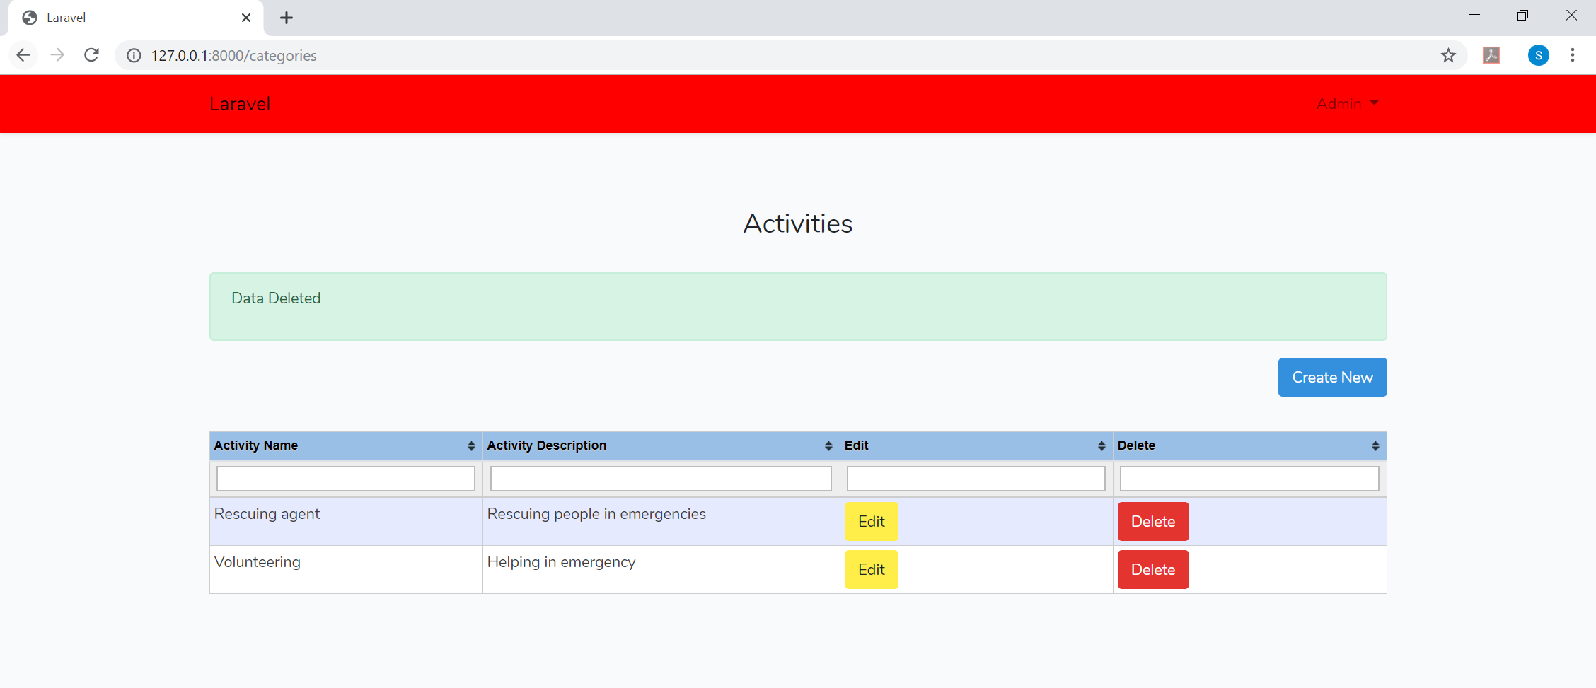

1. **New Equipment Entry:**

Admin can add/update/delete Equipment through the “EQUIPMENT LIST” button on the homepage:



**Adding new Equipment to the “Equipment List”:**

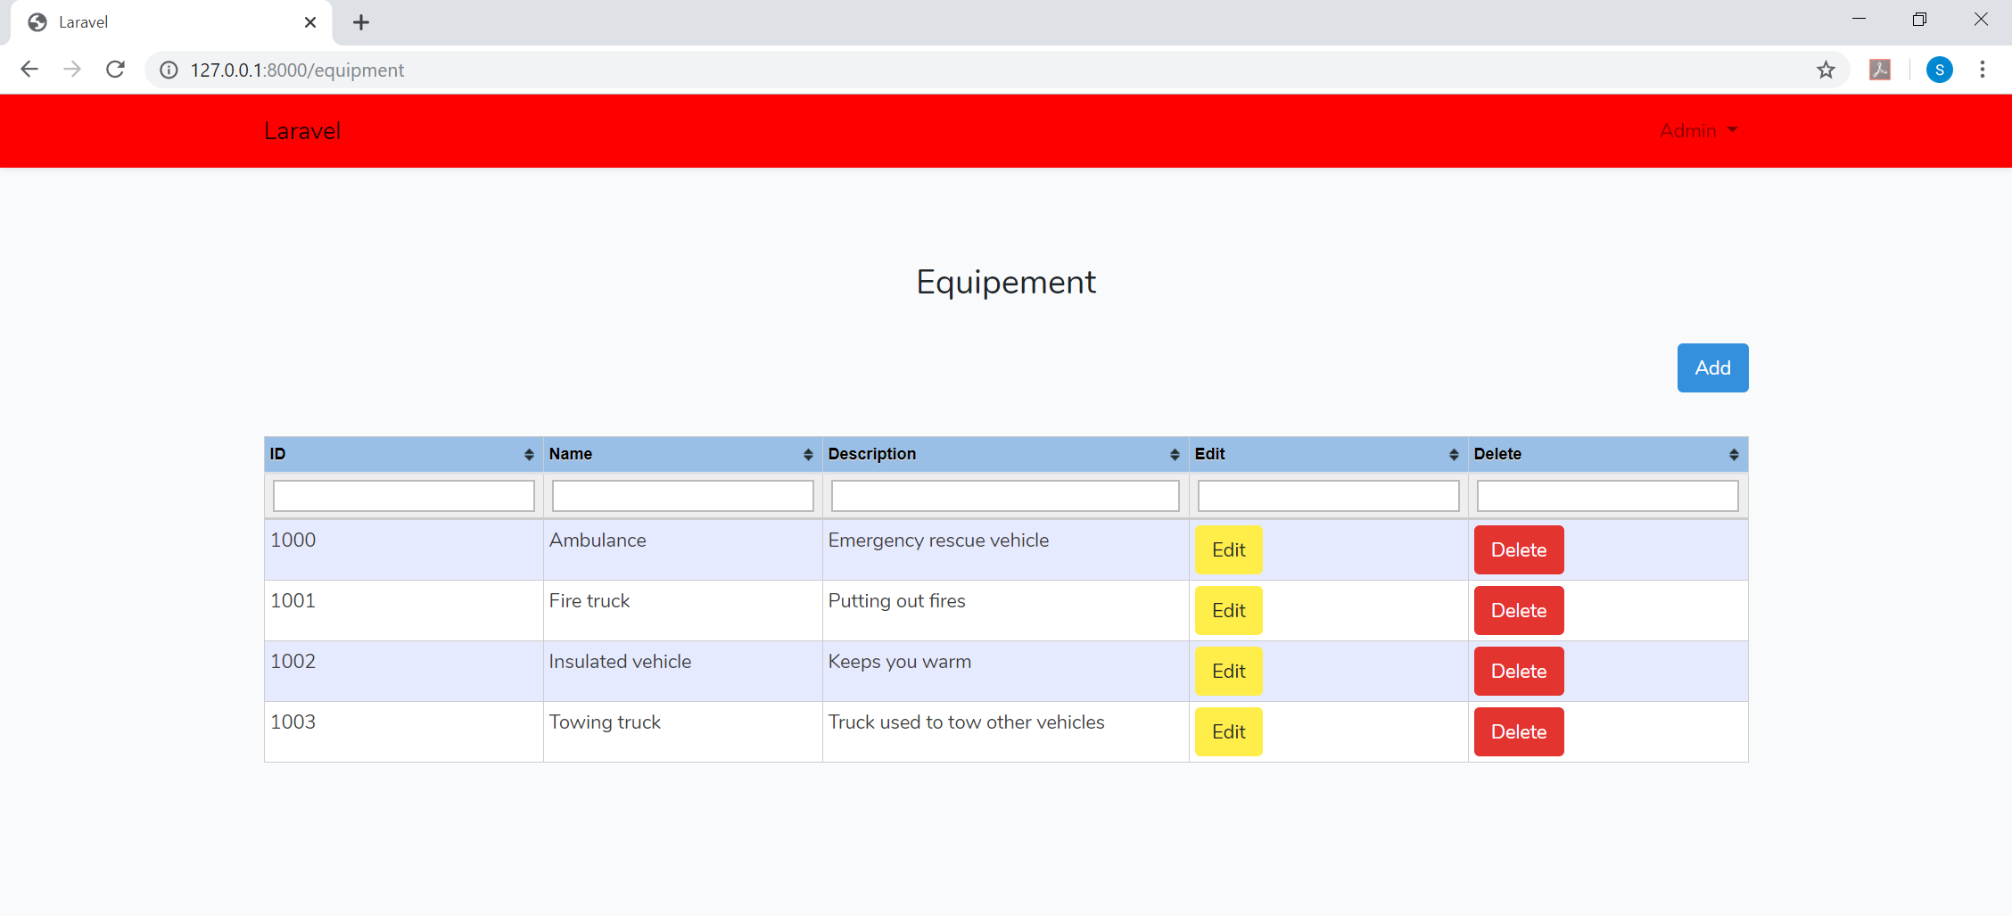

By clicking on the Add button, Admin can add a new Equipment. Equipment name and short description of the Equipment should be specified here. Hitting Submit would add the Equipment to the database.

**New Equipment Entry:**

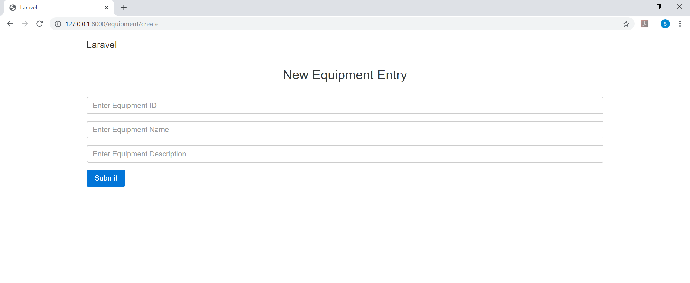

**List of the Equipment:**

You can see the Equipment List after you hit the submit button on the “New Equipment Entry” page:

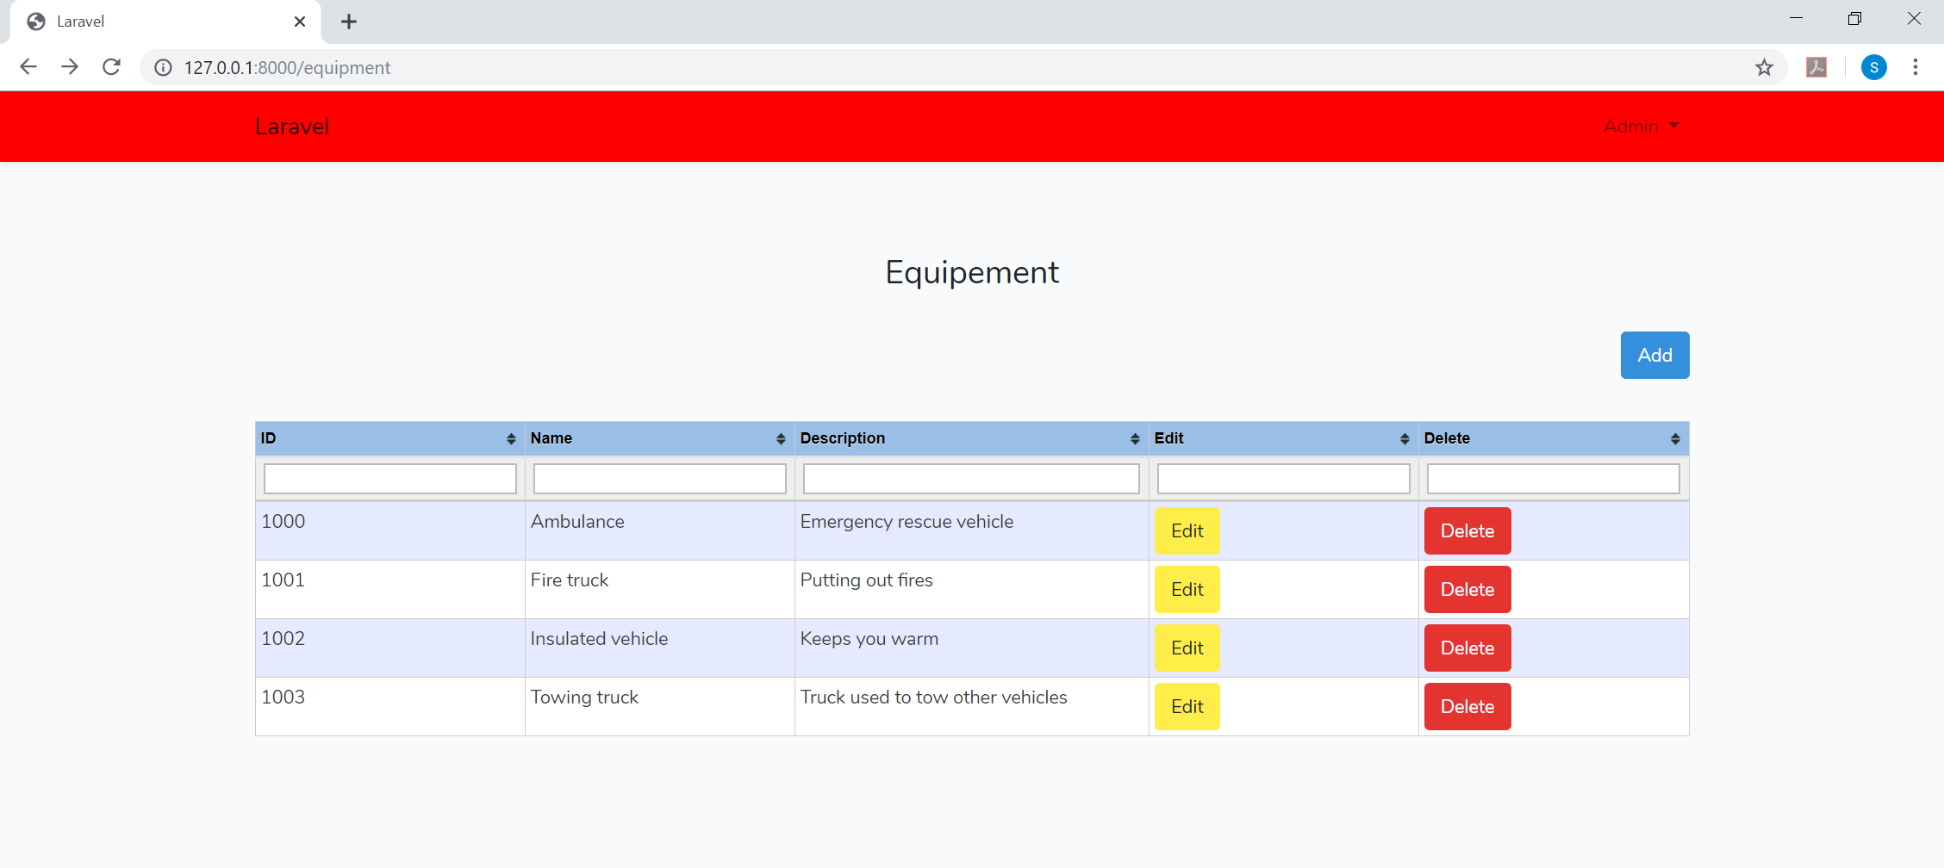

Further, just like activities, you can update and delete once you have added a new Equipment.



Admin can edit it and then hit submit button to save the changes:

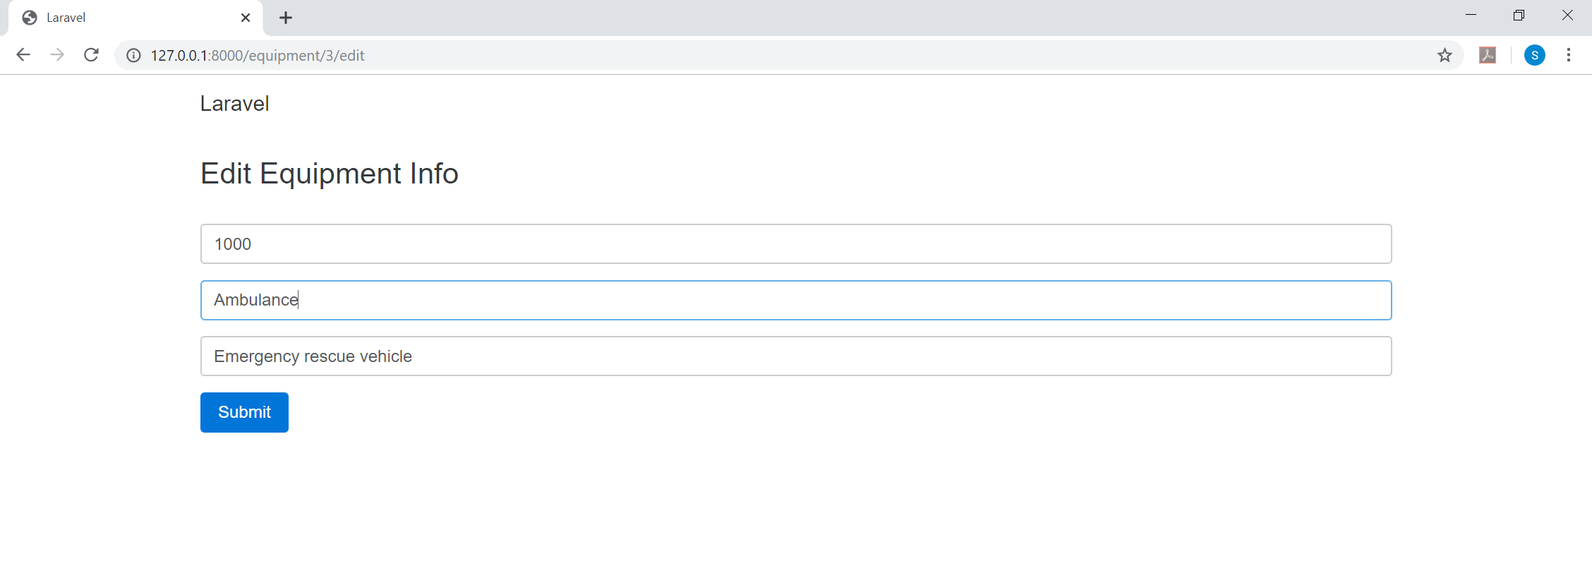

Similarly, admin can delete any Equipment from the list if he wishes:



As you can see, the “Fire Truck” entry is deleted.

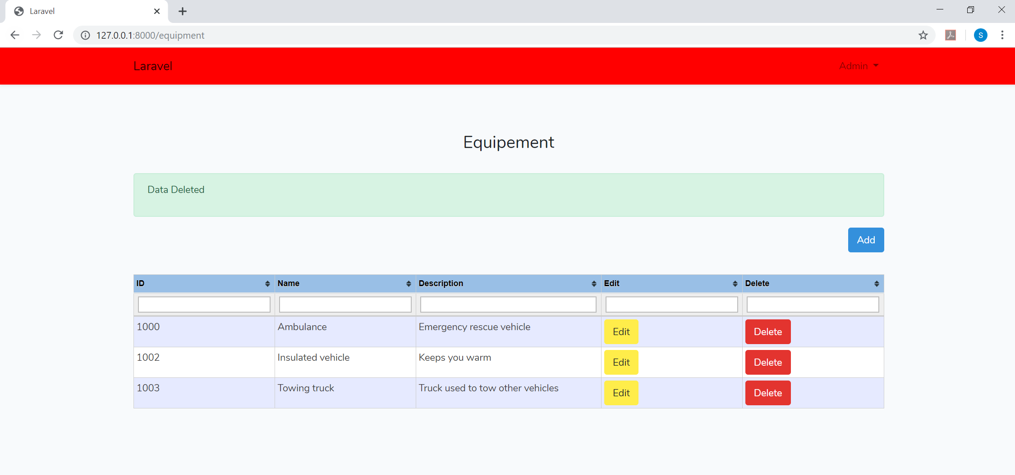

1. **Managing Users/roles:**

Admin can change the role of any user to admin, author or user by clicking on the “MANAGE USERS” on the homepage:

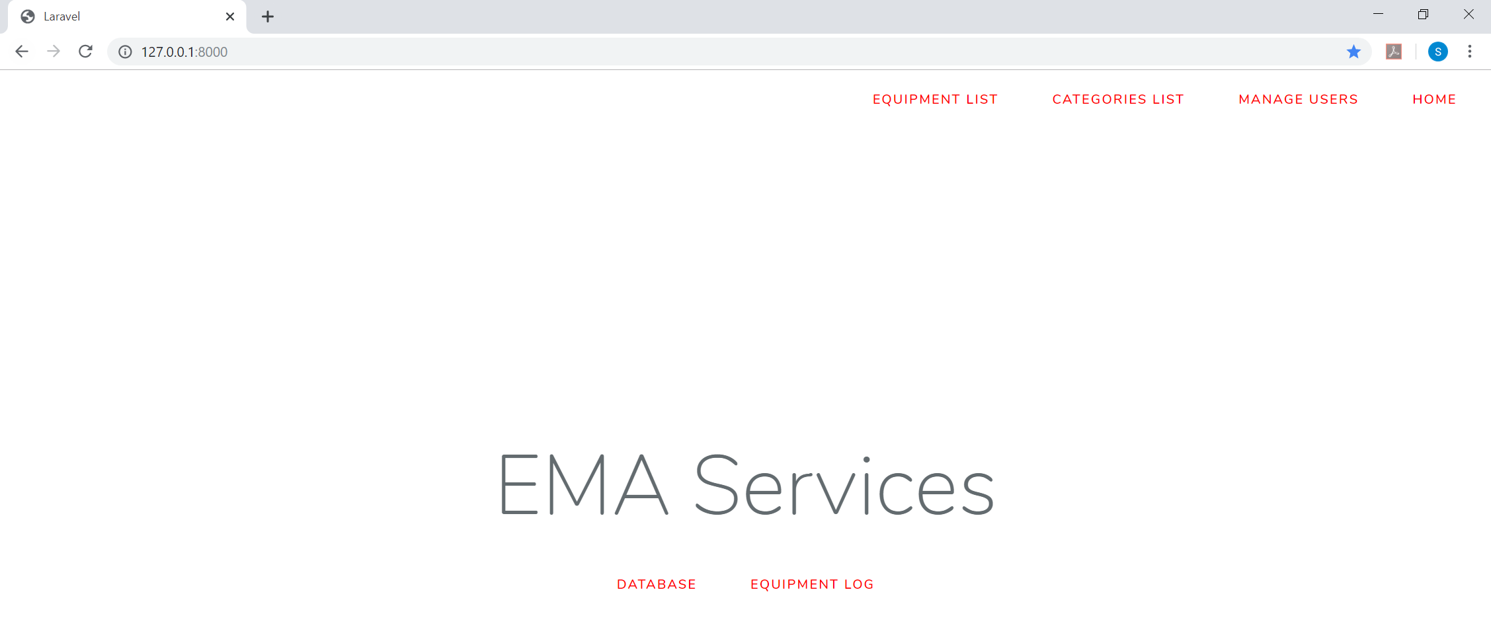

Changing the roles of Authors/Users to Admin, Author or User:

As seen below the role of an user can be changed to author or admin on the click of Update button.

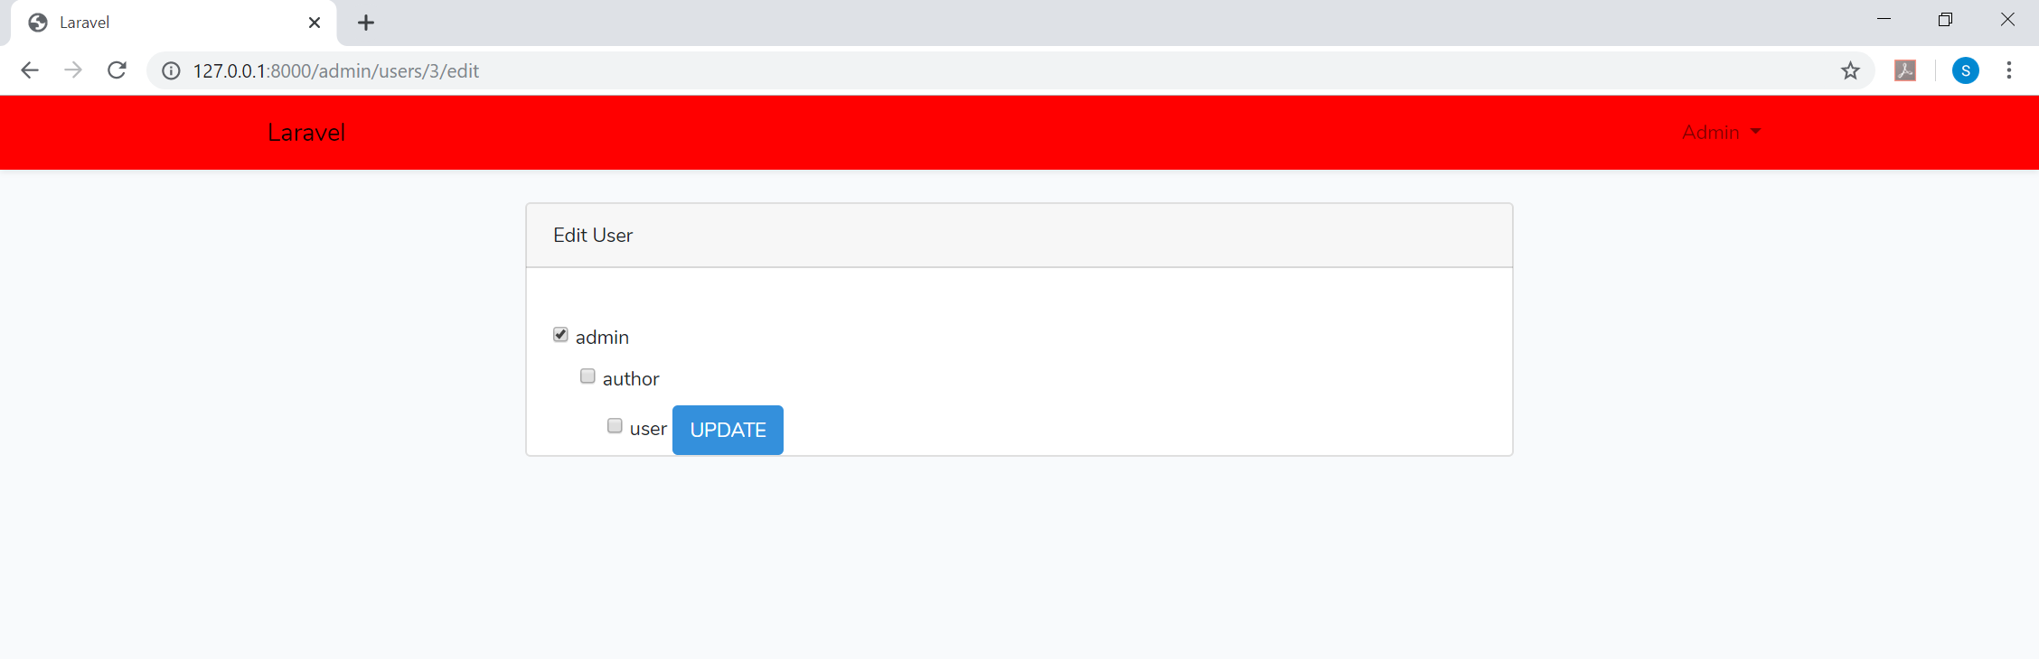

1. **Logging out:**

Click on Home, click on your name and you should see the button to logout:

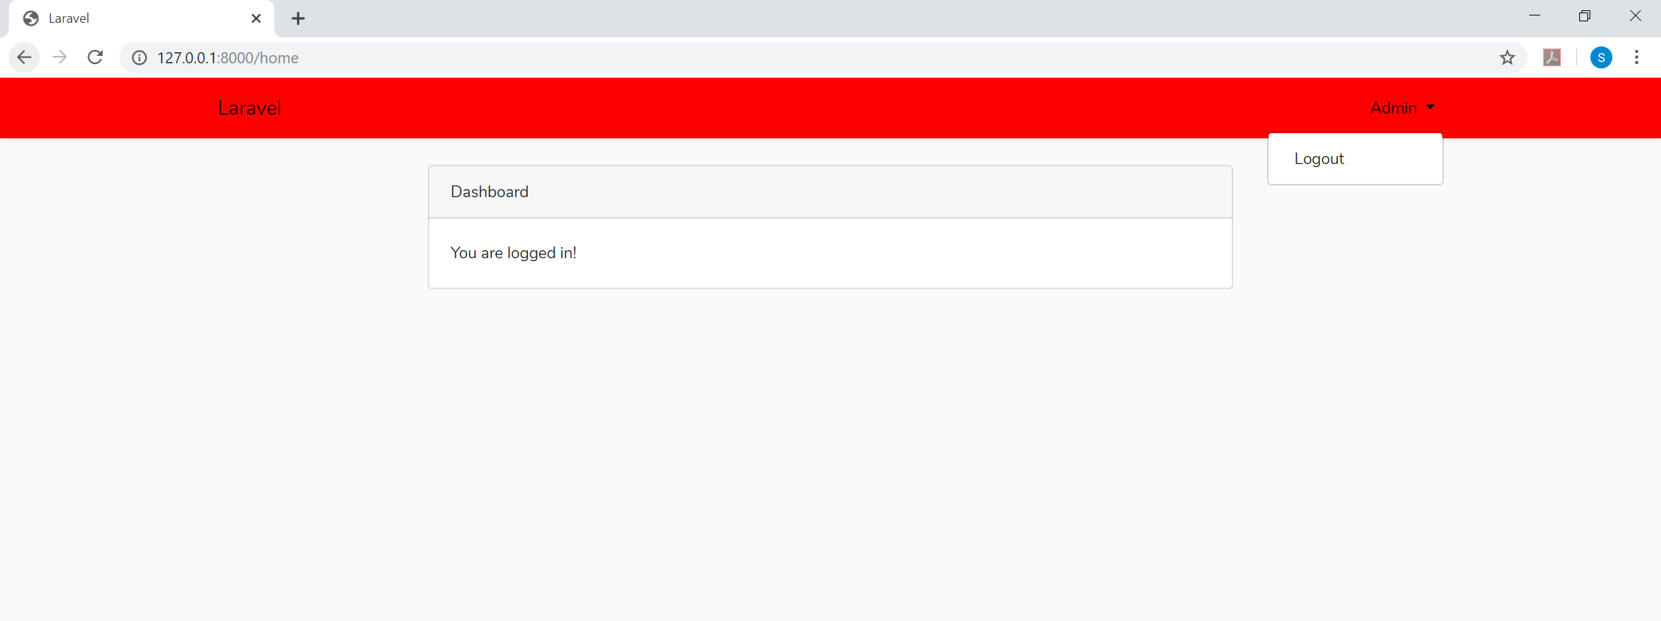

1. **Login and Registration for any other users:**

Other users can use the ‘LOGIN’ and ‘REGISTER’ option on the home page to sign up and login for the EMA services.

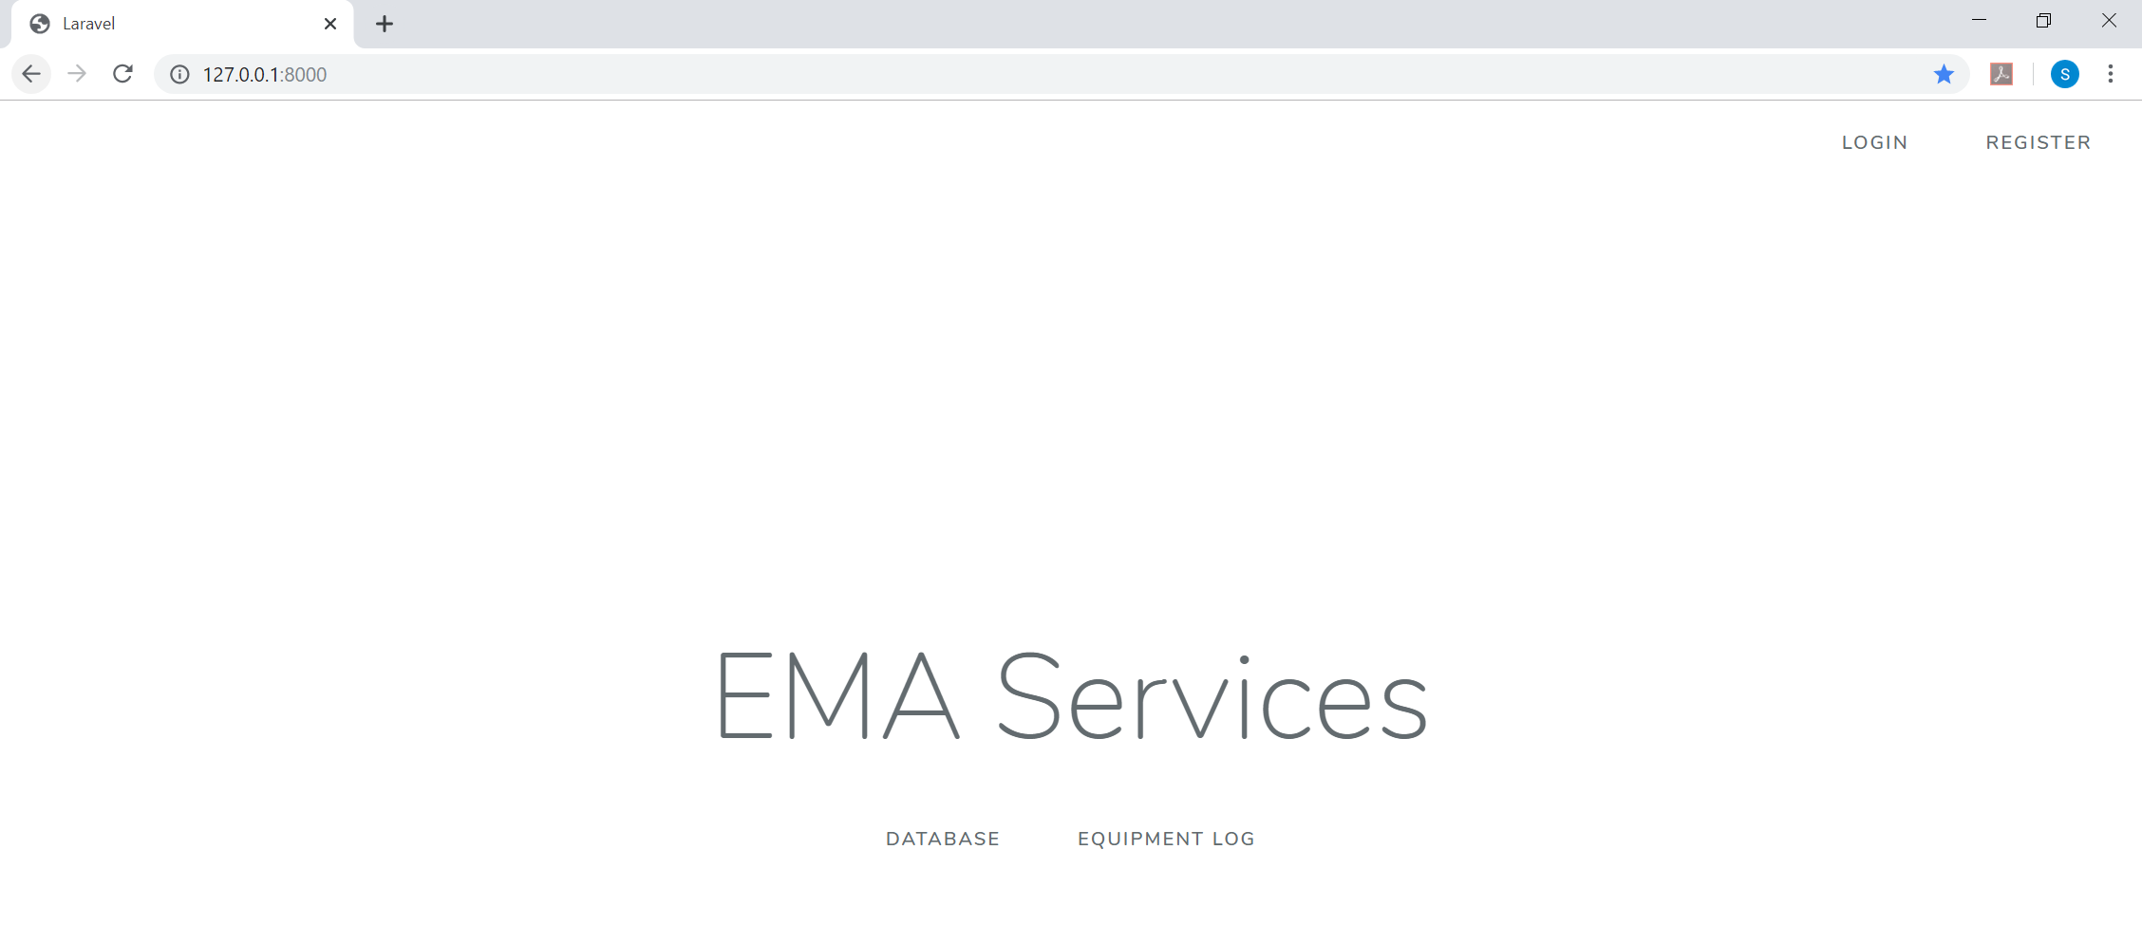

**Registering:**

Entering Name, Email and Password to register:

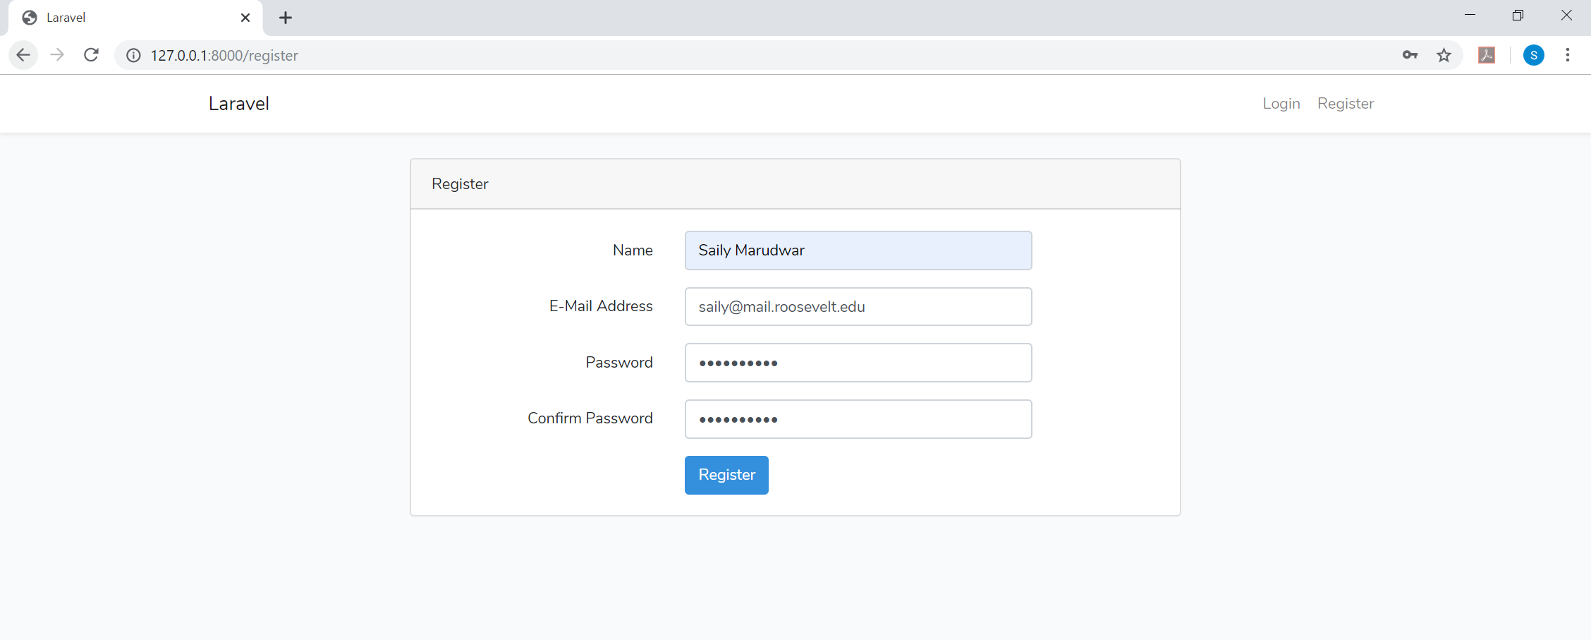

**Email address validation:**

An error message would be popped up if the email address entered by the user is not in the valid format. A user can register only if he fixes it and enters the email address again in the valid format.

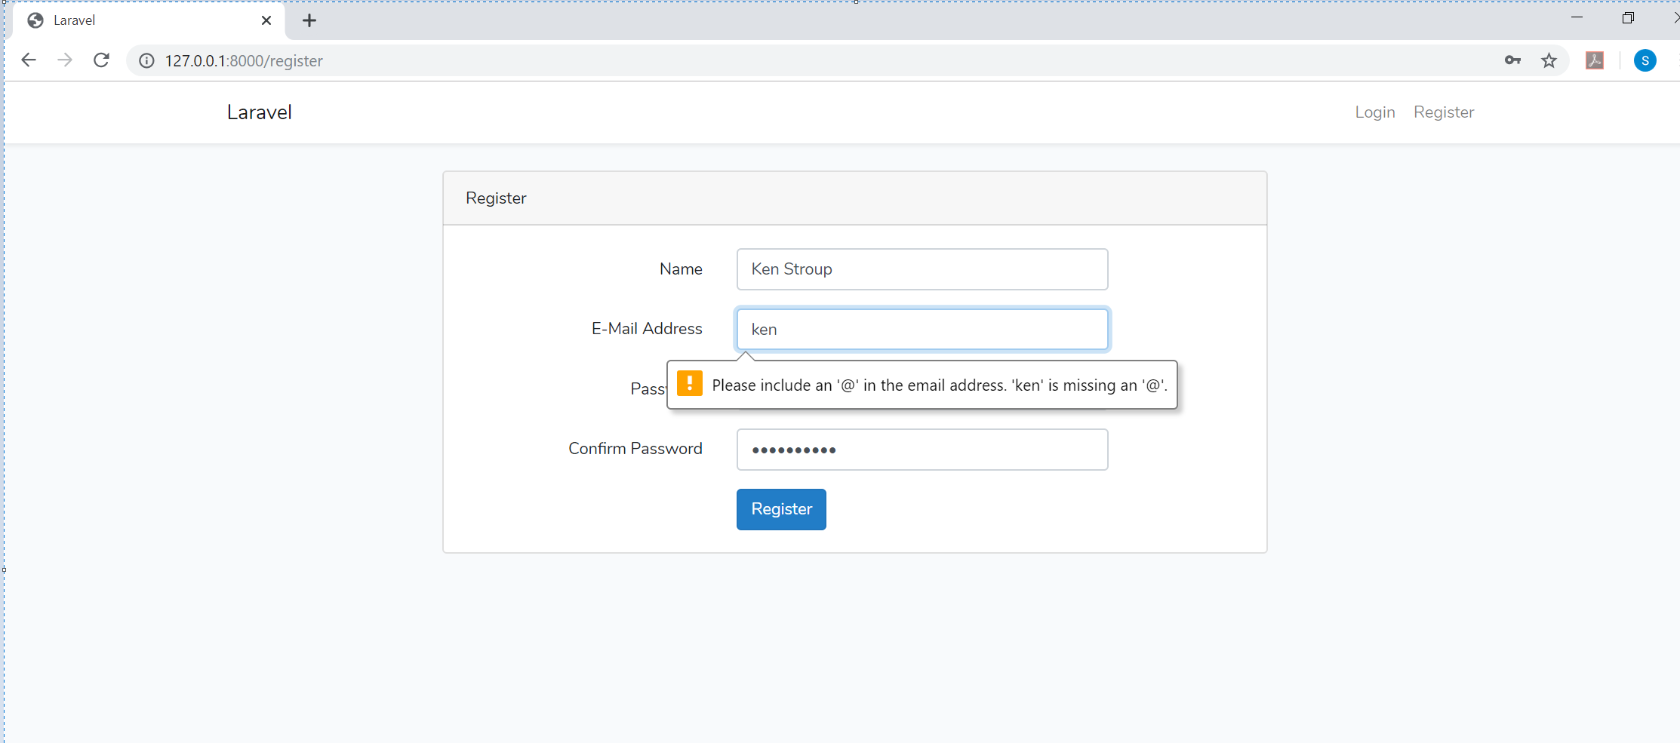

**Password validation:**

Password validation check is done if the password entered is less than 8 characters.

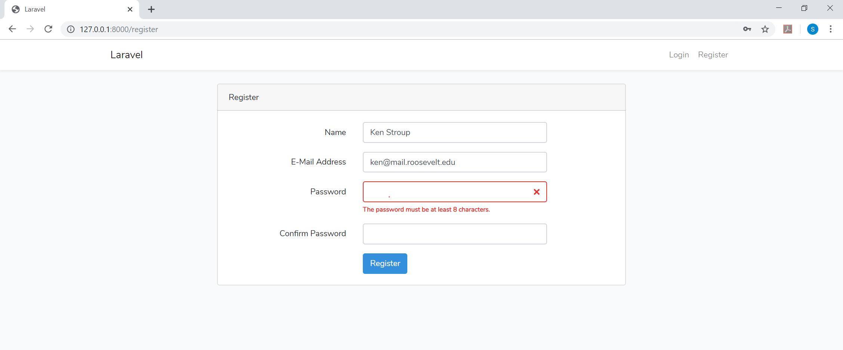

**User validation check:**

If a user who is not registered, cannot log in to the system directly using the Login option. A validation to check the user is in place:

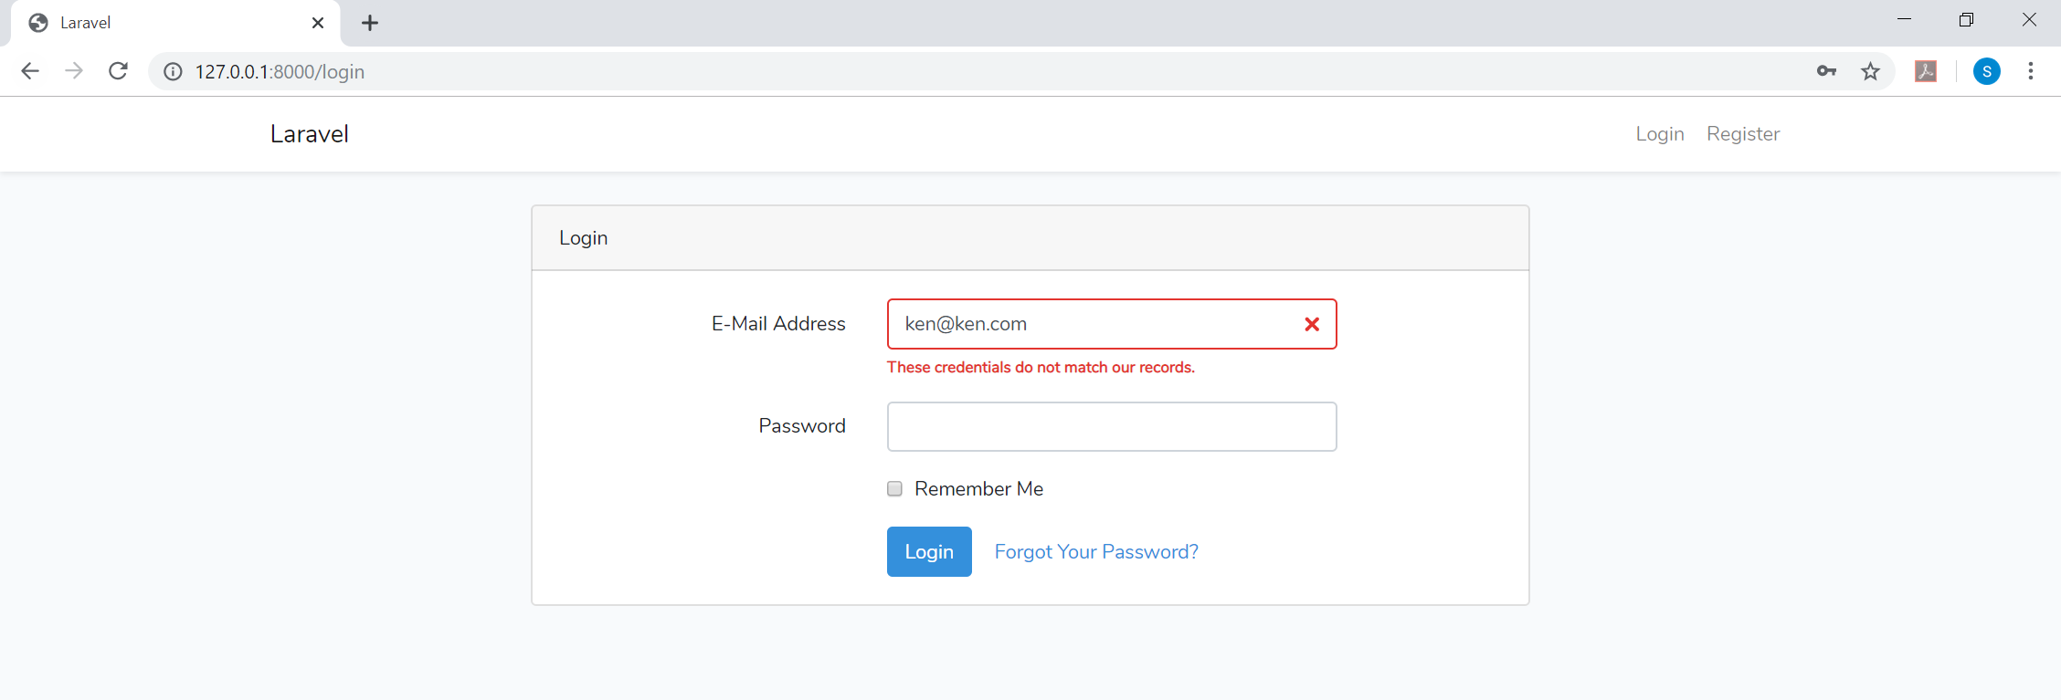

**Logging in:**

The email address and password used to register should be used to Log on to the application:

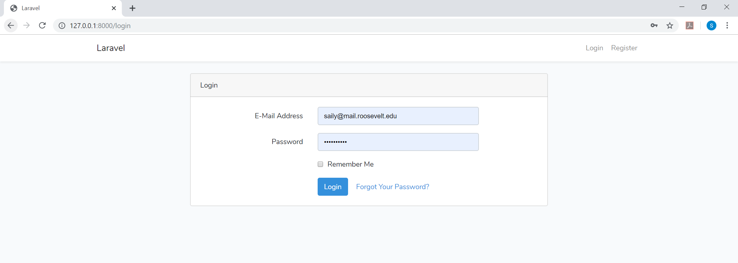

1. **Punching in:**

Click on the Database on the Homepage once logged in:

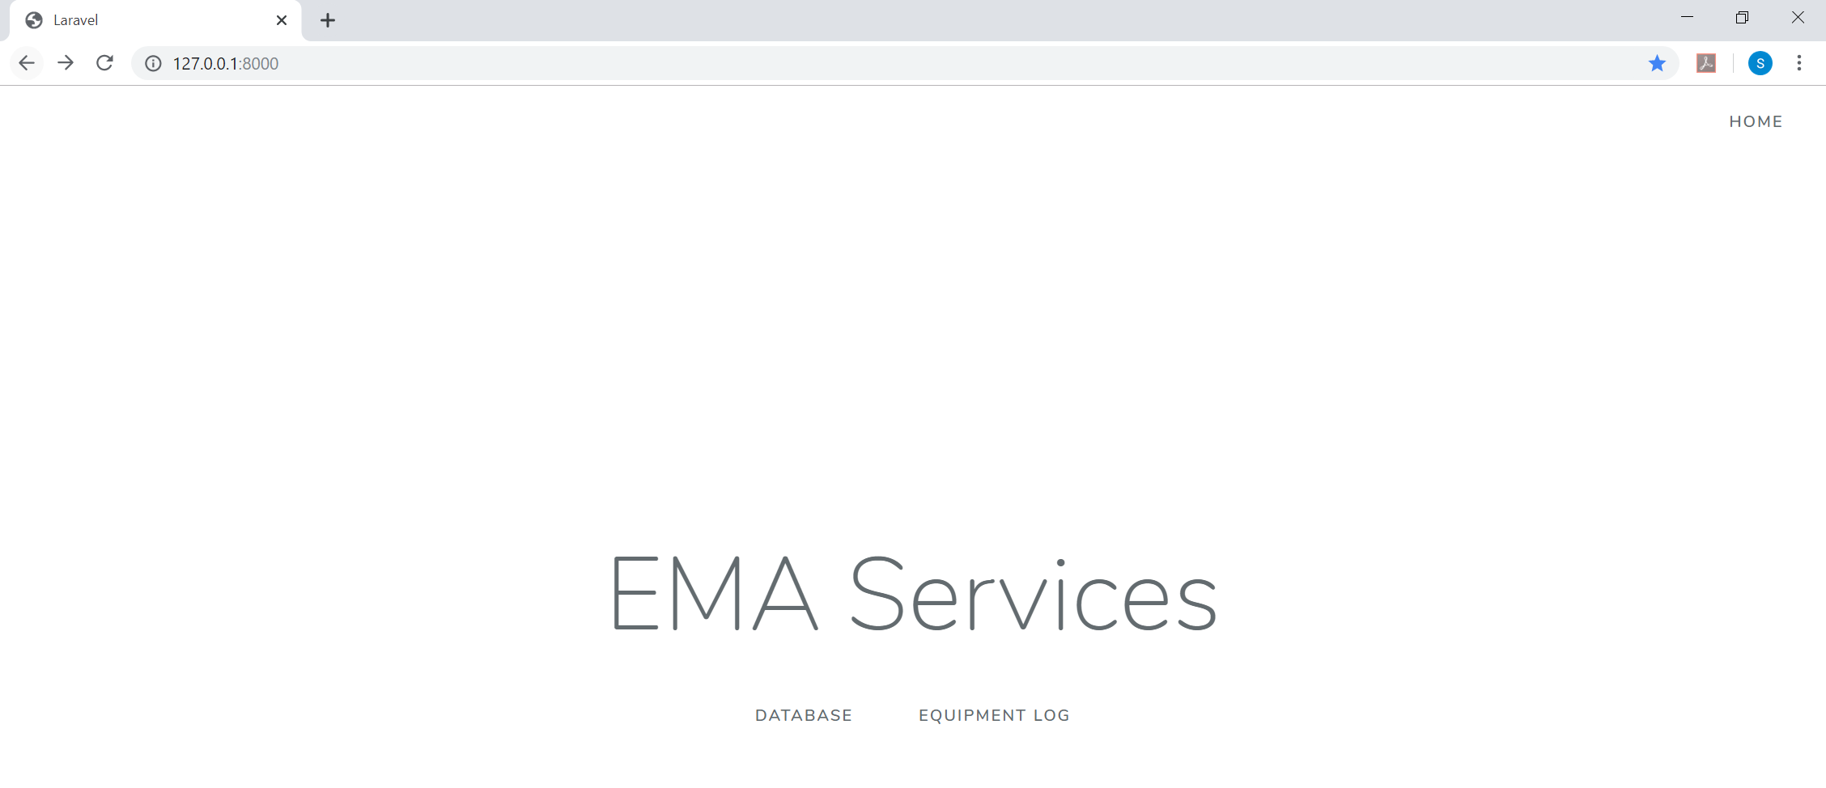

Once on the Log data page, you can click on the “Punch In” button” on the top right corner of the Log data table:

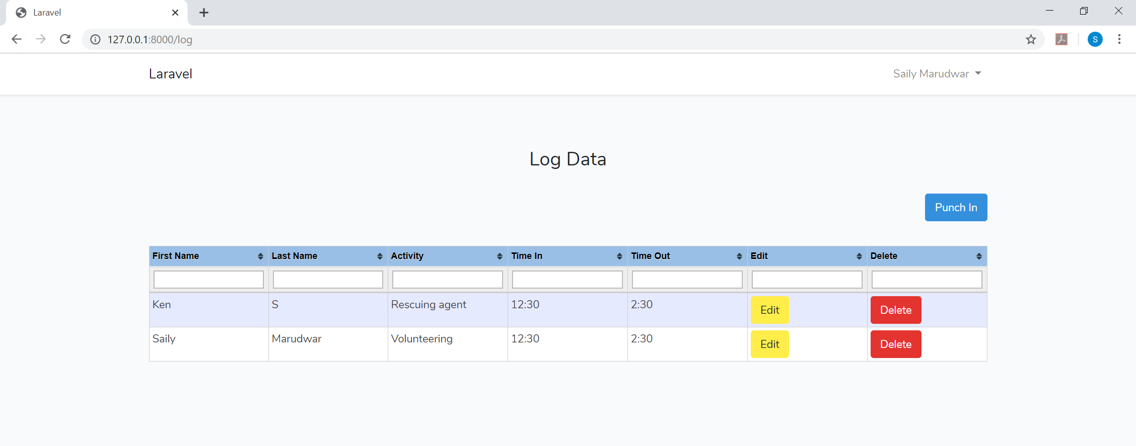

As you can see, once you hit the punch in button, user will be asked to enter his details and time. The activity for which he is punching in is pre-populated in the dropdown as seen. (We saw earlier how the admin can add the list of activities. The same activities are available here for the user to select and punch in his details to the database for that activity).

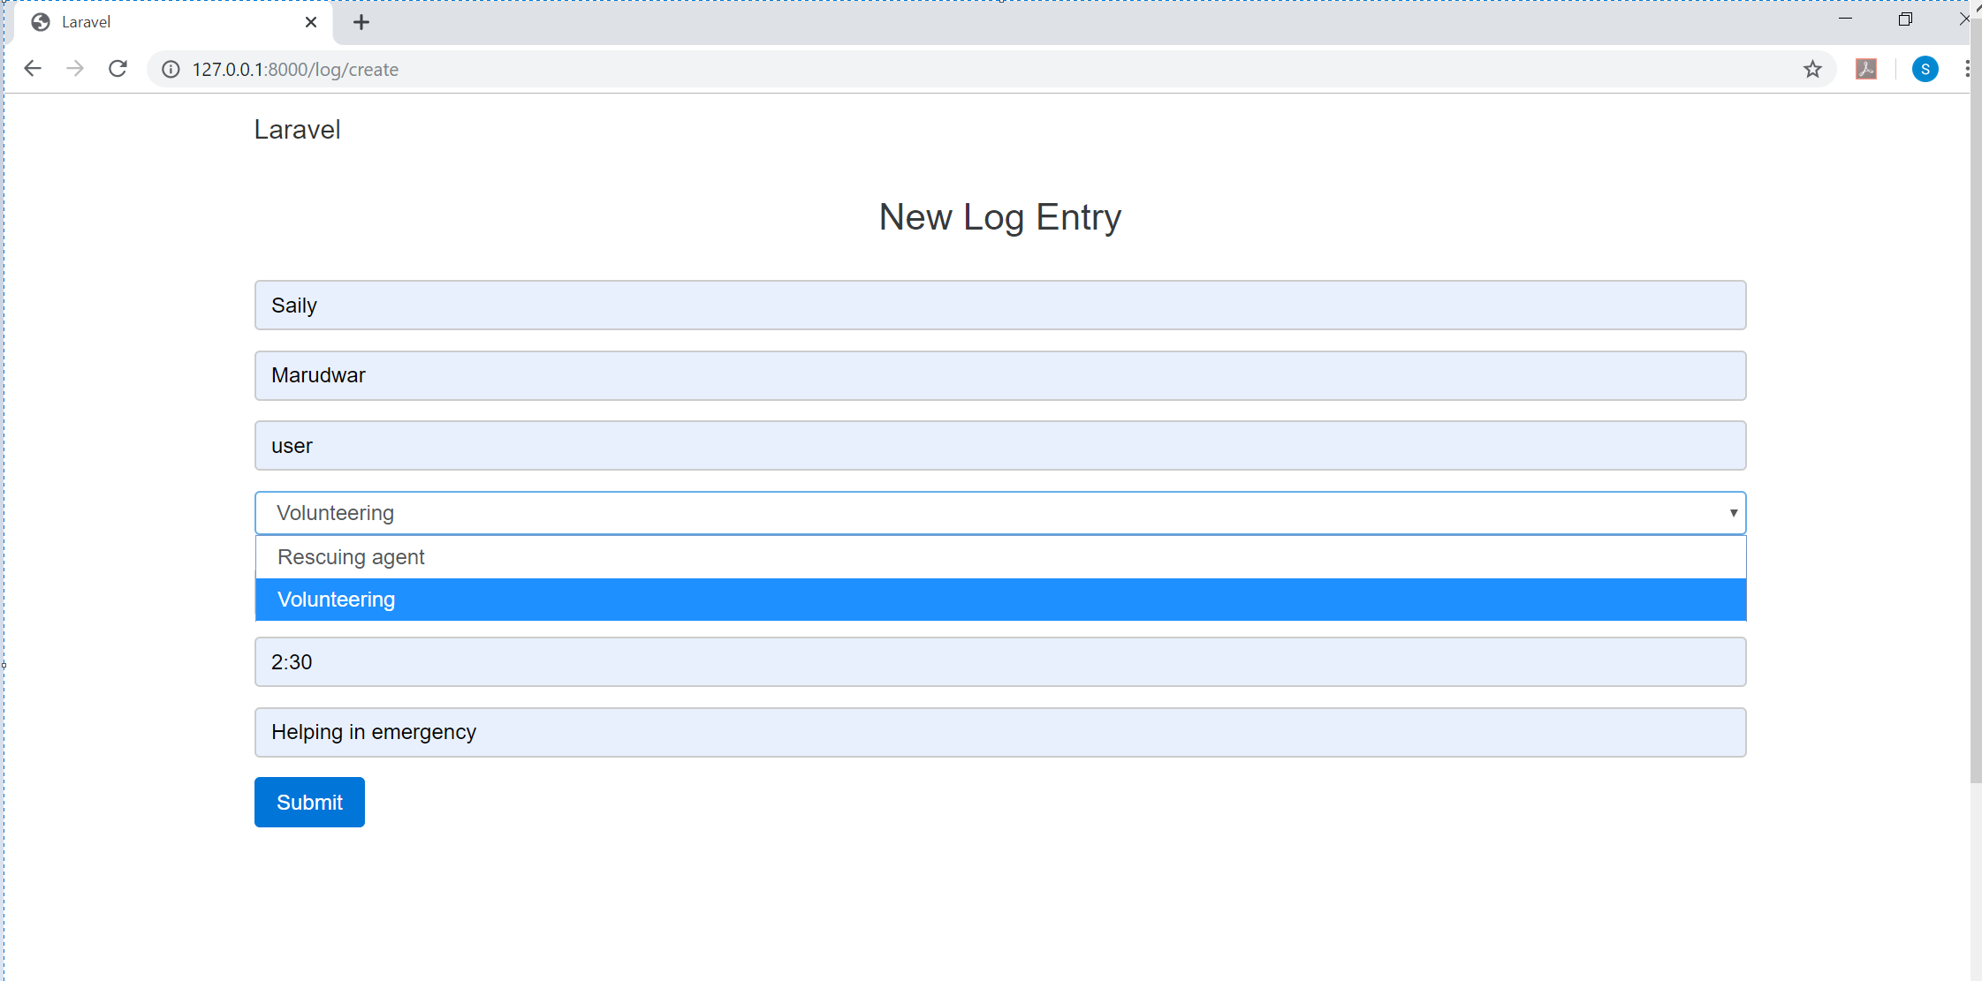

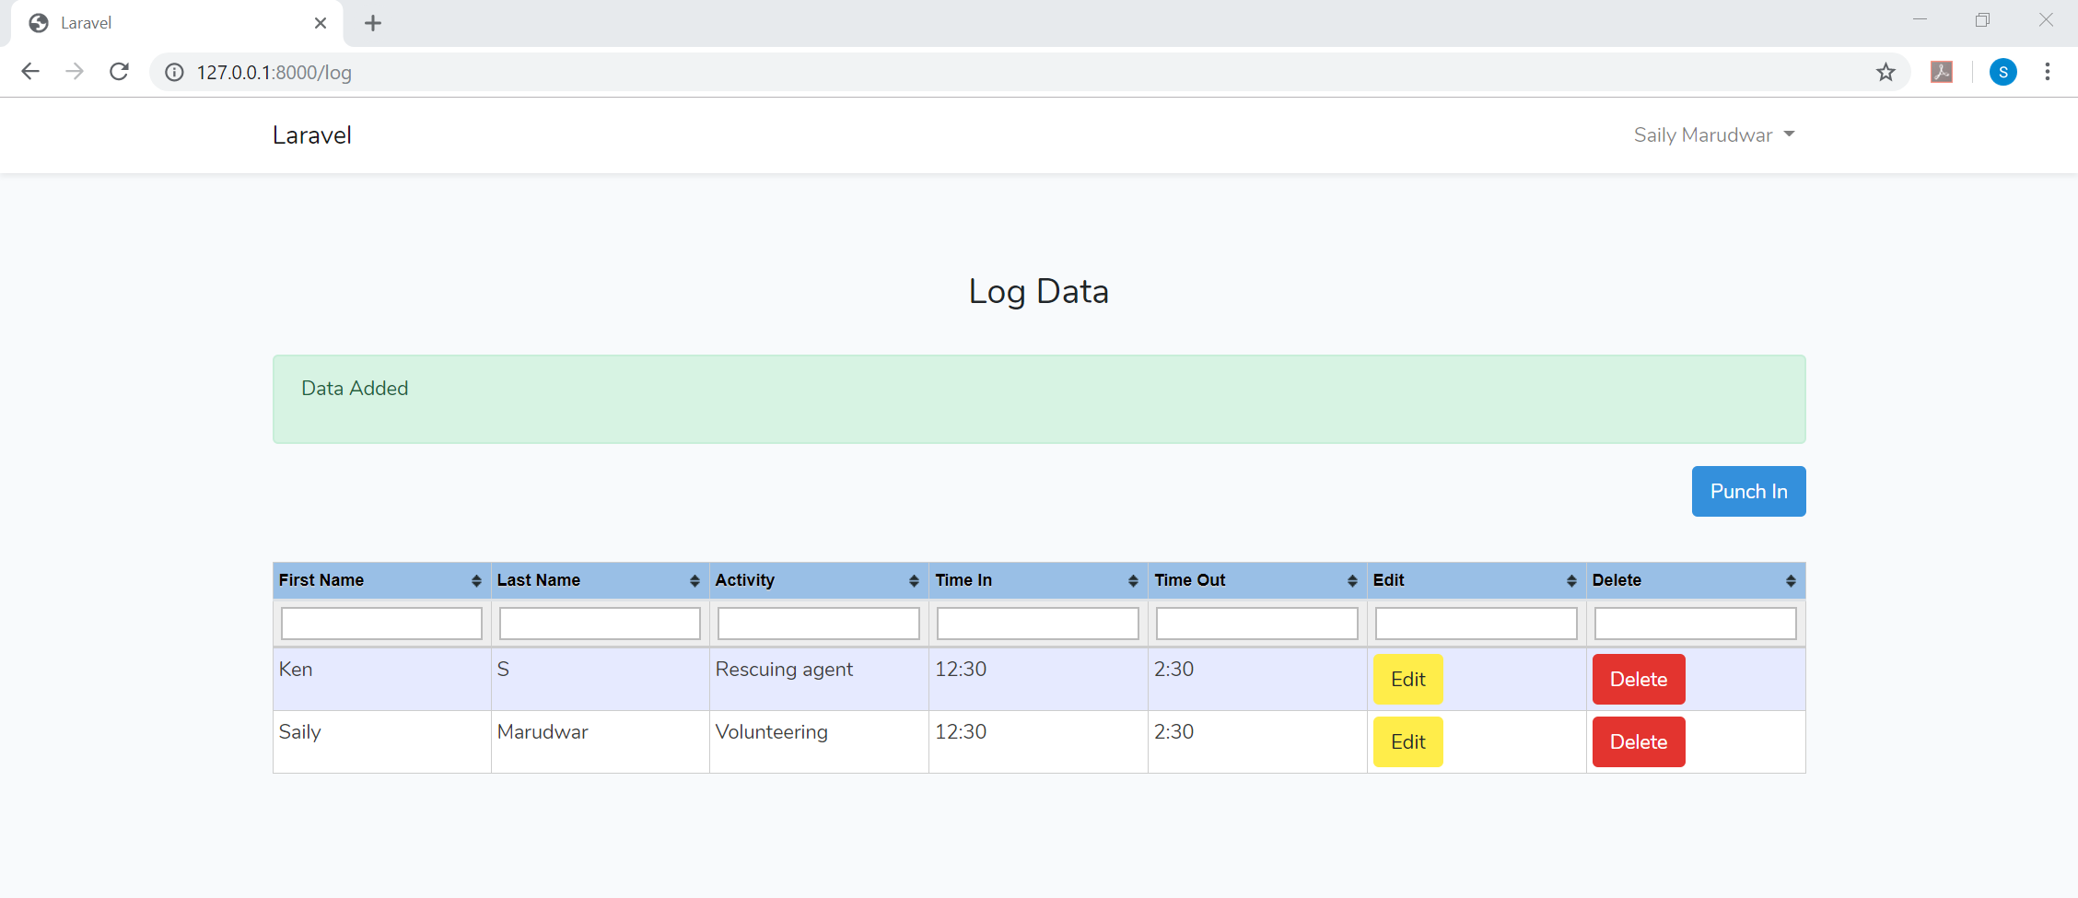

All the Users who have punched in for which activity can be viewed on this page:

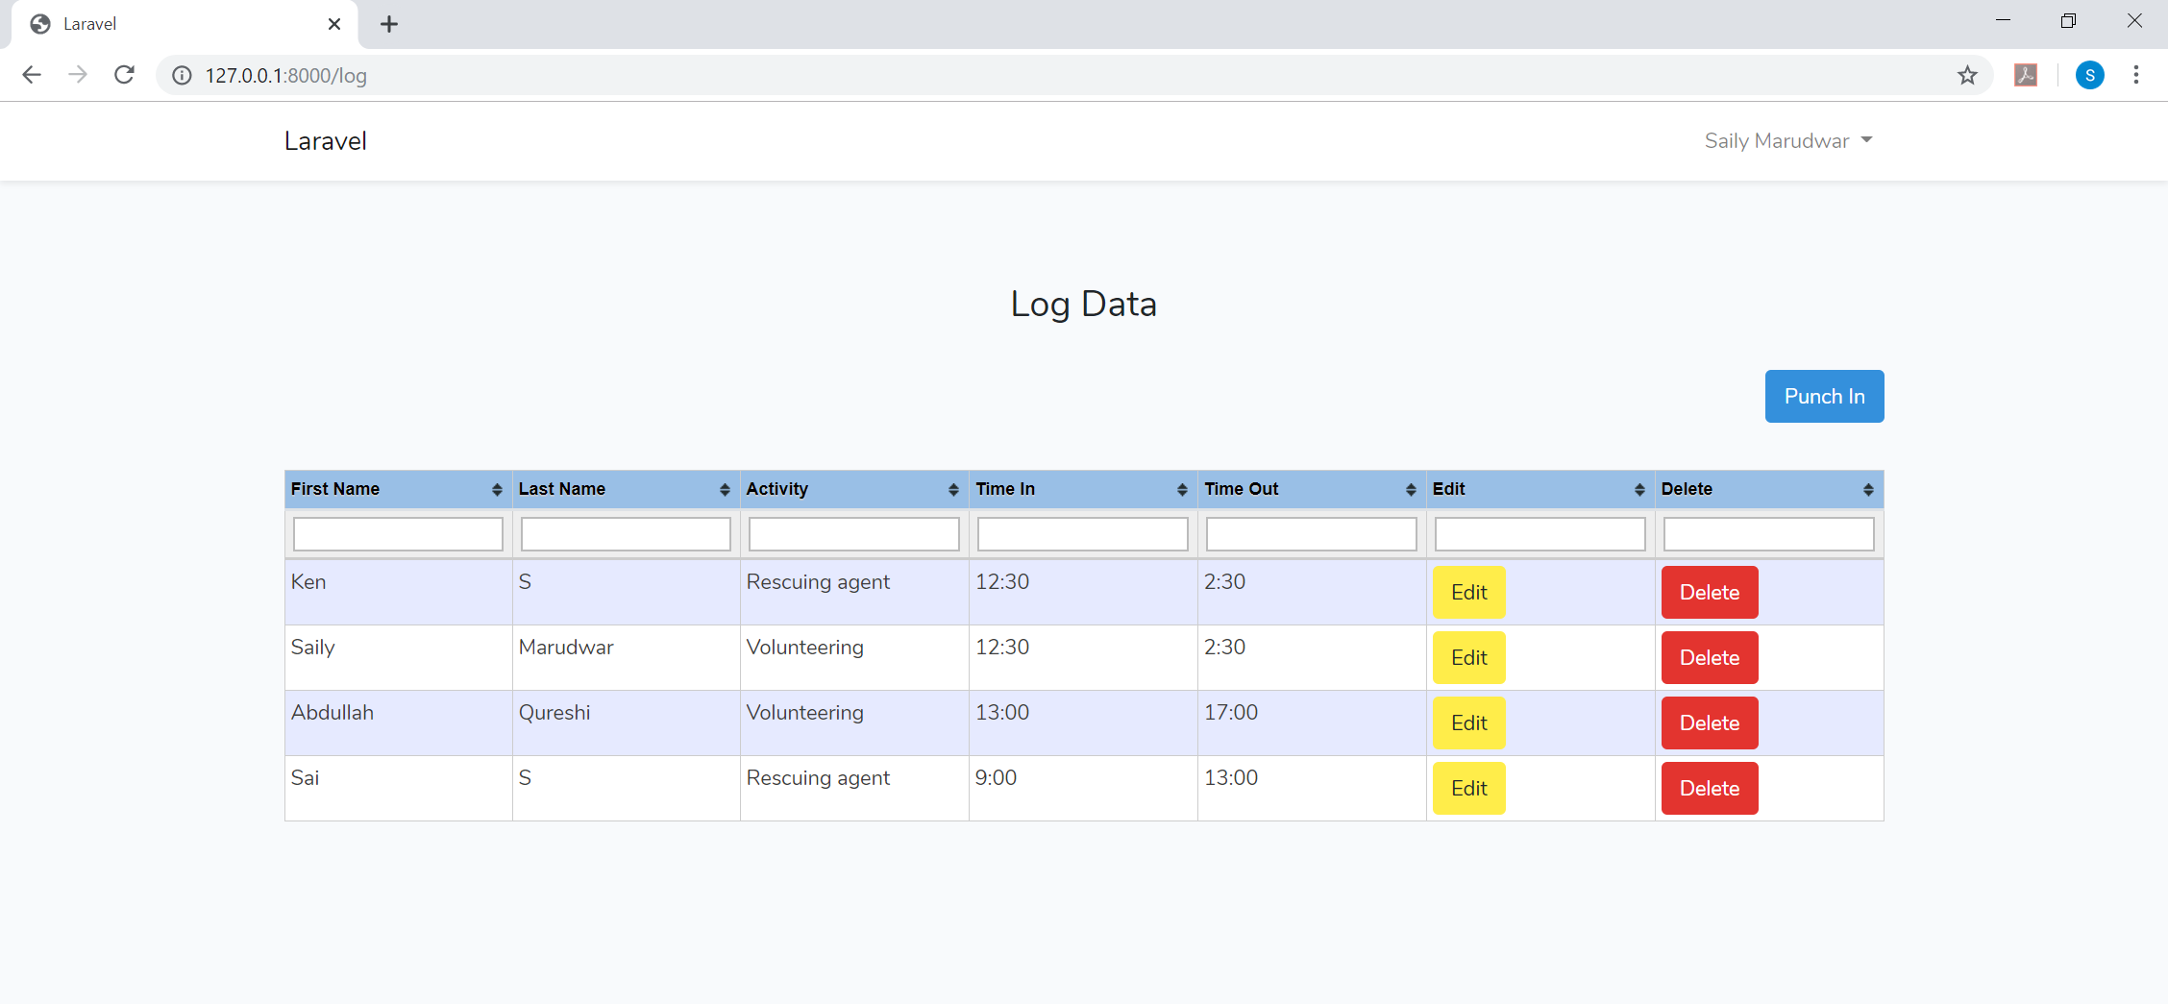

Furthermore, you can see/search for a user/activity by filtering in the boxes by typing in whatever you want to search for, in that category:

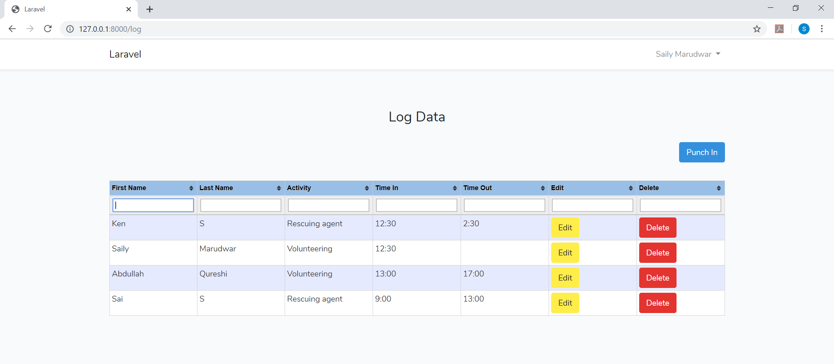

**Searching by name:**

You can type in the First name field to search and view their Punch in details by entering the first name:

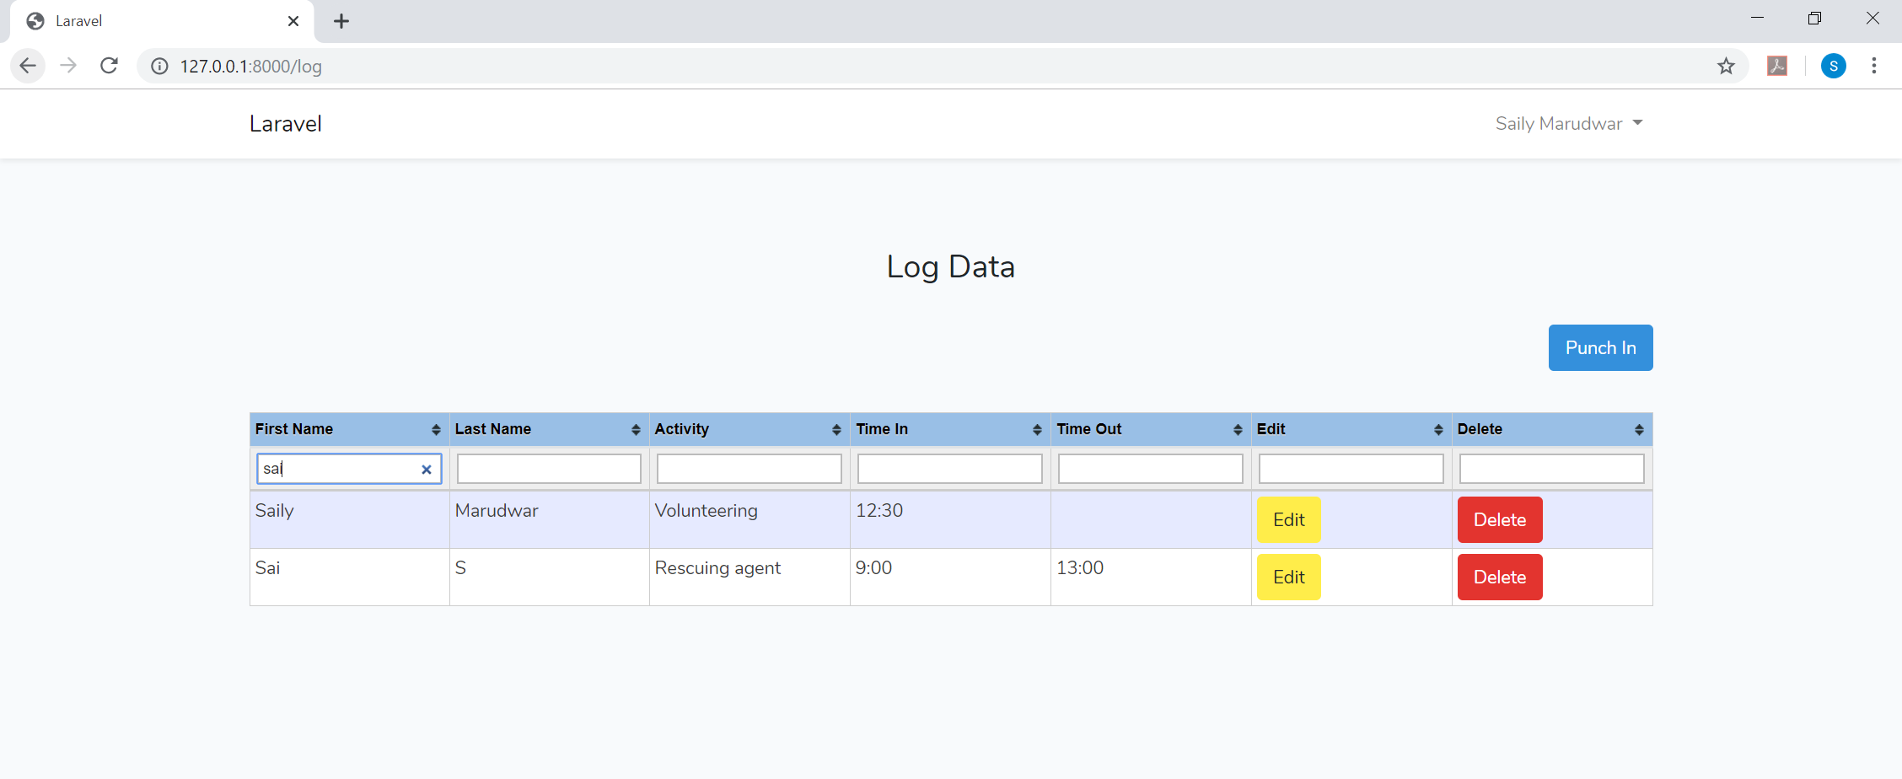

**Similarly, you can search by activity too:**

All the users who have punched for a particular activity can be views by doing this. Thus you can keep track of which users have punched in for that particular activity.

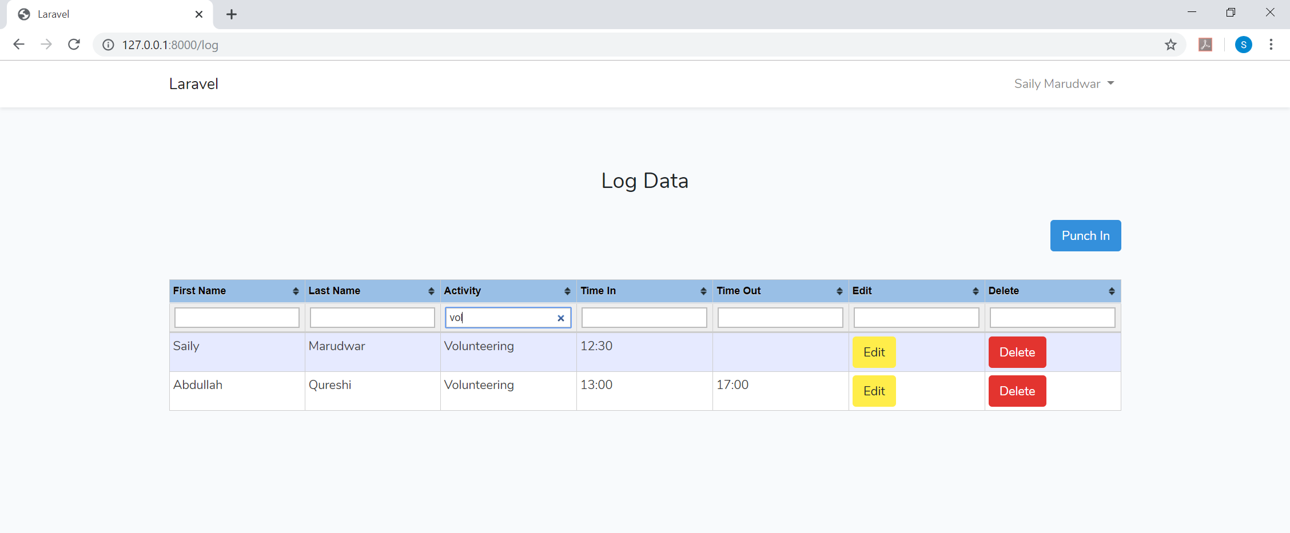

1. **Checking out Equipment:**

Once you are logged in, you can check out any equipment that is needed to use in case of any emergencies. A user can check out the Equipment and also see the logs of checked out equipment by clicking on the “EQUIPMENT LOG” on the home page:

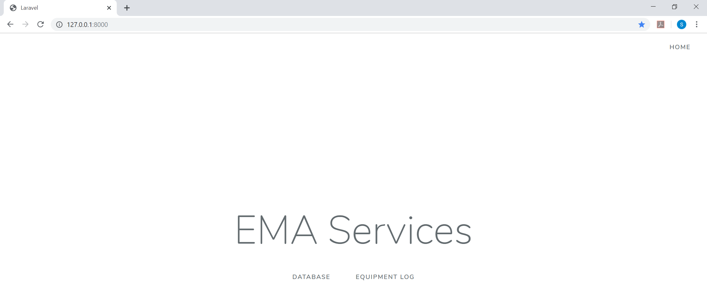

A user can check out an equipment by clicking on “Check Out”:

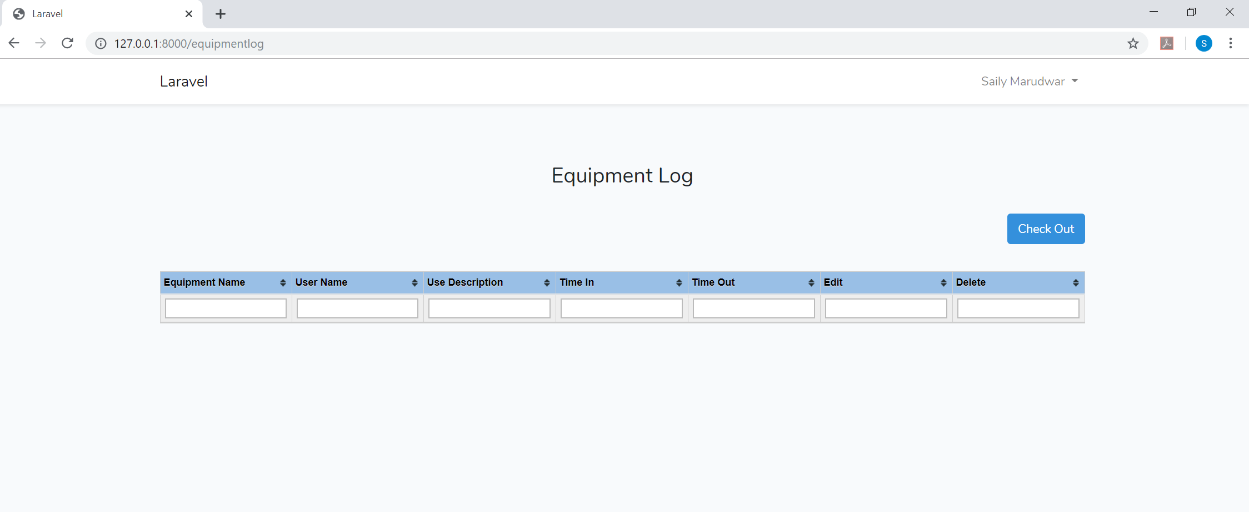

Once you click on the “Check Out” button, you will see that the name, time and date of the user who is currently logged in is automatically populated on the “Checkout Equipment” page:

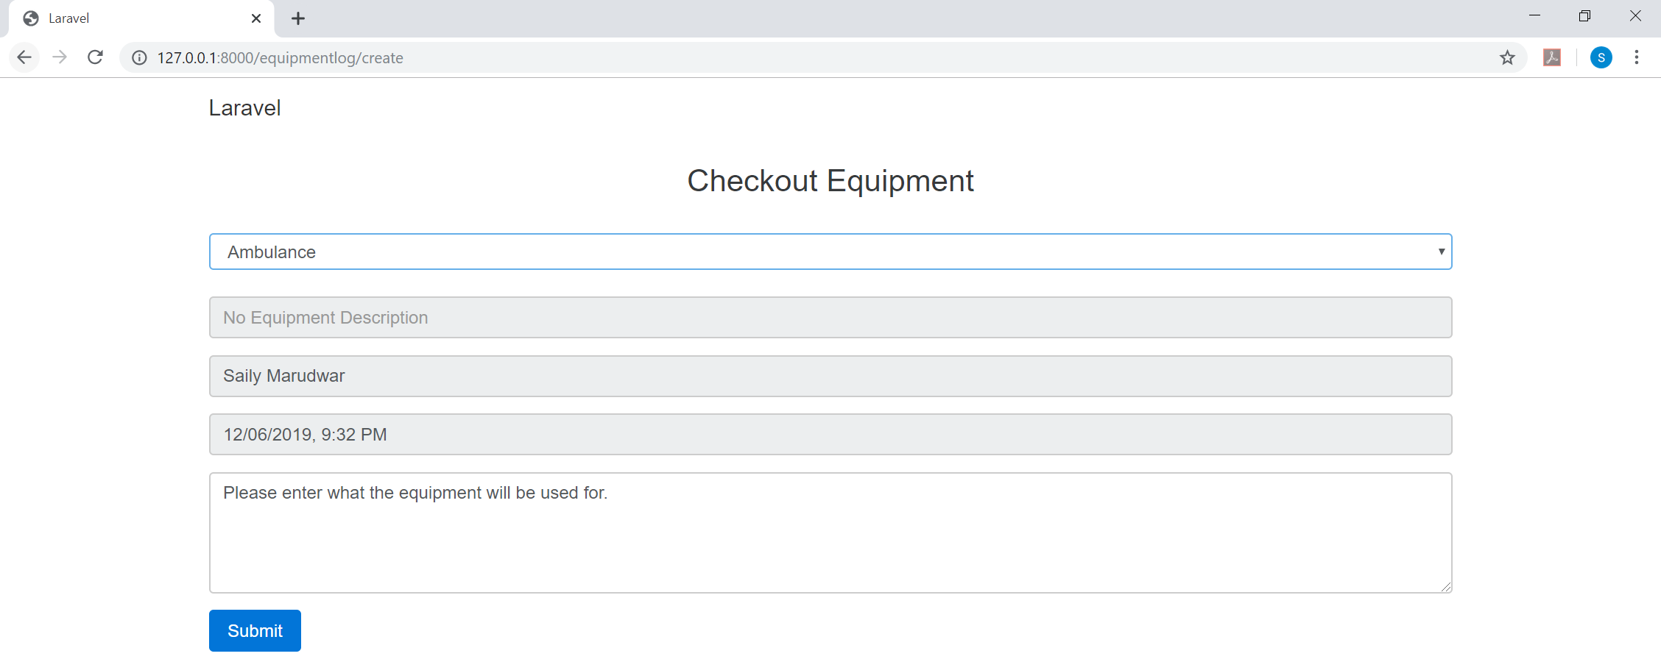

Also, the Equipment that you want to checkout is already populated in the Equipment dropdown in order to minimize the user input as much as possible.

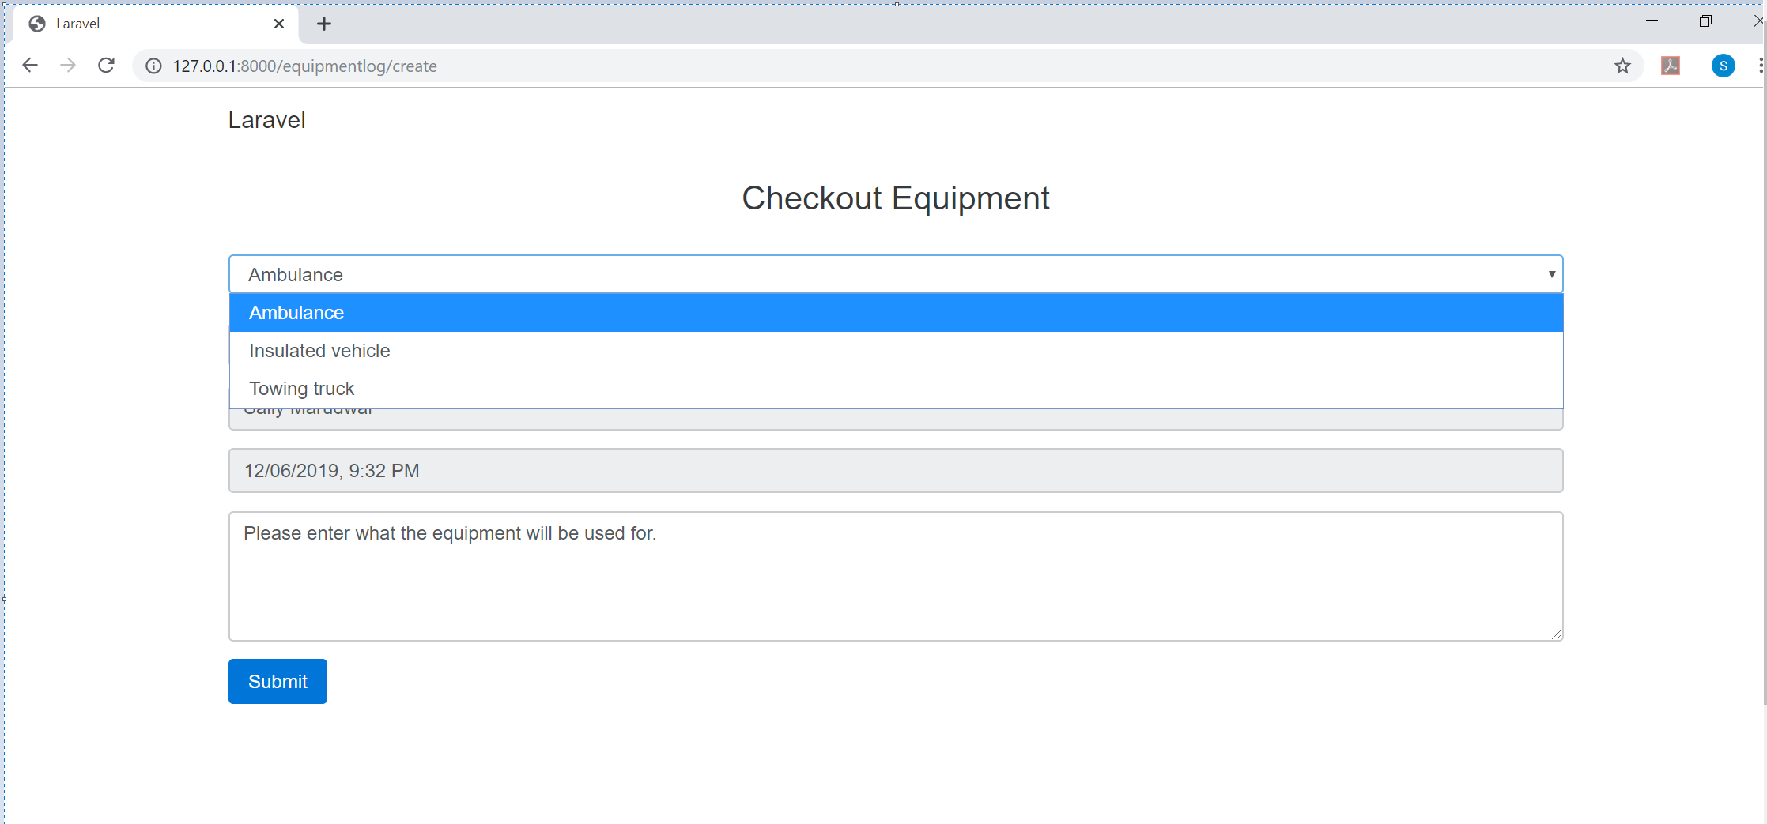

After you fill out the needed information you can hit the submit button and checkout any Equipment. The details of this equipment can be seen on the Equipment log page. Which user has checked out which equipment at what time and for what purpose can all be viewed on this page.

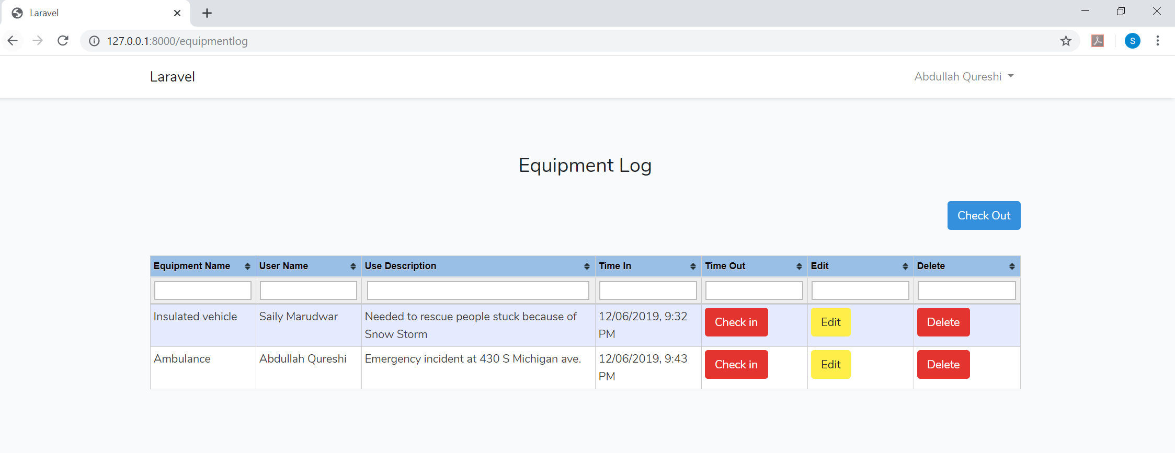

Once the user is done using the Equipment, the user can check in back the quipment by clicking on the “Check In” button on the Equipment log page:



Once Checked In, you can see the time at which the Equipment as checked back in is populated in the “Time-out” field.

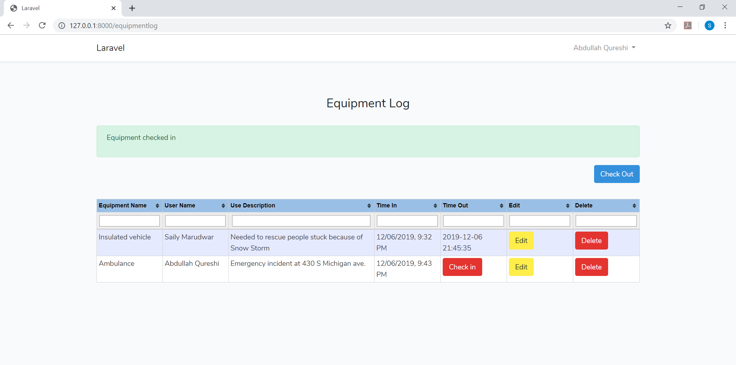

Just like the punch in details, there is search functionality available for the Equipment log as well.

A user can filter by Equipment name or the user name who has checked out that Equipment or any other field:

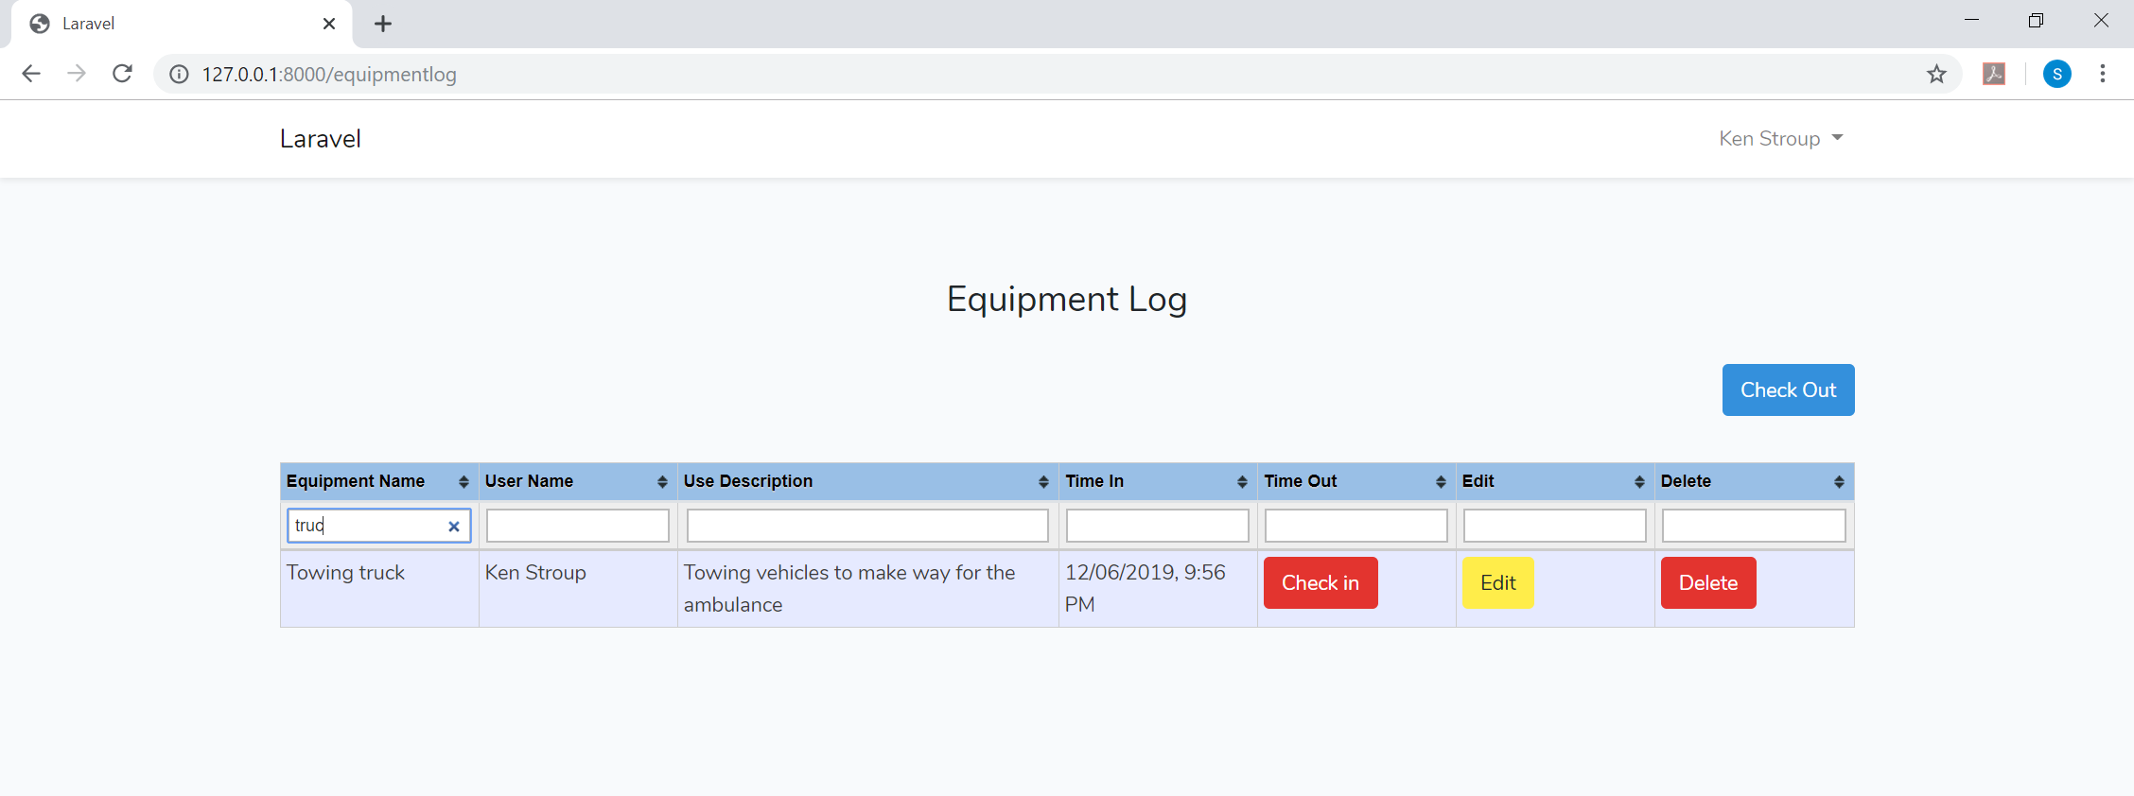

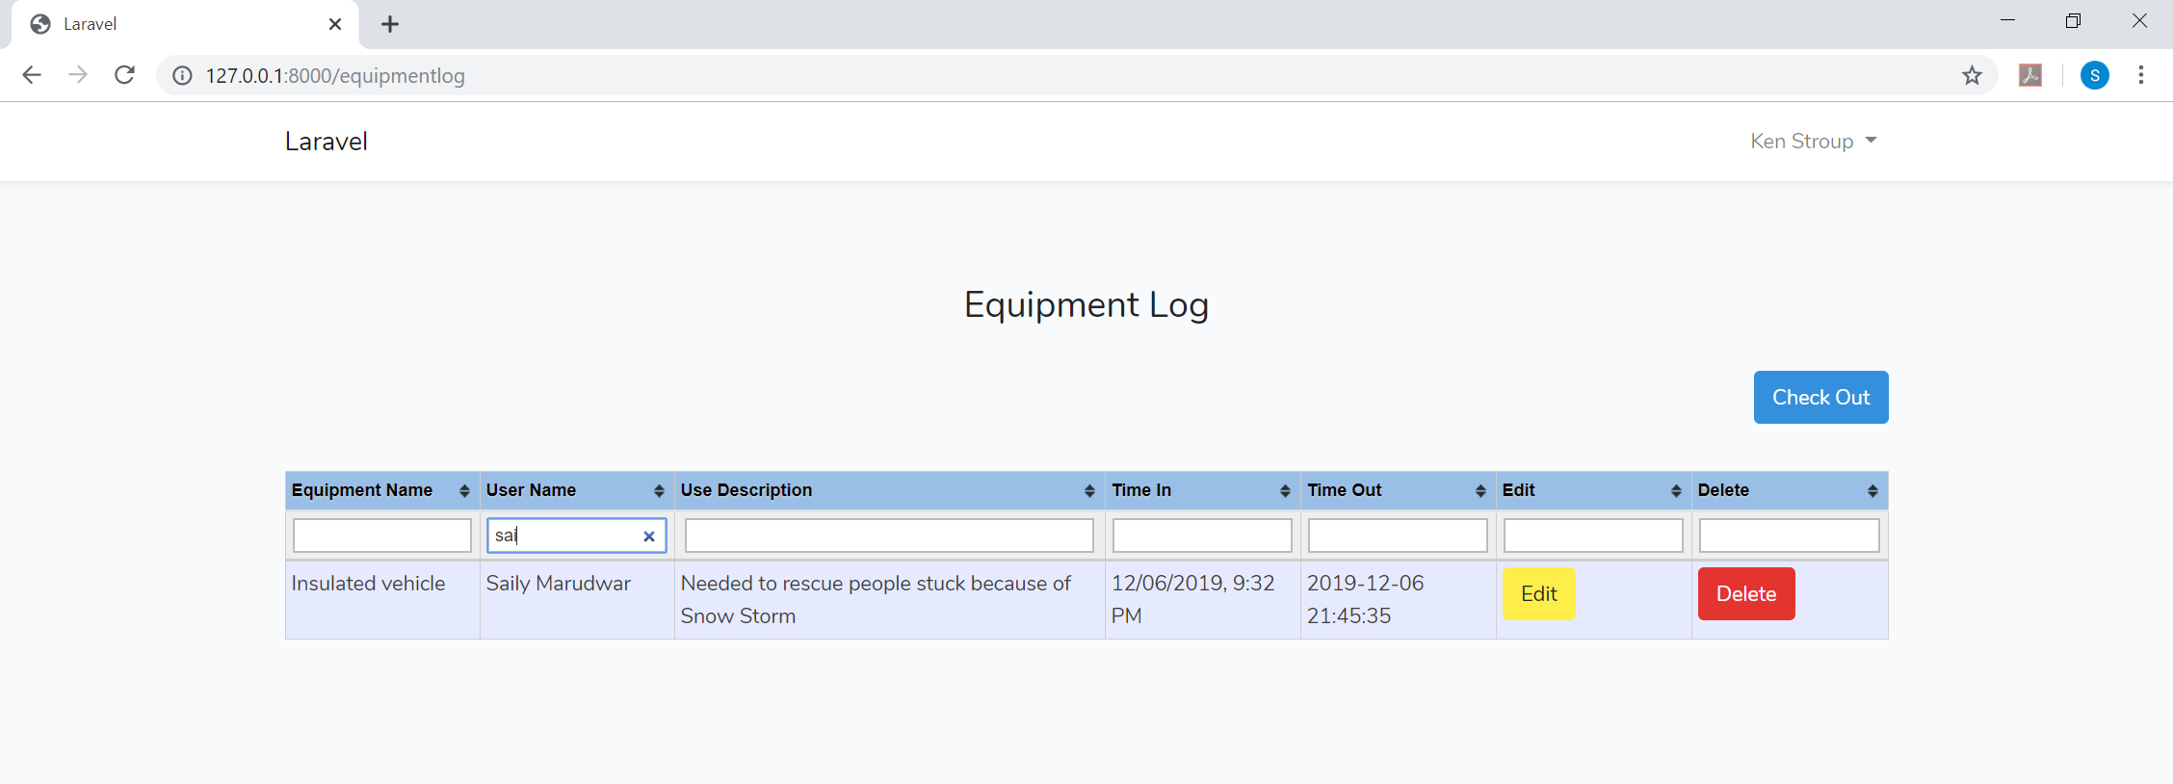

Thus, anyone who uses the search functionality can check the records for the Equipment as well as the users who checked out these equipment.