Component 2

Advanced Software Engineering

Id: 77202319, Joshna Poudel

# Version Control :

# Version Control Commit Summary:

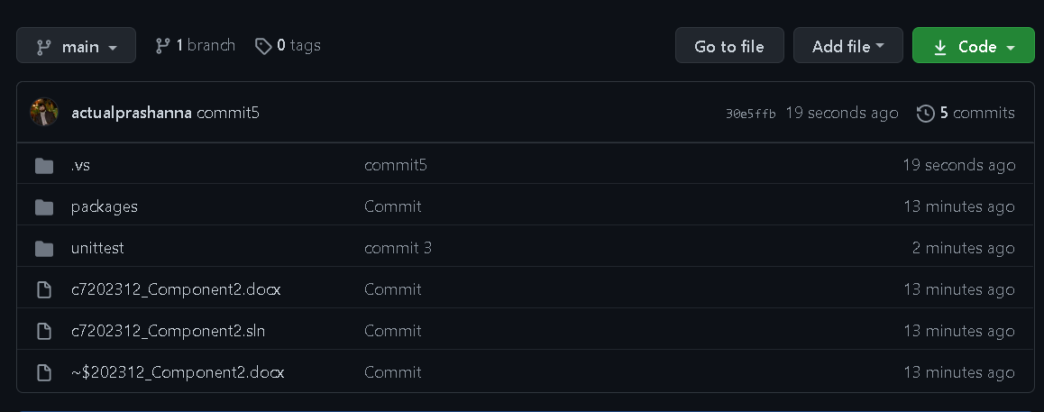

User defined variables can be created and used as parameters:

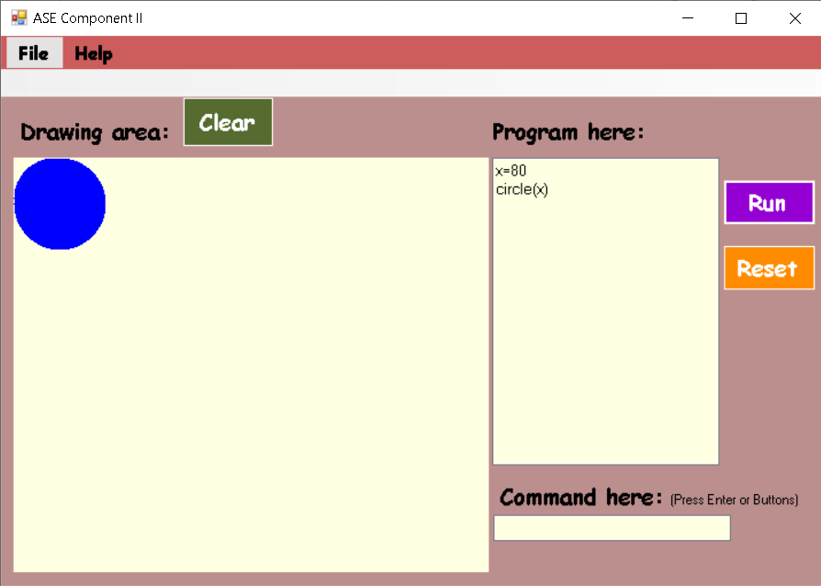

Declaring variable radius for circle which is used in parameters

# Passing variables by assigning it to parameters of square:

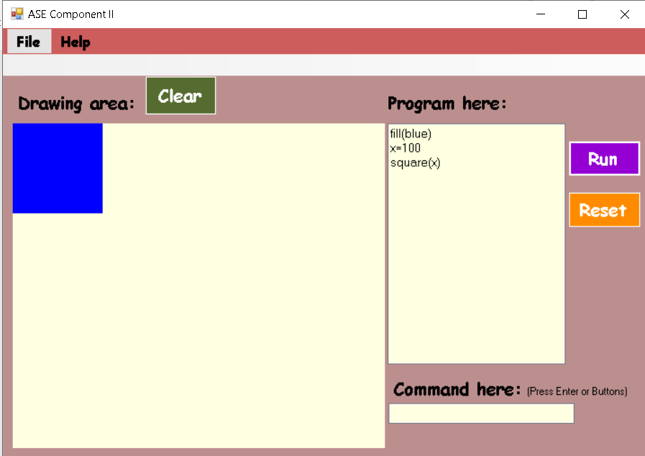

Declaring variable length for square which is used in parameters and square is created.

# Passing variables by assigning it to parameters of rectangle:

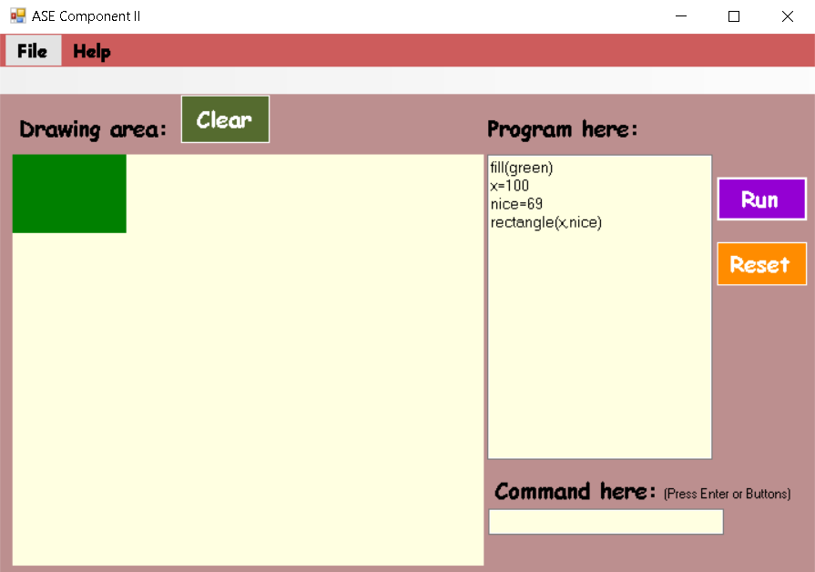

Width and height are assigned, and it helps in creating a rectangle.

# Passing variables by assigning it to parameters of triangle:

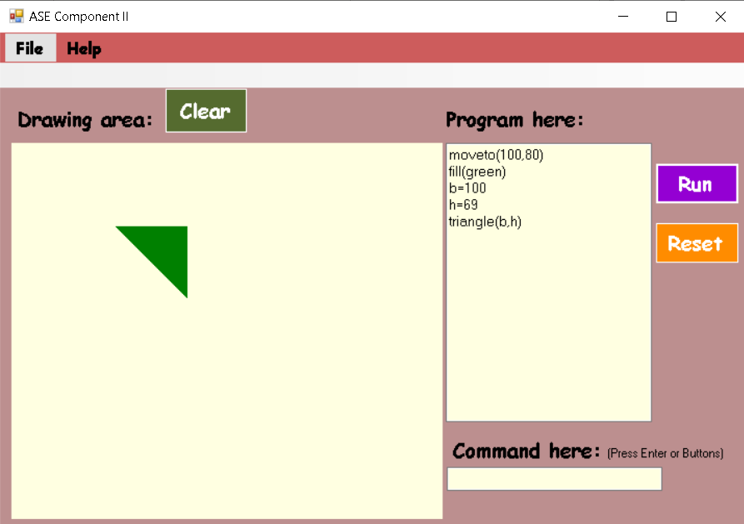

Base and height are assigned and it helps in creating a triangle.

# Loop command repeats everything between Loop on the first line and “end” on a later:

**Using loop command for creating many shapes at once:**

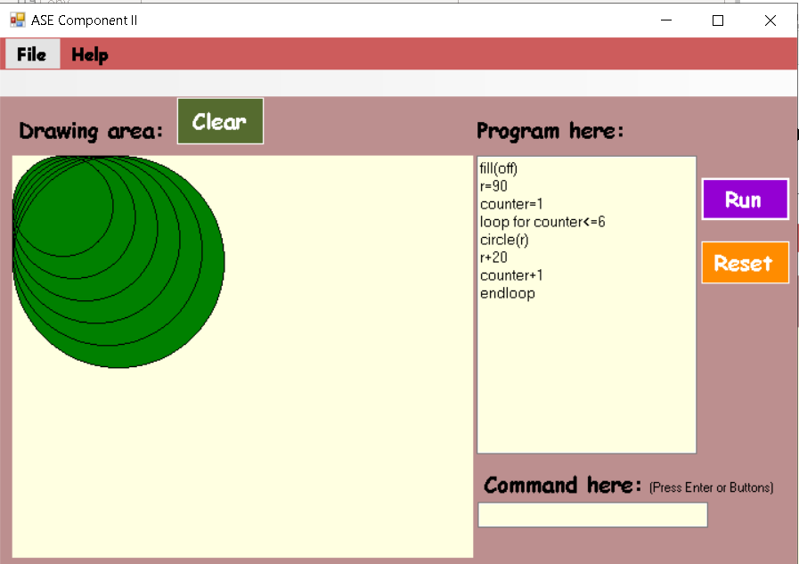

Circle is repeated 6 times with loop command where end loop ensures that the loop has been closed.

# Rectangle is repeated here two times with loop command where end loop ensures that the loop has been closed.

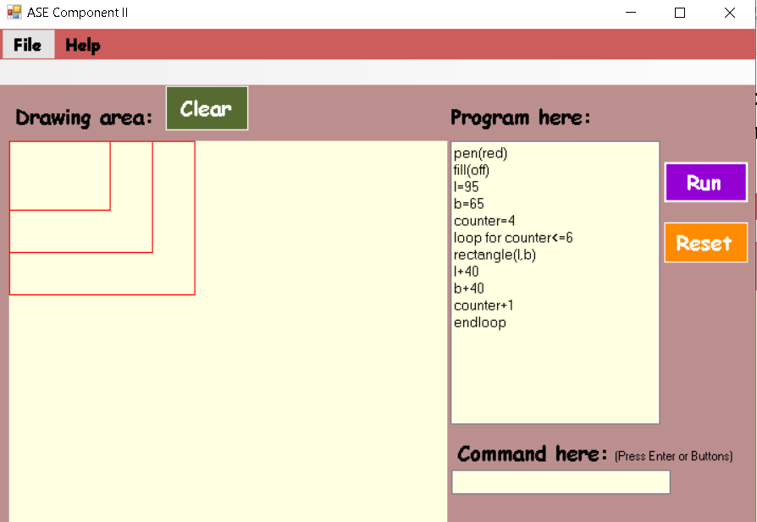

Rectangle shape is drawn here three times after executing the code.

# Triangle is repeated here four times with loop command where end loop ensures that the loop has been closed.

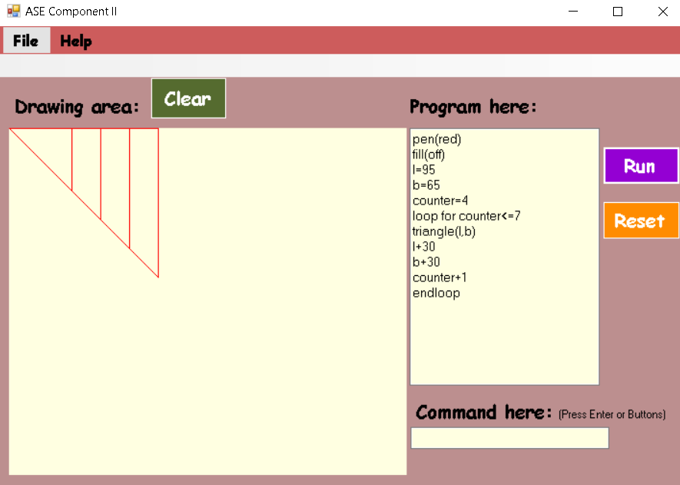

Triangle shape is drawn here four times after executing the code.

# Triangle and rectangle are repeated here four times and triangle four times with loop command where end loop ensures that the loop has been closed.

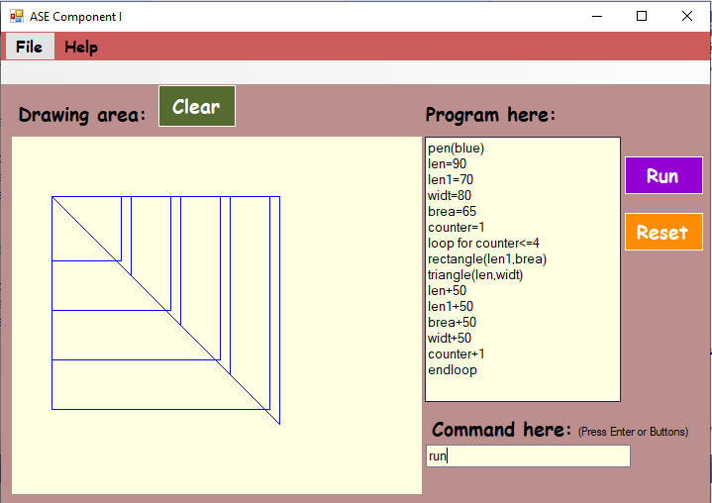

Triangle shape is drawn here four times and rectangle four times after executing the code.

# Creating method called circi for circle:

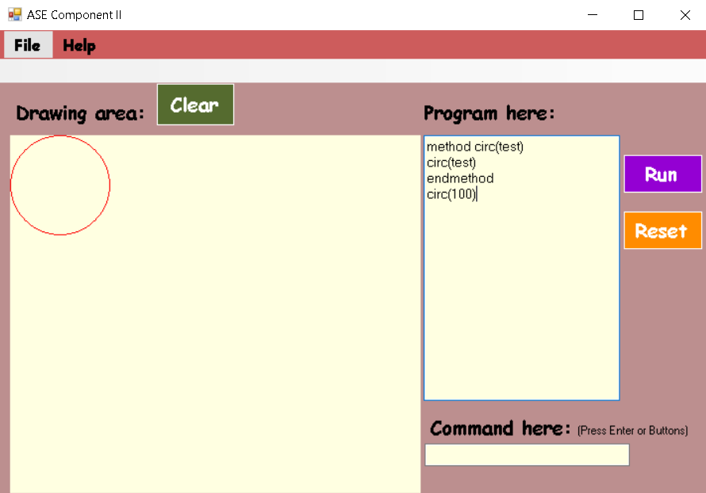

Creating methods can be used while giving different names to the shapes. Here, circle is given the name circ and can be used while creating circle.

# The given name by the user is used here for creating the circle.

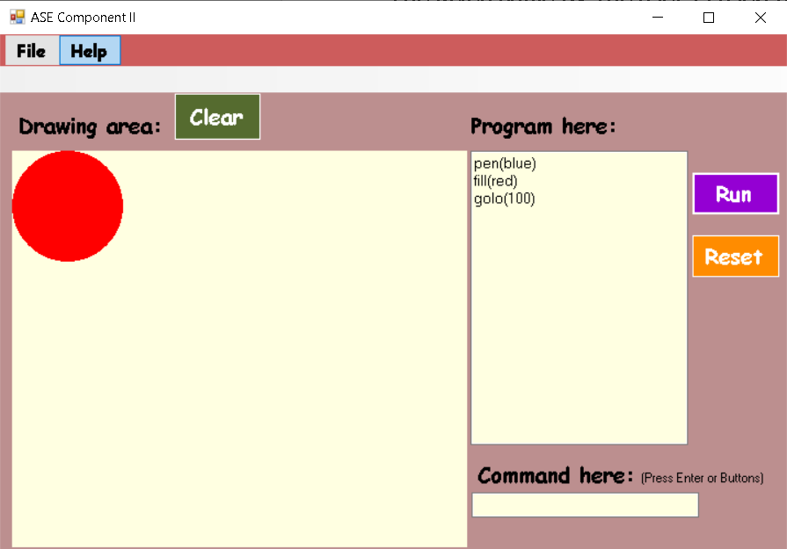

Hence, circle is created with the given name.

# Creating method called recti for rectangle:

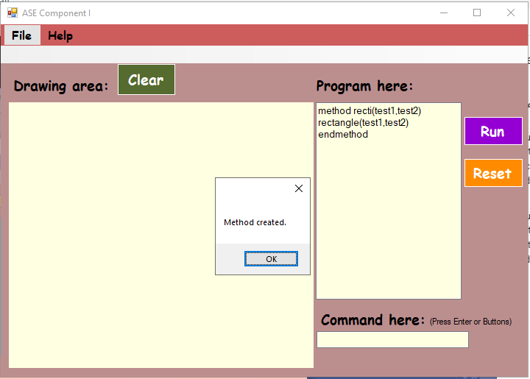

Creating methods can be used while giving different names to the shapes. Here, rectangle is given the name recti and can be used while creating circle.

# The given name by the user is used here for creating the rectangle.

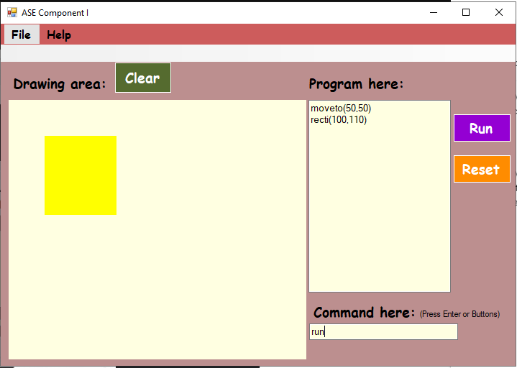

Hence, rectangle is created with the given name.

# Creating method called squ for rectangle:

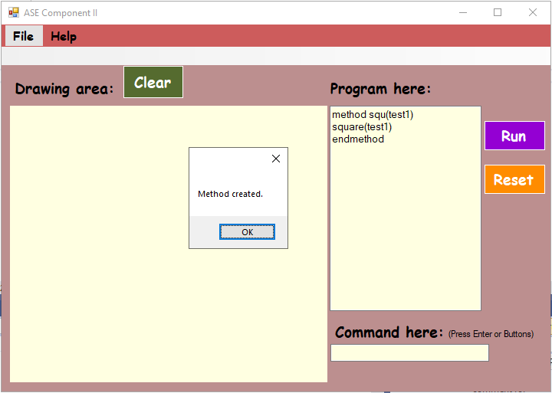

Creating methods can be used while giving different names to the shapes. Here, square is given the name squ and can be used while creating circle.

# The given name by the user is used here for creating the square.

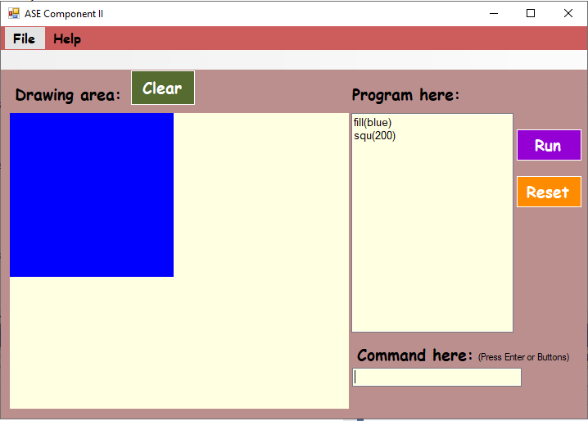

Hence, square is created with the given name.

# Creating method called trian for triangle:

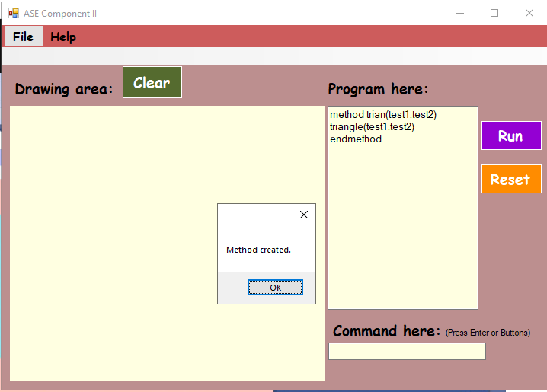

Creating methods can be used while giving different names to the shapes. Here, triangle is given the name trian and can be used while creating triangle.

# The given name by the user is used here for creating the triangle.

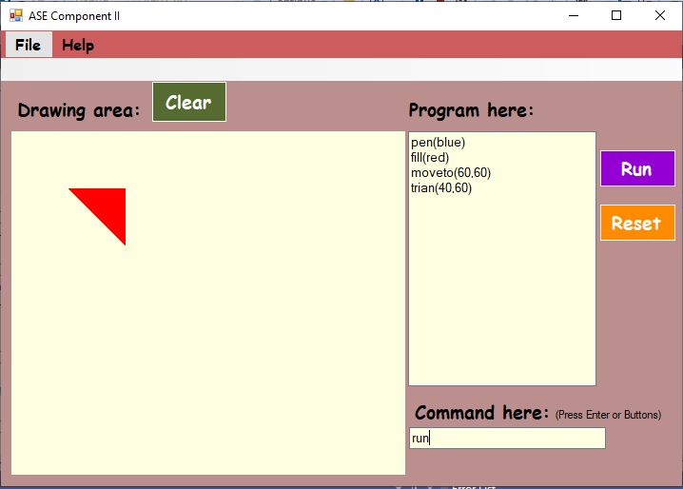

Hence, triangle is created with the given name.

# Syntax checking:

## Variable which can be used inside parameter and loop validation

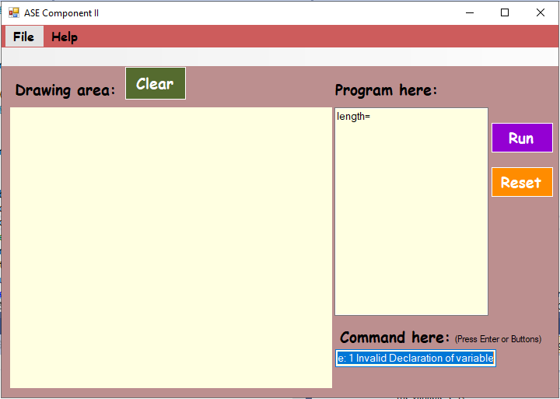

Invalid declaration of variable

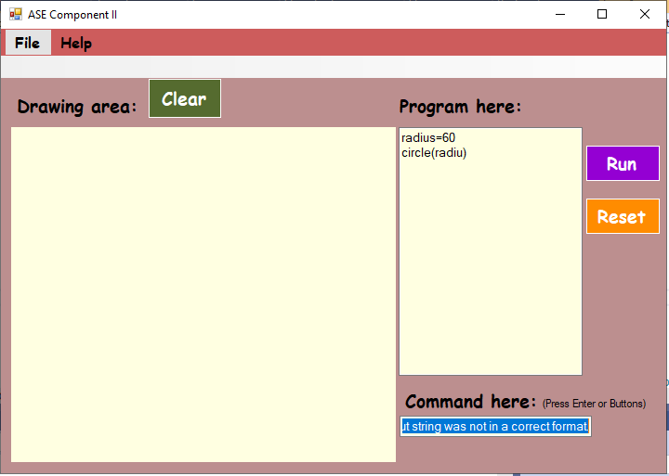

Error shown when not declared variable is passed in a parameter

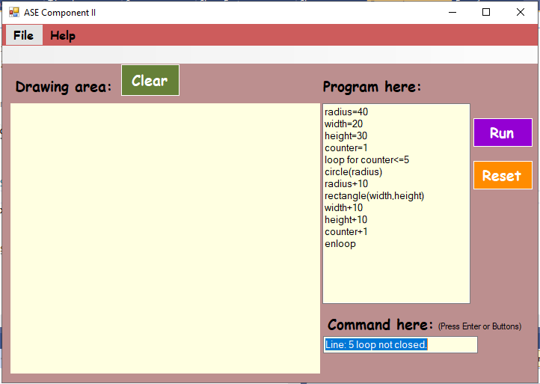

Showing error when loop statement is invalid.

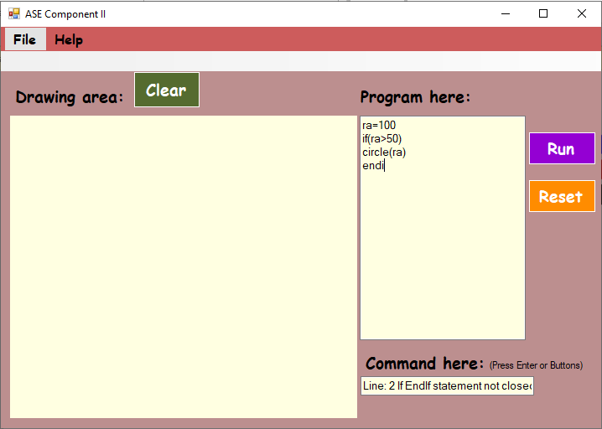

If statement not ended properly.

# Unit test:

