Akarat Suvitayasiri

akarat_su@minor.com

Abstract

The document is for Minor FoodIT department

ExPort Employee Program

Development Guide

Contents

Check out source code to local repository 1

Guide to build program 2

# Check out source code to local repository

1) Remote to url <https://github.com/akarat27/minor-foodit-menulinkexport.git>

2) Clone folder to local

# Guide to build program

1) Open program Auto Py To Exe

2) Select script “EmployeeExport.py” to build an executable file from local repository

3) On Additional files ,select add folder **minor** and **log** as folder output then select add files **config.ini** and **startup.bat** to put on root directory

4) Add icon for minor icon image selected as image below

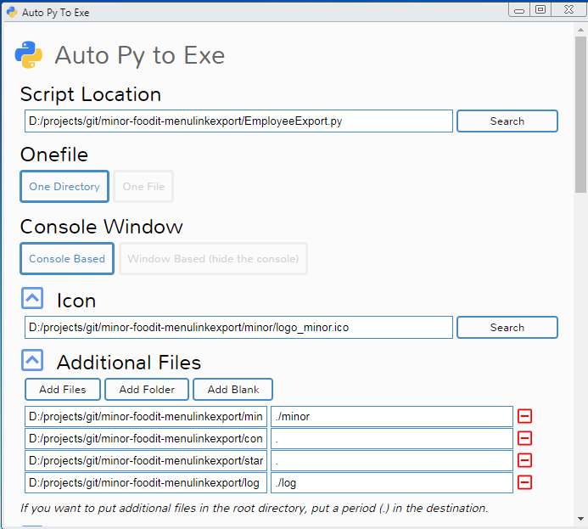

5) On Advanced select output directory for build program

Example as below

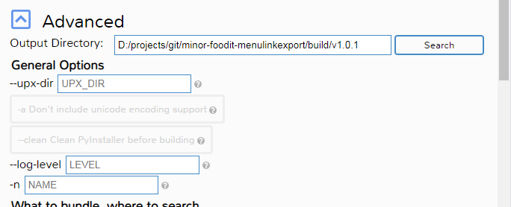

6) Click **CONVERT .PY TO .EXE** for build a program output

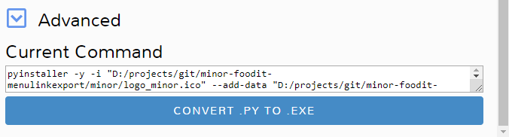

Build completed.

