DEM vs. Obstacle Base — Analysis (Montenegro)
51 obstacles compared against Copernicus DEM GLO-30 (no local high-resolution ground-truth DEM is available for Montenegro, unlike Austria — see docs/montenegro.md). Generated from obstacles_dem_diff.csv. Field definitions: docs/output_fields.md.
Scope, read before comparing to Austria: Montenegro's obstacle list is sourced from AIP ENR 5.4 (“Air Navigation Obstacles”), which by its own stated scope covers only permanent obstacles ≥328 FT (100 M) AGL — not a full national obstacle inventory like Austria's dataset. That's why n=51 here vs. ~1,932 for Austria: a real difference in what's measured, not a smaller country having proportionally fewer obstacles recorded. All obstacles here are either antennas or wind turbines — no towers, buildings, chimneys, cranes, etc., unlike Austria's broader mix. Vertical datum: EGM96 (SMATSA's own stated practical reference for sub-1m-accuracy conversions in AIP GEN 2.1 — Montenegro's true national datum, Trieste height/EPSG:5195, turned out to have no working PROJ transformation grid; see docs/montenegro.md for the full story).

Overview
Field | n | mean | median | stdev | p5 | p95 | min | max
Single-cell error | 51 | 5.3 | 7.2 | 5.4 | -3.1 | 13.6 | -6.0 | 15.5
5×5-window median error | 51 | 1.7 | 4.5 | 5.9 | -9.4 | 9.1 | -10.9 | 10.4

Single-cell error (m)
CopDEM (single-cell, bilinear) minus obstacle base elevation, both on EGM2008. Positive = DEM reads above the true base.
n | mean | median | stdev | p5–p95
51 | 5.3 | 7.2 | 5.4 | -3.1 – 13.6

Distribution (whole dataset):
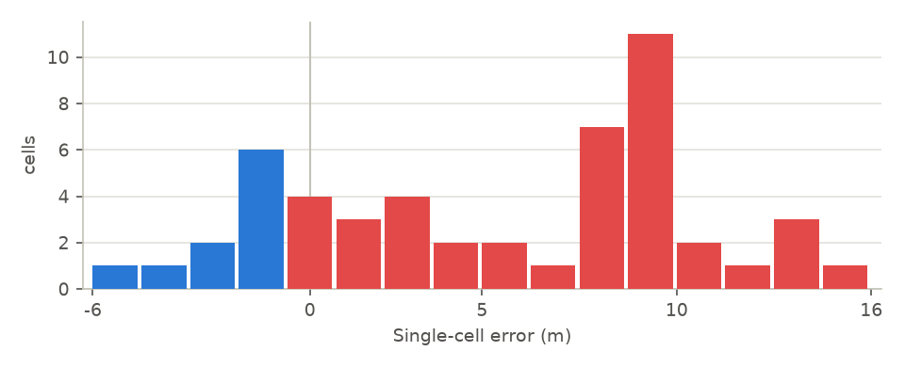
By obstacle type:
Obstacle type | n | mean | median | stdev | min | max
Antenna † | 2 | -0.2 | -0.2 | 1.7 | -1.4 | 1.0
Wind turbine | 49 | 5.5 | 7.8 | 5.4 | -6.0 | 15.5

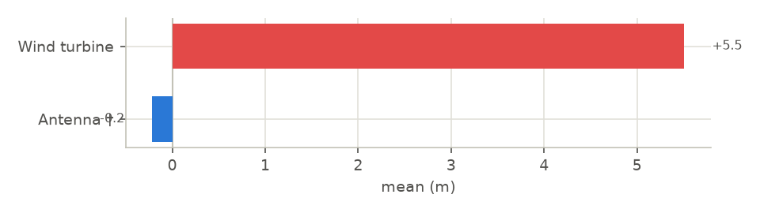

5×5-window median error (m)
5x5-window median CopDEM value minus obstacle base elevation, both on EGM2008. Positive = DEM reads above the true base.
n | mean | median | stdev | p5–p95
51 | 1.7 | 4.5 | 5.9 | -9.4 – 9.1

Distribution (whole dataset):
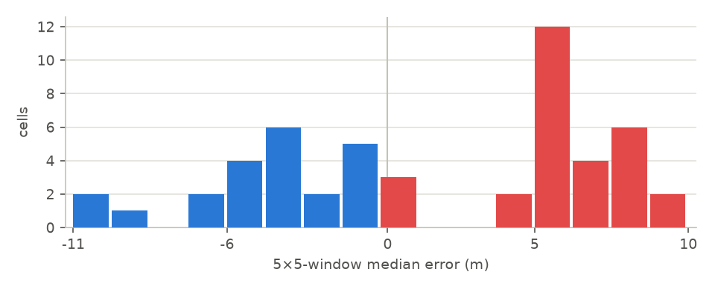
By obstacle type:
Obstacle type | n | mean | median | stdev | min | max
Antenna † | 2 | -0.6 | -0.6 | 1.1 | -1.4 | 0.2
Wind turbine | 49 | 1.8 | 4.8 | 6.0 | -10.9 | 10.4

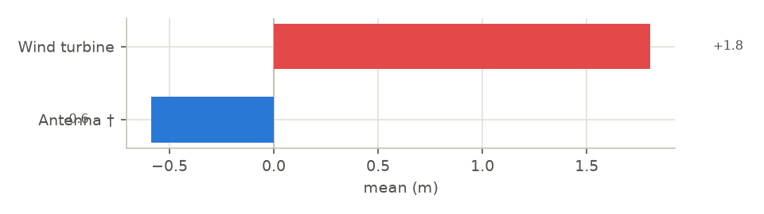

Notes
† obstacle type with n < 5 — too few points for a stable mean. See docs/montenegro.md for sampling method, the vertical-datum decision, and known limitations.

