DEM vs. Obstacle Base — Analysis (Austria)
1,932 obstacles (simple points, v1 scope) compared against two DEM sources — Copernicus DEM GLO-30 (1,928 with a valid 5×5-window sample) and Austria's LiDAR-derived DHM (1,932 with a valid 5×5-window sample). Generated from obstacles_dem_diff.csv. Field definitions: docs/output_fields.md; LiDAR vertical-datum source (GHA height, EPSG:5778): docs/lidar_comparison.md.

Overview
Field | n | mean | median | stdev | p5 | p95 | min | max
Copernicus DEM GLO-30 — Single-cell error | 1,932 | 5.2 | 4.2 | 8.8 | -7.2 | 20.3 | -32.1 | 41.3
Copernicus DEM GLO-30 — 5×5-window median error | 1,928 | 1.4 | 1.2 | 9.3 | -12.6 | 16.8 | -45.5 | 37.9
Austria LiDAR DEM (dhm_at_lamb_10m_2018) — Single-cell error | 1,932 | -0.2 | -0.0 | 6.4 | -11.2 | 9.8 | -29.8 | 29.6
Austria LiDAR DEM (dhm_at_lamb_10m_2018) — 5×5-window median error | 1,932 | -1.1 | -0.7 | 6.5 | -11.7 | 8.6 | -33.6 | 29.6

Copernicus DEM GLO-30

Single-cell error (m)
DEM (single-cell, bilinear) minus obstacle base elevation, both on EGM2008. Positive = DEM reads above the true base.
n | mean | median | stdev | p5–p95
1,932 | 5.2 | 4.2 | 8.8 | -7.2 – 20.3

Distribution (whole dataset):
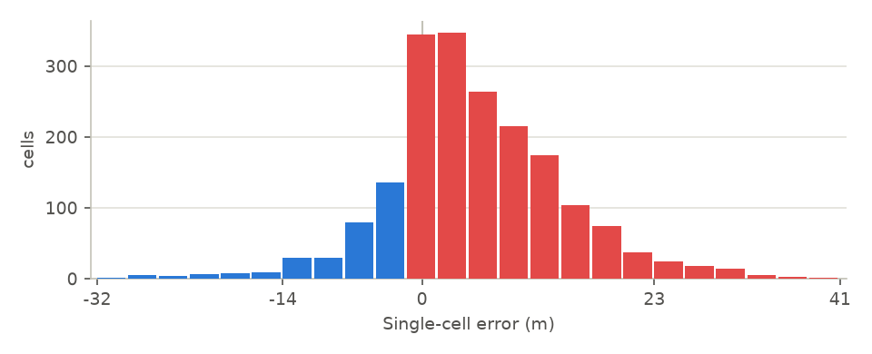
By obstacle type:
Obstacle type | n | mean | median | stdev | min | max
Gasometer / Tank † | 1 | -7.0 | -7.0 | 0.0 | -7.0 | -7.0
Navigationsanlage / Navaid † | 1 | -1.3 | -1.3 | 0.0 | -1.3 | -1.3
Windkraftanlage / Windpower plant | 44 | 0.7 | -0.2 | 7.7 | -23.5 | 21.4
Mast / Pole | 62 | 3.7 | 2.6 | 6.3 | -7.0 | 21.2
Turm / Tower | 16 | 4.3 | 3.9 | 5.2 | -8.4 | 12.6
Gittermast / Mast | 28 | 4.7 | 1.7 | 7.0 | -3.1 | 18.8
Antennenmast / Antenna | 1,710 | 5.4 | 4.5 | 9.0 | -32.1 | 41.3
Kran / Crane | 5 | 5.6 | 2.7 | 6.5 | -0.6 | 13.0
Gebäude / Building | 34 | 5.7 | 3.8 | 6.5 | -4.5 | 23.2
Schornstein / Stack | 30 | 7.0 | 6.4 | 5.7 | -9.4 | 19.9
Denkmal / Monument † | 1 | 8.2 | 8.2 | 0.0 | 8.2 | 8.2

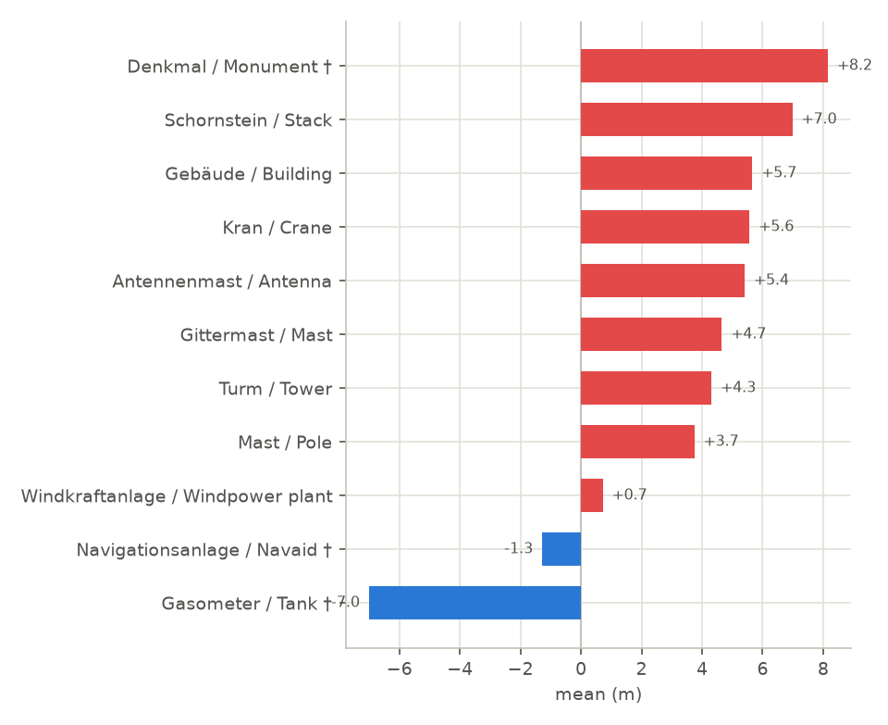

5×5-window median error (m)
5x5-window median DEM value minus obstacle base elevation, both on EGM2008. Positive = DEM reads above the true base.
n | mean | median | stdev | p5–p95
1,928 | 1.4 | 1.2 | 9.3 | -12.6 – 16.8

Distribution (whole dataset):
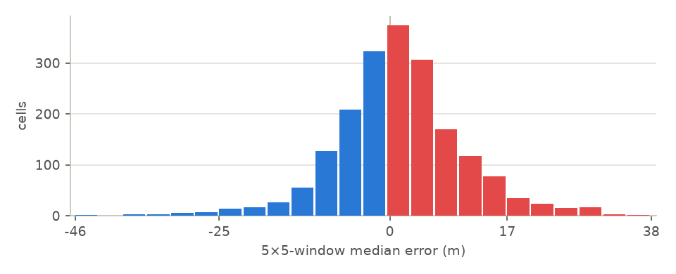
By obstacle type:
Obstacle type | n | mean | median | stdev | min | max
Navigationsanlage / Navaid † | 1 | -0.9 | -0.9 | 0.0 | -0.9 | -0.9
Gasometer / Tank † | 1 | -0.8 | -0.8 | 0.0 | -0.8 | -0.8
Windkraftanlage / Windpower plant | 44 | 0.8 | -0.5 | 8.9 | -24.9 | 33.4
Mast / Pole | 62 | 1.0 | 0.6 | 7.9 | -13.2 | 24.7
Antennenmast / Antenna | 1,706 | 1.3 | 1.1 | 9.5 | -45.5 | 37.9
Turm / Tower | 16 | 1.5 | 3.6 | 8.2 | -20.7 | 12.4
Gittermast / Mast | 28 | 1.7 | -0.2 | 6.8 | -8.2 | 13.2
Schornstein / Stack | 30 | 3.8 | 4.2 | 5.2 | -16.7 | 15.6
Gebäude / Building | 34 | 5.0 | 3.8 | 5.1 | -10.6 | 18.6
Kran / Crane | 5 | 5.8 | 2.7 | 5.7 | 0.7 | 12.7
Denkmal / Monument † | 1 | 15.5 | 15.5 | 0.0 | 15.5 | 15.5

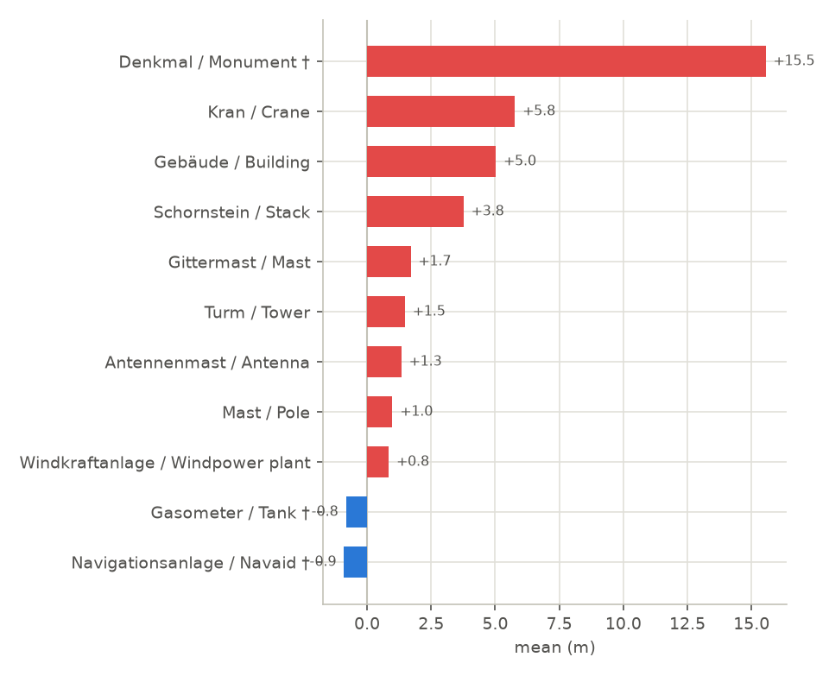

Austria LiDAR DEM (dhm_at_lamb_10m_2018)

Single-cell error (m)
LiDAR DEM (single-cell, bilinear) minus obstacle base elevation, both on EGM2008. Positive = LiDAR reads above the true base. Vertical datum: GHA height (EPSG:5778, 'Adria Triest'), matched to BEV's product-line documentation and confirmed numerically, though not to this exact file's own embedded metadata. See docs/lidar_comparison.md.
n | mean | median | stdev | p5–p95
1,932 | -0.2 | -0.0 | 6.4 | -11.2 – 9.8

Distribution (whole dataset):
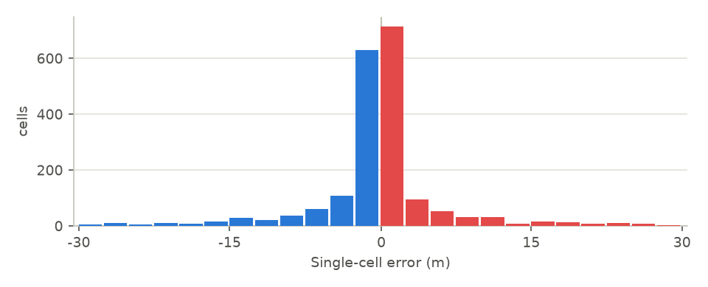
By obstacle type:
Obstacle type | n | mean | median | stdev | min | max
Turm / Tower | 16 | -0.8 | -0.1 | 3.8 | -8.6 | 8.6
Navigationsanlage / Navaid † | 1 | -0.7 | -0.7 | 0.0 | -0.7 | -0.7
Windkraftanlage / Windpower plant | 44 | -0.6 | -0.4 | 5.5 | -22.9 | 11.8
Antennenmast / Antenna | 1,710 | -0.2 | -0.0 | 6.7 | -29.8 | 29.6
Schornstein / Stack | 30 | -0.2 | -0.0 | 2.4 | -11.1 | 3.7
Gittermast / Mast | 28 | -0.1 | -0.0 | 2.0 | -6.6 | 6.2
Gebäude / Building | 34 | 0.5 | 0.2 | 1.7 | -3.1 | 6.9
Mast / Pole | 62 | 0.5 | 0.1 | 3.5 | -7.3 | 18.7
Denkmal / Monument † | 1 | 0.6 | 0.6 | 0.0 | 0.6 | 0.6
Gasometer / Tank † | 1 | 0.9 | 0.9 | 0.0 | 0.9 | 0.9
Kran / Crane | 5 | 2.1 | 0.5 | 4.6 | -1.3 | 10.0

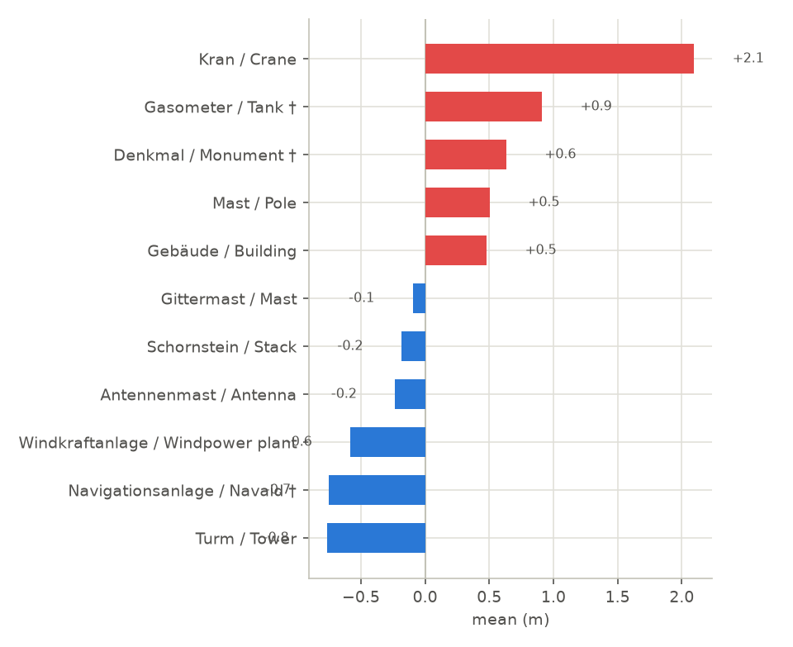

5×5-window median error (m)
5x5-window median LiDAR value minus obstacle base elevation, both on EGM2008. Window is 5x5 cells of LiDAR's native 10m grid (50m x 50m) - smaller footprint than CopDEM's 5x5-at-30m (150m x 150m); same algorithm, different physical area. See docs/lidar_comparison.md.
n | mean | median | stdev | p5–p95
1,932 | -1.1 | -0.7 | 6.5 | -11.7 – 8.6

Distribution (whole dataset):
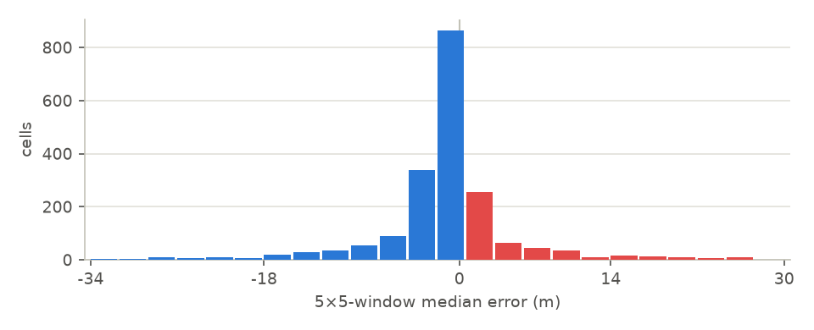
By obstacle type:
Obstacle type | n | mean | median | stdev | min | max
Turm / Tower | 16 | -1.3 | -0.6 | 3.8 | -8.1 | 8.6
Antennenmast / Antenna | 1,710 | -1.2 | -0.8 | 6.7 | -33.6 | 29.6
Windkraftanlage / Windpower plant | 44 | -0.8 | -0.5 | 5.5 | -24.1 | 10.5
Navigationsanlage / Navaid † | 1 | -0.7 | -0.7 | 0.0 | -0.7 | -0.7
Gittermast / Mast | 28 | -0.6 | -0.6 | 2.2 | -6.5 | 5.2
Schornstein / Stack | 30 | -0.3 | -0.1 | 2.5 | -11.1 | 3.9
Mast / Pole | 62 | -0.2 | -0.5 | 3.7 | -7.7 | 18.3
Denkmal / Monument † | 1 | 0.5 | 0.5 | 0.0 | 0.5 | 0.5
Gebäude / Building | 34 | 0.7 | 0.3 | 2.0 | -3.2 | 8.5
Gasometer / Tank † | 1 | 0.9 | 0.9 | 0.0 | 0.9 | 0.9
Kran / Crane | 5 | 2.2 | 0.5 | 4.6 | -1.0 | 10.2

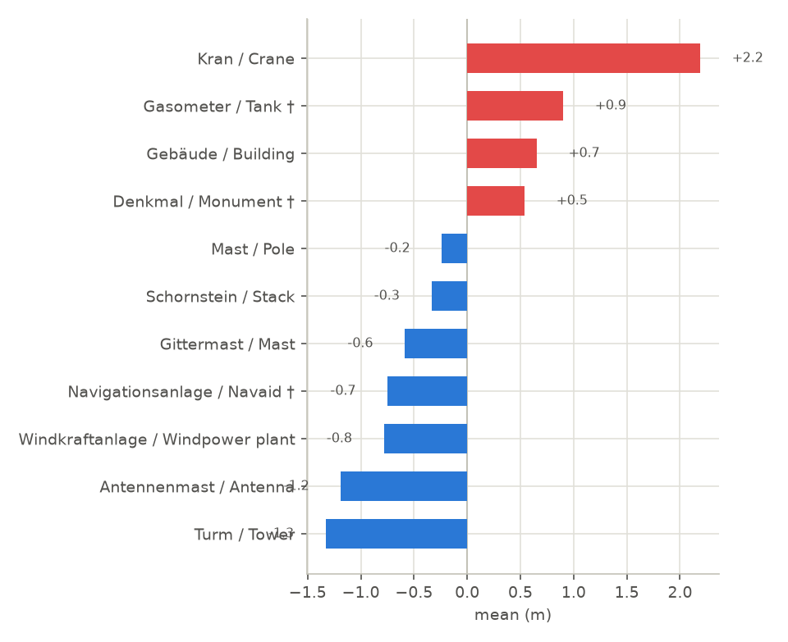

Notes
† obstacle type with n < 5 — too few points for a stable mean. See docs/dem_extraction.md (Copernicus DEM) and docs/lidar_comparison.md (Austria LiDAR DEM) for sampling method and known limitations.

