Workshop 4

ANDRES CAMILO RAMOS ROJAS – 20242020005

**Project**:

Outlook ( message app with a close environment)

this is a school project done in order to learn and apply concepts of object-oriented programming, it was decided to create a replica of an Outlook-style messaging service through object-oriented programming as is the objective of the course, additionally it is expected to achieve a graphical interface.

**Objectives:**

* Create the design for a system that will allow the users to communicate between them.
* Create a prototype of the system planned, and start verifying if there are any design error to correct.
* Create the final product with all the corrections.

**Requirements:**

* Functional requirements:
  + User register:

The user will be able to register himself

* + User login

The user will be able to login in his account

* + User identification

The user will be able to identify other users by the username

* + User communication

The user will be able to send messages to other users

* + User update (was added with human error in mind WS#2)

The user will be able to update his own information

* + User elimination (was added for users that leave the system WS#2)

The administrator will be able to eliminate users

* + User logout

The user will be able to logout from his account

* + Message management

The user will be able to view messages sended by other users

* + Archive management

The user will be able to manage the send and reception of archives (removed from the principal requirements)

* Non - functional requirements:
  + Multiple users simultaneously support
  + Outlook-like interface
  + Standard security parameters to password defining
  + Unique identifiers (usernames)

**User stories:**

|  |  |  |
| --- | --- | --- |
| Title: user register | Priority: high | Estimate: |
| User story:  As a user , I want to register my self, so that I can send messages to other users. | | |
| Acceptance criteria:  Given a user  When he register her self  Then he will be able to sing in | | |

|  |  |  |
| --- | --- | --- |
| Title: user access | Priority: High | Estimate |
| User story:  As a user, I want to be able to sing in, so that I will have acces to the system. | | |
| Acceptance criteria:  Given 10 users  When they acces to the system  Then will be able to send a message | | |

|  |  |  |
| --- | --- | --- |
| Title: user identification | Priority: high | Estimate: |
| User story:  As a user, I want have an identifier , so that my familiars, acquaintances and another users recognize me on the system. | | |
| Acceptance criteria:  Given hundreds of users  When they belong to the system  Then they will be able yo recognizes each other easily | | |

|  |  |  |
| --- | --- | --- |
| Title: user communication | Priority: high | Estimate; |
| User story:  As a user, I want to send messages to the other users when I need to, so that I can communicate with other people. | | |
| Acceptance criteria:  Given hundreds users  When they send a message to other user  Then the second user will have the message in her messages | | |

|  |  |  |
| --- | --- | --- |
| Title: user update | Priority: high | Estimate; |
| User story:  As a user, I want to update my profile, so that If I make a mistake when registering I can correct it. | | |
| Acceptance criteria:  Given a user  When he update his information  Then he will se the changes | | |

(If a user want to change his password for security reasons, also if there was an error in the register WS#2)

|  |  |  |
| --- | --- | --- |
| Title: user disable | Priority: high | Estimate; |
| User story:  As an administrator, I want to disable profiles, so that I can manage how many users the system have | | |
| Acceptance criteria: | | |

|  |  |  |
| --- | --- | --- |
| Title: user log out | Priority: High | Estimate |
| User story:  As a user, I want to be able to log out, so that I will disconnect from the system | | |
| Acceptance criteria:  Given 10 users  When they log out  Then they will be able to access again | | |

|  |  |  |
| --- | --- | --- |
| Title: message query | Priority: high | Estimate: |
| User story:  As a user, I want to see the messages the people send me, so that I can stay in contact with them. | | |
| Acceptance criteria:  Given hundred users  When the user receive a message  Then the user will be able to see al the messages he received | | |

|  |  |  |
| --- | --- | --- |
| Title: archive management | Priority: low | Estimate |
| User story:  As a user, I want to be able to attach archives, so that I can send photos or reports to other people. | | |
| Acceptance criteria:  Given a chat  When the user attach an archive  Then the other user will see and be able to open the archive | | |

|  |  |  |
| --- | --- | --- |
| Title: | Priority: | Estimate |
| User story:  As a user, I want to change the color of the interface , so that if I'm used to dark interfaces | | |
| Acceptance criteria:  Given [how things begin]  When [action taken]  Then [outcome of taking action] | | |

**Mockups:**

<https://www.figma.com/design/MdKn3vvMIK9hrLO47QKTft/Untitled?node-id=2-127&t=jVvi57LOTBsAzuqb-1>

**CRC cards:**

|  |  |
| --- | --- |
| Class: user | |
| Responsibility:   * Register * Sing in * Log out * Update * Send messages * Read messages | Collaborator:   * Email |

|  |  |
| --- | --- |
| Class: Email | |
| Responsibility: | Collaborator:   * User |

All the crc card have changed to be equal to the classes diagram, the responsibilities as the methods of each class WS#2

**PART 2 – WORKSHOP – 2**

**UML CLASSES DIAGRAM *CORRECTED AT WS-3\***

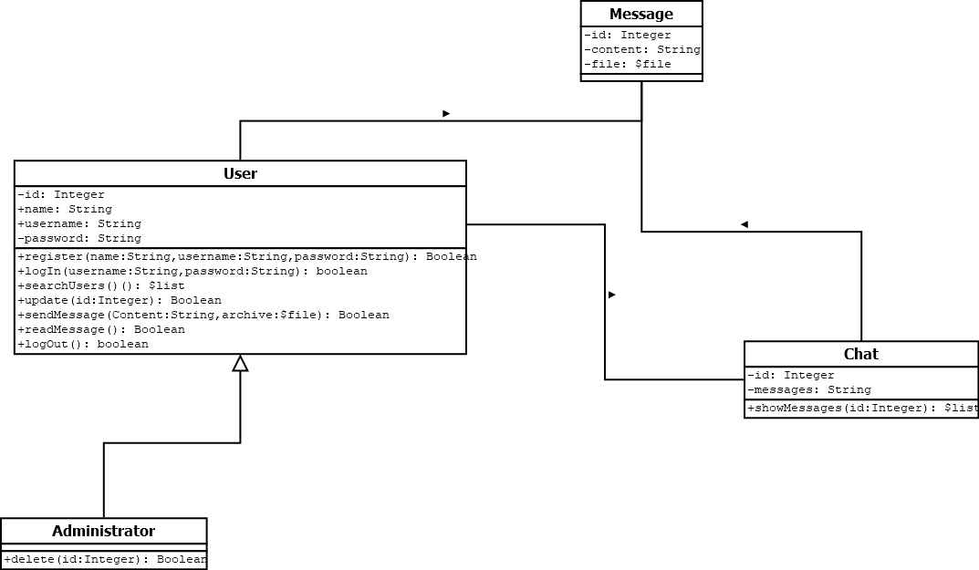

The class user has method to satisfy the sing up, sing in, log out, user update, and elimination requirements, the user identification will be able by the attribute username in the user class, the message and archive management is between the classes message and chat, where we will be able to store and show the messages. The same with the archive management

**Sequence diagram *CORRECTED AT WS-3\***

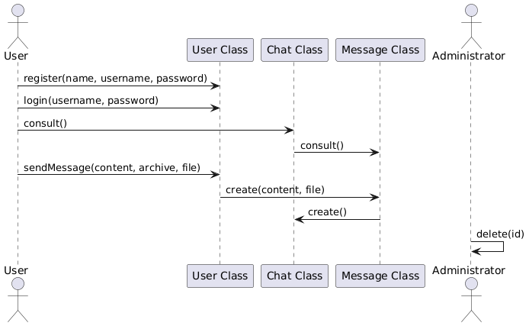

**Activities diagram *CORRECTED AT WS-3\***

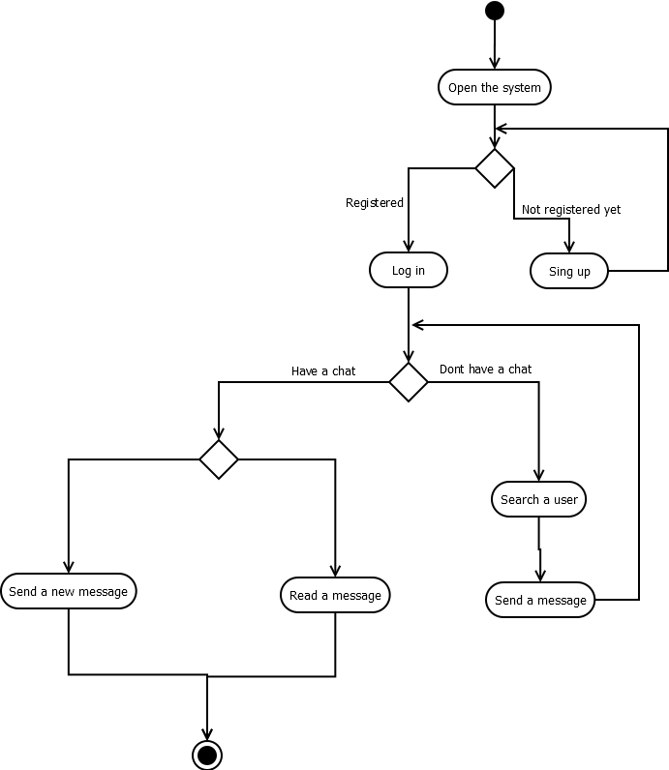

**IMPLEMENTATION PLAN FOR OOP CONCEPTS *CORRECTED AT WS-3\***

In the project we can see the inheritance working because the super class user has a sub-class administrator that have more methods, the classes message and chat have private attributes, I’ll apply the encapsulation by using a validations of the user and if the user is in the chat, he can see it, he also will have permission to send new messages.

The project will use MVC structure, starting with the models proposed in database, the views and all the controllers that will procesate the petitions from the user

Models

* User model
* Chat model
* Message model

Views

* Administrator views
  + Elimination views
  + Chat view
  + user view
  + general view
* User views
  + Chat view
  + user view
  + general view

controllers

* user validation
* validation of information for update

**CODE PROGRESS *CORRECTED AT WS-3\***

**CLASS USER**

public class User {

    private Integer **id**;

    public String **name**;

    public String **username**;

    private String **password**;

    public User (Integer id, String name, String username, String password) {

        this.**id** = id;

        this.**name** = name;

        this.**username** = username;

        this.**password** = password;

    }

    public boolean register(String name, String username, String password) {

*/\**

*\* This method will save the information of a user in the database.*

*\**

*\* @param name: the name of the user*

*\* @param username: the username of the user*

*\* @param password: the password of the user*

*\**

*\* @return a confirmation of the registration*

*\*/*

        this.**name** = name;

        this.**username** = username;

        this.**password** = password;

        return true;

    }

    public boolean login(String username, String password) {

*/\**

*\* This confirms the user exists, and if the credentials ingresed are correct.*

*\**

*\* @param username: the username of the user*

*\* @param password: the password of the user*

*\**

*\* @return a confirmation of the login, in case the information is correct, otherwise false*

*\*/*

        if (this.**username**.equals(username) && this.**password**.equals(password)) {

            return true;

        } else {

            return false;

        }

    }

    public String searchUsers() {

*/\**

*\* this method should show the information of all the users in the system, their name an their username*

*\**

*\* @return all the users registered in the system, their name an their username*

*\*/*

*//this method should validate if the user is logged in before returning the information, an also show the information of all the users in the system*

        return "Name: " + this.**name** + "\nUsername: " + this.**username** + "\nPassword: " + this.**password**;

    }

    public boolean update(Integer id, String newName, String newUsername, String newPassword) {

*/\**

*\* This method will update the information of a user in the database.*

*\**

*\* @param id: the id of the user*

*\* @param newName: the name of the user*

*\* @param newUsername: the username of the user*

*\* @param newPassword: the password of the user*

*\**

*\* @return a confirmation of the update*

*\*/*

*//the id will be used to identify the user in the system in the database*

        this.**name** = newName;

        this.**username** = newUsername;

        this.**password** = newPassword;

        return true;

    }

    public boolean sendMessage(String message) {

*/\**

*\* This method will save the content of a message in the database.*

*\**

*\* @param message: the message to be sent*

*\**

*\* @return a confirmation of the message sent*

*\*/*

*//this method should validate if the user is logged in before sending the message, and take the message from the interface and send it to the database in asociation with a chat*

        return true;

    }

    public boolean readMessage() {

*/\**

*\* This method will read the content of the messages the user has received.*

*\**

*\* @return the content of the message*

*\*/*

*//this method should validate if the user is logged in before reading the message, and take the message from the interface and send it to the database in asociation with a chat*

        return true;

    }

    public boolean logout() {

*/\**

*\* This method will log out the user from the system.*

*\**

*\* @return a confirmation of the logout*

*\*/*

        this.**username** = null;

        this.**password** = null;

        return true;

    }

}

**CLASS MESSAGE**

public class Message {

    private Integer **id**;

    private String **content**;

    private File **file**;*//the message is suposed to support files.*

}

**CLASS CHAT**

public class Chat {

    private Integer **id**;

    private String **messages**;

    public boolean showMessages(Integer Id;) {

*/\**

*\* This method will show the messages in the chat.*

*\**

*\* @param id: the identifier of the chat*

*\**

*\* @return mesagges in the chat*

*\*/*

        this.messages = messages;

        return true;*//this should return the messages in the chat, but for now it will return true.*

    }

}

**PART 3 – WORKSHOP – 3**

* **Revisiting Requirements & Design:**
* The classes diagram have changed due to the changes suggested by the teacher, also the requirements and the CRC cards have changed, implementing only two classes,
* **Enhanced UML Diagrams:**

**The classes message and chat have been replaced by the class email and the App was added to the diagram, all according to the corrections given by the teacher in the Friday class.**

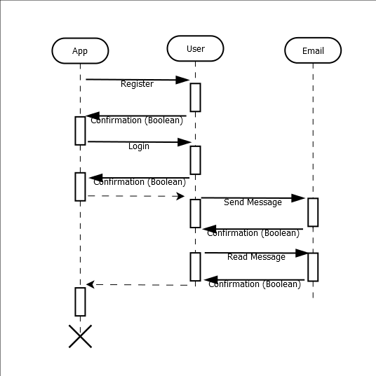

**The new sequence diagram allow a better comprehension of the designed system and how will it work.**

* **SOLID-Focused Implementation:**
  + **Single responsibility:**

**We can evidence that this principle is easy visible at the class email, because the email only has the functionality to see the emails, and the visualization the user class only manages what is related to the user, the information of her self and the messages that have been send**

* + **Open/Closed:**

**In this case there are no interfaces that allow us see this principle in a easy way but we can see the email class could be related to a interface for attachments if we need to develop this functionality in the future.**

* + **Liskov substitution:**

**The Liskov Substitution is not applicable to the system because the design does not need a interfaces or inheritances at this moment.**

* + **Interface segregation:**

**There are no interfaces so the principle doesn’t apply to the system**

* + **Dependency inversion:**

**There are no interfaces so the principle doesn’t apply to the system because there not high level modules in the system.**

* **Work in porgress Code & Documentation:**

Being strict in the code, there is no evidence of any interface or use of weak and strong classes, so the email class will be added as code.

import java.util.*List*;

public class Email {

    private Integer **id** = 1;

    private String **sender**;

    private String **receiver**;

    private String **subject**;

    private String **body**;

    private *List*<Email> **emails** = null;

    public Email(Integer id, String sender, String receiver, String subject, String body) {

        this.**id** = id;

        this.**sender** = sender;

        this.**receiver** = receiver;

        this.**subject** = subject;

        this.**body** = body;

    }

    public String showMessages() {

        String messagesPrint = null;

*/\**

*\* This method will show the messages in the chat.*

*\**

*\* @param id: the identifier of the chat*

*\**

*\* @return mesagges in the chat*

*\*/*

*//The system will validate wich are the users in the system*

        if (this.**emails**.isEmpty())

            return  "No emails registered in the system." ;

        for (Email email : this.**emails**) {

            if (email.**receiver** == this.**sender**){

                messagesPrint = email.**id** + " " + email.**sender** + " " + email.**receiver** + " " + email.**subject** + " " + email.**body**;

                return messagesPrint;

            }

        }

        return "Error";

    }

}

Due to some problems with the static value of the main method some things doesn’t work because I don’t know how make them work.

**PART 4 – WORKSHOP – 4**

* **Revisiting Layers & Design:**
* The classes diagram have changed due to the changes related to the correct execution of the code

* **Swing-based GUI Prototype:**

For the moment I have an unique frame, thinking in the use only, once the login method have been implemented the GUI will change allowing the user to see their messages, and also the logic of sending messages, because the user don’t be requested to send messages.

* **Documentation and Artifact submission:**

In the final solution the app manages the storage of users and emails, because there is not an file storage implemented, it allowing the user and emails visualization.

The principal Swing usage are the buttons so there you have an example of the sending email button configuration:

JButton sendEmailButton = new JButton("Send Email");

            sendEmailButton.addActionListener(e -> {

                String sender = JOptionPane.showInputDialog(frame, "Enter the sender's username:");

                String receiver = JOptionPane.showInputDialog(frame, "Enter the receiver's username:");

                String subject = JOptionPane.showInputDialog(frame, "Enter the subject of the email:");

                String body = JOptionPane.showInputDialog(frame, "Enter the body of the email:");

                if (sender != null && receiver != null && subject != null && body != null) {

                    try {

*// Create a new email and add it to the central list.*

                        Email newEmail = new Email(1, sender, receiver, subject, body);

                        emails.add(newEmail);

                        JOptionPane.showMessageDialog(frame, "Email sent successfully!");

                    } catch (Exception ex) {

                        JOptionPane.showMessageDialog(frame, "Error sending email");

                    }

                }

            });