Question 1

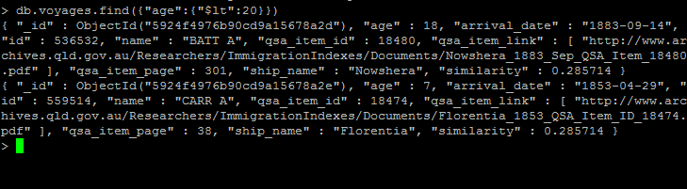

To find ages less than 20

db.voyages.find({“age”:{“$lt”:20}})

Question 2

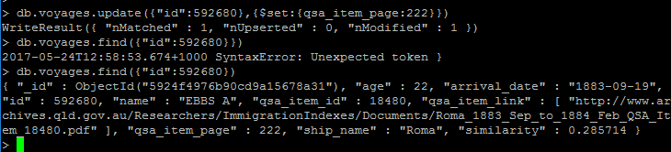

To update qsa_item_page with id of 592680

db.voyages.update({“id”:592680},{$set:{qsa_item_page:222}})

Question 3

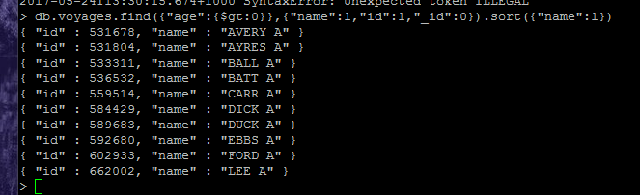

db.voyages.find({“age”:{$gt:0}},{“name”:1,”id”:1,”_id”:0}).sort({“name”:1})

Question 4

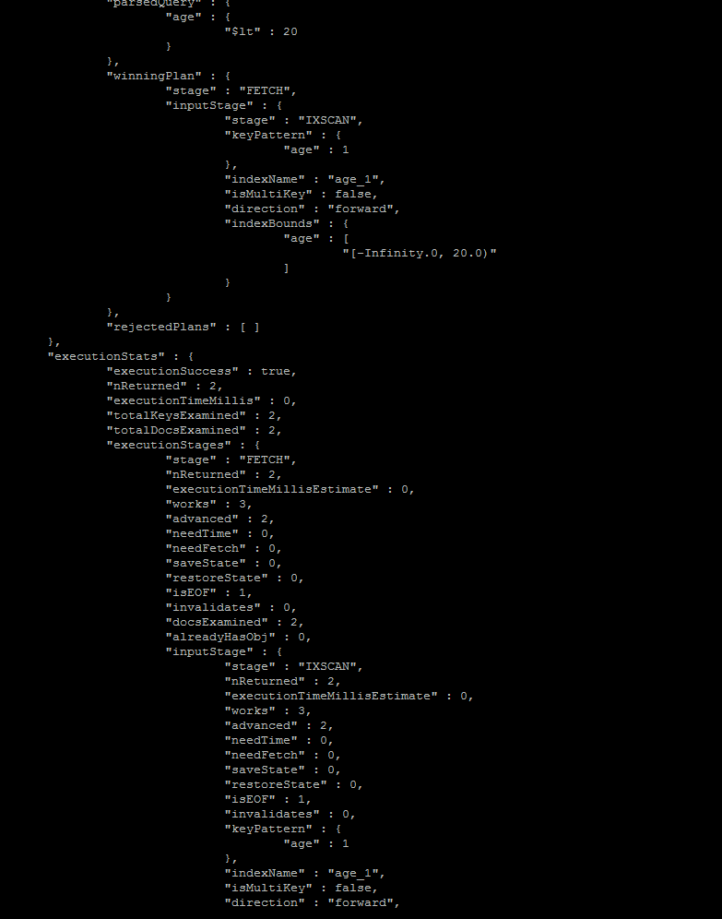

Index helps reduce the cost of scanning, the total docs scanned is 2. Without index, all docs have to be scanned.