Lentivirus Titer calculation

Day 0:

- Produce concentrated virus by usual method. Set aside an aliquot of ~35 uL when making other aliquots.
  - You can titer the same day as you make virus, but make sure to freeze and then thaw your titer aliquot before using in the experiment below.
- Plate concentrated virus in 96 well V bottom plate.
  - Add 90uL LCL 20% to each of 8 wells
  - Dilutions: 30 uL virus in the first well, mix, take from first well and then serial 4-fold serial dilutions (total 7 wells of virus). Leave 8th well as a no virus well.
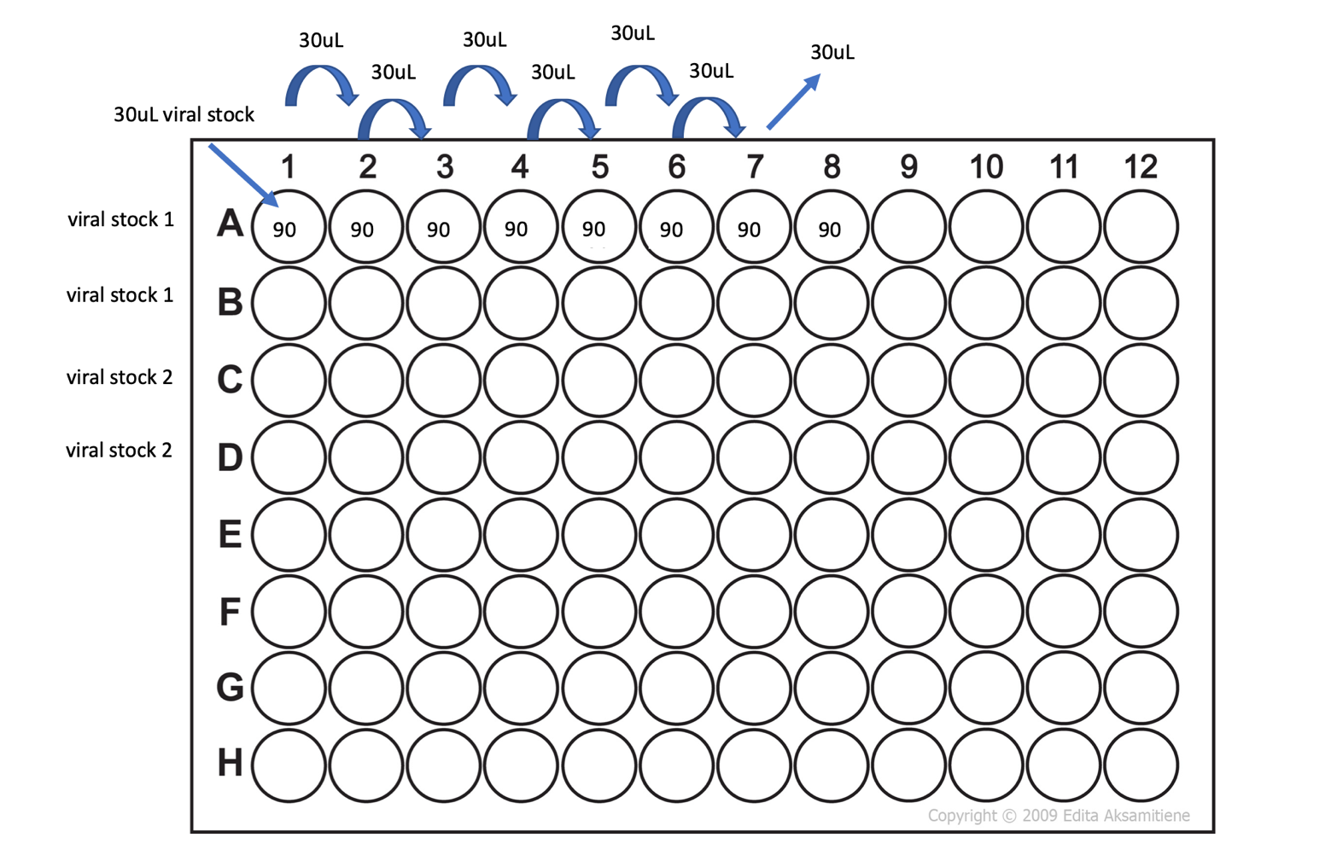

- Transfer viral dilutions to 96 well plate in which you will be growing cells.
  - Transfer 30uL from each well using a multi-channel pipette. Can transfer multiple rows if replicates are desired.
    - NB: two replicates is standard
  - NB: 96U is best for growing cells, but 96V is fine if you’d like to stain directly in the plate on d4
- Resuspend Jurkat 76 cells in media with polybrene
  - For each well, we want 100,000 cells per well, 120 uL of cell suspension per well, and 0.6 uL polybrene.
  - Here is an example of the math for the mastermix:
 | 1x | 8x (1 row)
Cells | 100,000 | 800,000
LCL 20% | 119.4uL | 955.2uL
Polybrene | 0.6uL | 4.8uL

- Plate 120 uL/well of cell mastermix (100,000 cells/well) on top of pre-plated diluted virus.
  - You should get 150uL of total volume, which is important to the math at the end
- Incubate at 37C, 5% CO2, etc. overnight.

Day 1-2:

- Add 50 uL LCL 20% daily x 2-3 days and split to other well if need it.
- Evaluate transduction by flow at 72h or 3 days (e.g., for RQR8 tag or GFP expression).
  - NB: results do not change much if you’d like to flow at a later timepoint, but make sure cells are kept well-fed to prevent die-off

Day 3 or 4: Tetramer Staining

Step 1: Tetramer stain (optional – dependent on construct)
- Plate cells (5,000 – 1M/well) in 96 well v-bottom plate if not already in one
- Spin down at 400g for 2 min
- Carefully remove supernatant. You want cells as dry as possible!
- Spin tetramer at 12000g for 2min at 4º before using
- Add 25uL tetramer mix (use 1:50 dilution if you do not have a known dilution)
- Gently resuspend cells in mix by pipetting
- Incubate 15 min at RT in the dark
Step 2: Antibody stain
- Make antibody mix
  - Use titrations for 50uL staining volume
    - CD34 AF700 (for RQR8 staining): 5 uL
    - CD3 BV786: 3uL
    - Optional: Murine C-beta PE-Cy5.5: 1uL
    - Optional: IO test PE/FITC: 5uL
  - Add MACS buffer to 25uL/well total, rather than 50uL
    - Only if using tetramer (since it will be added on top of previous 25uL); if no tetramer, bring to 50uL/well
- Add 25uL or 50uL antibody (see above) mix to each well, pipette gently
- Incubate 10-15min in the dark, on ice (not at 4º)
- Wash in 150 uL cold MACS/PBS +5% FBS
- Spin at 400g for 2 min
- Remove wash
- Wash with 200 uL cold MACS/PBS +5% FBS, spin again
- Resuspend in 100+uL DAPI (1:12k)
- Run flow: no current machine or template
- Flow analysis:
  - RQR8 staining is the standard for virus titration evaluation (other stains are helpful to gain understanding, but will not be factored into the math)
    - NB: sometimes RQR8 does not appear well, but CD3 and other TCR-specific stains look good – if so, don’t worry, use CD3 for math
  - You are looking for condition with ~10% transduced (well above background but not a huge amount).
  - ~10% transduction indicates 10,000 cells transduced so 10,000 infectious doses (=particles).
  - TU/mL = (Number of cells transduced x Percent fluorescent x Dilution Factor) / (Transduction Volume in mL)
- Then infect T cells with MOI 2 (standard chosen by ADE based on previous experiments)
  - MOI = multiplicity of infection
- Virus volume = (Number of cells transduced x MOI) / (TU/mL)

