10x Genomics V(D)J Library Construction for Human γδ TCRs
Written by: Megan Maerz, Dec. 6, 2021

Note: Unless otherwise indicated, all steps are identical to those described in the protocol here: https://support.10xgenomics.com/single-cell-vdj/library-prep/doc/user-guide-chromium-single-cell-vdj-reagent-kits-v11-chemistry

- Prepare Custom Primer Mixes
10x_hTCR-D/G_Outer Mix (4 uM Working Solution)
Primer | Sequence | Volume (100 uM stock)
10X-Outer-F | AATGATACGGCGACCACCGAGATCTACACTCTTTCCCTACACGACGCTC | 2 uL
R1_hTRDC | AGCTTGACAGCATTGTACTTCC | 1 uL
R1_hTRGC | TGTGTCGTTAGTCTTCATGGTGTTCC | 1 uL
Molecular-grade H2O |  | 96 uL

10x_hTCR-D/G_Inner Mix (4 uM Working Solution)
Primer | Sequence | Volume (100 uM stock)
Illumina-P5 | AATGATACGGCGACCACCGAGATCTACAC | 2 uL
R2_hTRDC | TCCTTCACCAGACAAGCGAC | 1 uL
R2_hTRGC | GATCCCAGAATCGTGTTGCTC | 1 uL
Molecular-grade H2O |  | 96 uL

- cDNA Synthesis and Amplification
  - Complete steps 1-3 of the Chromium Next GEM Single Cell V(D)J Reagent Kit v1.1 protocol.

- Step 4.1: Target Enrichment 1
  - Thaw, equilibrate, and prepare 10x reagents as described on pg. 47 of the protocol.
    - Deviation: Substitute the 10x_hTCR-D/G primer mixes for Human T Cell Mix 1 and Human T Cell Mix 2.
  - Add 33 µl nuclease-free water into a tube strip on ice and then transfer 2 µl sample (post cDNA Amplification & QC, step 3.3) to the same tube for a total of 35 µl.
  - Prepare Target Enrichment 1 Reaction Mix on ice. Vortex and centrifuge briefly.
    - Deviation: Substitute the 10x_hTCR-D/G_Outer primer mix for Human T Cell Mix 1, as indicated below.

Target Enrichment 1 Reaction Mix | PN | 1X (uL)
Nuclease-free Water | - | 5
Amplification Master Mix | 220125 | 50
cDNA Additive | 220067 | 5
10x_hTCR-D/G_Outer Mix | - | 5
Total | - | 65

  - Add 65 µl Target Enrichment 1 Reaction Mix to each tube containing 35 µl sample.
  - Pipette mix 5x (pipette set to 90 µl). Centrifuge briefly.
  - Incubate in a thermal cycler with the following protocol.
    - Deviation: Annealing temperature is optimized for the custom primer mix.

Lid Temperature | Reaction Volume | Run Time
105°C | 100 uL | ~20-30 min
Step | Temperature | Time
1 | 98°C | 00:00:45
2 | 98°C | 00:00:20
3 | 62°C | 00:00:30
4 | 72°C | 00:01:00
5 | Go to Step 2, 9x (10 total cycles)
6 | 72°C | 00:01:00
7 | 4°C | Hold

  - Store at 4°C for up to 72 h or proceed to the next step.

- Step 4.2: Post Target Enrichment 1 Cleanup – SPRIselect
  - Follow the protocol on pg. 49

- Step 4.3: Target Enrichment 2
  - Prepare Target Enrichment 2 Reaction Mix on ice. Vortex and centrifuge briefly.
    - Deviation: Substitute the 10x_hTCR-D/G_Inner Mix primer mix for Human T Cell Mix 2, as indicated below.

Target Enrichment 1 Reaction Mix | PN | 1X (uL)
Nuclease-free Water | - | 5
Amplification Master Mix | 220125 | 50
cDNA Additive | 220067 | 5
10x_hTCR-D/G_Inner Mix | - | 5
Total | - | 65

  - Add 65 µl Target Enrichment 1 Reaction Mix to each tube containing 35 µl sample.
  - Pipette mix 5x (pipette set to 90 µl). Centrifuge briefly.
  - Incubate in a thermal cycler with the following protocol.
    - Deviation: Annealing temperature is optimized for the custom primer mix.

Lid Temperature | Reaction Volume | Run Time
105°C | 100 uL | ~20-30 min
Step | Temperature | Time
1 | 98°C | 00:00:45
2 | 98°C | 00:00:20
3 | 62°C | 00:00:30
4 | 72°C | 00:01:00
5 | Go to Step 2, 9x (10 total cycles)
6 | 72°C | 00:01:00
7 | 4°C | Hold

  - Store at 4°C for up to 72 h or proceed to the next step.

- Step 4.4: Post Target Enrichment 2 Double Sides Size Selection – SPRIselect
  - Follow the protocol on pg. 51

- Step 4.5: Post Target Enrichment QC & Quantification
  - Follow the protocol on pg. 52
  - See the reference image below for an example of cDNA enriched for γδ TCR.
    - 1 uL of Step 4.4 product was run on an Agilent TapeStation D1000 Chip.
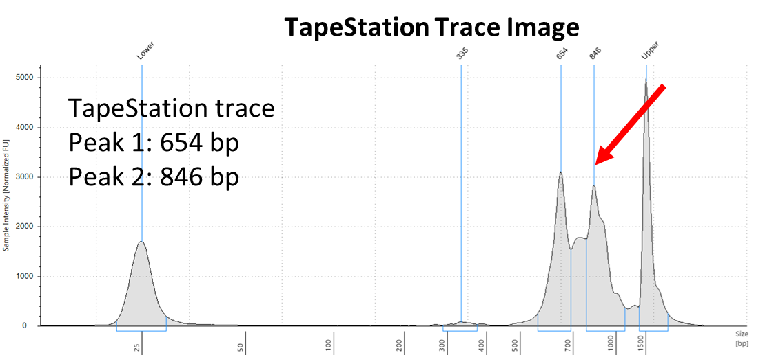
- Step 5: Library Construction
  - Continue with library construction and QC as described in the Chromium Next GEM Single Cell V(D)J Reagent Kit v1.1 protocol.
  - See the reference image below for an example of a γδ TCR V(D)J Library.
    - 1 uL of Step 5.5 product was run on an Agilent TapeStation D1000 Chip.
