[Prot 201] Mouse Transplant Donor Prep (BM and Spleen)
Last updated 5/15/19 by Albert Yeh

Notes:
This protocol describes the procedure to harvest bone marrow and splenic T-cells from donor mouse using MACS (Miltenyi) purification system. In this case, we are doing positive selection for CD4.

Materials:
- Sterile forceps, scissors, 6cm culture dishes, 70-100uM strainers
- 70% EtOH
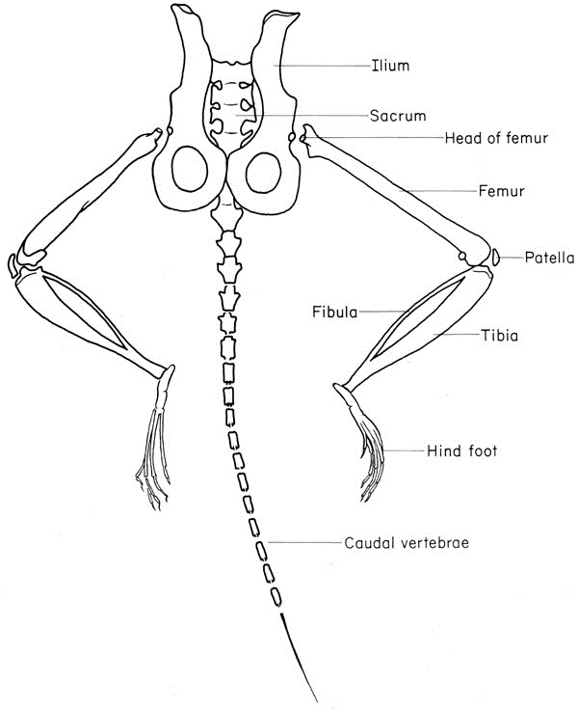
- Cell culture media
  - Red dot = RPMI + 2% FCS (use this to keep tissue in dish)
  - Blue dot = RPMI no FCS\
- Gey’s Buffer, L15 Liebovitz media, MACS Buffer (can use FACS buffer)
- CD4 (L3T4) microbeads (130-049-201); MACS system

Protocol:
- Sacrifice mice humanely
- Harvesting T-cells
  - Dissect spleen using mid-abdominal cut.
  - Asides from spleen, can increase T-cell yield by obtaining axillary, brachial, popliteal lymph nodes. If getting axillary/brachial nodes, better to do upper-abdominal cut.
  - Collect cells in 6cm dish
- Harvesting BM:
  - Asides from femur/tibia, can increase T-cell yield by obtaining hip, humerus
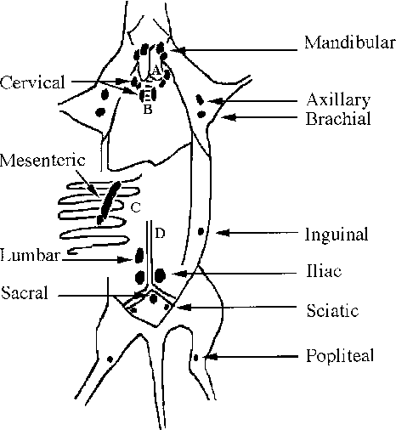
  - Cut ends of each long bone, flush.
  - Collect cells in 6cm dish
- Attached 70uM strainer to labeled 50cc Falcon tube. Use commercial 70uM strainer for harvesting – easier to mash up particles with plunger. Filter cells from 2) and 3) to new tube.
- LYSE RBCS: For spleen cells, need to lyse RBCs:
  - Centrifuge, decant
  - Add 1mL Gey’s buffer, incubate 1min at RT, top up (e.g. 9mL media)
  - Centrifuge, decant
- Perform cell count
- Centrifuge cell suspension at 300g for 10 minutes, pipette off supernatant.
- Magnetic labeling
  - Resuspend cells. For next step (adding CD4 MACS beads), note that we use 60% of the recommended amount of buffer/beads as we assume that 30% of splenocytes are CD4, and we use twice that.
  - After calculating 60% of final spleen count, add 90uL buffer per 10M cells and 10uL CD4 MACS beads per 10M cells.
  - Mix, incubate for 15 minutes in fridge or on ice.
  - Rinse by adding 1-2mL of buffer per 10M cells, centrifuge at 300g x 10min, decant.
  - Resuspend cells in 500uL buffer.
- Magnetic separation
  - Place column in magnetic field
  - Use MS column if <200M cells (mini); use LS column if < 2B cells (midi)
  - Prepare column by rinsing with buffer (500uL for MS, 3mL for LS)
  - Apply cell suspension.
  - Wash through with buffer 3x (3x500uL for MS, 3x3mL for LS) – the effluent contains unlabeled cells.
  - Remove column on separator and place on labeled collection.
    - Put 1mL buffer in for MS column and 5mL for LS column.
    - Use plunger to flush out the labeled cells.
- Count cells twice to get average.
- Do FACS (including CD4+ and viability dye) to get % viable for final count.
- Use Motoko’s transplant excel sheet to calculate fraction of cells needed to resuspend in L15 (Liebovitz) media. Make sure there is NO ALBUMIN! Note that final L15 media count is represented by either of the BM or T-cell fields, so no need to double. Final injection is 250ccs per mouse. Make sure to include ~1 extra mouse for every 4 or so sample. If can’t have this, increase injection volume to 350ccs to allow for more buffer.
- If saving cells for sequencing, process immediately (for TCR seq, use DNA mini kit – takes about 1 hr and requires you to resuspend cells into 200uL PBS). If do not process immediately, freeze down unused CD4+ cells.
- Since our plan is to do deep sequencing once on the donor cells, save 500K T-cells for DNA isolation.
- If saving other organs / skin, harvest as appropriate.

Notes on yield:
5/7/19: 80M B6.45.1 spleen cells (before Gey’s buffer) -> 100% CD4 MACS -> 6.17M/mL (1mL) final
7/31/19: 245M B6.wt spleen (2x) cells (before Gey’s buffer) -> 214M B6.wt spleen (2x) cells (after Gey’s buffer) -> 100% CD4 MACS ->14.75M final (average about 7.375M CD4+ per spleen)

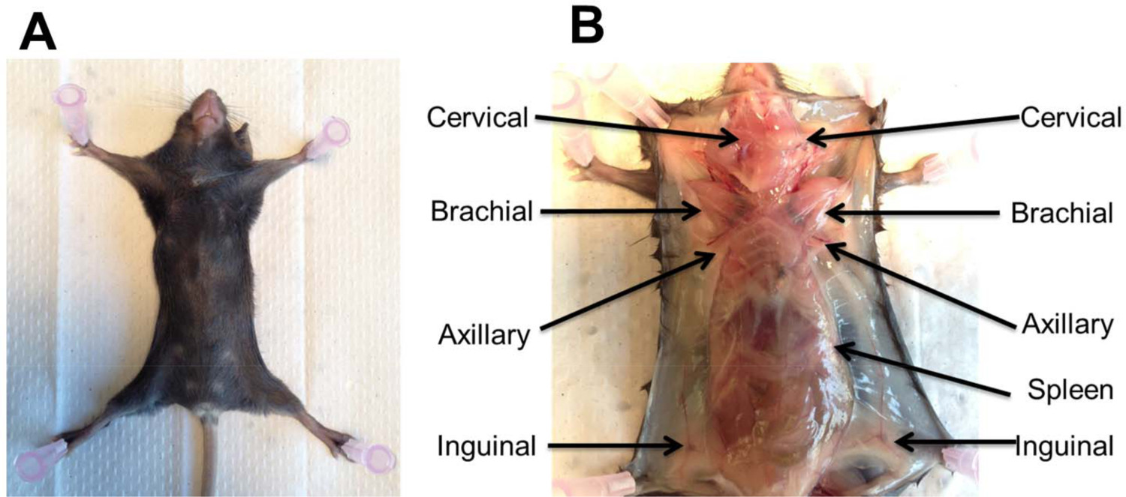
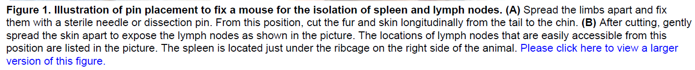
PMID: 25938923

