[Protocol 204] Organ harvesting for CMV experiments
Updated 10/29/24 by Albert Yeh

This is a pipeline to obtain frozen tissue for PFU analysis as well as FFPE samples for histology.

Frozen tissue collection: spleen, liver, lung, salivary glands
Histology: skin, liver, ileum, colon

**Note for all frozen tissue collection, it is important to weight the tissue mass!

- Prep all tubes (for snap frozen, can use Eppendorf; for histology, can use 12-well plates with formalin)
- Collect blood (eye bleed if desired)
- Shave skin, take off small bit of skin, put in FORMALIN for FFPE.
- Flip mouse over, make long midline excision up to neck,
  - Harvest salivary glands, SNAP FREEZE (see Fig 1, weigh tube before and after)
  - Harvest right middle (or entire left) lung lobe, SNAP FREEZE (see Fig 2, weigh tube before and after)
  - Harvest left lateral liver lobe, SNAP FREEZE HALF OF SAMPLE (see Fig 3, weigh tube before and after), take OTHER HALF and put in FORMALIN for FFPE
  - Harvest spleen, SNAP FREEZE
  - Flip over, take ileum and colon and make rolls, put in FORMALIN for FFPE.

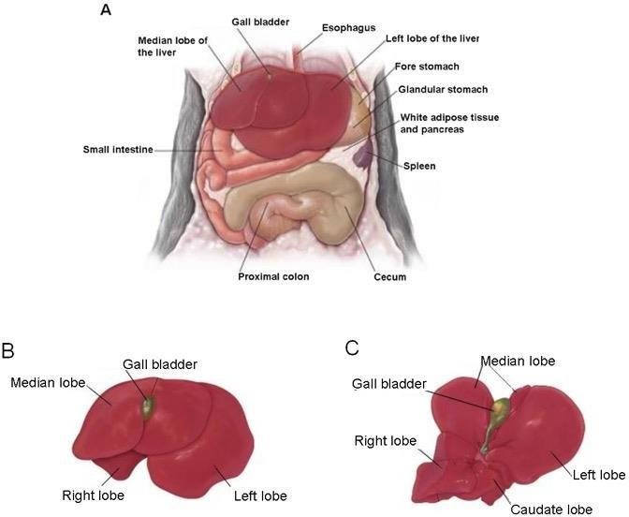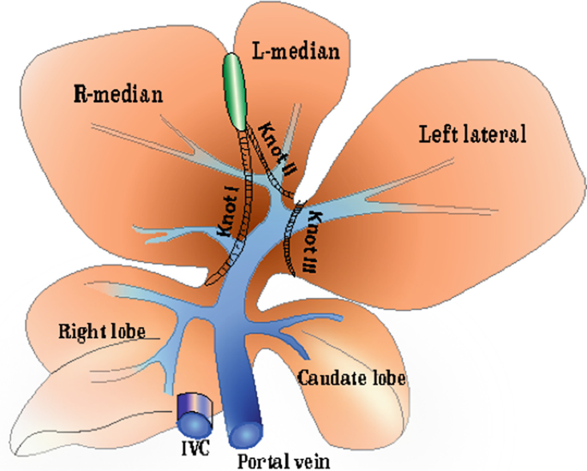

Figure 3 – Liver Lobs

Figure 1 – Salivary Glands

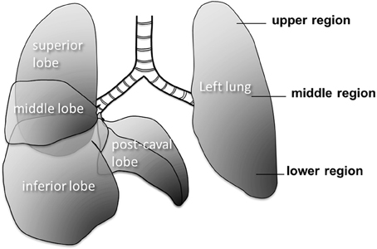

Figure 2 – Lung Lobes

