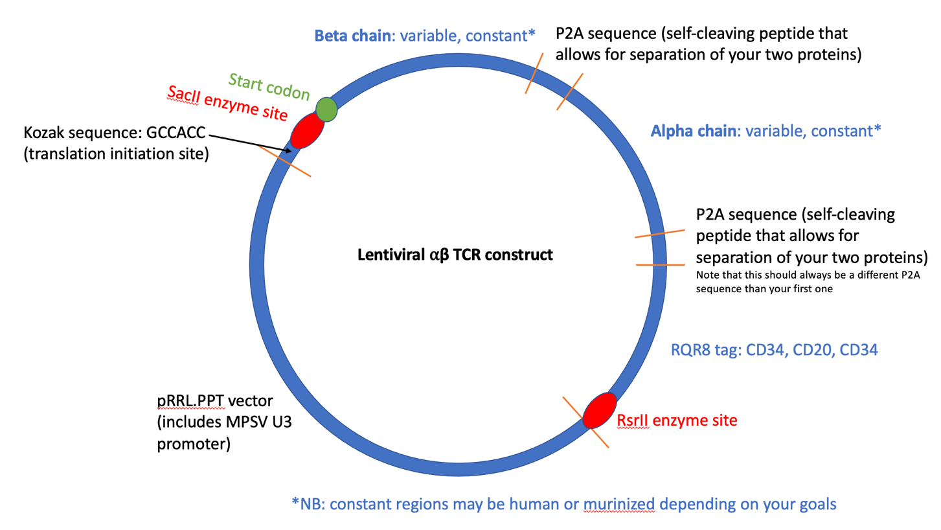

TCR alpha and beta chain variable regions: reconstruction
*See reconstruction powerpoint

After you have reconstructed your alpha and beta chains, plug them into your Ape template. Check that you can read the chains all the way through and that you are not missing an amino acid at the start of the constant region. Use the RsrII and SacII enzymes (in the enzyme selector) to figure out what region you will want to order.

GeneArt Codon Optimization
*Codon optimization keeps amino acid sequence the same, but changes nucleotides to ensure better protein production and expression of your gene

There are many companies that do this, but GeneArt is the one we’ve tested and had good results with

https://www.thermofisher.com/order/geneartgenes/projectmgmt
New Project > Provide name and select a folder > drag “gene synthesis” box into process #1 > double click the icon you just dragged > provide sequence name, select level 1, standard cloning vector > edit sequence tab, select your restriction enzymes > optimize sequence for homo sapiens only for the region after the Kozak > sequence summary, download as fasta
*All of the ordering info can also be found in more detail in the master TCR cloning document

IDT Geneblock Design
*Since this company sends the gene as a block, rather than within a construct, you need to create a place for the restriction enzymes to “land” where they will be cutting otherwise you will get poor results!

Any ~10 base pairs on either end of the construct is fine, but I’ve used the sequences below with great success, so I usually use them to avoid issues.

caggatcgac…insert sequence here…gtcaacgtaa

Ordering:
*Note that I have only ever used the HiFi and had great results. Non-HiFi is cheaper and arrives faster, but is untested
FMS > creat requisition > marketplace > IDT punchout > Products and Services > gBlocks & gBlocks HiFi Gene Fragments > gBlocks HiFi Gene Fragments in Tubes
- Enter the item name and sequence
- Validate
- Follow instructions to order
- Will take ~10 business days to arrive
- Will arrive lyophilized and fine at room temp until cloning

