TCR cloning
Table of Contents
Standard TCR cloning timeline 2
TCRA/B sequencing overview 3
TCRA/B sequencing by Adaptive 4
Assembling TCR consensus sequences 5
Building a TCR insert from consensus sequences 6
Ordering the TCR construct(s) as GeneArt 9
Restriction digest cloning of TCR construct into backbone vector 11
Concentrated TCR lentivirus stock production 15
Lentivirus titration 17
TCR transduction 20
T cell isolation and stimulation 20
T cell transduction with concentrated virus 20
Evaluation of transduction efficiency and flow sorting 21
Appendix 23
TCR cloning by RACE-PCR 23
RNA extraction 23
cDNA preparation 24
Amplify the full TCR region for sequencing 25
Topo cloning and sequencing RACE-PCR products 28
Riddell lab 5’/3’ SMARTer RACE protocol 30
Determining TCR sequences from RACE-PCR products 31
Amplify alpha and beta genes 33
Production of fresh TCR virus 35

Standard TCR cloning timeline

Times are for 1-3 TCRs and may need to be scaled up for larger batches of TCRs. These times do not account for troubleshooting at any step along the way.

- TCR sequencing by Adaptive Biotechnologies
  - 2-4 weeks from submission to sequence for TCRB
  - 4-6 weeks from submission to sequence for TCRA/D*
- In silico TCR reconstruction
  - <1 day
- In silico TCR construct assembly
  - <1 day
- Ordering TCR construct as GeneArt
  - <1 day to order
  - Up to 3 weeks for GeneArt to arrive
- Restriction digest cloning of TCR construct into backbone vector
  - 1 week
- TCR virus production
  - 1 week
- TCR transduction, sort, and expansion of TCR-transduced T cells
  - 3 weeks

*TCRA/D sequencing is only run quarterly so advance planning is needed!

TCRA/B sequencing overview

There are two primary ways of sequencing TCR alpha and beta chains for TCR reconstruction.

Adaptive TCR sequencing uses next-generation sequencing technologies to identify the V, D (for beta chains), and J regions as well as to resolve the CDR3 region from genomic DNA.

RACE-PCR (Rapid Amplification of CDNA Ends) allows one to PCR out an entire TCR alpha or beta chain from cDNA (introns spliced out) without knowing the sequence of the V(D)J region.

 | Adaptive | RACE-PCR
Pros | - User-friendly and few steps  - TCRB sequencing available through Fred Hutch core  - gDNA-based (more stable vs RNA)  - Minimal hands-on time (at most, gDNA isolation)  - Can be run on oligoclonal sample | - Resolves complete TCR chain sequence  - Can be run any time
Cons | - Does not resolve complete TCR chain sequence (only ~80 bp around CDR3)  - Cost  - TCRA/D runs are only done quarterly and directly through Adaptive | - Can be technically challenging  - Multiple steps (RNA extraction, cDNA, RACE-PCR, Topo cloning, sequencing)  - Cost  - Must be run on clone (>80-90%)

Post 2020, we generally prefer Adaptive sequencing up-front as it reliably provides TCR chain sequences and requires less hands-on time. run TCR assembly is also more streamlined. The protocol for Adaptive TCRA/D and TCRB sequencing is provided below in the main protocol.

RACE-PCR may be preferred if time is short and an Adaptive TCRA/D is far off, or to resolve uncertainty from Adaptive sequencing (standard PCR with gene-specific primers based on Adaptive sequence is an alternative). Protocols for RACE-PCR are provided in the Appendix.

TCRA/B sequencing by Adaptive

For TCR alpha sequencing:

- Contact FH Adaptive Rep well in advance of desired sequencing since TCRA/D sequencing is only run quarterly. The calendar of runs will be added to the Bleakley lab calendar and posted on the TCR cloning channel of the Bleakley Lab Teams once available. The Adaptive REP will provide detailed instructions for how to submit samples.
  - NB: as of 6/2020, IML will do TCRB but not TCRA/D sequencing.

- Isolate genomic DNA using QIAGEN miniAMP kit, elute in TE buffer, and determine concentration as well as A260/A280 ratio.

- Submit samples to Adaptive in plate provided. Time to results is 4-6 weeks.

For TCR beta sequencing:

- Can be done through Fred Hutch Immune Monitoring Lab (IML). Request service in iLab. Contact IML (as of 09/2020, contact was Mason Lai) and submit either a cell pellet from your T cell clone or genomic DNA extracted from your T cell clone. Time to results is about 2-4 weeks.

- TCR beta sequencing can also be submitted directly to Adaptive, i.e., included along with samples for TCR alpha sequencing as above if the timing is better.

Assembling TCR consensus sequences

You can do this using either RACE-PCR sequence or Adaptive sequence. RACE gives longer nt sequence so can increase confidence. If possible have at least 2 overlapping sequences (fwd/rev, RACE and Adaptive). Note: A detailed example powerpoint is saved on Teams (Bleakley lab>TCR cloning>Files>SOPs and examples>TCR reconstruction.pptx) and on the server (Bleakley lab>Michelle>Protocols>TCR reconstruction.pptx)

- Search your beta or alpha chain sequence on IMGT (http://www.imgt.org/IMGT_vquest/vquest?livret=0&Option=humanTcR).
  - Identify appropriate V, D (if applicable), and J regions.
  - Save IMGT output as PDF.
  - Note V and J regions used in spreadsheet.

- Search for V region sequence in IMGT Gene
  - Select "Homo sapiens", TR, "Variable" or "Joining", and "functional" then click submit.
  - Check appropriate boxes for V or J regions (Step 3) from list that is pulled up.
  - Then below list of genes under "IMGT label extraction from IMGT/LIGM-DB reference sequences (F+ORF+all P)" under choose label select "L-Part1+V-exon"
  - Copy and paste into excel spreadsheet. These will be your reference V sequences.

- Repeat Step 2 for J regions -- make sure you are not getting introns.

- Align original sequence (RACE-PCR and/or Adaptive) with V- and J-regions, as well as constant region (only if RACE-PCR was used)
  - Open Sequencher
  - Import .ab1 files for sequenced RACE products. If reverse sequence, under View, select "Reverse & Comp". Trim Ns.
  - Import ApE files for any reference sequences (any file type)
  - Create new sequences for V and J region nt sequences for Adaptive sequence.
  - Highlight all sequences and click "Align automatically". You should not need to change from standard parameters or do anything fancy.
  - Double click on the resulting contig and click "Bases" to view at NT level.
  - If RACE product included, delete 5' sequence up to where it aligns with the start codon of the V-region.

- Under "View/Translation" select protein 1st frame to see in line aa sequence.

- Scroll through contig to look for discrepancies.

- Clone sequence (RACE or Adaptive) ALWAYS trumps reference V or J sequence. Confidence in CDR3 sequence increases if you have duplication (ie fwd and reverse or Adaptive and RACE). If sequence quality is poor, confidence decreases.

- Edit to correct Ns and so that CDR3 is correct based on RACE/Adaptive. You may need to trim or edit V and/or J—that is okay! Be sure you DO NOT alter your CDR3 sequence.

- Confirm that the amino acid sequence for your CDR3 is CORRECT and that everything is IN FRAME.

- Make sequence from consensus and export as FASTA file. This will be the basis for your alpha or beta variable +/- constant.

- Save project file as Date_Clone_alpha/beta_assembly.SPF

Building a TCR insert from consensus sequences

This subprotocol assumes that sequences have already been aligned in Sequencher and consensus sequences representing the entire V(D)J region have been saved as FASTA files.

- Open pRRL_PPT_MP-p-TCR-B-A_RQR8_TEMPLATE.ape (found in "Bleakley-Fusion Genes/TCR sequencing" folder).

- Open spreadsheet with sequencing data for TCRs, including the amino acid sequence for CDR3 regions.

- Find and open FASTA files (saved as .txt; can be opened in ApE) of TCR variable regions in "Bleakley-Fusion Genes/TCR sequencing/TCR contigs aligned from RACE and Adaptive" folder then open sub-folders for appropriate project and T cell clone.
  - There should be at least one alpha chain sequence and one beta chain sequence for every T cell clone. These will be named [cloneID]_alpha1_consensus.txt for alpha chain #1, [cloneID]_alpha2_consensus.txt for alpha chain #2, etc.
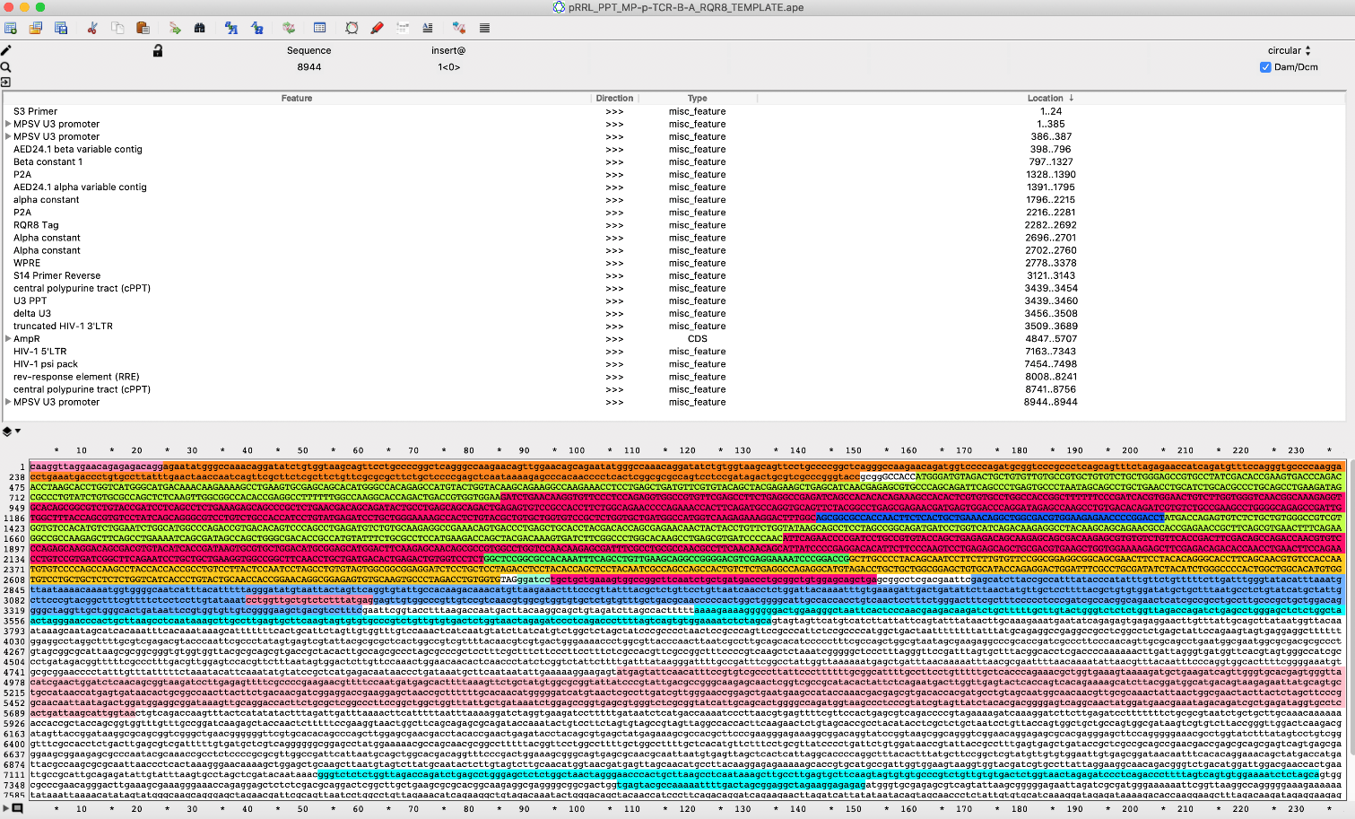
- Copy the beta 1 variable consensus sequence for the T cell clone and paste it into the beta variable region in the template ApE file (first green section). Recolor the new beta variable region and call it [cloneID]_beta1_consensus by making it a new Feature.

- Then do the same thing for the alpha 1 variable consensus region, pasting into the alpha variable region of the template (second green region). Also recolor and label the new alpha variable region as [cloneID]_alpha1_consensus in Features as above.

- Save the file as pRRL_PPT_MP-p-[cloneID]-B1A1_RQR8_not-CO.ape, substituting the clone name/ID for the section in brackets.

- Translate your new TCR starting from the beginning of your beta variable region (should begin with ATG and follow ccgcgg). Check that everything is in frame and that there are no stops until around amino acid 760-800.

- Then do the following QC checks:
  - Make sure your beta CDR3 is in frame (use sequence from Adaptive or from RACE-PCR). CDR3 should be near the end of the consensus sequence you pasted in. Make sure the amino acid sequence in your construct is identical to your CDR3.
  - Make sure your alpha CDR3 is in frame (see instruction for beta CDR3).
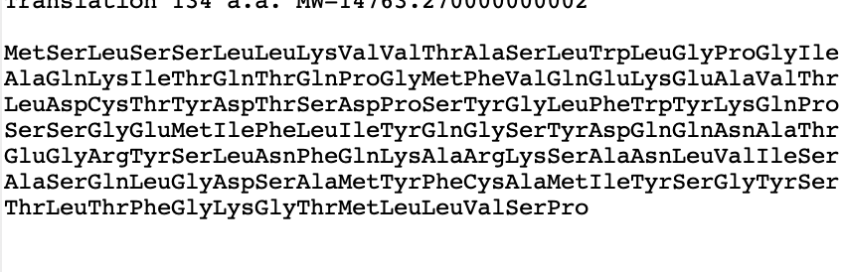
  - Make sure RQR8 is in frame (amino acid sequence below)

  - Make sure there are no stop codons until the end of the RQR8 sequence.
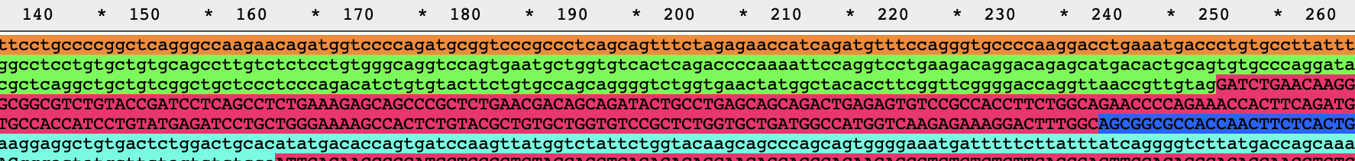
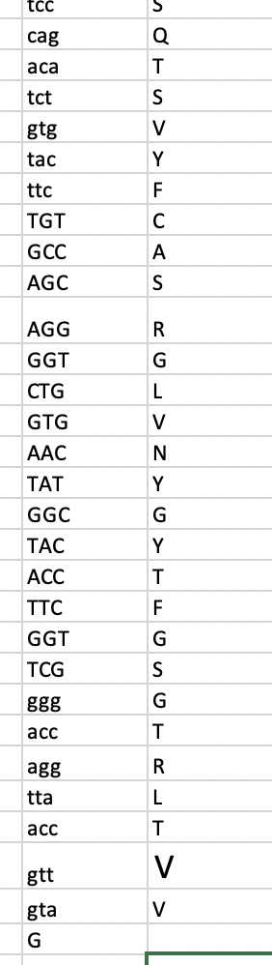
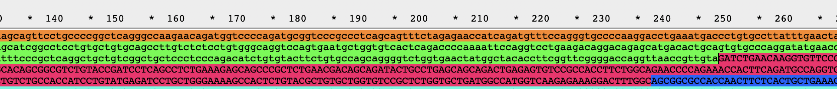
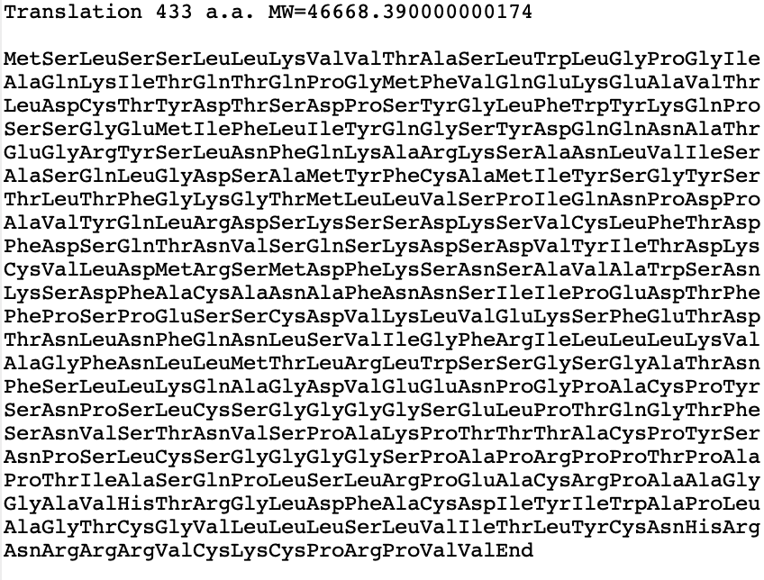
- If any of your QC checks fail (ie your sequence is not correct or there is a premature stop), it is likely that you have a problem at the junction between either your beta variable and constant regions or your alpha variable and constant regions or both. To fix it:
  - try adding a single nucleotide (a) at the junction (highlight in a new color and make lower case). Translate again. If everything is in frame, you have fixed* the problem.
  - if a) doesn't work, delete the nucleotide you added. Then delete another nucleotide from the 3' end of the variable region. Translate again. If everything is in frame, you have fixed* the problem.
  - If your beta and alpha junctions are off, you may need to do this twice.
  - Once you have done a) or b) and have everything in frame where it should be, you need to check again that your sequences are going to translate correctly. Repeat all of the steps in #8.
    - In addition, translate the consensus sequence of the variable region that you needed to modify (ie, if there was a problem at the alpha junction, translate your alpha variable consensus sequence). Check to make sure that the amino acid sequence of that region in your construct perfectly aligns.
    - Finally, go to a reference sequence (JG2 TCR, AED24.1 TCR etc), translate it, and confirm that the amino acid sequence of the constant region you modified are identical to the reference construct.

- Repeat steps #8 and #9 until you are satisfied that the sequences are correct. Phone a friend (Melinda, Michelle) if you are unsure.

- Once you are confident in your sequence, select the region between the RsrII and SacII cut sites and order as GeneArt.

*make sure that any additions or deletions do not change your sequence in either the variable or constant regions.

Ordering the TCR construct(s) as GeneArt

- Log into the ThermoFisher GeneArt synthesis portal: https://www.thermofisher.com/account-center/signin-identifier.html
  - NB: the link may be changed by the company in the future so if the above link doesn’t work, perform a web search for GeneArt.
  - Can generate your own account or use a shared one (tmcunnin@fhcrc.org, Hutch8).

- Click the red button that says “New Project,” enter a name and select (or create) a folder.

- In the new project, drag the “Gene Synthesis” icon into the dashed square. Double click the icon. The box below (Enter Sequence tab) will appear. Type in a name for your sequence. Paste in nucleotide or amino acid sequence. Make sure under Biosafety Classification that “Level 1” is checked and select “Standard cloning vector.”
  - NB: the default cloning vector can come with either ampicillin or kanamycin resistance. Specifying ampicillin is preferred as one does not find out resistance until the construct arrives and we do not always have kanamycin plates in house.

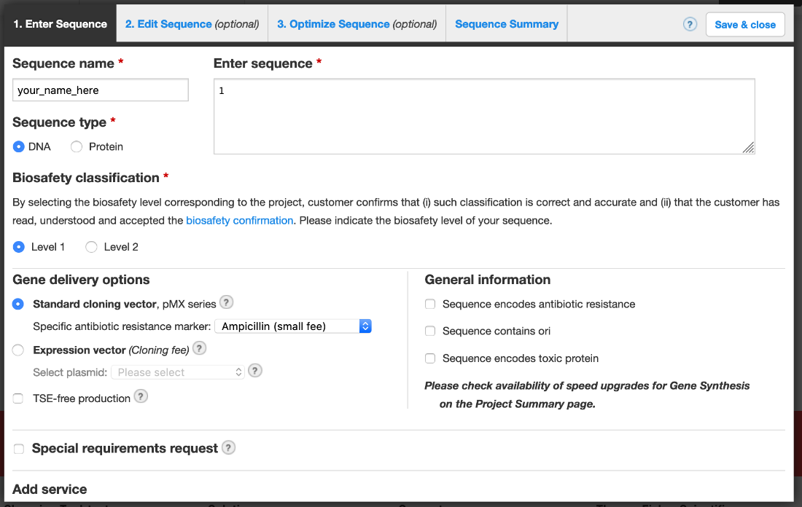

- Click “Edit Sequence” tab. In this tab, choose your open reading frame, which will begin at position 13 (after SacII and Kozak sequence) and end at the last nucleotide of your sequence (the last nucleotide of your RsrII restriction site). The stop codon is not included in your GeneArt construct as it is after RQR8 in final backbone plasmid.

- Click “Optimize Sequence” tab. Make sure SacII and RsrII are listed under “Protect restriction sites.” Under “Motifs to avoid,” select SpeI and AscI (in pRRL.PPT backbone) and make sure SacII and RsrII are also listed.

- Under “Optimization” (still on the “Optimize Sequence” tab), select “Homo sapiens” in drop-down menu, then click “Optimize.” This will generate a codon-optimized nucleotide sequence.

- Once codon optimization is complete, you will automatically be directed to the “Sequence Summary” tab. Review the translated sequence and restriction sites to ensure that everything is correct and in-frame.

- Once you are satisfied with your sequence, you can either generate more constructs in the same project or follow prompts to move your project and the sequences it contains into your shopping cart. At the last step, click the button to generate a quote and forward it to the appropriate technician who will be placing the order. Separately email the technician to request the order.

- GeneArt can take up to 3 weeks to arrive so plan accordingly.

Restriction digest cloning of TCR construct into backbone vector

Reagents Needed:
1x TE Buffer | 10 mM Tris-HCl (pH 8.0) + 1 mM EDTA | can use Buffer TE from Qiagen kits
Molecular Biological Grade (MBG) Water | Fisher Scientific (Corning Brand) | Cat #MT46000CM
10x CutSmart Buffer | New England BioLabs | Cat #B7204S
SacII Enzyme | New England BioLabs | Cat #R0157S
RsrII Enzyme | New England BioLabs | Cat #R0501S
BstEII-HF Enzyme | New England BioLabs | Cat #R3162S
10x TAE Buffer (Diluted to 1x with Millipore water) | Fisher Scientific (Corning Brand) | Cat #MT46010CM
Agarose LE | Fisher Scientific (Axygen Brand) | Cat #14-223-080
CIAP (20 U/µL) | Thermo Fisher | Cat #18009019*
T4 DNA Ligase (5 U/µL) | Thermo Fisher | Cat #EL0014*
One Shot Stbl3 Chemically Competent Cells** | Thermo Fisher | Cat #C737303*
LB/Carbenicillin Plates | Teknova | Cat #L1010
QIAprep Spin Miniprep Kit | Qiagen | Cat #27104* or #27106*
BigDye® Terminator v3.1 Ready Reaction Mix | Sequencing Core Facility
QIAquick Gel Extraction Kit | Qiagen | Cat #28704* or #28706*
Miller’s LB Broth | Corning | Cat #46-050-CM*
Ampicillin sodium salt | Sigma | Cat #A9518
DMSO | Sigma | Cat #D8418
MinElute PCR Purification Kit | Qiagen | Cat #28004
Qubit™ 1x dsDNA HS Assay Kit | Thermo Fisher | Cat #Q33230
HiSpeed Plasmid Maxi Kit | Qiagen | Cat #12662* or #12663
*Items available onsite in consignment room
**Make sure E.Coli is not expired
Items highlighted in yellow can be substituted with other equivalent brands

- Resuspend gBlock (1000 ng) in 20 µLs 1x TE Buffer.

- Digest gBlock (x2 tubes) as follows:

Component | 1X (ul) | _X
gBlock (300 ng) | 6
10x CutSmart Buffer (NEB) | 4
SacII Enzyme (NEB) | 1
RsrII Enzyme (NEB) | 1
MBG Water | 28
Total | 40

  - Digest for 2 hours at 37°C.
  - Purify digested inserts using MinElute PCR Purification Kit (combine like tubes into one column) and elute with 20 µLs MBG water.
  - Quantitate concentration of purified insert using Qubit™ 1x dsDNA HS Assay Kit.

- Digest pRRL.PPT_MP_CBF Bracelet-RQR8 backbone vector as follows (x3-4 tubes):

Notes:
    - The CBF vector can be found in the molecular cloning boxes at -20º C. Check with JAL if stock is running low.
    - BstEII-HF is used only in the vector digest as it cuts the CBF insert in half, thereby keeping it out of the way when the gel is run. This is for ease of band extraction and to keep the vector pure.
    - CIAP is a phosphatase which removes phosphate groups from the end of the digested vector and prevents the vector from closing back up prior to ligation.

Component | 1X (μl) | _X
Vector (2.5 µg) | varies
10x CutSmart Buffer (NEB) | 6
SacII Enzyme (NEB) | 1
RsrII Enzyme (NEB) | 1
BstEII-HF | 1
MBG Water | varies
Total | 60

- Digest for 3 hours at 37°C.
- Add 1 µL of CIAP (20 U/µL) to each tube.
- Incubate at 50°C for 15 minutes.
- Run digests in a 1% TAE Agarose Gel for 70 to 80 minutes at 100V (combine tubes into as few wells as possible).
- Cut largest bands and purify using QIAquick Gel Extraction Kit (use as few columns as possible).
- Elute each column with 30 µLs MBG water and combine if necessary.
- Quantitate concentration of purified backbone vector using Qubit™ 1x dsDNA HS Assay Kit.

- Set up ligations using the following formula (start with a 3:1 insert to vector ratio and 100-200 ng of vector). Also set up a negative control reaction (digested vector only, no insert):

Notes:
    - If your concentrations are not high enough to get the desired amount of insert and vector into the reaction, expand the total volume to 30 µLs (bump up the buffer to 6 µLs and ligase to 1.5 µLs). If you still cannot fit it within the 30 µL volume, bring down the ng of vector until the math works out.
    - We have both Invitrogen and NEB brand ligase. Make sure you match the brand of ligase buffer to the brand of the ligase.
(ratio)
ng of vector x kb of insert x insert = ng of insert to use
kb of vector vector

Example: 200 ng x 1.3 kb x 3 = 104 ng
7.5 kb 1

Component | 1X | _X
5x T4 DNA Ligase Buffer (comes with ligase) | 4 µL
Insert | Varies
Vector | Varies
T4 DNA Ligase (5 U/µL) | 1 µL
MBG Water | Varies
Total | 20 µL

- Mix the above table components together on ice.
- Incubate overnight at 16°C.

- Transform ligations into One Shot Stbl3 Chemically Competent Cells (E. coli) as follows:

  - Thaw Stbl3 cells on ice.
  - Add 5 µLs of each ligation reaction to one tube of competent cells and flick tubes gently to mix.
  - Incubate cells on ice for 15-30 minutes.
  - Heat shock cells in a 42°C water bath for 45 seconds, then place on ice for 2 minutes.
  - Add 200 µLs of room temperature SOC media (comes with cells) to each tube and incubate in a 37°C shaker (200-250 rpm) for 1 hour.
  - Plate each tube of cells on LB/Carbenicillin plates (prewarmed to 37°C) and incubate overnight in a 37°C incubator.

- Remove plates from incubator and check for colonies. Ligation plates should have more colonies than the negative control plate. If the ligations failed, repeat them using a different insert to vector ratio (5:1 or 10:1).

- Pick 4-6 colonies from each plate and grow overnight in 6 mLs Miller’s LB Broth + Ampicillin (100 µg/mL final conc.) at 37°C in a shaker (200-250 rpm). For each colony picked, also streak a small amount of the bacteria onto a new LB/Carbenicillin plate. Incubate the plate in a 37°C incubator overnight.

- Perform minipreps using QIAGEN kit. Elute minipreps with 55-60 µLs MBG water. Remove streak plate from the incubator, wrap in parafilm, and store at 4°C (for future maxipreps).

- Set up a diagnostic digest on minipreps as follows:

Component | 1X (μl) | _X
Miniprep DNA | 7
10x CutSmart Buffer (NEB) | 2
SacII Enzyme (NEB) | 0.5
RsrII Enzyme (NEB) | 0.5
MBG Water | 10
Total | 20

        - Digest for 1 hour at 37°C
        - Run digests in a 1% TAE Agarose Gel for 1 hour at 100V and check for proper band size (positive clones will have a band at the same size as the original insert).

- Set up sequencing PCR reactions on 2-4 positive minipreps from each ligation using a common forward and reverse primer (i.e. one reaction with the forward primer, a separate reaction with the reverse primer), as well as several primers that sit in the middle of your specific insert. Choose ONE of the following methods below, either A or B. Use recommended core sequencing tubes for reactions (Core facility requirements: strip tubes with strip caps and labeled numerically. Individual tubes or strip tubes with individual lids will not be accepted. FisherBrand strip tubes, cat. #14230210, or equivalent are recommended).

- For “Ready to Go” sequencing reactions:
Component | 1X (μl) | _X
Miniprep DNA | 1
Primer (10 µM) | 0.5
BigDye®Mix | 2
DMSO | 0.5
MBG Water | 6
Total | 10

- Common Forward Primer: pRRL.PPT_JG2_BB_8775_Seq_F
- Common Reverse Primer: pRRL.PPT_RQR8_Seq_R
Temperature (C) | Time | Cycles
96 | 5 min | x1
96 | 10 sec | x25
50 | 5 sec
60 | 4 min
4 | hold | x1
- PCR Reaction:

- Take sequencing reactions to core sequencing facility for processing (choose “Ready to Go” option in HutchBase).

- For “Full Service” sequencing reactions:

- Prepare a mix of 5 µLs of miniprep DNA (see table below for recommended amounts) and 3 µLs of primer (3 µM) for each sample using the same primers from A.1) above.
Plasmid Size: | Concentration:
<6 kb | 25 – 150 ng/µL
6 to 10 kb | 150 – 275 ng/µL
>10 kb | 275 – 500 ng/µL

- Take sequencing reactions to core sequencing facility for processing (choose “Full Service” option in HutchBase).

- Check sequencing reactions for proper insert by blasting against original gBlock sequence.

- Choose a positive clone for each and perform maxipreps (pick matching colonies from streak plate), then sequence the maxipreps as above to verify inserts again. Proceed with virus production.

Concentrated TCR lentivirus stock production

NB: There are many ways to make concentrated lentivirus. We have been using this one (from Carrie Cummings) successfully, but another standardized protocol could be substituted. If you are doing a one-time experiment, you may wish to skip this step and go to “Production of fresh TCR virus” in Appendix to make a small amount of virus.

Reagents Needed:
Gibco DMEM media | Thermo Fisher | Cat #11965092
FB Essence (or other FBS) | VWR | Cat #10803-034
Lipofectamine 2000 | Thermo Fisher | Cat #11668019
Opti-MEM I | Thermo Fisher | Cat #31985062
PEG-it Virus Precipitation Solution | System Biosciences | Cat # LV825A-1
HEPES Buffer | Available from various suppliers

- Plate 4.5 million HEK293T cells in a 10 cm dish in 10 mL DMEM + 10% FB Essence (FBE) - NO ANTIBIOTICS! Allow the cells to adhere to the plate by incubating them in a 37°C, 5% CO₂ incubator overnight.

- Co-transfect the next day with 8 µg of psPAX2 (gag pol) plasmid, 4 µg of pMD2.G (VsVg) plasmid, and 8 µg of lentiviral vector construct using Lipofectamine 2000:
- Mix 1.25 mLs of Opti-MEM I media with 50 µLs Lipofectamine 2000. Incubate at room temperature for 5 min.
- In a separate tube, mix 1.25 mLs of Opti-MEM I media with plasmid DNA (20 µg total).
    - Add enough TE buffer to your plasmid so that the 16ug of DNA are in 50uL total volume.
    - NB: it is highly suggested you use a construct that has been maxiprepped, rather than miniprepped as this gives better results.
- Add diluted Lipofectamine 2000 to the DNA mix. Mix gently by flicking or inverting tube (do not vortex) and incubate at room temperature for 20-30 min.
- Gently add Lipofectamine/DNA mix to cells. Swirl plate to mix and return cells to the incubator.

- 24 hours after transfection, remove the transfection media (discard) and gently add 10 mLs of fresh DMEM + 10% FBE (can be with antibiotics, if desired). Gently pipet media onto side of plate so you do not lift off cells on bottom.

- 48 after transfection (24 hrs post addition of new media), harvest the medium containing the lentiviral virions:
- At 48 hours, transfer media (~10 mLs) to a 50 mL conical tube (store at 4°C overnight).
- Bleach the remaining HEK293T cells and discard them.

- Centrifuge the viral supernatant at 3000 x g for 15 minutes at room temperature to pellet cell debris.

- Transfer viral supernatant to a sterile 50 mL conical tube by decanting liquid and discard cell debris pellet.

- Concentrate viral particles with PEG-it Virus Precipitation Solution:
- Add 1 volume of cold PEG-it Virus Precipitation Solution (4°C) to every 4 volumes of viral supernatant. (Example: 5 mLs PEG-it + 20 mLs viral supernatant).
- Refrigerate overnight at 4°C (at least 12 hours). Lentivector-containing supernatants mixed with PEG-it Virus Precipitation Solution are stable for up to 4-5 days at 4°C.
- Centrifuge supernatant/PEG-it mixture at 1500 × g for 30 minutes at 4°C. After centrifugation, the lentivector particles may appear as a beige or white pellet at the bottom of the vessel.
- Transfer supernatant to a fresh 50 mL conical tube by decanting. Leave tube containing concentrated viral pellet upside down on a paper towel for several minutes to allow fluid to be removed. Centrifuge residual PEG-it solution again at 1500 × g for 5 minutes. Decant fluid and discard. Leave the second tube upside down on a paper towel to allow remaining fluid to be removed for several minutes. Blot tubes by gently tapping on the paper towel to remove remaining fluid.
- Resuspend/combine lentiviral pellets in 1/100 of original volume using cold (4°C) DMEM containing 25mM HEPES buffer.
- Aliquot into cryogenic vials and store at -80°C until ready for use.

Lentivirus titration

Day 1:

- Produce concentrated virus by usual method in previous section. Set aside an aliquot of ~35 uL when making other aliquots.
  - You can titer the same day as you make virus, but make sure to freeze and then thaw your titer aliquot before using in the experiment below.

- Plate concentrated virus in 96 well V bottom plate.
  - Add 90uL media to each of 8 wells
  - Dilutions: 30 uL virus in the first well, mix, take from first well and then serial 4-fold serial dilutions (total 7 wells of virus). Leave 8th well as a no virus well.
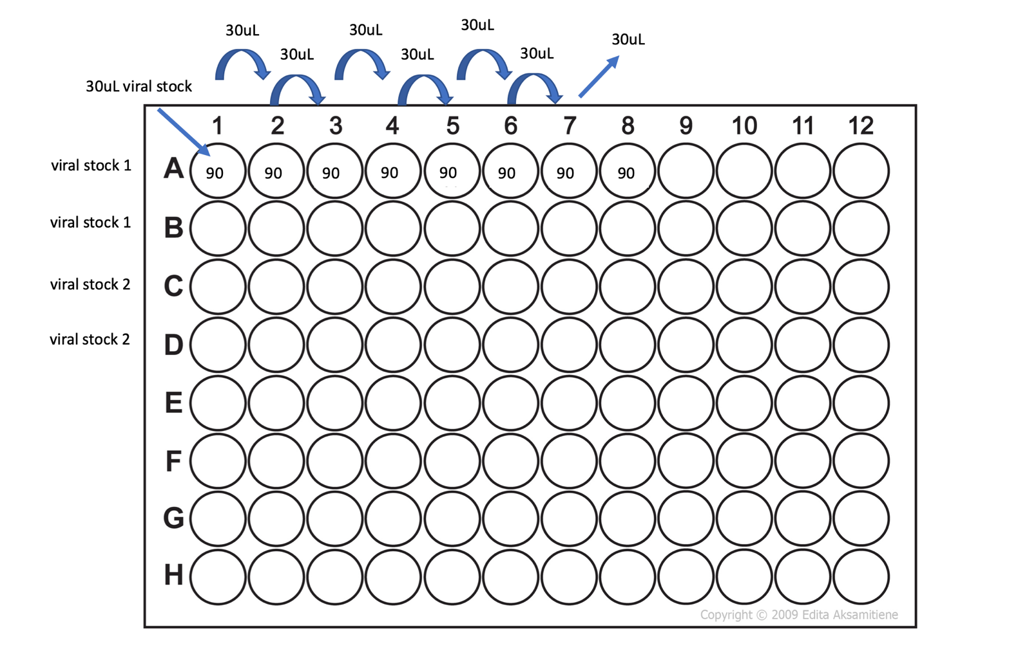

- Transfer viral dilutions to a 96 well flat bottom plate.
  - Transfer 30uL from each well using a multi-channel pipette. Can transfer multiple rows if replicates are desired.

- Resuspend Jurkat 76 cells in media with polybrene.
  - For each well, we want 100,000 cells per well, 120 uL of cell suspension per well, and 0.6 uL polybrene.
  - Here is an example of the math for the mastermix:
 | 1x | 8x (1 row)
Cells | 100,000 | 800,000
LCL media (to resuspend cells in) | 119.4uL | 955.2uL
Polybrene | 0.6uL | 4.8uL

- Plate 120 uL/well of cell mastermix (100,000 cells/well) on top of pre-plated diluted virus.

- Incubate at 37C, 5% CO2, etc. overnight.

Day 2-5:

- Add 50 uL LCL media daily x 3 days and split into other well if necessary.

- Evaluate transduction by flow at 72h or 4 days (e.g., for RQR8 tag or GFP expression).

Day 4 or 5: Tetramer Staining

Step 1: Tetramer stain
- Plate cells (5,000 – 1M/well) in 96 well v-bottom plate
- Spin down at 400g for 1-5min
- Carefully remove supernatant. You want cells as dry as possible!
- Spin tetramer at 12000g for 2min at 4o before using
- Add tetramer mix (depends on dilution)
  - Tetramer: 2.5 uL
MACS/PBS + 5% FBS: 22.5 uL
- Gently resuspend cells in mix by pipetting (25 uL mix per well)
- Incubate 15 min at RT in the dark
Step 2: Antibody stain
- Make antibody mix
  - Use titrations for 50uL staining volume
    - CD34 AF700 (for RQR8 staining): 5 uL
    - CD3 FITC: 5uL
  - Add MACS buffer to 25uL total, rather than 50uL
    - 15 or 20uL
- Add 25 uL antibody mix to each well, pipette gently
- Incubate 10-15min in the dark, on ice (not at 4o)
- Wash in 150 uL cold MACS/PBS +5% FBS
- Spin at 400g for 1-5 min
- Remove wash
- Wash with 200 uL cold MACS/PBS +5% FBS, spin again
- Resuspend in 100+uL DAPI (1:12k)
- Transfer to tubes and run
  - Keep on ice

- Flow analysis:
  - RQR8 staining is the standard for virus titration evaluation (other stains are helpful to gain understanding, but will not be factored into the math)
  - You are looking for condition with ~10% transduced (well above background but not a huge amount).
  - ~10% transduction indicates 10,000 cells transduced so 10,000 infectious doses (=particles).
  - TU/mL = (Number of cells transduced x Percent fluorescent x Dilution Factor) / (Transduction Volume in mL)

- Then infect T cells with MOI 2, 5, 10 to understand correlation between Jurkat 76 and primary T cells.
  - MOI = multiplicity of infection

- Virus volume = (Number of cells transduced x MOI) / (TU/mL)

TCR transduction

T cell isolation and stimulation

- Make CTL media (10% HS) fresh for the experiment.

- Isolate T cells from healthy donor apheresis PBMC according to kit protocol using Miltenyi CD8 and/or CD4 isolation kit and AutoMACS depleteS protocol (can also use deplete for this purpose).
  - Donor ID:
  - Deviation from standard kit protocols?
  - Starting number of PBMC:
  - CD8+ T cell yield:

- Count and re-suspend at 1M/ml=______M in ______mL CTL media

- Add CD28 beads 1:1 in CTL + 50 U/mL IL-2: Calculate volume of beads: Stock is 1x10e8 /mL, = 10μL beads/1M cells.

- Plate 2 mL/well in a 24 well plate (two wells for each TCR plus at least 1 control well).

- Incubate overnight (18-24 hrs) at 37C. Start of incubation = ___

T cell transduction with concentrated virus

Day 1: Transduction (using concentrated virus. For fresh virus, see Appendix.)

- Remove 1mL of CTL media from each well.

- Calculate volume of CTL media needed (1 mL/well x # wells). Make calculated volume of CTL media with 50 units/mL IL-2 plus 2x of Polybrene = 8µg/mL (will result in 4ug/mL once added on top of old media that does not contain polybrene). Polybrene stock is at 1µg/μL

- For control wells only, add 1 mL CTL + polybrene + IL-2 to each well.

- Inoculate cells in sample wells:
  - Calculate volume of virus needed based on MOI or on experience (e.g., using concentrated virus production method above, 25 μL is appropriate to start).
  - Put vial in water bath for ~10mins, vigorously vortex to break up the virus clump, spin down briefly.
  - Dilute virus in CTL + polybrene + IL-2 from step 2aiii. and mix well by pipetting.
(E.g., for 2 wells and using standard concentrated virus production without MOI, add 50 μL virus to 2 mL CTL + polybrene + IL-2)
  - Add appropriate volume of CTL + virus to each well of T cells (1 mL + volume of virus).

- Re-suspend cells in wells to mix all reagents.

- Spinoculation: 2000rpm (RCF 845xg), 32C, 90 min.
  - Spininoculation is optional if using concentrated virus produced by method described above.
  - If you are spinoculating, make sure to ask other lab members about using the centrifuge for so long, and be sure to allow enough time for it to come to temp.

- Incubate the plate at 37C overnight. Incubation started at: _________

Day 2: Add Fresh Media

      - Add media and cytokines to each well at exactly 24 hours:
        - Make mastermix of CTL media + 50 U/ml IL-2 (1:1000 dilution from our 50U/μl stock solution)
        - Add 1 mL CTL media + IL-2 to each well

      - Return to incubator.
Day 3 & 4: Partial change media

      - Remove 1.5 ml of used media from each well.

      - Replace with fresh media and cytokines:
        - Make mastermix of CTL media + 50 U/ml IL-2 (1:1000 dilution from our 50U/μl stock solution)
        - Add 2 mL CTL media + IL-2 to each well

      - Return to incubator.

Evaluation of transduction efficiency and flow sorting

Day 5: Flow evaluation for TCR expression

      - Stain with peptide-MHC tetramer(s) and/or CD34 (QBend mAb) (if RQR8 tag included), CD8, +/-CD4, viability dye.

      - Note % transduced (tetramer and/or RQR8 positive) to plan sorting: ___
Day 6 or 7: Sorting

      - Harvest, pool, and count T cells from same donor transduced with same TCR.
        - Count: _______

      - Spin down and resuspend to max 5e6 cells per 100 μL and divide in 100 μL aliquots in sterile v-bottom 96 well plate.

      - Stain as above only use 2x tetramer and 2x antibody and stain in 100 μL.

      - Sort tetramer+ cells (any sorter is appropriate). If the epitope specificity of the TCR is unknown, can sort for specific Vbeta (Beckman Coulter BetaMark IOTest kit) and/or CD34 if an RQR8 tag was included in the TCR construct. Sorting on a direct marker of TCR expression (i.e., tetramer or Vbeta) as well as transgene marker (i.e., RQR8) is highly recommended as TCR and marker expression are not always 1:1.

      - After sorting, check purity of your sorted samples as follows: Using a sterile dropper (can be found in the flow core supplies), take a small amount of each of your sorted cells from the collection tube. Transfer into a new flow tube. Add a few drops of PBS to bring up the volume if needed. Run through the sorter and record at least 5,000 events. Repeat for each of your sorted samples.

      - Save sort data and export PDF from sort as well as recording data into FCS file.

      - REP at least 50,000 cells (can count or approximate cell number by using # events collected x2).
        - # events collected = _______

      - Any remaining cells not put into REPs should go into CTL with IL-2 for use in functional assays. If >1e6 cells have been sorted, can also freeze down sorted cells directly for later REP.

Appendix

TCR cloning by RACE-PCR

This process can be used if Adaptive sequencing does not resolve your TCR down to the needed specificity.

RNA extraction

- Spray gloves with RNase away. Clean hood surface, racks, tip boxes, pipets, centrifuge etc. with RNase away.

- Thaw 5-10 M cells and wash in 1 x PBS

- Working quickly, follow instructions for RNaeasy Qiagen kit (summarized below, be sure to double check kit instructions).
- Add 600 μl Buffer RLT (with BME)
- Pipet up and down to mix and transfer lysate into QIAshredder spin column in a 2mL collection tube. Spin 2 mins at max speed.
- Add one volume 70% ethanol and mix by pipetting.
- Transfer 600 μl of lysate to an RNeasy spin column and spin 15 s. Discard flow through and repeat with remaining lysate.
- Add 700 μl buffer RW1 to column and spin 15 s. Discard flow through.
- Add 500 μl buffer RPE (with ethanol added) to column and spin 2 min. Discard flow through. Spin additional 1 min.

- Place column in clean eppendorf tube. Add 30 μl RNAse free water to membrane. Spin 1 min. Repeat with additional 30 μl water.

- Immediately transfer eluate to dry ice, then -80°C.

cDNA preparation

Note: You will likely need to order a new kit, as we do not use this protocol often and it is unlikely we will have a fresh kit. Order from Takara, catalog #634858 for 10 rxns or #634859 for 20 rxns. Kits have multiple components, some of which are stored at -20 and some at -80.

- Thaw RNA at R.T. Once thawed, keep on ice.

- Measure RNA concentration using nanodrop. An SOP for using the Nanodrop follows this protocol.

- Proceed with SMARTer RACE cDNA Amplification kit using 10ng – 1μg of RNA.

- Prepare sufficient Buffer Mix for all reactions, then set aside at room temperature until preparation of RT master mix (step 6):
Buffer mix | 1X (μL) |  | X
5X 1st strand buffer | 4
DTT (20 mM) | 0.5
dNTP mix (10 mM) | 1
Total | 5.5

- Prepare RNA + primer in a separate tube to denature RNA
  - 1-10 μl RNA (10-1000 ng)
  - 1 μl 5’ CDS Primer A
  - *For control reaction, use 1μl of Control Mouse Heart Total RNA (1μg/μl)
  - Add sterile H2O to bring to a final volume of 11 μl.
  - Mix and spin briefly
  - Incubate tube(s) at 72°C for 3’ in heated-lid thermal cycler.
  - Cool to 42°C for 2’ in heated-lid thermal cycler.
  - Spin 10” to collect condensation.
  - Add 1 μl of SMARTer IIA oligo to each tube of 5' RACE cDNA reactions

- Prepare RT master mix:
RT MM | 1X (μL) |  | X
Buffer mix | 5.5
RNase inhibitor (40 U/μL) | 0.5
SMARTScribe RT (100 U) | 2
Total | 8

- Add RT master mix (8 μl from step 6) to denatured RNA (11 μl from step 5).

- Mix by pipetting gently. Spin 5 seconds.

- Incubate at 42°C for 90’ in incubator or heated-lid thermal cycler.

- Heat tubes at 70°C for 10 mins in heated-lid thermal cycler.

- Dilute the first-strand reaction product with 20 μl Tricine-EDTA buffer.
  - Add 10 μL If you started with <200 ng total RNA
  - Add 90 μL If you started with >200 ng total RNA

Amplify the full TCR region for sequencing

Continue with the SMARTer RACE cDNA Amplification kit through the 5’ RACE reaction.

- Set up 2 sets of reactions; one for alpha chains and one for beta chains. The constant region primers are designed for regions that are shared across the all the possible C genes.
  - Primer RACE alpha1: GGTGAATAGGCAGACAGACTT
  - Primer RACE beta1: GTGGCCAGGCACACCAGTGT

- Prepare PCR master mix for 5’ RACE PCR
RACE-PCR MM | 1X (μL) | 11 | X
PCR grade H2O | 29.5 | 324.5
5X Phusion PCR buffer | 10 | 110
dNTP mix (10 mM) | 1 | 11
Phusion HiFi polymerase | 1 | 11
Total | 41.5 | 456.5

- To a 0.2 ml PCR tube, add the following reagents, in order, according to tables* below:
  - 2.5 μl cDNA from step 11 above.
  - 5 μl of 10X UPM (universal primer mix)
  - 1 μl primer (10 μM)
  - 41.5 μl of PCR master mix from step 2.

Table 1. For TCRs
For 1 TCR | 1 | 2 | 3 | 4 | 5
 | TCR-X | TCR-X | TCR-X | TCR-X | TXCR-X
 | alpha | beta | -ctrl | -ctrl | -ctrl
5’ cDNA | 2.5μl | 2.5μl | 2.5μl | 2.5μl | 2.5μl
10X UPM | 5μl | 5μl | - | - | 5μl
Alpha-primer | 1μl | - | 1μl | - | -
Beta Primer | - | 1μl | - | 1μl | -
H2O | - | - | 5μl | 5μl | 1μl
Master Mix | 41.5μl | 41.5μl | 41.5μl | 41.5μl | 41.5μl
Total | 50μl | 50μl | 50μl | 50μl | 50μl

Table 2. | Additional | controls
Controls | 1 | 2 | 3
 | + Control | - Control | - Control
5’ cDNA | 2.5μl | 2.5μl | 2.5μl
10X UPM | 5μl | - | 5μl
TFR | 1μl | 1μl | -
H2O | - | 5μl | 1μl
MM | 41.5μl | 41.5μl | 41.5μl
Total | 50μl | 50μl | 50μl

*performing all controls uses up a lot of reagents (i.e. one kit’s worth for one sample!), so suggest running only conditions 1, 2, and 5 in Table 1 and skipping all controls in Table 2 unless you have problems.

- Run PCR program**:
Temp | Time | Cycles
94C | 30s | 5
72C | 3 min
94C | 30s | 5
70C | 30s
72C | 3 min
94C | 30s | 25
68C | 30s
72C | 3 min

**Consider using touchdown PCR as in Riddell lab protocol if this doesn’t work. Touchdown PCR is programmed into the shared BioRad thermal cycler. Need more details.

Other troubleshooting advice: Check to make sure that master mixes and recipes are correct for the version of the 5’/3’ SMARTer RACE kit and other reagents you are using—they may change.
Alternative Riddell lab protocol can be found in the Appendix.

Nucleic acid quantification using Nanodrop Thermo Fisher 2000/2000c Spectrophotometer:
  - Sign in on the computer attached to the Spectrophotometer.
  - Wash the Spectrophotometer pedestal adding 2 μL of dwater to the lower pedestal and then lower the arm. Wait 30-60 seconds and lift the upper arm and use a wipe to vigorously scrub both the upper and lower pedestals.
  - Click on the Nanodrop icon to open the Spectrophotometer software.
  - Select the Nucleic acid bottom for DNA or RNA quantification.
  - Blank the Spectrophotometer adding 2 μL of the buffer that you used to resuspend your sample (TE, EB, dH2O). Lower the upper arm of the NanoDrop and click the “Blank” bottom on the software. Wait ~ 20 seconds for the blank measurement to be made. When is done, lift the upper arm and dry the pedestal with a wipe.
  - Measure your sample adding 2 μL of your sample to the lower pedestal, then lower the arm. Click the “measure” bottom on the software and wait ~ 20 seconds for the measurement. When is done, lift the upper arm and dry the pedestal.
  - Clean the pedestal adding 2 μL of purified water to the lower pedestal ad then lower the arm. Wait 30-60 seconds and lift the upper arm and use a wipe to vigorously scrub both the upper and lower pedestals.
  - Analyze results: purity ratios are important indicators of sample quality:
    - 260/280 Ratio: A 260/280 ration of ~ 1.8 is generally accepted as “pure” DNA.
    - 260/230 Ratio: The 260/230 values for a “pure” nucleic acid are often in the range of 1.8 – 2.2.
IMPORTANT: If the ratio is appreciably different than the accepted target described above, it may indicate the presence of protein, phenol or other contaminants that absorb strongly at or near 260 nm.

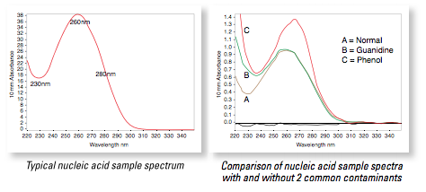

Topo cloning and sequencing RACE-PCR products

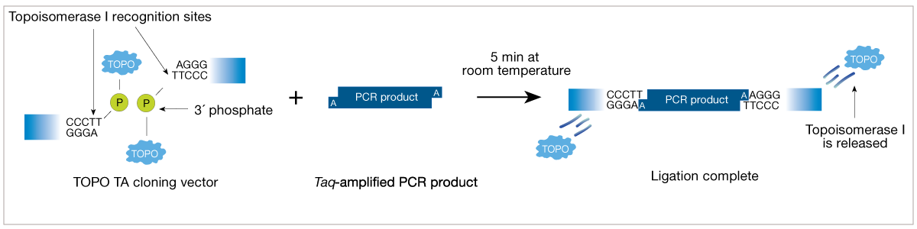
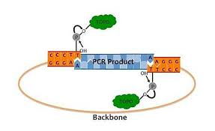

- Run the cDNA PCR products on a 1% gel.

- Cut out and purify the DNA using the Qiagen gel extraction and purification kit. Briefly:
  - Weigh gel fragments in eppendorf tubes
  - Add 3x volume of Buffer 1 (where 1x volume corresponds to the weight of the gel fragment).
  - Dissolve gel piece by shaking at 42°C for 3-5 min.
  - Add 1 x volume 2-propanol
  - Load on column, spin briefly (Load & spin multiple times as needed to load all of sample). Discard flow-through.
  - Wash column with 750 μL wash buffer. Discard flow through
  - Transfer column to new eppendorf tube and elute DNA in 20 μL nuclease free H2O by adding water directly to the filter, spin 1 min. at 14000 rpm

- Clone PCR fragment into Topo vector (if desired).

- Set up Big Dye sequencing mix: Use ¼ reaction recipe from FH Genomics Core sequencing instructions:
RACE-PCR Seqencing | 1X |  | X
Big Dye reaction mix | 2 μl
Primer** | 3-5 pmol (μl:____)
DNA template | 2-20 ng (μl:____)
DMSO | 0.5 μl
Water
Total | 10
**Seq primer: linker region primer from RACE cDNA kit)

- Submit samples for sequencing.

Riddell lab 5’/3’ SMARTer RACE protocol

Can use this as an alternative to Bleakley lab protocol if having problems. Main differences are:
- Enzymes (CloneAmp HiFi vs Phusion HiFi)
- TCR constant region primers
- Touchdown PCR rather than standard PCR is used in the RACE reaction (see below)

PCR Enzyme: CloneAmp HiFi PCR Premix (Clontech, cat# 639298)
RACE-PCR Primer List:
- Human TCR Cbeta1 Reverse Primer (hTCR Cb1 R)
5’-CCACTTCCAGGGCTGCCTTCAGAAATC-3'
- Human TCR Cbeta2 Reverse Primer (hTCR Cb2 R)
5’-TGGGATGGTTTTGGAGCTAGCCTCTGG-3’
- Human TCR Calpha Reverse Primer (RACE_hTCR_Calpha R)
5’-CAGCCGCAGCGTCATGAGCAGATTA-3’
- 10X Directional Universal Primer A Mix (dir UPM)

Long (0.4 µM)
5’-CACCTAATACGACTCACTATAGGGCAAGCAGTGGTATCAACGCAGAGT-3'

Short (2 µM)
5’-CACCTAATACGACTCACTATAGGGC-3’

Making 10 x UPM Primer Stock:
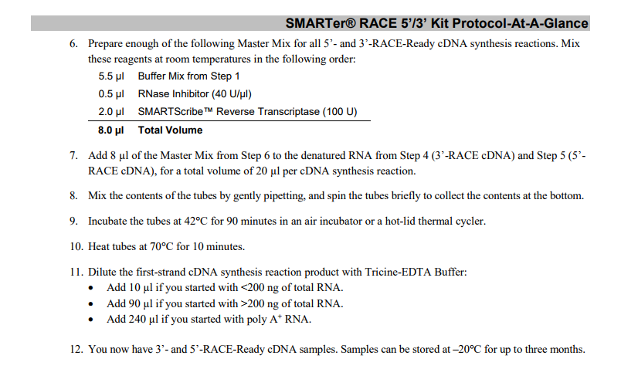
Mix 2 µl of Long primer stock (100 uM) + 10 µl of Short primer stock (100 uM) and then add 488 µl ddH₂O to make 500 µl 10 x UPM stock.
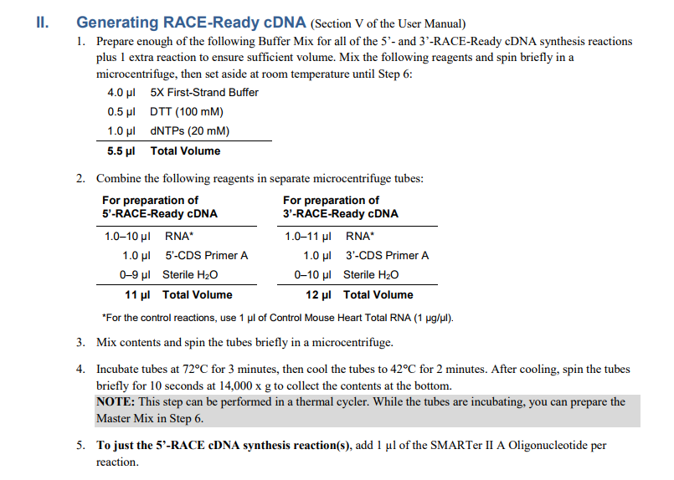

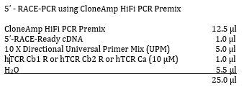
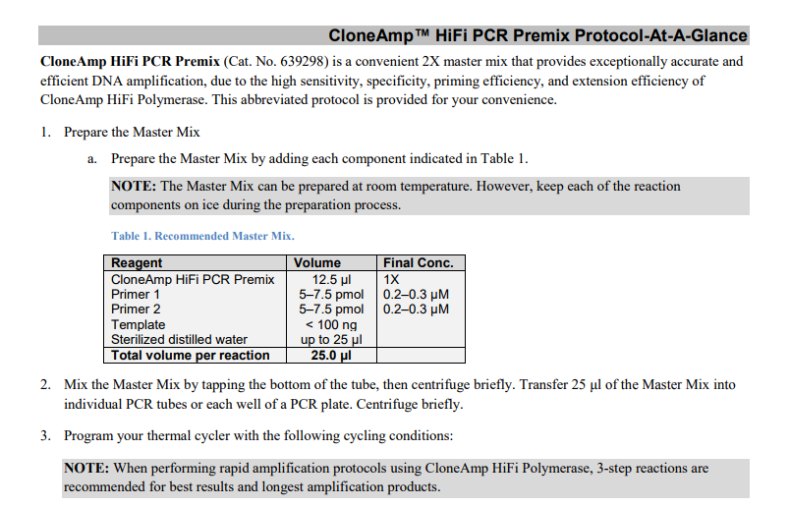
PCR works best annealing at 60C and doing a touchdown by .2C for 35 cycles. Run PCR rxn on EtBr gel and expect 1kb bands. Gel Purify fragments for pENTR Directional TOPO cloning.

Determining TCR sequences from RACE-PCR products

- Open .ab1 files from sequencing.

- Copy the central portion of the sequence with minimal “N”s.

- Open IMGT vquest human TR nucleotide set, linked here: http://www.imgt.org/IMGT_vquest/input

- Paste the sequence into the search box on IMGT.

- Insert “>” and a title as the first line to make it FASTA format, then click “start” to see results. It should return an alpha or beta gene that matches your sequence.

We typically obtain our TCR constructs as GeneArt (synthetic DNA block) from Invitrogen/ThermoFisher. This allows for codon optimization and engineering in specific restriction enzyme cut sites.


The only disadvantages to using GeneArt are 1) cost and 2) potential for point mutation to occur in the gene synthesis process (although GeneArt is a very reliable platform and PCR cloning can also introduce mutations). If you are cloning your TCR from cDNA (i.e., not having it synthesized as GeneArt), see “Amplifying TCR alpha and beta chains” in Appendix. Otherwise, skip to “Assembling TCR consensus sequences” in the main protocol.

Amplify alpha and beta genes

NB: this step is NOT needed if you are purchasing your TCR as GeneArt!

Once we know the TCR sequence, we can clone the TCR genes into a vector plasmid and amplify the plasmid in E. coli. We can do this by designing primers that will incorporate a restriction site at each end of the TCR chains. Be sure that the restriction sites used are not present within the gene.

Primer design
Forward primer: Va and Vb genes:
i. Go to NCBI, nucleotide, search “Homo sapiens T cell receptor beta locus (TRB@) on chromosome 7”.
ii. Control F, search on your vb gene eg: ‘Trbv6-2’
iii. Click on ‘CDS’ then when it says “warning: cannot highlight feature because no sequence is shown,” click ‘show the sequence’
iv. Find the first 20 nucleotides. Copy and paste into a word document.
v. Add the nucleotides for the restriction enzyme. Use cloning software to check that the enzyme will not cut within the sequence.
vi. Add an extra C/G as needed to get a Kozak sequence (GCCGCCACCAUGG)
vii. Add an extra 3 bp so the enzyme isn’t cutting at the very end, eg ACT

a. Full primer sequence using NotI enzyme will be:
ACT GCGGCCGC C NNNNNNNNNNNNNNNNNNNN

Example:

f_va23_NotI
ACTGCGGCCGCCatggagaccctcttgggcctgctt

f vb6 NotI
ACTGCGGCCGCCATGGGCACCAGCCTCCTCTGCT

Reverse primers:
1. For beta chains, determine the constant gene used:
i. Use NCBI again and look up TRAC, TRBC1 and TRBC2 separately
a. Align the TCRb sequencing results with Cb1 and Cb2 sequences from NCBI to determine which gene is used by the TCR.
iii. For primers, find the last 20 bp of last exon of the constant gene used. (Should end in TAG, TGA, TAA)
TRBC1 gtc aag aga aag gat ttc tga
TRBC2 aga aag gat tcc aga ggc tag
iv. Add the restriction site eg EcoRI: 5'...G^A A T T C...3’
v. Add a random 3 base sequence

No Kozak sequence required. Use reverse complement since this is the reverse primer:
Example:

r_bC1 EcoRI
AGCTTGGAATTCTCAGAAATCCTTTCTCTTGACC

r _aC EcoRI
AGCTTGGAATTCTCAGCTGGACCACAGCCGCAGC

vi. Using the full length cDNA product as template, set up a reaction using the linker region primer for the known Vb chain along with a primer for the appropriate constant region.

Reaction:
10 μL 5x Buffer
1 μL dNTP
0.5 μL Primer 1
0.5 μL Primer 2
2.5 μL cDNA
0.5 μL Phusion Hi Fidelity polymerase
35 μL H2O

Run pcr:
98°C 1:00
98°C 0:10
62°C 0:10
72°C 0:10
(38 cycles)
72°C 0:10

Production of fresh TCR virus
If using fresh viral supernatant:

PM: Preparation of 293T Lenti-X Cells, Round 1
Day -12 to -10 -> Thaw 293 cells 5M in T75 with 15ml cDMEM.
- Will need 1M per well X 2well/construct (add excess)

DAY -5:
- split 293T cells
- MaxiPREP plasmids for lentivirus production.

Day -2 (preparation of transfection)
Transfer 9x10^5 293T cells in 3mL cDMEM medium into a well of 6 wells culture plate to yield 60-70% confluence for transfection the next day. Prepare X plates

Day -1 (transfection, using ClonTech CalPhos transfection kit Cat# 631312)

1. Add transfection mix in 15 mL conical tube in this following order: water, DNA, 2MCaCl₂ solution.
Amount per reaction:
Vector DNA 7μg
PAX2 6μg
VSV-G 5μg
Total 18 μg
Water 150μL (total)
CaCl₂ solution 18.3μL (250mM final concentration)
DNA | Per 10 samples + 10% | Per 1 samples + 10% | Per 1 samples + 10%
PAX2  (gag+ polymerase)  6μg | 7.37μl x 11=  81.07μl | 5.1μl x 2=  10.2μl | 9.1μl x 2=  18.2μl
VSVg  (envelope)  5μg | 7.7μl x 11=  84.7μl | 4.2μl x 2=  8.4μl | 3.3μl x 2=  6.6.4μl
H20 = 100 | 84.93μl x 11=  934.23μl | 90.7μl x 2=  181.25μl | 87.6μl x 2=  175.2μl

2.Thaw 2xHBS from -20°C. Once thawed, 2xHBS can be stored in 4°C for another use within a week.

3. While vortexing water, DNA, and CaCl₂ solution mix, slowly and drop-wise add 150μL (300μl for plates 1 and 2) of 2xHBS. Keep vortexing for another ~5 secs.

4. Incubate 300μL (600μl) mixture at room temperature for 15 mins.

5. Add 300μL (600μl) of DNA suspension to each well in a slow drop-wise manner (use p200 pipetor; multiple spots on each well). Swirl the plate gently to distribute the DNA mixture evenly. Incubate in 37°C overnight. 10-12 hours

Day 0- (Medium exchange)
After incubation, aspirate all cDMEM medium from each well, replace it with 3mL of CTL medium.

Day 1- (Transduction)
1. Harvest supernatant: filter sup by using 0.45um filter
Fit the filter tip with 10mL pipet tip, collect the filtrate in 15 mL conical tube

Day 1: Transduction using fresh viral supernatant

- Remove 1mL of CTL media from each well.

- Add polybrene to 8 μg/mL f.c. into each well (stock at 1 μg/μl polybrene) and IL-2 to 100 units/mL into each well (will add back 1 mL media to controls or 1 mL viral sup to samples so f.c. will be 4 μg/mL for polybrene and 50 units/mL for IL-2)

- Add 1 mL filtered (0.45 um filter) viral supernatant to each well of T cells.

- Re-suspend cells in wells to mix all reagents.

- Spinoculation: 2000rpm (RCF 845xg), 32C, 90 min.
  - Spininoculation is optional if using concentrated virus produced by method described above.

- Incubate the plate at 37C overnight. Incubation started at: _________

- Perform media changes as described for concentrated virus protocol.

