COURSEWORK 3

PROPOSAL

SINGLE PAGE WEB APPLICATION

ADORA NAOMI FERNANDES

M00793012

CST2120- WEB APPLICATIONS AND DATABASES

**Contents**

**BOOK BARN** 3

**FUNCTIONALITY** 3

Registration 3

Login 3

Genre Categories 4

Top 4 Books 4

Top 4 Authors 4

Book Recommendations 4

Book Review Writing 4

Likes 5

User Profile 5

Search Functionality 5

**WIREFRAMES/WEBSITE DESIGN** 5

Single page web application wireframe 6

Zoomed in Registration wireframe 7

Zoomed in Login wireframe 7

Zoomed in Account Section wireframe 8

Zoomed in Add Book Review Section wireframe 8

Zoomed in Selected Genre Section wireframe 9

Zoomed in Searched Results Section wireframe 9

Zoomed in User Recommendations Section wireframe 10

**DATABASE DESIGN** 10

# **BOOK BARN**

BOOK BARN is a forum platform for avid book readers, where they come together to share reviews and opinions on their favorite books. This single-page web application is for book enthusiasts and newbies who need recommendations for their first-time read. There will be many features on this website ranging from sending likes to books to writing reviews on any books from any genre.

This website only requires One HTML page, where we’ll be using JavaScript to change the page’s contents.

# **FUNCTIONALITY**

In this single-page website, there will be multiple functionalities. And to fulfill these functionalities, I’ll be using JavaScript/NodeJS, MySql, and many more.

## Registration

The user must first create an account to log in to the website. The registration form will only ask for the user’s email id, name, date of birth, and password. JavaScript will do validation. These details are then saved in the MySql database.

## Login

To access most website features, the user has to log in and have an account. The login form will only ask for the user’s email id and password. JavaScript will do validation. These details are then checked from the MySql database if the user exists or not.

## Genre Categories

Main genres and sub-genres will arrange the books. There will be a list of genres in the web application, where on selecting one type of genre example: Thriller, books with that genre will show up like “Gone Girl.” “Silent Patient,” etc.

## Top 4 Books

Based on the number of likes, the books which get the highest likes will be displayed in the top 4 books displayed in the web application.

## Top 4 Authors

Based on the number of likes, the books which get the highest like, in those books, the authors with the highest number of the like count will be displayed in the top 4 authors expressed in the web application.

## Book Recommendations

Based on the user’s likes or previously read book reviews, a list of top three recommended books will be displayed.

## Book Review Writing

The logged-in user can provide their views or feedback on any book they wish to by entering the book title, author, genre, and a brief 100 words of their thoughts on the book. The user cannot write on a book where the review already exists.

## Likes

The logged-in user can give their likes for a book. Using these likes we can do various other functionalities.

## User Profile

The user can add a profile picture and can edit their profile details. They can see their previous reviews also.

## Search Functionality

The user can search for any book they wish to check using the search bar. And after clicking the search button, the website will display results according to the searched word.

# **WIREFRAMES/WEBSITE DESIGN**

Below are the intended designs for the websites using wireframes.

There are over eight wireframes for the single-page website:

1. Whole single-page wireframe. (Fig 1)
2. Zoomed in wireframe of registration (Fig 2)
3. Zoomed in wireframe of login (Fig 3)
4. Zoomed in wireframe of user information and previous reviews (Fig 4)
5. Zoomed in wireframe of adding book review. (Fig 5)
6. Zoomed in wireframe of genre category books display (Fig 6)
7. Zoomed in wireframe of search results display (Fig 7)
8. Zoomed in wireframe of Recommended books for the logged-in user (Fig 8)

## Single page web application wireframe

Fig 1: Wireframe for the whole single page web application

In this wireframe, we can see that all the functionalities and features displayed the single-page application.

## Zoomed in Registration wireframe

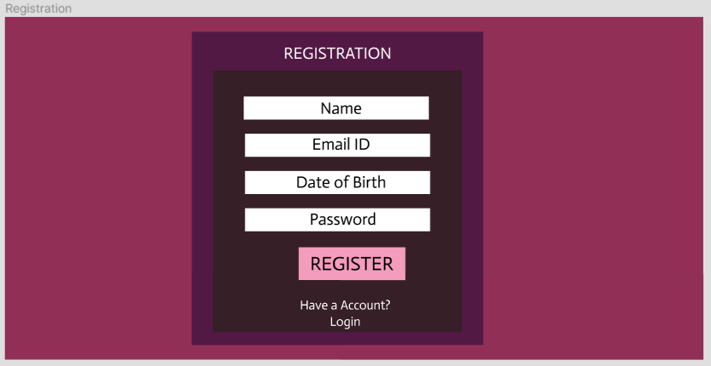

Fig 2: Wireframe for the Registration Section of the web application

## Zoomed in Login wireframe

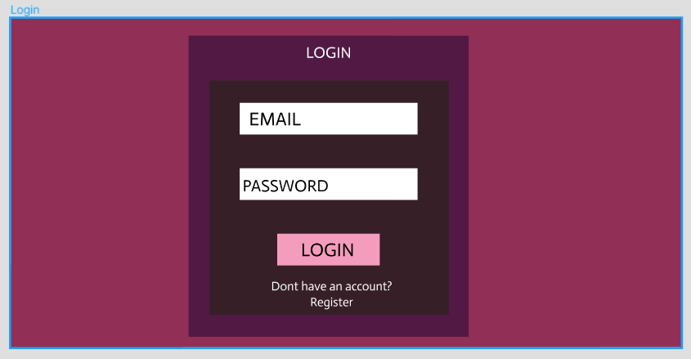

Fig 3: Wireframe for the Login section of the web application

## Zoomed in Account Section wireframe

Fig 4: Wireframe for the Account Section in the web application

## Zoomed in Add Book Review Section wireframe

Fig 5: Wireframe for the Add Review Section in the web application

## Zoomed in Selected Genre Section wireframe

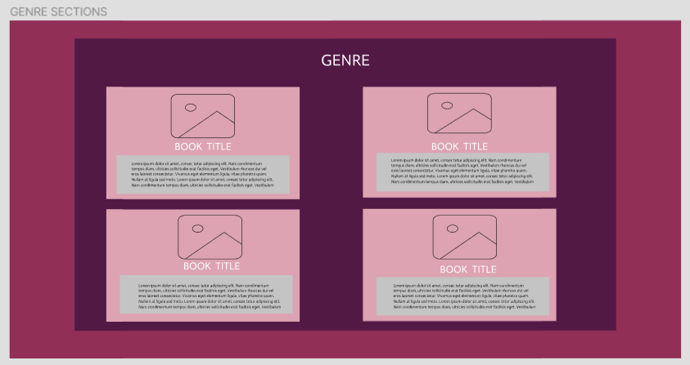

Fig 6: Wireframe for the Selected Genre Section in the web application

## Zoomed in Searched Results Section wireframe

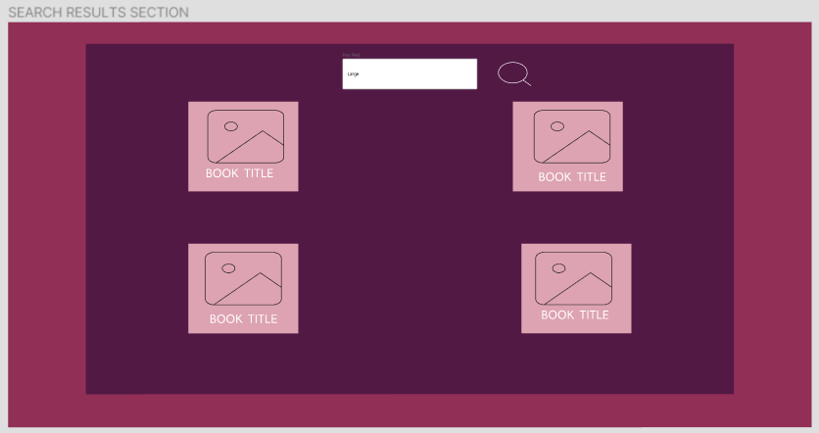

Fig 7: Wireframe for the Searched Results Section in the web application

## Zoomed in User Recommendations Section wireframe

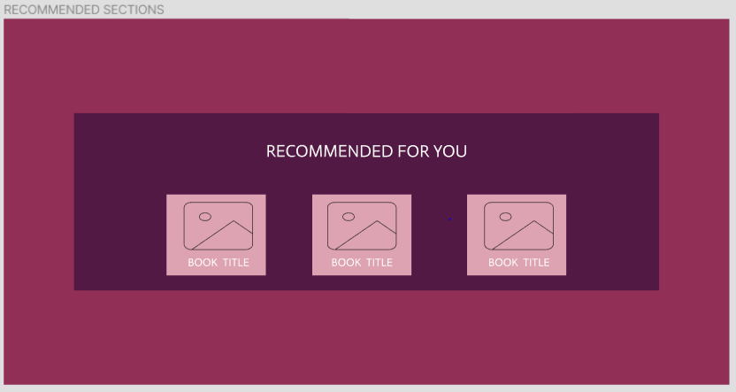

Fig 8: Wireframe for the User Recommendations Section in the web application

# **DATABASE DESIGN**

The data from this web application will be stored in MySQL. In the Book barn database, there are over six tables:

* Books
* Authors
* Genres
* Users
* Reviews
* Likes

The database design can be seen in the following diagram:

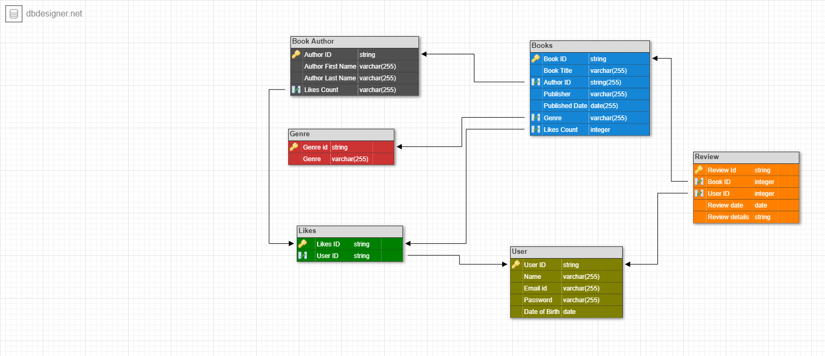 Fig 9: Database Design for the web application