E-Commerce Sales Data Report

Part 1: Cleaning the Data
Before we could study anything, we had to make sure the data was correct and neat. Imagine getting a homework sheet where some answers are smudged, some numbers are written as words, and some boxes are just empty. You'd want to fix that before grading it, right? That's what cleaning data means.
Here is what we fixed:
- Numbers that were saved as text got changed into real numbers (so a computer can add and compare them).
- Extra empty spaces around words were removed.
- Dates were changed into one standard format, like 2021-01-01.
- Zip codes kept their zeros at the front (like 04206), so they didn't get cut off.
We also double-checked the data using more than 30 tests. For example, we checked things like:
- Is every customer age a real number between 18 and 100?
- Does the math actually add up? (Selling Price − Discount + Tax + Shipping = Final Price)
- Does every country match its correct currency? (USA should use USD, not Euros!)
When something looked strange — like an order marked 'Completed' but the payment still says 'Pending' — we did NOT delete it. We just put a little flag/label on it so people know to look closer. It's like circling a weird answer instead of erasing it, because it might still be true!
Here's what we ended up with after cleaning:
What we measured | The number
Total orders | 138,116
Total money earned (net sales) | about $144.2 million
Average profit margin | 43.7%
Average order value | $1,269.79
Return rate | 6.9%
Cancel rate | 6.1%

A peek at the cleaned data
Here are 6 real (but random) orders from the cleaned file, just so you can see what it looks like:
Order ID | Country | Channel | Qty | Money Made (Net Sales) | Status
ORD-769762 | USA | Social Media | 3 | $312.99 | Completed
ORD-496041 | Canada | Website | 4 | $1,606.93 | Completed
ORD-315929 | UK | Website | 5 | $944.42 | Completed
ORD-248637 | India | Social Media | 8 | $1,115.31 | Completed
ORD-710051 | USA | Social Media | 8 | $1,769.97 | Completed
ORD-717702 | USA | Website | 1 | $533.77 | Pending

Part 2: Studying the Data (Analytics)
Once the data was clean, we could finally ask it questions and get true answers. This is called 'data analytics' — basically, it just means looking for patterns and interesting facts hiding inside the numbers.
Here's what we found out:
- The company made about $144.2 million from all these orders combined.
- On average, they keep 43.7 cents of profit for every $1 in final sales — that's a pretty healthy profit margin.
- The average order is worth $1,269.79 — that's a big purchase, not just a cheap little item!
- The Mobile App brings in more money than the Website. People really like shopping from their phones.
- 'Consumer' type customers (regular everyday shoppers) spend way more in total than Business, Premium, or VIP customers combined.
- Credit Card is the #1 way people pay.
- The most common reason people return items is 'Wrong Product' — meaning it often isn't even about quality, just a mix-up.
- Sales jump up a LOT every November and December — probably because of holiday shopping!
This step is important because it turns plain numbers into useful knowledge. Instead of just saying 'here is a spreadsheet,' we can now say 'hey, the Mobile App is doing great, and returns are mostly about wrong items, not broken ones.' That's something a manager can actually use to make decisions.

Part 3: Turning Data into Pictures (Visualization)
Numbers in a table are hard to understand at a quick glance. So the last step was building a dashboard — basically a screen full of charts and boxes that show the important numbers in a way your eyes can understand fast.
Below is the top part of our dashboard. It shows the main scoreboard numbers (like total sales and profit margin) plus some quick tables:
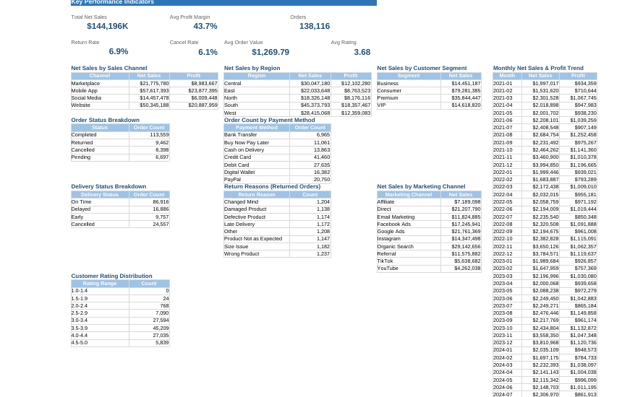
Figure 1: The dashboard's main numbers and breakdown tables
And here is the chart section of the dashboard. This turns all those numbers into bar charts, a pie chart, and a line chart, so patterns pop out immediately instead of needing to read hundreds of rows:
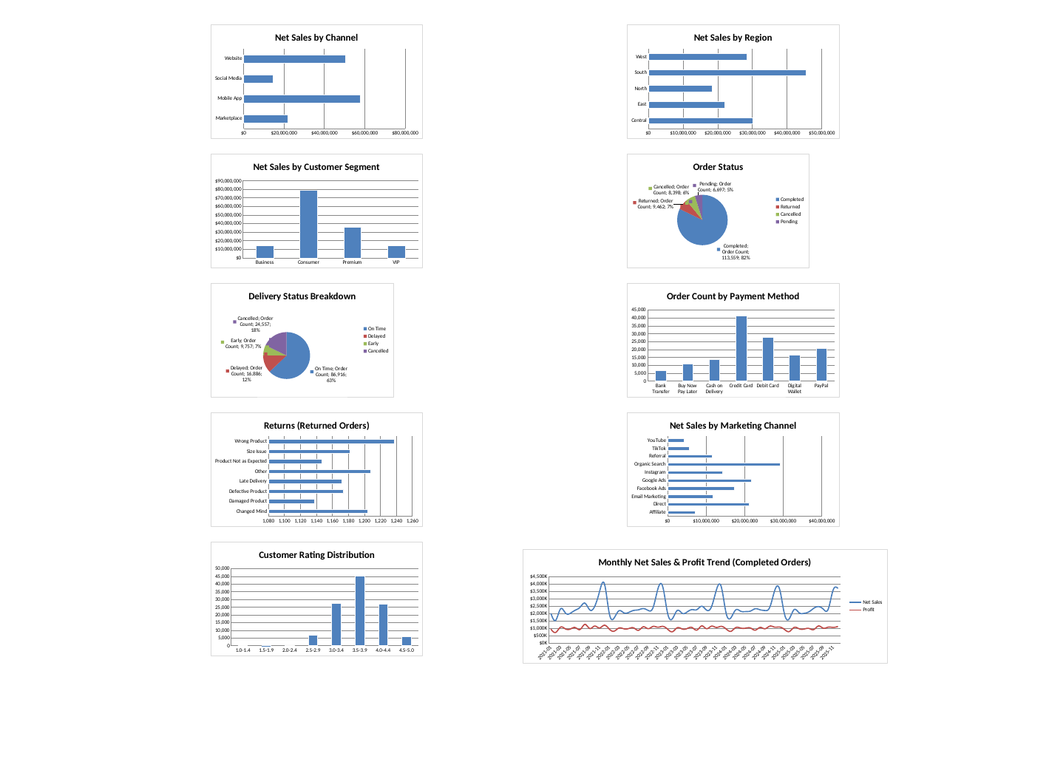
Figure 2: Charts showing sales by channel, region, payment method, and more
Notice how easy it is to see, just from the line chart, that sales spike every year around November and December? That's the whole point of visualization — it makes patterns obvious without needing to read every single number.

Customer Insights

1. Which segments order most frequently?
Consumer is by far the most active segment with 75,636 orders (~55% of all orders), followed by Premium (34,746), then VIP and Business roughly tied around 14,000 each.

2. Do repeat customers drive most revenue?
Yes, overwhelmingly — repeat/loyal customers account for 99.75% of total net sales (~$177M), while brand-new customers contribute less than $436K.

3. Which region/city has the highest order density?
At the region level, South leads with 43,990 orders, followed by Central and West. At the city level there's no real concentration. The dataset spans 15,516 unique (synthetically generated) cities, and even the busiest one has only 166 orders.

Wrapping It Up
So to sum up the whole journey:
- Step 1: We cleaned messy data so it was accurate and trustworthy.
- Step 2: We studied the clean data to find useful facts and patterns.
- Step 3: We turned those facts into charts so anyone can understand them in seconds.
This is basically how real companies handle their data every day — clean it, study it, and then show it off with pictures so everyone, even someone who has never opened a spreadsheet, can understand what's going on. Pretty cool, right?

