Academic Year 2025-26

Course - IT22 Full Stack Development

React JS – Hands on Assignment -1

- Create a Simple React App
Display “Hello, World!” inside an <h1> tag.

function App()
{
return (
<>
<h1>Hello World..!</h1>
</>
);
}
export default App;
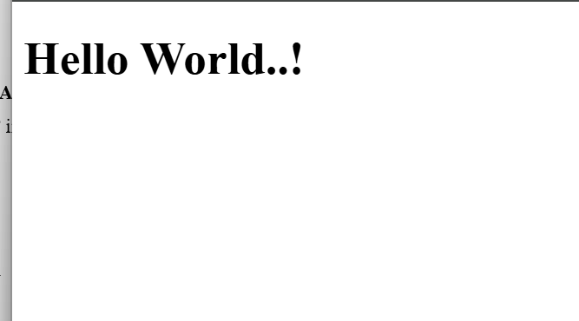
- Write JSX to Display a Paragraph
Inside a <div>, display a <p> tag with your name.
function App()
{
return (
<>
<h1>Hello World..!</h1>
<div>
<p>Hello My Name is Aditya</p>
</div>
</>
);
}
export default App;

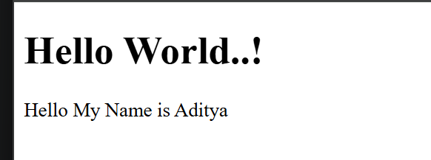

- Create a JSX expression that renders the current date and time dynamically.
function App()
{
let time=new Date().toLocaleTimeString();
let date=new Date().toLocaleDateString();
return (
<>
<h1>Time:{time}</h1>
<h1>Date:{date}</h1>
</>
);
}
export default App;
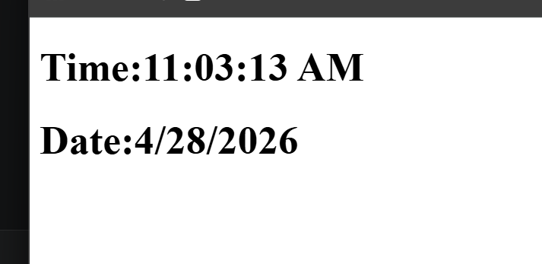
- Create a simple functional component that returns a heading <h2>
function Heading()
{
return <h2>This is a simple functional component</h2>;
}
export default Heading;

- Write a program to demonstration of nested functional component
function Child()
{
return "This is Child";
}
function parent()
{
return(

<>
<h1>This is Parent Component</h1>
<Child/>
</>

)
}
export default parent;
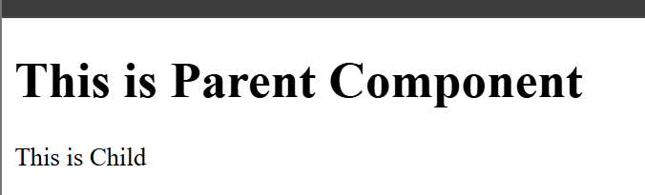
- Create a parent component that passes a name prop to a child component and displays it.
function Child(nm)
{
return <h1>My name is:{nm.name}</h1>
}
function parent()
{
return(

<>
<Child name="Aditya"/>
<Child name="Ram"/>
</>

);
}
export default parent;
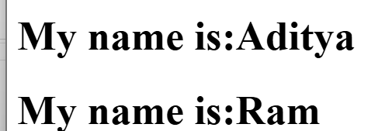
- Create an array of students which includes roll number, name and age pass it as a props to functional component and display all information.
function Child(nm) {
return (
<h1>
My name is: {nm.name} my roll no is: {nm.id} and age is: {nm.age}
</h1>
);
}

function Parent() {
let stud = [
{ id: 1, name: "Aditya", age: 31 },
{ id: 2, name: "Raj", age: 22 }
];

return (
<>
{stud.map((item) => {
return (
<Child
key={item.id}
id={item.id}
name={item.name}
age={item.age}
/>
);
})}
</>
);
}

export default Parent;
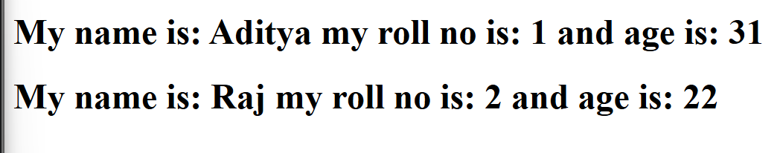

- Pass an array of colors (as props) to a child component and render them as <li> items.
function Child(props)
{
return (
<ul>
{props.clr.map(( item,idx)=>
(
<li key={idx}>{item}</li>
))}
</ul>
)
}
function Parent()
{
let colors=["red","Green","yellow"];
return (
<>
<h1>Color List</h1>
<Child clr={colors}></Child>
</>
)
}
export default Parent;
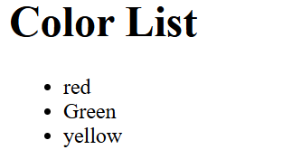
- Build a counter with two buttons (+ and -) to increment/decrement a state variable.
import {useState } from "react";
function Counter()
{
let[count,setCount]=useState(1);
function inc()
{
setCount(count+1)
}
function dec()
{
setCount(count-1)
}
return(
<>
<h1>Counter:{count}</h1>
<button onClick={inc}>+</button>
<button onClick={dec}>-</button></>
);
}
export default Counter;
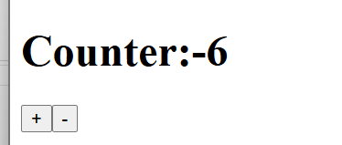
- Create an input field that logs its value to the console on every keystroke (use onChange).
function Input()
{
function display(data)
{
console.log(data.target.value)
}
return(
<>
<input type="text" onChange={display} />

</>
);
}
export default Input;

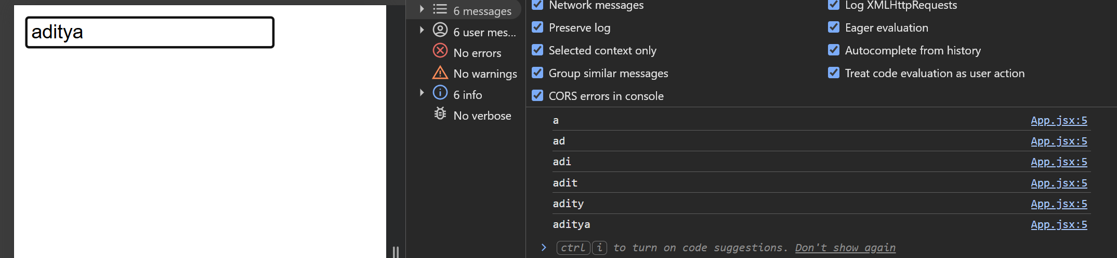
- Create a button that changes its background color when clicked (use onClick and state).
import { useState } from "react";

function SetBackground()
{
let [bg,setBg]=useState("Gray");

function setBgC()
{
if(bg==="Green")
{
setBg("Red")
}
else
{
setBg("Green")
}
}
return(
<>
<button style={{backgroundColor:bg}} onClick={setBgC}> Click Me </button>
</> )
}
export default SetBackground;

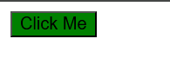

- Build a form with name and email fields that alerts the submitted values (use onSubmit).
import {useState} from "react";
function alertDate()
{
const[name,setName]=useState("Guest");
const[age,setAge]=useState("18")
return(
<>
<input type="text" placeholder="Enter Name:" value={name} onChange={(e)=>setName(e.target.value)} />
<input type="number" placeholder="Enter number:" value={age} onChange={(e)=>setAge(e.target.value)}/>
<button onClick={()=>alert("My Name:"+name+" & Age:"+age)}>Click</button>

</>
)

}
export default alertDate;
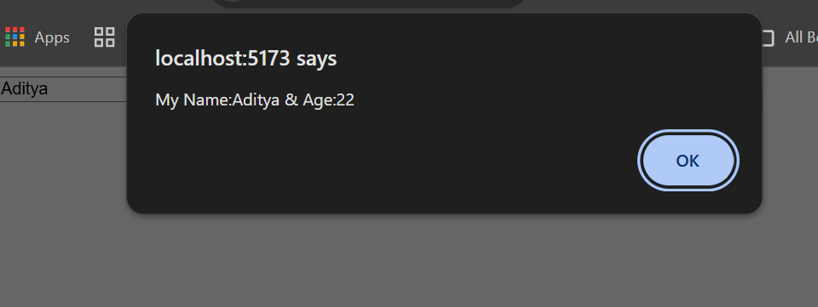
- Add a button that disables itself after 3 clicks (use state to track clicks).
import { useState } from "react";

function Count() {
let [ct, setCt] = useState(0);

return (
<>
{
ct <= 3 ? (
<>
<button onClick={() => setCt(ct + 1)}>
Button
</button>
</>
) : (
<button disabled>Disable</button>
)
}

<h1>{ct}</h1>
</>
);
}

export default Count;

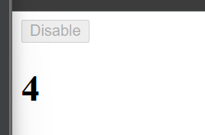
- Implement a <select> dropdown that updates state with the selected value.
import { useState } from "react";
function Dropdown()
{
let[val,SetVal]=useState("Select")
return(
<>
<select onChange={(e)=>SetVal(e.target.value)}>
<option value="First">First</option>
<option value="Second">Second</option>
<option value="Third">Third</option>
</select>
<h1>{val}</h1>
</>
)
}

export default Dropdown;

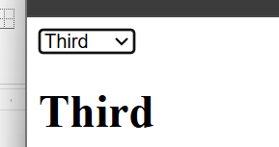
- Build a AADHAR Registration form with an input field and a submit button.
- Add Form Validation in above program.
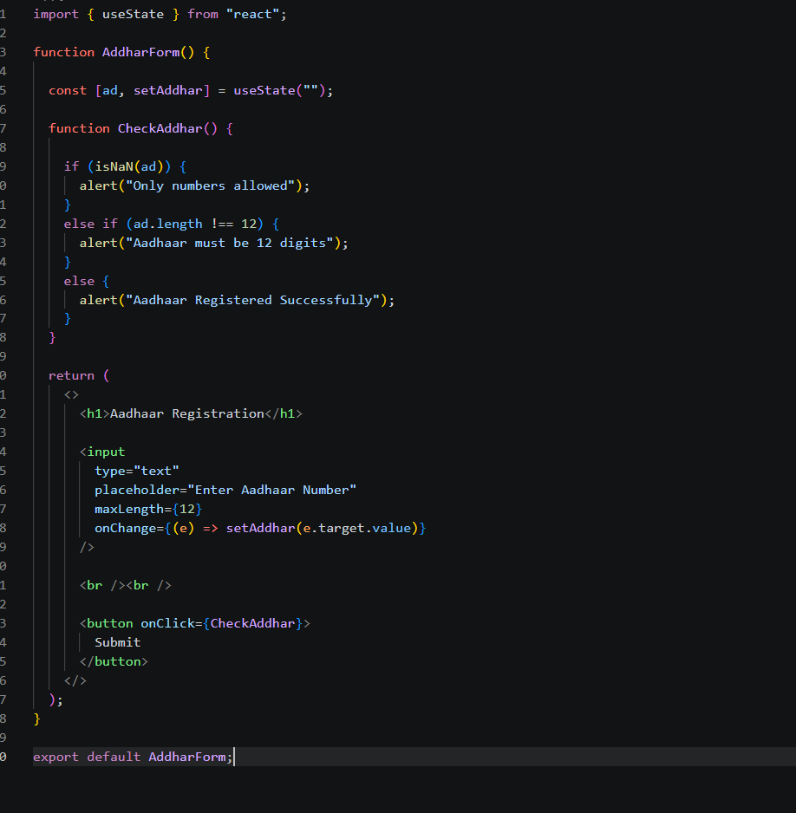
- Write a program to demonstrate functional component life cycle phases.
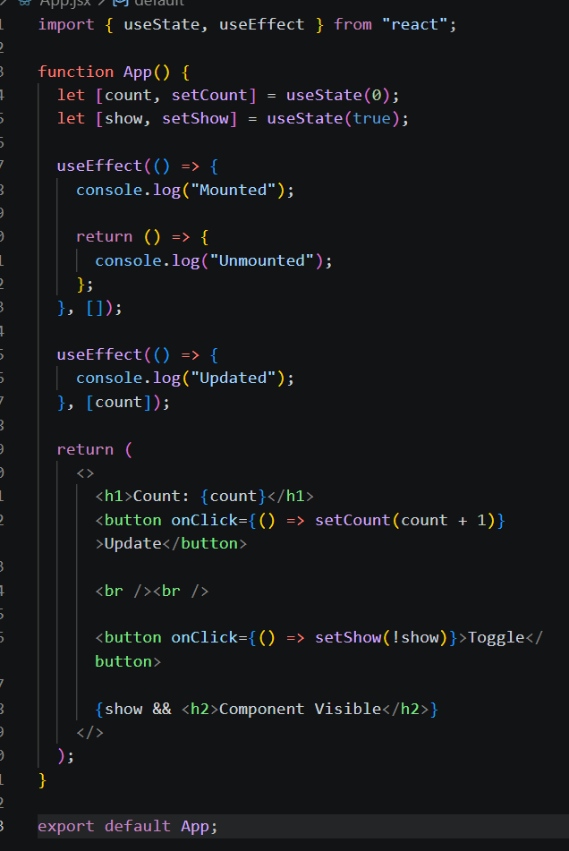
- Create a timer that updates the seconds elapsed every seconds.
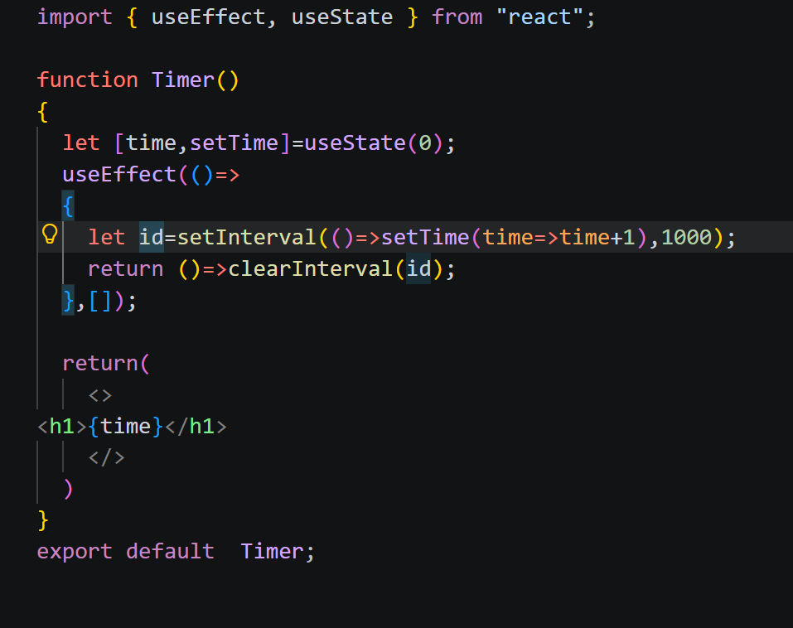
- Use useState to manage the visibility of a paragraph (toggle text with a button) 