A.Y. 2025-26

Scenario 1: Library
IT13: ADBMS
Chapter 2: Structured Query Language Handson Session
Using SQL

Schema:-
- BOOKS: (Book_ID, Title, Author, Genre, Price, Publication_Year, Copies)
- BORROWERS: (Borrower_ID, Name, Address, Phone, Membership_Type)
- ISSUES: (Issue_ID, Borrower_ID, Book_ID, Issue_Date, Return_Date)

Easy Questions (10)

- Create a table BOOKS with the given schema
CREATE TABLE book (
book_id INT PRIMARY KEY,
title VARCHAR(30),
author VARCHAR(30),
genre VARCHAR(30),
price FLOAT,
publication_year YEAR,
copies INT
);
- Insert at least 5 rows into the BOOKS table.
INSERT INTO book VALUES
(1, 'C Language', 'Dennis Ritchie', 'Programming', 450, 1988, 10),
(2, 'C++', 'Bjarne Stroustrup', 'Programming', 550, 1998, 6),
(3, 'Java Basics', 'James Gosling', 'Programming', 600, 2015, 8),
(4, 'Python', 'Guido van Rossum', 'Programming', 650, 2019, 4),
(5, 'DBMS', 'Navathe', 'Education', 500, 2014, 0);

- Display all the details of books available in the library.
Select * from book;
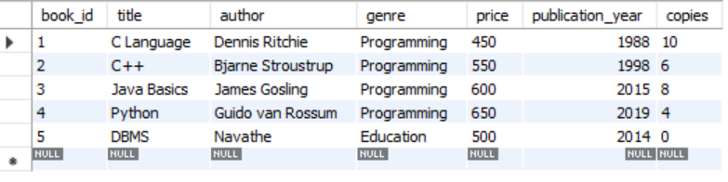
- Display the list of books published after 2015.
select * from book where publication_year>2015;
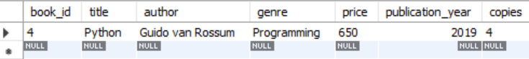
- Create a table BORROWERS with the given schema.
CREATE TABLE borrowers (
br_id INT PRIMARY KEY,
name VARCHAR(30),
address VARCHAR(30),
phone VARCHAR(30),
membership_type VARCHAR(30)
);
- Insert at least 5 rows into the BORROWERS table.
INSERT INTO borrowers VALUES
(1, 'Aditya', 'Pune', '9876543210', 'Gold'),
(2, 'Rahul', 'Mumbai', '9123456780', 'Silver'),
(3, 'Sneha', 'Nashik', '9988776655', 'Gold'),
(4, 'Amit', 'Nagpur', '9012345678', 'Platinum'),
(5, 'Pooja', 'Kolhapur', '9090909090', 'Silver');

- Display the names and phone numbers of all borrowers.
select name,phone from borrowers;
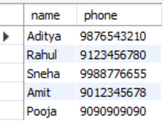
- Display the list of borrowers who have a "Gold" membership type.
select * from borrowers where membership_type='Gold';
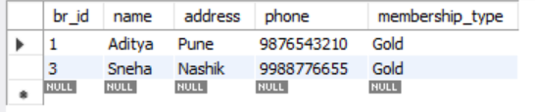
- Create a table ISSUES with the given schema.
CREATE TABLE issues (
issue_id INT PRIMARY KEY,
br_id INT REFERENCES borrowers (br_id),
book_id INT REFERENCES book (book_id),
issu_date DATE,
return_date DATE
);
- Insert 5 records into the ISSUES table.
INSERT INTO issues VALUES
(1, 1, 1, '2024-01-05', '2024-01-15'),
(2, 1, 2, '2024-01-10', '2024-01-20'),
(3, 2, 3, '2024-02-01', NULL),
(4, 3, 4, '2024-02-05', '2024-02-12'),
(5, 3, 1, '2024-02-10', NULL);

Medium Questions :

- Display the title and author of all books priced above 500.
select title ,author ,price from book where price >500;
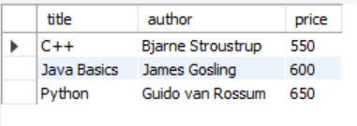
- Update the price of all books in the “Programing" genre by increasing it by 10%.
update book set price=price *1.10 where genre="Programming";
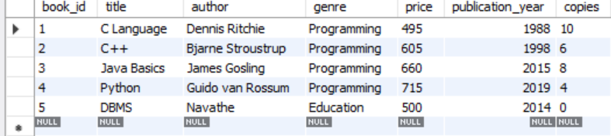
- Delete the records of books that have no copies left.
delete from book where copies=0;
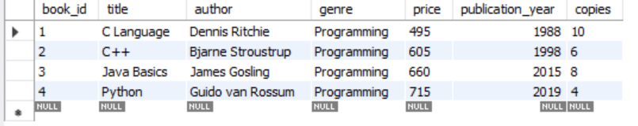
- Delete the records of books that have no copies left
- Create a view AVAILABLE_BOOKS showing all books with more than 5 copies.
create view bookmorethan500 as select * from book where copies>5;
select * from bookmorethan500;
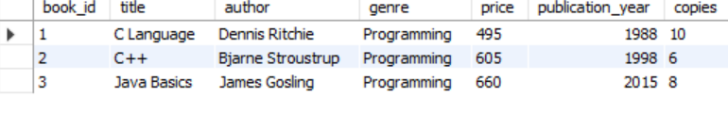

- Retrieve all the books sorted by Publication_Year in descending order.
select * from book order by publication_year desc;
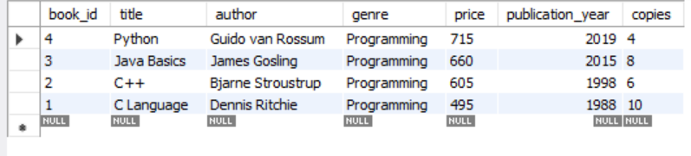
- Retrieve the details of borrowers who borrowed more than 2 books
select * from borrowers where br_id in(select br_id from issues group by br_id having count(book_id)>=2);

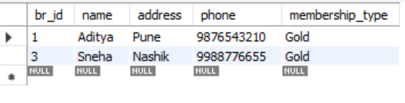

Scenario 2: Movie

create database movie;
use movie;

Schema:-

- MOVIES: (Movie_ID, Title, Genre, Release_Date, Rating, Director)
- CUSTOMERS: (Customer_ID, Name, Email, Phone, Membership_Type)
- RENTALS: (Rental_ID, Customer_ID, Movie_ID, Rental_Date, Return_Date)

Easy Questions (10)

- Create a table MOVIES with the given schema.
create table movies (
movie_id int primary key,
title varchar(100),
genre varchar(50),
release_date date,
rating decimal(3,1),
director varchar(100)
);
- Insert at least 5 rows into the MOVIES table.
insert into movies values
(1, 'fighter', 'action', '2024-01-25', 7.2, 'siddharth anand'),
(2, 'animal', 'action', '2023-12-01', 6.8, 'sandeep reddy vanga'),
(3, 'dunki', 'drama', '2023-12-21', 6.5, 'rajkumar hirani'),
(4, '12th fail', 'biography', '2023-10-27', 8.9, 'vidhu vinod chopra'),
(5, 'low budget film', 'thriller', '2025-01-10', 4.1, 'new director');

- Display all the details of movies available.
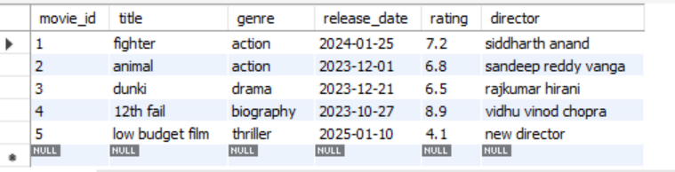

- Display the list of movies in the "Action" genre.
select * from movies where genre='action';
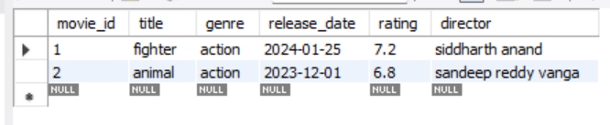
- Create a table CUSTOMERS with the given schema.
create table customers (
customer_id int primary key,
name varchar(100),
email varchar(100),
phone varchar(15),
membership_type varchar(50)
);
- Insert at least 5 rows into the CUSTOMERS table.
insert into customers values
(1, 'aditya chavan', 'aditya@gmail.com', '9876543210', 'premium'),
(2, 'rahul patil', 'rahul@gmail.com', '9123456780', 'basic'),
(3, 'neha sharma', 'neha@gmail.com', '9988776655', 'premium'),
(4, 'amit kulkarni', 'amit@gmail.com', '9090909090', null),
(5, 'pooja joshi', 'pooja@gmail.com', '9012345678', 'basic');
- Display the names and emails of all customers.
select name ,email from customers;
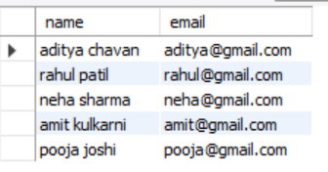

- Display the list of customers with a "Premium" membership.
select * from customers where membership_type='premium';
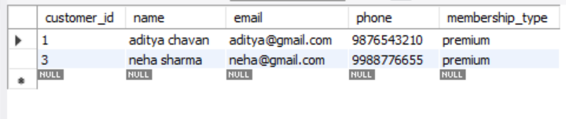
- Create a table RENTALS with the given schema.
create table rentals (
rental_id int primary key,
customer_id int,
movie_id int,
rental_date date,
return_date date
);
- Insert 5 records into the RENTALS table.
insert into rentals values
(1, 1, 1, '2025-01-05', '2025-01-08'),
(2, 2, 1, '2025-01-06', null),
(3, 3, 1, '2025-01-07', '2025-01-10'),
(4, 4, 2, '2025-01-08', null),
(5, 5, 3, '2025-01-09', '2025-01-12');

Medium Questions :-

- Add a NOT NULL constraint to the Genre column of the MOVIES table.
:- alter table movies modify genre varchar(40) not null;
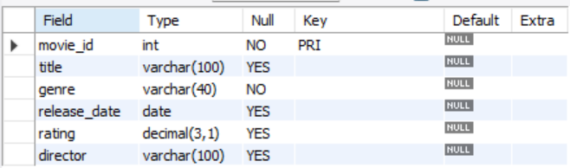

- Add a UNIQUE constraint to the Email column in the CUSTOMERS table.
alter table customers add constraint unique_email unique(email);
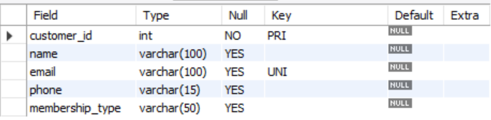
- Add a foreign key constraint on Movie_ID in the RENTALS table referencing MOVIES(Movie_ID).
alter table rentals add constraint fk foreign key (movie_id) references movies(movie_id);
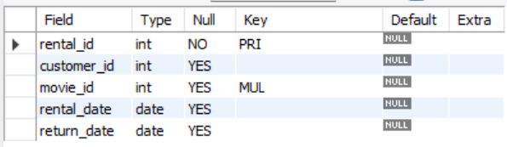
- Create an index on the Rating column in the MOVIES table to optimize queries
create index idx on movies(rating);
- Find the average rating of all movies in the MOVIES table.
select avg(rating) as average_rating
from movies;
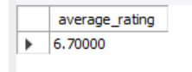
- Find the total number of movies rented and the maximum fees paid in a singlerental.
select count(rental_id) as total_rentals from rentals;
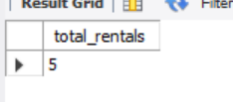

- Update all movies with a rating below 5 to change their genre to 'Uncategorized'.
update movies set genre='Uncategorized' where rating<5;
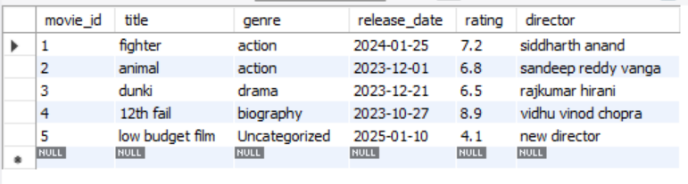
- Delete all customer records where the Membership_Type is NULL.
delete from customers
where membership_type is null;

Hard Questions:-

- Retrieve customers who rented movies but have not returned them (use WHEREand NULL check).
select distinct c.*
from customers c
join rentals r
on c.customer_id = r.customer_id
where r.return_date is null;
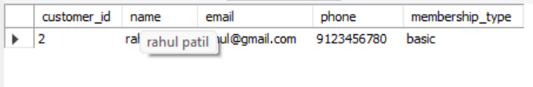

- Find the most rented movie(s) and the number of times they were rent

select movie_id, count(*) as rental_count from rentals group by movie_id having count(*) = (select max(cnt)from (select count(*) as cnt from rentals group by movie_id)t);

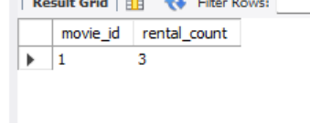

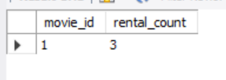

Chapter 3: Introduction to NoSQL Database Handson session
Using MongoDB

  - Inventory Management System

Easy Questions
    - Create a database called Inventory.
:- use inventory
    - Create a collection called Products with attributes: ProductID, Name, Category, Stock, and Price.
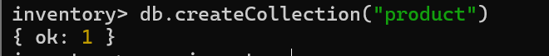
    - Insert 10 product documents into the Products collection.
db.Products.insertMany([
{ ProductID: 1, Name: "Laptop", Category: "Electronics", Stock: 15, Price: 50000 },
{ ProductID: 2, Name: "Mouse", Category: "Electronics", Stock: 8, Price: 500 },
{ ProductID: 3, Name: "Keyboard", Category: "Electronics", Stock: 20, Price: 800 },
{ ProductID: 4, Name: "Chair", Category: "Home Appliances", Stock: 25, Price: 1500 },
{ ProductID: 5, Name: "Table", Category: "Home Appliances", Stock: 35, Price: 3000 },
{ ProductID: 6, Name: "Fan", Category: "Home Appliances", Stock: 40, Price: 2000 },
{ ProductID: 7, Name: "Cable", Category: "Electronics", Stock: 12, Price: 10 },
{ ProductID: 8, Name: "Cup", Category: "Kitchen", Stock: 5, Price: 15 },
{ ProductID: 9, Name: "Bottle", Category: "Kitchen", Stock: 0, Price: 20 },
{ ProductID: 10, Name: "Calculator", Category: "Electronics", Stock: 18, Price: 600 }
])
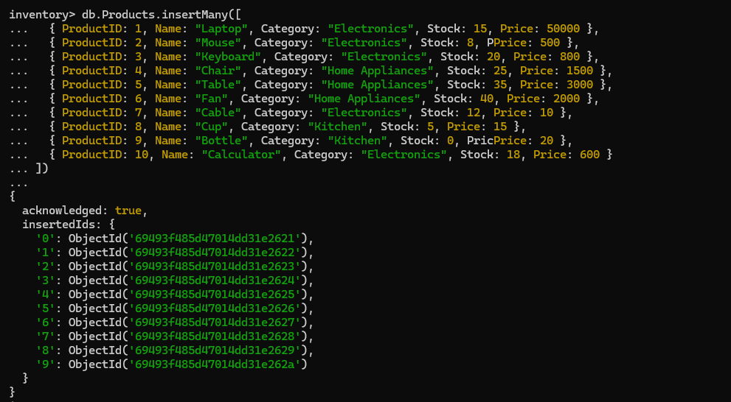
    - Retrieve all products with stock greater than 10.
inventory> db.Products.find({Stock:{$gt:10}})
[
{
_id: ObjectId('69493f485d47014dd31e2621'),
ProductID: 1,
Name: 'Laptop',
Category: 'Electronics',
Stock: 15,
Price: 50000
},
{
_id: ObjectId('69493f485d47014dd31e2623'),
ProductID: 3,
Name: 'Keyboard',
Category: 'Electronics',
Stock: 20,
Price: 800
},
{
_id: ObjectId('69493f485d47014dd31e2624'),
ProductID: 4,
Name: 'Chair',
Category: 'Home Appliances',
Stock: 25,
Price: 1500
},
{
_id: ObjectId('69493f485d47014dd31e2625'),
ProductID: 5,
Name: 'Table',
Category: 'Home Appliances',
Stock: 35,
Price: 3000
},
{
_id: ObjectId('69493f485d47014dd31e2626'),
ProductID: 6,
Name: 'Fan',
Category: 'Home Appliances',
Stock: 40,
Price: 2000
},
{
_id: ObjectId('69493f485d47014dd31e2627'),
ProductID: 7,
Name: 'Cable',
Category: 'Electronics',
Stock: 12,
Price: 10
},
{
_id: ObjectId('69493f485d47014dd31e262a'),
ProductID: 10,
Name: 'Calculator',
Category: 'Electronics',
Stock: 18,
Price: 600
}
]
inventory>
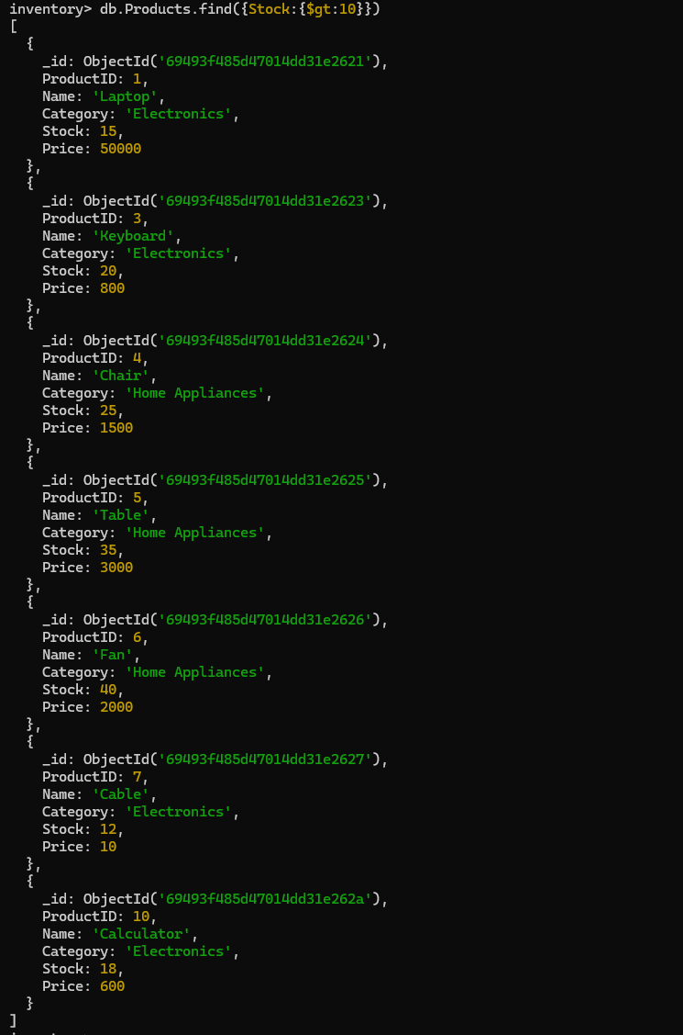
    - Find all products from the 'Electronics' category.
inventory> db.Products.find({Category:"Electronics"})
[
{
_id: ObjectId('69493f485d47014dd31e2621'),
ProductID: 1,
Name: 'Laptop',
Category: 'Electronics',
Stock: 15,
Price: 50000
},
{
_id: ObjectId('69493f485d47014dd31e2622'),
ProductID: 2,
Name: 'Mouse',
Category: 'Electronics',
Stock: 8,
Price: 500
},
{
_id: ObjectId('69493f485d47014dd31e2623'),
ProductID: 3,
Name: 'Keyboard',
Category: 'Electronics',
Stock: 20,
Price: 800
},
{
_id: ObjectId('69493f485d47014dd31e2627'),
ProductID: 7,
Name: 'Cable',
Category: 'Electronics',
Stock: 12,
Price: 10
},
{
_id: ObjectId('69493f485d47014dd31e262a'),
ProductID: 10,
Name: 'Calculator',
Category: 'Electronics',
Stock: 18,
Price: 600
}
]
inventory>

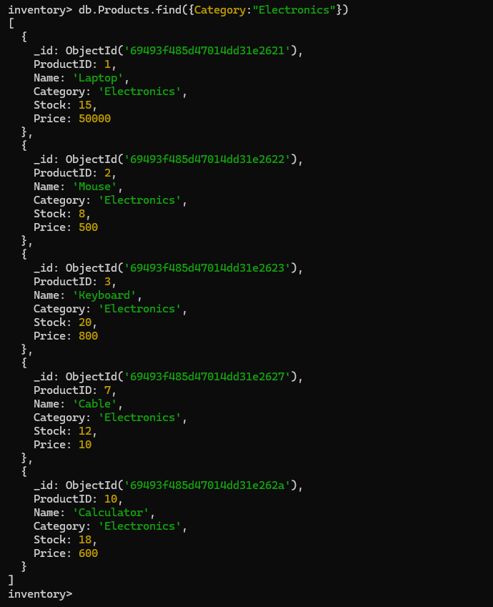

    - Update the price of the product with ProductID 7 to 19.99.

inventory> db.Products.updateOne({ProductID:7},{$set:{Price:19.99}})
{
acknowledged: true,
insertedId: null,
matchedCount: 1,
modifiedCount: 1,
upsertedCount: 0
}
inventory>
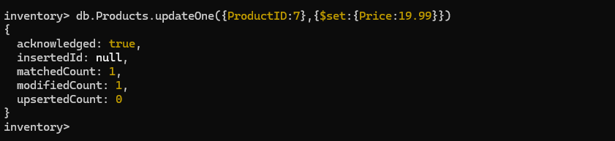
    - Delete the product with ProductID 2.
inventory> db.Products.deleteOne({ProductID:2})
{ acknowledged: true, deletedCount: 1 }
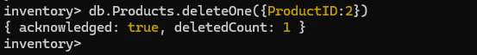
    - Count how many products are in stock.
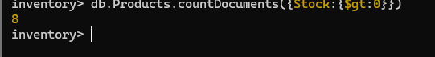
inventory> db.Products.countDocuments({Stock:{$gt:0}})
8

    - Sort products by Price in descending order.
inventory> db.Products.find().sort({Price:-1})
[
{
_id: ObjectId('69493f485d47014dd31e2621'),
ProductID: 1,
Name: 'Laptop',
Category: 'Electronics',
Stock: 15,
Price: 50000
},
{
_id: ObjectId('69493f485d47014dd31e2625'),
ProductID: 5,
Name: 'Table',
Category: 'Home Appliances',
Stock: 35,
Price: 3000
},
{
_id: ObjectId('69493f485d47014dd31e2626'),
ProductID: 6,
Name: 'Fan',
Category: 'Home Appliances',
Stock: 40,
Price: 2000
},
{
_id: ObjectId('69493f485d47014dd31e2624'),
ProductID: 4,
Name: 'Chair',
Category: 'Home Appliances',
Stock: 25,
Price: 1500
},
{
_id: ObjectId('69493f485d47014dd31e2623'),
ProductID: 3,
Name: 'Keyboard',
Category: 'Electronics',
Stock: 20,
Price: 800
},
{
_id: ObjectId('69493f485d47014dd31e262a'),
ProductID: 10,
Name: 'Calculator',
Category: 'Electronics',
Stock: 18,
Price: 600
},
{
_id: ObjectId('69493f485d47014dd31e2629'),
ProductID: 9,
Name: 'Bottle',
Category: 'Kitchen',
Stock: 0,
Price: 20
},
{
_id: ObjectId('69493f485d47014dd31e2627'),
ProductID: 7,
Name: 'Cable',
Category: 'Electronics',
Stock: 12,
Price: 19.99
},
{
_id: ObjectId('69493f485d47014dd31e2628'),
ProductID: 8,
Name: 'Cup',
Category: 'Kitchen',
Stock: 5,
Price: 15
}
]
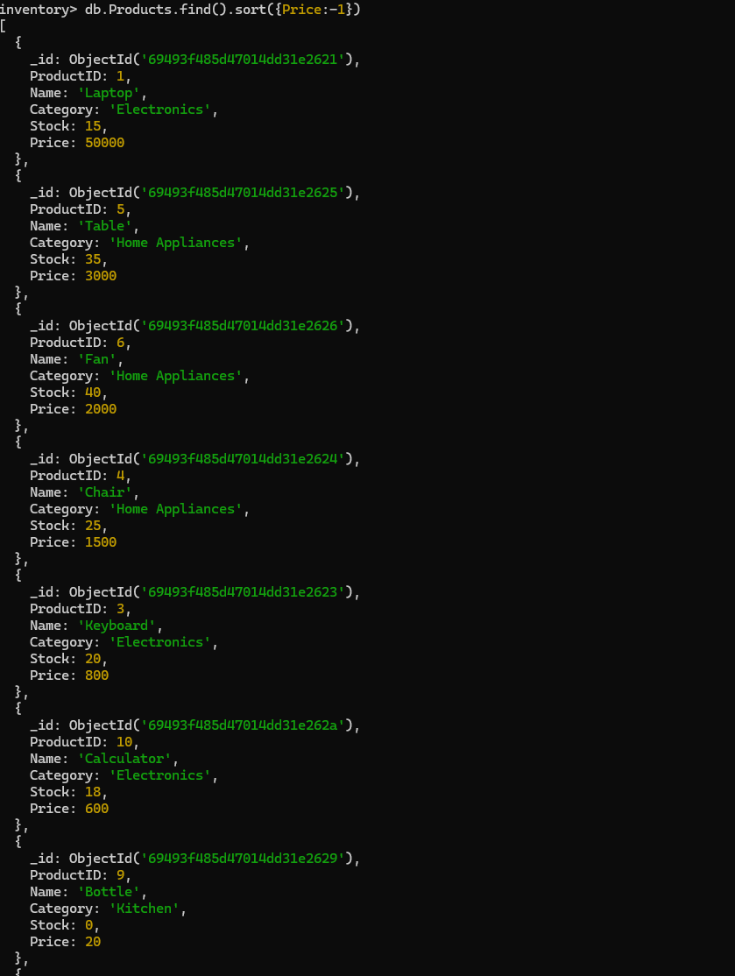
    - Find products whose price is either 10 or 15.
inventory> db.Products.find({Price:{$in:[10,15]} })
[
{
_id: ObjectId('69493f485d47014dd31e2628'),
ProductID: 8,
Name: 'Cup',
Category: 'Kitchen',
Stock: 5,
Price: 15
}
]
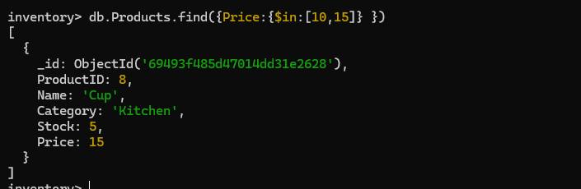

Hard Questions
1. Retrieve products whose Category is 'Home Appliances' and Stock > 30
db.Products.find({
Category: "Home Appliances",
Stock: { $gt: 30 }
})

2️⃣ Update the Category of ProductID = 4 to 'Furniture'
db.Products.updateOne(
{ ProductID: 4 },
{ $set: { Category: "Furniture" } }
)

3️⃣ Use $nin to exclude products with Stock = 10 or 15
db.Products.find({
Stock: { $nin: [10, 15] }
})

4️⃣ Find products with Stock < 5 and Price > 10
db.Products.find({
Stock: { $lt: 5 },
Price: { $gt: 10 }
})

5️⃣ Find products with Name containing character 'c'
(Case-insensitive search)
db.Products.find({
Name: { $regex: "c", $options: "i" }
})

6️⃣ Delete all products with Stock = 0
db.Products.deleteMany({
Stock: 0
})

7️⃣ Retrieve first 5 products, skipping first 2
db.Products.find()
.skip(2)
.limit(5)

  - Banking System

Easy Questions
    - Create a database called Bank.
    - Create a collection called Customers with attributes: CustomerID, Name, AccountBalance, and AccountType.
    - Insert 10 documents representing customer information.
    - Find all customers with AccountType 'Savings'.
    - Update the AccountBalance of the customer with CustomerID 4 to 5000.
    - Delete the customer with CustomerID 2.
    - Count the number of customers with an AccountBalance greater than 1000.
    - Sort customers by AccountBalance in ascending order.
    - Find customers whose AccountType is either 'Checking' or 'Business'.
    - Find customers with an AccountBalance between 2000 and 5000.

Hard Questions
- Update the AccountBalance of all customers with AccountType 'Savings' by 1000.
- Retrieve customers with an AccountBalance greater than 5000.
- Find customers with AccountType 'Checking' and AccountBalance less than 1000.
- Use $in to find customers with AccountType either 'Business' or 'Checking'.
- Find customers whose AccountBalance is between 3000 and 7000.
- Find all customers with AccountBalance less than 1000 and update it to 1500.
- Delete all the customers .

✅ Easy Questions
1️⃣ Create a database called Bank
use Bank

2️⃣ Create a collection Customers
(Collection auto-creates on insert)

3️⃣ Insert 10 customer documents
db.Customers.insertMany([
{ CustomerID: 1, Name: "Amit", AccountBalance: 3000, AccountType: "Savings" },
{ CustomerID: 2, Name: "Ravi", AccountBalance: 800, AccountType: "Checking" },
{ CustomerID: 3, Name: "Neha", AccountBalance: 12000, AccountType: "Business" },
{ CustomerID: 4, Name: "Pooja", AccountBalance: 2000, AccountType: "Savings" },
{ CustomerID: 5, Name: "Karan", AccountBalance: 6000, AccountType: "Checking" },
{ CustomerID: 6, Name: "Anita", AccountBalance: 4500, AccountType: "Savings" },
{ CustomerID: 7, Name: "Rahul", AccountBalance: 900, AccountType: "Checking" },
{ CustomerID: 8, Name: "Sneha", AccountBalance: 7000, AccountType: "Business" },
{ CustomerID: 9, Name: "Vikas", AccountBalance: 1500, AccountType: "Savings" },
{ CustomerID: 10, Name: "Meena", AccountBalance: 2500, AccountType: "Checking" }
])

4️⃣ Find all customers with AccountType = 'Savings'
db.Customers.find({ AccountType: "Savings" })

5️⃣ Update AccountBalance of CustomerID = 4 to 5000
db.Customers.updateOne(
{ CustomerID: 4 },
{ $set: { AccountBalance: 5000 } }
)

6️⃣ Delete customer with CustomerID = 2
db.Customers.deleteOne({ CustomerID: 2 })

7️⃣ Count customers with AccountBalance > 1000
db.Customers.countDocuments({
AccountBalance: { $gt: 1000 }
})

8️⃣ Sort customers by AccountBalance (Ascending)
db.Customers.find().sort({ AccountBalance: 1 })

9️⃣ Find customers with AccountType 'Checking' or 'Business'
db.Customers.find({
AccountType: { $in: ["Checking", "Business"] }
})

🔟 Find customers with AccountBalance between 2000 and 5000
db.Customers.find({
AccountBalance: { $gte: 2000, $lte: 5000 }
})

🔥 Hard Questions
1️⃣ Increase AccountBalance by 1000 for all 'Savings' accounts
db.Customers.updateMany(
{ AccountType: "Savings" },
{ $inc: { AccountBalance: 1000 } }
)

2️⃣ Retrieve customers with AccountBalance > 5000
db.Customers.find({
AccountBalance: { $gt: 5000 }
})

3️⃣ Find 'Checking' customers with AccountBalance < 1000
db.Customers.find({
AccountType: "Checking",
AccountBalance: { $lt: 1000 }
})

4️⃣ Use $in for 'Business' or 'Checking'
db.Customers.find({
AccountType: { $in: ["Business", "Checking"] }
})

5️⃣ Find customers with AccountBalance between 3000 and 7000
db.Customers.find({
AccountBalance: { $gte: 3000, $lte: 7000 }
})

6️⃣ Update customers with AccountBalance < 1000 to 1500
db.Customers.updateMany(
{ AccountBalance: { $lt: 1000 } },
{ $set: { AccountBalance: 1500 } }
)

7️⃣ Delete ALL customers
db.Customers.deleteMany({})

Chapter 4: Graph Database and Analytics Handson Session
Using Neo4j
- Social Media Network :
Question: "Create a social media network where:
  - There are five users: Alex, Maya, Ryan, Priya, and Sam
- create(:user{name:"Alex",date:"2025-01-03"}),(:user{name:"Maya",date:"2025-06-04"}),(:user{name:"Rayab",date:"2025-05-13"}),(:user{name:"Sam",date:"2025-02-03"});

  - Alex posts two photos: 'Vacation' and 'Party'
- create(:post{title:"Vacation",date:"2025-12-22"}),(:post{title:"Party",date:"2025-12-24"}),(:post{title:"Graduation",date:"2025-12-23"});
- match(u:user{name:"Alex"}),(p1:post{title:"Vacation"}),(p2:post{title:"Party"}) create (u)-[:Post]->(p1),(u)-[:Post]->(p2);

  - Maya posts one photo: 'Graduation'
- match(m:user{name:"Maya"}),(p:post{title:"Graduation"}) CREATE (m)-[:Post]->(p);

  - Ryan comments on Alex's 'Party' photo
- MATCH(u:user{name:"Rayab"}),(c:post{title:"Party"}) CREATE (u)-[:Comment{title:"Nice Phoot"}]->(c);

  - Priya likes both of Alex's photos
  - Sam follows everyone but hasn't posted anything
  - Include post dates, comment text, and user join dates"

Execute the following Queries:
- Find all posts by Alex
- Find all users who liked Alex's posts
- Find users who haven't posted anything
- Find who follows whom and their follow
- Find posts with comments and their commenters

Extra Query Challenges (Difficult Level):
- Find users who both posted and commented
- Count the number of likes per post
- Find the most active user (combining posts, comments, and likes)

✅ 1️⃣ Create Users (with join dates)
CREATE
(alex:User {name:'Alex', joinDate: date('2023-01-10')}),
(maya:User {name:'Maya', joinDate: date('2023-02-05')}),
(ryan:User {name:'Ryan', joinDate: date('2023-03-01')}),
(priya:User {name:'Priya', joinDate: date('2023-03-10')}),
(sam:User {name:'Sam', joinDate: date('2023-04-01')});

✅ 2️⃣ Create Posts (with post dates)
MATCH (alex:User {name:'Alex'}), (maya:User {name:'Maya'})
CREATE
(p1:Post {title:'Vacation', postDate: date('2023-05-01')}),
(p2:Post {title:'Party', postDate: date('2023-05-05')}),
(p3:Post {title:'Graduation', postDate: date('2023-06-01')}),
(alex)-[:POSTED]->(p1),
(alex)-[:POSTED]->(p2),
(maya)-[:POSTED]->(p3);

✅ 3️⃣ Ryan comments on Alex’s "Party" post
MATCH (ryan:User {name:'Ryan'}), (p:Post {title:'Party'})
CREATE
(ryan)-[:COMMENTED {text:'Nice party!', commentDate: date('2023-06-10')}]->(p);

✅ 4️⃣ Priya likes both of Alex’s posts
MATCH (priya:User {name:'Priya'}), (p:Post)
WHERE p.title IN ['Vacation','Party']
CREATE (priya)-[:LIKED]->(p);

✅ 5️⃣ Sam follows everyone
MATCH (sam:User {name:'Sam'}), (u:User)
WHERE sam <> u
CREATE (sam)-[:FOLLOWS]->(u);

🔷 PART 2: Execute Required Queries

🔍 1️⃣ Find all posts by Alex
MATCH (alex:User {name:'Alex'})-[:POSTED]->(p:Post)
RETURN p.title, p.postDate;

🔍 2️⃣ Find all users who liked Alex’s posts
MATCH (alex:User {name:'Alex'})-[:POSTED]->(p:Post)<-[:LIKED]-(u:User)
RETURN DISTINCT u.name;

🔍 3️⃣ Find users who haven't posted anything
MATCH (u:User)
WHERE NOT (u)-[:POSTED]->(:Post)
RETURN u.name;

🔍 4️⃣ Find who follows whom
MATCH (u1:User)-[:FOLLOWS]->(u2:User)
RETURN u1.name AS Follower, u2.name AS Following;

🔍 5️⃣ Find posts with comments and their commenters
MATCH (u:User)-[c:COMMENTED]->(p:Post)
RETURN p.title, u.name AS CommentedBy, c.text;

🔥 PART 3: Extra Query Challenges (Difficult Level)

🚀 1️⃣ Find users who both posted AND commented
MATCH (u:User)
WHERE (u)-[:POSTED]->(:Post) AND (u)-[:COMMENTED]->(:Post)
RETURN u.name;

🚀 2️⃣ Count number of likes per post
MATCH (p:Post)
OPTIONAL MATCH (p)<-[:LIKED]-(:User)
RETURN p.title, COUNT(*) AS TotalLikes;

🚀 3️⃣ Find the most active user
(Posts + Comments + Likes combined)
MATCH (u:User)
OPTIONAL MATCH (u)-[:POSTED]->(p)
OPTIONAL MATCH (u)-[:COMMENTED]->(c)
OPTIONAL MATCH (u)-[:LIKED]->(l)
RETURN u.name,
COUNT(DISTINCT p) +
COUNT(DISTINCT c) +
COUNT(DISTINCT l) AS ActivityScore
ORDER BY ActivityScore DESC
LIMIT 1;

- University Course Management System:
Question: "Create University Course Management System where:
  - Create two students, "Arun" (age 20) and "Bala" (age 21).
  - Create two courses, "CSE" and "IT".
  - Create one professor, "Dr. Smith".
  - Establish relationships: "Arun" enrolled in "CSE", "Bala" enrolled in "IT", and "Dr. Smith" taught both "CSE" and "IT".

Execute the following Queries:
- Find all students and the courses they are enrolled in
- Find which courses are taught by "Dr. Smith"
- Find all students who are enrolled in a course taught by "Dr. Smith"
- Find which course Bala enrolled in
- Find all students enrolled in CSE
- Find all students enrolled in IT
- Find professor teaching Arun’s course
- Show complete system details
- List all students
- List all professors

🔷 PART 1: Create the Graph (Data Creation)

✅ 1️⃣ Create Students
CREATE
(arun:Student {name:'Arun', age:20}),
(bala:Student {name:'Bala', age:21});

✅ 2️⃣ Create Courses
CREATE
(cse:Course {name:'CSE'}),
(it:Course {name:'IT'});

✅ 3️⃣ Create Professor
CREATE
(smith:Professor {name:'Dr. Smith'});

✅ 4️⃣ Create Relationships
MATCH (arun:Student {name:'Arun'}),
(bala:Student {name:'Bala'}),
(cse:Course {name:'CSE'}),
(it:Course {name:'IT'}),
(smith:Professor {name:'Dr. Smith'})
CREATE
(arun)-[:ENROLLED_IN]->(cse),
(bala)-[:ENROLLED_IN]->(it),
(smith)-[:TEACHES]->(cse),
(smith)-[:TEACHES]->(it);

🔷 PART 2: Execute Required Queries

🔍 1️⃣ Find all students and the courses they are enrolled in
MATCH (s:Student)-[:ENROLLED_IN]->(c:Course)
RETURN s.name AS Student, c.name AS Course;

🔍 2️⃣ Find which courses are taught by "Dr. Smith"
MATCH (p:Professor {name:'Dr. Smith'})-[:TEACHES]->(c:Course)
RETURN c.name AS Course;

🔍 3️⃣ Find students enrolled in a course taught by "Dr. Smith"
MATCH (p:Professor {name:'Dr. Smith'})-[:TEACHES]->(c:Course)<-[:ENROLLED_IN]-(s:Student)
RETURN s.name;

🔍 4️⃣ Find which course Bala enrolled in
MATCH (b:Student {name:'Bala'})-[:ENROLLED_IN]->(c:Course)
RETURN c.name;

🔍 5️⃣ Find all students enrolled in CSE
MATCH (s:Student)-[:ENROLLED_IN]->(c:Course {name:'CSE'})
RETURN s.name;

🔍 6️⃣ Find all students enrolled in IT
MATCH (s:Student)-[:ENROLLED_IN]->(c:Course {name:'IT'})
RETURN s.name;

🔍 7️⃣ Find professor teaching Arun’s course
MATCH (s:Student {name:'Arun'})-[:ENROLLED_IN]->(c:Course)<-[:TEACHES]-(p:Professor)
RETURN p.name;

🔍 8️⃣ Show complete system details
MATCH (n)-[r]->(m)
RETURN n, r, m;

🔍 9️⃣ List all students
MATCH (s:Student)
RETURN s.name, s.age;

🔍 🔟 List all professors
MATCH (p:Professor)
RETURN p.name;

