Name: Aditya Suresh Chavan
Roll.No:2501032
Div:A
Subject:Python Hands On Session
1)Write a Python program to demonstrate the use of basic arithmetic operators (+, -, *, /).
x=int(input("Enter first number:"))
y=int(input("Enter Second Number:"))
print("Addition of Two Number:",x+y)
print("Multiplcaion of Two Number:",x*y)
print("Substraction of Two Number:",x-y)
print("Division of Two Number:",x//y)
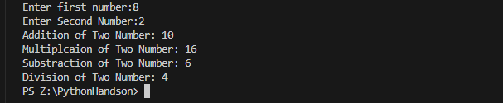
2. Create a program that converts a given Celsius temperature to Fahrenheit.
c=int(input("Enter in Farhanite:"))
f=(c*9/5)+32
print("Temperature in fr:",f)
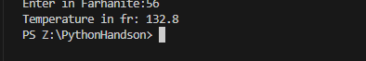
3. Write a Python script to declare and access values in a list.
l1=[1,2,3,4,5,6,6]
print(l1)
print("Element at location:",l1[4])
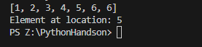
4. Define a dictionary with at least 3 key-value pairs and retrieve a value using its key.
d=[{"name":"Aditya","age":33},{"name":"Ram","age":34},{"name":"Radha","age":45}]
for d in d:
print(d["name"],d["age"])
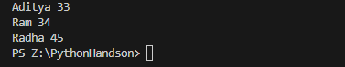
5. Use list comprehension to create a list of squares for numbers 1 to 10.
x=[x*x for x in range(1,10)]
print(x)
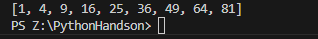
6. Write a program that checks if a number is even or odd using an if statement.
x=int(input("Enter a Number:"))
if x%2==0:
print("Even")
else:
print("Odd")
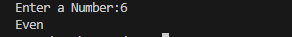
7. Create a Python function to find the maximum of three numbers.
def findmax(x,y,z):
return max(x,y,z)
x=int(input("Enter First Number:"))
y=int(input("Enter third Number:"))
z=int(input("Enter second Number:"))
print("Max from three:",findmax(x,y,z))
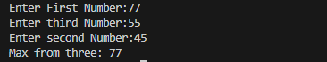
8. Write a Python program that reads a text file and prints its content line by line.
fp=open("p1demo.py","r")
line=fp.readlines()
for l1 in line:
print(l1)
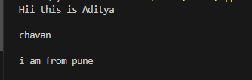
9. Create a program to count the number of characters in a string provided by the user.
str=" Create a program to count the number of characters in a string provided by the user. "
count=0
for ch in str:
if ch.isalpha():
count+=1
print("Total Number of character is:",count)

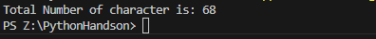
10. Define a simple class in Python and create an object of that class.
class Student:
def __init__(self,name):
self.name=name
def show(self):
print("Student Name is:",self.name)
s1=Student("Aditya")
s1.show()

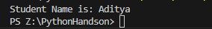
11. Write a Python function that accepts a list and returns its reverse.
def revlist(l):
return l[::-1]
l=[1,2,3,4,5]
print("Reverse List:",revlist(l))

12. Use a for loop to print the first 10 Fibonacci numbers.
a=0
b=1
print(a,end=" ")
print(b,end=" ")
for i in range(8):
c=a+b
print(c,end=" ")
a=b
b=c
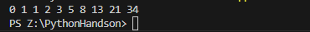
13. Write a Python program to append text to a file and then display its content.
fp=open("adi.txt","a")
fp.write("Hello My Name is Aditya")
print("Content Append Sucesfully")
fp.close()
14. Implement a function to check whether a string is a palindrome.
str="MADAM"
if str==str[::-1]:
print("String is palindrom")
else:
print("String is not palindrom")
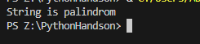
15. Demonstrate the use of a while loop by printing numbers from 1 to 10.
x=1
while x<=10:
print(x,end=" ")
x+=1
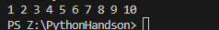
16. Write a recursive function to calculate the factorial of a given number n. What will be the output of factorial(6)?
def fact(x):
if x==0:
return 1
return x*fact(x-1)
x=int(input("Enter Number:"))
print("Factorial is :",fact(x))
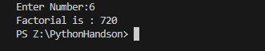

17.Create a class VowelCounter with a method count_vowels that returns the count of vowels in a given string. What will be the output of vc.count_vowels("Programming is fun")?
class VowelCounter:
def count_vowels(self,str):
count=0
for ch in str:
ch=ch.lower()
if ch in "aeiou":
count+=1
return count
vc=VowelCounter()
print("Count Vovels :",vc.count_vowels("Programming is fun"))
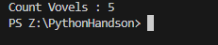
18. Using for loop demonstrate usage of continue, break and else .
for i in range(1,40):
if i==1:
continue
elif i==10:
break
else:
print(i,end=" ")
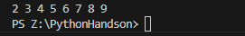
19. Write a Python program to count the number of lines in a file named data.txt. What function is used to read all lines of a file at once?
fp=open("data.txt","r")
lines=fp.readlines()
print(lines)
print("Total Number of lines is:",len(lines))
20. Create a class Student with a private attribute _name. Implement setter and getter methods for the attribute. How would you set the name to "Alice" and then retrieve it?
class Student:
def set(self,nm):
self._name=nm
def getName(self):
return self._name
s=Student()
s.set("Aditya")
print(s.getName())

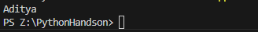
21. Write a Python program to sort a list of dictionaries by the age key in ascending and descending order. Then filter out dictionaries where the age is below 18.
d=[{"name":"Aditya","age":33},{"name":"Ram","age":34},{"name":"Radha","age":45},{"name":"Ravi","age":15}]
asc=sorted(d,key=lambda x :x["age"])
desc=sorted(d,key=lambda x:x["age"],reverse=True)
print("List in asc",asc)
print("List in desc:",desc)
for d in d:
if d["age"]>18:
print(d["name"],d["age"])

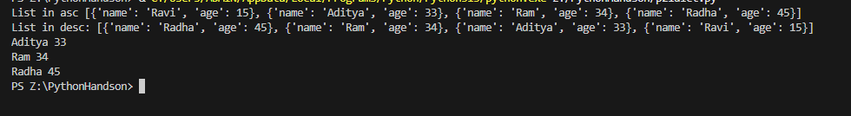
22. Write a Python program to demonstrate single inheritance (Person → Student) and multilevel inheritance (Person → Student → StudentGraduation) with appropriate attributes.
class Person:
def __init__(self,name):
self.name=name
def show(self):
print("This is Person name is:",self.name)
class Student(Person):
def __init__(self,age):
super().__init__(self)
self.age=age
def display(self):
print("This is Student")
class StudentGraduation(Student):
def __init__(self,name,age,gm):
super().__init__(self)
self.name=name
self.age=age
self.marks=gm
def show(self):
print("This is Grduate students")
print("Name:",self.name)
print("Age:",self.age)
print("Marks:",self.marks)
s=StudentGraduation("Aditya",34,56)
s.show()
s.display()

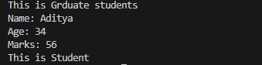
23. Write a Python program to read and print the third line from a file named example.txt. If the file has fewer than three lines, what should your code handle?
fp=open("data.txt","r")
lines=fp.readlines()
print(lines)
if len(lines)>=3:
print(lines[2])
else:
print("File has less than 3 lines")

24.Write a Python program to demonstrate static and class methods in a Car class, where is_valid_car_model() is a static method and get_total_cars() is a class method.
class Car:
def car(self,name):
self.carname=name
@staticmethod
def is_valide_car_model(name):
if name=="BMW":
print("Car is Valide")
else:
print("car is not valide")
@classmethod
def setName(self,name):
self.name=name
c=Car()
Car.is_valide_car_model("MBA")
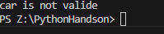
25. Create a class Person with a constructor to initialize name and age. Add a method to display these details and another method to check if the person is an adult (age 18 or above).
class Person:
def __init__(self,name,age):
self.name=name
self.age=age
def check(self):
if self.age>18:
print("Person is Adult")
p=Person("Aditya",33)
p.check()
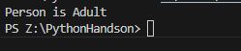

26)
class Number:
def __init__(self, value):
self.value = value

def __add__(self, other):
return Number(self.value + other.value)

def __str__(self):
return str(self.value)

# Usage
n1 = Number(10)
n2 = Number(20)

n3 = n1 + n2
print("Sum:", n3)

27)
class MyList:
def __init__(self):
self._data = []

def add(self, item):
self._data.append(item)

def remove(self, item):
self._data.remove(item)

def show(self):
return self._data

# Usage
obj = MyList()
obj.add(10)
obj.add(20)
obj.add(30)

obj.remove(20)
print("List contents:", obj.show())

28)
class FileHandler:
def write_file(self, filename, content):
try:
with open(filename, 'w') as file:
file.write(content)
print("File written successfully.")
except IOError:
print("Error writing to file.")

def read_file(self, filename):
try:
with open(filename, 'r') as file:
print("File content:")
print(file.read())
except FileNotFoundError:
print("File not found.")
except IOError:
print("Error reading file.")

# Usage
fh = FileHandler()
fh.write_file("test.txt", "Hello MCA Students")
fh.read_file("test.txt")

29)
class A:
def show(self):
print("Class A")

class B(A):
def show(self):
print("Class B")
super().show()

class C(A):
def show(self):
print("Class C")
super().show()

class D(B, C):
def show(self):
print("Class D")
super().show()

# Usage
obj = D()
obj.show()

30)

class BankAccount:
def __init__(self, account_number, balance=0):
self.account_number = account_number
self.balance = balance

def deposit(self, amount):
if amount > 0:
self.balance += amount
print("Deposited:", amount)
else:
print("Invalid deposit amount")

def withdraw(self, amount):
if amount > self.balance:
print("Insufficient balance")
elif amount <= 0:
print("Invalid withdrawal amount")
else:
self.balance -= amount
print("Withdrawn:", amount)

def check_balance(self):
print("Account Number:", self.account_number)
print("Balance:", self.balance)

# Usage
acc = BankAccount(101)
acc.deposit(1000)
acc.withdraw(300)
acc.check_balance()

