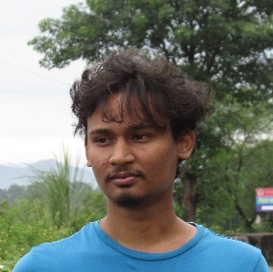Aditya Raushan

Alampur Simri, Muzaffarpur, 843312,

Bihar, India

+918294865510

[adityaraushanad@gmail.com](mailto:adityaraushanad@gmail.com)

Linkedin: <https://www.linkedin.com/in/ad-raushan/>

Github: <https://github.com/ad-raushan>

**Objective:**

Seeking for internship to work on real world projects and enhance my skills

**Education:**

Bachelor of Computer Application

Sri Dev Suman Uttarakhand University, Badshahithol, Tehri(Garhwal), Uttarakhand

Expected graduation: August 2025

**Technical Skills:**

Programming Languages: Javascript, C, C++

Web Technologies: HTML, CSS, Javascript, PHP

Tools: Git

Operating System: Windows

**Projects:**

* <https://petsok-ad.netlify.app/>
* <https://ad-raushan.github.io/>
* <https://realtime-bg-color-change-ad.netlify.app/>