# Motivation

Well we like beer what else do we need? Right! More beer!

We already know that alcohol is a big problem in our society (Austria is placed 6th in the world ranking of total alcohol consumption), so we wanted to see and visualize if there is a correlation between education, employment or other available data in Austria and the overall consumption.

# Related work / Datasets

There are several data sets available by the government and health organisation, which makes sense as alcohol is a rather big problem in Austria, even for minors.

Alcohol consumption per federal state 93/94 and 2008 statistic from 2015

http://www.bmgf.gv.at/cms/home/attachments/6/4/1/CH1039/CMS1305198709856/hbaoe_b a

nd1_statistiken_berechnungsgrundlagen.pdf

Unemployed per federal state

http://wko.at/statistik/Extranet/Langzeit/Blang/Blang-arbeitslose.pdf

Alcohol consumption per federal state

http://www.alkoholohneschatten.at/publikationen/basis-informationen/3-alkohol-in-osterreichin-zahlen-und-fakten/#_ftn2

Beer consumption 2013 in Austria

http://www.freizeitforschung.at/data/spectra/Spectra_Aktuell_06_13_Bierkonsum.pdf

Students per federal state

http://wko.at/statistik/Extranet/Langzeit/Blang/Blang-schueler.pdf

Education statistic for Austria

https://www.bmb.gv.at/ministerium/vp/2015/20150422a.pdf

Foreign workers per federal state

http://wko.at/statistik/Extranet/Langzeit/Blang/Blang-ausl.pdf

Unemployment/Alcohol consumption study

https://www.ncbi.nlm.nih.gov/pmc/articles/PMC3609661/

# Early designs

# C:\Users\Leander\AppData\Local\Microsoft\Windows\INetCacheContent.Word\skizze1.png

# #Grouped bars, show local value next to mean value

Problem: no good way to show mean value for all of Austria -> would need two bars for each year shown)

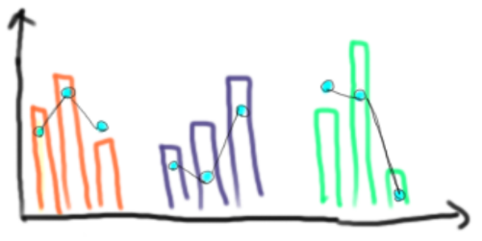

#Grouped bars, show Austrian mean with overlaid dots and lines

Better, but still not quite what we wanted.

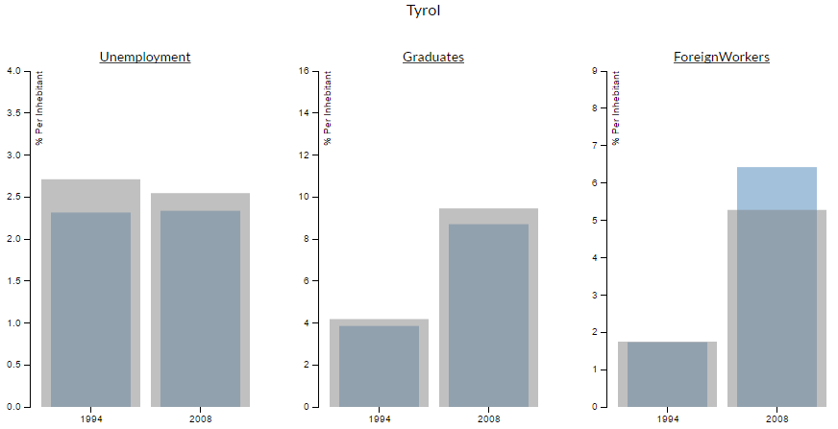

#Final Design:  
  
Show local and Austrian mean in overlaid bars with separate axis.

Advantage: The values of each field differ (as seen in the picture, it ranges between 2 and 10 %), so now we can use an adjusted axis-inscription for each bar-chart.

The design for the map was very clear from the beginning, we used a simple heat map with the alcohol consumption-growth/change over the years:

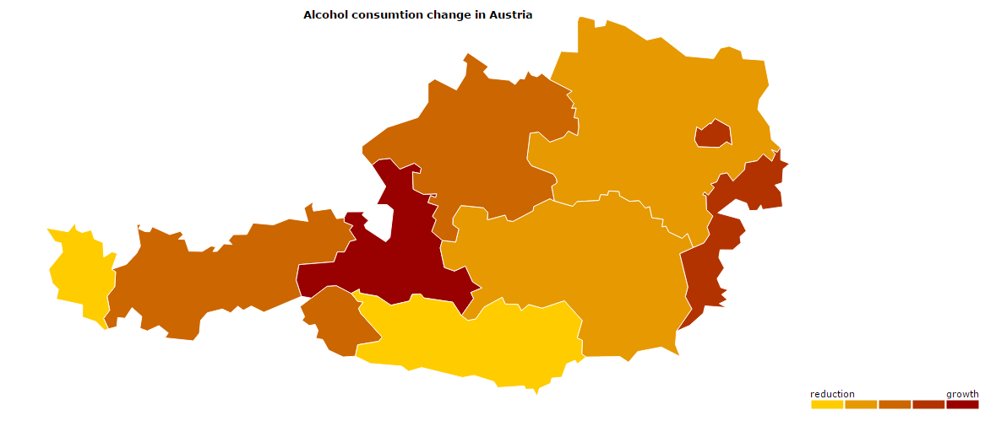

The map also functions as selector for the bar chart to be shown.

# Goals of our visualization

To show an interactive graphic for austria where you can look at beer/alcohol consumption divided into federal states, depending on number of college students, electional behaviour(?), age and any other data we can find and which is detailed enough to use. The additional data can be added and removed, the alcohol consumption is the consistent factor.

**Technical Implementation**

We used [AMCharts](https://www.amcharts.com/) for the heat-map because we liked it more than d3.js, and d3.js for the bar chart. The overlaid bars are simply that – Two bars of different size at the same coordinates.

**Lessons learned**

* JavaScript never was, and never will be, our favourite Language.
* The d3.js documentation could be better.
* Making a visualization is easy, making it look good is hard.

**Member Distribution**

Peter Ortner: Research, Set-Up, Programming

Leander Suda: Research, Concept, Documentation