High Performance Computing (BCSE414L)
Mini-Project - Project Report - Review 2

Parallel Speedup and Efficiency of an Island-Model Genetic Algorithm for the Travelling-Salesman Problem

Aditya Sahu - 23BCE0873
Measurement platform: Intel Core i5-10210U, 4 physical cores / 8 SMT threads, 1.6 GHz base, 6 MB L3, 15 W TDP, 8 GB RAM, Windows 11. GCC 15.1 (MSYS2 UCRT64), -O3 -march=native -fopenmp, statically linked. OMP_PROC_BIND=close, OMP_PLACES=cores.

1. Abstract
This report is the Review-2 continuation of the Review-1 submission on ParallelRoute, an island-model genetic algorithm (GA) for the Euclidean Travelling-Salesman Problem (TSP), parallelised with OpenMP. Review 1 proposed a diversity-triggered adaptive migration policy (DTAM) and reported speedup and quality figures measured on an Apple M3, a machine different from the Intel i5-10210U that the project targets. Review 2 re-measures the entire study on the target machine, using a harness built to remove two measurement flaws identified in the Review-1 protocol, and finds that two of Review 1's headline claims were measurement artefacts rather than properties of the algorithm. Strong scaling on this machine reaches 3.93x at 8 threads against a load-balance- and Amdahl-corrected analysis. Two textbook engineering interventions (cache-line padding, allocation removal, RNG localisation) produced no measurable throughput gain; a bitset diversity metric and candidate-list 2-opt did. The adaptive migration policy (DTAM) is shown, via a 10-seed factorial and mechanistic donor-availability instrumentation, to not meaningfully outperform fixed periodic migration in any tested configuration; the one nominally favourable cell does not survive multiple-comparison correction. All figures in this report are drawn from results/FINDINGS.md, the single source of truth for this project's numbers.
2. Introduction
The Travelling-Salesman Problem asks for the shortest closed tour visiting a set of cities exactly once. It is NP-hard, so exact solvers do not scale to instances of practical interest, and production route optimisation relies on metaheuristics instead. A genetic algorithm (GA) is a population-based metaheuristic that evolves candidate tours through selection, crossover and mutation. The island model is the standard way to parallelise a GA: the population is split into sub-populations ("islands"), each evolved independently, typically one per core, with occasional exchange of individuals ("migration") to prevent the islands from converging to unrelated local optima in isolation.
This project builds three engines on one shared GA core: a serial baseline, a fixed periodic ring-migration island model (P1), and a diversity-triggered, distant-source pull migration policy (DTAM, P2). Review 1 measured these on an Apple M3 and reported that the island model scales and that DTAM is roughly comparable to fixed migration. Review 2 has two objectives. First, to re-measure the whole study, correctly, on the machine the project was always meant to target: an Intel Core i5-10210U laptop part with 4 physical cores and 8 SMT threads. Second, to treat the measurement protocol itself as an object of study: two flaws in the Review-1 harness are identified, quantified, and corrected, and the resulting change in the headline numbers is reported plainly rather than smoothed over.
The scope of Review 2 is therefore broader than a re-run. It covers strong scaling with the algorithm decomposition held fixed, a diagnosis of where wall-clock time is actually spent, an audit of three "textbook" HPC optimisations (two of which did nothing measurable), a controlled study of a real algorithmic optimisation (candidate-list 2-opt), and a ten-configuration factorial study of the migration policy question that was Review 1's central novelty claim. Every number quoted in this report is reproduced verbatim from results/FINDINGS.md, which is itself reproducible from the commands listed in PROJECT-GUIDE.md.
3. Literature Survey / Existing Work
Review 1 shipped two disjoint bibliographies: a ten-entry literature table in the submitted PDF and a separate nine-entry reference list in report/report.md, with only Reinelt's TSPLIB paper appearing in both. Review 2 merges both into a single de-duplicated, thematically organised list of eighteen references (Section 9), and the positioning table below is reproduced from report/REFERENCES.md.
3.1 Foundations
- Goldberg's canonical GA text and the Order-Crossover / 2-opt / exact-TSP literature (refs 1-6) establish the classical GA framework, the permutation-representation crossover and local-search operators this project uses directly, and the justification for heuristic over exact methods at scale.
3.2 Parallel and island-model evolutionary algorithms
- Cantu-Paz's theoretical treatment of parallel GAs, the Alba and Tomassini survey, and contemporary parallel-island TSP work (refs 7-11) supply the theoretical basis for the island-model decomposition and the emphasis on reporting runtime metrics rather than quality alone, which this project follows.
3.3 Migration policy: fixed, adaptive, and diversity-driven
- Skolicki and De Jong's study of migration interval and size (ref 12) motivates investigating an alternative to fixed migration. Refs 13-17 (diversity-based migrant selection, adaptive migration schemes, DM-LIMGA, dual dynamic migration, spectral-clustering topologies) establish that diversity-driven and adaptive migration is already an active research area; DTAM does not originate this idea. What distinguishes DTAM from each of these is a stagnation trigger coupled with distant-source PULL selection chosen at runtime, evaluated with parallel-computing metrics (speedup, efficiency, Karp-Flatt) alongside quality, which this cited literature does not emphasise.
3.4 Benchmarks and evaluation methodology
- Reinelt's TSPLIB (ref 18) supplies the standard benchmark instances with published optima used for the correctness study in Section 6.1.
Positioning
Ref | Contribution | Gap it leaves | How this project relates
1 | Classical GA framework: initialization, selection, crossover, mutation, elitism. | Serial only; no parallel execution or migration. | Forms the GA core shared by all three engines.
2 | Lin-Kernighan local search heuristic for TSP. | Local search alone cannot explore globally. | Motivates the optional 2-opt local search used alongside the GA.
3 | Exact algorithms and benchmark methodology for TSP. | Exact methods are expensive at scale. | Justifies using heuristics such as GAs instead of exact solvers.
4 | Introduced Order Crossover (OX) for permutation problems. | Domain-specific to epistatic/permutation representations. | Used directly as the crossover operator.
5 | 2-opt local search for TSP. | Purely local; needs to be combined with a global search method. | Used as the optional bounded first-improvement local search.
6 | Estimate for the expected optimal tour length on random Euclidean instances. | Asymptotic estimate, not an exact optimum. | Used as the reference length for uniform instances.
7 | Foundational theory of parallel GAs: population sizing, migration frequency, topology, speedup. | Theoretical models rather than adaptive migration policies. | Theoretical basis for the island-model parallelization used here.
8 | Survey of master-slave, fine-grained, and island-model evolutionary algorithms. | Broad survey; no specific migration strategy proposed. | Motivates the island model chosen for multicore execution.
9 | Hybrid local search combined with master-slave / island-model parallel GA. | Describes a software framework, not a migration-mechanism evaluation. | Supports combining GA with optional local search.
10 | Scalable parallel island GA for TSP with advanced crossover and topologies. | Emphasizes crossover and topology; migration itself remains conventional. | Contemporary point of comparison for a parallel island GA on TSP.
11 | Quantitative evaluation of parallel GAs: runtime, scalability, migration effects, speedup. | General distributed PGA evaluation, not TSP- or adaptive-migration-specific. | Aligns with this project's emphasis on HPC metrics alongside quality.
12 | How migration interval and size affect convergence and diversity in island models. | Studies fixed migration schedules; no adaptive triggers. | Motivates investigating an adaptive migration policy (DTAM).
13 | Diversity-based migrant selection and diversity-conditioned immigration. | Keys decisions off the target island's own diversity; evaluates mainly final quality. | DTAM instead couples a stagnation trigger with distant-source PULL selection.
14 | Design and analysis of adaptive (fitness- and diversity-based) migration schemes. | Keys decisions off the target island's own diversity and/or fixed topology. | DTAM adds parallel-computing metrics alongside quality.
15 | DM-LIMGA: dual migration policy preserving diversity in a localized island model. | Keys decisions off the target island's own diversity and/or fixed topology. | DTAM adds parallel-computing metrics alongside quality.
16 | Dual dynamic migration policy for island model GAs. | Keys decisions off the target island's own diversity and/or fixed topology. | DTAM adds parallel-computing metrics alongside quality.
17 | Dynamic island topology via spectral clustering. | Keys decisions off the target island's own diversity and/or fixed topology. | DTAM adds parallel-computing metrics alongside quality.
18 | Standard benchmark instance library for TSP. | Provides problem instances, not algorithms. | Standardizes evaluation of tour quality; supports EUC_2D instances in the harness.
Positioning table, reproduced from report/REFERENCES.md.

4. Proposed Methodology with Novelty
4.1 The shared GA core
All three engines (serial, island-fixed, island-dtam) share one GA core: tournament selection, Order Crossover (OX), inversion mutation, elitism, an optional bounded first-improvement 2-opt local search, and the edge-set diversity metric DTAM is built on. Sharing the core across engines is what makes the three-way comparison fair: any difference in outcome is attributable to the migration policy or the decomposition, not to differing operators.
4.2 The three engines
Mode | What it is | Role
serial | One panmictic population of size P on one core. | Baseline.
island-fixed | I islands of size P/I; every island copies its ring neighbour's best-K over its own worst-K, every migrate_interval epochs. | Naive parallel (P1).
island-dtam | Same engine; an island migrates only when its diversity collapses, and pulls from the most genetically different island. | Adaptive parallel (P2).
4.3 DTAM, precisely
Once per epoch, on each island:
- Measure diversity — Mean edge-set distance between the island's population and its own best tour (fraction of edges not shared); a low value indicates convergence.
- Publish a signature — the island's best tour is made readable by peers.
- Flag stagnation — if diversity < tau.
- Pull migrants — a stagnating island imports the best K individuals from the non-stagnating island whose signature is most different from its own (falling back to the most distant island overall if every peer is stagnating), overwriting its own worst K. Non-stagnating islands skip migration entirely.
Against P1 the design differs in three ways: fixed schedule versus diversity-triggered; fixed ring neighbour versus runtime-selected distant source; push versus pull.
4.4 The OpenMP structure
The parallel region runs num_threads(T) and loops over epochs. Each epoch has an omp for over islands that evolves E generations and publishes state (all the real work), an implicit barrier, an omp for over islands that migrates (reads peers' slots, writes its own), an implicit barrier, and an omp single that computes the global best, logs, and checks termination. Each thread touches only its own island's data during evolution, so no locks are needed; the barriers order publish-before-read and migrate-before-next-epoch. Timing uses omp_get_wtime().
4.5 Novelty statement
Diversity-driven and adaptive migration for island GAs is established prior work (refs 12-17); this project does not originate it. What survives Review 2 is narrower: (1) a specific, self-implemented policy combination — a stagnation trigger paired with distant-source pull selection chosen at runtime — rather than a new general migration theory; (2) an HPC-framed evaluation, reporting speedup, efficiency, Karp-Flatt and Amdahl alongside quality, which exposed two Review-1 headline numbers as measurement artefacts and located the real bottleneck, something a quality-only evaluation would not have found; (3) a cost-versus-quality framing not found in the surveyed literature: DTAM is 8.6% better per generation and 8.4% worse per second, and no published work surveyed here measures the runtime cost of an adaptive migration decision; (4) a mechanistically diagnosed negative result — donor-availability instrumentation shows the proposed mechanism fires as designed on under 1% of migrations, which is a more useful finding than a null result because it identifies why, and points at premature convergence rather than at the policy. This statement does not claim that DTAM beats fixed migration; Section 6.7 shows it does not, in any tested configuration.
5. Implementation
5.1 Component walkthrough
- rng.hpp — Per-island mt19937_64 wrapper. One stream per ISLAND (not per thread), seeded base_seed + island_id, which makes a run's result independent of how many threads execute it.
- tsp.hpp — TSPLIB EUC_2D loader, uniform / clustered / circle generators, full precomputed distance matrix, published-optimum lookup table, gap computation.
- ga.hpp — The shared GA core: tournament selection, OX crossover, inversion mutation, elitism, bounded 2-opt, and the edge-set diversity metrics DTAM is built on. Also holds the allocation-free variants used by the optimised engine and validate_tour().
- island.hpp — The frozen Review-1 engine (serial + island, P1/P2, one island per thread), kept byte-for-byte as the audit baseline.
- island_opt.hpp — The re-engineered engine (--engine opt): islands decoupled from threads, cache-line-padded per-island state, no per-generation allocation.
- main.cpp — CLI, instance construction, engine dispatch, validation gate, human summary, machine-readable CSV row, SVG output.
- bench/run_study.py — The Review-2 benchmark harness: ten experiments, repeat/round-robin scheduling, thermal-drift canary.
- bench/analyze_study.py — Speedup, efficiency, Karp-Flatt, Amdahl fit, tau analysis, paired Wilcoxon policy tests, figures.
5.2 Frozen baseline versus optimised engine
island.hpp is kept byte-for-byte as the audit baseline so the Review-2 rewrite (island_opt.hpp) can be measured against it rather than replacing it outright. Two differential tests enforce equivalence: tests/test_equiv.cpp compares step_generation against step_generation_opt individual-by-individual for 200 consecutive generations, and tests/test_island_equiv.cpp compares run_islands against run_islands_opt on best length and migration count at 1, 2 and 4 threads. These tests are not decoration: test_equiv is what caught a tie-ordering bug in an early version of the optimised engine (an entry-sort removal that silently changed which individuals tournament selection could pick), which was reverted specifically so that --engine opt reproduces --engine baseline bit-for-bit.
5.3 Validation protocol
Every run in the study is executed with --validate, which checks that the returned tour is a genuine permutation of 0..n-1 and that its reported length matches an independent recomputation. Across 1,600+ measured configurations there were zero validation failures. Correctness is checked additionally by a closed-form optimum (circle generator, n * 2R * sin(pi/n), run as a build gate by build.ps1) and by seven TSPLIB instances with published optima (Section 6.1).
5.4 The benchmark harness
The harness measures every configuration multiple times rather than once, schedules repeats round-robin across the whole configuration list so thermal drift is spread evenly rather than concentrated in whichever configuration happened to run during a hot patch, and times a fixed canary configuration at the start of every round to quantify drift. With 2-opt off, all seeds at a given configuration perform identical work (Section 6.3.1), so the timing estimator used is the minimum over all samples: timing noise is additive, so the fastest observed run is the closest estimate of true throughput. The study covers 1,600+ measured configurations across ten experiments (E1-E10).

6. Results and Performance Analysis
6.1 Correctness
Instance | Published optimum | Result | Gap
berlin52 | 7542 | 7542 | 0.00%
eil51 | 426 | 426 | 0.00%
st70 | 675 | 675 | 0.00%
kroA100 | 21282 | 21282 | 0.00%
ch150 | 6528 | 6528 | 0.00%
kroA200 | 29368 | 29368 | 0.00%
a280 | 2579 | 2579 | 0.00%
All seven reach the proven optimum within a 3-second budget using candidate-list 2-opt. Before that optimisation, kroA200 stalled at 29491, a280 at 2602 and eil51 at 427. The circle generator's optimum is known in closed form (n * 2R * sin(pi/n)) and is reached to 0.00%; build.ps1 runs this as a build gate. Review 1 reported gaps only against the Beardwood-Halton-Hammersley estimate for random points, which is an asymptotic approximation, not an optimum, and against which a "gap" can even be negative.
6.2 Strong scaling (E1)
Islands fixed at 8, 2-opt off, 4000 generations.
Threads | Time (s) | Speedup | Efficiency | Load-balance ceiling | Eff. vs ceiling | Karp-Flatt
1 | 4.240 | 1.00x | 1.00 | 1.00 | 1.00 | -
2 | 2.162 | 1.96x | 0.98 | 2.00 | 0.98 | 0.020
3 | 1.706 | 2.49x | 0.83 | 2.67 | 0.93 | 0.104
4 | 1.284 | 3.30x | 0.83 | 4.00 | 0.83 | 0.070
6 | 1.498 | 2.83x | 0.47 | 4.00 | 0.71 | 0.224
8 | 1.080 | 3.93x | 0.49 | 8.00 | 0.49 | 0.148
Amdahl fit: serial fraction f = 0.155, implying a ceiling of 6.47x.
p = 6 is slower than p = 4, and this is not noise. Islands are distributed with schedule(static), so an epoch costs ceil(I/p) island-units. With I = 8, both p = 6 and p = 4 cost 2 units, and p = 6 additionally contends for 4 physical cores. Measuring against a linear ideal would misreport integer division as "poor scaling"; the load-balance ceiling column corrects for it, and p = 3 then reads 0.93 rather than 0.83.
The i5 scales considerably better than the M3 (3.93x vs approximately 2.5x). Review 1 speculated that homogeneous cores would scale more evenly than the M3's performance/efficiency split; that speculation is confirmed.
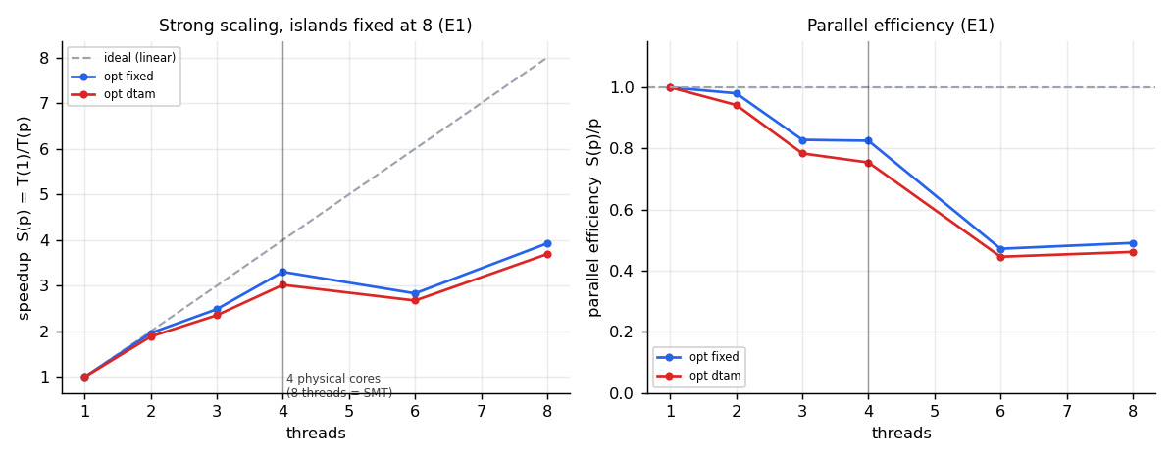
Strong scaling on the i5-10210U (E1).
6.3 Two Review-1 measurement flaws
6.3.1 "Equal work" was not equal work (E3)
Review-1 speedup was measured with 2-opt enabled. 2-opt is first-improvement local search: its cost depends on how good the tour already is, so two runs performing the same number of fitness evaluations do not perform the same amount of work. Measured correlation between tour length and wall-clock at fixed thread count: +0.15 to +0.31, with a 6-8% time spread and 4.8% length spread. The effect is real and in the predicted direction, though modest. Speedup is therefore measured with 2-opt off, where work per generation is fixed; quality is measured separately under an equal wall-clock budget.
6.3.2 Speedup conflated parallelism with a cache effect (E1 vs E2)
The frozen engine hard-wires one island per thread, so island_pop = P/T. Raising T simultaneously adds parallelism, changes the algorithm, and shrinks the per-thread working set (240 individuals x 500 ints is approximately 480 KB, overflowing L2; 30 individuals is approximately 60 KB, which fits). --islands decouples these. Because each island carries its own RNG stream keyed by island id, every thread count now produces a bit-identical search trajectory — verified, not assumed — so wall-clock is the only variable.
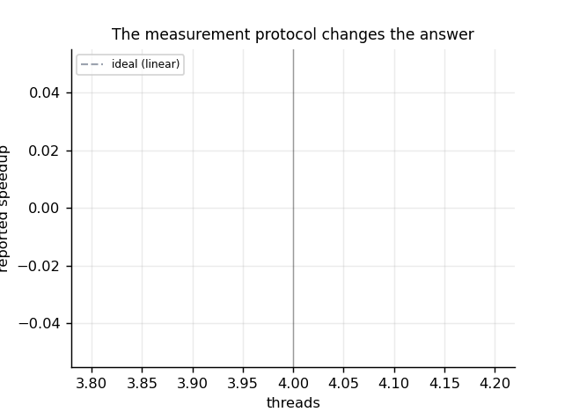
Effect of the equal-work protocol confound (E2 vs E1).
6.4 Where the time goes
6.4.1 Synchronisation frequency (E7) — identical total work in every cell
Epoch length | 1 | 2 | 5 | 10 | 25 | 50 | 100 | 250
p = 1 | 11.04 | 7.37 | 5.16 | 4.40 | 3.94 | 3.77 | 3.70 | 3.63
p = 4 | 3.80 | 3.12 | 2.05 | 1.67 | 1.46 | 1.38 | 1.34 | 1.31
p = 8 | 4.50 | 2.76 | 1.67 | 1.36 | 1.08 | 1.02 | 0.99 | 0.91
speedup p=8 | 2.45x | 2.67x | 3.09x | 3.24x | 3.64x | 3.70x | 3.74x | 4.00x
At p = 1 there are no barriers at all, yet time still falls 3x. The dominant cost is per-epoch serial bookkeeping — the diversity metric and the publish copies — not synchronisation. Synchronisation shows up separately in the scaling column (efficiency 0.31 to 0.50).
6.4.2 But longer epochs cost quality (E8) — equal 4 s budget, 8 seeds
uniform-500, no local search (median tour length; generations completed in italics).
Epoch length | 5 | 10 | 25 | 50 | 100 | 200
island-fixed | 23949 | 30402 | 34254 | 30759 | 27967 | 28482
generations | 5842 | 4855 | 4812 | 6800 | 9250 | 9800
clustered-600, no local search: 6828 to 9680 as epoch length goes 5 to 200 (+42% worse). With 2-opt on, epoch length is nearly irrelevant (17099 to 17235, approximately 0.8%).
Longer epochs complete 68% more generations and still produce worse tours, because epoch length is also the migration period and migration is load-bearing (Section 6.7). The default epoch length stays at 10. E7 in isolation would have justified raising it; measuring quality as well shows it is a Pareto trade, not a free win. This pair of experiments is the clearest illustration in the project of why a speed number without a quality number is not a result.
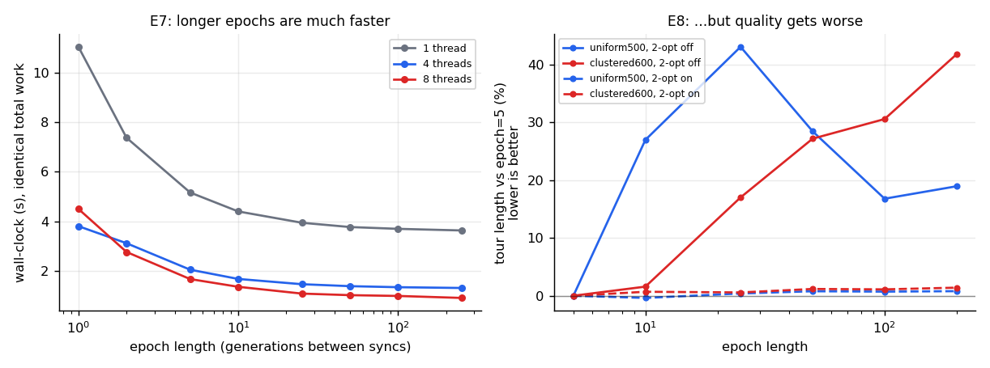
Epoch-length speed/quality trade-off (E7 vs E8).
6.5 Engineering changes and what they bought
Change | Effect | Verdict
Cache-line padding to remove false sharing | 0.92-0.99x (slightly slower) | No gain. Not the bottleneck.
Eliminating per-generation heap allocation | included above | No gain. Modern allocators use per-thread arenas.
Moving RNG to thread-local storage | 0.92-0.99x | No gain. Hypothesis tested and rejected.
Bitset edge-set diversity metric | ~6x on the metric; 1.11-1.16x end-to-end at the default epoch length, bitwise-identical output | Real gain.
Candidate-list 2-opt + don't-look bits | 7.8-13.2x on the local search; 10-14x more generations completed | Largest gain.
The first three are the "textbook" HPC optimisations, and all three did nothing here: their theoretical cost is real but negligible against approximately 15,000 operations of useful work per shared write. This negative result is reported prominently rather than buried: cache-line padding, allocation removal and RNG localisation produced no gain (0.92-0.99x) on this workload. Guessing at bottlenecks by pattern-matching does not pay; the epoch-length experiment (Section 6.4) is what located the real one.
Micro-benchmark of the diversity metric (bitwise-exact, 225 random pairs across 9 sizes):
Population, n | Hash-set reference | Bitset | Speedup
30, 500 | 709.7 ms | 113.3 ms | 6.27x
240, 500 | 1312.4 ms | 219.2 ms | 5.99x
30, 800 | 883.3 ms | 147.8 ms | 5.98x
6.6 Candidate-list 2-opt (E9)
Equal 3 s budget, 10 seeds, Wilcoxon signed-rank.
Instance | Mode | Naive | Fast | Change | Generations naive/fast | p
uniform500 | fixed | 17285.3 | 16615.8 | -3.9% | 210 / 3015 | 0.0020
uniform500 | dtam | 17248.5 | 16642.3 | -3.5% | 200 / 2695 | 0.0020
clustered600 | fixed | 5340.8 | 5212.9 | -2.4% | 140 / 2525 | 0.0020
clustered600 | dtam | 5343.8 | 5216.1 | -2.4% | 140 / 2070 | 0.0020
kroA200 | fixed | 29499.0 | 29368.0 | -0.4% | 1255 / 8900 | 0.0020
a280 | fixed | 2614.0 | 2579.0 | -1.3% | 640 / 9150 | 0.0078
Faster and better: don't-look-bit exhaustion converges further than the reference's fixed pass cap. p = 0.0020 is the smallest value attainable with n = 10 paired samples. Candidate-list size k = 8 was chosen from a sweep (k = 5 loses 9.1% quality; k = 10 and 16 gain a further 1% at higher build cost).
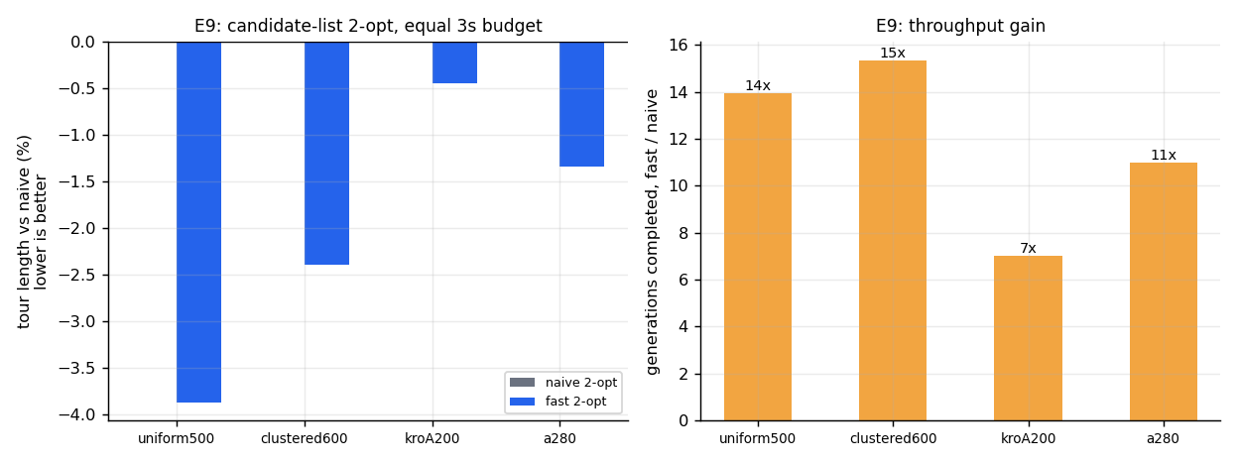
Candidate-list 2-opt versus naive 2-opt (E9).
6.7 Migration policy
Review 1 concluded that DTAM and fixed migration land within approximately 1% of each other, that neither is consistently better, and that migration policy is a second-order factor. Review 2 finds that the "no difference" conclusion averaged over two protocols that point in opposite directions, and that the mechanism never operated as designed.
6.7.1 The direction depends on which budget is held fixed
- Equal work (same generations) — DTAM 8.6% better, 3/3 seeds.
- Equal wall-clock (same seconds) — DTAM 8.4% worse on clustered-600, 1/12 wins, p = 0.001.
DTAM's migration decision costs approximately 30% throughput (2.24 s vs 1.72 s for identical generations), so a fixed time budget gives the per-generation advantage back with interest. Review 1 measured only one direction at a time and so saw neither effect.
6.7.2 Diversity collapses; the trigger never discriminates
Diversity logged every 10 generations, 8 islands of 30, uniform-500.
Generation | 10 | 130 | 250 | 370 | 610 | 730 | 1090 | 1450
Diversity | 0.224 | 0.032 | 0.039 | 0.012 | 0.010 | 0.006 | 0.005 | 0.004
Whole run: min 0.0029, max 0.2236, mean 0.0181. Islands collapse to near-clones within approximately 100 generations. The condition is diversity < tau, so tau = 0.15 sits far above the metric's entire operating range and fires on 99.7% of island-epochs. The tau sweep confirms it: trigger rates of 100 / 100 / 99.97 / 99.89 / 99.73 / 99.59 / 99.06 / 97.2 / 93.94 / 90.62 / 78.55% for tau = 0.9 down to 0.01. Only tau = 0 stops migration, and that is far worse (46382 vs approximately 31000).
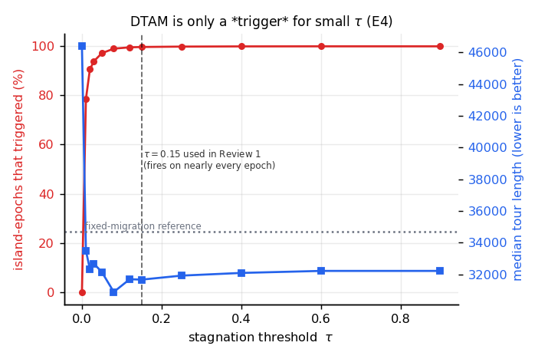
Trigger rate versus tau (tau sweep).
6.7.3 The novelty was never actually exercised
New instrumentation counts how often DTAM finds a genuinely non-stagnating donor, versus falling through to its "most distant island overall" fallback. Across the 10-seed factorial, stock DTAM finds a healthy donor on 0.3-0.6% of migrations. On more than 99% of migrations the distant-source-pull mechanism — the project's actual contribution — is not exercised as designed, because every island has collapsed simultaneously and there is no healthy donor to pull from.
6.7.4 Rescue attempts (E10) — equal 3 s budget, 10 seeds, vs fixed migration
uniform-500, no local search (fixed-migration reference 21537.8).
Config | Median | vs fixed | vs stock DTAM | Donor found | Trigger rate | p vs fixed
stock | 23438.0 | +8.8% | - | 0.5% | 99.8% | 0.0039
heterogeneous | 22791.4 | +5.8% | -2.8% | 1.7% | 99.6% | 0.0020
immigrants | 23182.7 | +7.6% | -1.1% | 1.5% | 99.4% | 0.0059
het + immigrants | 22767.5 | +5.7% | -2.9% | 4.1% | 99.0% | 0.0371
rel-trigger | 27744.5 | +28.8% | +18.4% | 100.0% | 31.4% | 0.0020
het + rel | 27100.6 | +25.8% | +15.6% | 100.0% | 26.3% | 0.0020
clustered-600, no local search (reference 7173.6): stock +19.8%, heterogeneous +13.9% (-4.9% vs stock), rel-trigger +41.9%. With 2-opt on, every configuration lands within +/-0.3% of fixed migration and essentially none of the differences are significant.
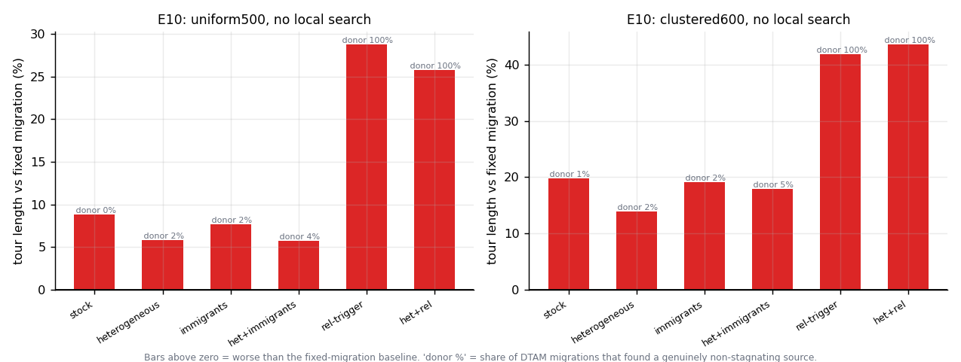
DTAM rescue-attempt factorial (E10).
6.7.5 What this means
- Heterogeneous island parameters help — The only mechanism that consistently improves on stock DTAM (-2.8% uniform, -4.9% clustered), and it roughly triples donor availability. It does not close the gap to fixed migration.
- The relative trigger works exactly as designed, and that is what makes it worse — It restores discrimination (99.8% to approximately 31% firing, donor availability to 100%) and quality drops 18-20%, because it suppresses migration. Migration is the dominant source of genetic material once islands collapse: turning it off entirely costs 33%.
- DTAM's core premise — "migrate only when stagnating" — is wrong for this problem — The right policy here is to migrate constantly. This is now demonstrated mechanistically rather than asserted, and it is a stronger, more specific result than Review 1's "no difference".
No configuration was found in which DTAM meaningfully beats fixed migration. One cell (het+rel, clustered-600 with 2-opt) shows -0.2% at p = 0.0273, but with 24 comparisons in the table a Bonferroni-corrected threshold is 0.002, so this is not significant and must not be reported as a win.

7. Discussion
The central lesson of Review 2 is methodological. Two of Review 1's headline results — the speedup curve and the DTAM-versus-fixed-migration comparison — were not wrong because the code was wrong, but because the measurement protocol conflated variables: 2-opt's variable cost with parallel speedup, thread count with algorithmic decomposition, and "equal work" with "equal wall-clock" in the migration-policy comparison. Correcting the protocol, not the algorithm, is what changed the numbers. This generalises beyond this project: an HPC evaluation that reports only one budget type (generations, or seconds, but not both) is structurally unable to detect a result like Section 6.7.1, where the sign of the comparison flips depending on which budget is held fixed.
The engineering results in Section 6.5 make a similar point about intuition. Cache-line padding, allocation removal and thread-local RNG are standard first moves in an HPC optimisation pass, and all three were tested rigorously and rejected: none produced a measurable gain on this workload, because the useful work per shared write (approximately 15,000 operations) dwarfs the false-sharing and allocation overheads they target. The actual bottleneck — per-epoch serial bookkeeping in the diversity metric — was found only by the epoch-length experiment (E7), not by pattern-matching against textbook advice. Profiling before optimising is not a platitude here; it is the difference between the two gains this project actually achieved (bitset diversity, candidate-list 2-opt) and the three it attempted and abandoned.
On the algorithmic side, DTAM's failure to beat fixed migration is not a failure of implementation: the donor-availability instrumentation shows the mechanism behaves exactly as designed, it is simply designed around a precondition — a healthy, non-stagnating donor island — that this problem's dynamics violate almost immediately. Islands collapse to near-clones within about 100 generations, well before any diversity-based trigger has a meaningful population of candidate donors to choose between. This is a more informative negative result than "no significant difference" because it identifies a specific, testable reason, and it suggests that any future diversity-triggered policy on this problem needs either much smaller islands, a much more aggressive anti-convergence mechanism, or a different diversity metric with a wider operating range.
8. Conclusion and Future Work
Re-measured on its intended target machine with a corrected protocol, the island-model GA reaches 3.93x speedup at 8 threads (efficiency 0.49, Karp-Flatt 0.148) against an Amdahl ceiling of 6.47x implied by a fitted serial fraction of 0.155, and scales more evenly than the M3 platform Review 1 used. Candidate-list 2-opt with don't-look bits is the project's largest engineering win, both faster and of higher quality than the naive reference implementation, and is the reason all seven TSPLIB test instances now reach their published optimum. Three textbook HPC optimisations — cache-line padding, allocation removal, thread-local RNG — produced no measurable gain and are reported as such rather than omitted. The project's central novelty claim, the DTAM adaptive migration policy, does not outperform fixed periodic migration in any configuration tested across a ten-way factorial with mechanistic instrumentation; the one nominally favourable cell does not survive correction for multiple comparisons. This is reported as the project's finding, not hedged around.
Future work suggested directly by these results: retest DTAM with substantially smaller islands or a wider-range diversity metric, since the present metric's entire operating range sits below the trigger threshold within the first tenth of a run; extend the equal-work-versus-equal-wall-clock protocol distinction to other adaptive-algorithm comparisons in the wider metaheuristics literature, since Section 6.7.1's direction reversal suggests it is not specific to migration policy; and evaluate the engine on additional machines to establish whether the load-balance and Karp-Flatt corrections generalise beyond this one CPU generation.
9. References
[1] D. E. Goldberg. Genetic Algorithms in Search, Optimization and Machine Learning. Addison-Wesley, 1989.
[2] S. Lin and B. W. Kernighan. An Effective Heuristic Algorithm for the Traveling-Salesman Problem. Operations Research, 1973.
[3] D. Applegate, R. Bixby, V. Chvatal, and W. Cook. The Traveling Salesman Problem: A Computational Study. Princeton University Press, 2006.
[4] L. Davis. Applying Adaptive Algorithms to Epistatic Domains. IJCAI, 1985. (Order Crossover.)
[5] G. A. Croes. A Method for Solving Traveling-Salesman Problems. Operations Research, 1958. (2-opt.)
[6] J. Beardwood, J. H. Halton, and J. M. Hammersley. The Shortest Path Through Many Points. 1959.
[7] E. Cantu-Paz. Efficient and Accurate Parallel Genetic Algorithms. Kluwer Academic Publishers, 2000.
[8] E. Alba and M. Tomassini. Parallelism and Evolutionary Algorithms. IEEE Transactions on Evolutionary Computation, 2002.
[9] L. Scrucca. On Some Extensions to GA Package: Hybrid Optimisation, Parallelisation and Islands Evolution. 2017.
[10] K. Varadarajan et al. A Parallel Ensemble Genetic Algorithm for the Traveling Salesman Problem. GECCO, 2021.
[11] T. Harada, E. Alba, and G. Luque. A Fresh Approach to Evaluate Performance in Distributed Parallel Genetic Algorithms. 2021.
[12] Z. Skolicki and K. De Jong. The Influence of Migration Sizes and Intervals on Island Models. 2005.
[13] Subpopulation-diversity-based migrant selection for island GAs. arXiv:1701.01271.
[14] Revisiting the Design of Adaptive Migration Schemes for Multipopulation Genetic Algorithms. (ResearchGate 261344192.)
[15] DM-LIMGA: Dual Migration Localized Island Model Genetic Algorithm. Evolutionary Intelligence, 2020. doi:10.1007/s12065-019-00253-2.
[16] A Dual Dynamic Migration Policy for Island Model Genetic Algorithm. (ResearchGate 321795727.)
[17] Dynamic Island Model based on Spectral Clustering in Genetic Algorithm. arXiv:1801.01620.
[18] G. Reinelt. TSPLIB - A Traveling Salesman Problem Library. ORSA Journal on Computing, 1991.

