REAL-TIME
STREAMING ANALYTICS
A Smart-Meter Electricity Monitoring Mini-Project

Project Report
Course: Data Stream Analytics
Technology Stack: Apache Kafka | Python | scikit-learn | MySQL | Streamlit
Prepared from the supplied mini-project guide, source code, README and sample dataset

Abstract
This project implements a small end-to-end real-time streaming analytics pipeline for household electricity consumption. A CSV file containing smart-meter readings is replayed as a paced stream by a Python Kafka producer. A Kafka consumer processes each event, maintains a rolling window of up to 30 active-power readings, calculates a rolling average and running peak, applies a previously trained Isolation Forest model to flag unusual readings, and stores the results in MySQL. A Streamlit dashboard queries the database and refreshes automatically every two seconds to display the latest power reading, rolling average, peak within the displayed sample, reading count and anomaly count.
The supplied dataset contains 17 rows and seven columns. In this sample, global active power ranges from 3.520 kW to 11.200 kW, with a mean of 5.034 kW. The implementation demonstrates the six-layer architecture described in the project guide. The report also identifies implementation boundaries: the supplied sample is short, the dashboard metrics are calculated over the most recent 120 stored records, and the current SQL schema contains one readings table rather than the separate current-state metrics table shown in the guide.

1. Introduction
Real-time streaming analytics analyses events as they arrive rather than waiting for a complete dataset to be collected and processed in a later batch. The project uses a smart-meter scenario: each CSV row represents an electricity measurement at a particular timestamp. The CSV is not a live physical sensor feed; instead, producer.py replays the available rows with a 0.2-second delay between messages. This creates a controlled stream suitable for demonstrating ingestion, processing, machine-learning inference, persistence and visualization.
The project follows the guide's six layers: data source, streaming tool, stream processor, ML algorithm, database and visualization. The guide emphasizes that a dashboard is genuinely live only when fresh data is arriving and the view automatically re-queries that data. The implementation addresses both parts through a paced producer and a two-second dashboard refresh.

2. Project Objectives
- Replay smart-meter electricity readings from a CSV file as a sequence of Kafka events.
- Use Kafka to decouple the data producer from the downstream consumer.
- Process incoming events continuously and maintain a sliding window of up to 30 readings.
- Calculate the rolling average and the running maximum active-power reading.
- Use an unsupervised Isolation Forest model to classify each incoming active-power value as normal or anomalous.
- Persist timestamps, active-power values, rolling averages and anomaly flags in MySQL.
- Present current and recent stream information in a Streamlit dashboard that refreshes automatically.
- Demonstrate the complete pipeline from event production through database storage to dashboard visualization.

3. System Architecture
The architecture below maps the supplied Python scripts and database schema to the six layers required by the guide. Events move from left to right. The database separates the processing component from the dashboard, allowing the processor to write results while the dashboard reads them.
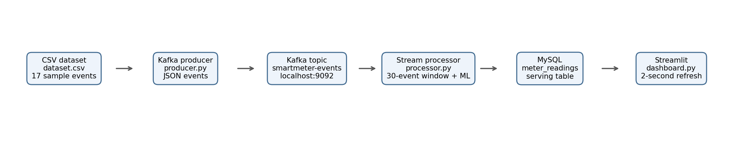
Figure 1. Architecture of the implemented smart-meter streaming pipeline.
Layer | Implementation | Responsibility
1. Data source | dataset.csv | Provides timestamped electricity measurements for replay.
2. Streaming tool | Apache Kafka; topic smartmeter-events | Transports JSON events from producer to consumer.
3. Stream processor | processor.py | Maintains a 30-event window, computes rolling average and peak, and orchestrates persistence.
4. ML algorithm | IsolationForest in scikit-learn | Scores each incoming active-power reading as normal or anomalous.
5. Database | MySQL; meter_readings | Stores each processed reading and its derived fields.
6. Visualization | dashboard.py using Streamlit | Displays KPI values and a recent time-series chart with automatic refresh.

4. Dataset Description and Preparation
The supplied dataset.csv is a compact smart-meter sample with 17 records and seven columns. The timestamps cover 16 December 2006 from 17:24:00 through 17:40:00, at one-minute intervals. The producer uses only Date_Time and Global_active_power when constructing Kafka messages. The remaining columns are retained in the CSV but are not currently sent through Kafka or stored by the supplied processor.
Column | Meaning in project | Used by current pipeline?
Date_Time | Timestamp associated with the meter reading. | Yes, sent as reading_time and stored.
Global_active_power | Household active power, in kW. | Yes, streamed, modelled and stored.
Global_reactive_power | Reactive power measurement. | No, retained only in CSV.
Global_intensity | Current intensity measurement. | No, retained only in CSV.
Sub_metering_1 | Sub-meter channel 1. | No, retained only in CSV.
Sub_metering_2 | Sub-meter channel 2. | No, retained only in CSV.
Sub_metering_3 | Sub-meter channel 3. | No, retained only in CSV.

Dataset summary: 17 records; no missing values in any of the seven supplied columns; mean active power 5.034 kW; median 4.216 kW; minimum 3.520 kW; maximum 11.200 kW; sample standard deviation 2.389 kW.
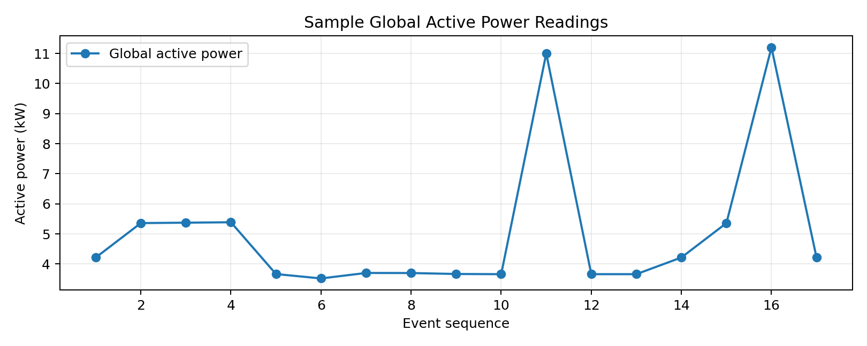
Figure 2. Active-power values in the supplied 17-record sample.
The producer converts Global_active_power to float and packages it with the timestamp as a JSON event. The code assumes that these fields are present and numeric. The guide recommends validating blank or invalid readings before sending them; the current producer does not yet implement that validation. The supplied sample itself has no missing values.

5. Layer 1 and Layer 2: Data Source and Kafka Streaming

5.1 Data producer
producer.py creates a KafkaProducer connected to 127.0.0.1:9092. Its value_serializer converts Python dictionaries into JSON-encoded UTF-8 messages. It opens dataset.csv with csv.DictReader, reads one row at a time, creates an event with reading_time and global_active_power, and sends the event to the smartmeter-events topic. A 0.2-second pause is applied after each send, equivalent to a nominal rate of five messages per second while rows remain available.
event = {'reading_time': row['Date_Time'],\n 'global_active_power': float(row['Global_active_power'])}\nproducer.send('smartmeter-events', value=event)\ntime.sleep(0.2)
The delay is a replay mechanism, not the original one-minute sampling interval. The event retains its original timestamp, but the demonstration delivers events much faster than real time. This is useful for a classroom demonstration because the dashboard changes visibly without waiting 17 minutes.

5.2 Kafka broker and topic
Kafka acts as the message broker between the producer and processor. The producer only needs to publish events to the topic; it does not need to know how the consumer calculates metrics or stores records. The processor subscribes to smartmeter-events and deserializes each JSON message. This separation supports independent execution and reduces direct coupling between components.
According to README.md, the local setup uses ZooKeeper and the Kafka server in separate terminal sessions, then creates the smartmeter-events topic. The producer and consumer both point to the local broker at 127.0.0.1:9092.

6. Layer 3: Stream Processing and Windowing
processor.py is the consumer and stream-processing component. It subscribes to smartmeter-events using KafkaConsumer and decodes each message from JSON. For every event, it extracts the timestamp and active-power value, appends the value to a collections.deque configured with maxlen=30, calculates the average of the values currently in that deque, and updates a running peak.
window = deque(maxlen=30)\npeak = 0.0\n\nfor message in consumer:\n power = message.value['global_active_power']\n window.append(power)\n rolling_avg = sum(window) / len(window)\n peak = max(peak, power)
The deque is a bounded sliding window. Before it reaches 30 events, the average uses all events received so far. Once it contains 30 events, adding a new event automatically discards the oldest value. The rolling average therefore represents the most recent 30 processed readings, or 30 minutes only if the incoming events are actually one minute apart. Because this project's producer replays events every 0.2 seconds, '30-event rolling average' is the most technically accurate description of the current demonstration.
The peak variable is initialized to 0.0 and updated with max(peak, power), so it tracks the maximum value seen since the processor started. However, the current processor does not write this peak to MySQL. The dashboard instead calculates a maximum over the records it has just queried.

7. Layer 4: Machine-Learning Anomaly Detection

7.1 Algorithm selection
The project uses IsolationForest from scikit-learn. Isolation Forest is an unsupervised anomaly detection algorithm. It is suitable for this demonstration because the code does not require a separate labelled column indicating which readings are abnormal. It learns a representation of the distribution of active-power values and identifies readings that appear unusual relative to the training sample.

7.2 Offline training
train_model.py loads only the Global_active_power column from dataset.csv, removes missing rows, creates an IsolationForest with contamination=0.01 and random_state=42, fits the model, and saves the fitted estimator to anomaly_model.pkl using joblib. This is the train/serve separation described in the guide: training occurs before stream processing, while the running consumer loads the saved model once at startup.
df = pd.read_csv('dataset.csv', usecols=['Global_active_power']).dropna()\nmodel = IsolationForest(contamination=0.01, random_state=42)\nmodel.fit(df[['Global_active_power']])\njoblib.dump(model, 'anomaly_model.pkl')

7.3 Live scoring
At startup, processor.py loads anomaly_model.pkl. For each incoming event it calls model.predict with the current active-power value. IsolationForest returns 1 for an inlier (treated as normal) and -1 for an outlier (treated as anomalous). The processor converts that output to an integer flag: 1 when anomalous and 0 otherwise, then inserts the flag with the reading into MySQL.
prediction = model.predict([[power]])[0]\nis_anomaly = 1 if prediction == -1 else 0
Re-fitting the exact supplied training procedure against the provided sample produces 1 flagged training-sample row(s) in this environment (one-based row position(s): 16). This is a descriptive check on the tiny supplied sample, not a validated anomaly-detection performance result. There are no ground-truth anomaly labels, so precision, recall, F1-score and false-alarm rate cannot be calculated from the supplied files.
The contamination parameter is configured as 0.01, which expresses the model's expected outlier fraction during fitting. With only 17 sample records, this is a very small training set and the result should be treated as a demonstration rather than a robust operational detector.

8. Layer 5: MySQL Database and Serving Layer
MySQL provides persistent storage between stream processing and visualization. The README creates a smartmeter database and a meter_app user, then applies schema.sql. The supplied schema defines one table, meter_readings, with an auto-increment primary key, timestamp, active-power value, 30-reading rolling average and anomaly flag.
CREATE TABLE meter_readings (\n reading_pk BIGINT AUTO_INCREMENT PRIMARY KEY,\n reading_time DATETIME,\n global_active_power DECIMAL(10,3),\n rolling_avg_30 DECIMAL(10,3),\n is_anomaly TINYINT DEFAULT 0\n);
For every consumed Kafka event, processor.py executes an INSERT into meter_readings and commits the transaction. The dashboard then reads this table. This establishes a clear write/read boundary: the processor is responsible for writing processed events, while the dashboard is responsible for querying and displaying them.
Difference from the guide: the guide's illustrative design describes both a meter_readings table and a separate meter_metrics current-state table. The submitted schema contains only meter_readings. Likewise, the current code does not store total energy or a persistent latest-state snapshot. The dashboard derives its KPI values from the recent rows it retrieves.

9. Layer 6: Streamlit Dashboard
dashboard.py creates a wide Streamlit page titled 'Smart Meter Real-Time Streaming Analytics'. It inserts an HTML meta-refresh instruction with a two-second interval. On each rerun, it opens a MySQL connection and selects the most recent 120 rows from meter_readings, ordered by descending reading_pk.
When rows are available, the dashboard displays five KPI tiles:
- Current Power: active-power value from the first row returned, which is the latest inserted row.
- 30-min Avg: rolling_avg_30 from that latest row. In the implementation this is a 30-event average.
- Peak Power: maximum active-power value among the queried recent rows, not necessarily the lifetime peak.
- Total Readings: number of rows in the current query result, capped at 120.
- Anomalies: sum of anomaly flags among those queried recent rows, also capped at 120.
The dashboard also draws a line chart of global_active_power and rolling_avg_30 indexed by reading_time. When the database query returns no rows, it displays 'Waiting for data...'. The automatic refresh makes the page re-query MySQL every two seconds. However, the numbers will only change when new events have been produced, consumed and committed to the database.
The guide's demonstration suggestion is to pause the producer: the dashboard continues to refresh, but the values stop changing. This distinguishes a page refresh from actual data movement.

10. End-to-End Execution Procedure
The README and guide establish the following startup sequence. Each long-running component should be started in its own terminal session.
- Install the Python dependencies listed in README.md: kafka-python, scikit-learn, pandas, mysql-connector-python, streamlit and joblib.
- Start the MySQL service, create the smartmeter database and meter_app user, and apply schema.sql.
- Start ZooKeeper and then the Kafka broker, as specified by the supplied README's Kafka setup.
- Create the Kafka topic smartmeter-events using the local broker at localhost:9092.
- Run python train_model.py once to generate anomaly_model.pkl.
- Run python processor.py so the consumer is ready to receive messages and write to MySQL.
- Run streamlit run dashboard.py to open the dashboard in a browser.
- Run python producer.py to begin replaying the CSV rows into Kafka.
The producer is started last so the consumer and dashboard are already waiting when events begin to flow. The README recommends separate terminal windows or tabs so the services can operate concurrently.

11. Results and Observations
Measure | Observed value from supplied CSV | Interpretation
Number of records | 17 | Small sample used for pipeline testing.
Time range | 2006-12-16 17:24:00 to 2006-12-16 17:40:00 | 17 consecutive minute timestamps.
Mean active power | 5.034 kW | Average across the 17 sample records.
Median active power | 4.216 kW | Middle value after sorting.
Minimum active power | 3.520 kW | Lowest sample value.
Maximum active power | 11.200 kW | Highest sample value.
Standard deviation | 2.389 kW | Sample standard deviation.
Isolation Forest flags | 1 | Result of refitting the supplied model configuration on this sample.

The maximum active-power reading in the supplied sample is 11.200 kW and the minimum is 3.520 kW. The data therefore contains visible variation that can be plotted and used to demonstrate the rolling average and anomaly-scoring path. The dashboard's displayed totals and anomaly count are runtime database values; they cannot be verified from the source files alone because no execution log or database export was supplied.

12. Implementation Review and Limitations
The submitted code implements the core pipeline, but a report should distinguish implemented features from the broader illustrative design in the guide. The following points are directly visible from the supplied files:
Area | Current implementation | Implication / improvement
Dataset size | 17 rows, seven columns. | Use a larger, more representative dataset for stronger evaluation.
Producer validation | Direct float conversion; no exception handling or invalid-value checks. | Validate timestamps and numeric fields; skip or quarantine malformed rows.
Stream timing | 0.2-second delay per row. | Describe as paced replay; use actual event-time handling if modelling real one-minute arrivals.
Window semantics | deque(maxlen=30), count-based. | Call it a 30-event window unless event-time spacing is guaranteed.
Peak metric | Processor tracks a running peak in memory. | Persist it if it must survive restarts or be displayed as a lifetime metric.
Database schema | Only meter_readings table. | A separate current-state metrics table is optional but would match the guide's example more closely.
Dashboard counts | Queries latest 120 rows. | Displayed reading and anomaly counts are recent-window counts, not lifetime totals.
Dashboard connection | Opens a new MySQL connection each refresh. | Close connections reliably and consider connection pooling for longer-running use.
Model evaluation | No labelled test set or evaluation metrics. | Obtain labels or expert review to measure false positives and missed anomalies.
Error handling | No explicit recovery logic for Kafka/MySQL/model failures. | Add retries, logging, graceful shutdown and health checks.

Security note: the README and scripts contain a local database username and password in plain text. This is acceptable only as a simple local demonstration. A stronger implementation should load credentials from environment variables or a protected configuration file and use a least-privilege database account.

13. Future Enhancements
- Expand the dataset to cover multiple days and varied household consumption patterns.
- Stream all useful smart-meter fields, not only active power, so multivariate patterns can be analysed.
- Add producer-side validation for missing, non-numeric or malformed values.
- Use event-time windows if the intended metric is truly the last 30 minutes rather than the last 30 events.
- Persist aggregate metrics such as lifetime peak, total energy and latest reading in a dedicated summary table.
- Add dashboard filters, anomaly highlighting and a detailed table of flagged readings.
- Evaluate alternative contamination values and compare the number of alerts generated.
- Introduce labelled validation data or expert-confirmed events to calculate precision, recall and F1-score.
- Add logging, exception handling, retries and graceful shutdown for Kafka and MySQL connectivity.
- Move database credentials out of source code and configure production-style access controls.

14. Conclusion
The Smart-Meter Real-Time Streaming Analytics mini-project demonstrates how a static CSV dataset can be replayed as a stream and passed through a complete analytics architecture. Kafka transports the events, Python performs stateful window calculations, Isolation Forest scores each reading, MySQL stores the processed records, and Streamlit presents a self-refreshing dashboard. The solution covers the central concepts required by the supplied guide: event streaming, consumer-side processing, sliding windows, offline model training with live inference, a database serving layer and automatic visualization refresh.
The implementation is a functional educational prototype rather than a production-grade smart-meter monitoring system. Its most important constraints are the 17-record sample, the accelerated replay rate, the count-based rather than event-time window, and the absence of labelled model evaluation. Addressing these limitations would improve reliability and make the anomaly-detection results more meaningful.

Appendix A: Project File Responsibilities
File | Role in the project
dataset.csv | Sample smart-meter readings used for training and stream replay.
producer.py | Reads CSV rows and publishes JSON events to Kafka.
train_model.py | Fits IsolationForest and saves anomaly_model.pkl.
processor.py | Consumes events, calculates rolling average and peak, scores anomalies, inserts rows into MySQL.
schema.sql | Creates the meter_readings table.
dashboard.py | Queries recent records and displays KPI tiles and a line chart in Streamlit.
README.md | Lists dependencies, setup steps and run order.

Appendix B: Key Configuration Values
Setting | Value in supplied code
Kafka bootstrap server | 127.0.0.1:9092
Kafka topic | smartmeter-events
Producer delay | 0.2 seconds per event
Sliding window | 30 readings
IsolationForest contamination | 0.01
IsolationForest random_state | 42
MySQL database | smartmeter
MySQL table | meter_readings
Dashboard refresh | 2 seconds
Dashboard query limit | 120 most recent rows

Source basis: MiniProject_Guide.pdf, README.md, producer.py, processor.py, train_model.py, dashboard.py, schema.sql and dataset.csv supplied with the project. Descriptions of implemented behaviour are derived from those files; calculated dataset statistics are computed from the supplied CSV.

