  


**Instructor: Prof. Esam Al Qaralleh**

**Supervisor: Eng. Saad Al-Zoubi**

**Adel Ismail 20210721**

**Ammar Ghanem 20190267**

**Ammar Doulat 20200249**

**2024/2025**

**Abstract**

This project focuses on designing and building a self-sufficient Sumo Robot driven by the PIC16F877A microcontroller. Equipped with ultrasonic sensors for obstacle detection, light sensors for line detection, and a potentiometer for manual adjustments, the robot combines advanced features like interrupt-based tasks, timers, and PWM motor control for precise speed and direction. A standalone power system ensures reliable operation, while the CCP module facilitates smooth startups and task management. This project highlights the integration of sensing, control, and power management for competitive robotics, demonstrating practical applications of embedded systems.

**Table Of Contents**

Contents

**Abstract** 2

**1 INTRODUCTION** 3

***1.1 THEORY*** 3

***1.2 OBJECTIVES*** 4

**2 DESIGN** 5

***2.1 MECHANICAL DESIGN*** 5

***2.2 Hardware Design*** 6

**3 Results** 8

**4 PROBLEMS AND RECOMMENDATIONS** 8

**5 Conclusion** 10

**6 REFERENCES** 10

**1 INTRODUCTION**

In this project we will be diving into the world of robotics, exploring the challenges of developing a sumo robot, where it’s objective will be to push its opponent out of a ring and avoid being pushed out, this project will highlight practical applications of embedded systems and design using pic controllers. The robot will have embedded system components including sensors, actuators, PWM, CCP, standalone circuit, power management. And it will have advanced features such as interrupt based tasks, timers ensuring it will meet the requirements of a sumo robot and the goals of this class.

***1.1 THEORY***

An autonomous robot using pic microcontroller combining sensing, control, power management for competitive environment managing inputs from ultrasonic sensor for obstacle detection , two light sensor for line detection and a potentiometer for manual speed and direction adjustment , the microcontroller pwm signals to control two dc motors ensuring precise speed and turning adjustment, an led for easy determination for ON/OFF state , a standalone power system most likely a 9v battery to ensure all components have enough power and a ccp module to enable timer based tasks such as delays and startups for smoother operations

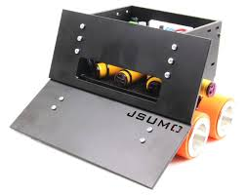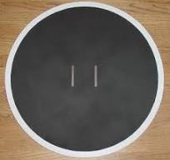

***1.2 OBJECTIVES***

**Autonomous Navigation:** Develop algorithms and techniques for autonomously navigating a sumo wrestling arena, avoiding obstacles and making smart judgments.

**Opponent Detection:** Implement sensor technology for accurate opponent detection, allowing robots to compete well in sumo battles.

**Automatic Control:** Create an autonomous control mode to give consumers the option of manually controlling the robot or allowing it to operate independently.

**Hardware Integration:** Integrate hardware components, including the PIC16F877A microprocessor, sensors, and actuators, for a reliable and efficient robotic system.

**2 DESIGN**

***2.1 MECHANICAL DESIGN***

 The mechanical design of our Sumo Robot focuses on strength, stability, and agility. We built a compact, resilient chassis out of lightweight yet sturdy components to ensure the robot can endure collisions while remaining flexible.

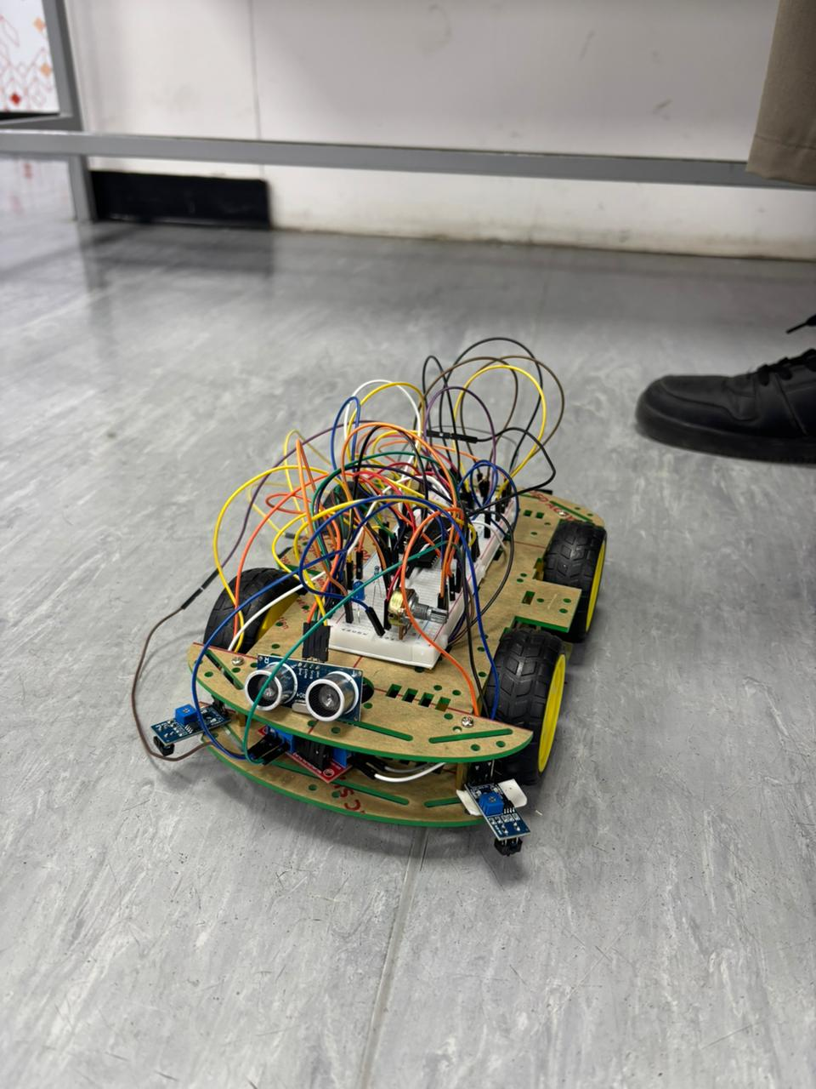

***2.2 Hardware Design***

For our Sumo Robot, we focused on creating a clever, dependable circuit that could power and regulate everything effortlessly. At the heart of our design is the PIC16F877A microcontroller, which serves as the robot's brain, controlling its motions and reactions. We used four DC motors to power the robot, one servo for accurate adjustments, two line sensors to determine borders, and an ultrasonic sensor to detect opponents. A potentiometer was fitted to fine-tune the controls as needed. We ensured that the circuit links well with all of these components, resulting in efficient power distribution and easy communication between them. We also kept the wiring nice and orderly to prevent confusion or problems during operation. Everything, from the power source to the sensors, is meant to work seamlessly. Our goal was to design a robust yet basic hardware arrangement that would match the Sumo Robot project's requirements while remaining simple to maintain and operate.

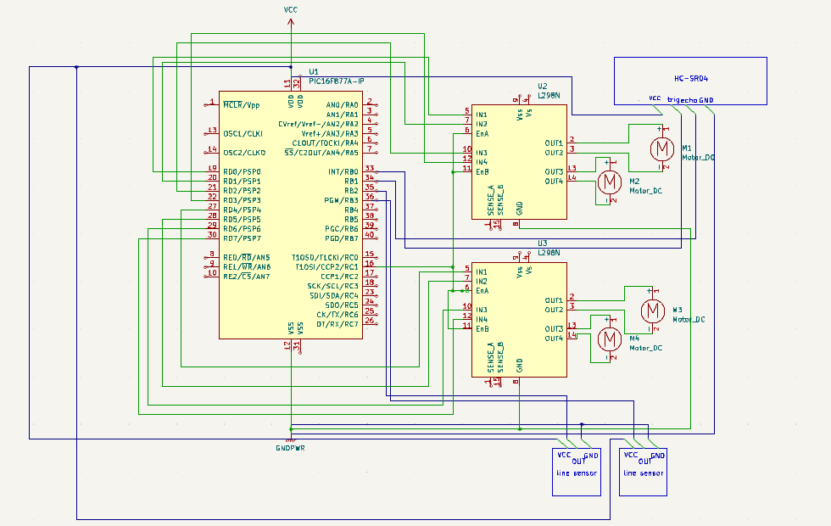

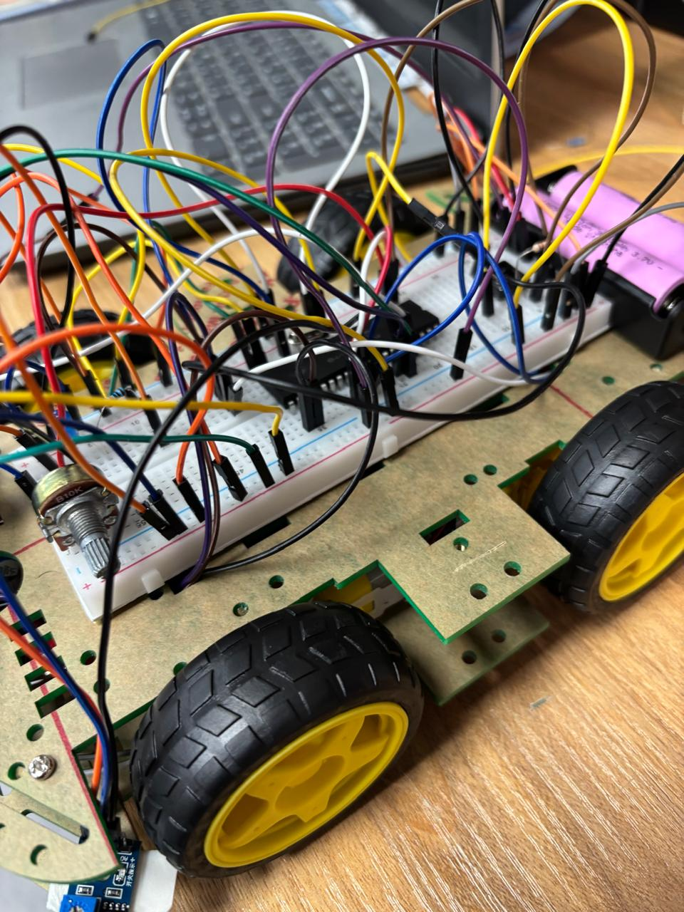

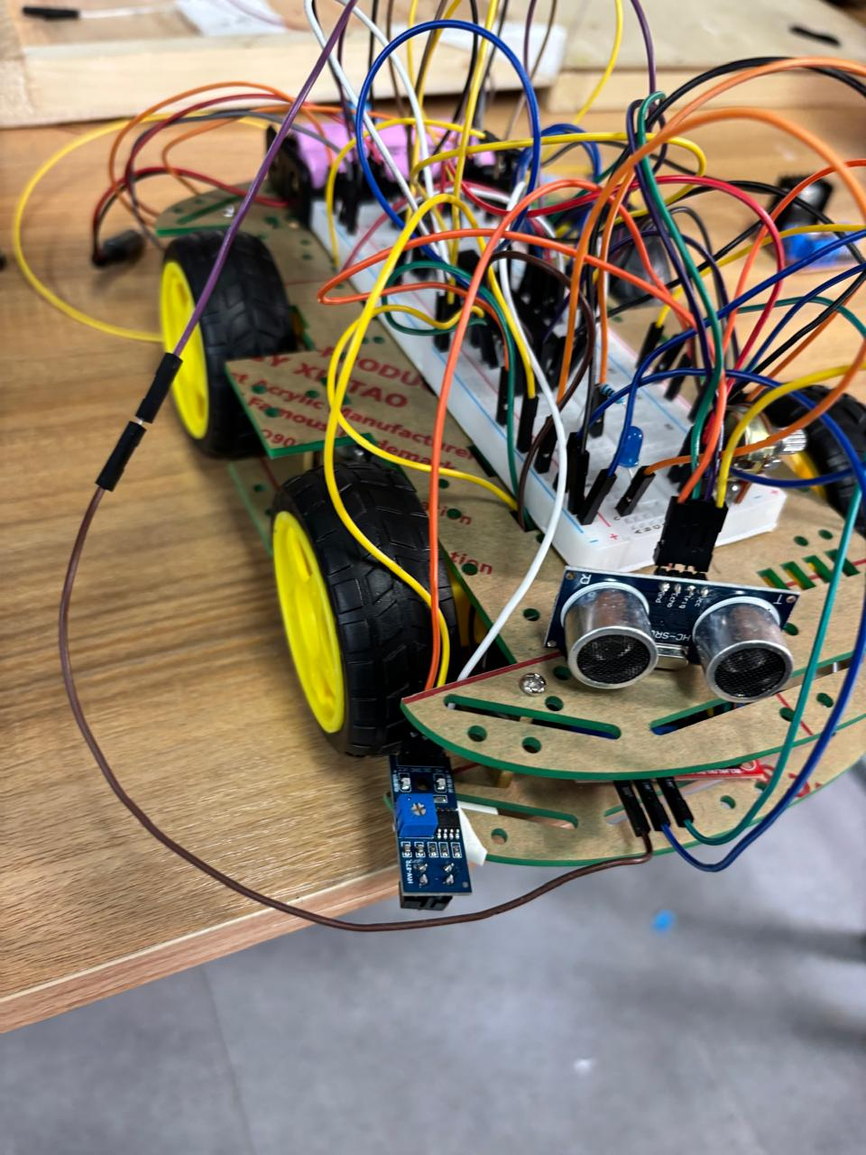

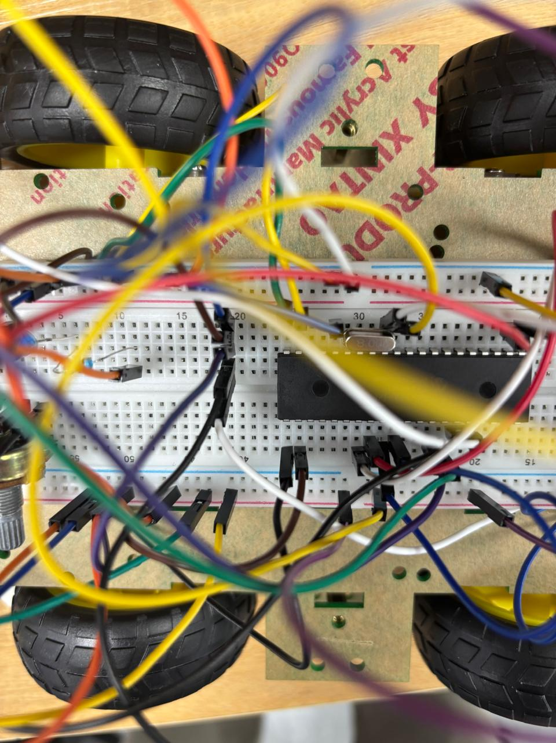

**3 Results**

Our Sumo Robot gave astounding results! We only tested it in autonomous mode, which showed the robot can make high quality and fast decisions, During the tests, it displayed smooth movement and accurate opponent detection, The PIC16F877A microprocessor allowed smooth coordination between the sensors, motors, and other components, allowing the robot to function consistently in this mode. These results show the robot's exceptional performance and adaptability, making us proud of our design.

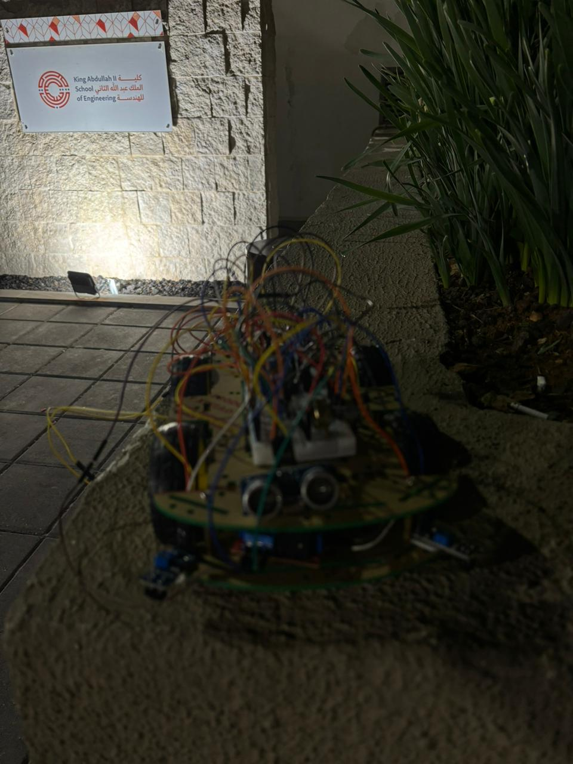

**4 PROBLEMS AND RECOMMENDATIONS**

1. Timer one and timer zero

* **Issue:** During our sumo car project, we found a critical issue with using the same Timer 1 for both the ultrasonic sensor and motor control. This caused inaccurate sensor readings and unpredictable motor behavior, affecting the car's performance in competitions.
* **Recommendation:** Assign Timer 1 exclusively for the ultrasonic sensor and Timer 2 for motor control to eliminate interference, ensuring stable and accurate operation of both components.

1. Port Misconfiguration:
   * **Issue:** Connecting sensors to PORTC initially produced issues due to conflicting PWM requirements (RC1&2). Switching to PORTA increased complexity owing to analog pins.
   * **Recommendation:** Plan port allocations carefully to satisfy both digital and analog needs. Choosing PORTB for sensors and RA0 for potentiometer connections simplifies the process.
2. The selection of the wheel size:
   * **Issue:** Finding the right wheel size was problematic until purchasing wheels with the needed holes, which required modification for a proper fit.
   * **Recommendation:** Prioritize research on compatible wheel sizes and work with the workshop for precise adjustments to avoid last-minute changes.

**5 Conclusion**

Creating a working Sumo-Robot for sumo matches was an enjoyable experience, despite  all of the obstacles. Although there is space for development, particularly in improving sensor capabilities, we effectively used our resources within the specified timeframe and knowledge restrictions. Despite challenges, creating and assembling the robot was a rewarding and enjoyable experience for our team.

**6 REFERENCES**

 1- Course Slides

 2- PSUT eLearning site

 3- PIC16F877A Datasheet

Github : <https://github.com/ad33ll/sumo_robot/blob/main/README.md>

Youtube : <https://youtu.be/sHy0AmkZ1N8>