1.Study the fundamentals of System Design and explore the installation, configuration, and applications of the software tools used in the System Design Laboratory.
2.Explore the purpose of each software tool used in the System Design Laboratory and prepare a comparison table indicating its role in developing scalable distributed systems.
3.Create a GitHub repository, configure a Java project in Visual Studio Code, and upload the project to GitHub.

Installation and Setup of different software for system-design:
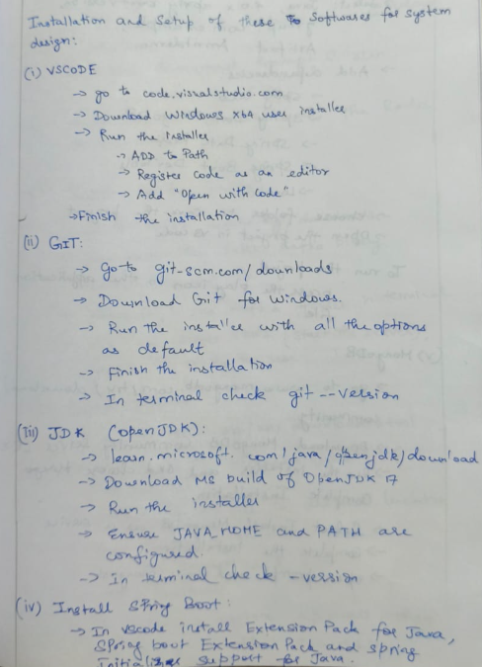
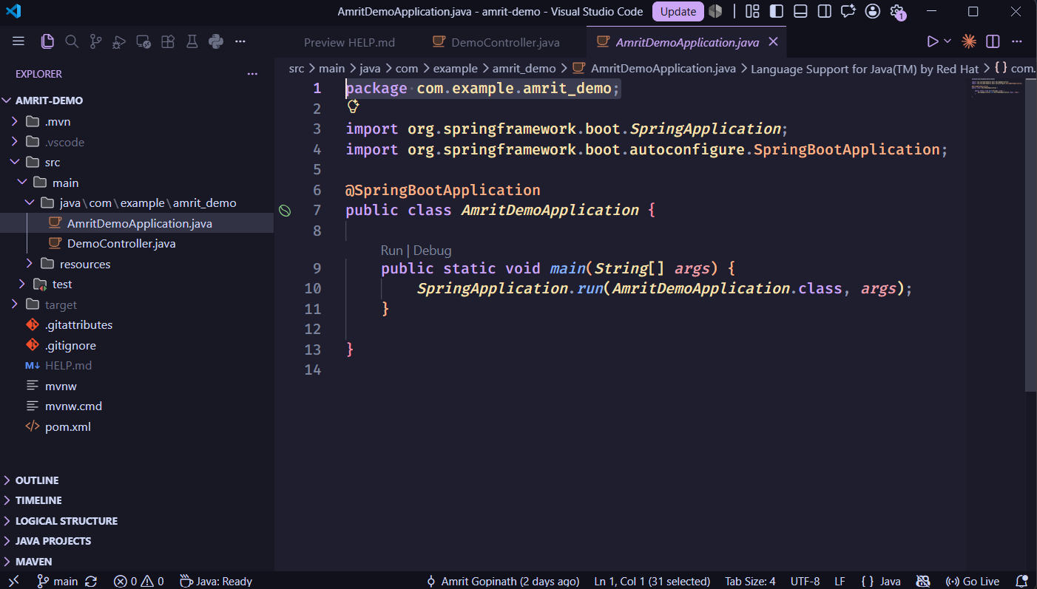

Installation Proof:
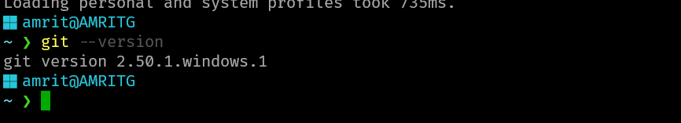

Installation Proof:
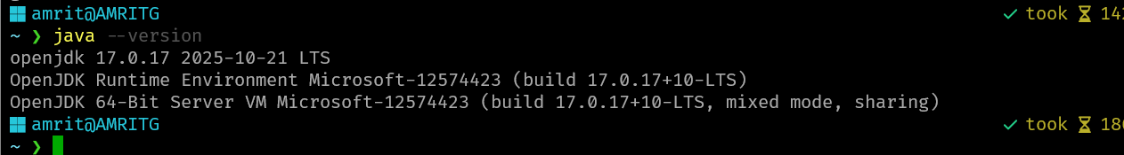

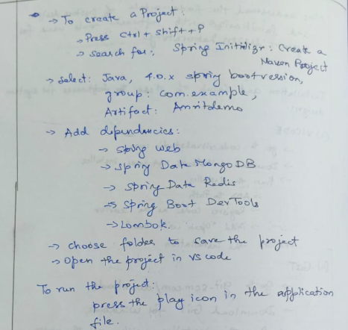

Project Structure:
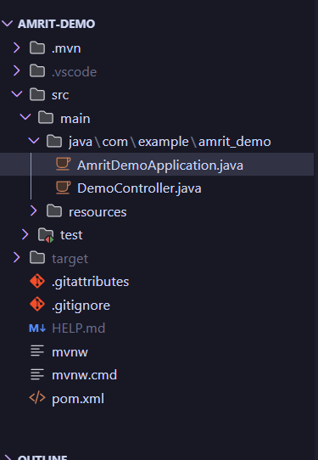

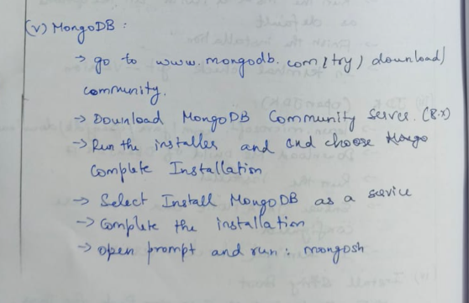
Installation Proof:
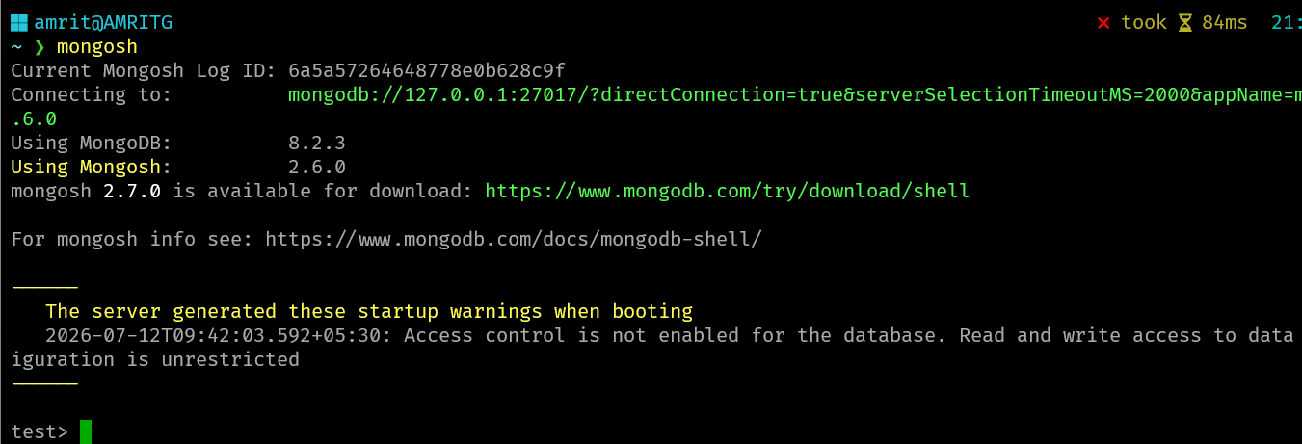

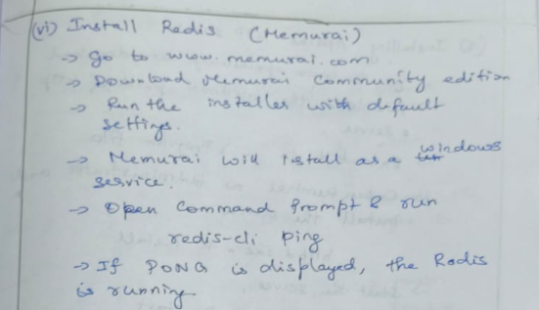
Installation Proof:
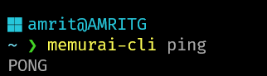


Installation Proof: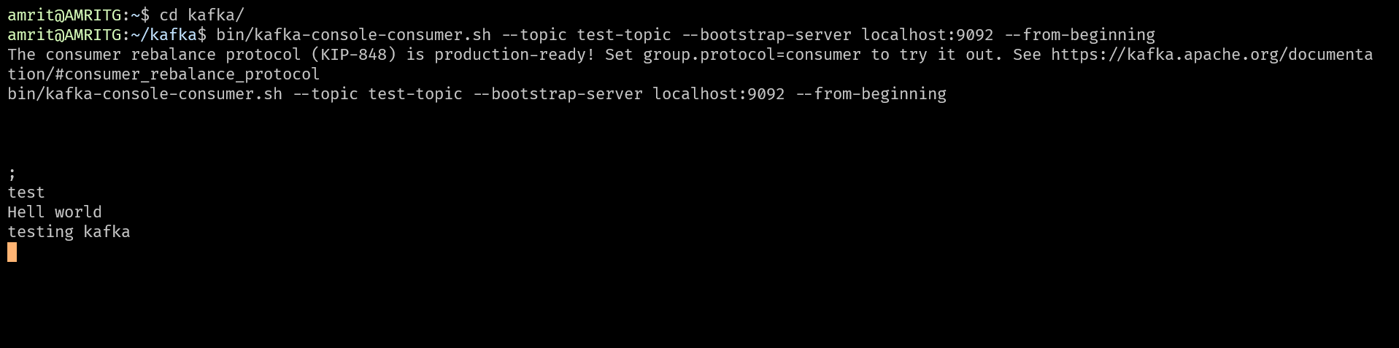 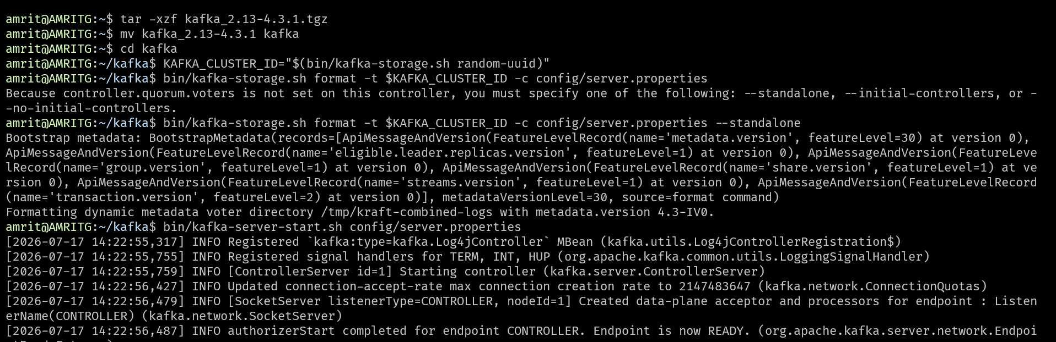

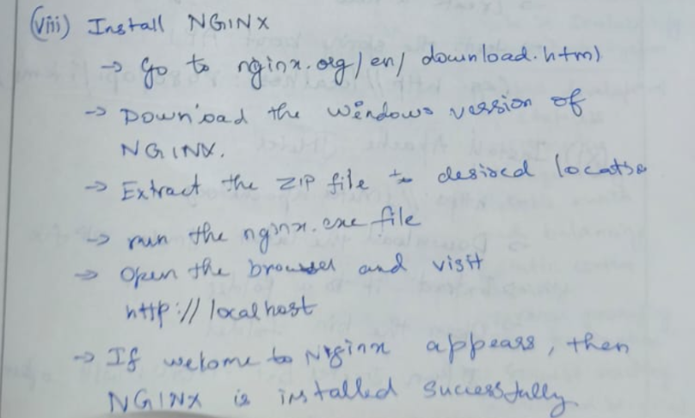
Installation step:
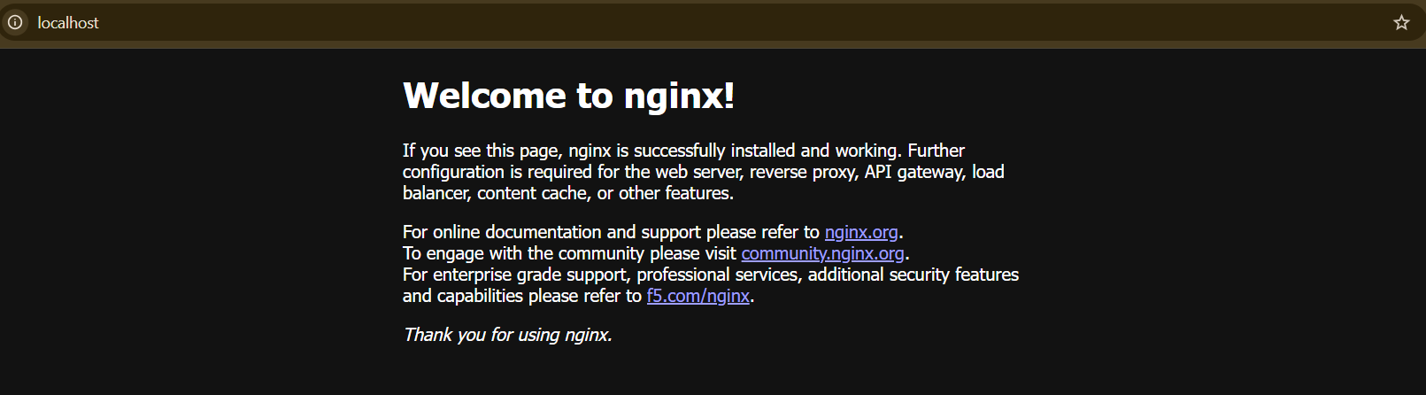

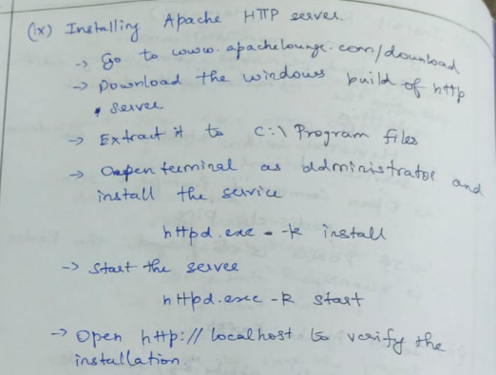

Installation step:
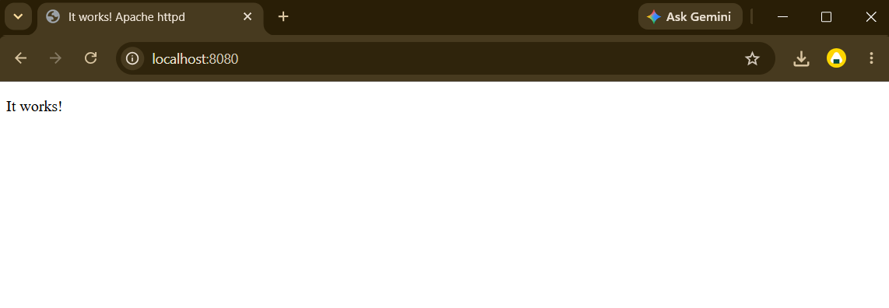

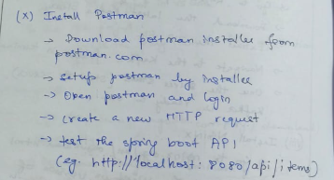
Installation step:
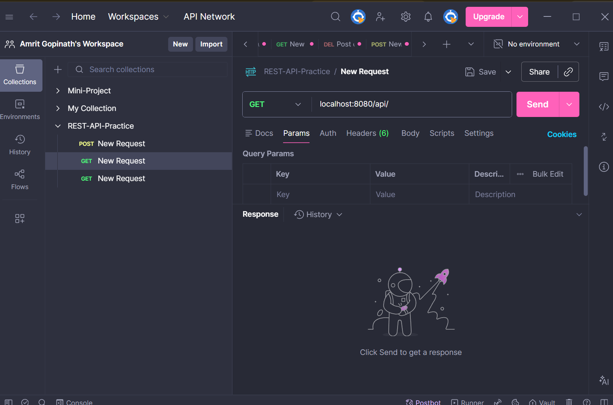

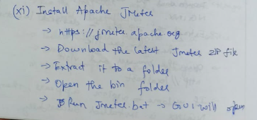
Installation step:
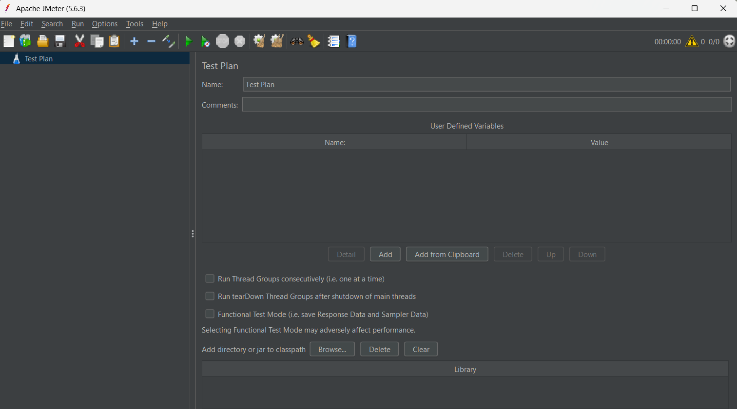

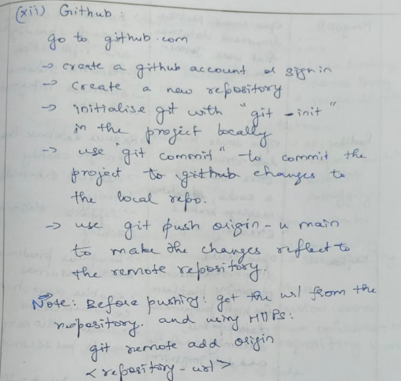
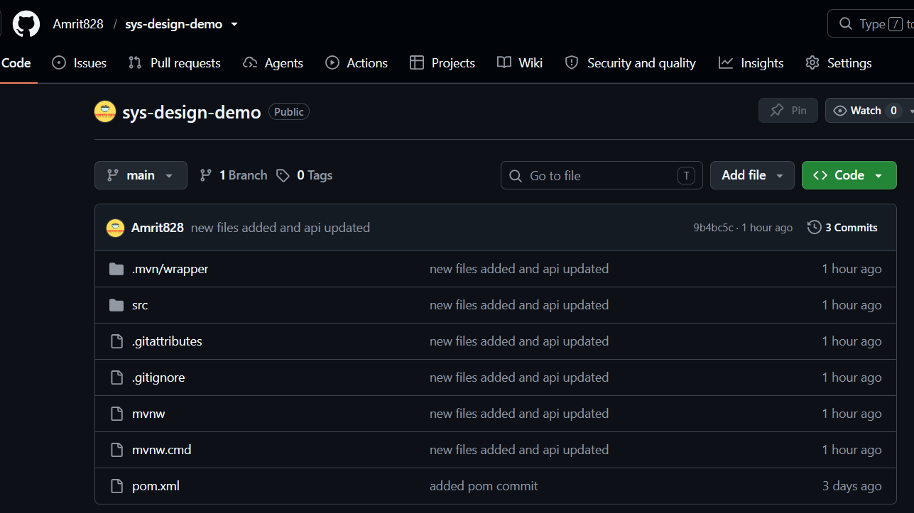

3) Github Link: https://github.com/Amrit828/sys-design-demo

Demo Output:
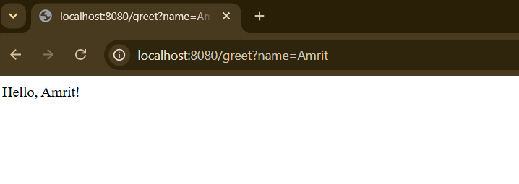

Postman Output:
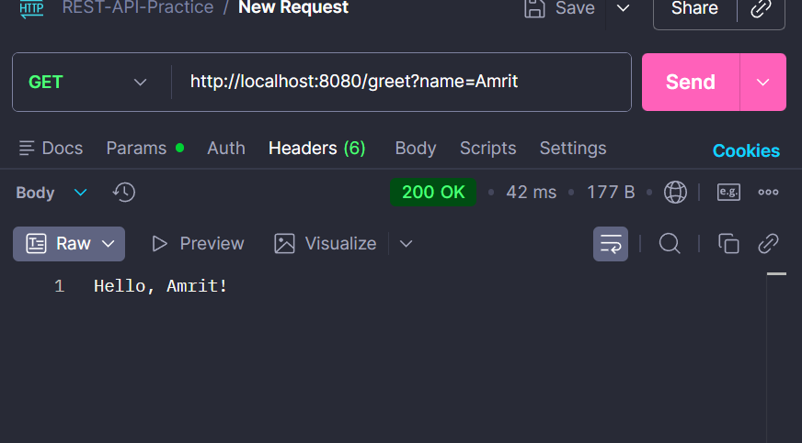

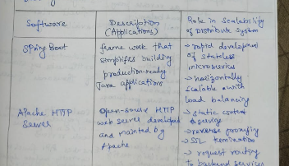
Comparison of different software for developing scalable and distributed systems:

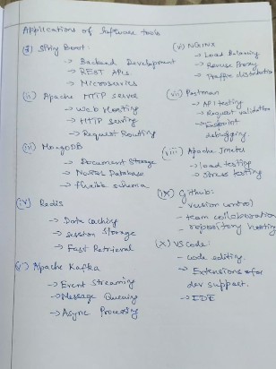

Learning Outcomes:
- Explain the fundamentals of system design.
- Describe the role of major components in scalable distributed systems.
- Identify the purpose of each software tool used in the laboratory.
- Set up the development environment required for implementing system design experiments.

