Aim: To design and implement a basic URL Shortener application using Spring Boot that generates a short URL for a given long URL using a hashing technique, and redirects users to the original URL.

Software Used and its Configuration

Software | Role | Purpose in this Assignment
Spring Boot 4.1.0 | Application Framework | Runs the Java application; routes HTTP requests to UrlController, wires up the service and repository layers, starts an embedded web server.
MongoDB | Database | Stores URL collection (id, shortURL, longURL), connected at mongodb://localhost:27017/urlshortner
Postman | API Client | Used to call POST /url/shorten and GET /url/{shortCode} manually while testing the endpoints.
VS Code | Editor / IDE | Where the API is built.

Spring Boot Configuration
Spring Boot itself is configured, not installed separately, through the dependencies (<dependency> entries) declared in pom.xml.
- spring-boot-starter-webmvc
  - REST controller support.
- spring-boot-starter-data-mongodb
  - The MongoDB driver and MongoRepository support.

Lombok
Lombok generates and writes getters, setters, and constructors for Entities and DTOs.

application.properties Configuration
- spring.application.name = url-shortner
- spring.mongodb.uri = mongodb://localhost:27017/url-shortner

Core Algorithm:

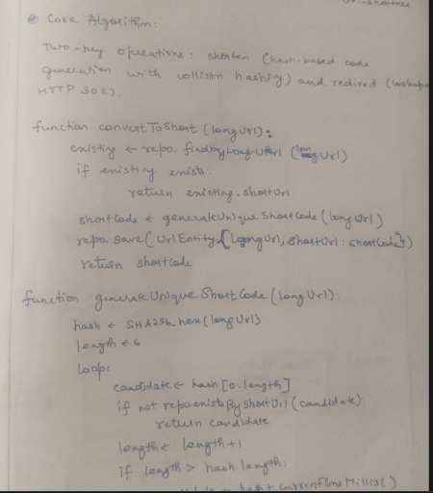
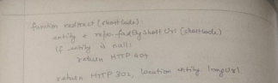

System Design and Flow:

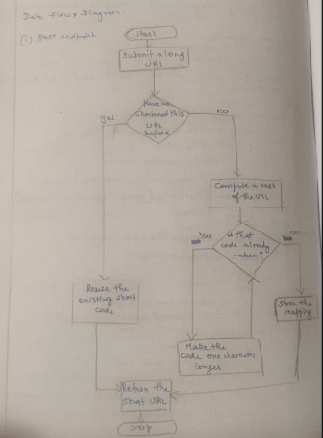

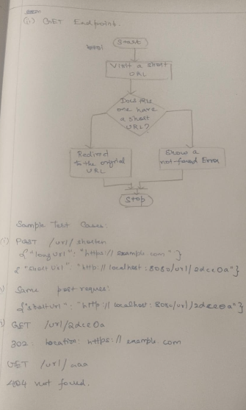

Test Cases (Screenshots):

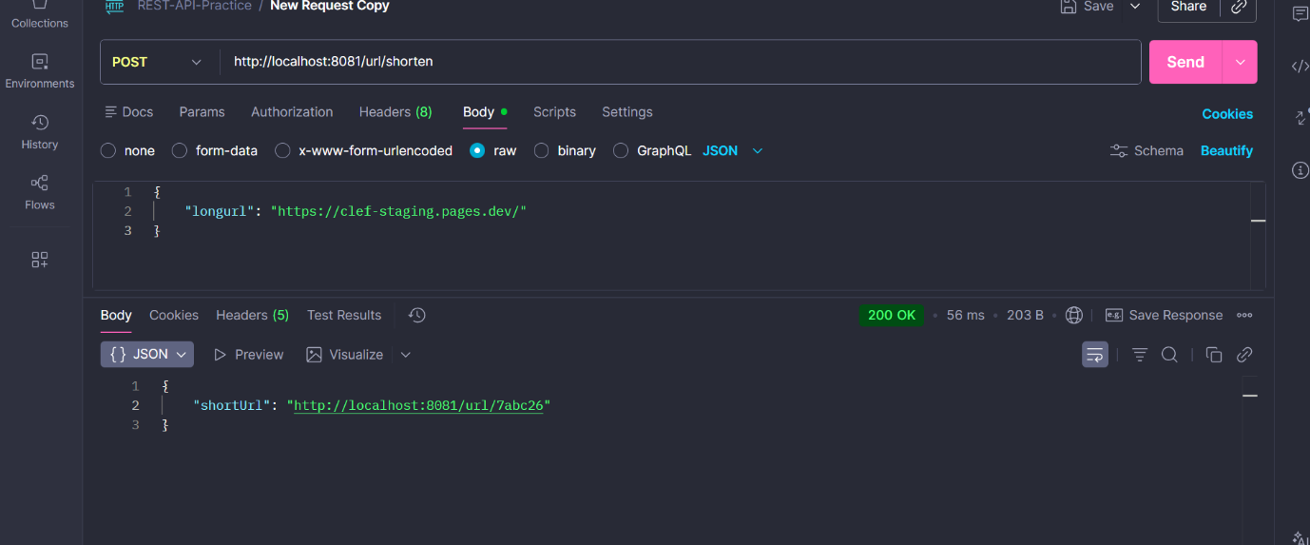
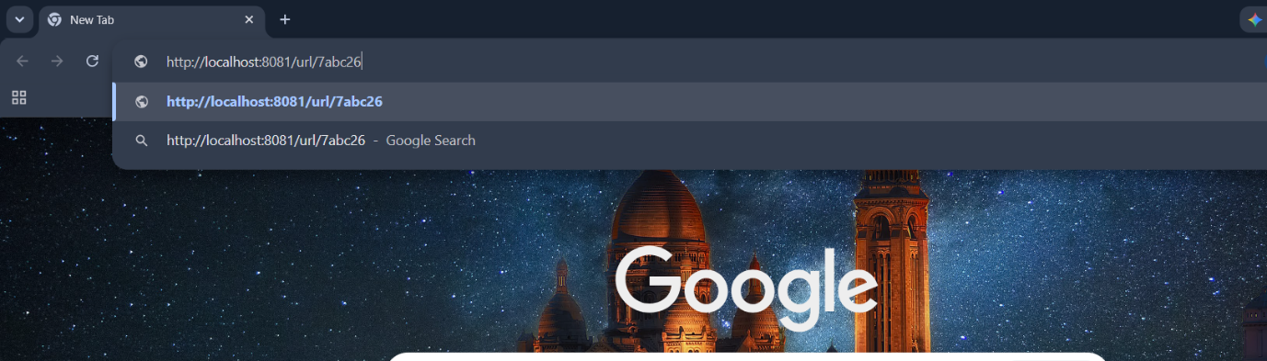
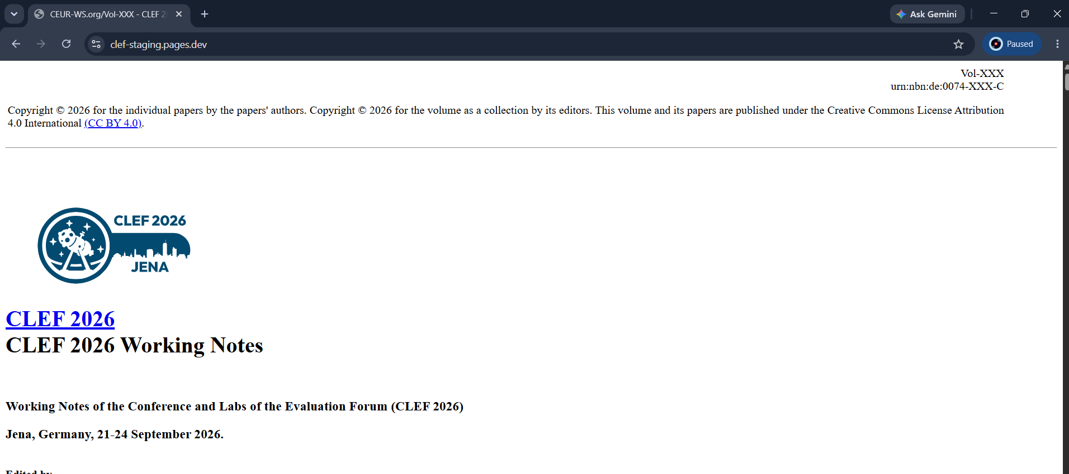

Resending the same URL in the request:
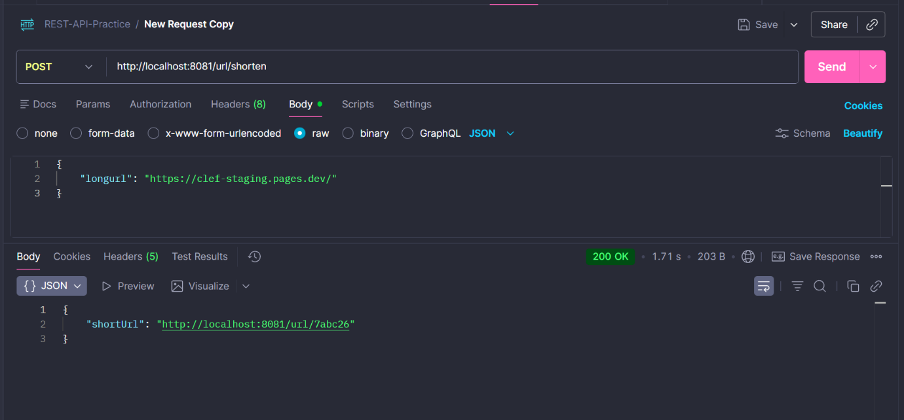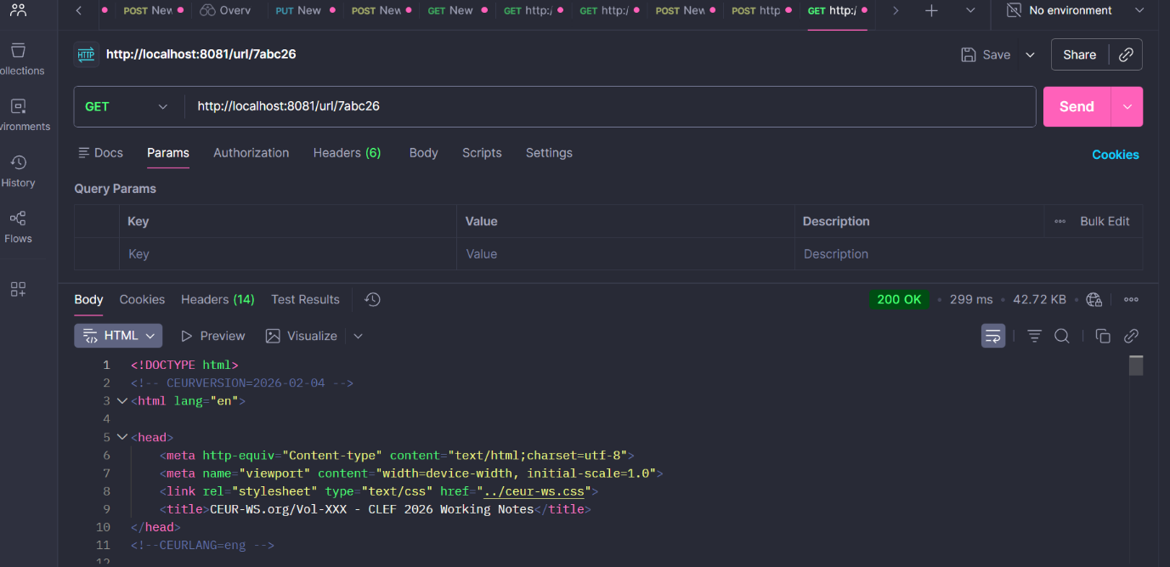

Test Case 2:
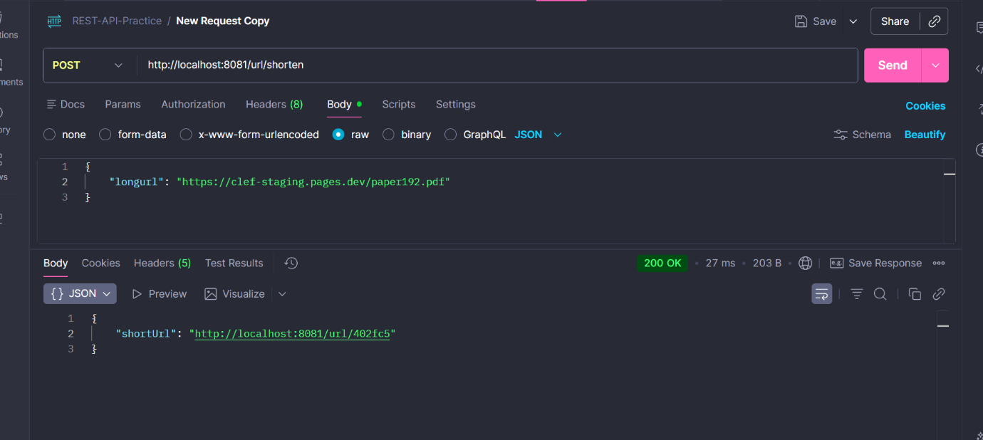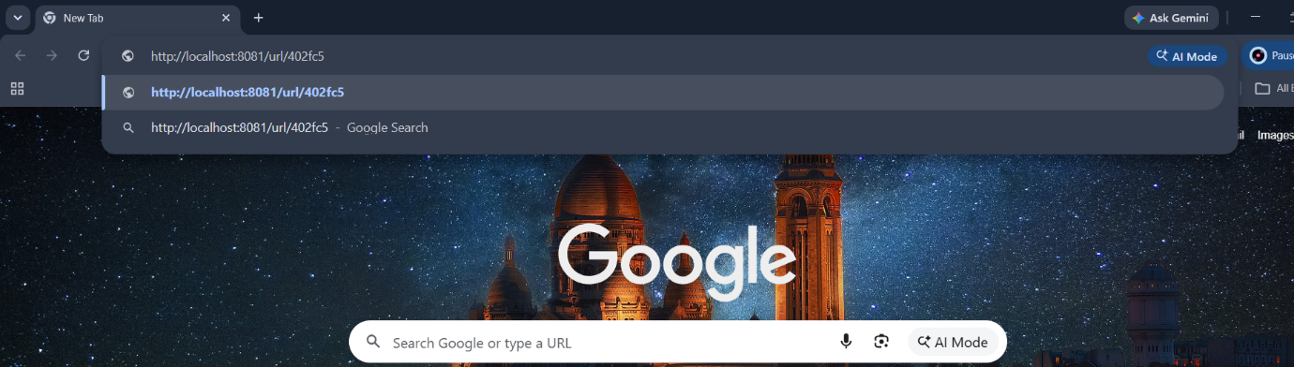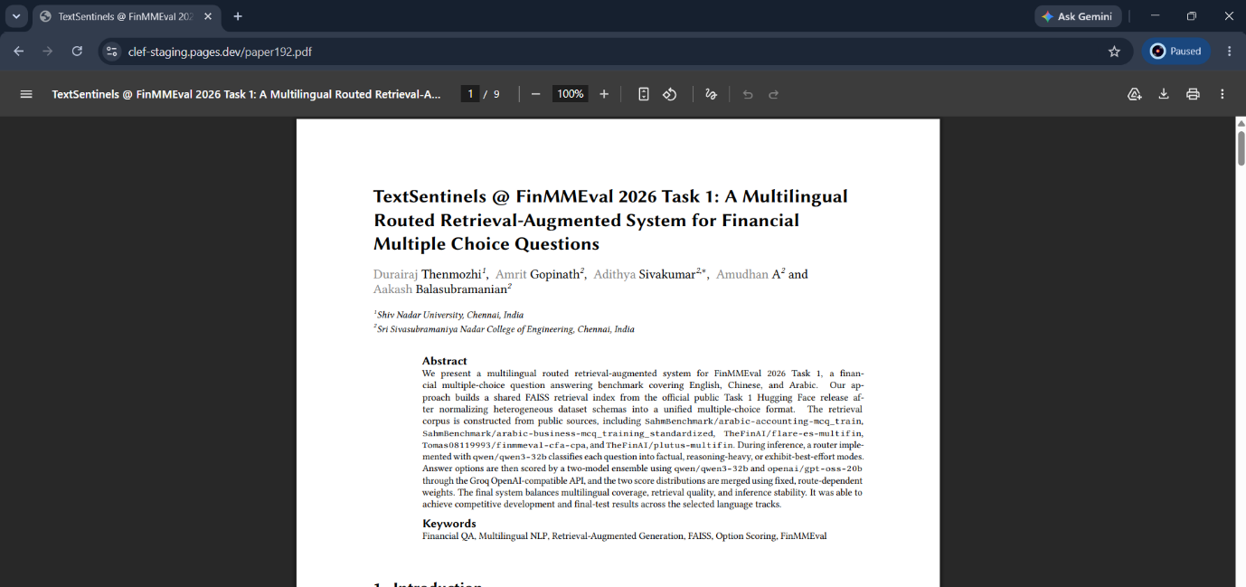

Learning Outcomes:
- Design and develop a URL Shortener application using Spring Boot and a layered architecture.
- Implement RESTful APIs to generate unique short URLs using hashing techniques and perform URL redirection.
- Store and retrieve URL mappings efficiently using MongoDB and Spring Data MongoDB.

