To design and simulate Horizontal Database Sharding using MongoDB by deploying a sharded cluster with Docker Compose, distributing the Student collection of a College database across multiple shards, and analysing the scalability and query performance of the resulting distributed database system.

Software Used and its Configuration

Software | Role | Purpose in this Assignment
Docker Desktop (WSL2 backend) | Container Runtime | Runs and networks the four MongoDB containers that make up the sharded cluster.
Docker Compose | Orchestration | Declares configsvr1, shard1svr1, shard2svr1 and mongos as one multi-container service and brings them up together on a shared bridge network.
mongo:7.0 (Docker image) | Database Engine | Run once per container as mongod with --configsvr / --shardsvr flags for the config and shard servers, and once as the mongos query router.
mongosh | Database Shell | Bundled inside the image; reached via docker exec to initiate replica sets, add shards, enable sharding and run queries.

System Design and Architecture
Config Server: stores the cluster metadata (shard list and chunk map).
Shard Servers: each holds one range of the Student collection, keyed on RollNo.
mongos Router: the only component the client talks to; it consults the config server and routes each query to the shard that owns the requested RollNo range.)
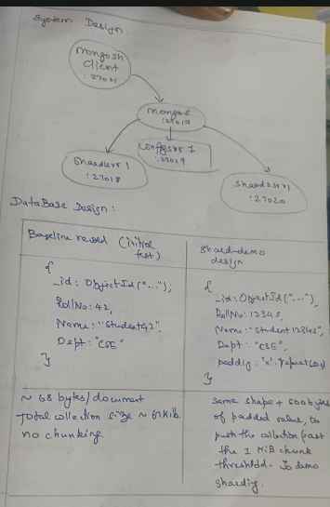

Test Cases (Screenshots)
Screenshots captured while executing the cluster setup and sharding commands through mongosh.
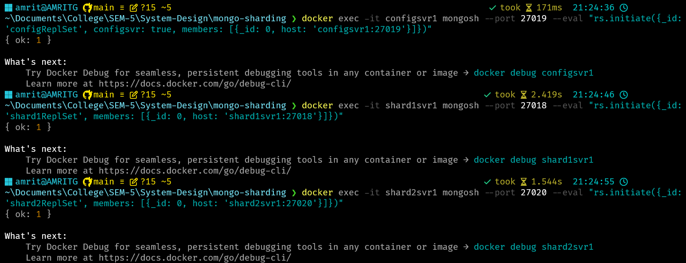
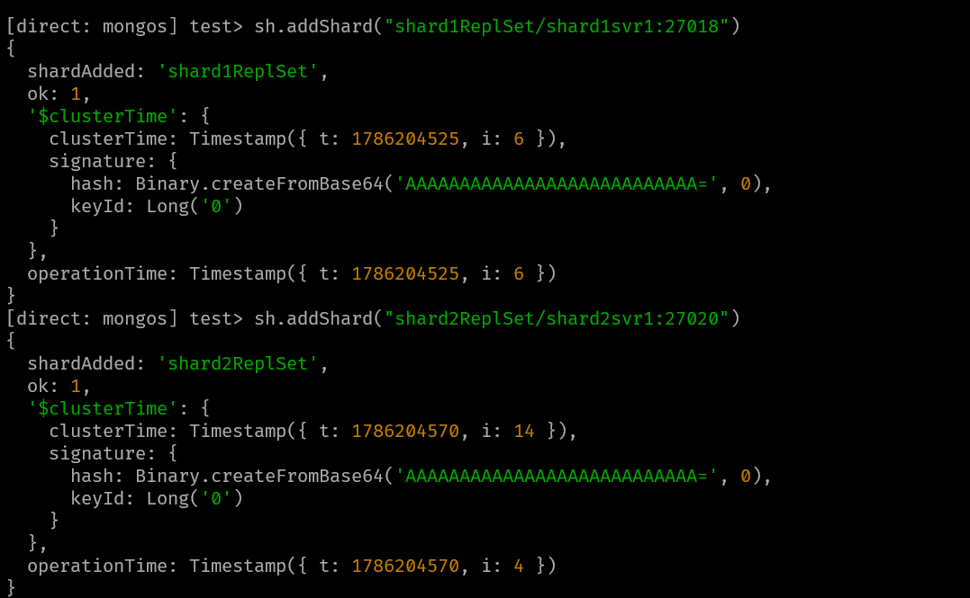

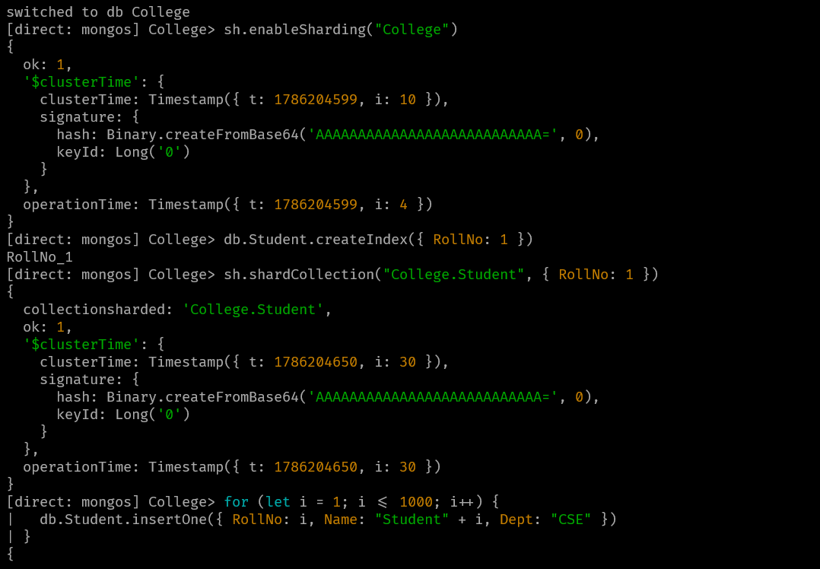

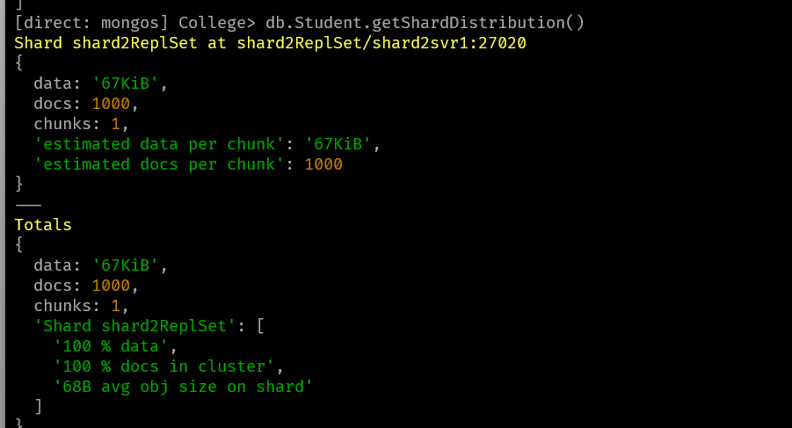

The reasoning behind this output is – the sizes of the document is very small for clustering to even happen. Hence I’ve deleted the documents and added 50k new ones.

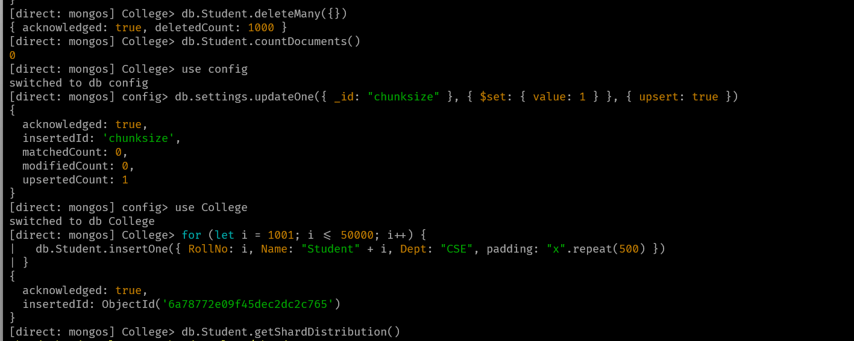
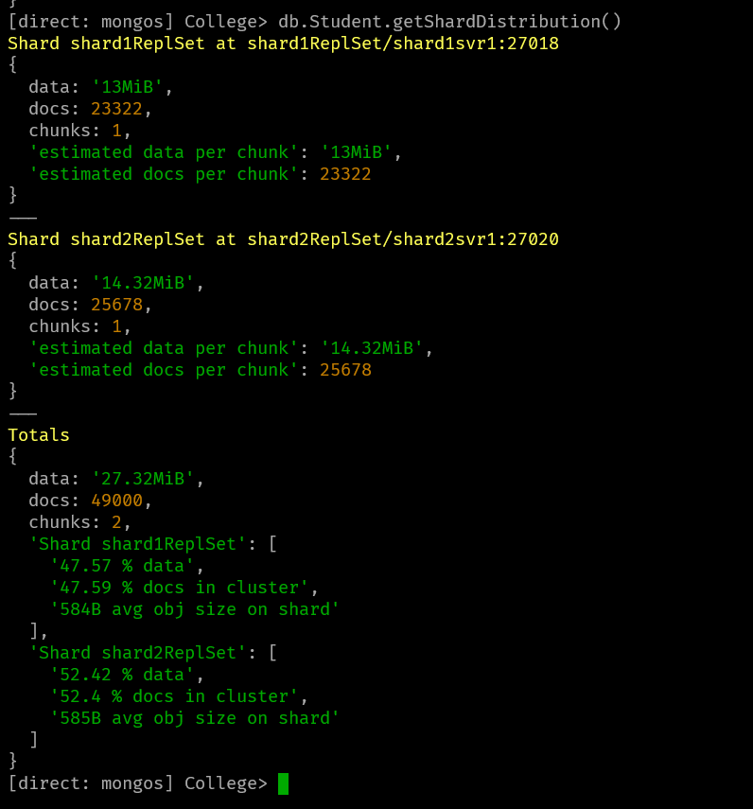

Performance / Shard Distribution Table
Result of db.Student.getShardDistribution() after loading 49,000 documents with a 1 MiB chunk size, showing the balancer final placement.
Shard | Host | Docs | Data Size | % Docs | % Data
shard1ReplSet | shard1svr1:27018 | 23,322 | 13.00 MiB | 47.59% | 47.57%
shard2ReplSet | shard2svr1:27020 | 25,678 | 14.32 MiB | 52.40% | 52.42%
Total | - | 49,000 | 27.32 MiB | 100% | 100%

Learning Outcomes
- Deployed and configured a multi-container MongoDB sharded cluster - config server, shard servers, and mongos router - using Docker Compose.
- Enabled horizontal sharding on the College database and sharded the Student collection using RollNo as an appropriate shard key.
- Verified and analysed document distribution across shards using sh.status() and db.Student.getShardDistribution().
- Understood the scalability and query-routing benefits of a sharded MongoDB cluster compared to a standalone MongoDB instance.

