Imperial College London
Department of Earth Science and Engineering
MSc in Applied Computational Science and Engineering

Independent Research Project
Final Report

Origins of Mars’s Moons: Physics-Structured ML Using Asteroid Tidal-Disruption SPH Simulations

by
Kristy Natasha Yohanes

Email: natasha.yohanes25@imperial.ac.uk
GitHub username: ada-nny124
Repository: https://github.com/ese-ada-lovelace-2025/irp-nny124

Supervisors:
Dr. Jacob Kegerreis
Dr. Tom Davison

September 2026

Abstract
Close encounters between asteroids and Mars can tidally disrupt the asteroid and leave some debris bound to the planet, a process that has been proposed as one possible pathway toward the formation of Mars’s moons, Phobos and Deimos. Smoothed-particle hydrodynamics (SPH) models this process in detail, but testing every input combination is computationally expensive. In this project, SPH outputs are processed into fragmentation measures, and machine learning models are then used to predict bound mass fraction (BMF) from the simulation inputs. The models are evaluated using grouped cross-validation, and the main model is a Random Forest using physics-derived features calculated from the raw simulation inputs, achieving a grouped cross-validated R² of 0.9225, MAE of 0.0179, and RMSE of 0.0259. In controlled tests, predicted BMF decreases from about 0.25 at 1.2 Mars radii as periapsis increases, while the available SPH cases fall to approximately zero beyond about 2.2 Mars radii. Increasing encounter speed produces a clearer decrease from about 0.25 at 0 km/s to approximately zero above 1 km/s. Periapsis is the strongest overall physical input, while the effects of spin and velocity depend on the encounter conditions, meaning that different physical inputs can become more influential in different parts of the sampled parameter range. In matched cases, changing spin produces BMF differences of about 0.06-0.09 below 1.5 Mars radii and up to about 0.24 at larger periapsis. A sparsely sampled 10^{19.5} kg case gives held-out errors near 0.08 BMF despite lying within the numerical training ranges, showing that being within the input range does not guarantee a reliable prediction. The model is therefore useful for rapidly screening well-supported encounter conditions and identifying parameter interactions that warrant further SPH study, but it does not replace SPH or establish physical causation.

1. Introduction

1.1 Research Problem and Questions
The origin of Mars's moons Phobos and Deimos remains unresolved. One proposed pathway is a close asteroid encounter with Mars. Differences in Martian gravity across the asteroid can stretch and break it apart. Some debris may escape, while some may remain gravitationally bound to Mars. This retained material could provide material for later orbital evolution and accretion into moons (Kegerreis et al., 2024).
Smoothed-particle hydrodynamics (SPH) is well suited to this problem because its particles move with the material as it deforms, fragments and interacts gravitationally. However, each new setup is computationally expensive to simulate. Testing every combination of asteroid mass, closest approach, encounter speed, spin and numerical settings is therefore impractical. This project uses the existing simulation archive to build a machine learning (ML) surrogate for screening promising cases and identifying when new SPH simulations are needed.
The report addresses three research questions: (1) how do orbital and physical parameters affect disruption and bound retention; (2) which inputs matter most for fragment formation and retained debris; and (3) can machine-learning models predict outcomes within the sampled data while showing when a prediction should or should not be trusted?

1.2 Significance and Originality
The work is useful both scientifically and computationally. Scientifically, the SPH archive contains simulations of a mechanism that could supply debris to the Martian system. Computationally, it addresses a common problem in simulation-based science: a detailed solver can model one setup well, but running many setups is computationally expensive. Once trained, an ML model can examine many combinations quickly, so full SPH simulations can be focused on cases where they are most useful.
The main contribution is combining physical interpretation with clear checks for when an ML prediction is reliable. The workflow converts particle-level SPH outputs into one set of results for each simulation, tests the model on physical simulations that were not used for training, compares controlled and matched cases, measures how much similar SPH data exist nearby, and uses these checks to recommend whether a new SPH run is needed.

1.3 Literature Review and Research Gaps
Several explanations have been proposed for Phobos and Deimos. Giant-impact simulations can produce debris disks around Mars (Citron et al., 2015; Canup & Salmon, 2018). Temporary inner moons may affect how material in the outer disk accretes (Rosenblatt et al., 2016), and orbital studies have suggested that Phobos and Deimos may come from a disrupted common parent body (Bagheri et al., 2021). However, the processes that produce and retain debris around Mars are still not fully explored. Kegerreis et al. (2024) therefore provides an important alternative formation pathway by showing that a close asteroid encounter with Mars can tidally disrupt the asteroid while capturing part of its debris. This directly motivates the present project. Their simulations show meaningful amounts of bound debris across different periapsis, velocity, mass and spin settings, but every new setup still requires another simulation. This project asks whether the existing archive can be used to train an ML model that screens new setups before SPH is run.
Because these tidal-disruption cases are simulated using SPH, it is also important to understand how the simulation data are produced and processed. SPH is a mesh-free Lagrangian method, meaning that computational particles move with the material they represent (Price, 2012). This makes it suitable for large deformation and fragmentation. However, the measured fragments also depend on how the simulation is processed afterwards. Here, post-processing algorithms such as friends-of-friends (FoF) groups nearby particles using a chosen linking length, so the reported number and mass of fragments depend partly on that processing choice as well as on the encounter physics (More et al., 2011). Bound mass is treated separately: a fragment is classed as bound or unbound using its orbital energy relative to Mars.
Post-processing converts the particle-level SPH outputs into scalar outcomes, producing a small tabular dataset suitable for ML. This makes the problem suitable for ML, particularly tree-based models, which work well with small, nonlinear tabular datasets (Grinsztajn et al., 2022). Tree-based ML surrogate models have also previously been used to predict outcomes from related SPH collision and giant-impact simulations (Cambioni et al., 2019; Timpe et al., 2020). However, their use for asteroid tidal-disruption encounters is still limited.

2. Methodology

2.1 Data Archive, Inputs, and Post-Processing
The archive contains 489 SPH outputs totalling about 218 GB of HDF5 particle data. Post-processing converts these particle outputs into fragment and bound-mass measurements. The primary target is bound mass fraction (BMF), the fraction of the original asteroid mass gravitationally bound to Mars after the encounter. The simulation setup gives the asteroid and input parameter values, while post-processing converts the particle data into fragments and then calculates bound-mass results. The main outcome used in this project is the bound mass fraction, represented by f_{bound​}, which is the fraction of the original asteroid mass that remains gravitationally bound to Mars after the encounter, this will be referred to as BMF throughout this report.
Table 1. Main SPH setup and post-processing parameters.
Some parameter values appear much more often than others in the archive.
Parameter | Coverage range | What it means
Asteroid mass | A₁₈₀₀-A₂₁₀₀; A₂₀₀₀ dominates | Mass of the incoming asteroid. For example, A₁₈₀₀ ≈ 10¹⁸ kg and A2100 ≈ 10²¹ kg. Its effect on BMF also depends on the other encounter conditions.
Periapsis | r₁₁-r₃₀; r₁₂ and r₁₆ common | Closest distance between the asteroid and Mars. For example, r₁₂ = 1.2 R_{Mars} (Mars-radii). Smaller values mean a closer encounter and stronger tidal forces.
Encounter speed | v₀₀-v₃₀; v₀₀ dominates | Speed of the asteroid during the encounter. v₀₀ is the lowest-speed case, while higher v codes represent faster encounters. Higher speeds generally make capture less likely.
Spin | none, x, y, z, mz; unevenly sampled | Rotation of the asteroid and the direction of its spin axis: none means no spin, x or y means equatorial spin, z means prograde z-spin, and mz means retrograde z-spin. Spin can change how the asteroid breaks up, but the different spin settings are unevenly sampled.
Resolution | n₅₀-n₇₀; n₆₅ dominates | Number of SPH particles used in the simulation. For example, n₆₅ is roughly 10^{6.5} particles. This is a numerical setting rather than a physical property of the encounter.
FoF linking length (post-processing) | 0.0001-0.0126; 0.004 common | Maximum distance used to decide whether nearby particles belong to the same fragment. It can change the measured fragments, but it does not change the physical encounter itself.
How the post-processing works is that FoF first groups nearby debris particles into fragments. For each group g, its mass is the sum of the particle masses, M_{g} = Σ_{i}m_{i}. The group's center-of-mass position and velocity are then used to calculate its specific orbital energy relative to Mars. A group is bound when ε_{g} < 0 and unbound when ε_{g} ≥ 0. The main recorded output is BMF, while other exploratory outputs include the number of bound fragments, the largest and average bound-fragment mass, total fragment count, and largest-remnant measures. It is also important to note that BMF only measures gravitational retention and does not yet establish later disk or moon formation.

2.2 Prediction Model Choices and Rationale
The main ML task is to predict the BMF value, or what percentage of the original asteroid mass is likely to remain bound to Mars. This keeps the difference between small, medium, and large retained fractions. In addition, a 10% BMF threshold is chosen as a simple screening level for higher-retention cases, motivated by Kegerreis et al. (2024), who found that “tens of percent of an unbound asteroid’s mass can be captured and survive beyond collisional timescales”. The 10% threshold is therefore used only to categorise and prioritise cases, not as an actual physical threshold for moon formation.
Several baseline models were selected for the prediction tasks. Although tree-based models are the main focus of this project, Logistic Regression is also used for the BMF ≥ 10% classification task because it provides a simple baseline for testing whether lower- and higher-retention cases can already be separated using a relatively simple combination of the inputs (Knauer et al., 2024). For continuous BMF prediction, Random Forest is tested because it can capture nonlinear relationships and interactions between the simulation parameters while averaging many trees to reduce sensitivity to individual cases (Breiman, 2001; Cambioni et al., 2019). Gradient Boosting is also tested because it builds trees sequentially, with each new tree correcting errors made by the previous ones, which may help capture sharper changes between different encounter conditions (Friedman, 2001; Valencia et al., 2019; Timpe et al., 2020).
Further model development after the baseline included tuning the model settings and adding physics-derived features calculated from the original simulation inputs, to test whether these changes improved prediction performance. Other more complex model variants were also explored, including XGBoost and two-stage hurdle models, however these remained exploratory and are not discussed further in detail in this project, as they were mainly used to show the potential for further model improvement in future work rather than as the main result of this project. More complex approaches such as physics-informed neural networks were not explored because they are mainly designed to learn continuous spatial or time-dependent fields while enforcing physical equations, whereas this project uses a small tabular dataset of simulation inputs and numerical outcomes (Raissi et al., 2019).

2.3 Model Testing and Performance Metrics
One of the main issues with the archive is that it contains repeated rows from the same physical SPH simulation, for example when the same simulation is post-processed using different FoF linking lengths. A random row split could therefore allow the model to train on one processed version of a simulation and test on another version of the same simulation. To avoid this, 5-fold GroupKFold cross-validation was used. All rows from the same physical simulation file are kept in the same fold, so each out-of-fold (OOF) prediction is made by a model that has not trained on that physical simulation.
Regression performance is measured using R², mean absolute error (MAE), and root mean squared error (RMSE). Classification performance is measured using balanced accuracy, F1, and ROC AUC.

2.4 How the Physical Effects Were Analysed
Overall scores are useful, but they do not show whether the model follows sensible physical behaviour in different cases. To check this, three complementary analyses are used. First, an input-removal test, also called ablation, removes one original input together with related derived features and measures how much model performance decreases, as this gives an overall measure of how strongly the model depends on each physical input across the dataset (Section 3.4). Second, controlled tests change one input while keeping the others fixed to show the direction and shape of the model response (Section 3.5, Figure 3). Third, matched SPH comparisons test whether the importance of an input changes under different encounter conditions (Section 3.5, Figure 4).

2.5 When to Trust the Model
Model accuracy alone cannot show whether every individual prediction is reliable, because an overall score can hide regions where the model has little data or makes larger errors, so the workflow also checks whether a new setup is similar to SPH simulations already present in the archive. Predictions are trusted more when the surrounding region has several independent SPH simulations and low held-out prediction error. Predictions are treated as less reliable when the input combination is sparsely sampled, near the edge of the available data, or outside the sampled region. These checks are analysed in section 3.6 and figure 5.
The final decision then separates two questions: (1) how strongly the asteroid breaks up, and (2) how much material remains bound to Mars. Breakup is described by the largest-remnant fraction f_{LR} = M_{largest}/M_{parent} where score above 0.90 is mostly intact, 0.50-0.90 is partial breakup, and at or below 0.50 is severe disruption. Retention is measured separately with BMF and Mars-bound mass, M_{bound} = BMF × M_{parent}, this is important because severe breakup can still leave almost no material bound to Mars (Richardson et al., 1998; Walsh & Richardson, 2006).

3. Results

3.1 Exploratory Physical Trends
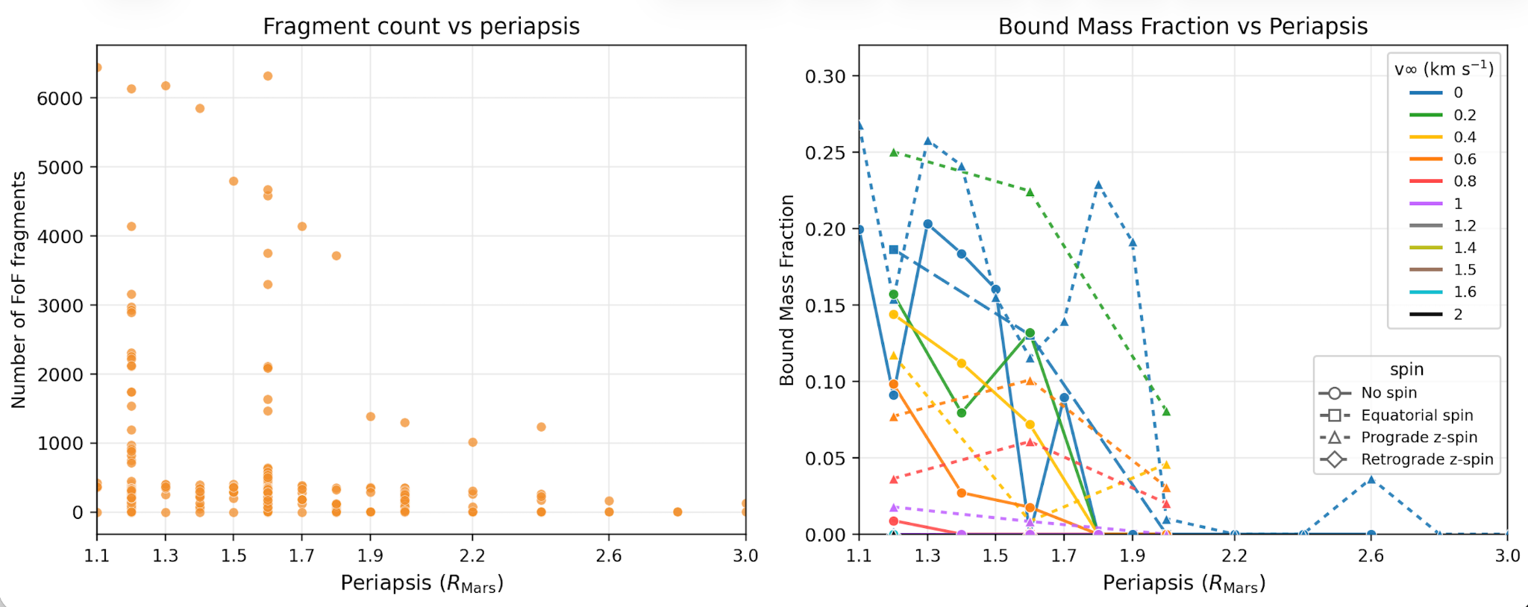
Figure 1. Exploratory SPH results. (a) The largest fragment counts occur only in close encounters, although a close periapsis does not guarantee strong fragmentation. (b) Bound retention is generally higher for closer and slower encounters. Colours show encounter speed, while marker and line styles distinguish spin settings. Lines connect sampled cases with the same settings and are not physical trajectories.
Figure 1 shows that both fragmentation and bound retention generally decrease as periapsis increases, although close encounters do not always produce strong fragmentation or high BMF. Mean BMF is highest at small periapsis and decreases as encounter speed increases. The relative effects also change across the sampled range: velocity differences are prominent at about 1.1-1.6 Mars radii, while separation between spin states becomes more visible around 1.7-2.0 Mars radii. One prograde-spin case retains about 3-4% BMF at 2.6 Mars radii while the other sampled cases are near zero, although the region is too sparsely sampled for a strong conclusion. The effect of asteroid mass also changes in size and direction with the other encounter conditions. Overall, the results indicate regime-dependent behaviour, where the relative effects of parameters vary across the parameter space and lead to different bound-mass outcomes.

3.2 Eccentricity and Bound Retention
Previously, it showed that fragmentation and BMF do not follow one simple input trend, therefore I want to check whether related physical parameters can describe this behaviour more clearly. Periapsis and encounter speed are combined into an encounter eccentricity, as this gives one physically meaningful measure of the orbit shape and allows retention to be examined using the overall encounter trajectory rather than as separate parameters.
The result shows that retention is concentrated near the parabolic limit, where the eccentricity proxy is close to 1. Strong retention (BMF ≥ 0.10) appears only up to a proxy of about 1.057, while any non-zero BMF extends to about 1.127. Figure 2 shows this directly: the points collapse toward BMF = 0 as the encounter becomes more hyperbolic. Faster, more hyperbolic fly-bys spend less time under conditions that favour capture and therefore leave less material bound to Mars.
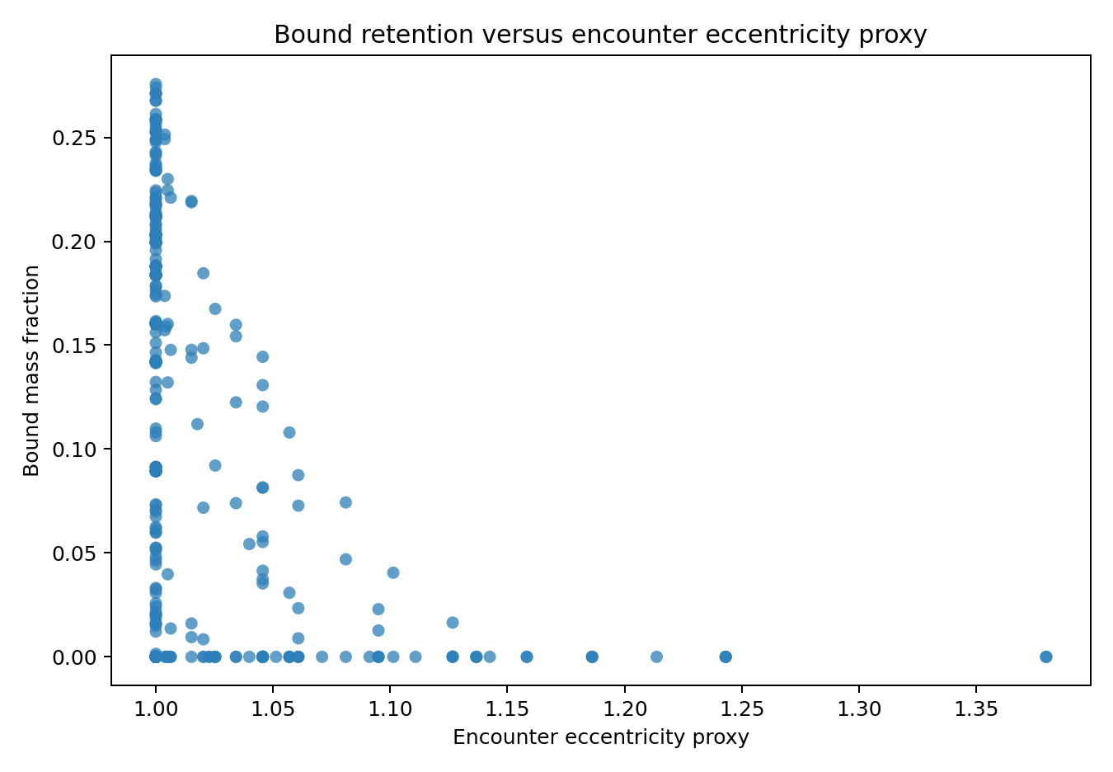
Figure 2. Bound mass fraction versus encounter eccentricity proxy. Strong and non-zero retention quickly disappears as the encounter becomes more hyperbolic.

3.3 Model Performance and Screening Use
The baseline model comparisons support the choice of Random Forest for continuous BMF prediction. Gradient Boosting achieves R² = 0.8840 and MAE = 0.0228, compared with R² = 0.8971, MAE = 0.0184 and RMSE = 0.0298 for Random Forest. Gradient Boosting therefore provides no improvement over Random Forest for this dataset.
Logistic Regression achieves grouped balanced accuracy of 0.849 and ROC AUC of 0.925 for the BMF ≥10% screening task, showing that the two retention classes are reasonably separable. The threshold is used only for prioritisation; continuous BMF remains the primary output.
Tuning the Random Forest, by adjusting its model settings, produces no meaningful improvement, changing performance only from R² = 0.8971, MAE = 0.0184 and RMSE = 0.0298 to R² = 0.8983, MAE = 0.0186 and RMSE = 0.0297. In contrast, adding the physics-derived features calculated from the original simulation inputs (see Appendix A, Table A1) improves performance to R² = 0.9225, MAE = 0.0179 and RMSE = 0.0259, so this version is used as the main model. This is an overall average and does not mean that every individual prediction has the same error (see Appendix A for further details).

3.4 Overall Physical Parameter Importance
The input-removal test gives the clearest overall result for BMF. Each original parameter is removed together with derived features that contain the same information, and the resulting decrease in R² shows how much predictive information is lost. Removing periapsis causes the largest decrease, ΔR² = -0.504, making it the strongest overall input. Removing velocity gives ΔR² = -0.279, while removing spin gives ΔR² = -0.258. Asteroid mass has a smaller and less consistent overall effect. These values are overall averages and cannot simply be added together. They show how much the model depends on each input, not whether increasing that input raises or lowers BMF, or whether it directly causes the outcome. Overall, periapsis is strongest, followed by velocity and spin; this ranking can change locally.
Fragmentation needs a separate answer. In the SPH data, very small periapsis is required for the most extreme fragmentation, but a close encounter does not guarantee strong breakup. Fragment count is also directly affected by FoF linking length. For that reason, this report does not give one simple global ranking for fragmentation. Periapsis defines where the strongest disruption can occur, while the actual fragment pattern depends on the full encounter and on how fragments are grouped during post-processing.

3.5 Checking Physical Trends and Condition-Dependent Effects
Overall ranking of which inputs the model depends on most, but it does not show how BMF changes with each input or whether the importance of an input remains the same under different encounter conditions. This section asks two follow-up questions: (1) how does BMF change when one input is varied while the others are fixed, and (2) do the effects of important inputs remain equally strong under different encounter conditions?
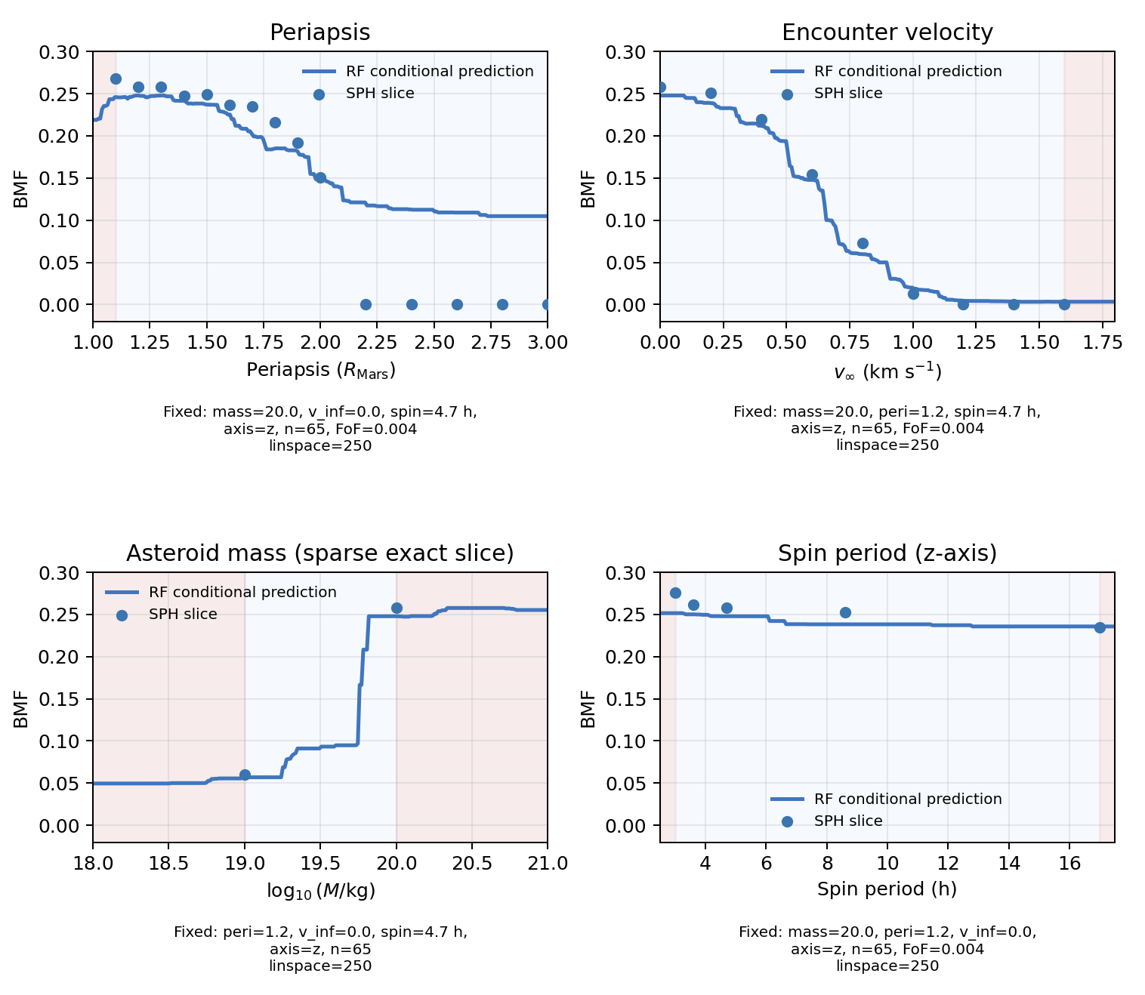
Figure 3. BMF checks where one input changes at a time. Dots are available SPH cases and curves are Random Forest predictions with the other inputs fixed. Blue background shows interpolation range, meanwhile red background shows extrapolation range.
Figure 3 varies one input at a time while keeping the others fixed and compares the Random Forest response with available SPH cases. Under the setup shown here, increasing periapsis generally reduces predicted BMF from about 0.25 at 1.2Mars-radii​ to about 0.10 at 3.0 Mars-radii​, although the available SPH cases fall to approximately zero beyond about 2.2 Mars-radii​. Increasing encounter velocity produces a clearer decrease, from about 0.25 at 0 km/s to approximately zero above 1 km/s.
The mass plot has much weaker support. Only about two asteroid-mass values have exact SPH cases where all the other chosen conditions are identical. The available higher-mass SPH cases are also concentrated at low periapsis and low velocity, so there is not enough matched data to establish a reliable mass trend. The sharp increase in the Random Forest curve should therefore be treated as model-dependent rather than as a physical threshold. The spin-period panel is nearly flat for the displayed z-axis case, showing that changing spin period has little effect under this particular setup. This does not contradict the overall importance of spin in Section 3.4: it instead shows that an input that is important across the full dataset can have only a small effect under one specific set of encounter conditions.
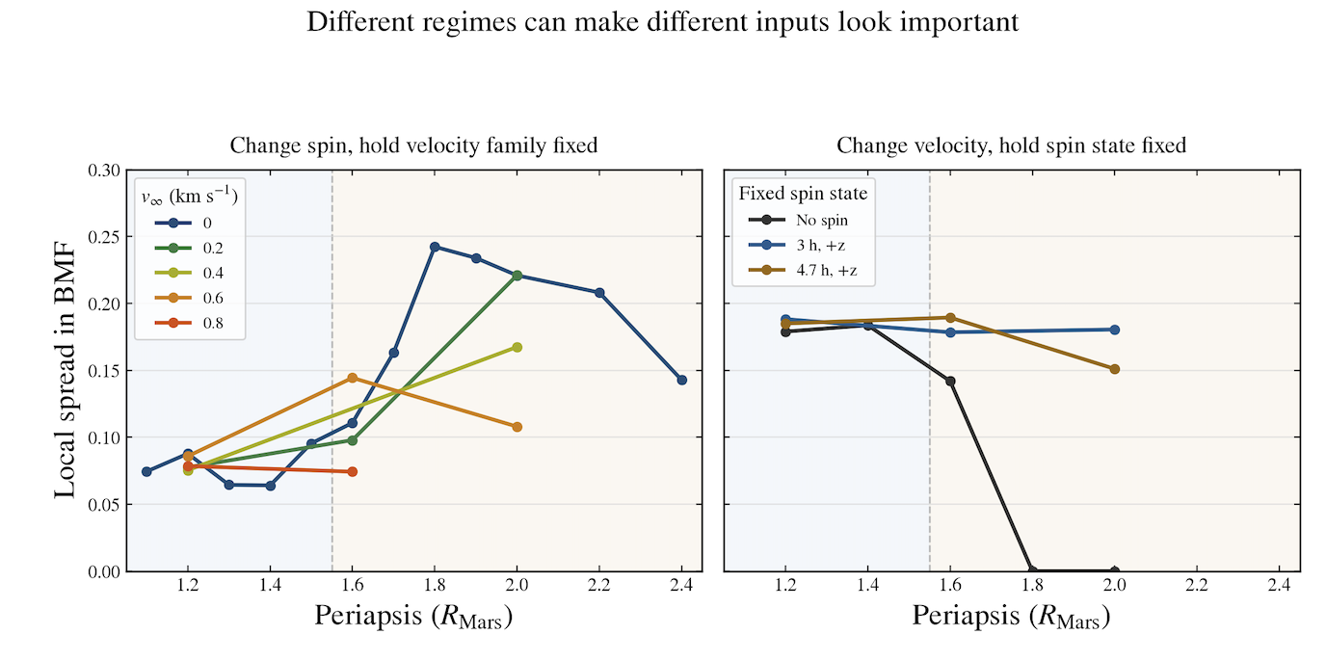
Figure 4. BMF differences within the matched A₂₀₀₀, n₆₅ subset at timestep 90000 and FoF linking length 0.004. Left: BMF range across spin states with velocity fixed. Right: BMF range across velocities with spin fixed. These ranges show how strongly outcomes differ within this subset; they do not show direction or prove causation.
In Figure 4, spin and velocity are used because the archive contains matched cases where these parameters can be varied while mass and key numerical and post-processing settings are kept fixed. Periapsis is then varied across the comparison. In the left panel, ΔBMF_{spin​} is the difference between the largest and smallest BMF across available spin states while velocity is fixed. In the right panel, ΔBMF_{velocity​} is the same range across available velocities while spin is fixed. A larger ΔBMF means that changing that parameter makes a larger difference to the retained mass under those conditions.
The result shows clearly that the strength of each parameter is not constant. Below about 1.5 Mars-radii​, changing spin gives a BMF range of roughly 0.06-0.09. At larger periapsis, this can become much stronger: for v∞​=0, the spin-related range rises to about 0.24 at 1.8 Mars-radii​, while several other velocity groups reach about 0.14-0.22 between 1.6 and 2.0 Mars-radii​. Velocity shows a different pattern. For the no-spin cases, the velocity-related BMF range is about 0.18 at 1.2-1.4 Mars-radii​, falls to about 0.14 at 1.6 Mars-radii​, and reaches zero by 1.8 Mars-radii​. In contrast, the sampled prograde z-spin cases still show velocity-related ranges of about 0.15-0.19 between 1.6 and 2.0 Mars-radii​.
These results confirm regime-dependent parameter importance: spin dominates some conditions while velocity dominates others, so the overall ablation ranking is not universal.

3.6 Where the Model Can and Cannot Be Trusted
Trust depends on both prediction error and the amount of nearby SPH data. The coverage-error maps count unique physical simulations rather than repeated FoF rows, then compare that count with the average held-out absolute error in the same region. Regions with more simulations often have lower error, while sparse or edge regions can be much worse. Low error alone is not enough: some poorly sampled regions look easy only because the true BMF is usually zero.
A case can lie within the range of every individual input and still be poorly supported because the model depends on input combinations. Figure 5 therefore compares local simulation coverage with held-out error and pairwise parameter coverage. The pairwise maps reveal unsampled combinations that are hidden by individual input ranges. A prediction is treated as interpolation only when similar SPH cases exist nearby in the input space.
Table 2 gives a concrete example of this problem for the sparsely sampled 10^{19.5} kg asteroid mass. It compares the true BMF, held-out prediction and absolute error at periapsis 1.2 and 1.6 Mars radii, where only one independent physical SPH simulation supports each periapsis despite five post-processing rows being present.

Table 2. Failure case at asteroid mass 10^{19.5} kg: the mass is within the sampled range,
but only two unique physical SPH simulations support these cases.
Periapsis | Actual BMF | OOF prediction | Abs. error | Failure
1.2 | 0.0913 | 0.0134 | 0.0779 | Underpredicts
1.6 | 0.000204 | 0.0827 | 0.0825 | Overpredicts

This shows that the held-out model underpredicts the 1.2 Mars-radii case by 0.0779 BMF and overpredicts the 1.6 Mars-radii case by 0.0825. Because the errors are both large and have opposite signs, the local relationship has not been learned reliably. A new case in this region should therefore be checked with additional SPH rather than trusted only because its mass lies between sampled masses.
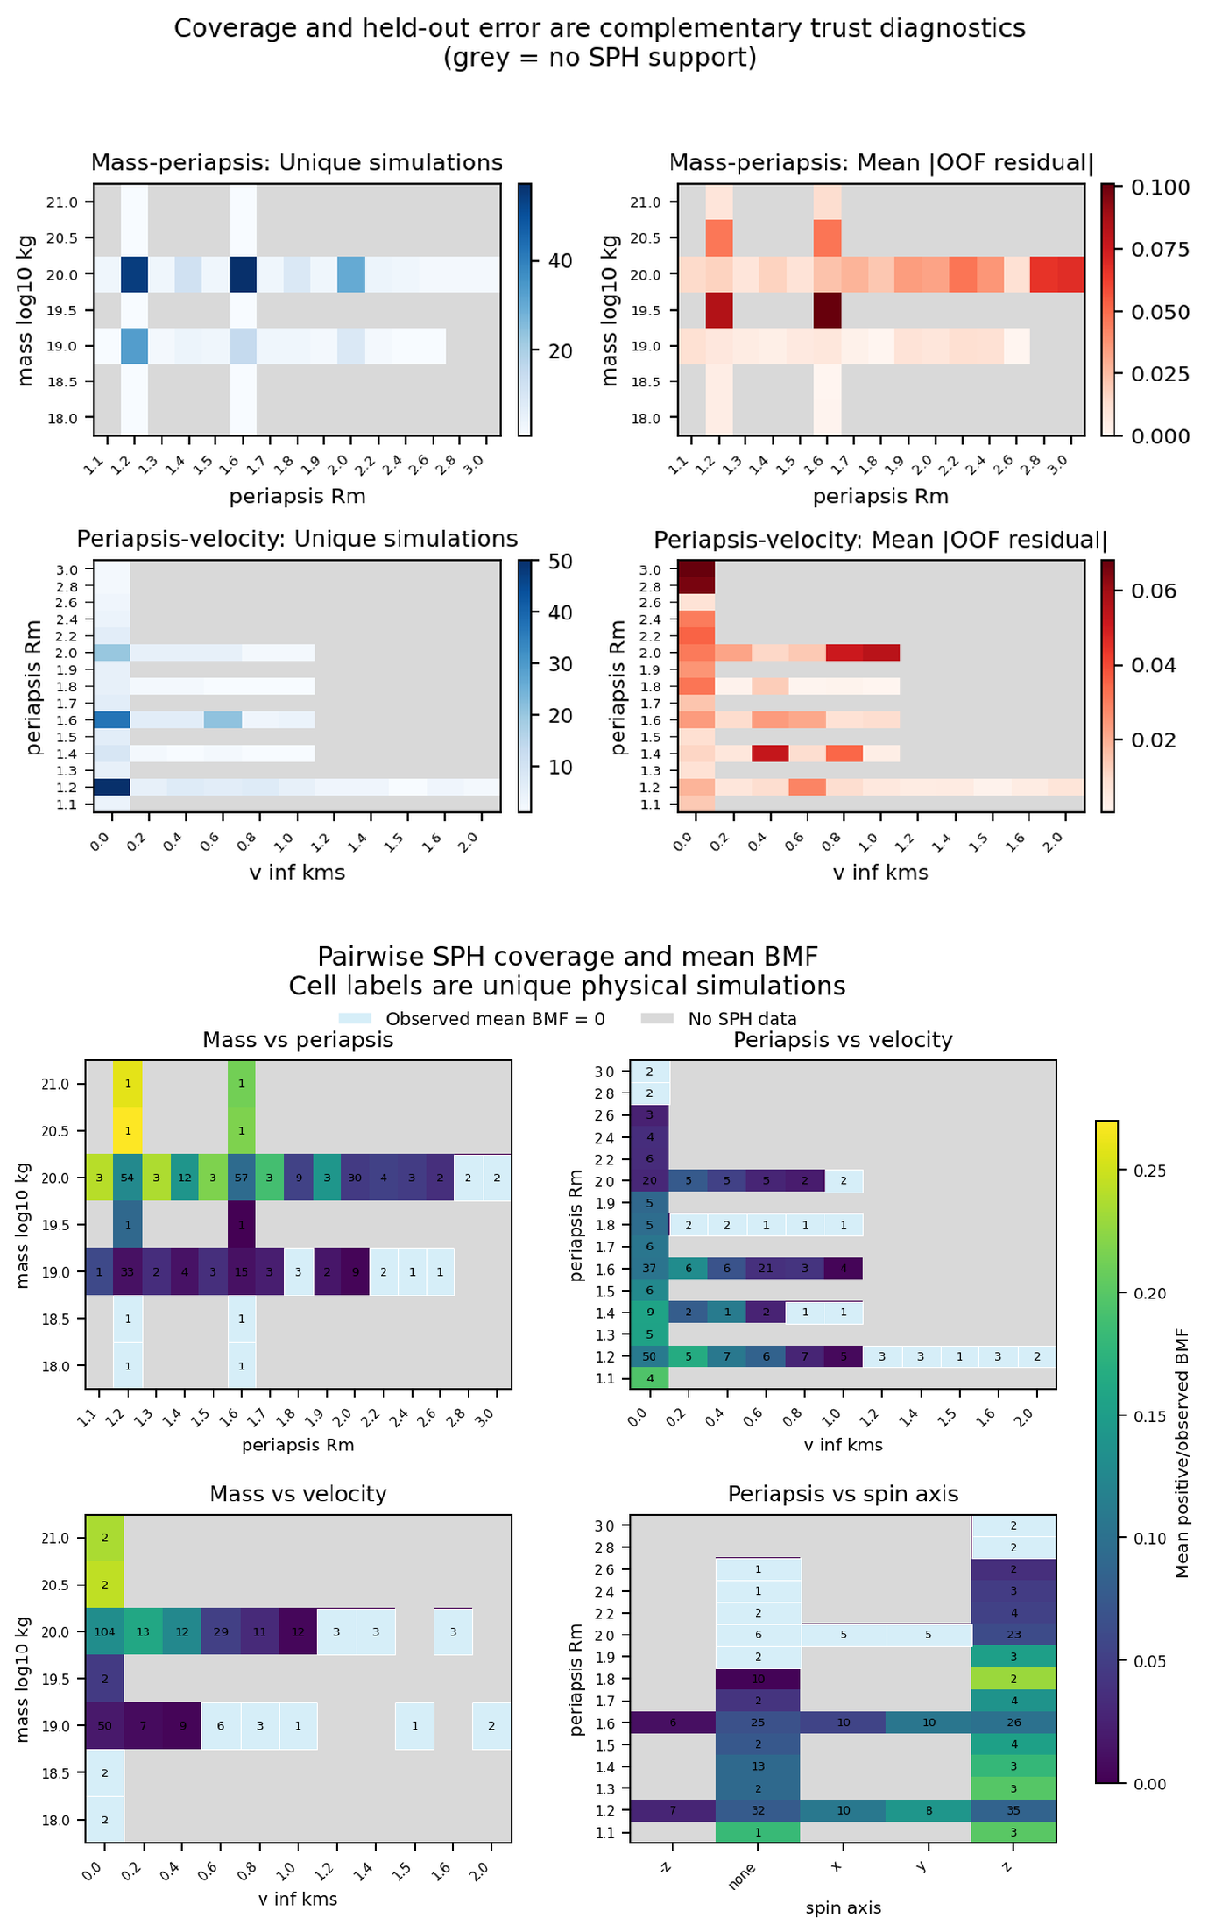
Figure 5. Checks used to judge prediction trust.
(Top: the number of unique SPH simulations and the mean held-out absolute error provide different information. Bottom: pairwise coverage shows input combinations that are missing even when each individual value is within its sampled range.) Grey means no SPH data in that bin, light blue means SPH data exists but the mean observed BMF is 0, while other coloured cells means that SPH data exists and mean observed BMF is > 0.

3.7 How the Model Supports SPH Decisions
So what is the model actually useful for? The screening process separates disruption from retention. The largest-remnant fraction describes whether the asteroid remains mostly intact, partially breaks up, or is severely disrupted, while BMF estimates how much material remains bound to Mars. These outcomes are separate because strong disruption can still produce mostly escaping debris.
The 10% BMF threshold is therefore only used to prioritise promising cases for further SPH simulation. It does not mean that a moon will form. Comparing the predicted bound mass with the present combined mass of Phobos and Deimos is also only a minimum check that enough material is available. Later processes such as debris survival, orbital circularisation, disk formation, and accretion into moons are outside this model and require additional physical modelling.
The prototype therefore reports the breakup class, predicted BMF, estimated Mars-bound mass, data coverage, and a recommendation on whether SPH should be run. Well-supported cases can be screened quickly with ML, while sparse, edge, transition, or uncertain cases should be checked with SPH.

4. Discussion
The main physical result is that the effect of each parameter depends on the other encounter conditions. Periapsis sets the broad strength of the tidal encounter, encounter speed affects how long the interaction lasts and how favourable capture is, and mass and spin modify the result within those conditions. The controlled tests show the clearest directions for periapsis and speed. The matched simulations show that the size of the spin and velocity effects changes with periapsis and spin state.
The ML model reproduces broad trends and reveals interactions across the archive, but these relationships are learned from SPH outputs rather than derived from physical laws. Grouped validation, controlled tests and matched comparisons therefore support interpretation but do not establish causation.
The practical value of ML is therefore limited but useful. It can quickly screen well-supported input combinations, find conditions that give promising retained mass, identify transition regions, and show where an additional simulation could add useful information. It cannot determine long-term debris survival, describe detailed fragment shapes and distributions from BMF alone, or justify predictions for poorly sampled input combinations. The 10^{19.5} kg example shows this clearly: being numerically inside the training range is not enough when only two independent simulations support the local combination.
The ablation and matched analyses answer different questions. Periapsis is strongest overall, but matched cases show that spin or velocity can become more influential under particular encounter conditions.
Fragmentation needs more caution than BMF. Close periapsis allows very strong fragmentation but does not guarantee it, and FoF linking length directly changes how many fragments are counted. Fragment count and largest-remnant measures therefore provide extra information rather than replacing BMF. The workflow keeps breakup severity and Mars-bound retention separate because strong breakup does not necessarily produce much bound debris.
Overall, the ML model is a fast screening tool for the existing SPH archive. SPH remains necessary for poorly sampled cases, transition regions and questions requiring detailed fragment properties.

5. Conclusions, Limitations and Future Work

5.1 Conclusions and Answers to the Research Questions
This research asked how orbital and physical parameters affect disruption and bound retention, which inputs matter most for fragment formation and retained debris, and whether ML can predict outcomes while showing when its predictions should be trusted. The answers are summarised below.
Q1. How do orbital and physical parameters influence disruption and bound mass? Closer and slower encounters generally retain more debris, but the effect depends on the other inputs. In the representative controlled test, predicted BMF decreases from about 25% as periapsis increases from 1.2 Mars radii, while the available SPH cases fall to approximately zero beyond about 2.2 Mars radii. Increasing encounter speed gives a clearer decrease, from about 25% at 0 km/s to approximately zero above 1 km/s. These are condition-specific responses rather than universal thresholds. Periapsis controls tidal strength, speed changes the encounter and capture conditions, and mass and spin modify the result.
Q2. Which parameters most strongly control fragment formation and retained debris? There is no single winner under every condition. Periapsis is the strongest overall input for BMF, while velocity, mass and spin change the outcome within that broad setting. In matched A2000, n65 cases, changing spin gives a BMF range of about 0.06-0.09 below 1.5 Mars radii and reaches up to about 0.24 at larger periapsis. Velocity differences also change with spin state. Fragmentation needs separate fragment and largest-remnant measures because BMF measures retained debris, not breakup alone, and fragment count depends on the FoF definition.
Q3. Can machine learning predict outcomes across the sampled domain with useful trust checks? Yes, when similar input combinations are supported by the SPH archive. The main Random Forest with physics-derived features achieves a grouped cross-validated R² of 0.9225, MAE of 0.0179, and RMSE of 0.0259. However, performance is not equally reliable everywhere. In the sparsely sampled 10^{19.5} kg case, held-out errors rise to about 0.08 BMF, or 8 percentage points, despite the input values lying within the numerical training ranges. This shows that being within the overall input range is not enough; reliable predictions also require similar SPH cases nearby. ML can therefore support fast screening and simulation prioritisation, while sparse, edge, transition, or poorly supported cases still require further SPH study.
Overall, the project shows that tidal-disruption outcomes depend on interacting physical conditions rather than one universal ranking of parameters. Machine learning makes the existing SPH archive faster to explore, shows where predictions are well supported, and highlights where new simulations would be most useful. It complements SPH rather than replacing the simulation physics.

5.2 Limitations
The main limitation is that the simulation archive is small and unevenly sampled. Many rows are not independent physical evidence because one SPH simulation can be processed several ways. Grouped validation prevents this from making the test score unrealistically optimistic, but it cannot create missing simulations. Predictions remain uncertain for poorly sampled combinations, near the edges of the data, or outside combinations seen during training, even when every individual input value lies within its observed minimum and maximum.
The ML model also learns patterns from SPH results rather than directly solving the physical laws. It does not enforce conservation of mass, momentum, energy or angular momentum, and it does not follow the later orbits of fragments. A good BMF prediction therefore cannot answer whether debris survives long term, forms a disk or accretes into moons. Fragment measures are also noisier than BMF and more sensitive to the FoF linking length used in post-processing.
Exploratory XGBoost and hurdle models achieve higher grouped-validation scores but require further testing before replacing the main Random Forest. Models using outcome-derived quantities are unsuitable for pre-SPH screening because those values are unavailable before simulation.

5.3 Future Work
The highest priority for future work is to run new SPH simulations in poorly covered mass-periapsis-velocity-spin combinations, especially near the change between retained and zero BMF. More matched groups should repeat the A₂₀₀₀, n₆₅ comparison at other masses and resolutions while keeping processing choices fixed. Reporting the BMF range together with the actual BMF values and the number of independent simulations would show whether the stronger spin differences also appear in other groups. Testing the model on completely new SPH runs made after training would be a stronger test than repeatedly splitting the existing archive.
Future work should improve per-prediction reliability estimates and automatic detection of poorly supported input combinations. Exploratory XGBoost and hurdle models should also be tested on newly generated SPH simulations before replacing the current model. Further extensions could include uncertainty estimation, multi-output prediction and stronger physical constraints.

References
Bagheri, A., Khan, A., Efroimsky, M., Kruglyakov, M. & Giardini, D. (2021). Dynamical evidence for Phobos and Deimos as remnants of a disrupted common progenitor. Nature Astronomy, 5, 539-543. doi:10.1038/s41550-021-01306-2.
Breiman, L. (2001). Random forests. Machine Learning, 45, 5-32. doi:10.1023/A:1010933404324.
Brunton, S. L., Noack, B. R. & Koumoutsakos, P. (2020). Machine learning for fluid mechanics. Annual Review of Fluid Mechanics, 52, 477-508. doi:10.1146/annurev-fluid-010719-060214.
Canup, R. M. & Salmon, J. (2018). Origin of Phobos and Deimos by the impact of a Vesta-to-Ceres sized body with Mars. Science Advances, 4(4), eaar6887. doi:10.1126/sciadv.aar6887.
Chen, T. & Guestrin, C. (2016). XGBoost: A scalable tree boosting system. Proceedings of the 22nd ACM SIGKDD International Conference on Knowledge Discovery and Data Mining, 785-794.
Citron, R. I., Genda, H. & Ida, S. (2015). Formation of Phobos and Deimos via a giant impact. Icarus, 252, 334-338. doi:10.1016/j.icarus.2015.02.011.
Duan, T., Anand, A., Ding, D. Y., Thai, K. K., Basu, S., Ng, A. & Schuler, A. (2020). NGBoost: Natural Gradient Boosting for Probabilistic Prediction. Proceedings of the 37th International Conference on Machine Learning, PMLR 119, 2690-2700.
Friedman, J. H. (2001). Greedy function approximation: A gradient boosting machine. Annals of Statistics, 29(5), 1189-1232. doi:10.1214/aos/1013203451.
Grinsztajn, L., Oyallon, E. & Varoquaux, G. (2022). Why do tree-based models still outperform deep learning on tabular data? Advances in Neural Information Processing Systems, 35.
Kegerreis, J. A., Lissauer, J. J., Eke, V. R., Sandnes, T. D. & Elphic, R. C. (2024). Origin of Mars’s moons by disruptive partial capture of an asteroid. Icarus, Article 116337. doi:10.1016/j.icarus.2024.116337.
More, S., Kravtsov, A. V., Dalal, N. & Gottlöber, S. (2011). The overdensity and masses of the friends-of-friends halos and universality of the halo mass function. The Astrophysical Journal Supplement Series, 195(1), 4. doi:10.1088/0067-0049/195/1/4.
Price, D. J. (2012). Smoothed particle hydrodynamics and magnetohydrodynamics. Journal of Computational Physics, 231(3), 759-794. doi:10.1016/j.jcp.2010.12.011.
Prokhorenkova, L., Gusev, G., Vorobev, A., Dorogush, A. V. & Gulin, A. (2018). CatBoost: unbiased boosting with categorical features. Advances in Neural Information Processing Systems, 31.
Raissi, M., Perdikaris, P. & Karniadakis, G. E. (2019). Physics-informed neural networks: A deep learning framework for solving forward and inverse problems involving nonlinear partial differential equations. Journal of Computational Physics, 378, 686-707. doi:10.1016/j.jcp.2018.10.045.
Richardson, D. C., Bottke, W. F. Jr. & Love, S. G. (1998). Tidal distortion and disruption of Earth-crossing asteroids. Icarus, 134, 47-76.
Rosenblatt, P., Charnoz, S., Dunseath, K. M., Terao-Dunseath, M. & Trinh, A. (2016). Accretion of Phobos and Deimos in an extended debris disc stirred by transient moons. Nature Geoscience, 9, 581-583. doi:10.1038/ngeo2742.
Villaescusa-Navarro, F. et al. (2021). The CAMELS project: Cosmology and Astrophysics with MachinE Learning Simulations. arXiv:2010.00619.
Walsh, K. J. & Richardson, D. C. (2006). Binary near-Earth asteroid formation: Rubble pile model of tidal disruptions. Icarus, 180(1), 201-216. doi:10.1016/j.icarus.2005.08.015.

Appendix A. Supporting Model Results
Table A1. Physics-derived features calculated from the original setup inputs. These features express useful combinations of encounter parameters.
Feature | Type | Why it was added
v∞² | Simple derived feature | Speed appears squared in kinetic-energy terms, so this gives the model an energy-related form of encounter speed.
1/r_{p} | Simple derived feature | Makes close encounters have larger values, helping the model distinguish the strongest close-approach cases.
r_{p} × v∞ | Combined input | Combines distance and speed so the model can distinguish cases such as close/slow and close/fast encounters rather than treating periapsis and speed separately.
1/P_{spin} | Simple derived feature | Converts spin period into spin frequency, so faster rotation gives a larger value and is easier to compare directly.
Asteroid radius | Simple derived feature | Mass tells how much material the asteroid contains, while radius gives its physical size. Using the assumed density, mass can therefore be expressed as an approximate asteroid size.
Encounter eccentricity | Combined physics feature | Combines periapsis and speed into one description of the encounter orbit, helping distinguish near-parabolic from more hyperbolic fly-bys.
Time within 2 R_{Mars} | Combined physics feature | Estimates how long the asteroid remains close to Mars, because two encounters with similar closest approaches can still spend different amounts of time near the planet.
Time within tidal-disruption radius | Combined physics feature | Estimates how long the asteroid stays in the region where Martian tides may be strong enough to disrupt it.

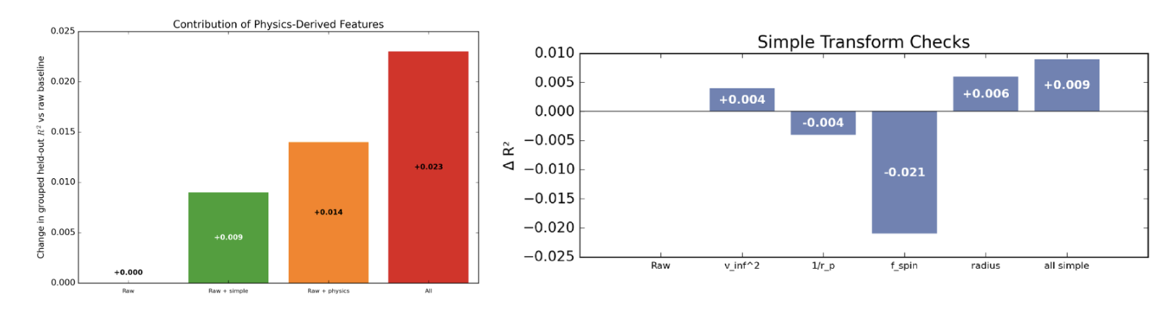
Figure A1. Change in held-out R² when different derived features are added. Using the setup-derived features together improves R² by about +0.023. Individual features can help, add little new information, or reduce performance. The experiment that uses an outcome-derived feature is not the model.
Table A2. Comparison of BMF regression models using five-fold GroupKFold by physical SPH simulation, including exploratory advanced models to show the potential for further performance improvement in future work.
Model | R² | MAE | RMSE | Status
Gradient Boosting | 0.8840 | 0.0228 | 0.0316 | Alternative baseline model
Random Forest | 0.8971 | 0.0184 | 0.0298 | Best baseline model
Tuned RF | 0.8983 | 0.0186 | 0.0297 | No material gain, not promoted
RF + derived features | 0.9225 | 0.0179 | 0.0259 | Includes engineered features from raw inputs in Table A1, modest improvement, promoted to main model
XGBoost | 0.9377 | 0.0132 | 0.0232 | Exploratory only; best single-stage alternative
CatBoost hurdle | 0.9483 | 0.0122 | 0.0212 | Exploratory only; lowest MAE in two-stage tests
NGBoost hurdle | 0.9485 | 0.0127 | 0.0211 | Exploratory only; best R²/RMSE in two-stage tests

Appendix B. Decision-Support Prototype

Figure B1. Mars Tidal Disruption Screening Explorer. The demonstration interface uses the main Random Forest model to report predicted BMF, estimated Mars-bound mass, data-coverage checks and a recommendation on whether another SPH simulation is needed.
A demonstration implementation of the screening workflow was developed as a dashboard and API package. It packages the model, input processing, coverage checks and screening rules into a runnable interface. The application can be downloaded and run locally by cloning the project repository.

Appendix C. AI acknowledgement Statement

No AI was used to write this report. Codex was used for some debugging during the project. I independently reviewed and verified the outputs used in the project, and I take full responsibility for the final analysis, results, code, and submitted work.

