I chose to approach this with classical CV over deep learning because of the limited data, as well my available hardware. All assessed features can be found in features.py. My full workflow can be seen in global_analysis.ipynb, patch_analysis.ipynb and external_validation.ipynb. Use infer.py to run a new input.

First thing was to resize the images because the bonafides were 1024*1024 whereas screen attacks had variable sizes. Then the next step was to inspect the data, purely visually, and compare the screens with their bona fide counterparts to notice differences.

I initially compute global features for the images, and also checked the max and std of these features across an 8*8 grid of 128px patches on these images. Features consist of generic features as well as specific targeted artefacts I found visible in the data - moiré from the display grid (high frequency energy in the FFT of the image), tab/device edges (line energies and orientation), specular glare, etc. These formulae come from PAD literature (Galbally 2014 image quality; Hasler & Süsstrunk 2003 colourfulness; Boulkenafet 2015/16 colour-texture; Patel 2015 moiré). Feature unit tests can be found in tests/ and run on push to the repo’s master branch.

Of the 15 features I computed, 6 were cut based on correlation with one another or when VIF (measures redundancy; high means overlap), ablation testing, L1 (zeroes out weak feature weights) and sign stability (ensures consistent feature impact) agreed - I intentionally used multiple methods to assess feature importance as I didn’t want to over-prune the model (again due to limited data). The same methodology was used on the patch versions of these features.

The final feature set is:

Name | Description | Used For
noise | Laplacian noise | Detecting the loss of sharpness or introduced sensor noise common when an image is recaptured from a screen or print.
chroma_std | Combined standard deviation of the two chrominance channels (Cr, Cb). | Highlighting unnatural color variance, bleeding, or gamut limitations caused by screen displays and printers.
glare_area | Area of the single largest glare blob, as a fraction of the image. | Identifying specular reflections created by the glossy glass surfaces of phones, tablets, or monitors.
line_ratio | Longest detected straight edge, as a fraction of the image diagonal. | Detecting the physical edges, bezels, or boundaries of the device used to present the spoof.
hf_energy | Fraction of FFT magnitude spectrum energy outside a low-frequency disk. | Capturing moiré patterns and the unnatural pixel grid structures inherent to digital displays.
prewitt_energy | Variance of Prewitt gradient magnitude. | Measuring texture sharpness and structural artifacts introduced by the spoofing medium.
orientation_entropy | Shannon entropy of the image’s edge-orientation histogram (from 0 to 180 degrees). | Identifying artificial regularity in textures (like a display pixel grid) versus the natural randomness of a genuine face/environment.
perpendicular_ratio | Share of edge energy in the dominant orientation and its perpendicular. | Specifically targeting the 90-degree corners and rectangular framing of mobile devices, tablets, or printed photos.
hf_energy_pstd | Standard deviation of 64 high-frequency patches. | Spotting the physical contrast between a spoof device (high-frequency moiré) and the true background behind it (low frequency).

I assessed five models crossing two deliberate axes, across various scalers (for completeness, I correctly assumed rank-based scaling would perform best due to the skewed features):

One-class models (Isolation Forest, One-Class SVM, Elliptic
Envelope) never see attack labels, so they cannot memorise attack-specific features (which should generalise better). I chose these three, because they assume different things - tree partitioning, kernel boundary, elliptical density - so which one fails is itself informative. Elliptic Envelope failed outright, correctly diagnosing skew in the computed features. Forest was also used successfully here https://github.com/ee09115/spoofing_detection/tree/master, so I wanted to test it on this data.

Linear vs non-linear, to test whether complexity earns its keep. It didn't: logistic
regression beat random forests once rank-based scaling removed the skew. That is the ideal
outcome, fewest parameters, (harder to overfit 23 positives), and easily explainable by looking at its feature coefficients. Nested-CV tuning gave no gain and picked `C` across four orders of magnitude, so the provided is the untuned default.

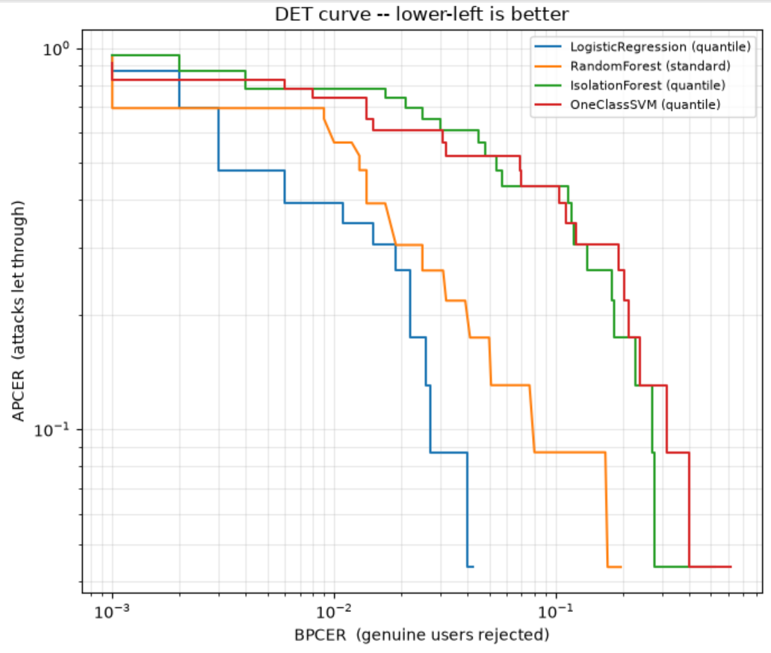

I assessed the models using APCER/BPCER across the full operating curve. I used stricter Clopper-Pearson confidence intervals, because normal approximations are invalid at n=23. Rank-based effect sizes, because three features have a standard deviation larger than their mean. Thresholds are calibrated on out-of-fold bona fide scores only, to avoid leakage.

The provided Logistic Regression model’s default BPCER is 1%. I figured this was realistic enough to act as a default. This can be changed with a --bpcer flag on the CLI. The final model was assessed over 20 random seeds for its final thresholds rather than just 1. Its DET curve is below:

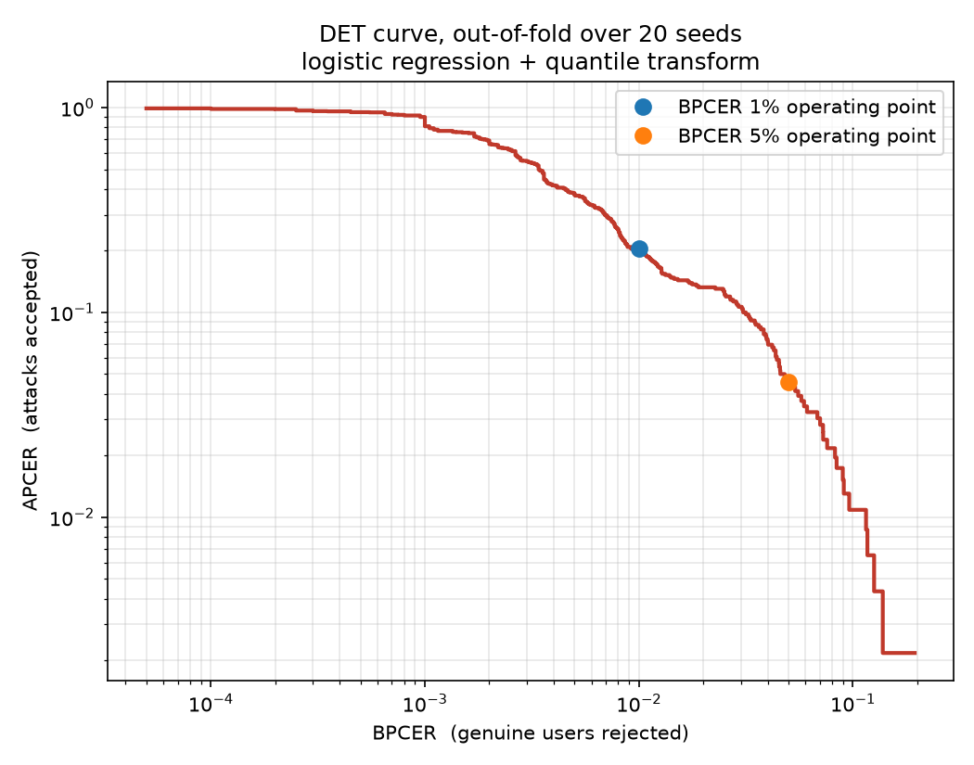

5% BPCER catches nearly everything but rejects one genuine user in twenty, which I assumed is not deployable in a real use case. At a more realistic 1% it misses 4 of 23. To test generalisability, I scored the model against two public replay-attack datasets the model has never seen (see external_validation.ipynb). Sadly, almost every external attack was accepted as genuine (APCER = 1.00 vs in-domain APCER = 0.17 at 1% BPCER), with scores around 0.001-0.005 whereas training attacks score above 0.98.

Upon inspection, we see six of the model’s nine features point the wrong way on external attacks, carrying 78% of the model's coefficient weight. The dominant feature ‘noise’ at 4.19 is inverted: training attacks are noisier than genuine images (1.75 vs 0.90), but external attacks are quieter (0.46), so the model's strongest rule votes "genuine" on them. This could be video-compression smoothing (attacks were extracted from H.264 frames, training attacks were PNG stills) or genuinely quieter capture hardware, I can't separate the two with this data.

However my PAD-specialist features did transfer: perpendicular_ratio, glare_area and orientation_entropy - geometry and reflection features derived from what a GUI or bezel and a glossy display physically are. They carry only 22% of the weight and are outvoted however. On the unseen data, cues grounded in the attack's physics generalised; cues grounded in the samples' quality did not. This would make me want to drop or de-weight noise, or find a better proxy feature, without it the model will score worse in-domain and likely better in the wild. That being said, I assume that the PAD images tested against will be from a similar distribution as the provided .pngs so I opted to keep noise as a feature.

I refrained from retraining with these external attacks as it felt like cheating for this particular exercise, but it would remove the single-device dependency and give a genuine held-out set to test the model against print and screen attacks.

If I had more time I would explore more specific feature detection, as well as more textural/colour features, and detection of UI elements present on screen display, CNN approaches. I would also expand exploration of one-class models with the hopes of better generalisation, as currently the model chosen risks overfitting the specific attack device provided.

