Chicago – DuPage < 0.01

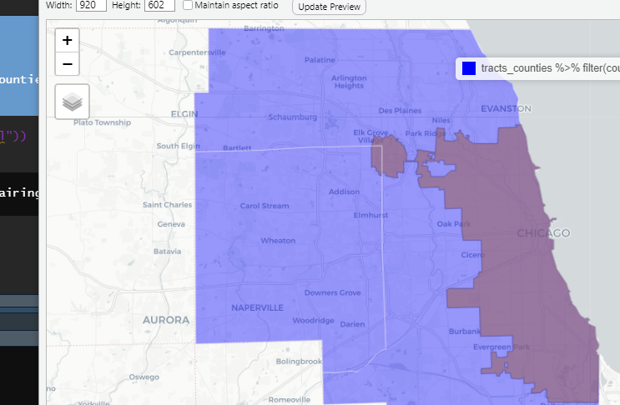

Dallas – Kaufman/Denton < 0.01, Collin < 0.04, Rockwall < 0.06

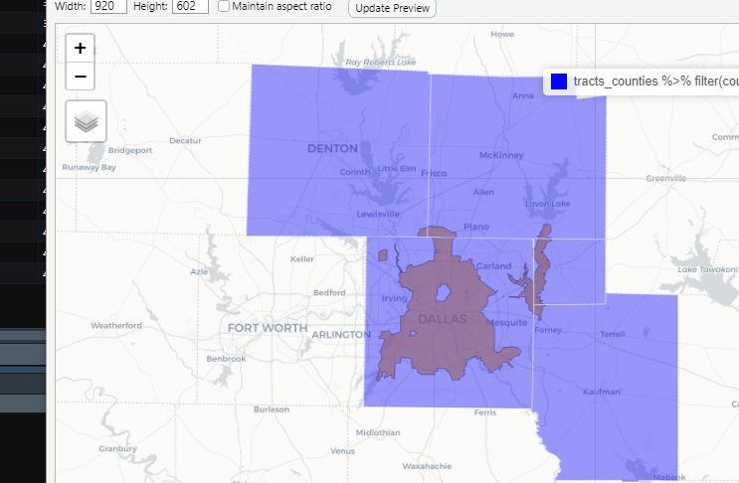

Houston – Montgomery < 0.01, Fort Bend 0.03

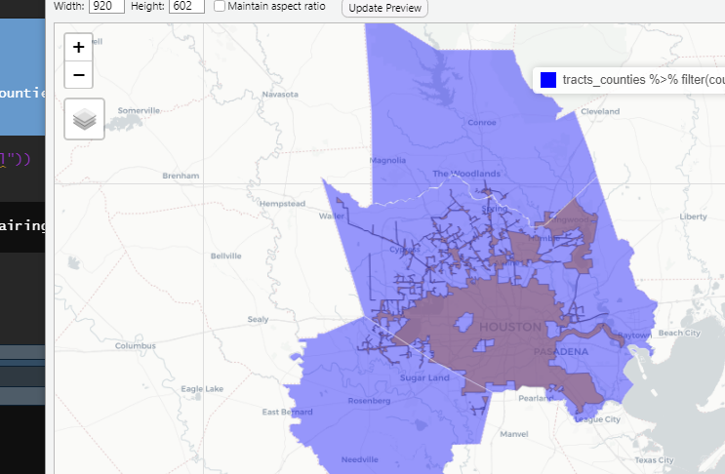

San Antonio – Medina < 0.01

