Imperial College London
Department of Earth Science and Engineering
MSc in Renewable Energy with AI & Data Science (Geology & Geophysics)

Independent Research Project
Final Report

Quantifying Uncertainty in Inter-Farm Wake Losses for Offshore Wind Farms Under Future Build-Out Scenarios

by
Varun Kokkiligadda

Email: varun.kokkiligadda25@imperial.ac.uk
GitHub username: ada-vk825
Repository: https://github.com/ese-ada-lovelace-2025/irp-vk825

Supervisors:
Dr. Simon Warder
Prof. Matthew Piggott

August 28, 2026

Abstract
Rapid offshore wind development is increasing the interaction between neighbouring wind farms, making inter-farm wake losses an increasingly important source of uncertainty in future energy production. Engineering wake models can represent these interactions, but repeated simulations become computationally expensive when many possible future offshore developments and turbine layouts must be explored. This project develops a topology-aware machine-learning surrogate for estimating turbine power and uses it to quantify uncertainty caused by unknown neighbouring wind-farm layouts. Target and neighbouring turbine layouts are generated geometrically using reproducible spacing-constrained placement; PyWake is then used to simulate turbine power for the generated layouts. Atmospheric variables, turbine specifications, neighbouring farm descriptors and physics-informed wake-topology features are used to train an XGBoost regressor to predict turbine capacity factor. The surrogate is assessed against simple regression baselines, a deliberately unseen wind farm and published topology-aware and physics-guided approaches. Sensitivity experiments test physical consistency, while Monte Carlo simulations propagate uncertainty in neighbouring spacing and turbine placement into inter-farm wake loss estimates. The resulting workflow provides a fast-screening framework for future offshore wind-farm interactions while making layout uncertainty explicit.

Introduction
Offshore wind is expanding rapidly, particularly in the North Sea, where the Ostend Declaration targets to reach 300 GW of installed capacity by 2050 [5]. As offshore wind projects move towards dense regional clusters, the wake generated by one wind farm can reduce the wind speed available to another farm downstream. These external interactions are important because a developer can optimise the internal layout of its own farm, but has much less control over the timing, turbine technology and siting decisions of neighbouring projects [5, 17, 18].
When a wind farm is designed, the configuration of nearby lease areas several years later may still be unknown. Published regional studies support this concern. Warder and Piggott show that the share of total North Sea wake losses attributable to intra-farm effects decreases as build-out progresses, while inter-farm effects become increasingly important and can extend over tens of kilometres [5]. Kainz et al. further show that assumptions concerning neighbouring farms can create AEP penalties of up to 1.8% in their reference cluster, comparable with or larger than gains obtained through advanced internal optimisation and control [17].
High-fidelity CFD and mesoscale numerical weather prediction can represent atmospheric interactions in greater detail, but their computational cost limits the number of future configurations that can be explored [5, 14]. Engineering wake models provide a practical alternative, yet even these become costly when many layouts, wind states, and neighbouring farm assumptions must be evaluated repeatedly. This motivates a surrogate model: the expensive simulator is used to generate training data once, and a faster machine learning model is then used for repeated prediction and uncertainty analysis.
This work develops a turbine-level topology-aware surrogate trained on PyWake simulations. The model predicts turbine capacity factor from atmospheric variables, turbine specifications, neighbouring-farm descriptors and physics-informed geometric features. The trained surrogate is then used for independent farm validation, sensitivity analysis and Monte Carlo uncertainty analysis. The central research question is whether a fast topology-aware surrogate can reproduce physically credible inter-farm wake behaviour while quantifying the variation in wake loss caused by uncertain neighbouring farm design.

Problem Description
The engineering problem is to estimate how much power a target offshore wind farm may lose because of a neighbouring development when that development is not yet fully specified. A conventional deterministic calculation requires a particular neighbour geometry and turbine layout. During early planning, however, the neighbouring project may only be known through approximate information such as separation distance, direction, turbine type and plausible spacing. Its final turbine positions may remain unknown. A single deterministic layout can therefore give an artificial precise wake loss estimate. The problem addressed here is to replace that single assumed layout with a fast prediction framework that can evaluate many plausible neighbouring layouts and summarise the resulting variation in target-farm wake loss.

Significance
Inter-farm wakes affect developers, wind-resource analysts, system planners and regulators because they change expected energy production and therefore project value. Warder and Piggott report that more than 95% of total wake-induced losses in the current North Sea fleet arise from intra-farm effects, but this share falls to about 70% by 2050 in their build-out scenario [5]. They also show that long-range interactions must be included to capture the majority of future wake effects [5]. The same study treats “wind theft” as the incremental loss imposed on an existing farm by later development, illustrating that a farm’s energy yield can deteriorate after commissioning because of decisions outside its boundary [5].
Kainz et al. report AEP penalties of 0-1.8% from assumptions about neighbouring farms in an IEA reference cluster, while advanced layout optimisation and control co-design delivered improvements of about 0.6-1.1% [17]. The comparison is case-specific, but it demonstrates that uncertainty in external wakes can be of the same order as improvements that developers work to obtain inside their own projects.

Review of Existing Work
Sant [18] reviews offshore wake modelling comprehensively, highlighting the need for fast prediction tools as clusters grow denser. Warder and Piggott [5] show that future North Sea build-out increases the importance and spatial research of inter-farm wakes, while their global analysis links wake loss with layout optimisation potential and wind climate [6]. More recent comparison with RANS-AWF likewise found broad agreement in wake expansion and spatial extent, although TurbOPark generally predicted stronger deficits and less lateral mixing, particularly at low wind speed and low turbulence intensity [11]. A surrogate trained on TurbOPark can reproduce TurbOPark efficiently, but it cannot remove TurbOPark’s model-form limitations.
Machine learning wake surrogates reduce repeated simulation cost by learning from physics-based data. Ti et al. used an ANN trained on CFD-generated wake fields, demonstrating that nonlinear models can learn wind-speed and turbulence-dependent wake behaviour [10]. Park and Park use a physics-induced graph neural network to represent turbine interactions [9], and convolutional approaches learn spatial wake fields for regional or inter-farm problems [11, 14]. These approaches are powerful but introduce architectural and data-representation complexity that is not necessary if the desired output is turbine-level power.
Zehtabiyan-Rezaie et al. [8] provide a closer methodological precedent for the present model. Their physics-guided XGBoost framework combines geometric wake descriptors with simplified physical information. The physics-guided models achieved training and testing R² values of approximately 98% and 97%, respectively, outperforming a geometry-only model and showing improved transfer to unseen wind-farm cases [8]. Their work also demonstrates that geometric features alone are insufficient because they do not encode turbine operating state or inflow conditions; atmospheric and turbine information must accompany the topology description [8].
The principal benchmark for this project is the topology-aware surrogate of Nguyen et al. [7]. Their method converts wind-farm geometry into turbine-level atmospheric, turbine-specific, geometric and physics-informed features instead of learning directly from raw coordinates. The model was trained on multiple offshore farms and evaluated on unseen Horns Rev I. Their neural network model achieved farm-level RMSE of 1.57 MW, RMSPE of 0.98%, MAE of 0.84 MW and MAPE of 0.53%, while the complete surrogate workflow was substantially faster than repeated FLORIS simulations [7].
The remaining gap addressed by this project is the combination of multi-farm topology-aware training with uncertainty in a not yet finalised neighbouring development. Regional studies investigate future build-out at fleet scale [5, 14], while topology-aware surrogate studies primarily evaluate power for specified layouts [7, 8]. Here, multiple target farms are combined with synthetic neighbouring developments during training so that the model learns inter-farm as well as intra-farm topology. The objective of this project is to: develop a surrogate that transfers across wind-farm geometries and turbine classes; verify that predicted wake-loss responses remain consistent with established wake physics and published trends; and quantify how uncertainty in neighbouring-farm spacing and turbine placement propagates into inter-farm wake-loss estimates.

Methodology
The workflow consists of geometric layout generation, PyWake power simulation, topology feature engineering, XGBoost fitting, independent farm validation, sensitivity analysis, and Monte Carlo uncertainty quantification. The implementation is organised in the installable “wake_uncertainty” package so that notebooks, the command-line interface and Streamlit use the same scientific functions.

2.1 Data, Site Geometry and Wind Climate
Wind-farm boundaries were obtained from the EMODnet Human Activities offshore wind-farm dataset [24] and stored in the project GeoPackage. GeoPandas is used to read the polygons, and each target farm is reprojected from geographic coordinates to an appropriate UTM coordinate reference system before distances, direction, and turbine positions are calculated. Wind-Climate information is derived from ERA5 reanalysis at 100m [23]. The horizontal u- and v-wind components are converted to free-stream wind speed and meteorological wind direction; for annual wind-climate representation, directions are regrouped into twelve 30º sectors and sector frequencies, and Weibull parameters are supplied to PyWake through ‘XRSite’. Wind direction is calculated as:
$$wd=270-atan2\left(v, u\right) \% 360$$
Figure 1 shows the processed Norther wind rose as an example of the site wind-climate representation.

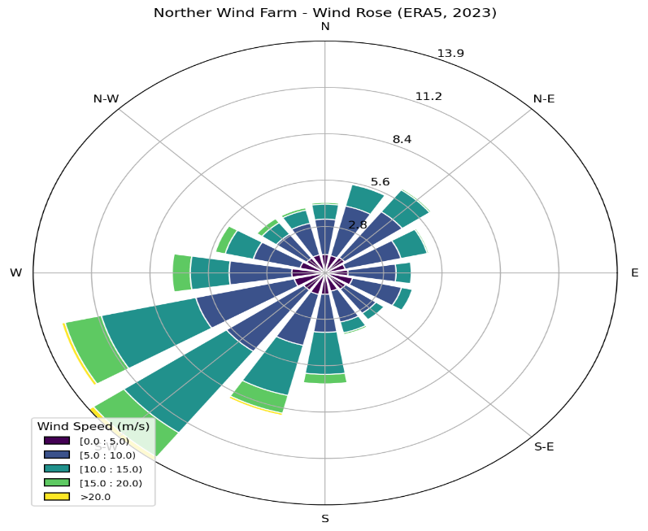
Figure 1. Twelve-sector ERA5 wind rose for the Norther site, Sector frequencies describe the direction distribution used to characterise the site wind climate
Turbine layouts are generated by the project geometry code, not by PyWake. For each synthetic layout, candidate turbine coordinates are drawn using a seeded random generator and accepted only when they lie inside the polygon and satisfy the specified minimum turbine spacing. If all requested turbines cannot be placed within the attempt limit, the synthetic polygon is expanded, and placement is repeated. This procedure creates reproducible but non-identical layout arrangements. Synthetic neighbouring farms are represented by square polygons whose centroids are positioned at a prescribed separation distance and direction from the target farm centroid. The square side length is determined from the turbine count, rotor diameter, and spacing so that the requested layout can be accommodated.
For the final Monte Carlo implementation, the target-farm layout is generated once and then held fixed. Only the neighbouring farm is resampled. At each simulation, a neighbour spacing is selected from the prescribed set, and a new spacing-constrained turbine arrangement is generated within the corresponding square neighbour polygon. Holding the target layout fixed isolates the uncertainty of interest: variation in the external wake caused by an incompletely specified neighbouring design, rather than random changes to both farms.

2.2 PyWake Simulations and Wake-Loss Calculation
Inter-farm wake loss is calculated from the difference between target-farm power without and with the neighbouring farm:
$$wake loss= \frac{Pwithout neighbour​-Pwith neighbour​​}{Pwithout neighbour​} ×100$$
Where P_{without neighbour} is the total predicted power of the target farm without the neighbouring farm and P_{with neighbour} is the total predicted target-farm power when the neighbouring farm is included. Using the same target layout in both terms ensures that the reported loss isolates the effect of the neighbour.
PyWake [12] is used after the layouts have been generated to provide the reference turbine-power labels for supervised learning. Turbine characteristics are represented with ‘GenericWindTurbine’, and the ‘Nygaard_2022’/TurbOPark engineered wake formulation [4] is used to calculate wake-affected turbine power for the prescribed layout and atmospheric state. PyWake returns power in watts; this is converted to kilowatts and divided by the turbine rated power. The resulting dimensionless quantity is the turbine capacity factor used as ML target.

2.3 Topology-Aware Machine Learning Formulation
The ML formulation follows the established topology-aware and physics-guided feature engineering approach of Nguyen et al. [7]. The machine learning inputs are grouped into atmospheric conditions, target-turbine properties, neighbouring-farm descriptors and physics-informed topology variables. The supervised target is the PyWake-derived turbine capacity factor. Table 1 lists the complete feature groups and explains the information supplied to the XGBoost model.
For each target turbine, all other turbines are transformed into a coordinate system aligned with the wind direction. For a candidate upstream turbine, x denotes the positive streamwise separation from the target turbine, y denotes the lateral separation, D denotes the upstream rotor diameter, and k_{w} is the wake-expansion coefficient. A turbine is treated as a potential blocker when it is upstream and its lateral separation lies within the expanding wake envelope, |y| ≤ D/2 + k_{w} * x. The implementation uses k_{w} = 0.05. From the set of blockers, the code derives the number of blocking turbines, a blocking ratio, blocking distance, and the streamwise distance, lateral distance and rotor diameter of the first blocker. These features encode wake-relevant geometry without requiring the ML model to infer rotation and translation from raw map coordinates.
The input representation combines operating state with topology. Atmospheric variables describe inflow; turbine variables describe the target machine; neighbour descriptors describe the external development; and topology variables describe wake exposure. This is necessary because identical geometry can produce different power responses at different wind speeds or turbine operating states [8].
Table 1 . Machine-learning input features used by the XGBoost surrogate. The table identifies each feature group, the variables supplied to the model and their modelling purpose. The topology variables follow the physics-informed feature-engineering principles of Nguyen et al. [7]
Feature group | Variables | Purpose in the ML model
Atmospheric | ws_free, wd, ti | Defines the inflow and turbulence state controlling wake strength and turbine operating regime.
Target turbine | rotor diameter, hub height, rated power | Describes the target machine so the surrogate can transfer across turbine classes.
Neighbour build-out | distance, direction, turbine count, spacing, rotor diameter, hub height, rated power | Describes the scale, position and technology of the external development.
Physics-informed topology | number blocking, blocking ratio/distance, first-blocker streamwise/lateral distance and rotor diameter | Encodes wind-aligned wake exposure for each target turbine following the topology-aware principles in [7].

2.4 Scenario Generation, Model Selection, and Training
The training data deliberately spans multiple target farms rather than a single farm layout. Eleven target farms are included in model development, with 200 synthetic scenarios generated per training farm. Across these scenarios, neighbouring-farm separation ranges between 5-50 km; direction between 0°-330° in 30° increments; neighbour turbine count takes values 20, 40, 80, 120, 160 and 200; spacing takes values 3D, 5D, 7D, 9D and 15D; turbulence intensity takes values 0.04, 0.06, 0.08 and 0.10; free-stream wind speed spans 3-25 m/s; and wind direction spans 0°-360°. One row is stored for every target turbine in every scenario, producing 219,400 turbine-level training observations. Horns Rev I is deliberately excluded from model development and reserved for independent transfer testing; its hold-out dataset contains 1,200 turbine rows across 15 scenarios. The sampled ranges and key reproducibility settings are consolidated in Appendix Table 4.
The features in Table 1 are supplied to ordinary linear regression, elastic net and XGBoost models, with turbine capacity factor as the target. Linear regression and elastic net provide simple baselines that test whether a predominantly linear relationship is already sufficient. XGBoost [21] is selected as the main surrogate because the inputs are structured tabular variables and the wake response contains nonlinear interactions between wind state, turbine operating regime and topology. Hyperparameters are selected using five-fold `GridSearchCV` over estimator count, maximum tree depth, learning rate and minimum child weight. The final tuned configuration uses learning rate 0.1, maximum depth 9, minimum child weight 1 and 500 estimators. Model selection uses R² together with mean squared error (MSE); MAE and RMSE are additionally used for the independent-farm evaluation because R² can become unstable when the target variance is very small.
Three one-factor-at-a-time sensitivity experiments are used to verify physical behaviour. In the distance experiment, neighbour separation is varied while neighbour direction, wind speed, turbulence intensity and turbine specifications are held fixed. In the direction experiment, neighbour direction is varied while separation, wind conditions and turbine specifications are held fixed. In the wind-speed experiment, free-stream wind speed is varied while the farm geometry, neighbour farm direction and turbulence intensity are fixed. Thirty seeded neighbouring-layout realisations are evaluated at each sensitivity value, and the mean wake loss and one standard deviation are reported. The separate Monte Carlo experiment fixes the target layout and the main farm and wind assumptions, then resamples neighbouring spacing and turbine placement over 100 simulations.

Results
Before fitting the surrogate, the topology variables were checked for physical meaning. At least one Jensen-defined blocker is present in 76.3% of the 219,400 turbine observations. The mean turbine capacity factor is 0.578 for observations without a blocker and 0.481 for blocked observations, a raw difference of 0.097. This comparison is not a controlled causal estimate because wind state and scenario composition also differ between the groups, but it confirms that the blocker features identify operating conditions associated with lower turbine output. Figure 3 shows the broader feature-correlation structure.
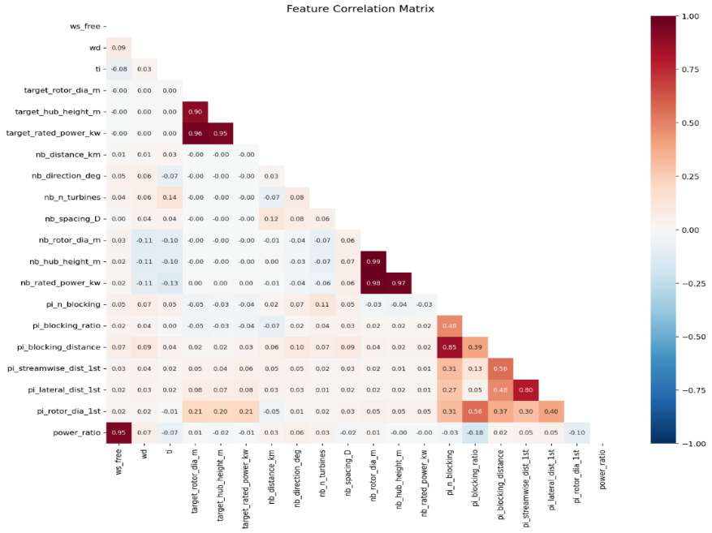
Figure 2 . Correlation structure of surrogate inputs and turbine power ratio. Free-stream wind speed dominates the linear signal, while topology variables contribute through conditional nonlinear interactions
Table 2 compares the regression baselines with the XGBoost surrogate. Linear regression achieves validation R² = 0.9415 with MSE = 8.12 × 10⁻³, showing that the broad turbine power curve and simple feature relationships already explain much of the variance. Elastic net performs worse, with validation R² = 0.7307 and MSE = 3.74 × 10⁻². The default XGBoost model improves to validation R² = 0.9935 and test R² = 0.9937, with validation MSE = 9.09 × 10⁻⁴. Hyperparameter tuning increases validation R² to 0.9951 and test R² to 0.9953. The improvement over the linear baselines supports the use of a nonlinear model: the effect of wake topology on power depends on wind speed, alignment and turbine operating regime rather than acting as a constant additive correction.
Relative to published work, the result is consistent with strong performance of physics-guided XGBoost reported by Zehtabiyan-Rezaie et al., whose physics-guided models achieved approximately 97% testing R² [8]. ]. Nguyen et al. reported an unseen-farm MAPE of 0.53% and RMSPE of 0.98% for their best topology-aware neural-network surrogate [7]. These metrics are not directly interchangeable with the turbine-level power-ratio metrics used here, but they provide a useful benchmark showing that topology-aware feature engineering can support accurate and fast wind-farm surrogates.
Table 2.. Baseline and XGBoost model performance used for model selection in this study
Model | Validation R² | Test R²
Linear regression | 0.9415 | 0.94
Elastic net | 0.7307 | 0.72
XGBoost (default) | 0.9935 | 0.9937
XGBoost (tuned) | 0.9951 | 0.9953

The random-split scores are consistent with other physics-guided surrogates; Zehtabiyan-Rezaie et al. report testing R² of approximately 0.97 [8]. Direct numerical comparison is limited by differences in simulation model, target variable and validation design, so the deliberately unseen Horns Rev I test is treated as the stronger generalisation assessment.

3.1 Generalisation to unseen Horns Rev I
Horns Rev I is withheld completely from the eleven-farm training campaign. Its 80 Vestas V80 turbines have 2 MW rated power and 80 m rotor diameter, so the evaluation changes both farm geometry and turbine class relative to the principal training set. The hold-out dataset contains 1,200 turbine observations across 15 scenarios. This design tests whether the topology-aware representation transfers to an unseen farm rather than simply interpolating among turbine rows from farms already represented during training.
Across the full Horns Rev I hold-out set, the surrogate achieves R² = 0.954 and MAE = 0.0068 in capacity-factor units. The reduction from the random-split R² of 0.9953 is expected because the hold-out removes farm-level overlap and is therefore a more demanding generalisation test. The absolute error remains small, supporting transfer beyond the farms used for model fitting. This result is conceptually consistent with Nguyen et al. [7], who also used Horns Rev I as an unseen-farm benchmark for a topology-aware surrogate.
Single-scenario R² values are not used as the main evidence of transfer. At high wind speeds, many turbines operate close to rated output, and the turbine-to-turbine target variance can become very small; under those conditions, small absolute residuals can produce negative or unstable R² values. Aggregating across the hold-out scenarios and reporting MAE alongside R² gives a more meaningful assessment. Table 3 places the present result alongside the main topology-aware, physics-guided and regional surrogate studies used as benchmarks.

3.2 Sensitivity of Inter-Farm Wake Loss
Neighbour separation produces the expected wake-recovery trend. Across the baseline sensitivity experiment, mean inter-farm wake loss falls by approximately 44% between 5 km and 30 km. The precise curve is configuration-specific, but the direction of change is consistent with the physical recovery and spreading of wakes downstream and with regional studies showing weaker inter-farm influence as separation increases [5,14]. Figure 4a summarises the distance response.
Wind direction produces the strongest local response. Wake loss remains small when the neighbour is not aligned with the inflow, increases rapidly as the wake path approaches the target farm and peaks close to 270° for the baseline geometry. The response is concentrated within roughly ±15-20° of alignment. This behaviour is consistent with the strong directional dependence reported for Horns Rev wake modelling, where relatively small wind-direction changes alter which turbines lie inside upstream wakes [2]. Figure 4b shows this directional sensitivity.
Wind-speed sensitivity is non-monotonic. The largest percentage loss occurs in the below-rated operating region and decreases as the turbines approach rated power. This is physically plausible because below rated speed, a wake-induced velocity deficit produces a strong reduction in electrical power, whereas near rated operation the power curve becomes less sensitive to additional wind speed. Warder and Piggott similarly emphasise the interaction between the wind-speed distribution, turbine thrust and power characteristics when interpreting percentage wake losses [6]. Figure 4c shows the wind-speed response.

Table 3. Literature benchmark for the present surrogate. Published studies are compared by model representation, reference simulator or data source, validation design and reported performance [7-9,14].
Study | Approach | Reference data/model | Validation | Reported performance | Relation to this work
Nguyen et al. [7] | Topology-aware neural-network surrogate | FLORIS / six training farms | Unseen Horns Rev I | RMSE 1.57 MW; RMSPE 0.98%; MAE 0.84 MW; MAPE 0.53% | Primary topology-aware benchmark.
Zehtabiyan-Rezaie et al. [8] | Physics-guided XGBoost | RANS + engineering wake information | Unseen wind-farm cases | Testing R² ≈ 0.97 | Closest model-class benchmark.
Park and Park [9] | Physics-induced graph neural network | FLORIS-based cases | Changing layouts and inflow | Mean MAPE ≈ 1.58% for wind-direction tests | Alternative topology representation.
This work | Topology-aware XGBoost + Monte Carlo | PyWake / multi-farm training set | Held-out Horns Rev I | R² = 0.954; MAE = 0.0068 capacity-factor units | Extends topology-aware modelling to neighbouring-layout uncertainty.

Taken together, the three sensitivity experiments reproduce the expected dependence of wake loss on downstream recovery, directional alignment and turbine operating regime. The agreement with physical intuition and published wake behaviour [2,5,6,14] does not independently validate the parent PyWake model, but it provides an important verification that the surrogate and feature-generation pipeline respond sensibly when key inputs are varied.
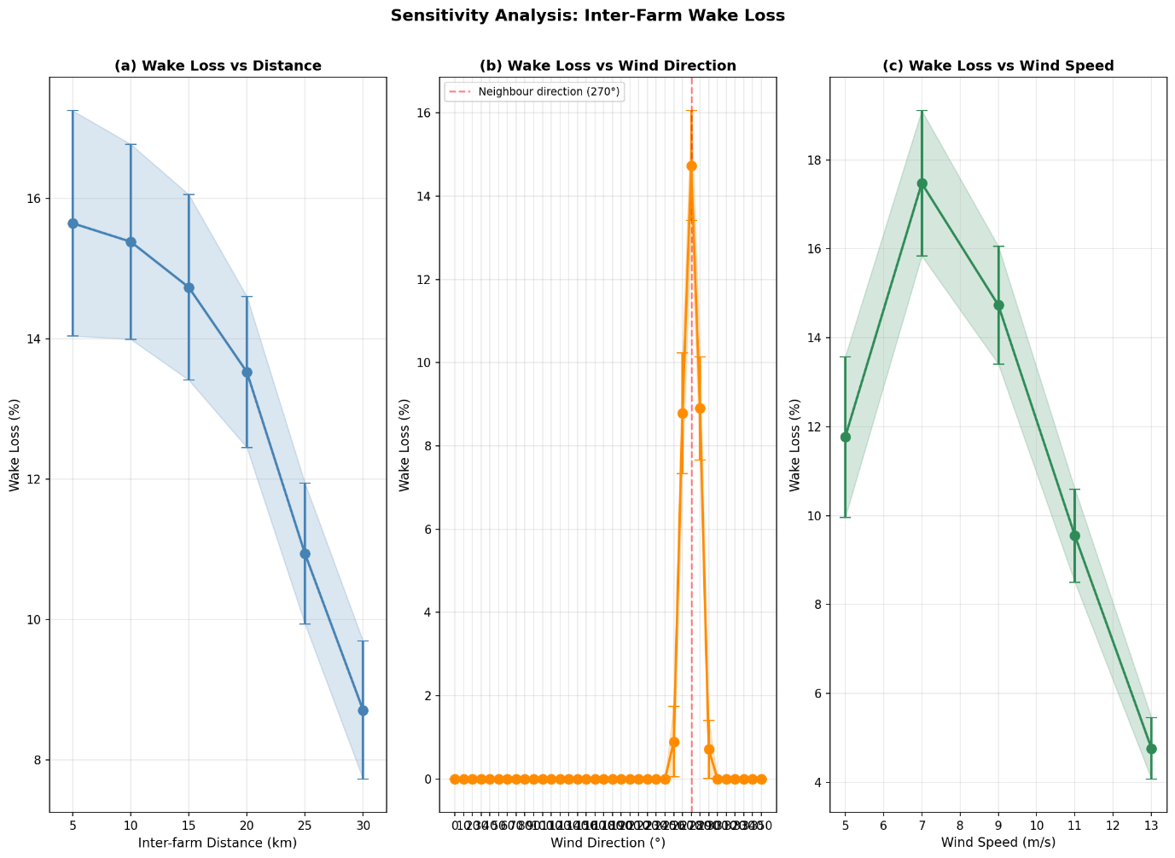
Figure 3 . Inter-farm wake-loss sensitivity to separation distance, wind direction and free-stream wind speed. Error bars/bands represent ±1 standard deviation over 30 layout realisations.

3.3 Monte Carlo Layout Uncertainty
The target layout was generated once and held fixed across all 100 Monte Carlo realisations. In each simulation, all 50 neighbouring turbines were successfully placed, while their spacing and the turbine positions varied according to the random seed. Mean target-farm power is 64,970 kW without the neighbour and 55,585 kW with the neighbour. The resulting mean inter-farm wake loss is 14.432%, with a standard deviation of 1.496 percentage points.
The interval is wide relative to the mean effect. Even when neighbour size, direction, separation, turbine specifications and wind state are fixed, changing only the sampled layout moves the predicted loss across roughly 8.5%. This demonstrates why a single arbitrary neighbouring layout can be misleading when the actual layout is unknown.
The result must nevertheless be interpreted narrowly. It is a conditional distribution generated by the assumed turbine-placement process. It does not represent uncertainty in the wake model, atmospheric stability, future turbine technology, farm location or developer design choices. Model-form uncertainty studies show that these additional sources can also materially change wake and power predictions [3,13].
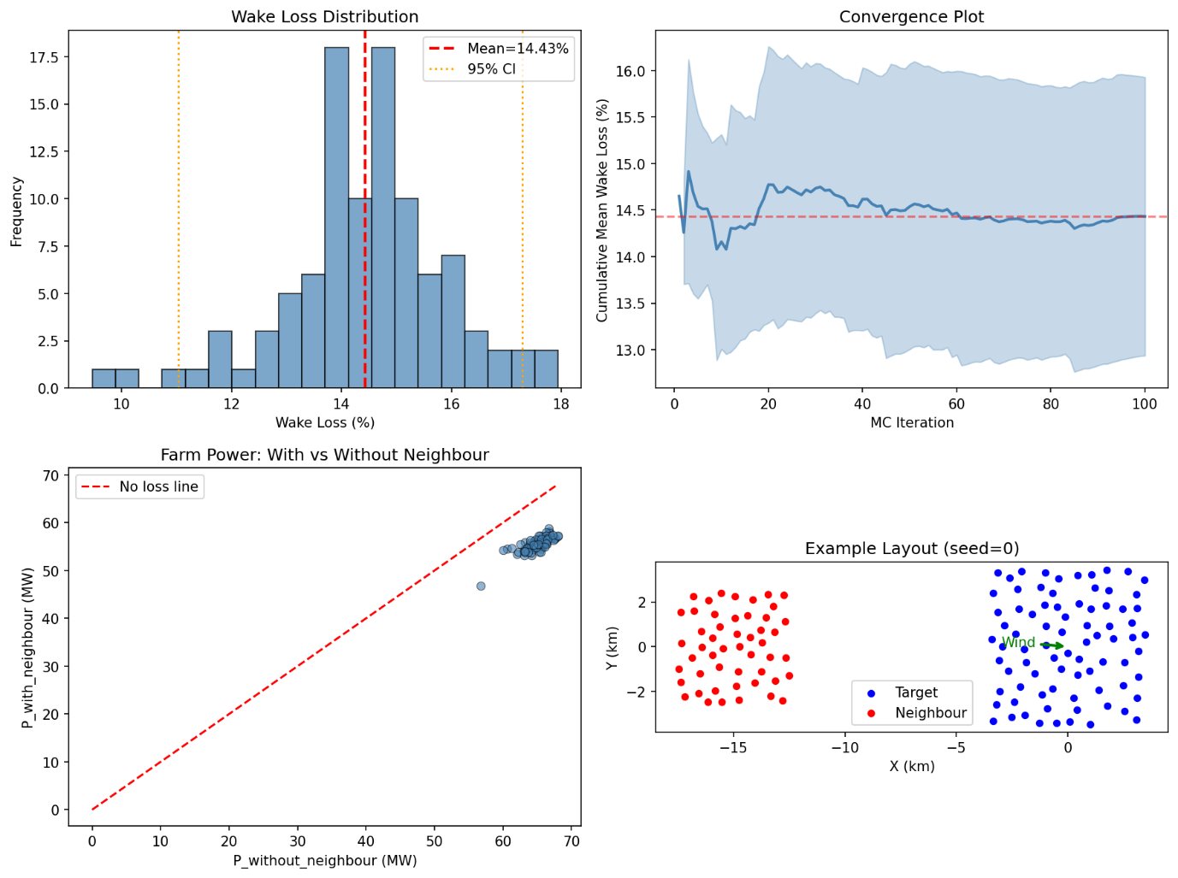
Figure 4. Monte Carlo distribution of inter-farm wake loss and convergence of the running mean for the baseline layout-uncertainty experiment.

3.4 Streamlit Web Application
A Streamlit web application, as shown in Fig. 5, was developed after the scientific workflow to demonstrate how the trained surrogate and Monte Carlo analysis can be used without editing Python code. The application is an interface to the same `wake_uncertainty` package functions used by the notebook and command-line workflows. The user supplies the information required to define the target farm, neighbouring development, wind state and Monte Carlo sampling, and the app returns inter-farm wake loss and power loss with the standard deviation across sampled neighbouring layouts.
The application supports two target-farm workflows. In existing-farm mode, the user selects a farm represented in the project GeoPackage. GeoPandas retrieves the stored farm polygon and reprojects it to the configured UTM coordinate system, while the corresponding target turbine specifications are loaded from the project configuration. The user then supplies the neighbouring-farm distance, direction, turbine count, turbine characteristics and the set of plausible spacing values, together with wind speed, wind direction and turbulence intensity.
In new-farm mode, the user provides both target- and neighbour-farm turbine specifications. Because no lease polygon is available, the application constructs a square target polygon from turbine count, rotor diameter and spacing and uses the same square-neighbour construction as the uncertainty workflow. The target layout is generated once, while neighbour spacing and turbine placement vary across the Monte Carlo realisations.
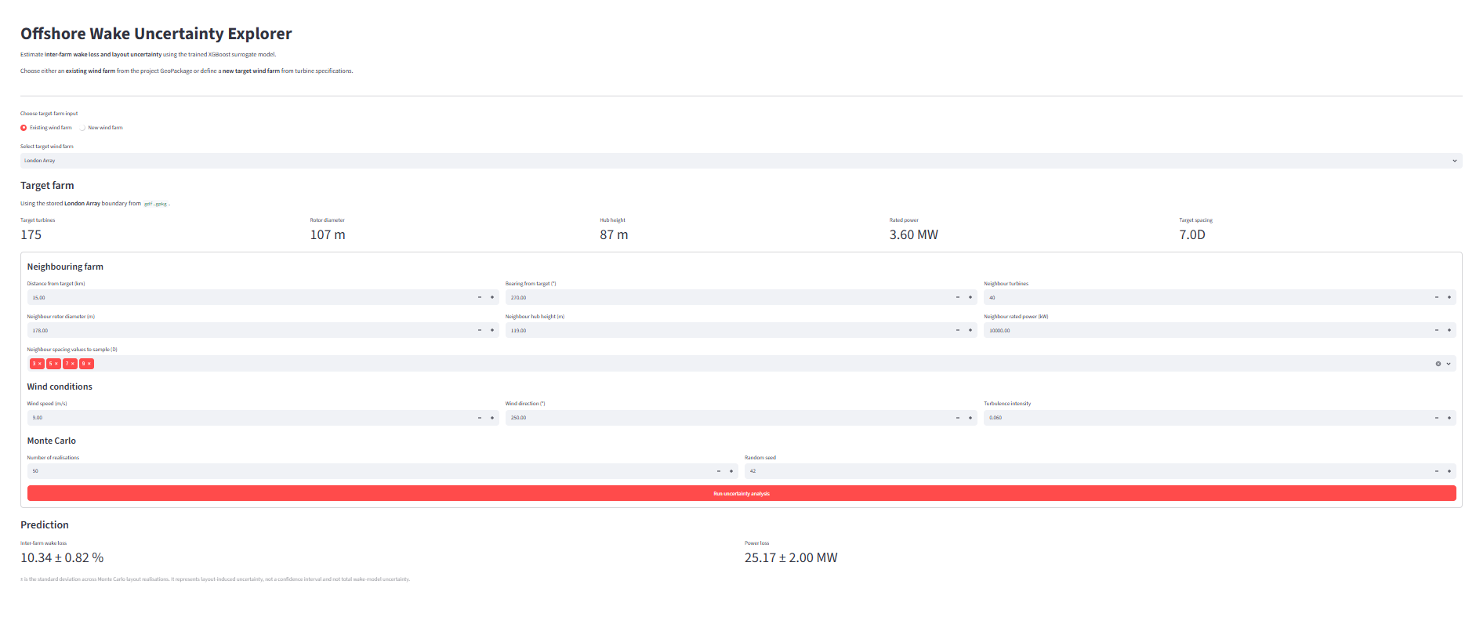
Figure 5. Streamlit application interface for wake loss with uncertainty prediction in offshore wind farms
In both Streamlit modes, topology features are derived automatically, `best_model.pkl` is loaded as the default XGBoost surrogate, and results are presented as wake loss ± standard deviation and yield loss ± standard deviation. Figure 6 summarises the two workflows.

4. Discussion
The first main finding is that explicit wake-topology features allow a standard gradient-boosted model to reproduce the selected engineering wake model accurately over the sampled domain. The tuned XGBoost model substantially outperforms the linear and elastic-net baselines, showing that nonlinear interactions are important even when physically meaningful features are supplied. This agrees with Zehtabiyan-Rezaie et al. [8], who found that physics-guided XGBoost improved both accuracy and generalisation relative to simpler feature formulations.
The Horns Rev I hold-out is the stronger evidence of generalisability. Unlike the random split, it changes the farm geometry and turbine class and prevents rows from that farm entering model development. The resulting R² = 0.954 and MAE = 0.0068 capacity-factor units show that accuracy decreases under a more demanding transfer test but remains strong. This is consistent with the central idea of Nguyen et al. [7]: wind-aligned and physics-informed topology descriptors can provide a representation that transfers more effectively than raw coordinates tied to one layout.
The sensitivity analysis provides a separate verification layer. The predicted loss weakens with increasing separation, is strongly concentrated around wind-neighbour alignment and is largest in the below-rated operating region. These are not merely statistical trends in a held-out dataset; in these experiments, one variable was changed at a time while all other variables were kept constant. Their agreement with published wake behaviour [2,5,6,14] increases confidence that the surrogate has learned a physically credible response within its training domain.
The Monte Carlo experiment adds the main uncertainty contribution of this study. Existing topology-aware surrogates principally estimate power for a specified geometry [7,8]. Here, the surrogate is used repeatedly over plausible neighbouring farm arrangements so that an uncertain design assumption is converted into a distribution of inter-farm wake loss. The 14.43% ± 1.50 percentage-point result for the baseline case shows that layout choice alone can create meaningful variation even when the broader farm and atmospheric conditions are fixed. The numerical value is scenario-specific; the methodological point is that the uncertainty can be explored cheaply once the surrogate has been trained.

4.1 Strengths and practical implications
A major strength is the separation of geometric preprocessing from statistical learning. Wind alignment and blocking features are calculated explicitly, so XGBoost learns from physically interpretable inputs rather than raw coordinates. A second strength is the multi-farm training design, which exposes the surrogate to different target farms and synthetic neighbouring developments rather than one fixed layout.
The software design supports reproducibility: turbine placement, feature engineering, model loading and Monte Carlo analysis are implemented in `wake_uncertainty`, and the same functions are used by notebooks, the command-line interface and Streamlit.
For early-stage planning, the practical value is rapid screening with an explicit uncertainty range. A user can test whether a proposed neighbour is likely to matter and estimate how unresolved layout configuration changes the predicted loss. The workflow is not a replacement for bankable energy-yield assessment; it helps identify cases that justify more expensive site-specific analysis.
4.2 Limitations
The main limitation of the random train/test split is that turbine observations from the same simulated scenario can appear in both partitions. The test of 0.9953 may therefore overestimate performance when transferring to a completely different wind farm. The deliberately withheld Horns Rev I experiment provides a stronger test because its farm geometry and turbine class were not included during model training. The model still achieved and MAE = 0.0068 in capacity-factor units, providing evidence that the topology-aware features support transfer to an unseen farm. However, validation on one unseen farm is not sufficient to demonstrate generalisation to all offshore wind farms. Testing several farms using leave-one-farm-out validation would provide a more rigorous assessment.
The surrogate also inherits the assumptions and limitations of the Nygaard_2022/TurbOPark wake model used to generate the training labels. The topology features represent wake interactions using quantities such as the number of blocking turbines, blocking ratio, blocking distance and first-blocker geometry. These features provide a computationally efficient representation of turbine interactions but do not represent the full three-dimensional atmospheric flow. Engineering wake models can also differ from higher-fidelity approaches in their prediction of wake deficits and lateral wake mixing [11,13]. Therefore, the high surrogate accuracy demonstrates that XGBoost can reproduce the selected PyWake model accurately; it does not demonstrate that the underlying wake model is free from model-form uncertainty.
The uncertainty analysis considers one neighbouring wind farm at a time. Existing neighbouring wind farms and the combined wake effects of several neighbouring developments are not included. In reality, a target farm may be affected simultaneously by multiple existing and future wind farms. The reported uncertainty should therefore be interpreted as uncertainty associated with the layout of a single neighbouring development rather than the total external-wake uncertainty experienced by the target farm.
The Monte Carlo analysis also focuses specifically on uncertainty in neighbouring turbine spacing and turbine placement. Other characteristics, including neighbour distance, direction, turbine count, turbine technology and wind conditions, are held fixed for each experiment. Future developments may be uncertain in all of these quantities. In addition, the neighbouring farm is represented using a square boundary. This provides a simple and controlled way of generating different layouts but does not represent site-specific constraints such as actual lease geometry, bathymetry, exclusion zones, foundation constraints, cable routing or developer layout optimisation.
Finally, XGBoost is primarily reliable within the range of conditions represented in its training data. Predictions for substantially different turbine sizes, farm scales, neighbour configurations or atmospheric conditions should therefore be interpreted cautiously.

4.3 Future Work
Future work should first strengthen the evaluation of model generalisability. Scenario-grouped train/test splitting would prevent turbines from the same simulated scenario appearing in both training and test sets. This could be extended to leave-one-farm-out validation, where each wind farm is excluded from training in turn and used as an independent test case. Such experiments would provide a clearer measure of how well the surrogate transfers to previously unseen farm geometries and turbine technologies.
The uncertainty framework could then be extended from a single neighbour to multiple neighbouring wind farms. Existing farms could be included using their known locations and layouts where available, while uncertain future developments could be sampled simultaneously. This would allow the model to represent the combined wake effects experienced by a target farm in a densely developed offshore region rather than considering each neighbouring development independently.
The Monte Carlo analysis could also include additional sources of uncertainty. In addition to turbine spacing and placement, future experiments could vary neighbour distance, direction, turbine count, turbine technology and lease geometry. Wind conditions could be sampled from a site-specific wind rose rather than evaluating a single wind state, allowing uncertainty to be propagated into annual energy production and annual yield-loss distributions. This would provide a more useful quantity for project-level energy assessment.

5.Conclusions
This project developed a reproducible topology-aware XGBoost surrogate for turbine-level offshore wind-farm power and applied it to uncertainty in inter-farm wake loss. The training data span eleven target farms combined with synthetic neighbouring developments, producing 219,400 turbine-level observations. Turbine layouts are generated geometrically using reproducible spacing-constrained placement, while PyWake provides the simulated turbine-power labels. The tuned XGBoost model achieves random-split test R² = 0.9953, and the deliberately unseen Horns Rev I evaluation achieves R² = 0.954 with MAE = 0.0068 in capacity-factor units.
Controlled sensitivity experiments show physically credible behaviour: wake loss decreases by approximately 44% between 5 km and 30 km in the baseline distance experiment, is concentrated within roughly ±15-20° of neighbour-wind alignment and is largest in the below-rated operating region. These responses agree with established wake physics and published offshore wake studies [2,5,6,14]. In the 100-realisation Monte Carlo experiment, uncertainty in neighbouring spacing and turbine placement produces a mean wake loss of 14.43% with a standard deviation of 1.50 percentage points for the investigated baseline case.
The central conclusion is that a topology-aware surrogate makes uncertainty in future neighbouring development inexpensive to explore. A single assumed neighbour layout can conceal meaningful variation when the final design is unknown. By combining multi-farm training, explicit wake-topology features, XGBoost and Monte Carlo sampling, the framework converts uncertainty in neighbouring design and layout into an explicit wake-loss distribution for early-stage screening. The result remains conditional on the parent wake model, sampled parameter ranges and synthetic-layout assumptions, so it should guide rather than replace higher-fidelity assessment. The accompanying Streamlit application demonstrates how the same workflow can be used with either an existing target-farm polygon or a new hypothetical farm defined from turbine specifications.

Appendix. Reproducibility Summary
The quantitative ranges and implementation choices needed to reproduce the reported scenario generation, model fitting and uncertainty experiments are consolidated in Table 4. This separates fixed implementation settings from the narrative methodology and provides a single reproducibility reference for the simulation campaign.
Table 4. Reproducibility summary for scenario generation, model fitting and uncertainty analysis. The table records the sampled ranges, fixed modelling choices, scenario counts and final XGBoost settings used in this project.
Item | Value / range | Role
Neighbour separation | 5-50 km | Training scenario input
Neighbour bearing | 0°-330° in 30° increments | Training scenario input
Neighbour turbine count | 20, 40, 80, 120, 160, 200 | Training scenario input
Neighbour spacing | 3D, 5D, 7D, 9D, 15D | Training scenario input
Turbulence intensity | 0.04, 0.06, 0.08, 0.10 | Atmospheric input
Free-stream wind speed | 3-25 m/s | Atmospheric input
Wind direction | 0°-360° | Atmospheric input
Wake expansion coefficient | K_{w} = 0.05 | Topology feature calculation
Random seed | 42 unless experiment-specific seed is stated | Reproducibility
Monte Carlo realisations | 100 | Reported baseline uncertainty experiment
Selected XGBoost settings | learning_rate=0.1; max_depth=9; min_child_weight=1; n_estimators=500 | Final surrogate
Training scenarios | 200 per training farm; 11 farms | Primary simulation campaign
Horns Rev I hold-out | 1,200 turbine rows; 15 scenarios | Independent-farm validation

References
[1] R. J. Barthelmie et al., "Modelling and measuring flow and wind turbine wakes in large wind farms offshore," Wind Energy, 2009.
[2] M. Gaumond et al., "Evaluation of the wind direction uncertainty and its impact on wake modeling at the Horns Rev offshore wind farm," Wind Energy, 2013.
[3] N. G. Nygaard, "Systematic quantification of wake model uncertainty offshore," conference presentation, 2015.
[4] N. G. Nygaard et al., "Modelling cluster wakes and wind farm blockage," J. Phys.: Conf. Ser., vol. 1618, 062072, 2020; TurbOPark/Nygaard formulation as implemented in PyWake.
[5] S. C. Warder and M. D. Piggott, "Wind farm wake losses under future build-out scenarios," Wind Energy Engineering Research, vol. 5, 100025, 2026.
[6] S. C. Warder and M. D. Piggott, "Mapping global offshore wind wake losses, layout optimisation potential, and climate change effects," Energy, vol. 331, 136573, 2025.
[7] T.-H. Nguyen, J.-F. Toubeau, E. De Jaeger and F. Vallée, "Topology-aware surrogate for future offshore wind farms using machine learning," Renewable Energy, vol. 256, 123657, 2026.
[8] N. Zehtabiyan-Rezaie, A. Iosifidis and M. Abkar, "Physics-guided machine learning for wind-farm power prediction: Toward interpretability and generalizability," PRX Energy, vol. 2, 013009, 2023.
[9] J. Park and J. Park, "Physics-induced graph neural network: An application to wind-farm power estimation," Energy, vol. 187, 115883, 2019.
[10] Z. Ti, X. W. Deng and M. Zhang, "Artificial neural networks based wake model for power prediction of wind farm," Renewable Energy, vol. 172, pp. 618-631, 2021.
[11] J. P. Schøler, F. P. W. Rasmussen, M. P. van der Laan, A. Peña et al., "Machine-learning models for inter-farm wake prediction," Wind Energy Science Discussions, 2026, doi: 10.5194/wes-2026-54.
[12] M. M. Pedersen, A. Meyer Forsting, P. van der Laan, R. Riva, L. A. Alcayaga Román, J. Criado Risco, M. Friis-Møller, J. Quick, J. P. Schøler Christiansen, R. Valotta Rodrigues, B. T. Olsen and P.-E. Réthoré, "PyWake 2.5.0: An Open-Source Wind Farm Simulation Tool," DTU Wind, Technical University of Denmark, 2023.
[13] A. Eidi, R. Ghiassi, X. Yang and M. Abkar, "Model-form uncertainty quantification in RANS simulations of wakes and power losses in wind farms," Renewable Energy, vol. 179, pp. 2212-2223, 2021.
[14] S. C. Warder, M. C. A. Clare, B. Bhaskaran and M. D. Piggott, "Assessment and optimisation of regional scale wind farm deployment using machine learning," Communications Engineering, 2026.
[15] "Dynamic wind farm model based on deep learning," uploaded project literature.
[16] "Physics-induced / data-driven wind-farm surrogate literature," supporting project literature.
[17] S. Kainz, M. Baricchio, J. Quick and C. L. Bottasso, "How do wind farm layout design, control and co-design optimization compare in mitigating external and internal wake effects," J. Phys.: Conf. Ser., vol. 3224, 032039, 2026.
[18] T. Sant, "Progress in the modelling and management of offshore wind farm wakes: A literature review," Ocean Engineering, vol. 352, 124544, 2026.
[19] P. Hou et al., "A review of offshore wind farm layout optimization and electrical system design methods," J. Mod. Power Syst. Clean Energy, vol. 7, pp. 975-986, 2019.
[20] L. Cao et al., "Wind farm layout optimization to minimize the wake induced turbulence effect on wind turbines," Applied Energy, vol. 323, 119599, 2022.
[21] T. Chen and C. Guestrin, "XGBoost: A scalable tree boosting system," Proc. KDD, 2016.
[22] M. Bastankhah and F. Porté-Agel, "A new analytical model for wind-turbine wakes," Renewable Energy, vol. 70, pp. 116-123, 2014.
[23] H. Hersbach et al., "The ERA5 global reanalysis," Quarterly Journal of the Royal Meteorological Society, vol. 146, pp. 1999-2049, 2020.
[24] European Marine Observation and Data Network (EMODnet), "Human Activities: Offshore Wind Farms," spatial dataset used for project wind-farm boundaries.

