Imperial College London
Department of Earth Science and Engineering
MSc in Renewable Energy with AI & Data Science (Geology & Geophysics)

Independent Research Project
Project Plan

Quantifying Uncertainty in Inter-Farm Wake Losses Under Future Build-Out Scenarios

by
Varun Kokkiligadda

Email: varun.kokkiligadda25@imperial.ac.uk
GitHub username: ada-vk825
Repository: https://github.com/ese-ada-lovelace-2025/irp-vk825

Supervisors:
Dr. Simon Warder
Prof. Matthew Piggott

June 2026

Abstract
Offshore wind farms are increasingly being built in dense clusters, which means wakes from the one farm can significantly reduce the energy available to its neighbouring farms. While several studies have modelled these inter-farm wake losses for known layouts, very little work has quantified the uncertainty that arises when we do not yet know what the neighbouring farms will look like in the future. This project proposes building a machine learning surrogate model trained on PyWake/TurbOPark simulations that can predict inter-farm wake losses and quantify uncertainty across plausible future build-out scenarios. The model will first be developed for a single target farm and then generalised across multiple farms, so it can predict wake losses for any unseen wind farm without retraining the model. All the data will come from the real lease area boundaries and real wind conditions (ERA5). However, the turbine layouts and spacing within each lease area will be hypothetical. The final deliverables include a generalised ML surrogate model and a Streamlit web application where users can input farm parameters, wind conditions, and neighbour assumptions to receive instant wake loss predictions with uncertainty, along with the yield loss.

Introduction
Offshore wind is expanding rapidly, particularly in the North Sea, where the Ostend Declaration targets to reach 300 GW of installed capacity by 2050 [2]. As the number of installations grows, wind farms are increasingly being developed in close proximity, forming dense clusters. When wind passes through a farm, it slows down and becomes more turbulent due to the wake effects. Within a single farm, developers can optimise turbine spacing to minimise the internal losses [10, 11]. However, when multiple farms are built close together, the wakes from one farm travel downstream and reduce the wind available to the next. These inter-farm wake effects are becoming a serious concern as more lease areas get developed in proximity [12, 13].
The financial consequences of underestimating the wake losses are substantial. If a developer underestimates the losses, the farm will produce less energy than expected, leading to revenue shortfalls that can jeopardise the entire investment. Kainz et al. [1] studied IEA Wind 2200-22-MW reference cluster using Pywake and TurbOPark and found that incorrect assumptions about neighbouring farms can introduce AEP penalties of 0 to 1.8%, which is larger than the gains achievable through advanced layout optimisation and control co-design (0.6% to 1.1% improvement). At a regional scale, Warder and Piggott [2] showed that inter-farm losses reach a mean of 5.1% at the 2050 build-out stage when all interactions up to 125 km are considered, with annual economic losses estimated at £461 million at full build-out assuming 40 GBP per MWh [3]. Nygaard et al. [12] demonstrated that the TurbOPark model captures these long-range cluster wake interactions effectively when calibrated against SCADA data.
The real challenge here is the uncertainty. When a developer designs a new wind farm today, they often have no idea what will be built in the neighbourhood lease areas in the next five or ten years. The neighbouring farms may use different turbine types and spacings, changing how much wake the target farms will experience. Running physics-based simulations for every possible future scenario is computationally expensive. Warder et al. [3] showed that the computational cost of mesoscale NWP models is a barrier to multi-scenario assessment at the regional scale, making it impractical to explore hundreds of future scenarios directly. There is therefore a clear need for a fast, data-driven tool that can explore this uncertainty space and tell developers, for a given scenario, what range of wake losses they should expect. This project addresses a specific and well-defined challenge: developing a computationally feasible approach to quantify the uncertainty in the wake loss and the associated financial risk with unknown future neighbour developments.

1.1 Review of Existing Work
Sant [9] reviews offshore wake modelling comprehensively, highlighting the need for fast prediction tools as clusters grow denser. Warder and Piggott [2] modelled the entire North Sea fleet using TurbOPark, finding that the proportion of losses due to intra-farm wakes decreases from over 95% to around 70% by 2050, with interactions simulated up to 125 km. Warder et al. [3] combined WRF with a U-Net to predict inter-farm deficit fields and explored uncertainty with respect to farm locations, showing that 22 out of 82 farms would incur losses greater than 3% AEP. Warder and Piggott [8] mapped global wake losses using ERA5 data, demonstrating that wind-rose characteristics dominate wake behavior. Bastankhah and Porté-Agel [13] developed the Gaussian wake model that underpins many modern engineering tools, including the TurbOPark formulation used in this project.
On the topic of layout optimisation methods, Hou et al. [10] provide a comprehensive review of offshore wind farm layout optimisation methods, while Cao et al. [11] demonstrate that optimised layouts can reduce internal wake losses by 10-20%. These studies demonstrate that while internal wake losses can be managed through design, inter-farm losses from external neighbours remain outside the developer’s control.
On ML surrogates, Nguyen et al. [4] built a topology-aware model trained on 52,746 FLORIS simulations across six offshore wind farms, using geometric features like blockage ratio to achieve 0.53% MAPE while running 25 times faster than the simulation. Zehtabiyan-Rezaie et al. [5] showed physics-guided XGBoost achieves R² of 97% and generalises to unseen farms. Ti et al. [6] developed ANN-based wake models from CFD data, and Park and Park [7] proposed a Physics-induced GNN for wind farm power estimation. All provide single-point estimates for known layouts.

1.2 Research Gap and Proposed Contribution
While Warder et al. [3] explored uncertainty with respect to farm locations using a U-Net surrogate, the uncertainty arising from unknown turbine layouts and spacing within fixed lease areas remains unaddressed. Furthermore, existing studies have not combined inter-farm wake modelling, ML surrogate prediction, and uncertainty quantification arising from unknown future build-out scenarios into a single framework. This project aims to fill this gap by developing a machine learning surrogate model that predicts inter-farm wake losses and quantifies uncertainty across multiple plausible future deployment scenarios. Rather than training a separate model for each farm, the surrogate will encode the spatial relationships between farms using topology-based features such as relative distances, angular positions, capacity density, etc. This allows the model to generalise across different farm clusters without retraining, following the approach demonstrated by Nguyen et al. [4].
The specific objectives are:
- Establish a real-world baseline using EMODnet lease area polygons and ERA5 wind rose data for the selected case study location.
- Build a PyWake/TurbOPark simulation pipeline to calculate inter-farm wake losses for multiple neighbouring farm configurations generated within real lease boundaries.
- Train and validate a Machine Learning surrogate model predicting wake loss percentage from neighbouring farm parameters and wind conditions
- Quantify uncertainty by running thousands of Monte Carlo simulations through the surrogate to produce mean and standard deviation.
- Generalise the model across multiple target farms following the topology-aware approach of Nguyen et al. [4].
- Build a Streamlit web application for interactive predictions with uncertainty estimates.

Methodology

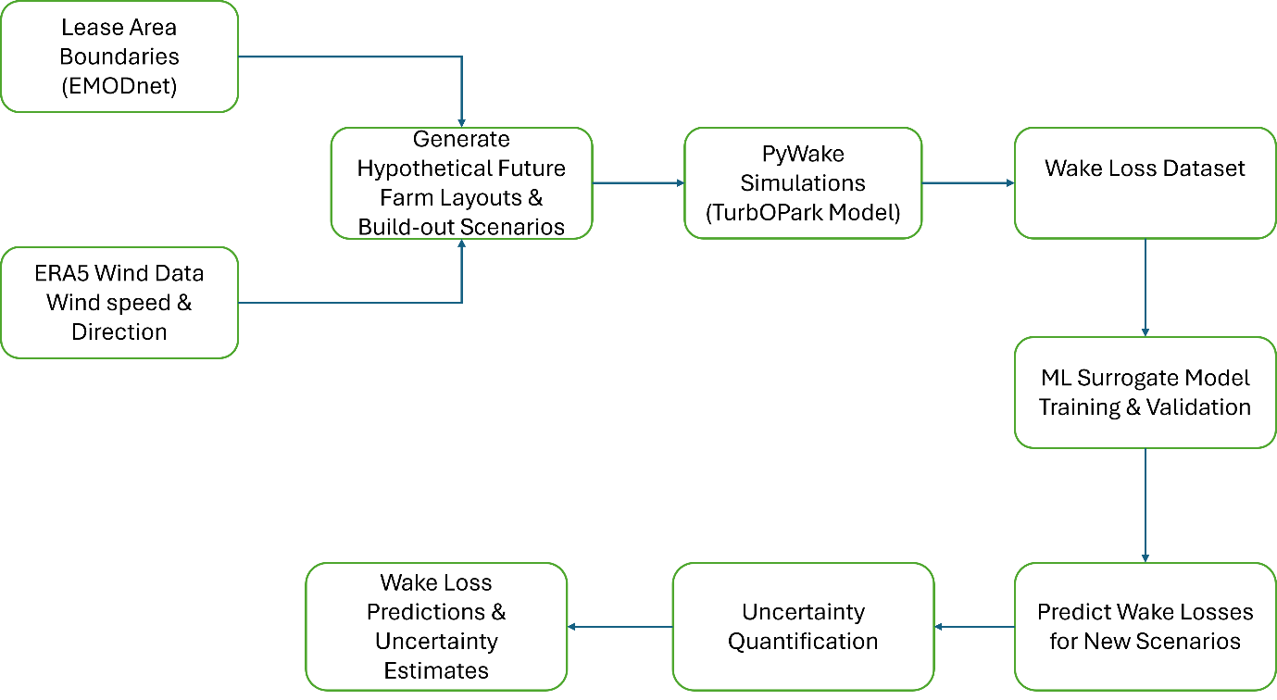
Figure 1. Proposed workflow for developing a machine-learning surrogate model for inter-farm wake-loss prediction and uncertainty quantification under future offshore wind farm build-out scenarios

2.1 Data and Case Study
Real lease area boundaries from EMODnet will be loaded via geopandas. The target farm will be selected from a region surrounded by other lease areas, some built and some planned, providing a realistic spatial context where the future is uncertain. Wind conditions come from ERA5 reanalysis, providing a real wind rose for the location. All turbine specifications will be real from the manufacturer's public data.

2.2 Simulation Setup
All simulations use PyWake with the TurbOPark wake deficit model, chosen because it models long-range wakes effectively and is used by both Kainz et al. [1] and Warder and Piggott [2] for inter-farm studies. The target farm is first simulated alone, then with neighbours introduced to measure the wake loss percentage.

2.3 Scenario Generation and ML Training
Neighbouring lease areas will be populated with varying turbine spacing, turbine count, turbine type, and orientation. Each configuration represents one plausible future build-out scenario. XGBoost is chosen as the primary model due to its proven performance on tabular physics-derived features, achieving R² above 97% in comparable wind farm prediction tasks [5]. Random Forests will be trained as a baseline model. Input features follow the geometric approach of Nguyen et al. [4], using blockage ratio, blocking distance, and turbine-relative geometric features rather than raw coordinates.

2.4 Uncertainty Quantification
The validated surrogate replaces PyWake for predictions. Thousands of randomly sample future scenarios are passed through the model, and the mean and the standard deviation of the wake loss prediction is calculated to quantify the uncertainty rather than a single deterministic value.

2.5 Limitations and Justification
TurbOPark assumes steady-state, uniform wind conditions and neglects mesoscale atmospheric variations [2], but CFD/WRF alternatives are too expensive for the thousands of scenarios required for uncertainty quantification [3]. Tree-based models such as XGBoost cannot extrapolate beyond the training data, unlike linear regression models. This limitation is mitigated by ensuring the training set spans the full physically plausible parameter space for turbine spacing, capacity, and layout density. A physics-induced GNN [7] was considered as an alternative but XGBoost with engineered features is more practical given the three-month project timeline.

Plan of Work

Phase | Tasks | When
1. | Download EMODnet data, select target farm, process ERA5 wind rose data, collect turbine specs | Week 1-3
2. | Run baseline, generate scenarios, train ML model | Week 4-6
3. | Scale scenarios, Monte Carlo Uncertainty Quantification, begin multi-farm data generation, start report outline | Week 7-9
4. | Train generalised model, build Streamlit app, validate, complete report writing, code documentation | Week 10-12

Table 1 Project Timeline

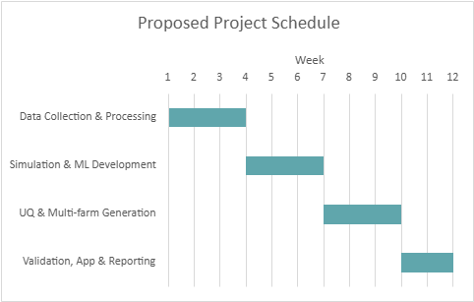
Figure 2. Gantt chart showing the project timeline with parallel and sequential tasks

Risk Mitigation
Simulation time is the primary risk, managed by bounding the parameter space and parallelising the PyWake runs. If any component takes longer than expected, the single-farm uncertainty quantification stands as a complete contribution. Report writing begins at week 7 to avoid overloading the final weeks.

References
[1]. S. Kainz, M. Baricchio, J. Quick, and C. L. Bottasso, How do wind farm layout design, control and co-design optimization compare in mitigating external and internal wake effects, J. Phys.: Conf. Ser., vol. 3224, p. 032039, 2026.
[2]. S. C. Warder and M. D. Piggott, Wind farm wake losses under future build-out scenarios, Wind Energy Eng. Res., vol. 5, p. 100025
[3]. S. C. Warder, M. C. A. Clare, B. Bhaskaran, and M. D. Piggott, Assessment and optimisation of regional scale wind farm deployment using machine learning, Commun. Eng., 2026.
[4]. T.-H. Nguyen, J.-F. Toubeau, E. De Jaeger, and F. Vallée, Topology-aware surrogate for future offshore wind farms using machine learning, Renew. Energy, vol. 256, p. 123657, 2026.
[5]. N. Zehtabiyan-Rezaie, A. Iosifidis, and M. Abkar, Physics-guided machine learning for wind-farm power prediction: Toward interpretability and generalizability, PRX Energy, vol. 2, p. 013009, 2023.
[6]. Z. Ti, X. W. Deng, and M. Zhang, Artificial neural networks based wake model for power prediction of wind farm, Renew. Energy, vol. 172, pp. 618631, 2021
[7]. J. Park and J. Park, Physics-induced graph neural network: An application to windfarm power estimation, Energy, vol. 187, p. 115883, 2019.
[8]. S. C. Warder and M. D. Piggott, Mapping global offshore wind wake losses, layout optimisation potential, and climate change effects, Energy, vol. 331, p. 136573, 2025.
[9]. T. Sant, Progress in the modelling and management of offshore wind farm wakes: A literature review, Ocean Eng., vol. 352, p. 124544, 2026.
[10]. P. Hou, W. Hu, J. Zhu, K. MA, G. Yang, and Z. Chen, A review of offshore wind farm layout optimization and electrical system design methods, J. Mod. Power Syst. Clean Energy, vol. 7, pp. 975-986, 2019
[11]. L. Cao, M. Ge, X. Gao, B. Du, B. Li, Z. Huang, and Y. Liu, Wind farm layout optimization to minimize the wake induced turbulence effect on wind turbines, Appl. Energy, vol. 323, p. 119599, 2022.
[12]. N. G. Nygaard, S. T. Steen, L. Poulsen, and J. G. Pedersen, Modelling cluster wakes and wind farm blockage, J. Phys.: Conf. Ser., vol. 1618, p. 062072, 2020.
[13]. M. Bastankhah and F. Porté-Agel, A new analytical model for wind-turbine wakes, Renew. Energy, vol. 70, pp. 116–123, 2014.

