Compounding climate isolation across Africa's road network

Hang Su^{1,2,3,4,6}, Yichen Liu^{5,6}, Shuisong Ke^{2,4}, Haoran Zhang^{1,3,7}
- School of Urban Planning & Design, Peking University, Shenzhen, Guangdong, China
- Shenzhen Data Management Center of Planning and Natural Resource, Shenzhen, Guangdong, China
- Guangdong Provincial Key Laboratory of Risk Perception and Sustainable Governance in Energy Transition, Shenzhen 518055. Guangdong, China
- Key Laboratory of Urban Land Resources Monitoring and Simulation, Ministry of Natural Resources, Shenzhen, Guangdong, China
- Department of Earth Sciences and Engineering, Imperial College London, London, UK
- These authors contributed equally: Hang Su, Yichen Liu.
- Corresponding author. Email: h.zhang@pku.edu.cn

Abstract
African road systems are unusually vulnerable to climate stress because a large share of the network is unpaved, yet the network-scale consequences of this exposure remain poorly quantified. We integrated a continent-scale road network across 49 African countries with climate-driven road deterioration, population distribution and healthcare accessibility data to test whether extreme weather causes compounding climate isolation. Extreme weather reduced mean road speed by only about 9-10%, but increased travel time by 36.3% across connected international city pairs and by 41.0% across within-country city pairs, revealing a 3.67-4.47-fold amplification of direct road-level degradation through network structure. These losses were strongly unequal. In 47 of 49 countries, the worst-affected populations experienced larger travel-time increases than the median group, with a mean tail-gap ratio of 3.60; the share of the population within 1 h of a healthcare facility fell from 88.0% to 81.7% under extreme conditions. Critical bottlenecks were rare but persistent under future climate, and paving just 0.1% of unpaved roads restored 71.7% of lost network efficiency, outperforming random paving by roughly 1,200-fold. These results show that in unpaved-dominant road systems, climate risk is governed less by local exposure alone than by network amplification, unequal redundancy and a small set of high-leverage bottlenecks.

Introduction
Africa hosts the fastest-growing population in the world, projected to exceed 2.5 billion by 2050¹. It also depends on a road network that is highly exposed to climate stress. Of the continent's approximately 3.4 million kilometres of roads, about half are unpaved², a share far larger than on any other continent. Unpaved roads respond to climate very differently from paved roads³. Prolonged rainstorms can turn earthen surfaces into impassable mud. Floodwaters can wash away the road base within hours. Persistent heat and drought cause surface disintegration and dust or sand encroachment⁴. Poor road conditions impose substantial economic and development costs across sub-Saharan Africa, while road spending and investment needs are themselves on the order of 2-2.5% of GDP^{5,6}. The IPCC Sixth Assessment Report projects intensification of heavy precipitation across many parts of Africa, while transport-sector adaptation has increasingly focused on the climate resilience of road infrastructure^{7,8}. For the hundreds of millions of rural residents who depend on unpaved roads to reach hospitals, schools and markets, these lifelines now face the risk of systemic breakdown^{9,10}.
Existing research has approached the climate and transport relationship through several lenses, including the physical mechanisms by which climate degrades road segments⁴, topological compounding effects at the network scale^{11,12}, and spatial inequalities in accessibility^{13,14}. Its empirical basis, however, has been built almost entirely on paved road systems in developed countries. There, surfaces are largely sealed, climate-induced degradation is local and probabilistic, and network redundancy is generally sufficient to absorb disruption. The African context differs fundamentally. When about half of a continent's roads are unpaved, climate shocks no longer act as random disturbances on isolated links. They become a systemic erosion of the network itself^{15,16}. Under climate events, degradation of unpaved roads is not exceptional but routine, not localised but pervasive¹⁷. Whether resilience and equity findings derived from paved networks remain valid in unpaved-dominant systems therefore stands as an unresolved empirical question. Africa is also the continent where climate vulnerability and transport vulnerability overlap most intensely.
The dominance of unpaved roads gives Africa a distinctive risk structure. When climate events strike, what deteriorates is not a few peripheral links but the backbone and body of the system. Simultaneous degradation across large unpaved areas becomes coupled through the network. Local impassability accumulates into regional connectivity collapse and cuts off peripheral communities from basic services. The communities most dependent on unpaved roads are often the most remote and the poorest. They occupy the ends of the network, retain the fewest alternative routes, and experience the deepest forms of isolation. We define this phenomenon as compounding climate isolation (CCI). In road networks dominated by unpaved roads, climate-driven degradation over large areas is amplified through network coupling and translated into a systematic and disproportionate deprivation of accessibility for the most vulnerable populations.
Here we test the existence and magnitude of CCI across the African continent. We integrate a complete road network dataset covering all 49 African countries and approximately 3.4 million kilometres of roads, together with high-resolution CMIP6 climate projections and gridded population and service-facility data. A three-stage coupled framework links climate-driven degradation, network compounding failure and the equity distribution of accessibility. We find that extreme weather slows African roads by just 10%, yet connected city-pair travel times rise by 36.3% internationally and 41.0% within countries. The road network amplifies the impact nearly fourfold. This burden is deeply unequal — the most vulnerable populations experience 3.4 times the travel-time loss of the national median. Yet paving just 0.1% of critical roads restores over 70% the lost network efficiency, outperforming random paving by a factor of over 1,000. These results reframe climate adaptation in unpaved-dominant road systems as a problem of structural connectivity rather than aggregate exposure. They identify a tractable and low-cost pathway to safeguard the lifelines of hundreds of millions of people under intensifying climate stress.

Analytical framework for compounding climate isolation
To quantify compounding climate isolation, we treat extreme weather not as an isolated link-level disturbance but as a spatially extensive degradation process acting on unpaved roads (Fig. 1). This calculation framework was externally checked against independently documented road disruptions from Cyclone Idai in Mozambique (2019) and the Kenya floods (2024) (Supplementary Methods S9). We first translate climate-induced road degradation into changes in segment-level travel speed, and then propagate these changes through the African road network to estimate accessibility losses across three nested scales: cross-country city pairs, within-country city pairs and local city networks. This design allows us to test whether direct road degradation is transmitted linearly, or instead amplified by network structure.
We then link network degradation to population exposure and healthcare access. For each populated grid cell, we estimate travel time to the nearest healthcare facility under normal and extreme-weather conditions, and summarize the resulting accessibility loss using population-weighted travel-time increases, fixed travel-time coverage thresholds and within-country distributional gaps. This step separates mean accessibility loss from inequality in loss, allowing us to identify whether climate shocks disproportionately affect already isolated populations.
Finally, we identify adaptation bottlenecks by combining two complementary road-segment attributes: climate vulnerability, which captures the magnitude of weather-induced degradation, and network importance, which captures the contribution of a segment to system-wide accessibility. Comparing these attributes under present and future climate conditions allows us to assess whether critical bottlenecks are spatially stable, and whether targeted paving can recover network function more efficiently than vulnerability-only or random strategies.
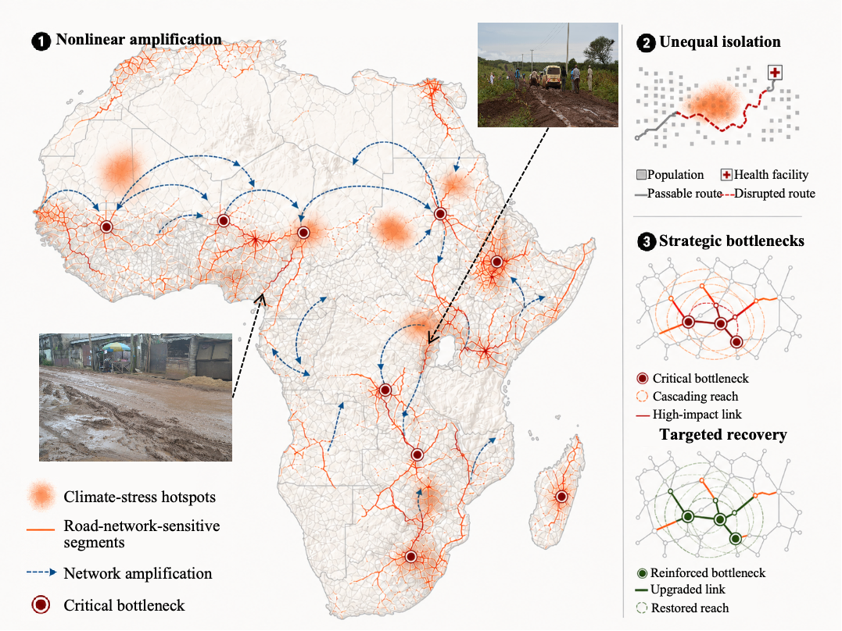
Fig. 1 | Conceptual framework of compounding climate isolation in African road networks. Extreme weather degrades climate-sensitive unpaved roads over large areas, and these local disruptions propagate through network structure into amplified and unequal accessibility loss. The framework highlights three linked components: network amplification, unequal isolation from essential services, and strategic bottlenecks for targeted recovery.

Results

Extreme weather generates network-scale climate isolation through nonlinear amplification
Extreme weather propagated through Africa’s road network in a strongly nonlinear manner, generating network-scale climate isolation that far exceeded the magnitude of direct road-level degradation. This pattern was consistent across three nested spatial scales. At the continental scale, the mean speed reduction across road segments was only 9.9%, yet travel time across connected international city pairs increased by 36.3%, yielding an amplification factor of 3.67 (Fig. 2a). These cross-border penalties were highly uneven in space, concentrating along major inter-country corridors in West and Southern Africa. Routes linking landlocked countries to coastal economic centres were especially affected, indicating that degradation of climate-sensitive, often unpaved segments can cascade through network structure and push strategically important corridors towards functional isolation.
The amplification was even stronger within national road systems. Across connected within-country city pairs, mean travel time increased by 41.0% under extreme weather despite an average direct road-speed loss of only 9.2%, corresponding to an amplification factor of 4.47, the largest among the three scales examined (Fig. 2b-d). This national-scale climate isolation was spatially heterogeneous: amplification ratios were especially high across parts of the Sahel, West Africa and Central Africa, and generally lower in parts of southern and coastal Africa (Fig. 2b). The distribution of within-country travel-time increases was strongly right-skewed: 27.1% of city pairs experienced increases exceeding 50%, and a smaller but still notable upper tail exceeded 100%, implying an effective doubling of travel time for some connections (Fig. 2c). Country-level aggregation reinforced this asymmetry. In every country, mean inter-city accessibility loss lay above the 1:1 road-loss reference, showing that moderate average reductions in road performance were systematically translated into disproportionately large penalties for national connectivity (Fig. 2d). Although countries with greater mean road loss tended to show larger travel-time increases, the broad dispersion around this trend indicates that the severity of isolation depended strongly on network configuration rather than direct degradation alone.
At the city-network scale, the same mechanism remained evident. A mean road-speed drop of 9.8% translated into a 38.5% loss of global network efficiency, equivalent to a 3.93-fold amplification (Fig. 2e, inset). Local accessibility-loss hotspots were concentrated in a broad belt spanning the Sahel, the Horn of Africa and parts of southern Africa, where dependence on vulnerable unpaved links is extensive (Fig. 2e). Percolation analysis revealed the structural basis of this effect. As road segments were progressively removed in decreasing order of climate stress, network loss remained above the 1:1 road-loss reference across nearly the entire removal trajectory, and the normalized amplification gap reached 93.4% (Fig. 2e, inset). The divergence was greatest at low to intermediate removal fractions, where disruption of a relatively small share of degraded segments was sufficient to sever links between otherwise intact subnetworks. Extreme weather therefore does not simply slow roads in proportion to local damage; it reorganizes connectivity through network dependence, producing continent-wide, national and city-scale climate isolation several times larger than the underlying direct shock.
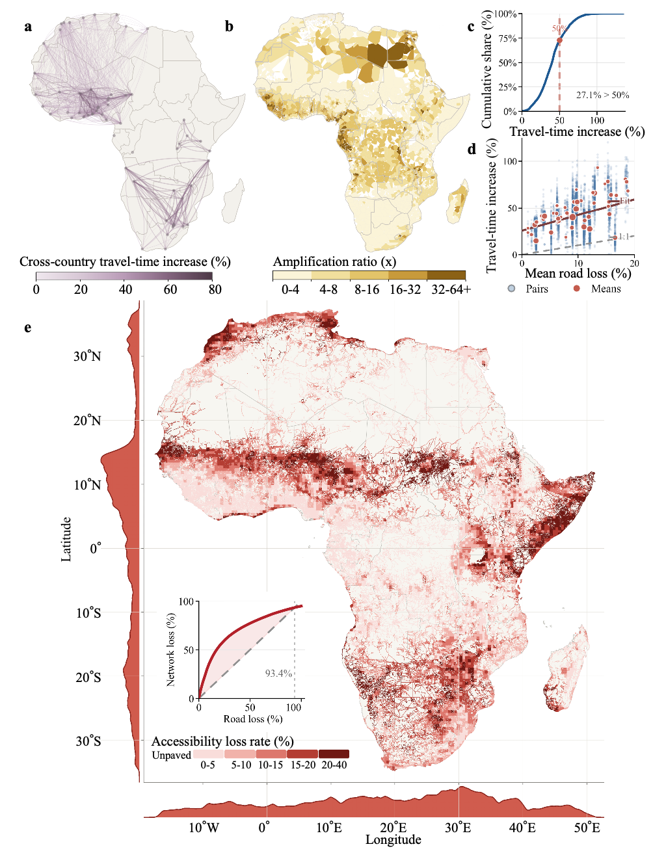
Fig. 2 | Extreme weather generates network-scale climate isolation through nonlinear amplification. a, Cross-country travel-time increase for connected international city pairs under extreme weather. b, Country-level amplification ratio between within-country accessibility loss and mean national road loss. c, Cumulative distribution of within-country city-pair travel-time increases; 27.1% of pairs exceed a 50% increase, indicating severe functional isolation for a substantial share of connections. d, Within-country travel-time increase versus mean national road loss for individual city pairs (blue) and country means (red); dashed line, 1:1 reference. e, Spatial distribution of accessibility loss rate linked to unpaved-road exposure across Africa, with marginal profiles along latitude and longitude. Inset, network loss versus road loss under progressive removal of climate-degraded segments, showing the nonlinear amplification through which local degradation is converted into broader climate isolation.
Climate isolation disproportionately falls on already vulnerable populations
Network amplification of climate shocks did not affect all populations equally. We assessed its distributional consequences by disaggregating increases in travel time to the nearest healthcare facility by baseline accessibility. Extreme-weather impacts were systematically concentrated among populations already facing poor access: in 47 of 49 countries, the upper tail of the within-country travel-time increase distribution exceeded the median, while only two countries showed no measurable tail gap (Fig. 3a). Across countries, the mean and median tail-gap ratios were 3.6 and 3.38, indicating that the worst-affected populations typically experienced about 3.4-3.6 times the travel-time increase of the median group.
This asymmetry was not driven by peripheral populations traversing more degraded roads. Direct degradation intensity, measured as the ratio of path-level degradation to baseline travel time, was nearly identical for median and upper-tail populations across the continent (median P₉₀/P₅₀ ratio = 1.01). Instead, the disparity reflected unequal access to network redundancy. Populations at the 50th percentile of baseline travel time had a typical buffering ratio of 6.1%, compared with only 4.1% for the 90th-percentile group; in 35 of 49 countries, buffering was higher for P₅₀ than for P90 populations (Fig. 3a). Populations already at the margins of service access therefore retained a larger share of direct road degradation as realized accessibility loss.
Extreme weather also eroded threshold-based healthcare access (Fig. 3b). At the continental scale, the population share within 1 h of a healthcare facility declined from 88.0% under normal conditions to 81.7% under extreme weather, a loss of 6.3 percentage points. The largest contraction occurred at the 30 min threshold, reaching 7.9 percentage points, compared with 3.0 percentage points at 2 h and 2.0 percentage points at 4 h. Populations close to service thresholds were therefore especially vulnerable to being shifted into substantially worse access conditions by modest network disruption.
At the facility level, these losses were also highly unequal in space (Fig. 4). Most healthcare facilities experienced only small accessibility losses, whereas a limited number of dispersed hotspots carried a disproportionate share of the continental burden. These hotspots were often located away from dense network cores, where sparse service provision and limited route redundancy allow local road degradation to translate into much larger accessibility losses. The concentration curve reinforces this pattern: the highest-loss 10% of facilities accounted for 81.5% of total facility-level loss. Climate-induced healthcare isolation is therefore not a uniform weakening of the health-access network, but a spatially selective process that amplifies vulnerability in already peripheral and poorly buffered areas.
Cross-country variation in accessibility loss was closely linked to structural disadvantage. Countries with fewer healthcare facilities and lower population density experienced larger population-weighted travel-time increases (Fig. 3c). These two predictors explained 42.9% of the variation and were both significant negative predictors of accessibility loss (coefficients −0.038 and −0.044, respectively; both P < 0.001). They were also associated with greater inequality worsening under climate stress (Fig. 3d).
Taken together, these results show that climate isolation is uneven across populations, facilities and countries. Network amplification protects better-connected populations through rerouting capacity, whereas marginal populations experience the largest realized losses, threshold-coverage declines and inequality worsening.
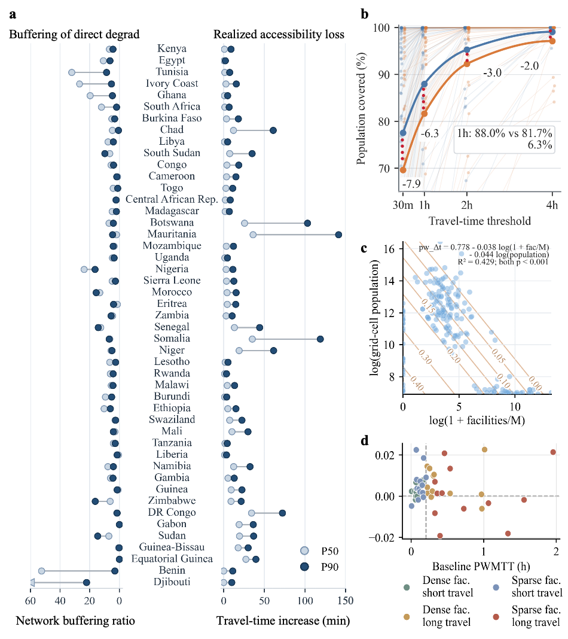
Fig. 3 | Climate isolation disproportionately affects already vulnerable populations. a, Within-country contrasts in network buffering and realized accessibility loss under extreme weather across 49 countries. For each country, points show populations at the 50th (P50, light blue) and 90th (P90, dark blue) percentiles of baseline travel time to the nearest healthcare facility. Left, the network buffering ratio, indicating the share of direct road degradation offset by rerouting through alternative routes. Right, the realized increase in travel time to the nearest healthcare facility after network effects are taken into account. b, Population coverage within fixed travel-time thresholds to the nearest healthcare facility under normal and extreme-weather conditions. Thin lines show country-specific trajectories and thick lines show the continental aggregate. Labels indicate percentage-point losses at 30 min, 1 h, 2 h and 4 h, showing that the largest coverage declines occur at shorter access thresholds. c, Cross-country association of population-weighted travel-time increase with healthcare-facility density and population density. Points denote countries and contours show fitted loss values from the regression surface, illustrating that larger accessibility losses are concentrated in countries with fewer facilities and lower population density. d, Change in within-country accessibility inequality under extreme weather plotted against baseline population-weighted mean travel time (PWMTT). Colours distinguish countries by combinations of healthcare-facility availability (dense or sparse) and baseline travel-time condition (short or long), showing greater inequality worsening in countries with sparse provision and longer baseline travel times.

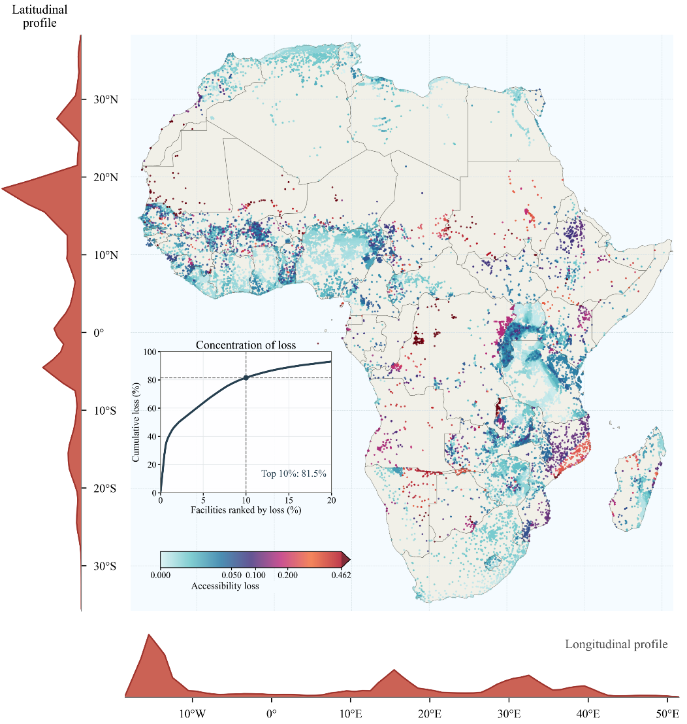
Fig. 4 | Facility-level healthcare isolation is spatially concentrated in peripheral hotspots. Facility-level distribution of climate-induced healthcare accessibility loss across Africa under extreme weather. Points denote healthcare facilities, with darker colours indicating larger accessibility losses. Marginal profiles summarize the aggregate loss along latitude and longitude, showing that impacts are concentrated in spatially uneven hotspots rather than evenly distributed across the health-access network. The inset concentration curve ranks facilities by loss magnitude and shows that the highest-loss 10% of facilities account for 81.5% of total facility-level loss, indicating that climate-induced healthcare isolation is dominated by a small subset of poorly buffered facilities in peripheral areas.

Persistent bottlenecks offer a durable pathway to reverse climate isolation
The preceding results show that extreme weather amplifies climate isolation across Africa’s road network and distributes these losses unevenly among places and populations. The key adaptation question is therefore whether such compounding losses require broad network-wide upgrading, or whether they can be reversed through a much smaller set of structurally targeted interventions. We found that priority bottlenecks were highly persistent under future climate conditions. Across the 2045, 2065 and 2085 projections, the spatial pattern of priority segments remained largely conserved, with only localized turnover in eastern Ethiopia, eastern Angola and southern Morocco (Supplementary Fig. S3). This spatial persistence was mirrored by the ranking statistics: Spearman rank correlations between present-day and future bottleneck importance remained high, and Jaccard overlap increased from approximately 57% for the top 1% of segments to 83% for the top 10% (Fig. 5a). Thus, the identity of critical bottlenecks is not primarily a transient outcome of any single climate realization, but a durable property of the road network’s topology.
This persistence translates into a large adaptation leverage. Paving strategies guided by network importance substantially outperformed both random paving and strategies guided only by climate vulnerability (Fig. 5b). Paving just 0.1% of unpaved roads, approximately 767 edges, restored 71.7% of the lost network efficiency, compared with only 0.06% under random selection. The recovery curve rose sharply thereafter: targeted paving of 1.0%, 2.0% and 5.0% of unpaved roads restored 91.2%, 96.1% and 99.5% of lost efficiency, respectively. By contrast, climate-vulnerability-guided paving produced only marginal recovery over the same investment range. Adaptation priority is therefore not determined by exposure alone. The highest-return segments are those where climate sensitivity intersects with disproportionate structural control over continental connectivity.
These high-leverage segments were strongly clustered in space, forming concentrated corridor systems in West Africa, along the Sahel–Horn belt, in eastern Africa and across parts of southern Africa (Fig. 5c). Their spatial concentration explains why a small amount of targeted paving can produce continent-scale recovery. The population-weighted maps show that climate-attributed accessibility losses under extreme weather are closely countered by paving-attributed recovery under network-importance-guided intervention: substantial gains emerge after paving only 0.1% of unpaved roads and become widespread after 2.0% paving (Fig. 5d). At the 5.0% intervention level, severely isolated city pairs declined from 1,330,783 to 29,021, a 97.8% reduction, while extremely isolated city pairs declined from 4,408 to 541, an 87.7% reduction. Population exposure was similarly reversed: the number of people losing access to at least one city within the 1-hour threshold fell from 904.2 million to 87.6 million, reconnecting 816.6 million people, or 90.3% of those initially affected. Together, these results show that Africa’s climate-induced isolation is not an intractable consequence of widespread road exposure. Much of it can be reversed by paving a small, persistent and topologically critical subset of unpaved roads.

Discussion
Here we extend the compounding-failure and percolation view of network-scale regime shifts to a continental road network dominated by unpaved roads. We define and quantify compounding climate isolation as the dominant failure mode in such systems. Prior empirical work has focused on paved networks^{18,19}, but the transferability of those insights to unpaved-dominant systems had not been tested at scale²⁰. A substantial share of African roads are unpaved. Under this condition, climate-sensitive segments no longer behave as isolated anomalies that redundant paths can absorb^{21,22}. They form the network skeleton itself. Degradation therefore shifts from a local event to a spatially correlated and functionally cumulative erosion of the system¹⁷.
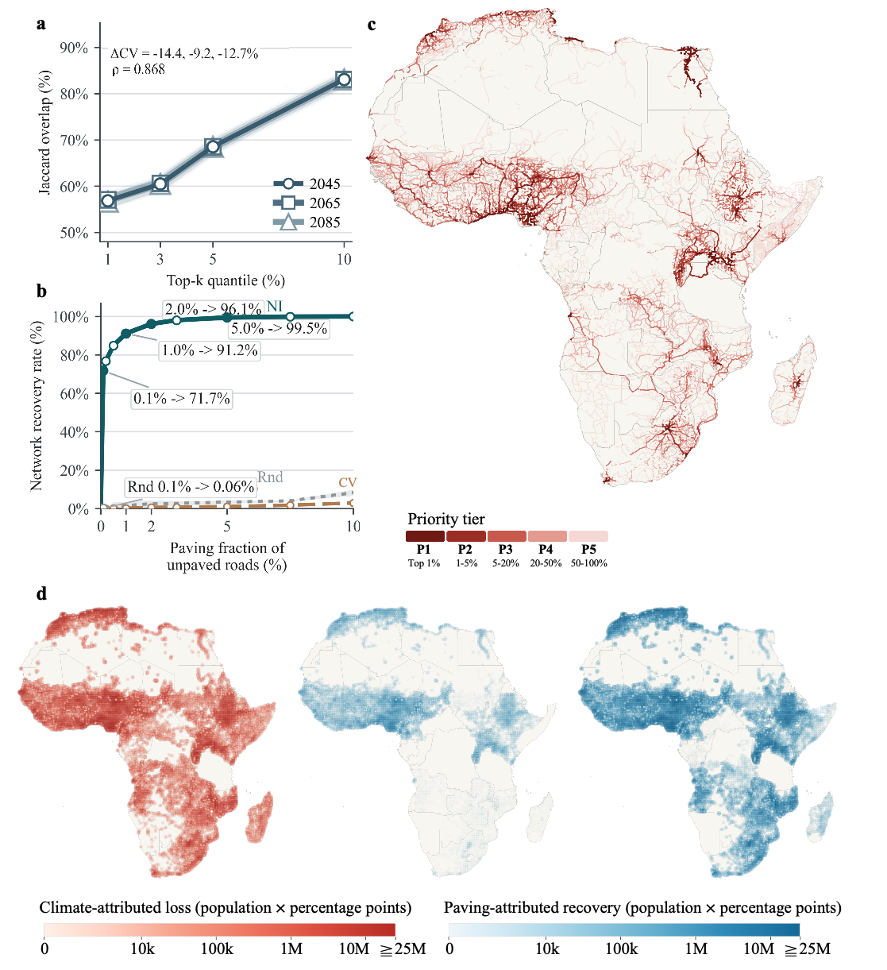
Fig. 5 | Persistent bottlenecks enable high-leverage reversal of climate isolation. a, Temporal stability of priority bottlenecks across future climate periods, quantified by Spearman rank correlation and Jaccard overlap between present-day and future top-ranked unpaved road segments. Spatial rank changes are shown in Supplementary Fig. S3. b, Recovery of lost network efficiency under random, climate-vulnerability-guided and network-importance-guided paving strategies. c, Spatial distribution of high-priority unpaved road bottlenecks across Africa, with darker red indicating higher priority. d, Population-weighted accessibility loss and recovery. The left panel shows climate-attributed loss under extreme weather; the centre and right panels show paving-attributed recovery after targeted paving of 0.1% and 2.0% of unpaved roads, respectively. Darker colours indicate larger losses or recovery gains.
We observe consistent nonlinear amplification across continental, national and city-network scales. This indicates that resilience frameworks derived from paved networks have limited applicability in unpaved-dominant systems. The consequence of climate shock is a structural collapse of connectivity, rather than a proportional decay of infrastructure performance.
The finding also changes how climate adaptation investment for African roads should be prioritized. Exposure-ranked practice rests on an untested assumption. It assumes that the most climate-vulnerable segments are also the largest contributors to system accessibility. Our results show a clear spatial mismatch between the two. High climate vulnerability is widespread across nearly half of all unpaved roads. Structural bottlenecks defined by the intersection of climate vulnerability and network importance, however, account for only 4.9%. Targeted paving guided by network importance restores 71.7% of lost network efficiency by upgrading only 0.1% of unpaved roads, and more than 90% by upgrading 1.0%. Its leverage clearly exceeds that of exposure-based or random selection. These results extend the established criticality and vulnerability coupling paradigm to the unpaved-dominant continental scale. They support broadening the decision basis from single-dimensional exposure ranking to a coupled assessment of climate risk and network topology^{23,24}. They also provide an operational pathway to maximum system resilience under extreme budget constraints with minimal physical intervention²⁵.
Our analysis covers 49 African countries, enabling continent-scale comparison under a consistent framework. It cannot, however, fully capture local factors such as drainage quality, bridge vulnerability, maintenance status and informal alternative routes²⁶. The conversion from climate exposure to speed degradation uses a simplified HDM-4 framework. Actual road performance reflects the interaction of local rainfall intensity, soil type and maintenance capacity. Even so, independent event-based comparisons for Cyclone Idai in central Mozambique and the 2024 Kenya floods show that the model recovers the main corridor-scale geographies of disruption, supporting the realism of the underlying accessibility-loss mechanism (Supplementary Figure.1-2). Travel-time increases should therefore be interpreted as scenario-based indicators of structural risk rather than exact reconstructions of individual events. Structural bottlenecks are identified from static network importance under a single shock. Under multi-event sequences and flow redistribution, the set of critical segments may shift dynamically²⁷. The targeted set should be treated as a baseline priority rather than a final investment list. The accessibility analysis focuses on travel time to health facilities. It does not yet incorporate behavioural adaptation, modal substitution or emergency response²⁸. Future work should integrate higher-resolution road condition surveys, actual disruption records and localized repair-cost data. It should also combine these with dynamic criticality analysis under multi-event sequences, so that structural bottlenecks can be translated into actionable investment portfolios.

Methods
Data
Road network and terrain attributes. Road network data for 49 African countries were obtained from Liu et al²⁰. The dataset provides per-segment surface classification (paved or unpaved) at sub-kilometre resolution, with a median segment length of approximately 200 m. Horizontal curvature (deg km⁻¹) was computed from road geometry, and segment slope was extracted from a continental slope raster derived from the Shuttle Radar Topography Mission digital elevation model²⁹, processed via Google Earth Engine³⁰ at 1 km resolution and sampled at each segment centroid. Slope and curvature were used as geometric covariates in the HDM-4-based deterioration model.
Current and future climate. Monthly precipitation and soil moisture were derived from the CORDEX Africa regional climate archive at 0.44° spatial resolution³¹. Present-day climate was represented using the SMHI-RCA4 regional climate model driven by MPI-M-MPI-ESM-LR for 2011–2020. Future climate was represented using CORDEX AFR-44 outputs from MPI-M-MPI-ESM-LR and MIROC-MIROC5, both downscaled with SMHI-RCA4 under RCP 4.5, for 2041–2050, 2061–2070 and 2081–2090. In all cases, monthly total precipitation and total column soil moisture were used to parameterize climate-related road deterioration.
Population, facilities and urban nodes. Population data were obtained from the WorldPop 2020 constrained, UN-adjusted dataset at 100 m resolution³². Health-facility locations were retrieved from OpenStreetMap via the Overpass API³³ and served as destinations in the healthcare accessibility analysis. Country and district boundaries were obtained from GADM v4.1³⁴. Urban nodes were derived from the Natural Earth 1:10m Populated Places dataset³⁵. For the continent-scale analysis, 49 national capitals and 34 non-capital megacities were used as origin–destination nodes. For country-level analyses, national capitals, provincial capitals and major cities (population ≥100,000) were used. City-node classification rules are described in Supplementary Methods S1.
Road speed
To quantify how rainfall-driven climate stress on unpaved roads translates into accessibility disruption, we modelled precipitation-driven roughness growth and soil-moisture-related passability, and converted the resulting road condition into segment-level travel speed. Deterioration was modelled explicitly for unpaved segments.
Roughness (IRI). Road speed on unpaved segments was modeled using the HDM-4 unpaved road deterioration framework³⁶, with parameter choices and sensitivity checks reported in Supplementary Methods S2. The equilibrium roughness (IRI_max, m km⁻¹) for each segment is:
$\text{IR}{\text{I}}_{\text{max}}\text{=}\text{max}\left(\text{21.4−32.4(0.5−}{\text{m}}_{\text{GD}}{\text{)}}^{\text{2}}\text{+0.97}{\text{K}}_{\text{CV}}\text{−7.64SP, 12.0}\right)$ (1)
where $\text{P}$ is monthly precipitation for the corresponding time step (m month⁻¹), $\text{S}$ is road slope (%), ${\text{K}}_{\text{CV}}$ is horizontal curvature (deg km⁻¹), and ${\text{m}}_{\text{GD}}$ is mean gravel depth. The lower bound of 12.0 m km⁻¹ reflects the minimum maintainable roughness on unpaved surfaces. IRI evolves monthly from an initial value $\text{IR}{\text{I}}_{\text{0}}\text{=6.0}$ m km⁻¹ via:
$\text{IRI(t+Δt)=}{\text{IRI}}_{\text{max}}\text{−p}\left({\text{IRI}}_{\text{max}}\text{−IRI(t)}\right)$ (2)
where the monthly progression factor $\text{p}$ is:
$\text{p=}\text{exp}\left[\text{−0.001}\left(\text{0.461+0.0174}{\text{Q}}_{\text{L}}\text{+0.0114}{\text{Q}}_{\text{H}}\text{−0.0287QP}\right)\text{Δt}\right]$ (3)
with ${\text{Q}}_{\text{L}}$= 42 and ${\text{Q}}_{\text{H}}$= 8 vehicles day⁻¹ (light and heavy traffic respectively, HDM-4 defaults for remote rural roads³⁶), $\text{Q}$=${\text{Q}}_{\text{L}}$+${\text{Q}}_{\text{H}}$=50 vehicles day⁻¹, and $\text{Δt}$= 1/12 year. The update equation was iterated over 12 monthly steps to obtain the annual climate-conditioned $\text{IRI}$ for each segment.
Speed and passability. Segment travel speed was derived from IRI using the HDM-4 empirical speed–roughness relationship³⁶,which maps IRI values between 6 and 20 m km⁻¹ to speeds between 106 and 32 km h⁻¹ by piecewise linear interpolation (Supplementary Methods S3). High soil moisture reduces the load-bearing capacity of unpaved road surfaces and can render them seasonally difficult or impossible to traverse, independently of their roughness condition³⁷. Total column soil moisture ($\text{mrso}$) was used as a proxy for saturation-related passability constraints. A segment was treated as passable in months when $\text{mrso}$ did not exceed its baseline-period 75th percentile. Let $\text{r}$ denote the fraction of baseline-period months satisfying this condition. Effective speed was then calculated as:
$\text{V=}{\text{V}}_{\text{base}}\text{(IRI)×r}$ (4)
$\text{r=}\frac{\text{1}}{\text{12}}\sum_{\text{m=1}}^{\text{12}}{\text{I}}\left(\text{mrs}{\text{o}}_{\text{m}}\text{≤}{\text{q}}_{\text{0.75}}\text{(mrso)}\right)$ (5)
where ${\text{V}}_{\text{base}}\text{(IRI)}$ is the roughness-based travel speed.
Road network construction
The road system was represented as a weighted graph from which origin–destination (OD) travel times were computed under normal and extreme climate scenarios. In the continent-scale graph, paved roads were retained as climate-neutral links to preserve cross-border connectivity, whereas all climate-driven variation in edge weights was applied to unpaved segments. Sensitivity to alternative paved-road assumptions is reported in Supplementary Methods S5.
Climate scenarios. Two graphs were constructed in parallel: ${\text{G}}_{\text{0}}$ under the normal scenario and ${\text{G}}_{\text{1}}$ under the extreme scenario. Climate statistics were computed as temporal percentiles over 2011–2020 for the grid cell nearest to each segment centroid. The normal scenario used the temporal mean of monthly precipitation and defined the soil-moisture passability threshold as the segment-specific temporal 75th percentile of mrso (${\text{q}}_{\text{0.75}}$). The extreme scenario substituted the temporal 95th-percentile precipitation (${\text{P}}_{\text{95}}^{\text{pr}}$) into the IRI deterioration model and assessed soil-moisture stress using the temporal 95th percentile of mrso (${\text{q}}_{\text{0.95}}$). Robustness to alternative precipitation percentiles, soil-moisture thresholds and passability-penalty functions is reported in Supplementary Methods S4. Where ${\text{q}}_{\text{0.95}}$ exceeded ${\text{q}}_{\text{0.75}}$, the passability rate was scaled as:
${\text{r}}_{\text{extreme}}\text{=}{\text{r}}_{\text{normal}}\text{×}\frac{{\text{q}}_{\text{0.75}}}{{\text{q}}_{\text{0.95}}}$ (6)
otherwise ${\text{r}}_{\text{extreme}}\text{=}{\text{r}}_{\text{normal}}$. Differences in travel time between ${\text{G}}_{\text{0}}$ and ${\text{G}}_{\text{1}}$ therefore reflect climate-induced changes in segment roughness and passability alone, with network topology held fixed.
Travel time. Travel time was used as the core accessibility metric³⁸. For ${\text{G}}_{\text{0}}$, edge weights were defined as:
${\text{w}}_{\text{0}}\text{=}\frac{\text{L}}{\text{V}}$ (7)
where $\text{L}$ is segment length (km) and $\text{V}$ is the climate-adjusted speed derived from the road speed model above. For ${\text{G}}_{\text{1}}$, edge weights additionally penalized reduced passability:
${\text{w}}_{\text{1}}\text{=}\frac{\text{L}}{\text{V}}×\frac{\text{1}}{r}$ (8)
Shortest-path routing on ${\text{G}}_{\text{0}}$ and ${\text{G}}_{\text{1}}$ yielded scenario-specific OD travel times.
Network efficiency analysis
To quantify climate-induced disruption at the network level, we measured fragmentation, efficiency loss and an amplification ratio.
Efficiency loss. Global network efficiency was defined as:
$\text{E=}\frac{\text{1}}{\text{N(N-1)}}\sum_{\text{i≠j}}{\frac{\text{1}}{{\text{d}}_{\text{ij}}}}$ (9)
where ${\text{d}}_{\text{ij}}$ is the shortest travel time between nodes $\text{i}$ and $\text{j}$, and $\text{N}$ is the number of nodes. Climate-induced efficiency loss was quantified as:
$\text{ΔE/}{\text{E}}_{\text{0}}\text{=}\frac{{\text{E}}_{\text{0}}\text{-}{\text{E}}_{\text{1}}}{{\text{E}}_{\text{0}}}$ (10)
where ${\text{E}}_{\text{0}}$and ${\text{E}}_{\text{1}}$ are efficiencies under ${\text{G}}_{\text{0}}$ and ${\text{G}}_{\text{1}}$.
Network amplification ratio. To assess whether the network amplified road-level degradation, we defined:
$\text{AR=}\frac{\text{ΔE/}{\text{E}}_{\text{0}}}{\overline{\text{ΔV}}\text{/}\overline{{\text{V}}_{\text{0}}}}$ (11)
where $\overline{\text{ΔV}}\text{/}\overline{{\text{V}}_{\text{0}}}$ is the mean fractional speed reduction across unpaved segments. Values of AR > 1 indicate nonlinear amplification from segment-level degradation to network-level disruption.
Health accessibility and inequality
Healthcare accessibility was assessed using nearest-facility travel time, threshold-based coverage, inequality and buffering metrics^{39,40}. Facility definitions, population assignment and snap-distance robustness are described in Supplementary Methods S6.
Population-weighted mean travel time. Population-weighted mean travel time (PWMTT) was defined as:
$\text{PWMTT=}\frac{\sum_{\text{i}}{{\text{t}}_{\text{i}}}{\text{p}}_{\text{i}}}{\sum_{\text{i}}{{\text{p}}_{\text{i}}}}$ (12)
where ${\text{t}}_{\text{i}}$ is travel time to the nearest healthcare facility and ${\text{p}}_{\text{i}}$ is the population allocated to node $\text{i}$. Population-weighted percentiles (P10, P50, P90) were derived from the cumulative population distribution of travel times.
Isochrone. Isochrone coverage was defined as the share of population reaching a healthcare facility within a threshold T:
$\text{Coverage(T)=}\frac{\sum_{\text{i}}{{\text{p}}_{\text{i}}}\text{ 1[}{\text{t}}_{\text{i}}\text{<T]}}{\sum_{\text{i}}{{\text{p}}_{\text{i}}}}$ (13)
where ${\text{t}}_{\text{i}}$ denotes the normal or extreme-weather scenario. Thresholds of 30 min, 1 h, 2 h and 4 h were used. Coverage loss under extreme weather was reported as the absolute percentage-point decline relative to normal conditions:
$\begin{matrix}\text{∆}{\text{C}}_{\text{pp}}\text{ (T)=100 [}{\text{Coverage}}_{\text{0}}\text{(T)-}{\text{Coverage}}_{\text{1}}\text{ (T)]}\end{matrix}$ (14)
Inequality and tail-gap ratio. The population-weighted Gini coefficient of travel time was computed under each scenario, yielding ${\text{G}}_{\text{0}}^{\text{Gini}}$ and ${\text{G}}_{\text{1}}^{\text{Gini}}$
$\text{ΔGini= }{\text{G}}_{\text{1}}^{\text{Gini}}\text{-}{\text{G}}_{\text{0}}^{\text{Gini}}$ (15)
The tail-gap ratio was defined as:
$\text{TGR=}\frac{\text{Δ}{\text{t}}_{\text{P90}}}{\text{Δ}{\text{t}}_{\text{P50}}}$ (16)
where $\text{Δ}{\text{t}}_{\text{P90}}$ and $\text{Δ}{\text{t}}_{\text{P50}}$ are the 90th and 50th percentiles of the distribution of node-level travel-time increases.
Network buffering decomposition. To separate the role of network topology from that of local road deterioration, node-level travel-time increase was decomposed into direct degradation and buffering. Direct degradation was defined as:
$\text{D}{\text{D}}_{\text{i}}\text{=}{\tilde{\text{t}}}_{\text{i}}^{\text{(1|0)}}\text{−}{\text{t}}_{\text{i}}^{\text{(0)}}$ (17)
where ${\tilde{\text{t}}}_{\text{i}}^{\text{(1|0)}}$ is the cost of the${\text{ G}}_{\text{0}}$-optimal path evaluated under ${\text{G}}_{\text{1}}$ edge weights. The buffering ratio was defined as:
$\text{B}{\text{R}}_{\text{i}}\text{=1−}\frac{\text{Δ}{\text{t}}_{\text{i}}}{\text{D}{\text{D}}_{\text{i}}}$ (18)
$$and direct−degradation intensity as:$$
$\text{DD}{\text{I}}_{\text{i}}\text{=}\frac{\text{D}{\text{D}}_{\text{i}}}{{\text{t}}_{\text{i}}^{\text{(0)}}}$ (19)
Bottleneck identification and intervention.
To identify paving priorities and test whether targeted intervention could reverse climate-induced accessibility loss, we designed a counterfactual paving experiment.
Network importance and climate vulnerability. Each road segment was assigned two scores. Network importance (NI) was defined as gravity-weighted edge betweenness under normal conditions:
$\text{N}{\text{I}}_{\text{e}}\text{=}\sum_{\text{(i,j): e∈}{\text{π}}_{\text{ij}}}{\frac{{\text{p}}_{\text{i}}{\text{p}}_{\text{j}}}{{\text{d}}_{\text{ij}}^{\text{α}}}}$ (20)
where ${\text{π}}_{\text{ij}}$ is the shortest path between population-weighted settlement nodes $\text{i}$ and $\text{j}$, ${\text{p}}_{\text{i}}$ and ${\text{p}}_{\text{j}}$ are their populations, ${\text{d}}_{\text{ij}}$ is baseline travel time, and $\text{α}$= 2. Climate vulnerability (CV) was defined as the fractional travel time increase under extreme conditions:
$\text{C}{\text{V}}_{\text{e}}\text{=}\frac{{\text{t}}_{\text{e}}^{\text{(1)}}\text{−}{\text{t}}_{\text{e}}^{\text{(0)}}}{{\text{t}}_{\text{e}}^{\text{(0)}}}$ (21)
where ${\text{t}}_{\text{e}}^{\text{(0)}}$ and ${\text{t}}_{\text{e}}^{\text{(1)}}$ are edge travel times under ${\text{G}}_{\text{0}}$ and ${\text{G}}_{\text{1}}$, respectively. A composite bottleneck score was defined as:
$\begin{matrix}{\text{B}}_{\text{e}}\text{=(}{\text{NI}}_{\text{e}}\text{ / }{\text{max}}_{\text{e'∈E}} {\text{NI}}_{\text{e'}}\text{) × (}{\text{CV}}_{\text{e}}\text{ /}{\text{max}}_{\text{e'∈E}} {\text{CV}}_{\text{e'}}\text{) }\end{matrix}$ (22)
where both NI and CV were normalized by their maximum values across all road segments. Sensitivity to bottleneck-score construction, NI gravity exponent and top-K definitions is reported in Supplementary Methods S7.
Bottleneck stability.
To test whether present-day priority segments remained important under future climate, CV was recomputed for future climate conditions using projected road speeds. Stability was assessed by Jaccard similarity of top-ranked bottleneck sets, Spearman rank correlation of bottleneck scores across all edges, and the retention rate of present-day strategic segments (Supplementary Methods S10).
Paving intervention experiment. Increasing fractions of unpaved segments (0–50%; ${\text{CV}}_{\text{e}}\text{ > 0.02}$) were incrementally paved under four prioritization strategies: bottleneck-guided, NI-only, CV-only and random. Paving a segment set its ${\text{G}}_{\text{1}}$ edge weight equal to its ${\text{G}}_{\text{0}}$ edge weight. Robustness of the recovery index and alternative score formulations is reported in Supplementary Methods S7. Recovery was measured as:
$\text{R=}\frac{{\text{A}}_{\text{paved}}\text{−}{\text{A}}_{\text{extreme}}}{{\text{A}}_{\text{normal}}\text{−}{\text{A}}_{\text{extreme}}}$ (23)
where $\text{A}$ is the gravity-weighted population-weighted accessibility index
$\text{A=}\sum_{\text{i≠j}}{\frac{{\text{p}}_{\text{i}}{\text{p}}_{\text{j}}}{{\text{d}}_{\text{ij}}^{\text{α}}}}$ (24)
and $\text{R}$ = 1 represents complete recovery to normal-scenario accessibility.
De-isolation analysis.
To translate aggregate efficiency recovery into concrete changes in climate isolation experienced by specific city pairs and populations, isolation was defined at the origin–destination pair level and its spatial distribution tracked before and after targeted paving.
OD-level climate vulnerability. For each ordered pair of city nodes (i, j) with finite normal-scenario travel time, it was classified as severely climate-isolated if $\text{C}{\text{V}}_{\text{OD}}\text{ > 0.5}$ (extreme travel time ≥ 1.5× normal baseline) and extremely climate-isolated if $\text{C}{\text{V}}_{\text{OD}}\text{ > 1.0}$ (≥ 2.0× baseline). After applying guided paving at fraction $\text{f}$, a post-paving analogue $\text{C}{\text{V}}_{\text{OD}}^{\text{P}}\text{(i,j)}$ was computed by substituting post-paving travel times for ${\text{t}}_{\text{ij}}^{\text{E}}$.
Isolation quantity recovery. For each severity tier $\text{τ∈}\left\{\text{severe,extreme}\right\}$ with threshold ${\text{θ}}_{\text{τ}}$ (${\text{θ}}_{\text{severe}}\text{=0.5}$, ${\text{θ}}_{\text{extreme}}\text{=1.0}$), the count of isolated city pairs over all reachable pairs before and after paving was
${\text{N}}^{\text{before}}\text{τ = }\left|\left\{\text{(i,j): i<j, }{\text{CV}}_{\text{OD}}\text{(i,j) ≥}{\text{ θ}}_{\text{τ}}\right\}\right|$ (25)
${\text{N}}^{\text{after}}\text{τ = }\left|\left\{\text{(i,j): i<j, }{\text{CV}}_{\text{OD}}^{\text{P}}\text{(i,j) ≥}{\text{ θ}}_{\text{τ}}\right\}\right|$ (26)
with de-isolation count $\text{Δ}{\text{N}}_{\text{τ}}\text{ = }{\text{N}}^{\text{before}}\text{τ − }{\text{N}}^{\text{after}}\text{τ}$.
One-hour reachability and population isolation. The 1-hour near-neighbour reachability of city node $\text{k}$ under scenario $\text{S in }\left\{\text{Normal (N), Extreme (E), Paved (P)}\right\}$ was defined as
${\text{R}}_{\text{k}}^{\text{S}}\text{ = }\left|\left\{\text{j: j≠k, }{\text{t}}_{\text{kj}}^{\text{S}}\text{<}{\text{T}}_{\text{reach}}\right\}\right|$ (27)
with ${\text{T}}_{\text{reach}}\text{=1h}$. The population losing at least one 1-h neighbour under extreme conditions and the population de-isolated by paving were respectively,
$\text{Popisolated = }\sum_{k: {\text{R}}_{\text{k}}^{\text{E}}<{\text{R}}_{\text{k}}^{\text{N}}}{p_{k}}$ (28)
$\text{Poprecovered =}\sum_{k:{\text{R}}_{\text{k}}^{\text{P}}>{\text{R}}_{\text{k}}^{\text{E}}, {\text{R}}_{\text{k}}^{\text{E}}<{\text{R}}_{\text{k}}^{\text{N}}}{{\text{p}}_{\text{k}}}$ (29)
where ${\text{p}}_{\text{k}}$ is the population of node $\text{k}$.
External event-based plausibility check
To assess whether the modelled climate-to-accessibility loss mechanism is externally plausible, we compared district- or county-level model outputs with independently documented road disruptions from two rainfall-driven events: Cyclone Idai in central Mozambique (March 2019) and the Kenya floods (April-May 2024). Because the model represents a climatological P₉₅ stress scenario rather than event-specific meteorological forcing, this comparison was not designed as an event-prediction test. Instead, we examined whether districts and corridors identified by the model as highly susceptible to precipitation-driven accessibility loss coincided with the main reported disruption geographies and corridor failures documented by OCHA and related sources. These comparisons were used only as external plausibility checks and did not inform model calibration (Supplementary Methods S9; Supplementary Figs. S1 and S2).

Data availability
Road surface data for 50 African countries were obtained from Liu et al.²⁰ and are publicly available via Figshare (https://doi.org/10.6084/m9.figshare.29424107).
Terrain data were derived from the Shuttle Radar Topography Mission (SRTM) digital elevation model²⁹, accessed and processed via Google Earth Engine (https://earthengine.google.com); the SRTM dataset is publicly available through the Google Earth Engine Data Catalog (dataset ID: USGS/SRTMGL1_003).
Current and future climate data (monthly precipitation and soil moisture) were obtained from the CORDEX Africa AFR-44 archive³¹ and are publicly accessible through the Earth System Grid Federation (ESGF; https://esgf-node.llnl.gov).
Administrative boundary data were obtained from the GADM v4.1 database (https://gadm.org) and are freely available for academic use.
Populated-place data were obtained from the Natural Earth 1:10m Populated Places dataset (https://www.naturalearthdata.com), which is in the public domain.
Population distribution data were obtained from the WorldPop 2020 constrained UN-adjusted dataset (https://hub.worldpop.org) under a Creative Commons Attribution 4.0 licence.
Health facility data were obtained from OpenStreetMap via the Overpass API (https://overpass-api.de) and are available under the Open Database Licence (ODbL; https://www.openstreetmap.org/copyright).

Code availability
All custom code used for data processing and analysis is publicly available at GitHub:
https://github.com/ada-yl2425/Compounding-climate-isolation-across-Africa-s-road-network.git.

References
1. United Nations Department of Economic and Social Affairs, Population Division. World Population Prospects 2022: Summary of Results. UN DESA/POP/2022/TR/No. 3 (United Nations, 2022).
2. African Development Bank. African Economic Outlook 2018. (2018).
3. Chinowsky, P., Schweikert, A., Strzepek, N., Manahan, K., Strzepek, K. & Schlosser, C. A. Climate change adaptation advantage for African road infrastructure. Climatic Change 117, 345–361 (2013).
4. Schweikert, A., Chinowsky, P., Kwiatkowski, K. & Espinet, X. The infrastructure planning support system: Analyzing the impact of climate change on road infrastructure and development. Transport Policy 35, 146–153 (2014).
5. World Bank. To Pave or Not to Pave: Developing a Framework for Systematic Decision-Making in the Choice of Paving Technologies for Rural Roads. (2021).
6. Benmaamar, M. Financing of Road Maintenance in Sub-Saharan Africa: Reforms and Progress towards Second Generation Road Funds. SSATP Discussion Paper No. 6 (World Bank, 2006).
7. IPCC. Climate Change 2022: Impacts, Adaptation and Vulnerability. Contribution of Working Group II to the Sixth Assessment Report of the Intergovernmental Panel on Climate Change (eds Pörtner, H.-O. et al.) (Cambridge Univ. Press, 2022). https://doi.org/10.1017/9781009325844
8. IPCC. Climate Change 2021: The Physical Science Basis. Regional Fact Sheet – Africa. Intergovernmental Panel on Climate Change. (2021).
9. Weiss, D. J. et al. Global maps of travel time to healthcare facilities. Nature Medicine 26, 1835–1838 (2020).
10. Liu, K., Wang, Q., Wang, M. & Koks, E. E. Global transportation infrastructure exposure to the change of precipitation in a warmer world. Nature Communications 14, 2541 (2023).
11. Koks, E. E. et al. A global multi-hazard risk analysis of road and railway infrastructure assets. Nature Communications 10, 2677 (2019).
12. Ganin, A. A., Kitsak, M., Marchese, D., Keisler, J. M., Seager, T. & Linkov, I. Resilience and efficiency in transportation networks. Sci. Adv. 3, e1701079 (2017).
13. Weiss, D. J. et al. A global map of travel time to cities to assess inequalities in accessibility in 2015. Nature 553, 333–336 (2018).
14. Nelson, A. et al. A suite of global accessibility indicators. Scientific Data 6, 266 (2019).
15. Tracking Africa's Progress in Figures (African Development Bank Group, 2014).
16. Xu, Z. & Chopra, S. S. Interconnectedness enhances network resilience of multimodal public transportation systems for Safe-to-Fail urban mobility. Nature Communications 14, 4291 (2023).
17. Dong, S., Gao, X., Mostafavi, A. & Gao, J. Modest flooding can trigger catastrophic road network collapse due to compound failure. Communications Earth & Environment 3, 38 (2022).
18. Bergantino, A. S., Gardelli, A. & Rotaris, L. Assessing transport network resilience: empirical insights from real-world data studies. Transport Reviews 44, 834–857 (2024).
19. Martín, B., Ortega, E., Cuevas-Wizner, R., Ledda, A. & De Montis, A. Assessing road network resilience: An accessibility comparative analysis. Transportation Research Part D: Transport and Environment 95, 102851 (2021).
20. Liu, Z., Zhou, Q., Zhang, F. & Laari, P. B. The first road surface type dataset for 50 African countries and regions. Earth Syst. Sci. Data 18, 267–285 (2026). https://doi.org/10.5194/essd-18-267-2026
21. Jenelius, E. Redundancy importance: Links as rerouting alternatives during road network disruptions. Procedia Engineering 3, 129–137 (2010).
22. Wang, W., Yang, S., Stanley, H. E. & Gao, J. Local floods induce large-scale abrupt failures of road networks. Nat Commun 10, 2114 (2019).
23. Ortega, E., Martín, B. & Aparicio, Á. Identification of critical sections of the Spanish transport system due to climate scenarios. Journal of Transport Geography 84, 102691 (2020).
24. Jafino, B. A., Kwakkel, J. & Verbraeck, A. Transport network criticality metrics: a comparative analysis and a guideline for selection. Transport Reviews 40, 241–264 (2020).
25. Hamedmoghadam, H., Jalili, M., Vu, H. L. & Stone, L. Percolation of heterogeneous flows uncovers the bottlenecks of infrastructure networks. Nat Commun 12, 1254 (2021).
26. Rolt, J., Mukura, K. & Otto, A. Development of a Simplified Agency Life-Cycle Costing Tool for Gravel Roads. Sustainability 12, 4512 (2020).
27. Duan, J., Li, D. & Huang, H.-J. Reliability of the traffic network against cascading failures with individuals acting independently or collectively. Transportation Research Part C: Emerging Technologies 147, 104017 (2023).
28. Petricola, S., Reinmuth, M., Lautenbach, S., Hatfield, C. & Zipf, A. Assessing road criticality and loss of healthcare accessibility during floods: the case of Cyclone Idai, Mozambique 2019. Int J Health Geogr 21, 14 (2022).
29. Farr, T. G. et al. The Shuttle Radar Topography Mission. Rev. Geophys. 45, RG2004 (2007).
30. Gorelick, N. et al. Google Earth Engine: Planetary-scale geospatial analysis for everyone. Remote Sensing of Environment 202, 18–27 (2017).
31. Filippo Giorgi, Colin Jones, & Ghassem R. Asrar. Addressing climate information needs at the regional level: the CORDEX framework. WMO Bulletin 58, 175–183 (2009).
32. Tatem, A. J. WorldPop, open data for spatial demography. Sci Data 4, 170004 (2017).
33. OpenStreetMap contributors. OpenStreetMap https://www.openstreetmap.org (2024).
34. Hijmans, R. J. Database of Global Administrative Areas (GADM) version 4.1. https://gadm.org (2022).
35. Natural Earth. 1:10m Populated Places https://www.naturalearthdata.com/downloads/10m-cultural-vectors/10m-populated-places/ (2022).
36. Morosiuk, G. & Riley, M. Modelling Road Deterioration and Works Effects in HDM-4. Volume 6 (World Road Association (PIARC) & The World Bank, Paris, 2004).
37. Reintam, E. et al. Measuring and predicting soil moisture conditions for trafficability. Acta Agriculturae Scandinavica, Section B — Soil & Plant Science 66, 698–705 (2016).
38. Geurs, K. T. & Van Wee, B. Accessibility evaluation of land-use and transport strategies: review and research directions. Journal of Transport Geography 12, 127–140 (2004).
39. Hsia, R. Y., Mbembati, N. A., Macfarlane, S. & Kruk, M. E. Access to emergency and surgical care in sub-Saharan Africa: the infrastructure gap. Health Policy and Planning 27, 234–244 (2012).
40. Ouma, P. O. et al. Access to emergency hospital care provided by the public sector in sub-Saharan Africa in 2015: a geocoded inventory and spatial analysis. The Lancet Global Health 6, e342–e350 (2018).

Acknowledgements
This work was supported by the National Natural Science Foundation of China (Grant Nos. 52472316, 52461160297 and 52341203), the Guangdong Basic and Applied Basic Research Foundation (Grant No. 2025A1515010251), and the Shenzhen Natural Science Foundation (Basic Research Fund; Grant No. JCYJ20250604175822030). The authors also acknowledge support from the Shenzhen Postdoctoral Innovation Practice Base Program (SNGDC).

Author contributions
Hang Su: formal analysis, visualization, writing—original draft. Yichen Liu: data curation, methodology, validation. Shuisong Ke: project administration, writing— review and editing. Haoran Zhang: conceptualization, supervision, funding acquisition.

Competing interests
The authors declare no competing interests

