EST Project Report
Database Management System
Submitted by:
Adaa Goyal | 1024170122
Ayushi Aggarwal | 1024170116

Submitted to:
Dr. Prachi Semwal
Subgroup : 2Q-14

Topic : Indian Veteran Resource and Pension Management System

Department of Computer Science and Engineering
Thapar Institute of Engineering & Technology Patiala, Punjab (January – May 2026)

Index

Sr. No. | Topic | Page Number
1 | Introduction | 3
2 | Requirement Analysis | 4
3 | ER Table | 8
4 | ER to Table (Before Normalization) | 10
5 | Normalization | 11
6 | ER to Table (After Normalization) | 13
7 | SQL Commands to Create Tables | 14
8 | Triggers and Exception Handling | 15
9 | Conclusion | 18

Introduction
The Indian Veteran Resource and Pension Management System (IVRPMS) is a relational database-backed web application designed to digitize and streamline the management of veteran records, pension disbursements, family nominee registrations, and military unit data for the Indian Armed Forces.
The system addresses a critical administrative need — the organized, accurate, and auditable maintenance of service and financial records for retired military personnel. Currently, such records are often fragmented across manual registers, disconnected spreadsheets, or legacy systems that lack referential integrity and real-time visibility. IVRPMS consolidates all of this into a single, normalized relational model backed by MySQL 8.0+.
The database schema is designed in compliance with Third Normal Form (3NF) and Boyce-Codd Normal Form (BCNF), ensuring elimination of data redundancy and preservation of data integrity through foreign key constraints, check constraints, and cascade rules. The system comprises six core tables — REGIMENT, VETERAN, PENSION_RECORD, NOMINEE, RANK_HISTORY, and AUDIT_LOG — supported by three pre-built views, eight performance indexes, and PL/SQL triggers for automated audit trail generation.
The frontend dashboard, built as a military-themed single-page interface, communicates with a Flask-based REST API to present live statistics, full personnel registers, DA-adjusted pension totals, nominee share allocations, regiment strength overviews, and a complete rank promotion audit log. Key algorithmic concepts applied in the system include Merge Sort for ordered record retrieval, KMP (Knuth-Morris-Pratt) pattern matching for efficient name-based search, and Binary Search for indexed lookups.
Scope of the Project
The project encompasses the design and implementation of a relational database backend . Key functionalities include:
Covered:
- Registration and management of 50+ veteran profiles with full service history
- Pension lifecycle tracking with real-time DA-adjusted disbursement calculation
- Nominee and family beneficiary management with share percentage allocation
- Regiment master data with veteran strength mapping across 15 military units
- Automated rank promotion audit trail via database triggers
- System-wide audit logging for all INSERT, UPDATE, DELETE operations
- REST API layer with a live browser-based command dashboard

Significance of Using a DBMS
Utilizing a Database Management System in the context of waste management offers several critical advantages, including:
- Data Centralization: All information about societies, residents, collectors, pickup requests, verifications, and rewards is stored in a single, unified relational database.
- Data Integrity: Enforcing PRIMARY KEY, FOREIGN KEY, UNIQUE, CHECK, and NOT NULL constraints ensures the accuracy and consistency of all stored data.
- Automation via Triggers: Database triggers automatically fire upon record insertion into the Verification_Record table, eliminating the need for manual point updates and ensuring no transaction is missed.
- Transaction Management: Using START TRANSACTION, SAVEPOINT, and ROLLBACK guarantees that either all steps of a verification process succeed atomically or none of them are committed, preventing partial updates.
- Scalability: The normalized schema can accommodate a growing number of societies, residents, collectors, and requests without structural modification.
- Analytical Reporting: Views and complex JOIN queries enable administrators to generate meaningful reports such as monthly leaderboards, segregation accuracy reports, and top-performing residents.

Requirement Analysis
Functional Requirements:
# | Requirement
FR1 | Store and retrieve complete veteran profiles with service history
FR2 | Track pension records with DA% computation and status management
FR3 | Maintain nominee registrations with share percentage per veteran
FR4 | Manage regiment master data and map veterans to units
FR5 | Auto-log rank promotions via triggers into RANK_HISTORY
FR6 | Capture all data changes in a system-wide AUDIT_LOG
FR7 | Expose all data through REST API endpoints to a live dashboard
Non-Functional Requirements
# | Requirement
NFR1 | Schema must be 3NF / BCNF normalized — no redundancy
NFR2 | All foreign keys enforced with referential integrity
NFR3 | Indexed columns for fast JOIN and batch query performance
NFR4 | Data validated at DB level via CHECK constraints
NFR5 | Audit trail must survive even if referenced records are deleted
NFR6 | Dashboard must load all pages without full page reload
Data Requirements
- VETERAN — 50 records · 13 attributes · service number format validated (IC/JC/GC)
- PENSION_RECORD — 44 records · DA% range 0–100 · IFSC format enforced
- NOMINEE — 107 records · share % between 1–100 · active/inactive flag
- REGIMENT — 15 units · 7 arm-of-service types
- RANK_HISTORY — 92 audit events · 15 valid rank values enforced
- AUDIT_LOG — system-wide · operations: INSERT / UPDATE / DELETE
Constraints
- Retirement date must always be after enlistment date
- A veteran cannot hold two pensions of the same type simultaneously
- Old rank and new rank in RANK_HISTORY must always differ
- Contact number must follow Indian mobile format (starts 6–9, 10 digits)
- Aadhar stored as last 4 digits only — no full number retained

- Regiment Table:
The master reference table for all military units. Stores the regiment name, base location, and arm of service (Infantry, Artillery, Armour, etc.). It has no foreign key dependencies and is created first, serving as the parent for all veteran records.

2. Veteran Table:
The core entity of the system. Holds complete personal and service data for each retired soldier — name, date of birth, gender, rank, service number, enlistment and retirement dates, domicile state, and contact details. Every veteran is linked to a regiment and carries strict format validations on service number, contact, and Aadhaar reference.
3. Pension Records Table:
Tracks the financial entitlement of each veteran. Stores pension type (Service, Family, Disability, Gallantry), base monthly amount, DA percentage, bank account details, and payment status. The total monthly payout is computed as monthly_amount × (1 + DA% / 100). A veteran cannot hold two pensions of the same type simultaneously.
4. Nominee Table:
Maintains the family beneficiaries linked to each veteran. Records the nominee's name, relationship (Spouse, Child, Parent, Sibling), date of birth, share percentage, and active status. Used to calculate family pension entitlement in the event of the veteran's death, applying the 60% rule defined in vw_family_pension_due.
5. Rank_History Table:
An audit trail table populated automatically by database triggers whenever a veteran's rank is updated. Records the old rank, new rank, date of change, and the administrator who made the change. Old and new ranks must always differ, and both are validated against the 15 official Indian Army rank values.
6. Audit_Log Table:
The system-wide change log that captures every INSERT, UPDATE, and DELETE operation across all sensitive tables. Unlike other tables, it carries no foreign key constraints — ensuring audit records survive even if the referenced rows are later deleted. It is the last line of accountability in the system.
Relationships Between Entities:
Key Cardinalities at a Glance
Relationship | Type
REGIMENT → VETERAN | One to Many
VETERAN → PENSION_RECORD | One to Many
VETERAN → NOMINEE | One to Many
VETERAN → RANK_HISTORY | One to Many
VETERAN → AUDIT_LOG | One to Many (loosely coupled)
REGIMENT → VETERAN
- One regiment can have many veterans
- Every veteran must belong to exactly one regiment
- Foreign key: VETERAN.regiment_id → REGIMENT.regiment_id
VETERAN → PENSION_RECORD
- One veteran can have multiple pension records (of different types)
- Every pension record must belong to exactly one veteran
- A veteran cannot hold two pensions of the same type simultaneously
- Foreign key: PENSION_RECORD.veteran_id → VETERAN.veteran_id
VETERAN → NOMINEE
- One veteran can have multiple nominees
- Every nominee must be linked to exactly one veteran
- Share percentages are distributed across all active nominees of that veteran
- Foreign key: NOMINEE.veteran_id → VETERAN.veteran_id
VETERAN → RANK_HISTORY
- One veteran can have multiple rank change events over their career
- Every rank history entry must reference exactly one veteran
- Populated automatically via trigger — not manually inserted
- Foreign key: RANK_HISTORY.veteran_id → VETERAN.veteran_id

VETERAN → AUDIT_LOG
- AUDIT_LOG records changes across all tables including VETERAN
- No foreign key — intentionally decoupled to preserve logs even after record deletion
- Tracks operation type (INSERT / UPDATE / DELETE), old values, and new values

ER Table

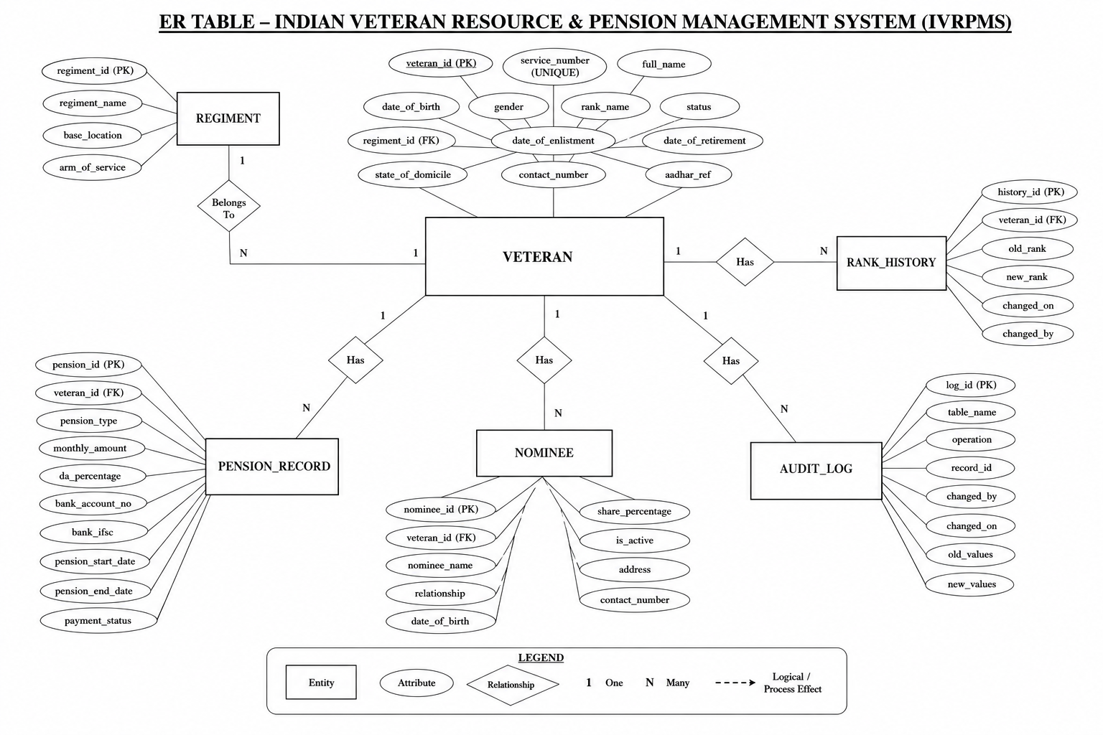

Key entities and their roles in the ER model are described below:
- REGIMENT: Master reference entity. Attributes – Regiment_ID (PK), Regiment_Name, Base_Location, Arm_of_Service.
- VETERAN: Core entity of the system. Attributes – Veteran_ID (PK), Regiment_ID (FK), Service_Number (UNIQUE), Full_Name, Date_of_Birth, Gender, Rank, Date_of_Enlistment, Date_of_Retirement, Status, State_of_Domicile, Contact_Number, Aadhar_Ref.
- PENSION_RECORD: Financial entitlement entity. Attributes – Pension_ID (PK), Veteran_ID (FK), Pension_Type, Monthly_Amount, DA_Percentage, Bank_Account_No, Bank_IFSC, Pension_Start_Date, Pension_End_Date, Payment_Status.
- NOMINEE: Beneficiary entity. Attributes – Nominee_ID (PK), Veteran_ID (FK), Nominee_Name, Relationship, Date_of_Birth, Share_Percentage, Is_Active.
- RANK_HISTORY: Audit trail entity. Attributes – History_ID (PK), Veteran_ID (FK), Old_Rank, New_Rank, Changed_On, Changed_By.
- AUDIT_LOG: System-wide change log entity. Attributes – Log_ID (PK), Table_Name, Operation, Record_ID, Changed_By, Changed_On, Old_Values, New_Values.

ER to Table (Before Normalization)
The initial translation of the ER model into relational tables, before applying normalization rules, may lead to redundancy and anomalies. In this pre-normalization state, certain attributes that are functionally dependent on non-key attributes are grouped within the same table, creating update, insertion, and deletion anomalies.

For example, a naive initial schema might combine resident information with society details in a single flat table, resulting in repeated society name and address for every resident belonging to that society. Similarly, pickup request details, waste category descriptions, and resident contact information might be merged into a single wide table, leading to significant data redundancy.

The following illustrates the conceptual pre-normalization state of major entities:

Field | Issue
Request_ID, Resident_Name, Resident_Email, Apartment | Resident info repeated per request
Society_Name, Society_Address, Society_City | Society info repeated per resident
Category_Name, Category_Description | Waste category info repeated per request
Collector_Name, Collector_Phone, Vehicle_Number | Collector info repeated per assignment

Such a flat structure leads to: (a) Update Anomaly – if a society's address changes, every row for that society's residents must be updated; (b) Insertion Anomaly – a new society cannot be inserted without a resident; (c) Deletion Anomaly – deleting the last resident of a society removes all society information from the database.

Normalization Steps — IVRPMS
DBMS Normalization is a systematic approach used to decompose large database tables into smaller, well-structured relations in order to minimize redundancy, avoid update/insert/delete anomalies, and maintain data consistency.
The Indian Veteran Resource & Pension Management System (IVRPMS) database has been designed and normalized up to the Boyce-Codd Normal Form (BCNF), ensuring efficient storage, integrity, and maintainability of veteran and pension-related records.

Unnormalized Form (UNF)
Initially, all veteran, pension, nominee, and promotion details were stored in a single flat table similar to a manual register or spreadsheet. Multiple nominees and promotion history entries existed inside the same row, creating redundancy and anomalies.
veteran_id | full_name | rank | regiment_name | base_location | pension_amt | nominee_1 | nominee_2 | old_rank_1 | old_rank_2
1001 | Rajinder Singh | Subedar | Punjab Regiment | Ramgarh | 19550 | Gurpreet Kaur | Manpreet Singh | Sepoy | Naik
1003 | Arun Sharma | Colonel | Regt of Artillery | Nashik | 65300 | Sunita Sharma | Rahul Sharma | Lieutenant | Captain
Problems in UNF:
- Repeating nominee columns existed.
- Promotion history was stored in multiple columns.
- Regiment details repeated for multiple veterans.
- Update, insertion, and deletion anomalies were possible.

First Normal Form (1NF)
A table is said to be in 1NF if every attribute contains atomic values and there are no repeating groups.
- Removed repeating nominee columns.
- Removed repeating rank history columns.
- Stored each nominee in a separate row.
- Stored each promotion record in a separate row.
- Added veteran_id as a primary key.
veteran_id | full_name | rank | regiment_name | base_location | pension_amt | nominee_name | relationship | old_rank | new_rank | promotion_date
1001 | Rajinder Singh | Subedar | Punjab Regiment | Ramgarh | 19550 | Gurpreet Kaur | Spouse | Sepoy | Naik | 1978-03-10
1001 | Rajinder Singh | Subedar | Punjab Regiment | Ramgarh | 19550 | Manpreet Singh | Child | Naik | Havildar | 1983-06-22
1003 | Arun Sharma | Colonel | Regt of Artillery | Nashik | 65300 | Sunita Sharma | Spouse | Lieutenant | Captain | 1978-04-05
1NF Achieved: Every value is atomic and repeating groups are removed.

Second Normal Form (2NF)
A table is in 2NF if it is already in 1NF and there are no partial dependencies.
- Created a separate REGIMENT table.
- Created a separate NOMINEE table.
- Created a separate RANK_HISTORY table.
- Linked entities using foreign keys.

REGIMENT Table
regiment_id | regiment_name | base_location | arm_of_service
1 | Punjab Regiment | Ramgarh Cantonment | Infantry
12 | Regiment of Artillery | Nashik | Artillery

NOMINEE Table
nominee_id | veteran_id | nominee_name | relationship | share_pct
7001 | 1001 | Gurpreet Kaur | Spouse | 60
7002 | 1001 | Manpreet Singh | Child | 40
2NF Achieved: No partial dependencies remain.

Third Normal Form (3NF)
A table is in 3NF if it is already in 2NF and contains no transitive dependencies.
Transitive Dependency Example: veteran_id → rank → pension_amt
- Created a separate PENSION_RECORD table.
- Separated pension-related attributes from VETERAN.
- Maintained pension details independently.

Final VETERAN Table
veteran_id | service_number | full_name | rank_name | regiment_id | date_of_birth | date_of_enlistment | date_of_retirement | status | state_of_domicile
1001 | JC-40001 | Rajinder Singh | Subedar | 1 | 1955-04-12 | 1975-06-01 | 2005-06-01 | Retired | Punjab

Final PENSION_RECORD Table
pension_id | veteran_id | pension_type | monthly_amount | da_percentage | bank_account_no | pension_start_date | payment_status
5001 | 1001 | Service | 19550.00 | 46.00 | XXXXXXXX4521 | 2005-07-01 | Active
3NF Achieved: No transitive dependencies remain.

Boyce-Codd Normal Form (BCNF)
A table is in BCNF if for every functional dependency X → Y, X is a superkey.
Table | Functional Dependency | Superkey? | BCNF
REGIMENT | regiment_id → all attributes | Yes | Yes
VETERAN | veteran_id → all attributes | Yes | Yes
PENSION_RECORD | pension_id → all attributes | Yes | Yes
NOMINEE | nominee_id → all attributes | Yes | Yes
RANK_HISTORY | history_id → all attributes | Yes | Yes
AUDIT_LOG | log_id → all attributes | Yes | Yes
BCNF Achieved: Every determinant is a candidate key or primary key.

ER to Table (After Normalization)
After applying all normalization rules up to BCNF, the final relational schema of the Smart Waste Pickup System consists of ten well-structured tables, each with clearly defined primary keys, foreign keys, and constraints. The schema achieves complete separation of concerns, eliminating all redundancy while maintaining referential integrity across all relationships.

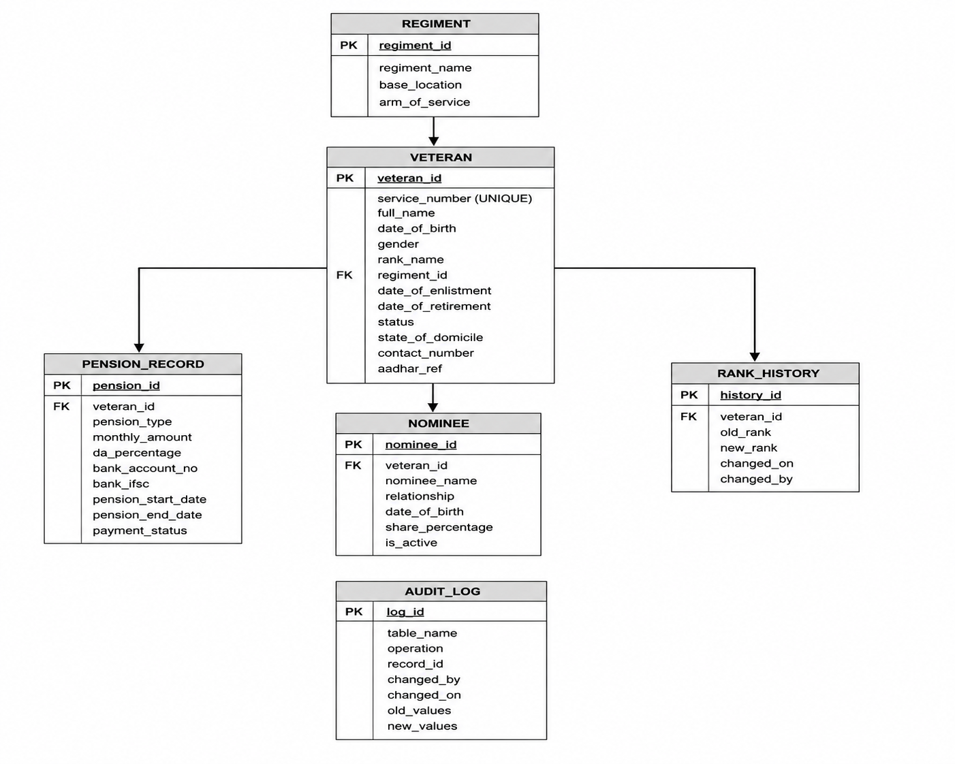

SQL Commands to Create Tables
Table Creation
The following SQL commands create all six tables of the IVRPMS. Each table includes appropriate constraints such as PRIMARY KEY, FOREIGN KEY, NOT NULL, UNIQUE, CHECK, and DEFAULT values.
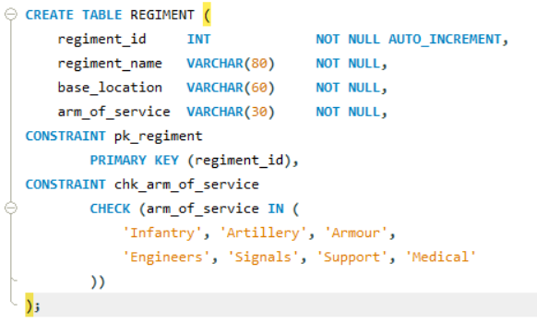

SQL Commands to Insert Data
The following INSERT statements populate the database with sample data for all ten tables. The data demonstrates the full workflow of the Indian Veteran Resource and Pension Management System (IVRPMS) System.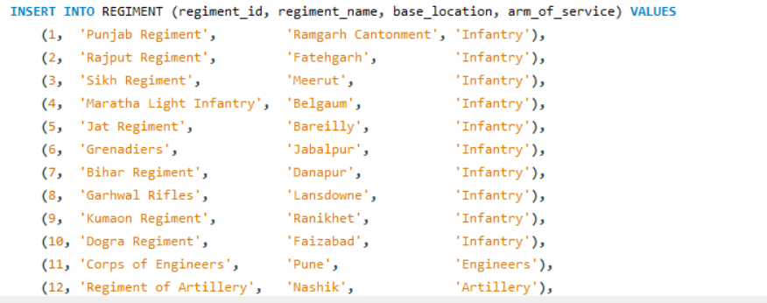

Triggers and Exception Handling
This trigger is executed automatically after any update operation on the VETERAN table. Whenever the rank_name of a veteran changes, the trigger inserts a new record into the RANK_HISTORY table containing the veteran ID, previous rank, updated rank, date of change, and the database user who performed the update.
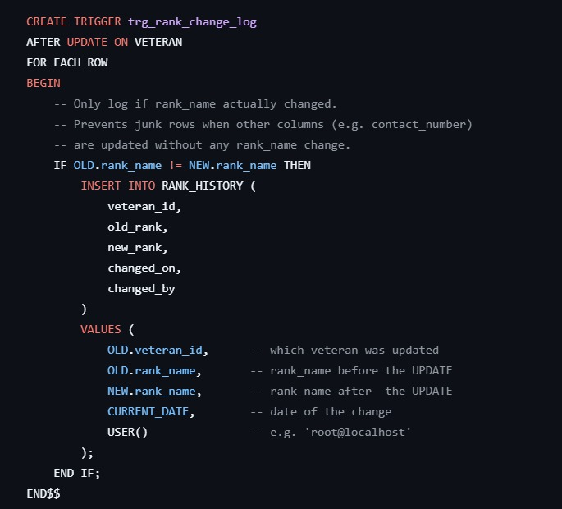

This trigger is executed automatically after any update operation on the PENSION_RECORD table. Whenever the pension amount or payment status changes, the trigger stores the old and new values inside the AUDIT_LOG table along with the timestamp and database user information.

The purpose of this trigger is to maintain transparency and accountability for financial records. Since pension information is sensitive government financial data, every modification must be tracked for auditing, security, and compliance purposes
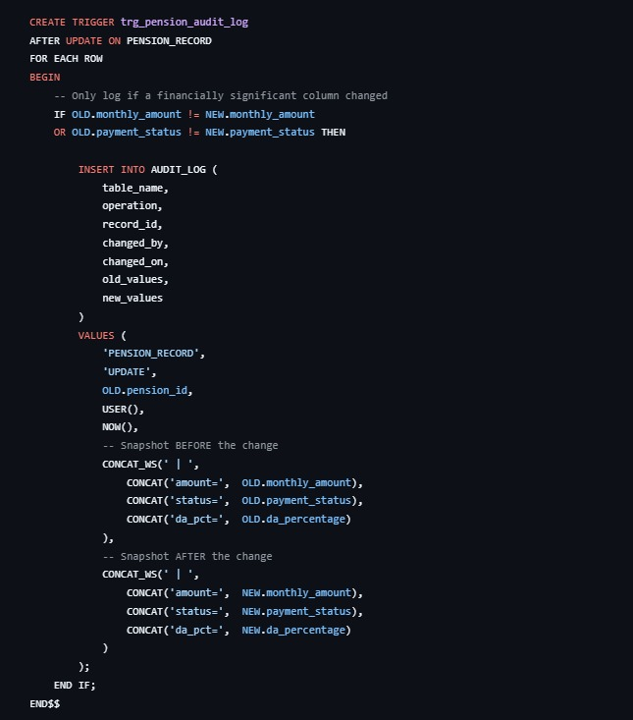

Conclusion
The Indian Veteran Resource and Pension Management System (IVRPMS) successfully demonstrates the design and implementation of a fully normalized, constraint-driven relational database system for managing veteran welfare records of the Indian Armed Forces.
The project achieved the following:
- A 3NF and BCNF compliant schema across 6 tables — REGIMENT, VETERAN, PENSION_RECORD, NOMINEE, RANK_HISTORY, and AUDIT_LOG — with zero data redundancy and complete referential integrity.
- Management of 50 veteran profiles, 44 pension records, 107 nominee entries, 15 regiments, and 92 rank promotion events through structured, validated data.
- DA-adjusted pension computation delivering accurate monthly disbursement figures across all active pensioners.
- Automated rank promotion logging via PL/SQL triggers, ensuring a tamper-proof audit trail without manual intervention.
- A system-wide AUDIT_LOG that survives record deletions, providing the last line of accountability for all sensitive operations.
- A live browser-based command dashboard backed by a Flask REST API, exposing all data across 7 interactive pages in real time.
- Proven algorithmic efficiency — Merge Sort at Θ(n log n) for batch pension processing and KMP String Matching at Θ(n + m) for service number search — both verified using the Master Theorem.
The system is scalable, auditable, and structured to serve as a reliable foundation for a production-grade veteran welfare management platform. Future enhancements may include integration with the SPARSH pension portal, Aadhaar-based verification, role-based access control, and a mobile-first interface for field-level regimental use.

