
Project Report

on

Porting of RTOS to a Multi-Core System

Submitted in partial fulfillment for the award of

Post Graduate Diploma in Embedded Systems Design

From C-DAC, ACTS (Pune)

Guided by:

Mr. Babu Krishnamurthy

Presented by:

Shantanu Nigam | 170840130090
Supriti Ghosh | 170840130101
Akshay Chaphekar | 170840130115

Centre of Development of Advanced Computing (C-DAC), Pune


CERTIFICATE

TO WHOMSOEVER IT MAY CONCERN

This is to certify that

Shantanu Nigam |  |  | 170840130090
Supriti Ghosh |  |  | 170840130101
Akshay Chaphekar |  |  | 170840130115
have successfully completed their project on

PORTING OF RTOS (FREERTOS) TO A
MULTICORE SYSTEM(LPC4367)

under the guidance of Mr. Babu Krishnamurthy.

Project Guide Project Supervisor

HOD ACTS
Mita Karajagi

ACKNOWLEDGEMENT

This project “Porting of RTOS (FreeRTOS) to a multicore system (LPC4367)” was a great learning experience for us and we are submitting this work to Advanced Computing Training School (CDAC ACTS).

We all are very glad to mention the name of Mr. Babu Krishnamurthy for his valuable guidance to work on this project. His guidance and support helped us to overcome various obstacles and intricacies during the course of project work.

We are highly grateful to Ms. Risha P.R., Manager (ACTS training Centre), C-DAC, for her guidance and support whenever necessary while doing this course Post Graduate Diploma in Embedded System Design (PG-DESD) through C-DAC ACTS, Pune.

Our most heartfelt thanks goes to Miss. Shilpi Shalini D’Costa (Course Coordinator, PG-DESD) who gave all the required support and kind coordination to provide all the necessities like required hardware, internet facility and extra Lab hours to complete the project and throughout the course up to the last day here in C-DAC ACTS, Pune.



TABLE OF INDEX

 | Topic |  |  | Page No.
1. | Abstract |  | ----------------------------------------------------------------------------- | 1
2. | Literature Survey ------------------------------------------------------------------ |  |  | 2
 | 2.1 | ARM Cortex M4 Architecture--------------------------------------------- |  | 2
 | 2.2 | ARM Cortex M0 Architecture --------------------------------------------- |  | 3
 | 2.3 | ADC--------------------------------------------------------------------------- |  | 13
 |  | 2.3.1 | Definition-------------------------------------------------------------- | 13
 |  | 2.3.2 | Architecture----------------------------------------------------------- | 13
3. | Requirements---------------------------------------------------------------------- |  |  | 15
 | 3.1 | Hardware Requirements---------------------------------------------------- |  | 15
 |  | 3.1.1 | Introduction to LPCXpresso4367 Board------------------------- | 15
 |  | 3.1.2 | LM35------------------------------------------------------------------ | 16

3.3 | 3.2 Software Requirements-----------------------------------------------
 | 3.2.1 | LPCXpresso IDE------------------------------------------------------
4. Design and Flow Chart---------------------------------------------------------
4.1 | Block Diagram----------------------------------------------------------------
4.2 | Description--------------------------------------------------------------------
4.3 | Flow Chart---------------------------------------------------------------------
Conclusion and Future Scope-----------------------------------------------------
References---------------------------------------------------------------------------

Diploma in Embedded Systems Design /Aug 2017


Chapter 1

Abstract: This project involves porting of RTOS (Amazon's FreeRTOS) to a multi-core system (NXP LPCXpresso4367) with one ARM Cortex M4 core and two ARM Cortex M0 cores (M0 App and M0 Sub). In addition, development of a suitable application on top of it to demonstrate the benefits of an asymmetric multicore systems over conventional uniprocessor system.

In this project only one M0 core (M0 App) is used.

Diploma in Embedded Systems Design/AUG 2017 P a g e | 1
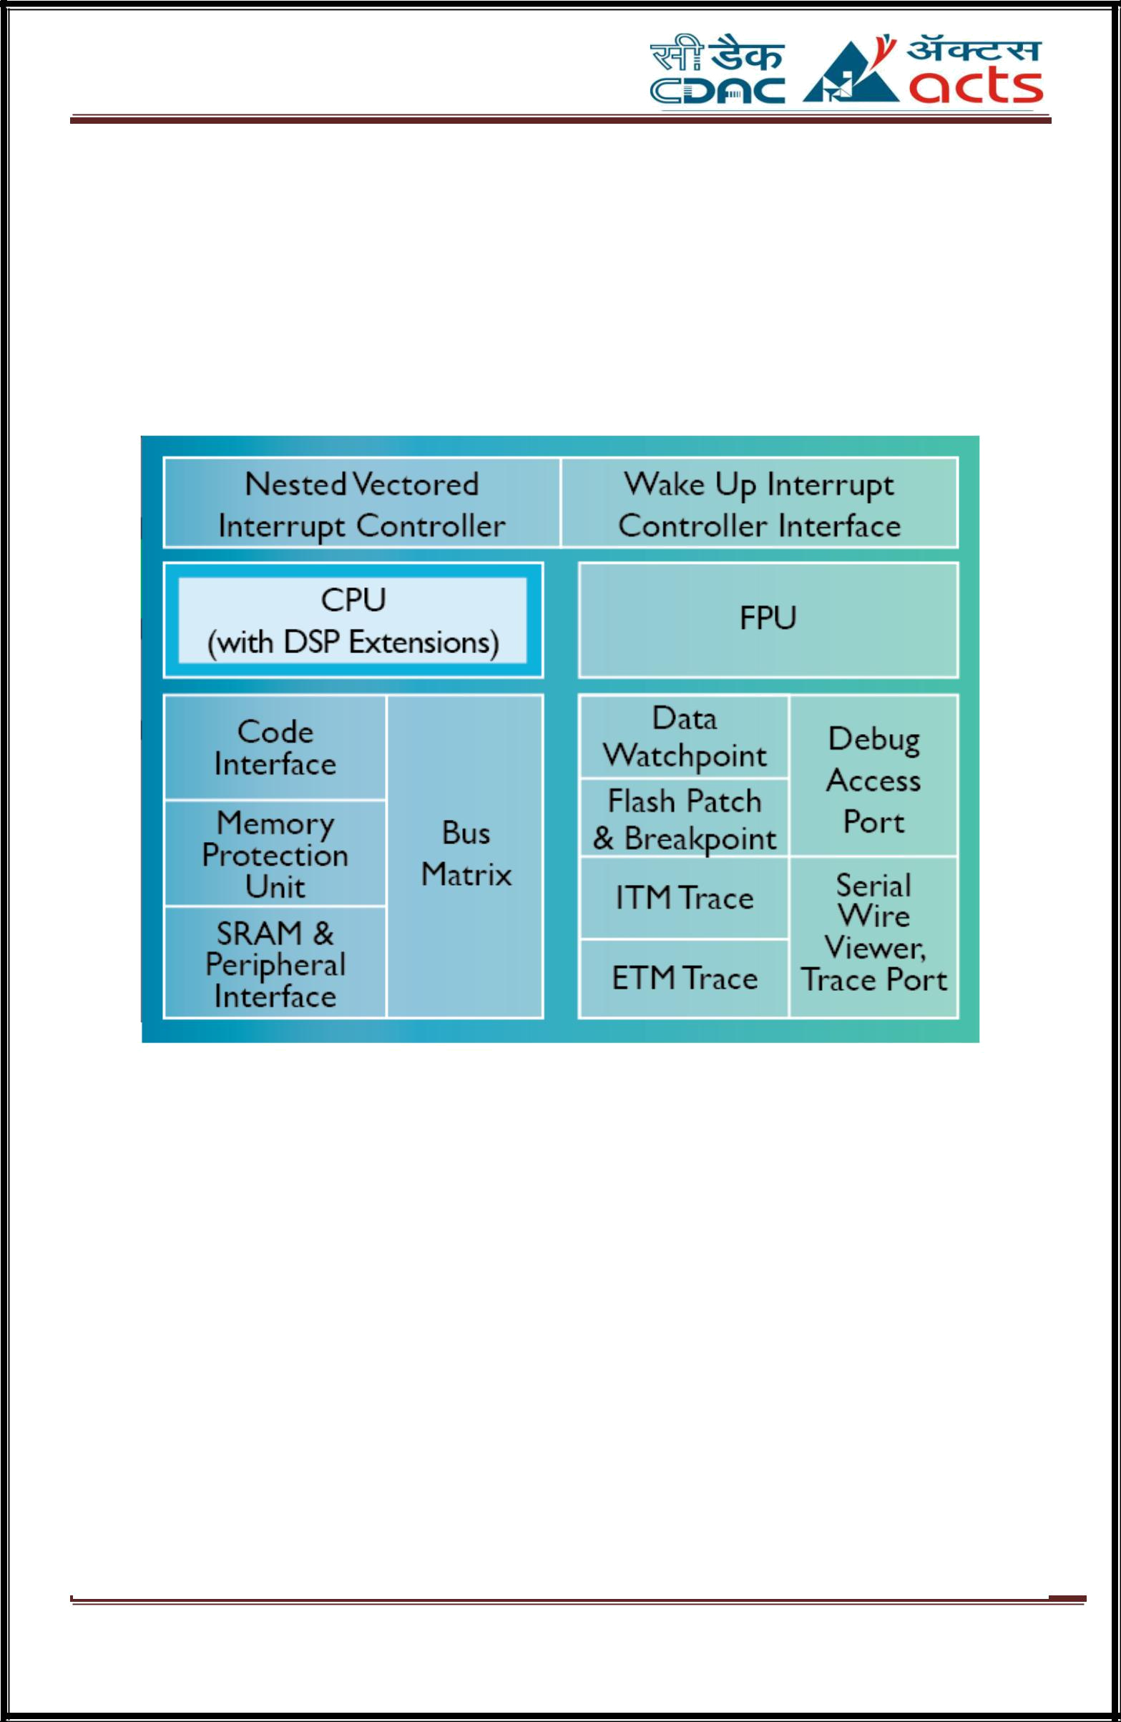

Chapter 2

Literature Survey

2.1 ARM Cortex M4 Architecture

Figure 2.1 ARM Cortex M4 Architecture

The ARM® Cortex®-M4 processor is a high performance embedded processor with DSP instructions developed to address digital signal control markets that demand an efficient, easy-to-use blend of control and signal processing capabilities. The processor is highly configurable enabling a wide range of implementations from those requiring floating point operations, memory protection and powerful trace technology to cost sensitive devices requiring minimal area.

Diploma in Embedded Systems Design /AUG 2017 P a g e | 2

Key Benefits

- Gain the advantages of a microcontroller with integrated DSP, SIMD, and MAC instructions that simplify overall system design, software development and debug
- Accelerate single precision floating point math operations up to 10x over the equivalent integer software library with the optional floating point unit (FPU)
- Develop solutions for a large variety of markets with a full-featured ARMv7-M instruction set that has been proven across a broad set of embedded applications

- Achieve exceptional 32-bit performance with low dynamic power, delivering leading system energy efficiency due to integrated software controlled sleep modes, extensive clock gating and optional state retention.

2.2 ARM Cortex M0 Architecture

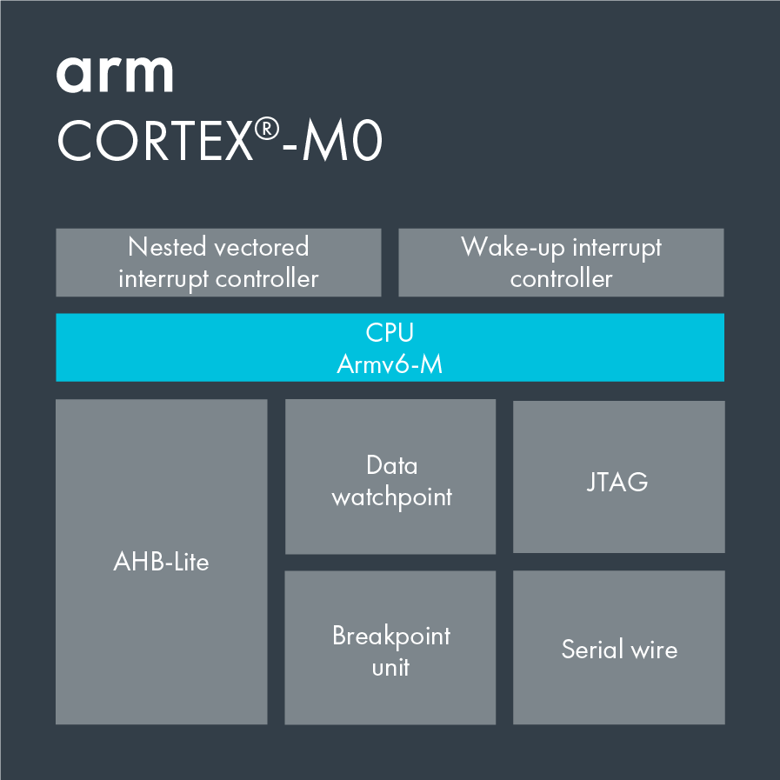

Figure 2.2 ARM Cortex M0 Architecture

Diploma in Embedded Systems Design /AUG 2017 P a g e | 3
The exceptionally small silicon area, low power and minimal code footprint of the processor enables developers to achieve 32-bit performance at an 8-bit price point, bypassing the step to 16-bit devices.
The ultra-low gate count of the Cortex-M0 processor also enables its deployment in analog and mixed signal devices. Arm Design Start provides the fastest, simplest, no-risk route to custom silicon success.

Key benefits
- Smallest footprint Arm processor with a total floorplan area of 0.007 mm2 in a 40nm technology process.

- Simple and quick development. With just 56 instructions, it is possible to quickly master the entire Cortex-M0 instruction set and its C-friendly architecture.

- A low-cost and simplified fast-track license option is available for the Cortex-M0 through the Arm Design Start portal.

Diploma in Embedded Systems Design /AUG 2017 P a g e | 4

2.3 ADC

An Analog-Digital Converter (ADC) is a widely used electronic component that converts an analog electric signal (usually a voltage) into a digital representation. The ADCs are at the front-end of any digital circuit that needs to process signals coming from the exterior world.
The output of a microphone, the voltage at a photodiode or the signal of an accelerometer are examples of analog values that need to be converted so that a microprocessor can work with them.
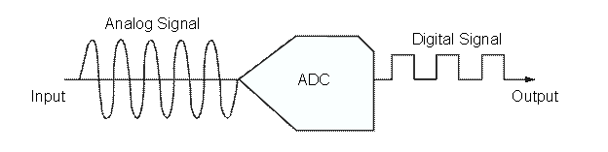

Figure 2.3 Analog to Digital conversion

An ADC samples an analog waveform at uniform time intervals and assigns a digital value to each sample. The digital value appears on the converter’s output in a binary coded format. The value is obtained by dividing the sampled analog input voltage by the reference voltage and them multiplying by the number of digital codes. The resolution of converter is set by the number of binary bits in the output code.
An ADC carries out two processes, sampling and quantization. The ADC represents an analog signal, which has infinite resolution, as a digital code that has finite resolution. The ADC produces 2N digital values where N represents the number of binary output bits. The analog input signal will fall between the quantization levels because the converter has finite resolution resulting in an inherent uncertainty or quantization error. That error determines the maximum dynamic range of the converter.
The performance of ADC is characterized by its bandwidth and its signal-to-noise ratio. The bandwidth of an ADC is characterized primarily by its sampling rate. The dynamic range of an ADC is influenced by many factors, including the resolution, linearity and accuracy (how well the quantization levels match the true analog signal), aliasing and jitter. The dynamic range of an ADC is often summarized in terms of its effective number of bits (ENOB), the number of bits of each measure it returns that are on average not noise. An ideal ADC has an ENOB equal to its resolution. ADCs are chosen to match the bandwidth and required signal-to-noise ratio of the signal to be quantized. If an ADC operates at a sampling rate greater than

Diploma in Embedded Systems Design /AUG 2017 P a g e | 5

twice the bandwidth of the signal, then perfect reconstruction is possible given an ideal ADC
and neglecting quantization error. The presence of quantization error limits the dynamic
range of even an ideal ADC. However, if the dynamic range of the ADC exceeds that of the input signal, its effects may be neglected resulting in an essentially perfect digital representation of the input signal.

2.3.1 Resolution
The resolution of the converter indicates the number of discrete values it can produce over the range of analog values. The resolution determines the magnitude of the quantization error and therefore determines the maximum possible average signal to noise ratio for an ideal ADC without the use of oversampling. The values are usually stored electronically in binary form, so the resolution is usually expressed in bits. In consequence, the number of discrete values available, or "levels", is assumed to be a power of two. For example, an ADC with a resolution of 8 bits can encode an analog input to one in 256 different levels, since 2⁸ = 256. The values can represent the ranges from 0 to 255 (i.e. unsigned integer) or from −128 to 127 (i.e. signed integer), depending on the application.
Resolution can also be defined electrically, and expressed in volts. The minimum change in voltage required to guarantee a change in the output code level is called the least significant bit (LSB) voltage. The resolution Q of the ADC is equal to the LSB voltage. The voltage resolution of an ADC is equal to its overall voltage measurement range divided by the number of intervals:
Q= E_{FSR/2^M}
where M is the ADC's resolution in bits and E_{FSR} is the full scale voltage range (also called 'span'). E_{FSR} is given by
E_{FSR} = V_{RefHi -} V_{RefLow}
where V_{RefHi} and V_{RefLow} are the upper and lower extremes, respectively, of the voltages that can be coded.
Normally, the number of voltage intervals is given by
N=2^M
where M is the ADC's resolution in bits.^{[1]}
That is, one voltage interval is assigned in between two consecutive code levels.

Diploma in Embedded Systems Design /AUG 2017 P a g e | 6

2.4 RTOS

Most operating systems appear to allow multiple programs to execute at the same time. This is called multi-tasking. In reality, each processor core can only be running a single thread of execution at any given point in time. A part of the operating system called the scheduler is responsible for deciding which program to run when, and provides the illusion of simultaneous execution by rapidly switching between each program.
The type of an operating system is defined by how the scheduler decides which program to run when. For example, the scheduler used in a multi user operating system (such as Unix) will ensure each user gets a fair amount of the processing time. As another example, the scheduler in a desk top operating system (such as Windows) will try and ensure the computer remains responsive to its user. [Note: FreeRTOS is not a big operating system, nor is it designed to run on a desktop computer class processor, I use these examples purely because they are systems readers will be familiar with]
The scheduler in a Real Time Operating System (RTOS) is designed to provide a predictable (normally described as deterministic) execution pattern. This is particularly of interest to embedded systems as embedded systems often have real time requirements. A real time requirements is one that specifies that the embedded system must respond to a certain event within a strictly defined time (the deadline). A guarantee to meet real time requirements can only be made if the behavior of the operating system's scheduler can be predicted (and is therefore deterministic).
Traditional real time schedulers, such as the scheduler used in FreeRTOS, achieve determinism by allowing the user to assign a priority to each thread of execution. The scheduler then uses the priority to know which thread of execution to run next. In FreeRTOS, a thread of execution is called a task.
2.4.1 Designs
The most common designs are
- Event-driven – switches tasks only when an event of higher priority needs servicing; called preemptive priority, or priority scheduling.
- Time-sharing – switches tasks on a regular clocked interrupt, and on events; called round robin.
Time sharing designs switch tasks more often than strictly needed, but give smoother multitasking, giving the illusion that a process or user has sole use of a machine.

Diploma in Embedded Systems Design /AUG 2017 P a g e | 7

2.4.2 Memory Allocation

Memory allocation is more critical in a real-time operating system than in other operating systems.First, for stability there cannot be memory leaks (memory that is allocated, then unused but never freed). The device should work indefinitely, without ever needing a reboot. For this reason, dynamic memory allocation is frowned upon. Whenever possible, all required memory allocation is specified statically at compile time.
Another reason to avoid dynamic memory allocation is memory fragmentation. With frequent allocation and releasing of small chunks of memory, a situation may occur when the memory is divided into several sections, in which case the RTOS cannot allocate a large continuous block of memory, although there is enough free memory. Secondly, speed of allocation is important. A standard memory allocation scheme scans a linked list of indeterminate length to find a suitable free memory block,^{[7]} which is unacceptable in an RTOS since memory allocation has to occur within a certain amount of time.
Because mechanical disks have much longer and more unpredictable response times, swapping to disk files is not used for the same reasons as RAM allocation discussed above.The simple fixed-size-blocks algorithm works quite well for simple embedded systems because of its low overhead.

2.4.3 Scheduling Policies
Some commonly used RTOS scheduling algorithms are:
- Cooperative scheduling.
- Preemptive scheduling Rate-monotonic scheduling
- Round-robin scheduling
- Fixed priority pre-emptive scheduling, an implementation of preemptive time slicing
- Fixed-Priority Scheduling with Deferred Preemption
- Fixed-Priority Non-preemptive Scheduling
- Critical section preemptive scheduling
- Static time scheduling
- Earliest Deadline First approach
- Stochastic digraphs with multi-threaded graph traversal

Diploma in Embedded Systems Design /AUG 2017 P a g e | 8

2.5 FreeRTOS

The FreeRTOS project was founded by Richard Barry. Richard graduated with 1st Class Honors in Computing for Real Time Systems. He's been directly involved in the startup of several companies, primarily working in the industrial automation and aerospace and simulation markets. Richard is currently a Principal Engineer at Amazon Web Services, owners and maintainers of the FreeRTOS project.
FreeRTOS is a class of RTOS that is designed to be small enough to run on a microcontroller - although its use is not limited to microcontroller applications. A microcontroller is a small and resource constrained processor that incorporates, on a single chip, the processor itself, read only memory (ROM or Flash) to hold the program to be executed, and the random access memory (RAM) needed by the programs it executes. Typically the program is executed directly from the read only memory.
Microcontrollers are used in deeply embedded applications (those applications where you never actually see the processors themselves, or the software they are running) that normally have a very specific and dedicated job to do. The size constraints, and dedicated end application nature, rarely warrant the use of a full RTOS implementation - or indeed make the use of a full RTOS implementation possible. FreeRTOS therefore provides the core real time scheduling functionality, inter-task communication, timing and synchronization primitives only. This means it is more accurately described as a real time kernel, or real time executive. Additional functionality, such as a command console interface, or networking stacks, can then be included with add-on components.
2.5.1 Quality Management

FreeRTOS is very strictly quality managed, not just in software coding standards and look and feel, but also in implementation. For example:
- FreeRTOS never performs a non-deterministic operation, such as walking a linked list, from inside a critical section or interrupt.
- We are particularly proud of the efficient software timer implementation that does not use any CPU time unless a timer actually needs servicing. Software timers do not contain variables that need to be counted down to zero.
- Likewise, lists of Blocked (pended) tasks do not require time consuming periodic servicing.

Diploma in Embedded Systems Design /AUG 2017 P a g e | 9

- Direct to task notifications allow fast task signaling, with practically no RAM overhead, and can be used in the majority of inter-task and interrupt to task signaling scenarios.
- The FreeRTOS queue usage model manages to combine simplicity with flexibility (in a tiny code size) - attributes that are normally mutually exclusive.
- FreeRTOS queues are base primitives on top of which other communication and synchronization primitives are built. The code re-use obtained dramatically reduced overall code size, which in turn assists testing and helps ensure robustness.

RTOS Technology Highlights
Pre-emptive scheduling option | Easy to use message passing
Co-operative scheduling option | Round robin with time slicing
Fast task notifications | Mutexes with priority inheritance
6K to 12K ROM footprint | Recursive mutexes
Configurable / scalable | Binary and counting semaphores
Chip and compiler agnostic | Very efficient software timers
Some ports never completely disable interrupts | Easy to use API

Diploma in Embedded Systems Design /AUG 2017 P a g e | 10

2.5.2 Implementation

FreeRTOS is designed to be small and simple. The kernel itself consists of only three C files. To make the code readable, easy to port, and maintainable, it is written mostly in C, but there are a few assembly functions included where needed (mostly in architecture-specific scheduler routines).
FreeRTOS provides methods for multiple threads or tasks, mutexes, semaphores and software timers. A tick-less mode is provided for low power applications. Thread priorities are supported. FreeRTOS applications can be completely statically allocated. Alternatively RTOS objects can be dynamically allocated with five schemes of memory allocation provided:
- allocate only;
- allocate and free with a very simple, fast, algorithm;
- a more complex but fast allocate and free algorithm with memory coalescence;
- an alternative to the more complex scheme that includes memory coalescence that allows a heap to be broken across multiple memory areas.
- and C library allocate and free with some mutual exclusion protection.
There are none of the more advanced features typically found in operating systems like Linux or Microsoft Windows, such as device drivers, advanced memory management, user accounts, and networking. The emphasis is on compactness and speed of execution. FreeRTOS can be thought of as a 'thread library' rather than an 'operating system', although command line interface and POSIX-like I/O abstraction add-ons are available.
FreeRTOS implements multiple threads by having the host program call a thread tick method at regular short intervals. The thread tick method switches tasks depending on priority and a round-robin scheduling scheme. The usual interval is 1/1000 of a second to 1/100 of a second, via an interrupt from a hardware timer, but this interval is often changed to suit a particular application.
The download contains prepared configurations and demonstrations for every port and compiler, allowing rapid application design. The FreeRTOS.org site also contains a lot of documentation and RTOS tutorials (additional manuals and tutorials are available for a fee), as well as details of the RTOS design.

Diploma in Embedded Systems Design /AUG 2017 P a g e | 11

Key benefits
- Book and reference manuals.
- Small memory footprint, low overhead, and fast execution.
- Tick-less option for low power applications.
- Intended for both hobbyists and professional developers working on commercial products.
- Scheduler can be configured for both preemptive and cooperative operation.
- Coroutine support (coroutines in FreeRTOS are simple and lightweight tasks with limited use of the call stack)
- Trace support through generic trace macros. Tools such as Tracealyzer by FreeRTOS partner Percepio can thereby record and visualize the runtime behavior of FreeRTOS-based systems. This includes task scheduling and kernel calls for semaphore and queue operations. Tracealyzer a freemium pricing strategy, offering a feature-limited free version.

Diploma in Embedded Systems Design /AUG 2017 P a g e | 12

2.6 Amazon FreeRTOS
Amazon FreeRTOS is a microcontroller operating system based on the FreeRTOS kernel. It includes libraries for connectivity and security. You can use the Amazon FreeRTOS console to configure and download the FreeRTOS kernel and software libraries for your application. The Amazon FreeRTOS Qualification Program gives you the confidence that the microcontroller you choose fully supports the Amazon FreeRTOS features and capabilities.

2.6.1 The FreeRTOS Kernel
The FreeRTOS kernel is a real-time operating system that supports numerous architectures and is ideal for building embedded microcontroller applications. The kernel provides:
- A multitasking scheduler.
- Multiple memory allocation options (including the ability to create statically allocated systems).
- Inter-task coordination primitives, including task notifications, message queues, multiple types of semaphores, and stream and message buffers.

2.6.2 Amazon FreeRTOS Libraries
Amazon FreeRTOS includes libraries that enable you to:
- Securely connect devices to the AWS IOT cloud using MQTT and device shadows.
- Discover and connect to AWS Green grass cores.
- Manage Wi-Fi connections.

Diploma in Embedded Systems Design /AUG 2017 P a g e | 13

2.6.3 Amazon FreeRTOS Console
The Amazon FreeRTOS console is used to create software configurations that you can download onto your development computers to get started with Amazon FreeRTOS. The console allows you to select the hardware platform, compiler and IDE used for development, and Amazon FreeRTOS libraries required for your application. After you have made these selections, a custom zip file of the required files is created along with demo projects that make it easy to get started with Amazon FreeRTOS. This zip file includes the FreeRTOS kernel, Amazon FreeRTOS libraries, and board support packages (BSPs) and hardware drivers for the hardware platform.

2.6.4 Amazon FreeRTOS Qualification Program
The Amazon FreeRTOS Qualification Program (Amazon FQP) is for microcontroller vendors who want to qualify their microcontroller-based hardware on Amazon FreeRTOS. The goal of Amazon FQP is to ensure that developers can use Amazon FreeRTOS on their choice of microcontroller-based hardware. In order to deliver a consistent experience for developers, the Amazon FQP outlines a set of security, functionality, and performance requirements that all microcontrollers (and the associated hardware abstraction layers and drivers) must meet.

Diploma in Embedded Systems Design /AUG 2017 P a g e | 14

Chapter 3

Hardware Requirements

3.1 LPCXpresso4367 Board

Document information

Info | Content
Keywords | LPCXpresso4337, LPCXpresso43S37, LPCXpresso43S67, LPC4300, LPC43S00, LPC43xx, LPC43Sxx
Abstract | LPCXpresso4367/43S67 User Manual

3.1.1 Introduction

The LPCXpresso™ family of boards provides a powerful and flexible development system for NXP's Cortex®-M family of MCUs. They can be used with a wide range of development tools, including the NXP’s LPCXpresso IDE. The LPCXpresso4367 (OM13088), LPCXpresso43S67 (OM13084) and Revision B LPCXpresso18S37 (OM13076) boards have been developed by NXP to enable evaluation of and prototyping with the LPC4300, LPC43S00 and LPC18S00 MCUs respectively, and are based on the 100 pin BGA versions of these MCUs

Diploma in Embedded Systems Design /AUG 2017 P a g e | 15

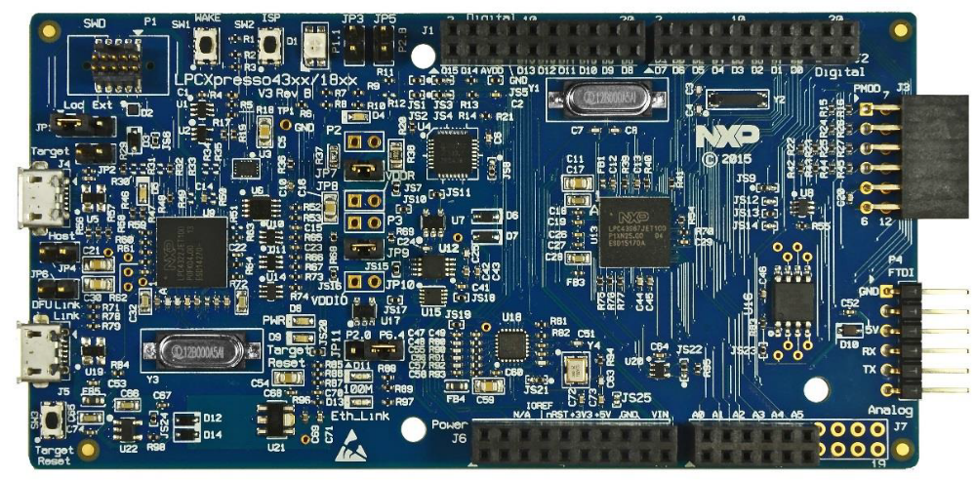

Fig 3.1 Blueboard Diagram of LPCXpresso4367

This document describes the LPCXpresso4367, LPCXpresso43S67 and LPCXpresso18S37 board hardware. These boards are functionally identical (using an underlying Revision B circuit board) with the exception of target MCU and the inclusion/exclusion of the A7001CM Secure Element device. The name LPCXpresso4367 is used throughout this document to refer to all boards. The term “Target MCU” is used to refer to the Target microcontroller (LPC4367, LPC43S67 or LPC18S37). The following aspects of interfacing to the boards are covered by this guide:
- Main board features
- Setup for use with development tools
- Supporting software drivers
- Board interface connector pin out
- Jumper settings
- Powering the board
- Mechanical drawing

Diploma in Embedded Systems Design /AUG 2017 P a g e | 16

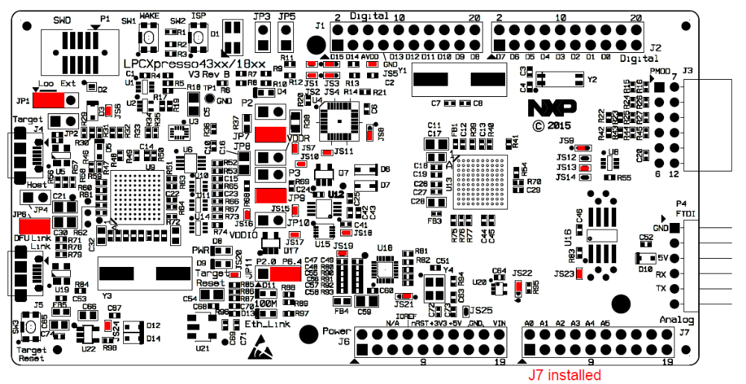

Fig 3.2 Board Layout
The LPCXpresso4367 board includes the following features:

- On-board, high-speed USB based, Link2 debug probe with support for ARM’s CMSIS-DAP and SEGGER J-Link protocol options
- Link2 probe can be used with on-board Target MCU or external target
- Built-in current measurement
- Support for external debug probes
- Tri-color LED
- Target Reset, ISP and WAKE buttons
- Expansion options based on Arduino UNO and PMod™, plus additional expansion port pins
- UART, I2C and SPI port bridging from Target MCU to USB via the on-board debug probe
- FTDI UART connector
- 8Mb Macronix Quad SPI flash (MX25L8035EM2I-10G)
- Ethernet PHY (LAN8720A)
- A7001CM Secure Element (LPCXpresso43S67/18S37 only)

Diploma in Embedded Systems Design /AUG 2017 P a g e | 17

3.1.2 Application Programming Interface
Three alternative implementations for IPC communication are provided: an interrupt based mechanism, a “message queue” based mechanism and a “mailbox” based
mechanism.
The interrupt mechanism is the simplest, and can be used to send a notification (or
signal) to the other core, without associated data.
The message queue mechanism follows the approach and guidelines mentioned in the
device user manual. The mailbox approach is an alternative implementation.
The pros and cons of each are detailed in the next sections.
All implementations include common APIs which allow a master processor to download a slave processor application image, start, and halt the slave processor.
In the message queue or mailbox implementations, it is assumed that the “communication channels” (one queue, or one specific mailbox) are not shared between multiple tasks or functions. For the message queue interface, this implies there is one entry point (or “gatekeeper “task) within the sending application where messages are inserted into the queue.
Similarly, there is one entry point (or “gatekeeper” task) within the receiving application where messages are retrieved from the queue.
For the mailbox interface, this implies there is one entry point (or “gatekeeper” task) within the sending application where a message can be sent to one specific mailbox.
Similarly, there is one entry point (or “gatekeeper” task) within the receiving application where a message gets processed from one specific mailbox. The actual implementation was not designed for access sharing on one queue (or one specific mailbox) between multiple tasks or functions.

Diploma in Embedded Systems Design /AUG 2017 P a g e | 18

3.2 Sensor(LM 35)

In this tutorial we will see how to interface LM35 Temperature sensor with ARM7 LPC2148 Microcontroller. LM35 is a well-known low cost temperature sensor. It is directly calibrated in Degrees Celsius meaning that the output voltage is directly proportional to Degrees Celsius readings. Its measurement range is from -55°C to 150°C having typical accuracy(s) of 0.25°C at room temperature and 0.75°C for full range. LM35 also supports a wide range of supply voltage from 4V to 30V and is available in 4 different packages viz. TO-CAN, TO-92, SOIC and TO-220.
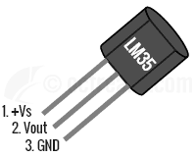
Fig 3.2 LM35 Pinout for TO-92 Package

Pin 1 (+Vs) is the positive power supply pin, Pin 2 (V_{OUT}) provides the output voltage linearly proportional to temperature and Pin 3 is for Ground.

3.2.1 Configuration
LM35 can be configured in two ways:
- Basic Centigrade Temperature Sensor (2°C to 150°C)
- Full Range Centigrade Temperature sensor (-55°C to 150°C)
For the sake of simplicity, we will use LM35 in basic configuration. The first thing to note when interfacing LM35 with 3.3v MCUs is that LM35 has a supply voltage range of 4V to 30V. Hence, another supply of say 5V would be required to get proper readings. The second thing to note is that the output voltage has a scale factor of 10mV per Degree Centigrade and this is fixed irrespective of what supply voltage you use between 4V to 30V. Hence, the output voltage can go max up to 1.5V and as low as -55mV when configured as Full Range Centigrade Sensor.

Diploma in Embedded Systems Design /AUG 2017 P a g e | 19

When using the Basic configuration we have an output swing of ~0V(20mV) to 1.5V. So, if we use a VREF of 3.3 Volts we get a resolution of 3.3V/1024 = 0.00322V or 3.22mV since LPC2148 has a 10-bit ADC. Considering that LM35’s typical accuracy at room temperature(25°C) is 0.25°C (worst case accuracy = 0.5°C @ 25°C) and scale factor of 10mV/°C, a resolution of 3.22mV barely fits the bill. To get better resolution we can use a lower voltage reference like 1.8V or 2V. For example, using 1.8V reference we get a resolution of 1.75mV. For the interfacing example given below, we will assume a voltage reference of 3.3V which is commonly used on development boards. If these connections are not present on your development board please make sure VREF pin is connected to 3.3V.

LM35 Transfer Function & Output Conversion to °C
The formula for V_{OUT} is given as:
V_{OUT}(mV) = 10mV/°C * T
Using the above formula, with VERF in Volts and Scale-factor in V/°C, we can compute the temperature(T) from 10-bit ADC Result as:
T =
ADC_RESULT * VREF1024 * 0.01

°C
Which can be simplified as,
T =
ADC_RESULT * VREF * 1001024

°C
So, when using VREF = 3.3V we get,
T =
ADC_RESULT * 3301024

°C

Example for LM35 Interfacing with ARM7 LPC4367
Now lets cover a simple programming example. As obvious, we will use the ADC block of LPC214x for interfacing our temperature sensor using reference voltage as mentioned above. We will use UART0 to send the data to terminal. You can refer my LPC4367 ADC Tutorial and UART Tutorial for more. The example project linked below also contains retargeted printf() for LPCXpresso IDE which redirects its output to UART0.

Diploma in Embedded Systems Design /AUG 2017 P a g e | 20

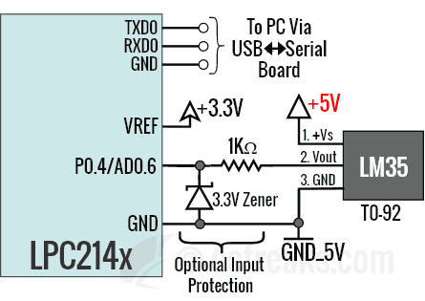

Figure 3.3 Interfacing Schematic

Diploma in Embedded Systems Design /AUG 2017 P a g e | 23

3.3 Software Requirements

3.3.1 LPCXpresso IDE

3.3.1.1 Introduction
LPCXpresso is a low-cost microcontroller (MCU) development platform ecosystem from NXP, which provides an end-to-end solution enabling engineers to develop embedded applications from initial evaluation to final production. The LPCXpresso platform ecosystem includes: • The LPCXpresso IDE, a software development environment for creating applications for NXP’s ARM-based “LPC” range of MCUs. • The range of LPCXpresso development boards, each of which includes a built-in “LPC-Link”, “LPC-Link2”, or CMSIS-DAP debug probe. These boards are developed in collaboration with Embedded Artists. • The standalone “LPC-Link2” debug probe. This guide is intended as an introduction to using LPCXpresso, with particular emphasis on the LPCXpresso IDE. It assumes that you have some knowledge of MCUs and software development for embedded systems.

3.3.1.2 LPCXpresso IDE Overview of Features

- Complete C/C++ integrated development environment
- Latest Eclipse-based IDE with many ease-of-use enhancements
- Eclipse Mars (v4.5) and CDT (8.8)
- The IDE can be further enhanced with Eclipse plugins
- CVS source control built in; Subversion, TFS, Git, and others available for download • Command-line tools included for integration into build, test, and manufacturing systems
- Industry standard GNU toolchain (v5) including
- C and C++ compilers, assembler, and linker
- Converters for SREC, HEX, and binary
- Advanced project wizards
- Simple creation of preconfigured applications for specific MCUs
- Device-specific support for NXP’s ARM-based MCUs (including Cortex-M, ARM7 and ARM9 based parts)
Automatic generation of linker scripts for correct placement of code and data into flash and RAM .
- Automatic generation of MCU-specific startup and device initialization code
- No assembler required with Cortex-M MCUs
- Advanced multicore support
- Provision for creating linked projects for each core in multicore MCUs
- Debugging of multicore projects within a single IDE instance, with the ability to link various debug views to specific cores
- Fully featured debugger supporting JTAG and SWD connection
- Built-in optimized flash programming for internal and SPI flash
- High-level and instruction-level debug
- Views of CPU registers and on-chip peripherals
- Support for multiple devices on the JTAG scan-chain

Diploma in Embedded Systems Design /AUG 2017 P a g e | 27

Chapter 4

Design and Flow Chart

4.1 Block Diagram:

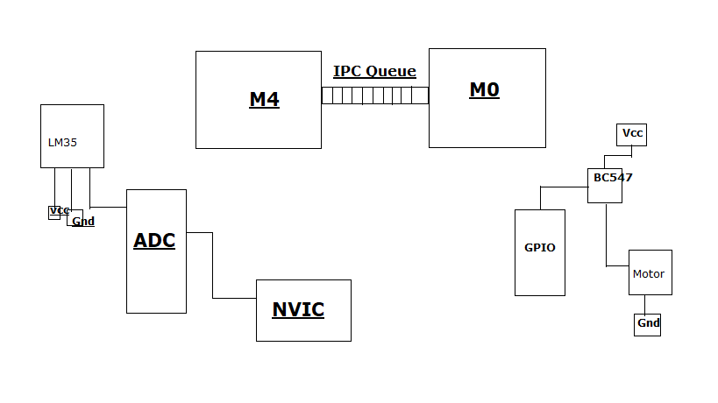
Figure 4.1 Block Diagram

Diploma in Embedded Systems Design /AUG 2017 P a g e | 29

Chapter 5

Conclusion and Future Scope

In an asymmetric multiprocessing system (AMP), not all CPUs are treated equally; for example, a system might allow (either at the hardware or operating system level) only one CPU to execute operating system code or might allow only one CPU to perform I/O operations. Other AMP systems would allow any CPU to execute operating system code and perform I/O operations, so that they were symmetric with regard to processor roles, but attached some or all peripherals to particular CPUs, so that they were asymmetric with respect to the peripheral attachment. Asymmetric multiprocessing was the only method for handling multiple CPUs before symmetric multiprocessing (SMP) was available. It has also been used to provide less expensive options on systems where SMP was available. Additionally, AMP is used in applications that are dedicated, such as embedded systems, when individual processors can be dedicated to specific tasks at design time.
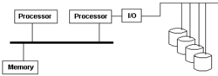
Asymmetric multiprocessing
Multiprocessing is the use of more than one CPU in a computer system. The CPU is the arithmetic and logic engine that executes user applications. With multiple CPUs, more than one set of program instructions can be executed at the same time. All of the CPUs have the same user-mode instruction set, so a running job can be rescheduled from one CPU to another.

Diploma in Embedded Systems Design /AUG 2017 P a g e | 32

Chapter 6

References

- https://community.nxp.com/docs/DOC-330813

- FreeRTOS pdf

- RTOS pdf

- ADC pdf

- AN11177.pdf

- LPC4367 User Manual

- LPC4367 Datasheet

- https://www.freertos.org/FreeRTOS_Support_Forum_Archive/May_2011/freertos_Multicore_support_4522953.html
- https://community.nxp.com/message/842004?commentID=842004#comment-842004
- How to run Multicore examples provided in LPCOp... | NXP Community

Diploma in Embedded Systems Design /AUG 2017 P a g e | 33

