**Seed = 39**

**Model:**

Logistic Regression:

|  |  |
| --- | --- |
| CutOff | TestError |
| 0.30 | 0.1950000 |
| 0.35 | 0.1907778 |
| 0.40 | 0.1844444 |
| 0.45 | 0.1806667 |
| 0.50 | 0.1782222 |
| 0.55 | 0.1785556 |
| 0.60 | 0.1773333 |
| 0.65 | 0.1802222 |
| 0.70 | 0.1917778 |

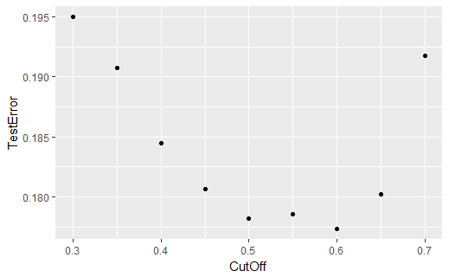

* Logistic Regression only includes significant variables

|  |  |
| --- | --- |
| CutOff | TestError |
| 0.30 | 0.1998889 |
| 0.35 | 0.1875556 |
| 0.40 | 0.1828889 |
| 0.45 | 0.1814444 |
| 0.50 | 0.1803333 |
| 0.55 | 0.1804444 |
| 0.60 | 0.1825556 |
| 0.65 | 0.1895556 |
| 0.70 | 0.1970000 |

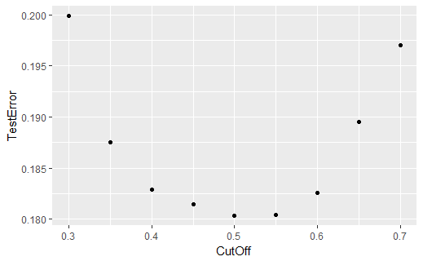

K Nearest Neighbor:

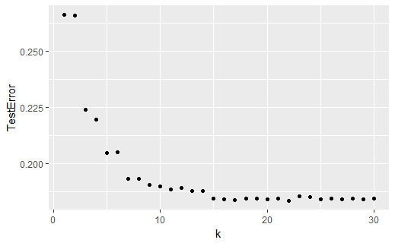

|  |  |
| --- | --- |
| k | TestError |
| 22 | 0.1833333 |
| 17 | 0.1837778 |
| 16 | 0.1838889 |
| 20 | 0.1838889 |
| 27 | 0.1838889 |
| 25 | 0.1840000 |
| 29 | 0.1840000 |
| 18 | 0.1842222 |