[UNIVERSITY LOGO — INSERT HERE]
1. COVER SHEET — RESERVED
Replace this page with your university cover layout.
Project: Dwell — Secure Multi-Vendor Product Discovery Platform
Group members and student IDs: [INSERT]
Module / course / university: [INSERT]
Supporting tutor: [INSERT confirmed name]
Project sponsor: [INSERT confirmed name]
Submission date: [INSERT]
Completed artefact — https://zetahub.co.uk/dwell

Table of contents
2. Project summary and introduction 3
3. Project objectives 4
4. Requirements 5
5. Scope and exclusions 7
6. Monitoring and evaluation 8
7. Project organisation structure 9
8. Project deliverables 10
9. Project milestones and management 11
10. Design and implementation 12
11. Results and evaluation 17
12. Conclusions and recommendations 19
13. References 20
14. Appendices 22

Cover reserved on page 1. Main sections follow the requested PID numbering. Appendix titles are listed at the start of Section 14.
Document status: evidence-led draft for team completion. Reviewed release: 8fba4fd. Survey results, cover details and approval records remain editable placeholders.

2. Project summary and introduction

2.1 Purpose and context
Dwell is a database-driven, multi-vendor product discovery MVP developed for the Industrial Consulting Project. Its purpose is to bring product information from different vendors into one consistent interface, allowing visitors to search, filter, inspect products and follow an external vendor link. The assessment brief combines software delivery with research, user-experience design, secure account handling and evaluation.
The problem addressed is the effort involved in moving between separate online shops to compare products and identify relevant information. The supplied competitor analysis considered Google Shopping, Amazon, eBay and Etsy and identified reusable patterns: visible vendor attribution, image-led cards, category and price filters, clear navigation and vendor profiles. This report treats those observations as the team’s supplied desk research, not as a newly verified audit of those commercial services (Dwell team, n.d.-a).

2.2 Delivered artefact
The delivered application uses React 19 with the Next.js App Router and TypeScript, a separate Express 5 REST API, and PostgreSQL accessed through Prisma. The current demonstration catalogue contains 30 products, five vendors and four categories. Public browsing, registration, login, saved products and an administrator product-management dashboard are implemented. A browser-local cart and explicitly simulated checkout extend the discovery workflow, but do not take payments, place orders or arrange delivery (Dwell repository, 2026).
Completed artefact — https://zetahub.co.uk/dwell
Source repository — https://github.com/adaeltonG/Industrial_project_Dwell
The reviewed release is commit 8fba4fd, deployed on 11 September 2026. This document combines the requested PID structure with a retrospective implementation and evaluation report. It distinguishes the original brief, design intentions, implemented behaviour and evidence still awaiting insertion. It does not reconstruct unrecorded meetings, approvals, individual working hours or participant responses.

2.3 Research and reporting boundary
The project owner reports that a survey was conducted, but the questionnaire, responses, dates and sample size were not supplied for this report. Editable spaces are reserved in Section 11 and Appendix A. Three supplied personas and the available wireframes and high-fidelity mockups are included as design artefacts. Their existence does not establish that the PRD’s ten-interview requirement was fulfilled. Five-user task-based usability testing is a separate deliverable and is not represented by automated browser checks.
Before submission: complete the cover, confirm team identities and responsibilities, insert the real survey evidence, resolve the interview/usability evidence gaps, and review the AI Usage Declaration.

3. Project objectives
The following objectives translate the project aim into observable acceptance criteria. Status refers to the reviewed release, rather than an assumed final assessment grade.
Objective | Acceptance criterion | Position at review
O1 - Unified discovery | Visitors can search and filter by category, vendor and price, sort by price/newest, open a detail page and follow a vendor link. | Implemented; API, fixture-browser and public-site checks support the core journey.
O2 - Persistent catalogue | At least 30 products and five vendors, backed by related user, vendor, category and product records. | Met: 30 products, five vendors and four categories; schema and repeatable seed supplied.
O3: - Controlled administration | An administrator can create, edit and delete products; a visitor or ordinary user cannot perform those writes. | Implemented and tested at API and UI boundaries.
O4 - Account security | Registration/login, password hashing, signed authentication tokens, validation and role checks. | Core controls implemented; further hardening remains necessary.
O5 - Responsive, consistent UX | A recognisable design system and working desktop/mobile discovery pages. | Mockups, reusable CSS/components and browser checks available; full accessibility conformance not established.
O6 - Evidence-based design | Competitor review, three personas, wireframes, mockups and research findings inform decisions. | Design artefacts available; empirical survey/interview linkage awaits evidence.
O7 - Evaluated handover | Tests, documentation, deployment, research results and final demonstration materials support handover. | Technical checks and deployment available; user-study evidence and demo video not found.

The objectives prioritise a coherent discovery and administration flow over marketplace scale. A 30-product seed is a demonstration threshold, not a performance benchmark or evidence of commercial adoption. Likewise, five seeded vendors are fictional catalogue entities, not five recruited trading partners. These distinctions prevent technical completeness from being confused with market validation.

4. Requirements

4.1 Requirements sources and prioritisation
Requirements were traced from the full PRD, the supplied competitor analysis, the persona images, the wireframes and the high-fidelity specification. The minimum product and security capabilities were treated as mandatory. Saved products were optional in the brief but implemented. Cart and checkout simulation were later extensions. Survey-derived priorities cannot be finalised until the actual responses are attached; the design needs below are presently supported by artefacts rather than quantified survey findings.
Design input | Need or observation | Requirement response
Competitor analysis | Reduce visual clutter while exposing product and vendor information. | Consistent card fields, prominent search and a compact filter system.
Emily Johnson persona | Quick discovery; fewer sites to inspect; clear navigation. | Search, categories, predictable card/detail navigation and responsive layout.
Samir Hadid persona | Budget-aware comparison and concerns about misleading prices. | Minimum/maximum price filters, price sorting and vendor attribution.
Victoria Henderson persona | Detailed information and confidence in vendors. | Descriptions, availability, vendor profile and outbound website link.
Survey / interviews | [INSERT supported themes and anonymised evidence references.] | [INSERT any resulting priority or design change.]

4.2 Functional requirements and traceability
Status key: Implemented = present in code and/or supported by checks; Partial = some of the requested scope is present; Pending evidence = an artefact or activity is not evidenced in the supplied material.
ID / PRD | Point-by-point requirement | Status and evidence
R01 / 1.1 | Review 3–5 relevant platforms; define the problem and initial features. | Available: competitor_analysis.docx covers four platforms and functionality.
R02 / 1.2 | Interview at least 10 potential users and retain questions, summaries and themes. | Pending evidence. A survey is reported, but no response set or interview records were supplied.
R03 / 1.3 | Produce at least three detailed personas. | Three images available; Appendix B. Research provenance and some accessibility details need confirmation.
R04 / 1.4–1.5 | Provide a journey map, sitemap and navigation structure. | This report documents the implemented journey and sitemap retrospectively; original standalone maps were not located.
R05 / 1.6–1.7 | Provide low-fidelity wireframes and high-fidelity desktop/mobile designs. | Available: seven wireframe PNGs; nine high-fidelity PNGs and design specification.
R06 / 2.1 | React frontend, Express backend, database and Git repository/branches. | Implemented: app/, api/, Prisma migration and Git history including a merged test branch.
R07 / 2.2 | Users, Vendors, Products and Categories with specified attributes. | Implemented through equivalent physical columns and mapped Prisma fields; Appendix E.
R08 / 2.2 | Schema, ER diagram, at least 30 products and at least five vendors. | Implemented: schema.prisma, SQL migration, PNG ERD and seed.ts.
R09 / 2.3 | Homepage hero, search, categories, product grid and detail page. | Implemented: app/page.tsx, app/products/ and shared components.
R10 / 2.3 | Cards show image, title, vendor, price, category and View details action. | Implemented, including vendor/category labels on mobile; asset and browser checks.
R11 / 2.3 | Filter by category, price and vendor; sort by price or newest. | Implemented in URL-driven UI and API query schema; combined filters tested.
R12 / 2.3 | Vendor profile and responsive mobile layout. | Implemented: vendor list/profile and CSS breakpoints; desktop/mobile captures.

4.3 API, administration and non-functional requirements
ID / PRD | Point-by-point requirement | Status and evidence
R13 / 2.4 | GET products/list and detail, vendors/list and detail, categories. | Implemented at /api and /api/v1; product/vendor details accept UUID or slug.
R14 / 2.4–2.5 | POST auth/register and auth/login; password hashing and JWT/session authentication. | Implemented: bcrypt cost 12, signed JWT and safe user response; tested.
R15 / 2.4–2.6 | POST, PUT and DELETE products restricted to Admin. | Implemented; 401 for missing auth and 403 for insufficient role tested.
R16 / 2.6 | View all products; add/edit/delete; assign vendor and category; image and external link inputs. | Implemented in one protected /admin page with list and form modes.
R17 / 2.5 optional | Registered users can save/favourite products. | Implemented on detail page and authenticated saved-product API; no dedicated favourites page.
R18 / 3.2 | Validate input, consider injection, protect secrets and avoid exposing internal errors. | Core controls present; checklist in Section 10 identifies limits rather than claiming a security certification.
R19 / 3.3 | Functional test cases, screenshots and bug-fix evidence. | Automated tests, verification record, captures and code history supplied.
R20 / 3.4 | Contrast, keyboard operation, labels, alt text, readable text and responsive pages. | Partial assurance: design contrast review and selected browser checks; full keyboard/screen-reader/tablet audit pending.
R21 / 3.1 | Task-based usability evaluation with at least five users, metrics and improvements. | Pending evidence; blank recording template in Appendix A, not invented participants.
R22 / 1.5 | About page and Privacy page. | Partial / missing: About is a home-page anchor; Privacy is a mailto link, not a policy page.
R23 / 3.5 | GitHub, README, final demo video and presentation. | Repository and API README available; no final video or presentation evidence located.
R24 / extension | Persistent cart and checkout preview without payments/orders. | Implemented as a local-browser simulation; beyond the core discovery brief.

Add and edit are modes within the admin dashboard rather than separate routes. This implements the required management tasks but differs from the PRD’s suggested page-level information architecture. Product comparison is supported by consistent listing fields and sorting, not by a dedicated side-by-side comparison engine. These differences should be made explicit in the demonstration.
Non-functional priorities are maintainability through feature-focused modules, data integrity through relational constraints, predictable errors, responsive presentation and reproducible verification. No numeric throughput, uptime, load-time or usability success target was supplied or measured; none is claimed retrospectively.

5. Scope and exclusions

5.1 Work streams and delivered scope
Work stream | Work packages | Products produced
Research and UX | Brief interpretation, competitor review, personas, wireframes and visual design. | Analysis document; three personas; seven wireframes; nine mockups; style guide.
Data and API | Relational modelling, migration, catalogue seeding, public queries, validation and protected mutations. | PostgreSQL schema; Prisma client; Express API; seed and API documentation.
Frontend | Reusable components, live discovery pages, authentication, vendor views and admin forms. | Next.js routes, React components and responsive CSS.
Demonstration extension | Local cart, quantity validation, price checks and simulated receipt. | CartProvider, cart utilities, cart and checkout pages, regression tests.
Quality and release | Unit/HTTP/integration/browser checks, imagery, documentation and Linux deployment. | Tests, verification notes, PNG ERD, local images and deployed release.

5.2 Explicit exclusions and unresolved gaps
The MVP does not process payments, create persisted orders, manage delivery, reserve stock or integrate supplier inventory feeds. Vendors do not have self-service accounts, onboarding or settlement functionality. It does not include a review/rating system, an automated trust-verification service, a dedicated comparison table or a recommendation engine. The vendor verification dates and product descriptions are demonstration metadata, not independently validated commercial claims.
Email verification, password reset, multi-factor authentication, token revocation, a full account-management screen and an audit-log interface are not implemented. Public product listing currently requests up to 100 records without a pagination control; the admin list does fetch multiple API pages. Production-scale search, image optimisation, systematic load testing and availability monitoring remain future work.
A privacy page, a standalone About page and final assessment video are gaps against the wider PRD, not requirements that can simply be reclassified as optional. Survey/interview records, five-user usability evidence and confirmed governance information are also outstanding in this report. The project is best described as a deployed technical MVP with remaining research, assurance and submission work.

6. Monitoring and evaluation

6.1 Technical monitoring and evidence handling
Verification was separated into layers so that each result has a defined meaning. Node tests exercise cart calculations and asset integrity. Vitest/Supertest exercises Express routes and middleware with a mocked Prisma boundary. A separate integration script creates real records in a disposable PostgreSQL database. Playwright browser scripts use deterministic API fixtures to exercise UI states. Read-only public-site checks then confirm that the deployed catalogue and pages are reachable (Dwell team, 2026a).
The test definitions are retained in tests/, api/src/*.test.ts and api/tests/. Consolidated results and reproduction instructions are in docs/verification.md. Automated browser screenshots were generated under ignored tmp/marketplace-qa/, tmp/shopping-qa/ and tmp/live-qa/; selected captures are embedded here to make the report self-contained. Current public-page captures for this report were collected on 11 September 2026. These screenshots are technical evidence, not recordings of research participants.
Tests are analysed as pass/fail checks against expected behaviour; a failure should be recorded with a reproducible action, expected versus actual outcome, severity, fix and regression result. Git commits provide evidence for specific changes. The repository contains implementation plans, but no complete sprint board, attendance record or issue-export history was supplied, so a formal process compliance claim would be unsupported.

6.2 Survey and interview evidence awaiting insertion
The owner’s completed survey should be added with its exact questionnaire, fieldwork dates, recruitment method, inclusion criteria, respondent count, incomplete-response rules and anonymised export. Closed questions can be summarised using counts and percentages with a denominator for each question. Open answers should be grouped into named themes, supported by anonymised excerpts and linked to design decisions. No themes, quotations or satisfaction scores have been generated for missing responses.
SURVEY PLACEHOLDER — Add the original questionnaire, actual sample size n = [INSERT], collection dates [INSERT], anonymised results, charts and a short limitations statement. Complete Appendix A before interpreting findings in Section 11.
The PRD explicitly requests at least ten interviews (pp. 2–3). A survey is not automatically equivalent to an interview study. If the team used a survey instead, document the substitution and obtain or reference tutor agreement; if interviews were also conducted, attach their questions, participant count and summaries separately.

6.3 Usability method and sample-size justification
The brief specifies a minimum of five usability participants (pp. 10–11). Five is defensible for a small formative round aimed at identifying problems, rather than estimating population-wide success rates; Nielsen (2000) advocates repeated small studies and distinguishes situations with different user groups. Dwell should recruit relevant shoppers and test the administration task with suitably briefed participants using disposable accounts. Different user roles and accessibility needs may require additional participants or rounds.
The planned tasks are product search, category filtering, product inspection, vendor click-through and adding a product as an administrator in a test environment. Record unassisted success, assisted success or failure, task time, observations and improvement suggestions. Report success as x/n for each task; if all five participants attempt all five tasks there are 25 task attempts, not 25 participants. Describe sampling limitations and separate shopper and administrator findings. No claim is made that this task study has occurred.
Research records should be anonymised in the submission, with participant identifiers such as P01 and a private evidence index for any consent records. The actual storage location, access permissions, retention period and consent procedure must be completed by the team. Appendix A provides space for these details without exposing personal information.

7. Project organisation structure
The available evidence supports attribution to document authors and Git identities, not a complete organisational chart or timesheet. The following table therefore separates observed contributions from roles requiring confirmation. Commit authorship may represent integration of another person’s work and should not be interpreted as sole authorship.
Person / identity | Supported contribution and timing | Confirmation needed
San | Named author of the high-fidelity specification, dated 5 July 2026; desktop/mobile mockups and design-system rationale. | Full name, student ID, group role and contribution dates.
Narcis-Gheorghita Stoica | Git commits on 5–6 August 2026 add the frontend scaffold/pages and later CSS/auth-page updates. | Preferred name, student ID and final agreed responsibility.
adaelton goulart / adaeltonG / Your NameAdaelton | Git records mockup import, branch integration, backend/database work on 25 August, application integration on 10 September, and release/verification/image work on 11 September. | Confirm that these aliases identify the same member and distinguish personal work from assisted/integrated work.
Invadelina | Git uploads competitor_analysis.docx and logo assets on 27 July 2026. | Full name, student ID and authorship versus upload responsibility.
Supporting tutor | [INSERT confirmed name and oversight responsibilities.] | PRD lists Dr Ajmal Gharib as contact; tutor/sponsor role is not explicitly established.
Project sponsor / client | [INSERT confirmed sponsor and acceptance authority.] | Name, organisation, review points and sign-off evidence.
Research / test coordinator | [INSERT responsible member(s).] | Survey fieldwork, consent, interview/usability records and final analysis.

A suitable reporting structure is sponsor/tutor oversight, a team integration lead and contributors for research/design, frontend, backend/data and testing/reporting. This is a proposed structure for completing the handover, not an assertion that the team used these named roles throughout the project.
TEAM COMPLETION — Confirm full member names and IDs; add who owned each work package, who reviewed it, and when it was completed. Attach a contribution log or agreed RACI matrix if required by the university.

8. Project deliverables
Deliverable | Contents and location | Evidence position
Requirements / competitor analysis | Root PRD PDF and competitor_analysis.docx. | Available; PRD referenced throughout this report.
Personas | report/Persona 1.png, Persona 2.png and Persona 3.png. | Available and reproduced in Appendix B.
Low-fidelity wireframes | Seven PNGs under report/wireframes/. | Available; selected plates in Appendix C; all indexed.
High-fidelity design | Nine PNG screens, Dwell_HighFidelity_Mockup_Spec.docx and Dwell_Developer_Style_Guide.md. | Available; Appendix D includes desktop/mobile examples and full inventory.
Frontend application | app/, components/ and lib/: public pages, authentication, saved products, admin, cart and demo checkout. | Implemented and deployed.
REST API | api/src/: auth, products, vendors, categories, saved products and shared middleware. | Implemented; endpoint documentation in api/README.md.
Database design | api/prisma/schema.prisma and initial SQL migration. | Available with relationships, constraints and mapped names.
ER diagram | docs/database-erd.png and .svg; scripts/render-erd.mjs. | PNG embedded in Appendix E; reproducible from schema.
Seed catalogue and imagery | api/prisma/seed.ts; 30 local PNG assets and provenance records. | 30 products, five vendors and four categories verified.
Test assets | Root tests/, API test files, integration helper and docs/verification.md. | 8 frontend tests, 39 API tests and 51 database checks recorded.
Deployment | Public Dwell site; GitHub release commit 8fba4fd. | Live pages checked; database and source backup recorded during release.
Operational documentation | api/README.md, docs/database-design.md, docs/cart-checkout.md and implementation plans. | Available; some historical documents describe earlier states.
Project report | This editable Word document with source citations and appendices. | Draft for owner review and insertion of outstanding evidence.
Research and final presentation | Survey/interview records, usability findings, demo video and final presentation. | Survey reported but results absent; other evidence not located.

This inventory covers the project-owned application, design and verification artefacts rather than dependency folders, build caches or private environment files. No database credentials, JWT secrets or administrator passwords are reproduced. The report should accompany the repository and supplied design files, not replace executable source or the original research records.

9. Project milestones and management

9.1 Baseline and observed completion
The PRD proposes research/design in weeks 1–4, MVP development in weeks 5–8, and testing/evaluation in weeks 9–12. The supplied material does not establish a project start date or approved calendar baseline. The dates below are document or commit evidence, not fabricated target dates. Add the agreed target dates and any variance from the team’s actual plan before submission.
Milestone | Original target | Observed evidence/date
Design specification prepared | Weeks 1–4; calendar date [INSERT]. | 5 July 2026 date within San’s specification; imported into Git on 21 July (74f91ab).
Competitor analysis and branding stored | Weeks 1–4; calendar date [INSERT]. | 27 July: document and logo uploads (314c8c9, 940a9d0).
Frontend prototype implemented | Weeks 5–8; calendar date [INSERT]. | 5–6 August: pages/components and styling commits (b1da78e, 39c322f).
Development branch integrated | [INSERT approved target]. | 12 August: test-branch pull request merged (cd240ca).
Backend/database foundation | Weeks 5–8; calendar date [INSERT]. | 25 August: Express API, Prisma schema, migration and seed (b9e8b65).
Live application and cart integration | [INSERT approved target]. | 10 September: account/catalogue/admin wiring, cart and checkout simulation committed (e7fd538).
Requirements and verification release | Weeks 9–12; calendar date [INSERT]. | 11 September: compatibility routes, seed minimums and tests (6416031).
Image and ERD release | [INSERT approved target]. | 11 September: 23 added product images, safe backfill and PNG ERD; deployed commit 8fba4fd.
Human evaluation and final submission | Weeks 9–12; calendar date [INSERT]. | Survey results to insert; usability evidence, video and approval dates not established.

9.2 Management approach and change control
The repository shows staged implementation plans and incremental commits, consistent with iterative delivery. It does not prove that fixed-length sprints, daily stand-ups or a particular project-management tool were used. The report therefore uses the PRD’s phases as a reference structure and Git/document evidence as the delivery record.
Important changes included connecting the static frontend to live data, adding an optional cart simulation, expanding the seed catalogue, supporting the brief’s API paths while retaining existing clients, and replacing placeholder imagery. Database renaming was rejected as unnecessary because the existing names already mapped to equivalent required fields. These changes reduced compatibility risk while meeting the task requirements.

9.3 Risks and controls
Risk | Existing control / remaining action
Late research evidence | Keep placeholders explicit; obtain anonymised survey/interview/task records and complete analysis before submission.
Deployment or seed damage | Use staging checks, source/database backups and narrow image backfill; preserve existing credentials and custom product edits.
Security beyond MVP scope | Core auth/validation checks exist; add rate limits, session hardening and targeted security testing before wider use.
Misleading demonstration content | Replace fictional vendor claims/links with verified information before a real launch; label illustrative imagery.
Unclear accountability or deadlines | Confirm names, target dates and approvals against team records; do not infer them from file timestamps alone.

10. Design and implementation

10.1 Architecture and separation of concerns
The browser-facing application is a Next.js frontend mounted under /dwell. A typed API helper adds the API prefix, bearer token where appropriate and JSON request headers; it unwraps successful responses and converts API failures into user-facing errors. The Express application owns authentication, validation and database operations. Prisma provides a typed boundary to PostgreSQL. React components do not connect directly to the database.
Layer | Implementation | Responsibility
Browser / React | app/, components/, lib/api.ts | Page state, navigation, input, display and API calls.
Frontend hosting / routing | Next.js; /dwell basePath; nginx reverse proxy in deployment | Serve pages/assets and route API requests to the separate service.
HTTP application | Express feature routers and middleware | Validate, authenticate, authorise, query and serialize responses.
Persistence | Prisma models/migration; PostgreSQL | Users, vendors, categories, products and saved-product relationships.
Browser-only extension | CartProvider, lib/cart.ts and checkout page | Local cart state and simulated receipt; no order/payment persistence.

The production release uses separate dwell-web and dwell-api processes managed with PM2 on Linux, with the project under /var/www/dwell. The release checks reached the web service on port 3000 and API on port 4200 through the configured routing. Local API defaults differ (port 4000); API_ORIGIN can configure the Next proxy. These are recorded deployment details, not instructions to expose database or backend ports publicly.

10.2 Implemented sitemap and user journey
Route below /dwell | Role / purpose
/ and /#about | Public home, hero, categories and short About/trust section.
/products and /products/[slug] | Public listing/search/filter/sort and individual product detail.
/vendors and /vendors/[slug] | Public vendor directory and vendor profile/products.
/login and /register | Separate account forms.
/admin | Administrator-only product list and add/edit form modes.
/cart and /checkout | Public local cart and checkout simulation.
Privacy / separate About / saved-list page | No dedicated routes implemented.

The principal journey is Homepage → search or category → filtered listing → product card → product detail → external vendor page. Search and filter values are held in URL parameters, allowing a result state to be revisited or shared. Saving a product branches through login for anonymous visitors; the admin journey branches from successful administrator login to the product table and validated management form. This is a retrospective map of the application, not a recovered Sprint 1 research artefact.

10.3 UX design and translation into code
The low-fidelity wireframes established the navigation, filter sidebar, grid, product detail hierarchy and combined admin table/form. San’s specification added a forest-green/mint palette, Poppins/Lato typography intentions, rounded cards and a consistent set of primary, secondary, outline and ghost buttons. The frontend retains these palette tokens in globals.css and expresses them through reusable Header, SearchBar, ProductCard, CategoryCard and related components (San, 2026).
The implementation is not pixel-identical to the mockups. It uses the supplied Dwell logo instead of the mockup’s LOGO placeholder. Login and registration are separate routes, not stacked cards. Price filtering uses numeric inputs rather than the drawn slider. On mobile, Filters reveals an in-page panel and Sort cycles choices rather than opening the originally proposed overlay. Product cards now include category labels and Add to cart. These are implementation decisions; no user-research finding is claimed as their cause without supporting records.
The supplied style guide declares Poppins and Lato. The code sets those names with fallback fonts but app/layout.tsx does not load webfont files or use next/font. Rendering those exact typefaces therefore depends on their availability; the report does not claim guaranteed font parity. The stylesheet uses CSS grid/flex and breakpoints around 1180, 760, 430 and 360 pixels. Mobile admin tables scroll within their container, while product forms stack vertically.
Journey stage | Potential friction | Implemented response / outstanding work
Arrive and search | Too much content or unclear starting action. | Prominent hero/search/category entry; validate clarity using real survey/task evidence.
Narrow results | Difficulty scanning vendors and prices. | Consistent metadata, category/vendor controls and price range; mobile filter discoverability still needs user evaluation.
Inspect product | Insufficient detail or unclear destination. | Description, availability, vendor profile and labelled outbound link; demonstration URLs do not represent real purchase destinations.
Manage catalogue | Accidental changes or invalid relationships. | Role checks, vendor/category selects, feedback and delete confirmation; add audit history as future work.

Appendices C and D show representative wireframes and mockups; Appendix F shows the deployed application. Design plates remain labelled as designs so that they cannot be mistaken for tested screens.

10.4 Accessibility implementation and limits
The interface includes product-title alt text, labelled account/admin fields, semantic buttons and links, alert/status feedback and responsive layouts. The mockup specification reports a correction from a leaf-green secondary button to darker mid-green after a contrast failure. These design-stage ratios are not a complete audit of the running application. WCAG 2.2 provides criteria for contrast, keyboard access, labels, focus and reflow; selected screenshots and automated checks cannot establish conformance (W3C, 2024).
A full keyboard/focus-order review, screen-reader exercise, zoom/reflow checks and tablet coverage remain to be documented. The global search form has an accessible form name, but the search input itself lacks an explicit associated label/aria-label in SearchBar.tsx; this merits correction and testing. Other areas to assess include mobile sort feedback and multiple heading levels on the vendor directory.

10.5 Database design and naming
The schema contains users, vendors, categories, products and saved_products. Every product has one vendor and one category; either parent can relate to many products. The saved_products join table connects users and products through a composite primary key, preventing duplicate favourites. Vendor/category deletion is restricted while referenced, and saved rows cascade when their user or product is removed. Prices use Decimal(10,2), and the API serializes them to two-decimal strings.
Brief terminology | Implemented equivalent | Reason
user_id / vendor_id / product_id / category_id as entity keys | Each entity table uses id (UUID). | Unique identifiers exist; foreign-key columns retain descriptive names.
vendor_name / category_name | vendors.name / categories.name | Names are scoped to their entity tables.
Products.category | products.category_id → categories.id | Normalised relation avoids repeated category text.
product_url | products.external_url | Explicitly represents the external product destination.
CamelCase application properties | Prisma @map / @@map declarations | Keep TypeScript names while mapping to snake_case SQL tables/columns.

No rename migration was necessary. Renaming otherwise valid tables only to mirror labels in the brief would introduce migration and compatibility work without adding information. The model avoids repeating vendor/category attributes in products; counts are derived rather than stored. Unique slugs support readable URLs, while UUIDs support API identity. The PNG ER diagram generated from the actual schema is reproduced in Appendix E (Dwell team, 2026b).

10.6 Seed data and product assets
The repeatable seed creates missing categories, vendors and products using stable slugs. Existing records are not overwritten wholesale. Image backfill is restricted to missing URLs, the exact earlier placeholder URLs and default localhost image URLs when a public site URL is configured. This preserves administrator-supplied images, prices and other edits. An existing administrator’s password is not reset; a missing seed administrator is created only when an explicit password of at least 12 characters is supplied.
All 30 seeded products have distinct local PNG assets. Seven were generated for the earlier catalogue; of the 23 additions, 12 retained generated images and 11 used downloaded stock photographs. ProductImage tries an explicit database URL, then the bundled slug asset, then an accessible unavailable-image placeholder. The stock source/credit/license manifest and generated-image prompts are retained in public/images/products/. Category illustrations, vendor-logo fallbacks and admin table thumbnails can still display placeholders; product-image coverage does not mean every decorative image was replaced.
Seed entities are fictional. Stock photographs are illustrative and may differ in material or design from a seeded description. Marketing copy about hundreds of vendors or universal vendor verification is not substantiated by the five-vendor demonstration dataset and should be corrected before public promotion.

10.7 REST API and administration
The API supports the assignment paths under /api and the existing frontend paths under /api/v1. Product/vendor GET detail endpoints accept either UUID or slug. Lists return data with pagination metadata where applicable; errors return a structured error object. The product query validates page/limit, search, category, vendor, price range, availability and sort. Stable secondary ordering by ID helps avoid inconsistent pagination.
Method and route | Access | Behaviour
GET /api/products | Public | Search/filter/sort/page results; maximum page size 100.
GET /api/products/:idOrSlug | Public | Individual product with vendor/category data.
GET /api/vendors and /api/vendors/:idOrSlug | Public | Vendor list/counts and vendor profile/products.
GET /api/categories | Public | Category list with related product counts.
POST /api/auth/register and /api/auth/login | Public | Register/login; return safe user data and token.
POST /api/products | Admin | Create product; HTTP 201.
PUT /api/products/:id | Admin | Replace editable product input; HTTP 200.
PATCH /api/products/:id | Admin | Non-empty partial update; compatibility extension.
DELETE /api/products/:id | Admin | Delete product; HTTP 204.
GET /api/auth/me; saved-product routes | Authenticated | Profile, list/save/unsave favourite products.

The dashboard waits for authentication to resolve, redirects visitors to login and ordinary users to products, and fetches all API pages for the admin table. Creation uses POST; edit uses PUT with the full form data. Vendor/category select values are real UUIDs. The server repeats authorisation checks, so bypassing the UI does not bypass role protection. Vendor and category mutation endpoints also exist for administrators, although dedicated management screens for those entities are not provided.

10.8 Authentication and basic security
Registration normalises email, validates input and hashes passwords using bcrypt with work factor 12. It does not accept an administrator role from the caller. Login compares the hash and issues a signed JWT; middleware verifies the token and role for protected actions. Password hashes are removed from account responses. The API uses Helmet, configured CORS, a 100 kB JSON limit, validated environment settings and structured error translation. Prisma query construction reduces the need for hand-built SQL; this is a design control, not proof of immunity to injection.
The JWT is stored in localStorage, so script execution within the origin could expose it. OWASP warns against storing session identifiers there; a hardened session design should be evaluated before real-user rollout (OWASP, n.d.-b). The current role is carried in the token; immediate role-change/deleted-account revocation is not implemented. There is also no application-level login rate limiter in the inspected Express code.
OWASP recommends modern password-hashing choices such as Argon2id and notes bcrypt’s 72-byte input boundary (OWASP, n.d.-a). The application limits password string length to 72 characters, which is not identical to a UTF-8 byte limit. Unicode boundary tests and an explicit byte-limit or migration strategy are therefore worthwhile follow-up work. No penetration-test or production-security certification is claimed.

10.9 Security checklist and implementation reflection
Check from PRD 3.2 | Evidence / conclusion
Passwords hashed | bcrypt hash/compare code and unit/integration checks; no plaintext password field.
Admin pages protected | Frontend role redirects plus server-side ADMIN middleware.
Non-admin deletion blocked | API tests expect 401/403; database integration checks repeat the restriction.
Forms and API validate input | HTML constraints and Zod schemas; complete PUT and non-empty PATCH validation.
Injection risks considered | Typed Prisma queries and allowlisted sort/input values; no exhaustive attack test recorded.
Secrets not public | Environment files ignored; report omits credentials. Repository-wide secret scanning and rotation review still recommended.
Errors limit implementation disclosure | Structured validation/domain errors and generic unexpected-error response; server logs still require access control.
Dependency maintenance | Verification record reports zero frontend audit findings at release and two moderate development-only backend entries; not a guarantee of ongoing safety.

The most important boundary is that authorisation is enforced by the API, not merely by hiding admin controls. Conversely, a signed token and strong hash do not resolve all operational risks: session storage, account recovery, rate limiting, logging and dependency maintenance need continuing attention. Local docker-compose credentials are development conveniences and must not be copied into a shared production environment.

10.10 Cart and checkout extension
The cart stores validated product snapshots and quantities in browser storage, with an in-memory fallback when storage is unavailable. It rejects invalid quantities, out-of-stock additions, incompatible currencies and malformed persisted data. Money is calculated in integer minor units to avoid floating-point errors. Storage events keep open tabs in sync.
Before confirming the demo, checkout re-fetches product data and verifies identity, availability, currency and price. A changed product, failed API response or changed cart preserves the cart and shows an actionable message. Success displays a temporary DEMO reference and clears the checked snapshot. No payment endpoint or order table is involved, and the sample delivery fields are not sent to the server or persisted. This is a UX demonstration, not a transaction system (Dwell team, 2026c).

10.11 Release and operational verification
The 11 September image release was built in an isolated Linux staging copy. A disposable PostgreSQL test database was migrated and used for the 51 integration checks, then removed by the helper. Production source and database were backed up before a narrow file/build deployment. The seed operation updated image references without changing users, vendors, categories or non-image product fields; all 30 PNG responses were verified.
The recorded release backup is /var/backups/dwell-images-fZwjWr. Read-only browser verification covered product/vendor counts, both API formats, detail lookup, mobile cards, product images and the visitor admin redirect. This provides point-in-time release evidence, not a measured uptime history. Only the requested Dwell service was restarted; unrelated applications were outside the release scope.

11. Results and evaluation

11.1 Technical results
Evaluation layer | Observed result | Interpretation / boundary
Frontend tests | 8 passed, 0 failed; rerun for this report on 11 September 2026. | Five cart tests plus three asset/provenance/ERD checks.
API HTTP tests | 39 passed, 0 failed; rerun for this report. | Real Express/middleware with mocked database boundary; not database persistence evidence.
PostgreSQL integration | 51 checks passed in the 11 September staged verification. | Real migrations, seed, persistence, role checks, queries and saved-product cascade in a temporary database.
Production builds / types | Frontend and API checks passed in the preceding release verification. | Compilation and types; not a usability or load test.
Fixture browser flows | Marketplace and shopping scripts recorded pass results. | Controlled UI cases, including admin CRUD and checkout failure states; fixture accounts are not users.
Live catalogue / imagery | 30 products, five vendors, four categories; all 30 PNGs verified during deployment. | A functioning demonstration dataset; no claim of real supplier participation.
Current report captures | Desktop and 375-pixel mobile public pages; visitor admin redirect; no page errors in the capture run. | Selected point-in-time functional/responsive observations.
Human research outcomes | Survey reported by owner; responses and sample size not supplied. | No numeric or qualitative result can yet be asserted.
Five-user usability study | No task results supplied. | Not evaluated; Appendix A contains only a completion template.

These counts refer to different test layers and should not be summed into a single coverage or usability percentage. Passing assertions demonstrate the named behaviours under the tested conditions, not the absence of all defects. The public capture run is read-only and does not repeat live administrator mutations; persisted CRUD was checked separately in the disposable database.

11.2 Functional acceptance examples
Feature | Expected result | Available outcome
Search and combined filters | Only products matching search/category/vendor/price constraints. | API/integration and fixture-browser checks passed.
Sort | Ascending/descending price and newest ordering. | Database ordering checks passed; browser controls exercised.
Product detail and vendor link | Correct record and destination shown. | UUID/slug API checks and current public detail capture passed; example.com links are demonstrations.
Admin create/edit/delete | Authorised updates persist and unauthorised writes fail. | HTTP, database integration and controlled UI checks passed.
Invalid login / protected route | Error returned; visitor/user cannot enter admin management. | Invalid-credential and role tests passed; public visitor redirect rechecked.
Cart and checkout failure | Totals remain exact and failed refresh checks preserve cart. | Unit and browser regression evidence available.

11.3 Survey findings — reserved for actual evidence
INSERT COMPLETED SURVEY RESULTS HERE
Actual valid responses: [INSERT n]
Dates and recruitment: [INSERT]
Question-level counts/charts: [INSERT]
Anonymised themes and quotations: [INSERT]
Implications for Dwell: [INSERT evidence-linked changes]
Limitations and tutor-approved method: [INSERT]
Keep this space blank until the response export is available. Distinguish what respondents said from the team’s interpretation and from requirements already imposed by the brief. If a chart omits unanswered questions, state the denominator. Where multiple-choice answers permit several selections, explain why percentages can exceed 100%.

11.4 Critical evaluation
The strongest result is end-to-end technical integration: public catalogue data is persistent, the UI consumes the API, administration has server-side protection, and the seed and images can be reproduced without resetting existing credentials or custom data. Compatibility routes avoided breaking existing client URLs. The design uses a consistent information hierarchy and retains vendor/category context on small screens.
The evidence is weaker for actual usefulness and trust. No supplied research results show that users find products faster, trust vendors more or prefer Dwell to their existing methods. There is no real supplier feed, verified seller process, transaction completion or market uptake evidence. A small demonstration dataset and illustrative images make functional testing practical but limit realism. The homepage’s broad trust/scale claims should not be treated as validated outcomes.
Further limitations include the public list’s 100-record cap without page controls, absent privacy page, incomplete accessibility audit, placeholder category/admin/vendor imagery and session-hardening gaps. The historical cart documentation still describes the original seven-image state; the later database/image documentation and current code supersede that detail. Similarly, the earlier plan to synchronise seed administrator credentials was superseded by the safer current preserve-existing-password behaviour.

11.5 Evidence-backed fixes and learning
Issue / change | Resolution and evidence | Learning
API contract differed from brief | Added /api compatibility and UUID detail lookup while retaining /api/v1 and slugs (6416031). | Support existing consumers when adapting a contract.
Express 5 validated query assignment | Define validated req.query on the request instance instead of assigning to its getter; regression test present. | Test framework-specific middleware behaviour.
Catalogue minimum and mobile card fields | Expanded seed to 30 products/five vendors; category/vendor labels retained on mobile. | Trace requirements to both data and rendered UI.
Placeholder/missing product images | Added assets and narrow seed backfill, preserving administrator images/credentials (8fba4fd). | A repeatable seed must not silently erase edited data.
Design button contrast | Specification records a darker secondary green after contrast review (San, 2026). | Design checks are useful, but must be repeated on the built interface.

12. Conclusions and recommendations
Dwell delivers the principal technical capability requested by the brief: a responsive product-discovery interface supported by a relational catalogue and a protected management API. Visitors can browse, search, filter and inspect products; registered users can save products; administrators can create, replace and delete catalogue records. The deployed 30-product/five-vendor catalogue, local imagery, reproducible schema and automated checks provide a credible demonstrable MVP.
The project should not yet be described as fully satisfying every PRD deliverable or as validated for commercial use. The report still needs the owner’s survey results, evidence or an approved explanation for the interview requirement, genuine usability records, confirmed contribution/management information and final demonstration materials. Dedicated privacy content and a broader accessibility/security review also remain outstanding.
Priority | Recommended action | Completion evidence
Before academic submission | Insert real survey/interview evidence, distinguish the two methods, and complete five-user task evaluation when available. | Anonymised source records, sample sizes, analysis and traceable changes.
Before academic submission | Confirm cover details, team responsibilities, actual milestone targets and the AI declaration; add demo video/presentation. | Named approvals, contribution log and working artefact/video links.
Before real-user promotion | Provide a privacy page and accurate About/trust/scale statements; replace demonstration supplier URLs/data. | Reviewed published content and verified vendor information.
Before wider rollout | Strengthen session handling, login abuse controls, token revocation and password-boundary handling. | Documented design and security regression tests, with operational review.
Next iteration | Audit keyboard navigation, search input naming, focus, zoom, screen-reader use and tablet layout. | Completed accessibility checklist and before/after evidence.
Next iteration | Add public pagination and optimise large images; test larger datasets and API failure/race conditions. | Performance measurements, realistic data volumes and regression cases.
Optional future expansion | Develop vendor self-service, verified comparison data or real orders only under an agreed new scope. | Revised requirements, data model, risk review and acceptance plan.

The recommended immediate focus is evidence completion and clear communication of the MVP’s boundaries, followed by targeted hardening. Adding new commercial features before validating the current journey would increase complexity without resolving the principal research and assurance gaps. The final assessment demonstration should show both the frontend and backend, explain the simulated checkout and present the remaining limitations openly.

13. References
Project sources are identified by their supplied filenames or repository paths. They are unpublished project artefacts unless a public URL is given. Dates reflect document content or recorded release history; n.d. means a reliable authoring date was not established. Online guidance was accessed on 11 September 2026.
Project brief (n.d.) Industrial Consulting Project: MVP Development of a Secure Multi-Vendor Product Discovery Platform. Supplied 13-page PDF: PRD - MVP Development of a Secure Multi-Vendor Product Discovery Platform.pdf. Contact named in the brief: Dr Ajmal Gharib. Requirements cited by printed section and PDF page.
Dwell team (n.d.-a) Application Functionality Identification and Competitor Analysis. Supplied competitor_analysis.docx. Reviews Google Shopping, Amazon, eBay and Etsy; repository upload dated 27 July 2026. Observations are attributed to this document rather than asserted as current service facts.
Dwell team (n.d.-b) User personas and low-fidelity wireframes. report/Persona 1.png, Persona 2.png, Persona 3.png and report/wireframes/01_homepage.png–07_mobile_listing.png. Unpublished design artefacts; research provenance to be completed.
San (2026) High-Fidelity Mockup Design Specification: Dwell — Secure Multi-Vendor Product Discovery Platform. 5 July. High-Fidelity Mockup/Dwell_HighFidelity_Mockup_Spec.docx; accompanying nine PNG mockups and Dwell_Developer_Style_Guide.md.
Dwell repository (2026) Industrial_project_Dwell. Reviewed commit 8fba4fd, 11 September. Primary implementation sources: app/, components/, lib/, api/src/, api/prisma/, tests/ and package manifests/lockfiles. Git history used for the observed contribution and milestone record.
Dwell source repository — https://github.com/adaeltonG/Industrial_project_Dwell
Dwell team (2026a) Automated verification — 11 September 2026. docs/verification.md; associated tests/marketplace.browser.mjs, tests/shopping.browser.mjs, tests/*.test.mjs, api/src/*.test.ts, api/tests/integration.mjs and api/tests/verify-linux.mjs.
Dwell team (2026b) Database schema and entity relationship diagram. docs/database-design.md; api/prisma/schema.prisma; initial migration 20260825184000_init; docs/database-erd.png; api/prisma/seed.ts.
Dwell team (2026c) Cart and checkout demo. docs/cart-checkout.md and docs/superpowers/plans/2026-09-10-cart-checkout.md. Historical seven-product imagery description is superseded by the 11 September release.
Dwell team (2026d) Product image provenance. public/images/products/README.md and stock-sources.json. Records 19 generated images in total and 11 downloaded stock photographs, with generation prompts, source URLs and license links.

External guidance and asset sources
Nielsen, J. (2000) Why You Only Need to Test with 5 Users. Nielsen Norman Group, 18 March. Used only to contextualise small formative usability rounds, not to justify representative survey estimates.
Nielsen usability-testing guidance — https://www.nngroup.com/articles/why-you-only-need-to-test-with-5-users/
W3C (2024) Web Content Accessibility Guidelines (WCAG) 2.2. W3C Recommendation, 12 December. Reference for future systematic accessibility checks; no conformance certification is claimed.
WCAG 2.2 recommendation — https://www.w3.org/TR/2024/REC-WCAG22-20241212/
OWASP (n.d.-a) Password Storage Cheat Sheet. OWASP Cheat Sheet Series. Used to contextualise password hashing and bcrypt’s byte-length boundary.
OWASP Password Storage Cheat Sheet — https://cheatsheetseries.owasp.org/cheatsheets/Password_Storage_Cheat_Sheet.html
OWASP (n.d.-b) HTML5 Security Cheat Sheet. OWASP Cheat Sheet Series. Used to identify the risk of storing authentication tokens in localStorage.
OWASP HTML5 Security Cheat Sheet — https://cheatsheetseries.owasp.org/cheatsheets/HTML5_Security_Cheat_Sheet.html
Pexels (n.d.) Pexels License; Unsplash (n.d.) Unsplash License. Product-level photo sources and recorded creator credits are retained in the project’s stock-sources.json and indexed in Appendix G. Images are used as illustrative demonstration assets.
Pexels license — https://www.pexels.com/license/
Unsplash license — https://unsplash.com/license
OpenAI Codex / image generation assistance (2026) AI-assisted project development, asset generation and report preparation. Declared in Appendix H; this entry describes tool use and is not a substitute for source evidence or human review.
RESEARCH REFERENCE TO ADD — [Author/team, year, survey/interview title, actual dates, anonymised dataset location and approved access arrangement.] Do not cite an unavailable response set as if it had been analysed.

14. Appendices
The appendices distinguish original design artefacts, current implementation evidence and uncompleted research templates. Captions retain source filenames so that the report can be checked against the workspace.
Appendix | Contents
A | Survey, interview and usability evidence placeholders
B | Three supplied personas
C | Low-fidelity wireframe plates and complete inventory
D | High-fidelity mockup plates and complete inventory
E | PNG entity relationship diagram and data summary
F | Deployed-page and controlled browser-test screenshots
G | Technical evidence index, catalogue summary and image provenance
H | AI Usage Declaration — to be reviewed and signed
Images in the following appendices are embedded in the Word document, not linked to temporary files. The underlying project files remain the higher-resolution originals. Research records should be inserted in anonymised form only.

Appendix A — Survey and user-study evidence
A1. Completed survey — evidence awaiting insertion
The project owner reports that a survey was conducted. This page reserves space for that real evidence and does not present a proposed questionnaire as the instrument actually used.
INSERT SURVEY TITLE AND ORIGINAL QUESTIONNAIRE
Survey platform / fieldwork dates: [INSERT]
Recruitment and inclusion criteria: [INSERT]
Number invited (if known): [INSERT]
Responses received: [INSERT]
Valid analysed responses: [INSERT]
Incomplete / excluded responses and reasons: [INSERT]
Consent method and anonymised evidence reference: [INSERT]
Question / theme | Actual result | Design implication / evidence reference
[INSERT actual item] | [INSERT n/N, chart or anonymised excerpt] | [INSERT supported conclusion]
[INSERT actual item] | [INSERT n/N, chart or anonymised excerpt] | [INSERT supported conclusion]
[INSERT actual item] | [INSERT n/N, chart or anonymised excerpt] | [INSERT supported conclusion]
[INSERT actual item] | [INSERT n/N, chart or anonymised excerpt] | [INSERT supported conclusion]
Store the original export securely and cite an anonymised version here. Add charts below after checking denominators, multiple-answer questions and missing responses.
[SPACE FOR SURVEY CHARTS AND FINDINGS]

A2. Interviews and task-based usability — separate evidence
The PRD requires at least ten potential-user interviews and a later task test with at least five users. Complete each activity’s actual sample size and method separately. If the survey replaced interviews, attach tutor approval rather than asserting that the methods are identical.
Evidence item | Owner entry
Interviews: actual sample and dates | [INSERT; or explain approved substitution]
Interview questions and thematic summary | [INSERT anonymised evidence reference]
Task study: actual participant count and roles | [INSERT; no sessions are assumed in this report]
Devices, test build, recruitment and consent | [INSERT]
Storage location, access and retention | [INSERT approved research-data arrangement]
Blank task-recording template — duplicate for each actual participant. Use unassisted success / assisted success / failure. Do not fill rows with invented participants or quotations.
Participant / task | Outcome / time | Observation / improvement
[ID] Search for a product | [INSERT] | [INSERT]
[ID] Filter by category | [INSERT] | [INSERT]
[ID] View product details | [INSERT] | [INSERT]
[ID] Follow vendor link | [INSERT] | [INSERT]
[ID] Add product as test administrator | [INSERT] | [INSERT]
Analysis to add: task-level x/n success, time summary appropriate to the small sample, recurring problems, severity, implemented changes and retest outcome. Keep qualitative findings separate from generalisable claims. Record any administrator training, moderator help or device differences that affect interpretation.
[INSERT REAL USABILITY FINDINGS AND RESEARCH-DRIVEN IMPROVEMENTS]

Appendix B — Persona 1: Emily Johnson
Busy professional; convenience, clear navigation and rapid comparison. Source: report/Persona 1.png. Supplied design persona, not an identified research participant.
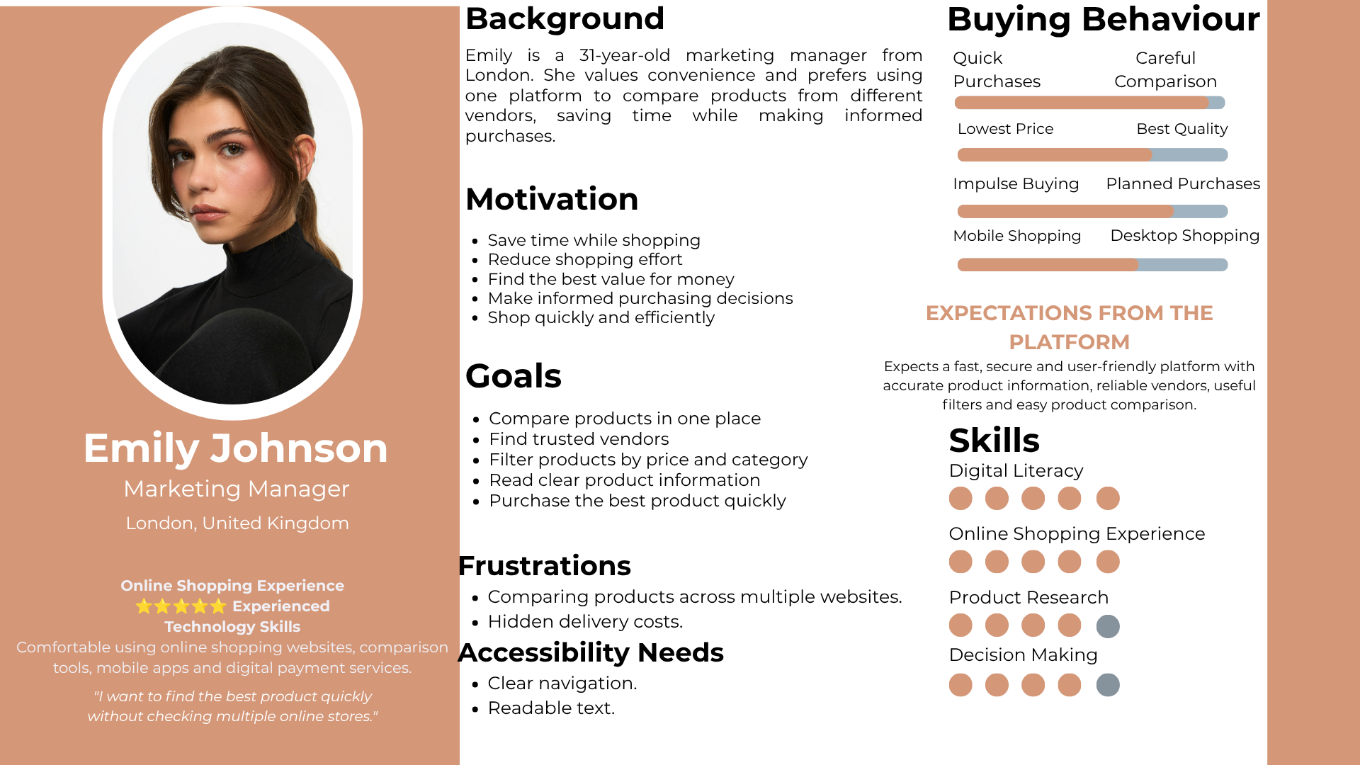
Figure B1. Original supplied persona. The underlying research, image provenance and any consent details should be confirmed by the team.

Appendix B — Persona 2: Samir Hadid
Budget-conscious student; price transparency, filtering and value comparison. Source: report/Persona 2.png. Supplied design persona, not an identified research participant.
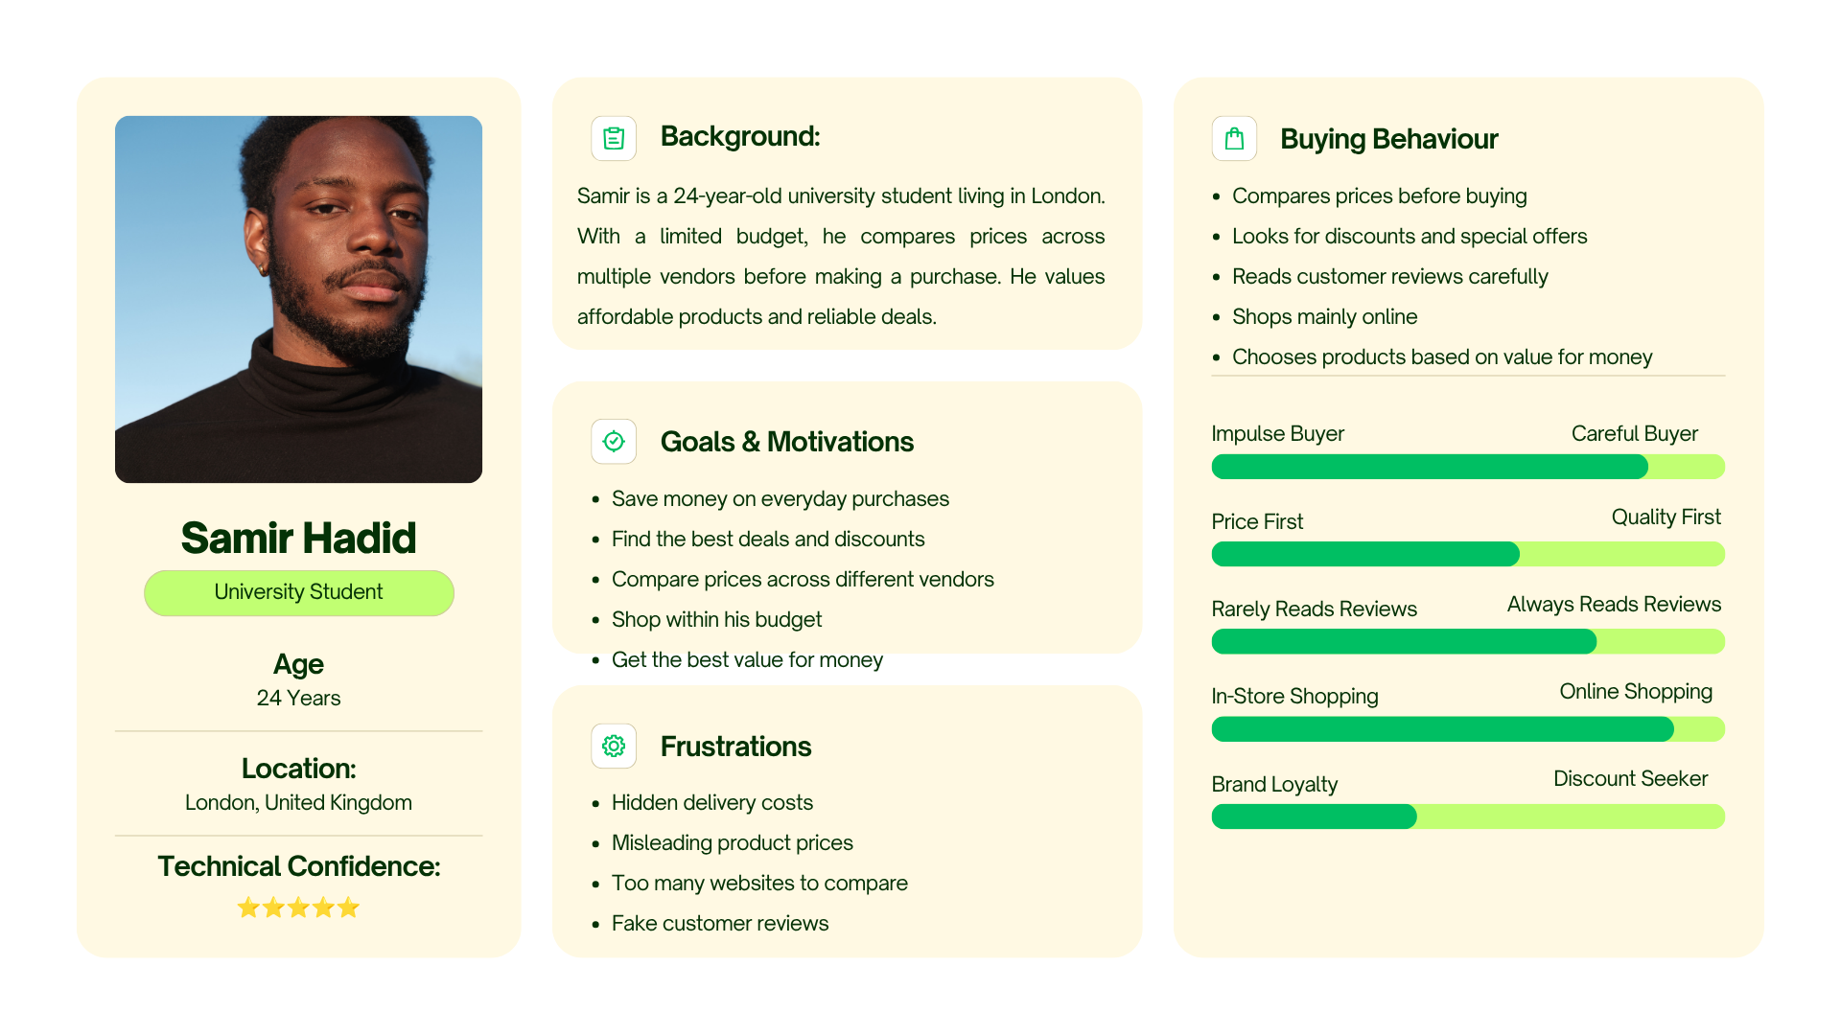
Figure B2. Original supplied persona. The underlying research, image provenance and any consent details should be confirmed by the team.

Appendix B — Persona 3: Victoria Henderson
Quality-focused shopper; detailed information and trustworthy vendor context. Source: report/Persona 3.png. Supplied design persona, not an identified research participant.
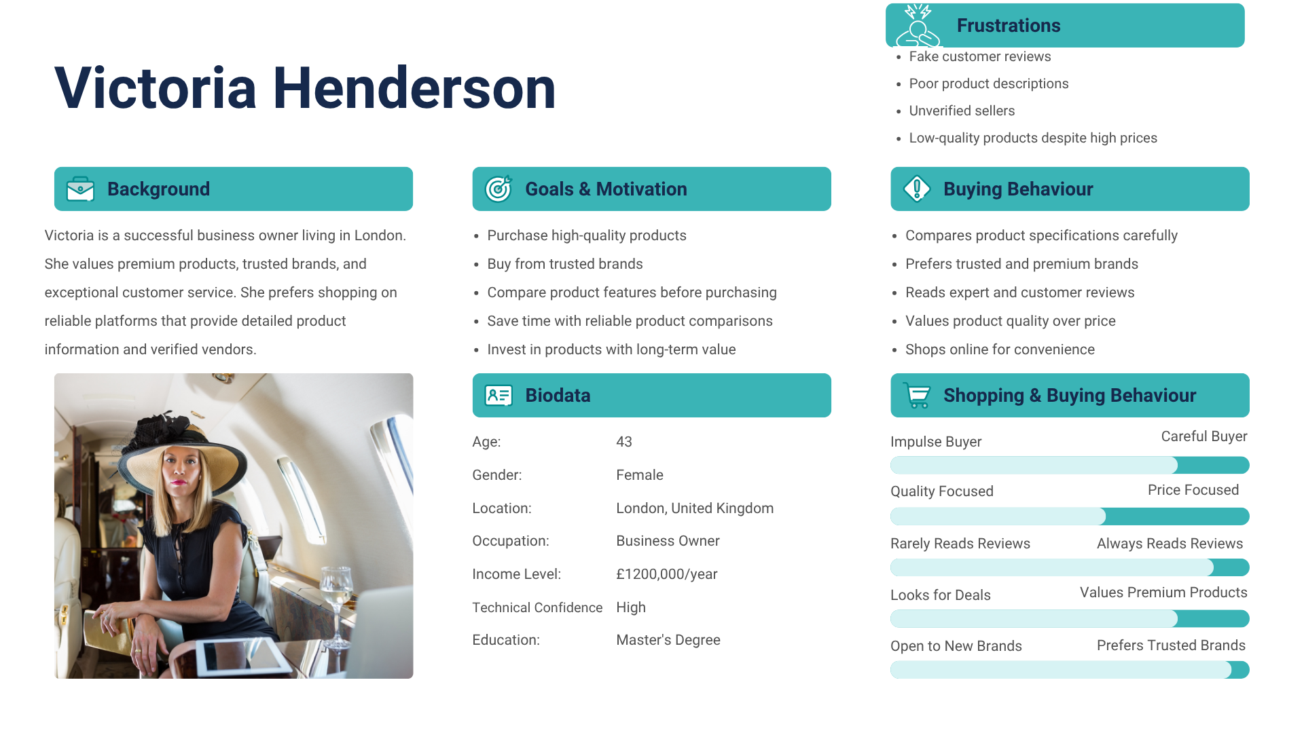
Figure B3. Original supplied persona. The underlying research, image provenance and any consent details should be confirmed by the team.

Appendix C — Low-fidelity wireframes
Seven supplied wireframes cover the original page structure. The admin screen includes the product form; the combined login/register design was later split into two application routes. These are design artefacts, not screenshots of the deployed site.
File | Screen
01_homepage.png | Homepage
02_product_listing.png | Product listing
03_product_detail.png | Product detail
04_vendor_profile.png | Vendor profile
05_admin_dashboard.png | Admin dashboard / product form
06_login_register.png | Login/register
07_mobile_listing.png | Mobile listing
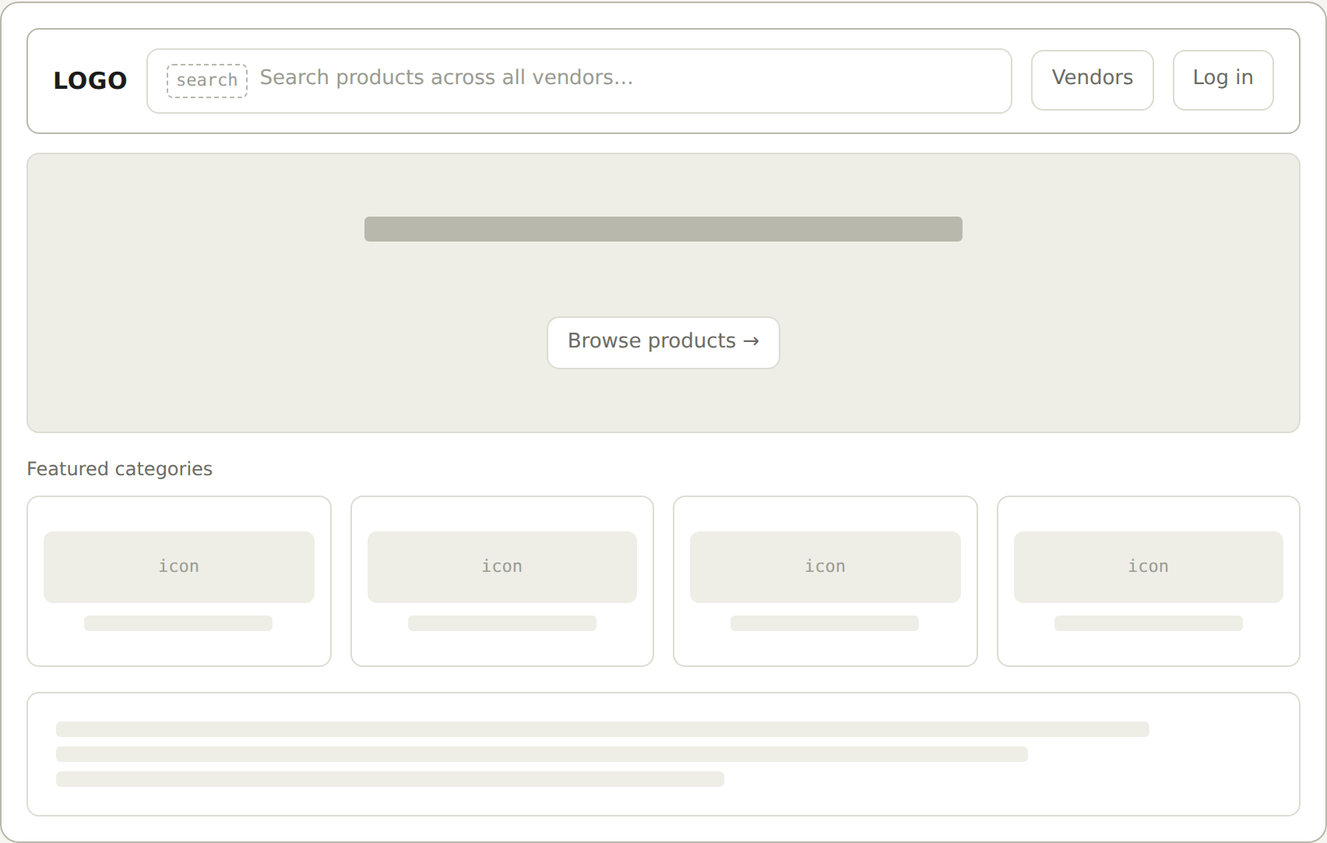
Figure C1. Homepage wireframe. Source: report/wireframes/01_homepage.png

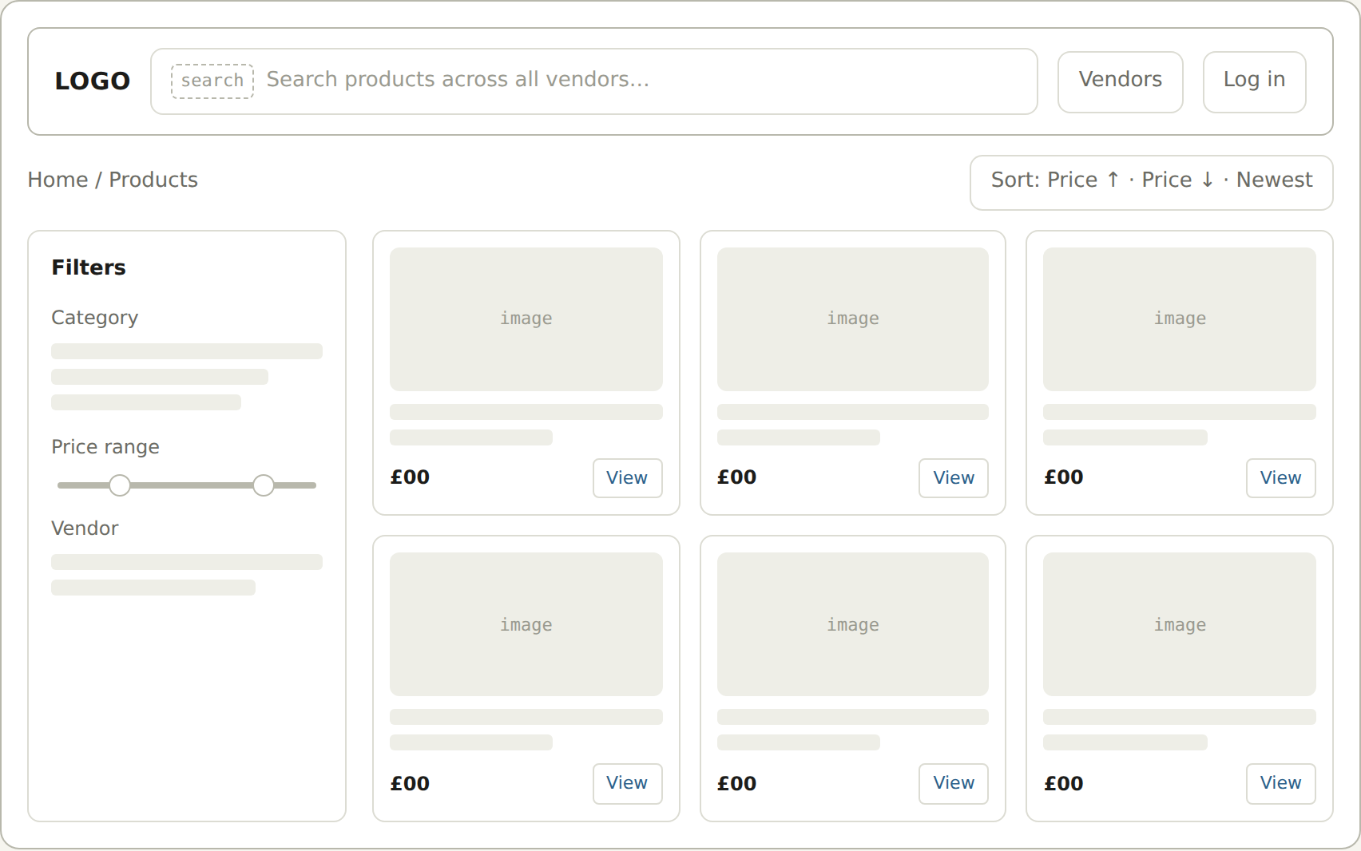
Figure C2. 02_product_listing.png. Supplied low-fidelity design.
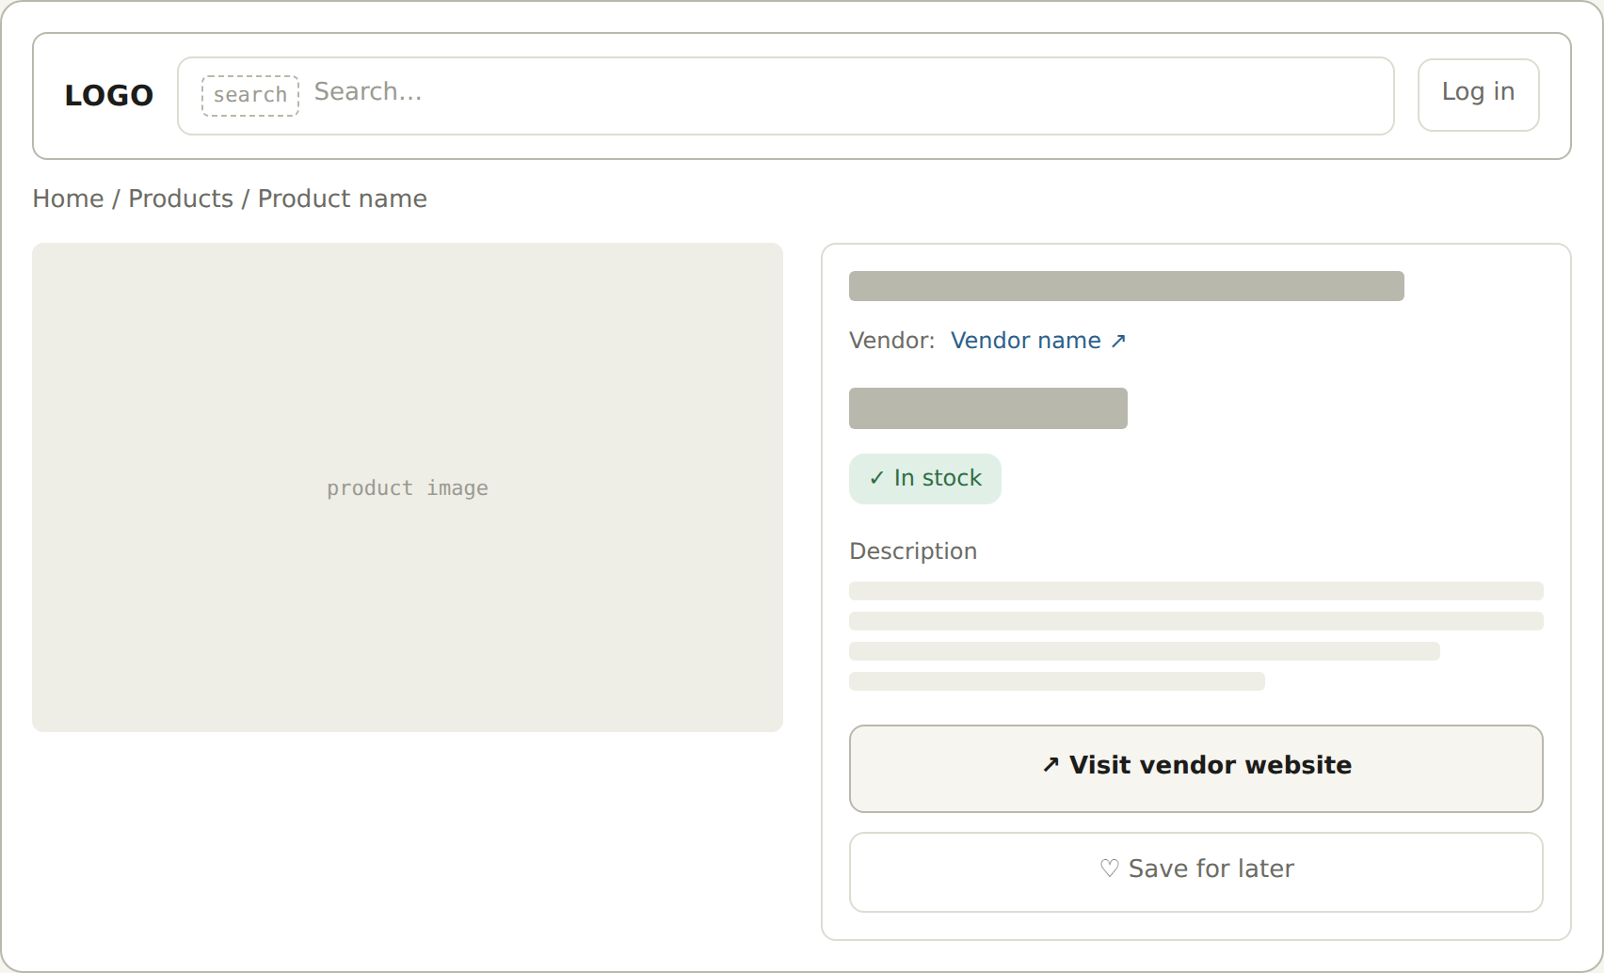
Figure C3. 03_product_detail.png. Supplied low-fidelity design.

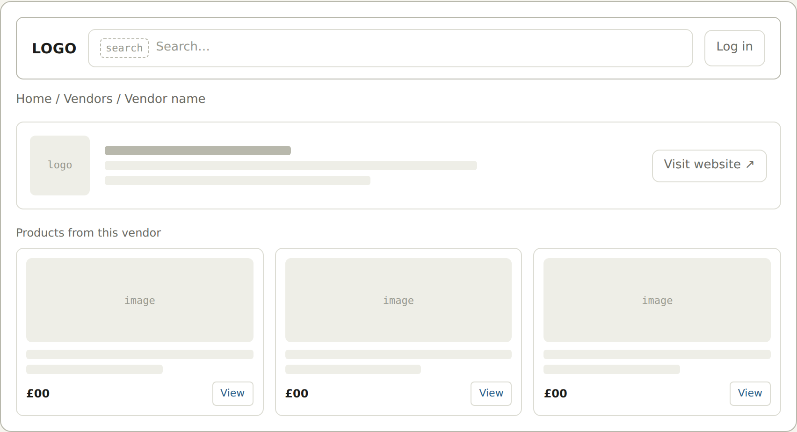
Figure C4. 04_vendor_profile.png. Supplied low-fidelity design.
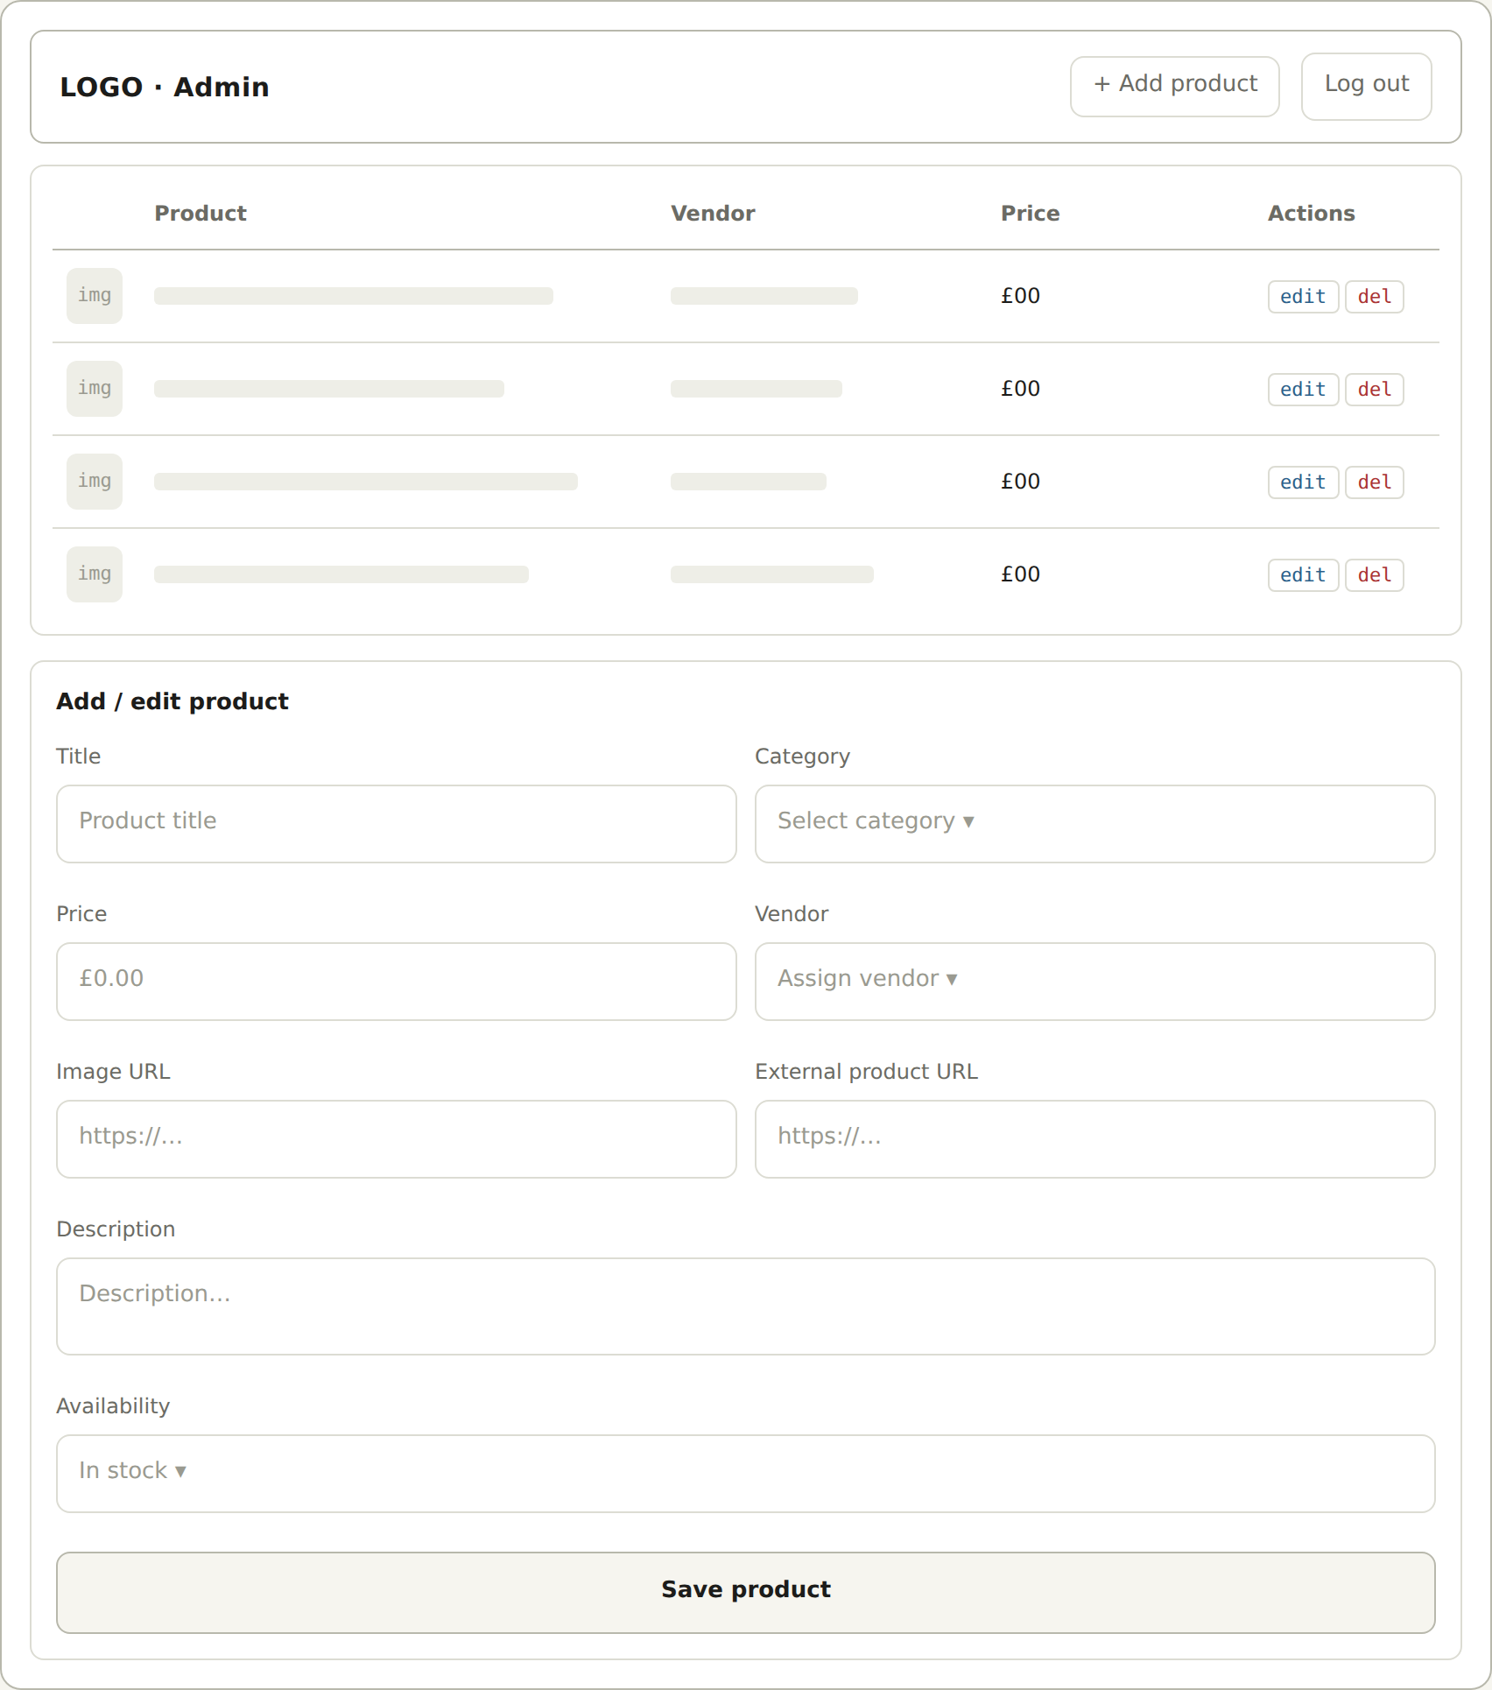
Figure C5. 05_admin_dashboard.png. Supplied low-fidelity design.

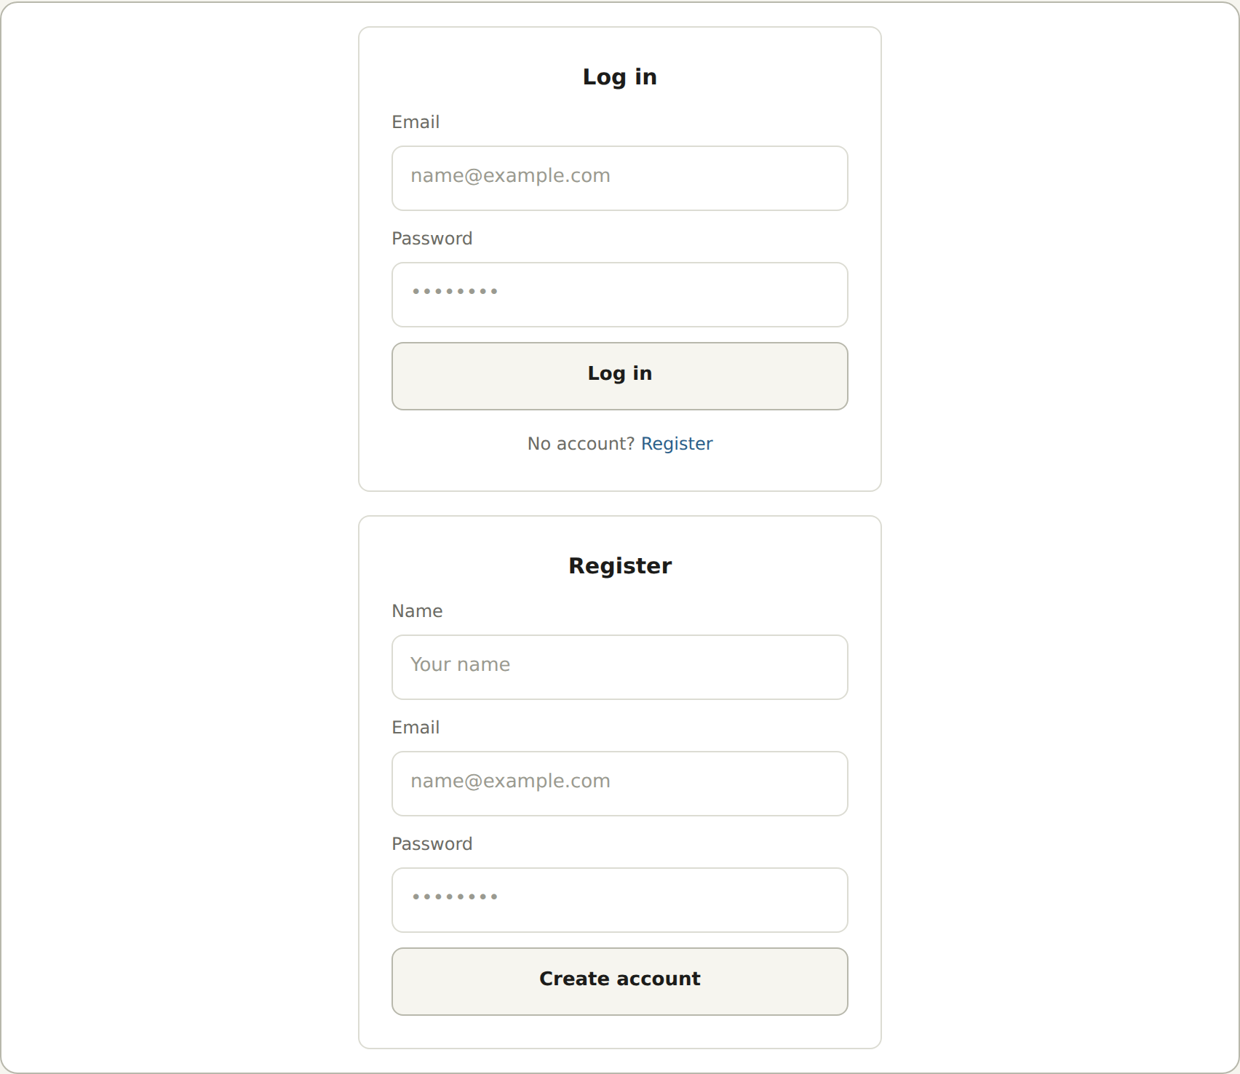
Figure C6. 06_login_register.png. Supplied low-fidelity design.

C7. Mobile product-listing wireframe
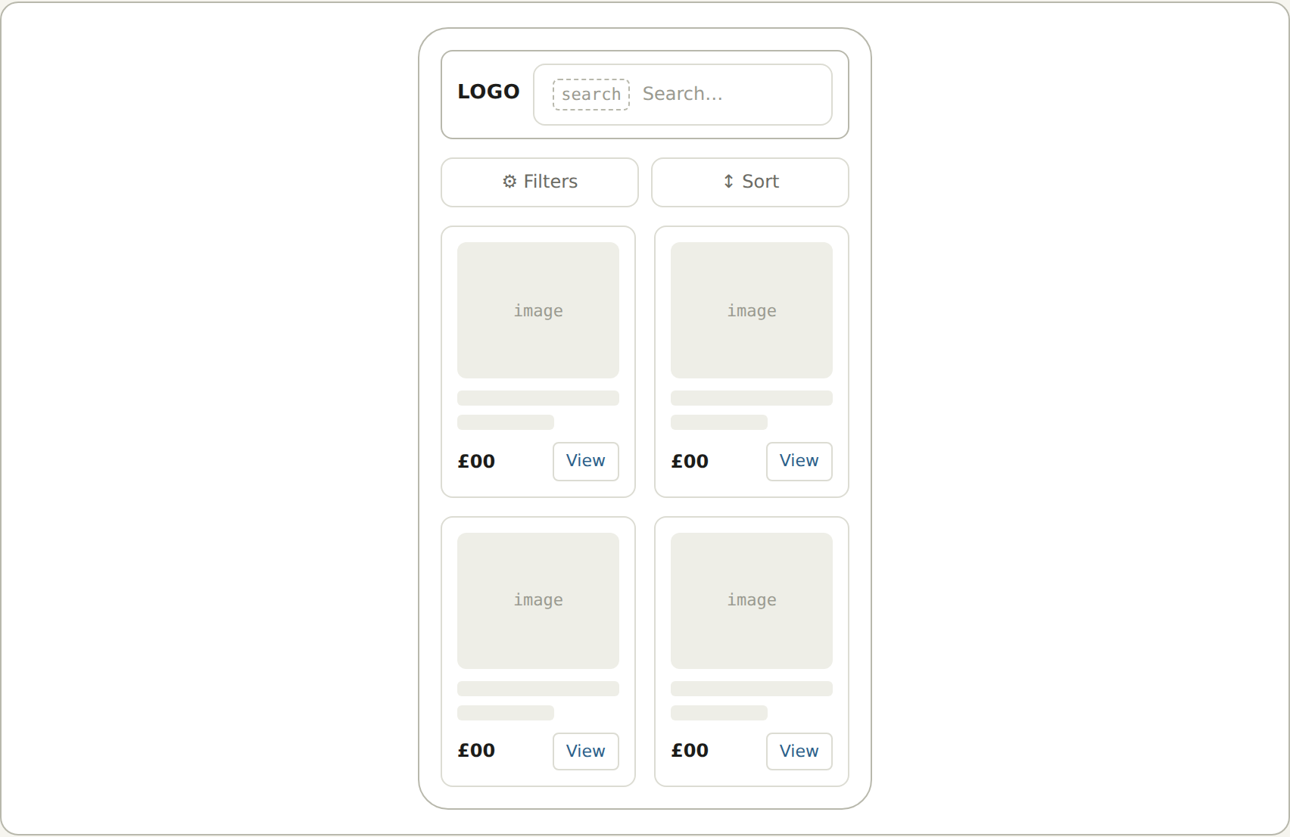
Figure C7. Mobile discovery layout. Source: report/wireframes/07_mobile_listing.png

Appendix D — High-fidelity mockups
Source: San’s high-fidelity specification (5 July 2026) and its nine PNG screens. The desktop set covers six screens; the mobile set covers the homepage, listing and detail journey. These show design intent, including placeholder imagery and the pre-brand LOGO label.
File | Variant
01_Homepage_Desktop.png | Desktop
02_ProductListing_Desktop.png | Desktop
03_ProductDetails_Desktop.png | Desktop
04_VendorPage_Desktop.png | Desktop
05_AdminDashboard_Desktop.png | Desktop
06_LoginRegister_Desktop.png | Desktop
07_Homepage_Mobile.png | Mobile
08_ProductListing_Mobile.png | Mobile
09_ProductDetails_Mobile.png | Mobile
The specification and style guide are retained in High-Fidelity Mockup/. Section 10 discusses differences between the intended design and actual implementation.

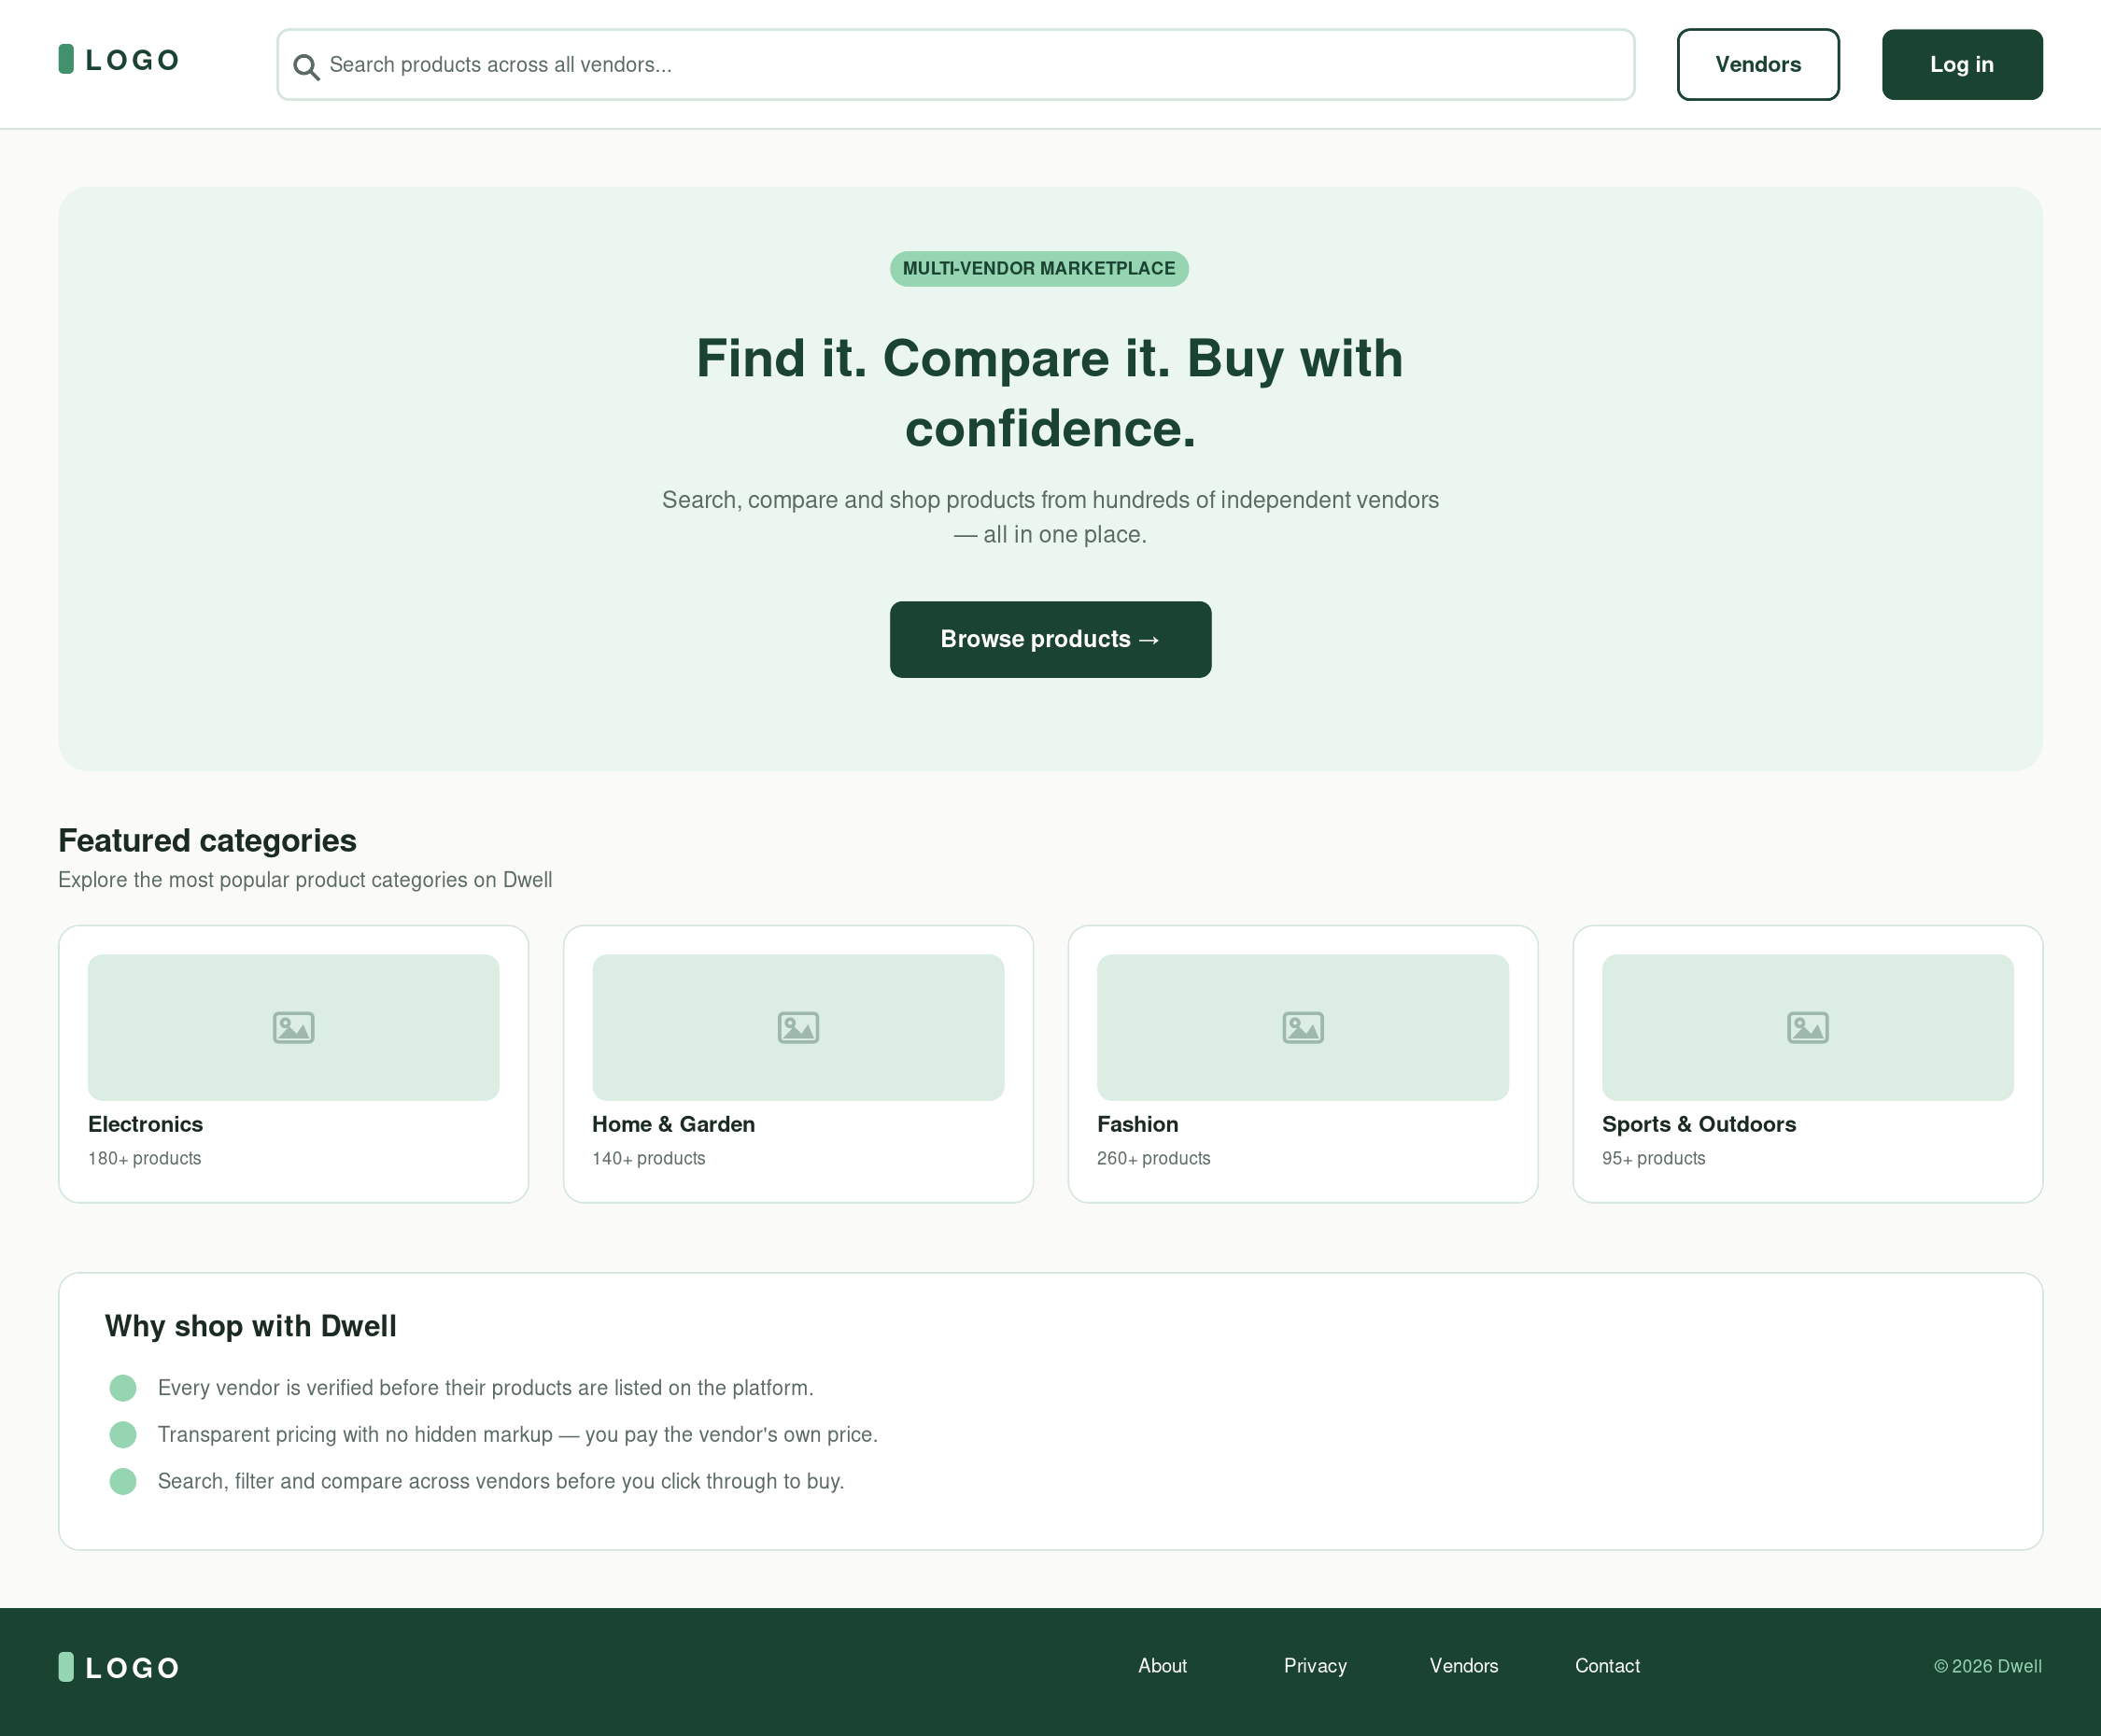
Figure D1. 01_Homepage_Desktop.png. Original high-fidelity design.
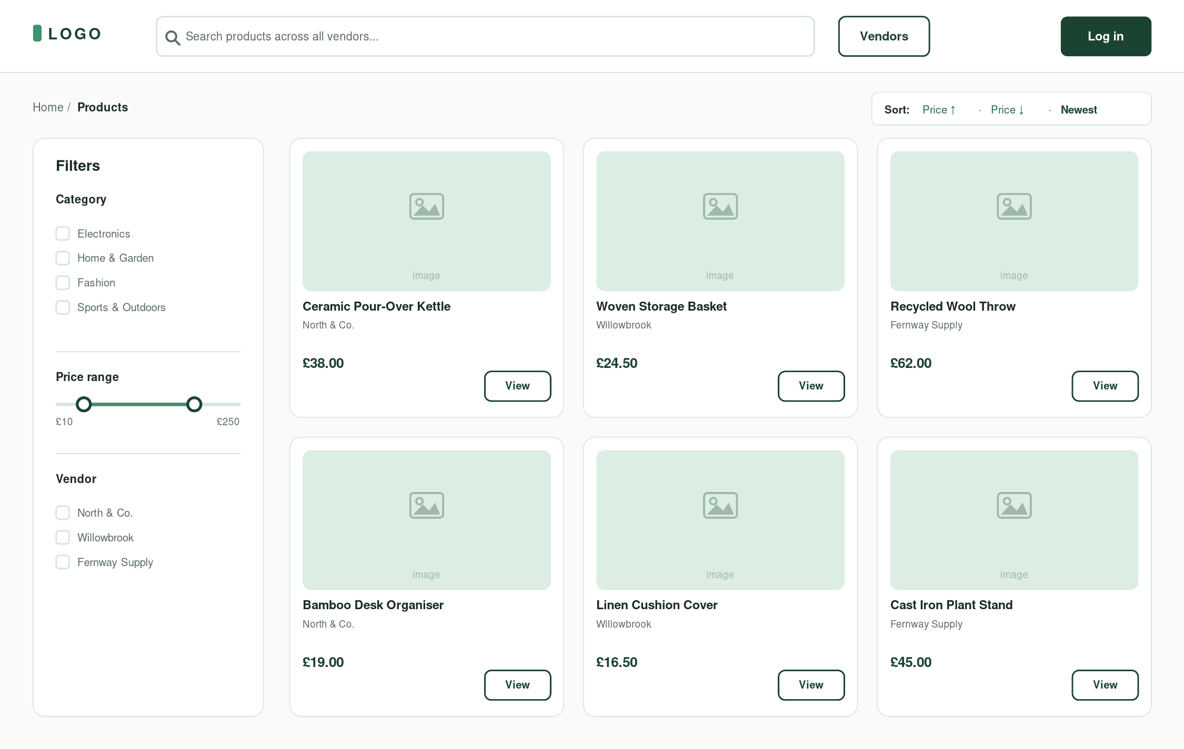
Figure D2. 02_ProductListing_Desktop.png. Original high-fidelity design.

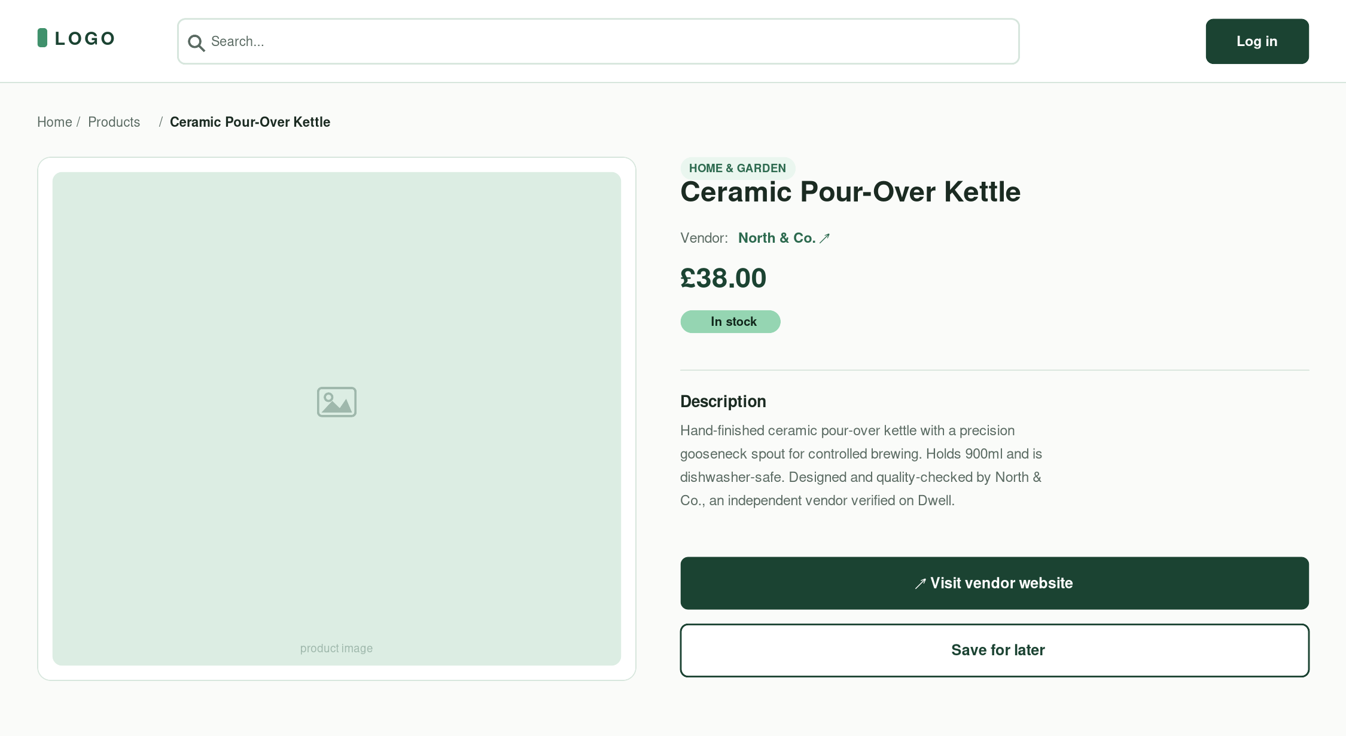
Figure D3. 03_ProductDetails_Desktop.png. Original high-fidelity design.
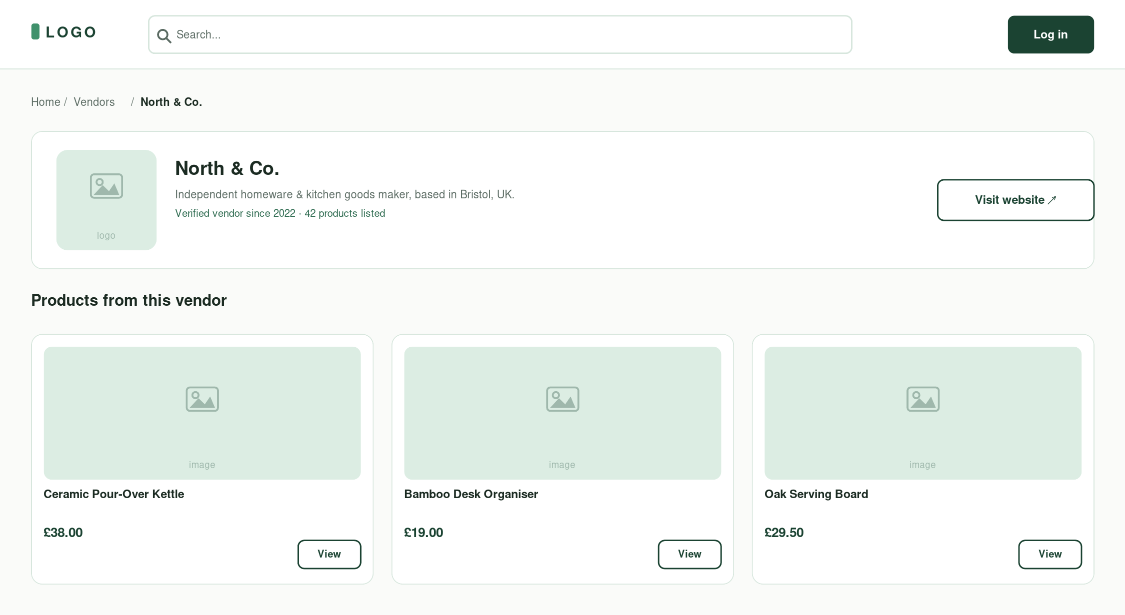
Figure D4. 04_VendorPage_Desktop.png. Original high-fidelity design.

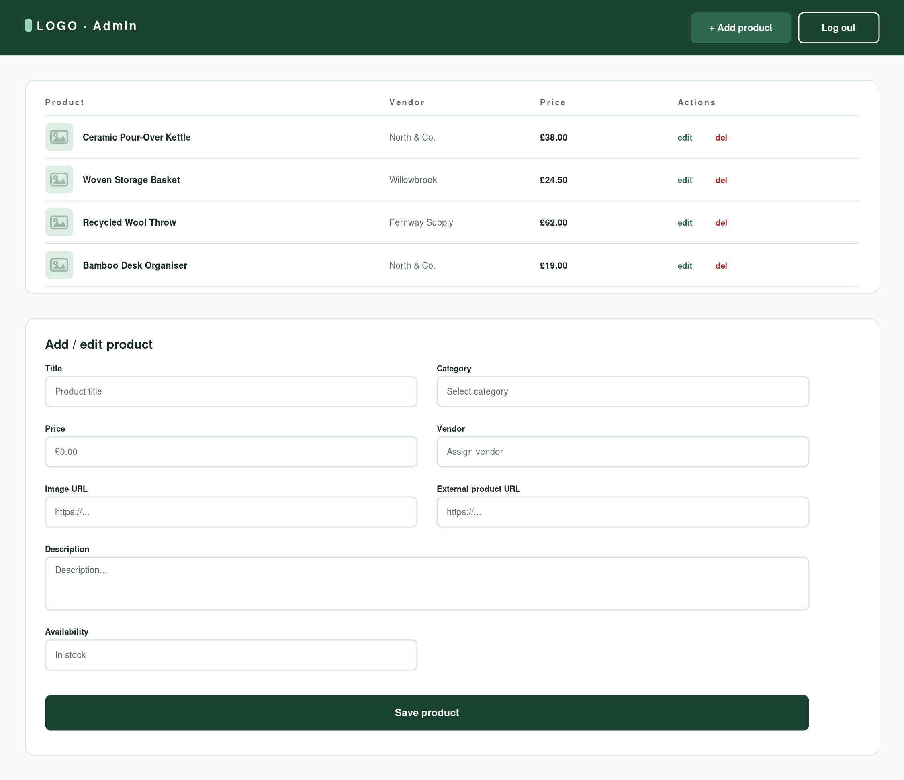
Figure D5. 05_AdminDashboard_Desktop.png. Original high-fidelity design.
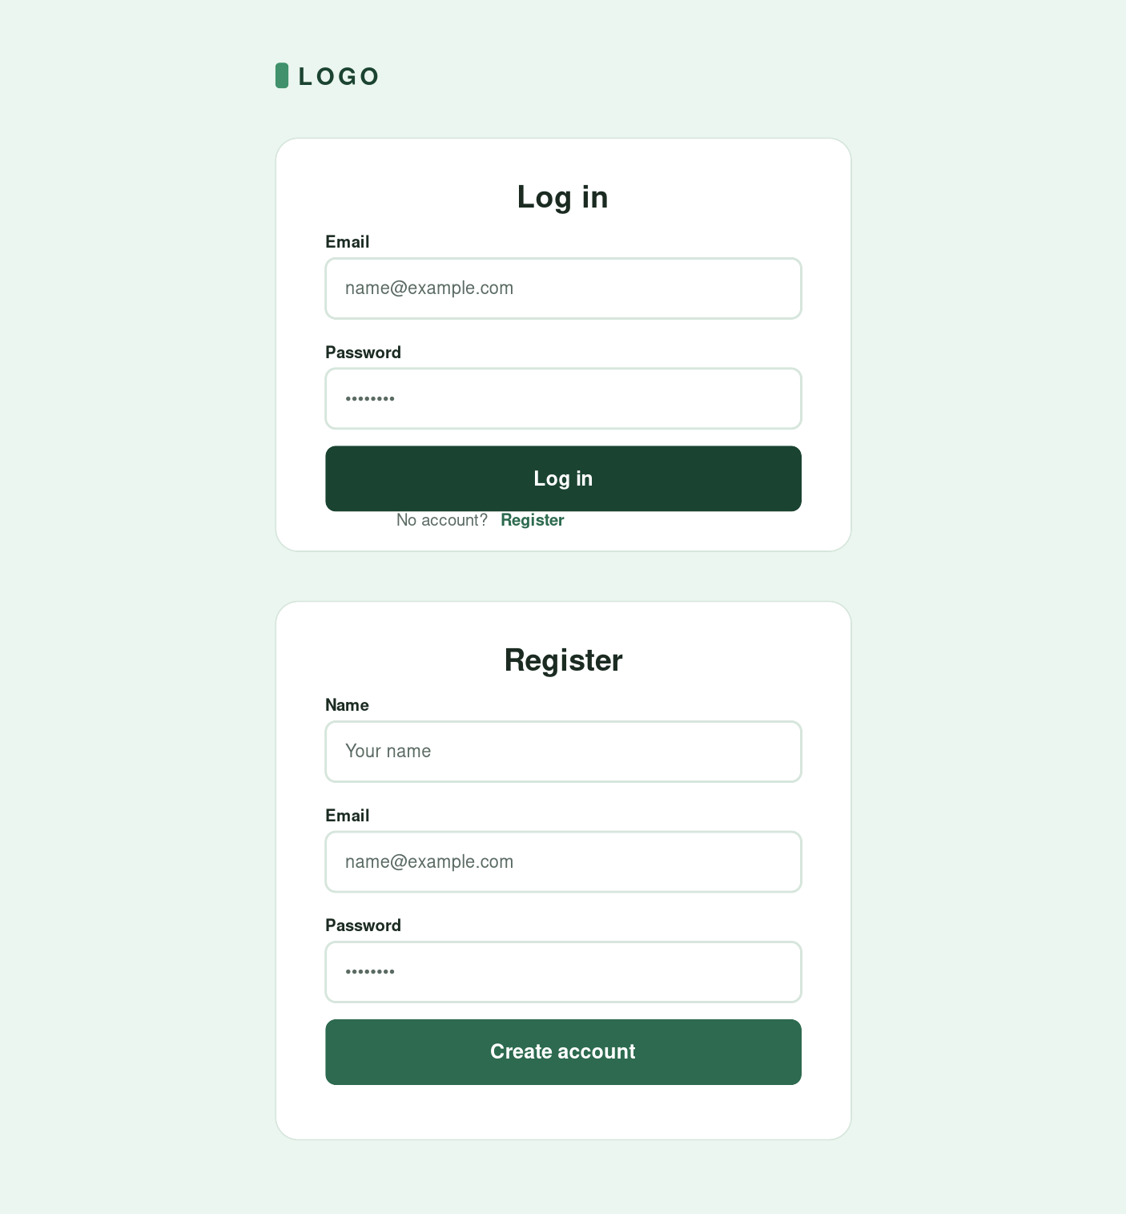
Figure D6. 06_LoginRegister_Desktop.png. Original high-fidelity design.

D7–D9. Mobile mockups
Homepage, product listing and product details, in that order. Source files 07_Homepage_Mobile.png, 08_ProductListing_Mobile.png and 09_ProductDetails_Mobile.png.
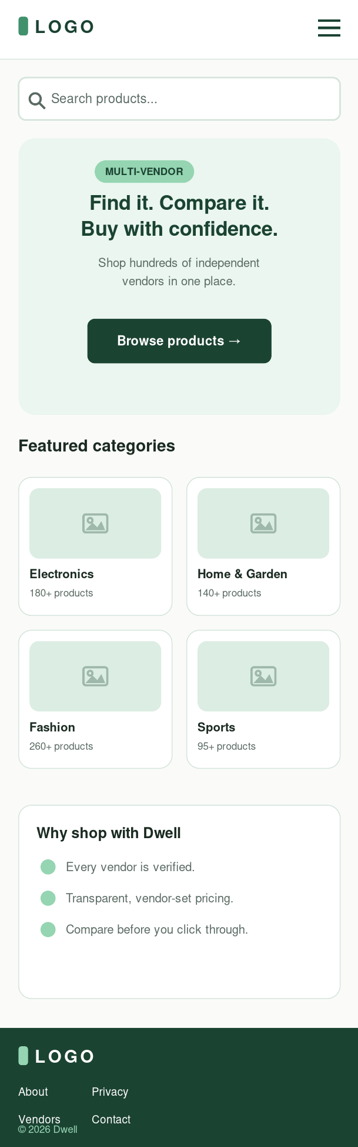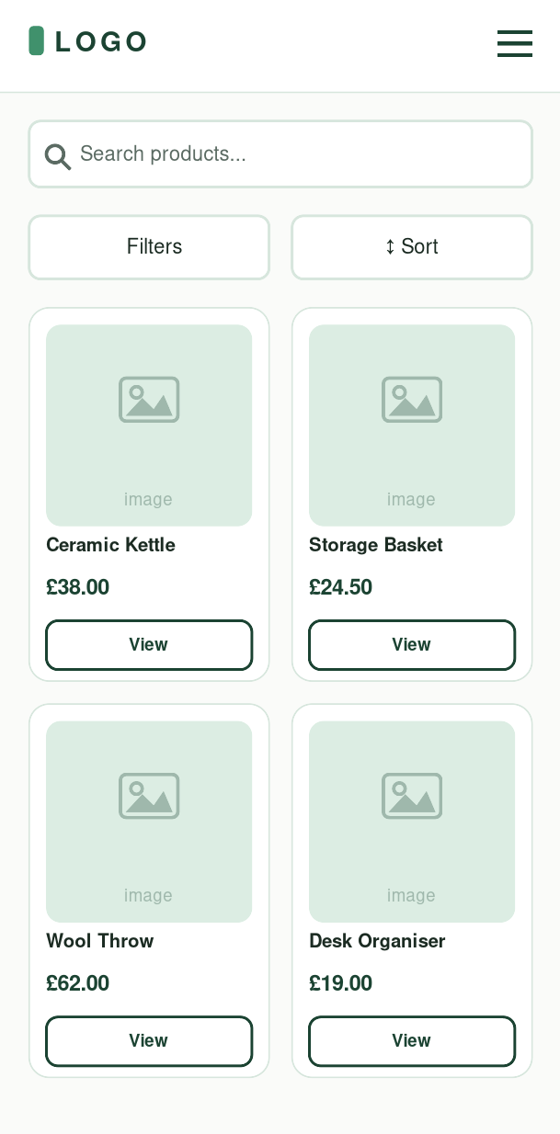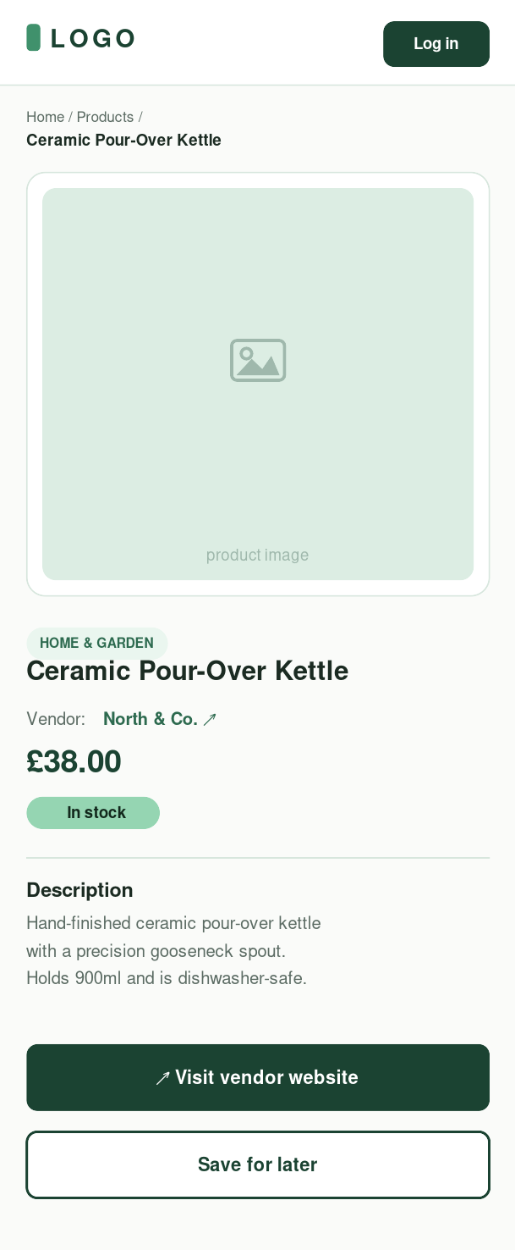
Figures D7–D9. Original mobile designs; not participant test records.

Appendix E — Entity relationship diagram
Actual PostgreSQL table/column names, keys and relationships from api/prisma/schema.prisma. The original PNG is 3600 × 2240 pixels; generated with npm run docs:erd.
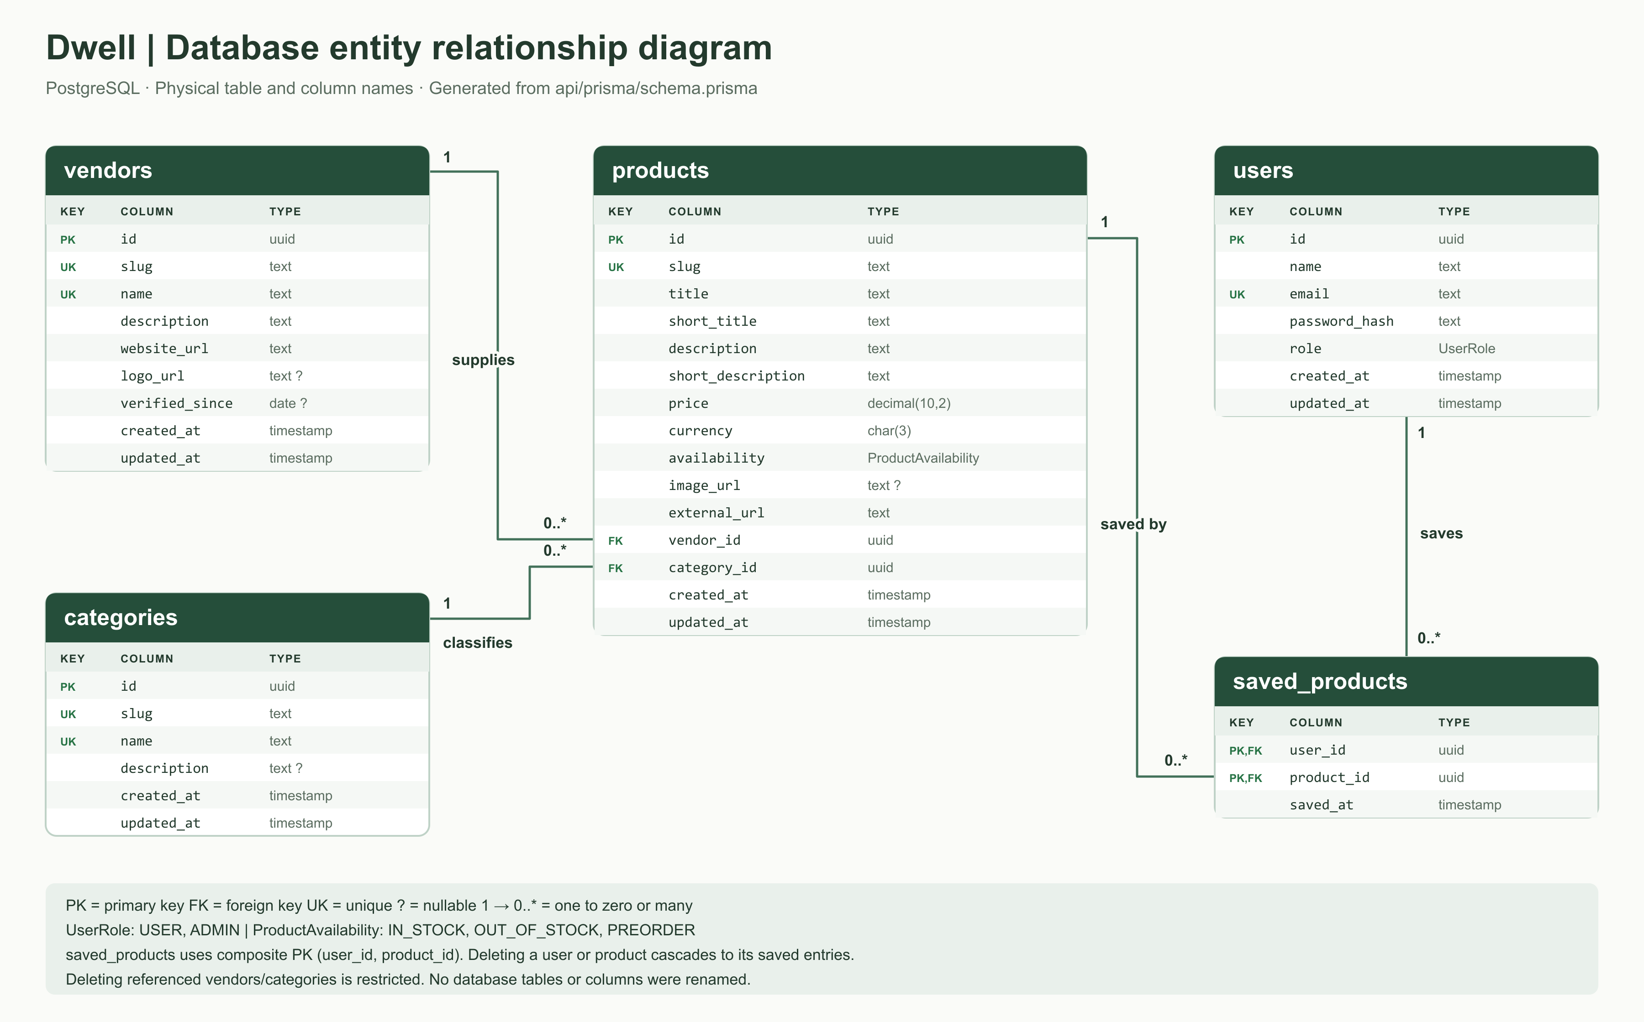
Figure E1. Dwell relational schema. Source: docs/database-erd.png. Names were retained; Prisma maps application properties to the SQL columns.

Appendix F — Implementation screenshots
F1–F5 were captured from the public deployed site on 11 September 2026 at a 1440 × 1000 desktop viewport. These are viewport captures, not full-page exports. F6–F8 use a 375 × 812 mobile viewport. No live accounts or products were changed for these report captures.
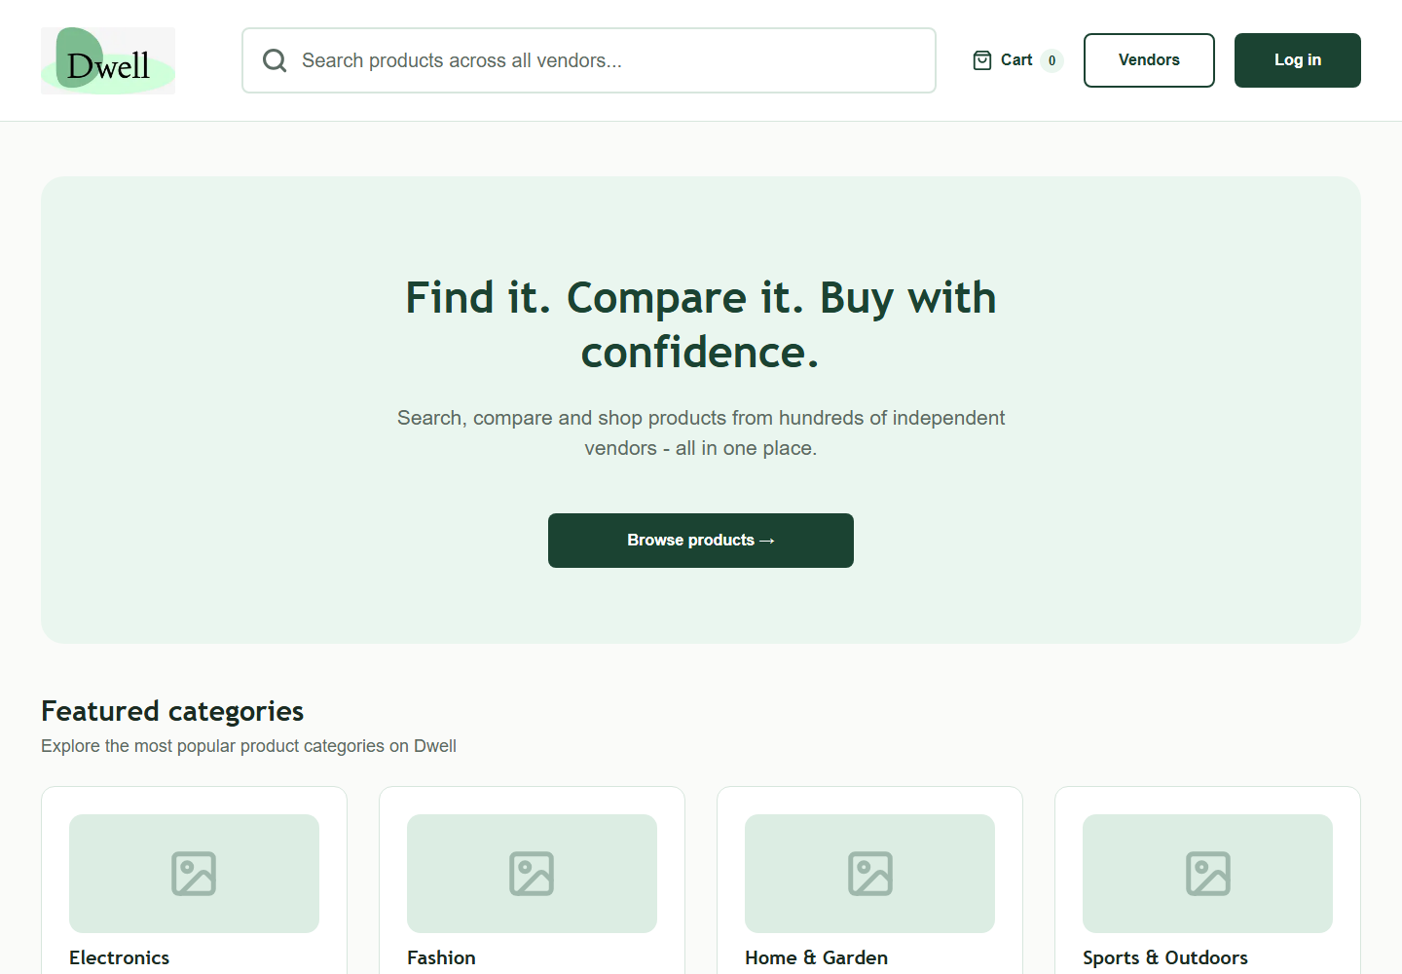
Figure F1. Live homepage, including Dwell branding and primary discovery entry.

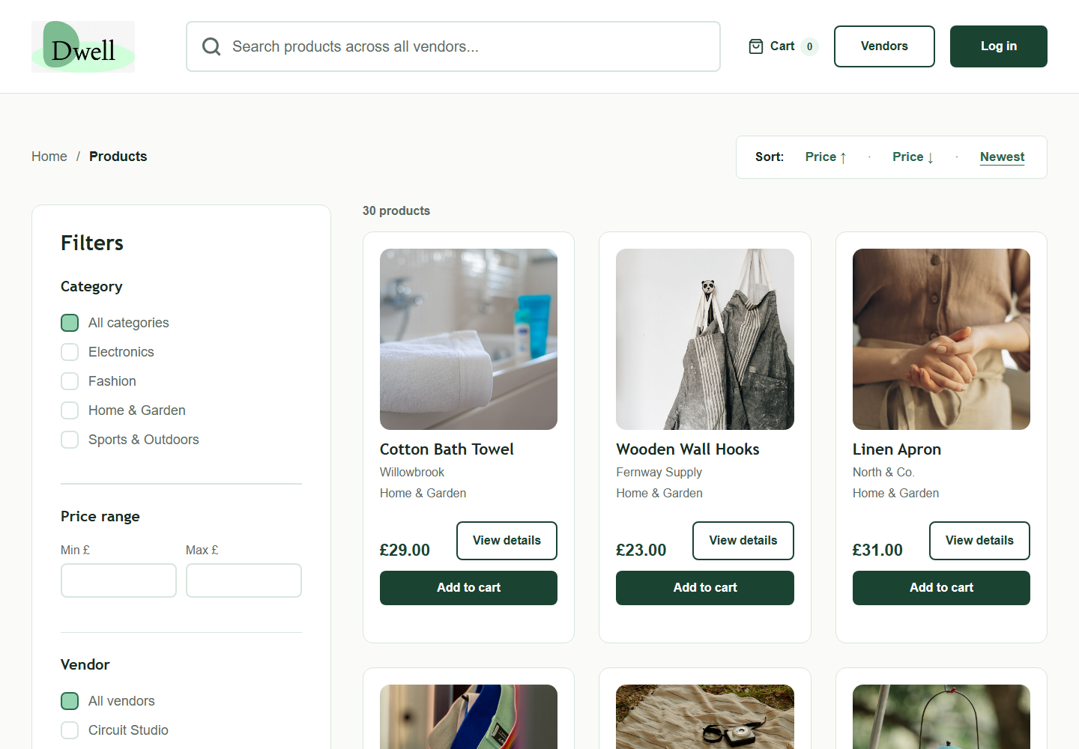
Figure F2. Live Catalogue with seeded product photography. Source: public Dwell site, 11 September 2026.
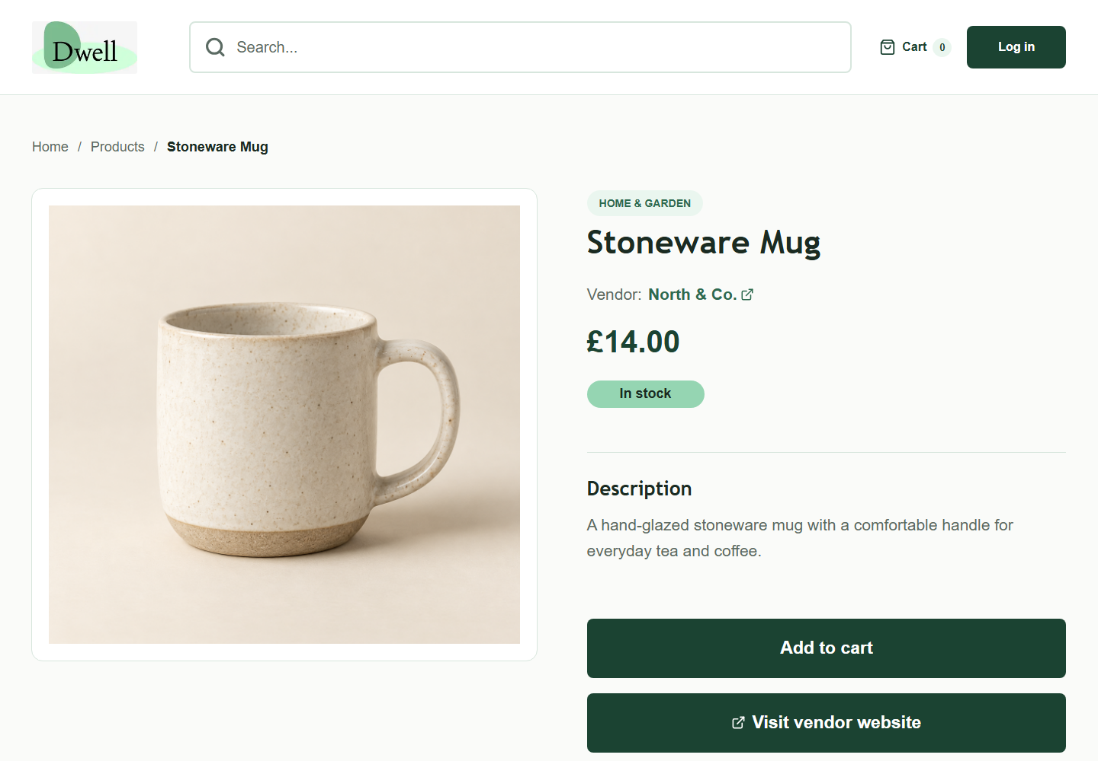
Figure F3. Live Stoneware Mug product detail. Source: public Dwell site, 11 September 2026.

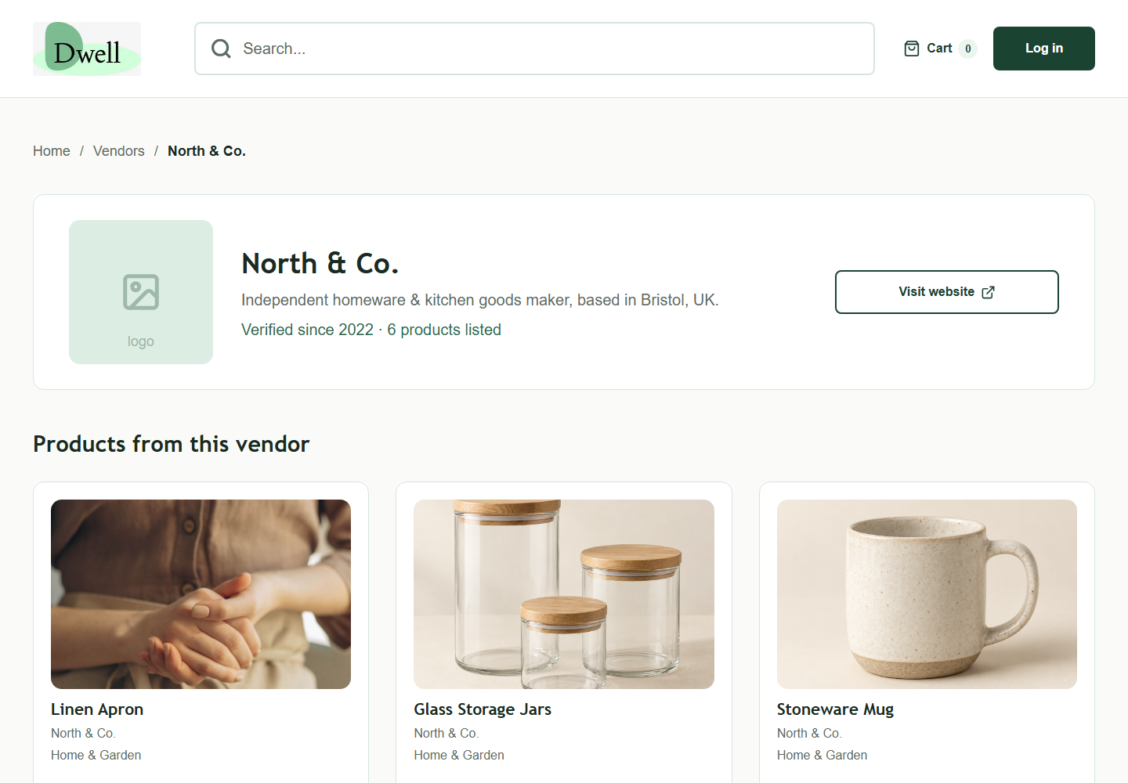
Figure F4. Live North & Co. vendor profile. Source: public Dwell site, 11 September 2026.
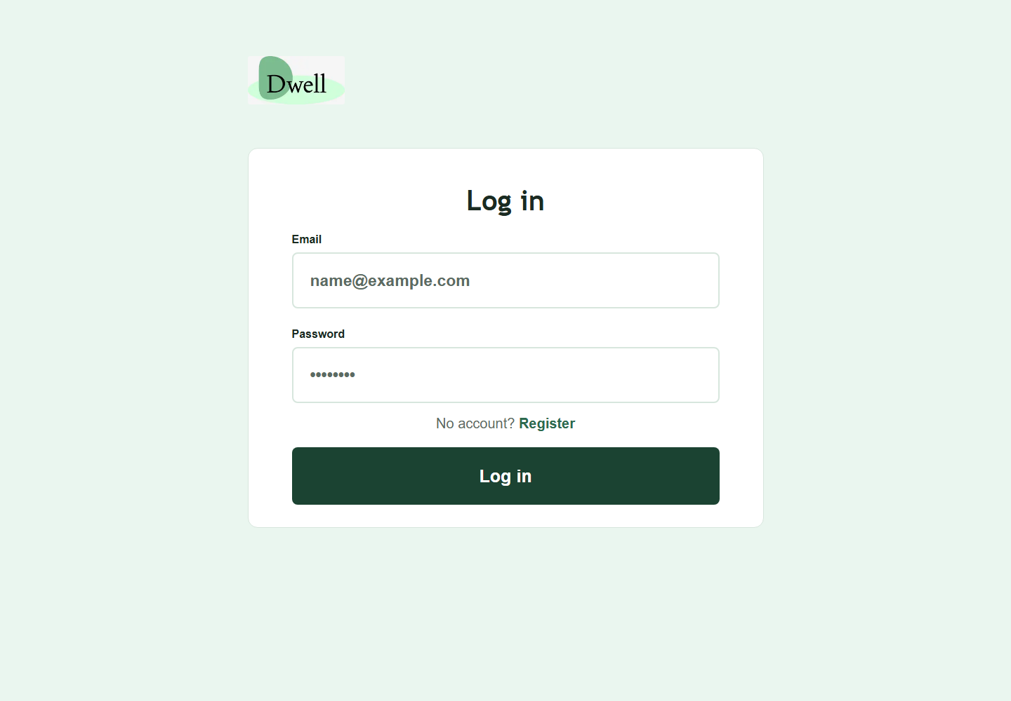
Figure F5. Live Login form. Source: public Dwell site, 11 September 2026.

F6–F8. Current mobile pages
Homepage, catalogue and product detail, respectively. The capture checks found no page-level horizontal overflow at 375 pixels; this is not a full accessibility audit.
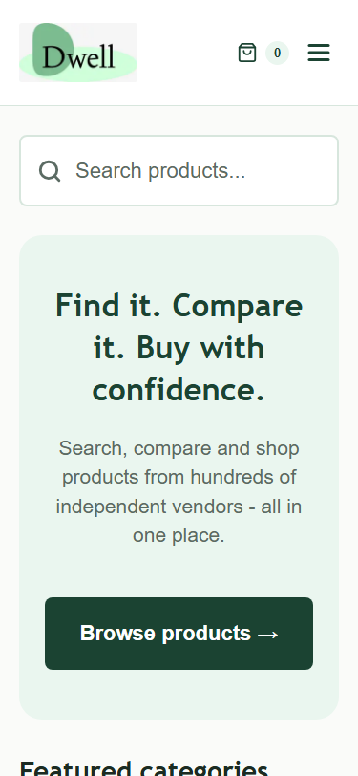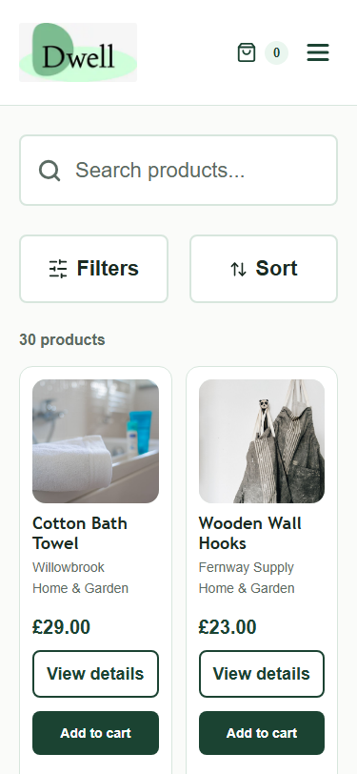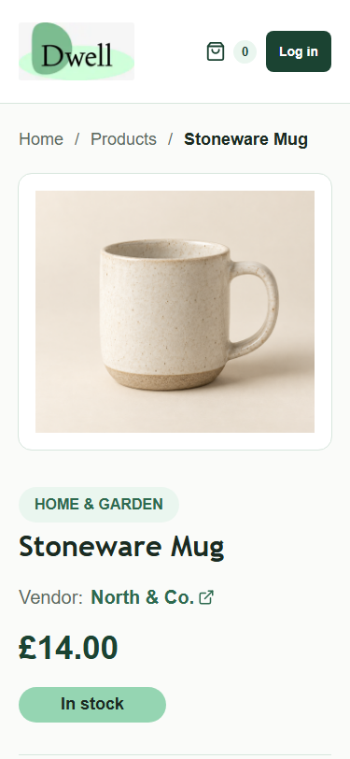
Figures F6–F8. Live mobile viewport captures, 11 September 2026.

F9–F10. Controlled browser-test evidence
The following images come from automated fixture-based browser checks, not from human usability sessions and not from live administrator transactions. Product names and credentials shown are test fixtures.
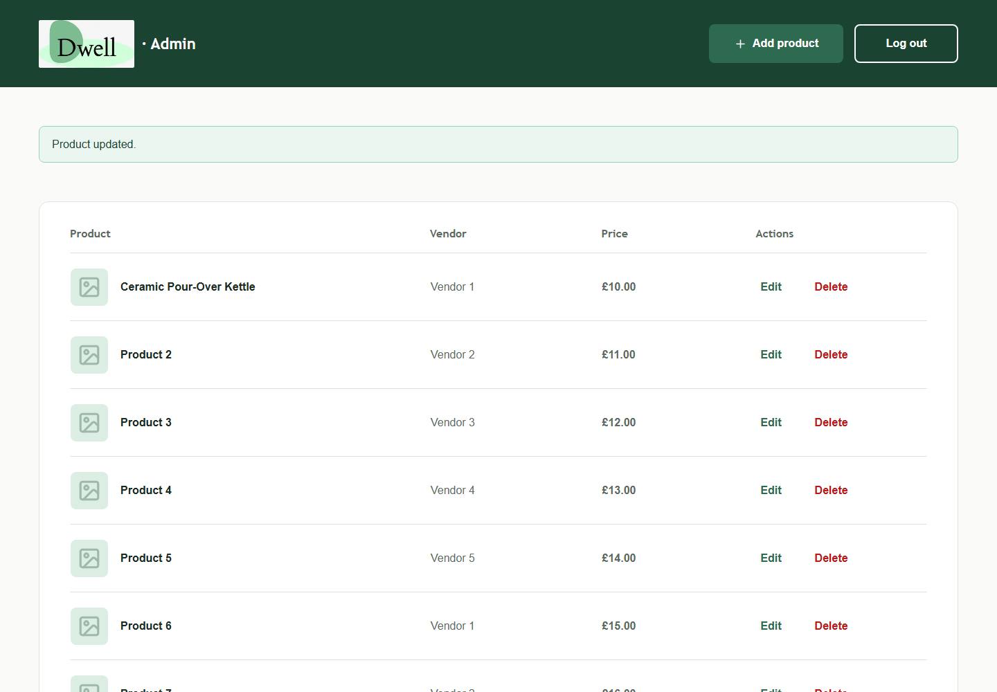
Figure F9. Admin table after controlled create/edit interaction. Source: tmp/marketplace-qa/admin-desktop.png. Top 1000-pixel viewport excerpt, cropped for readability.
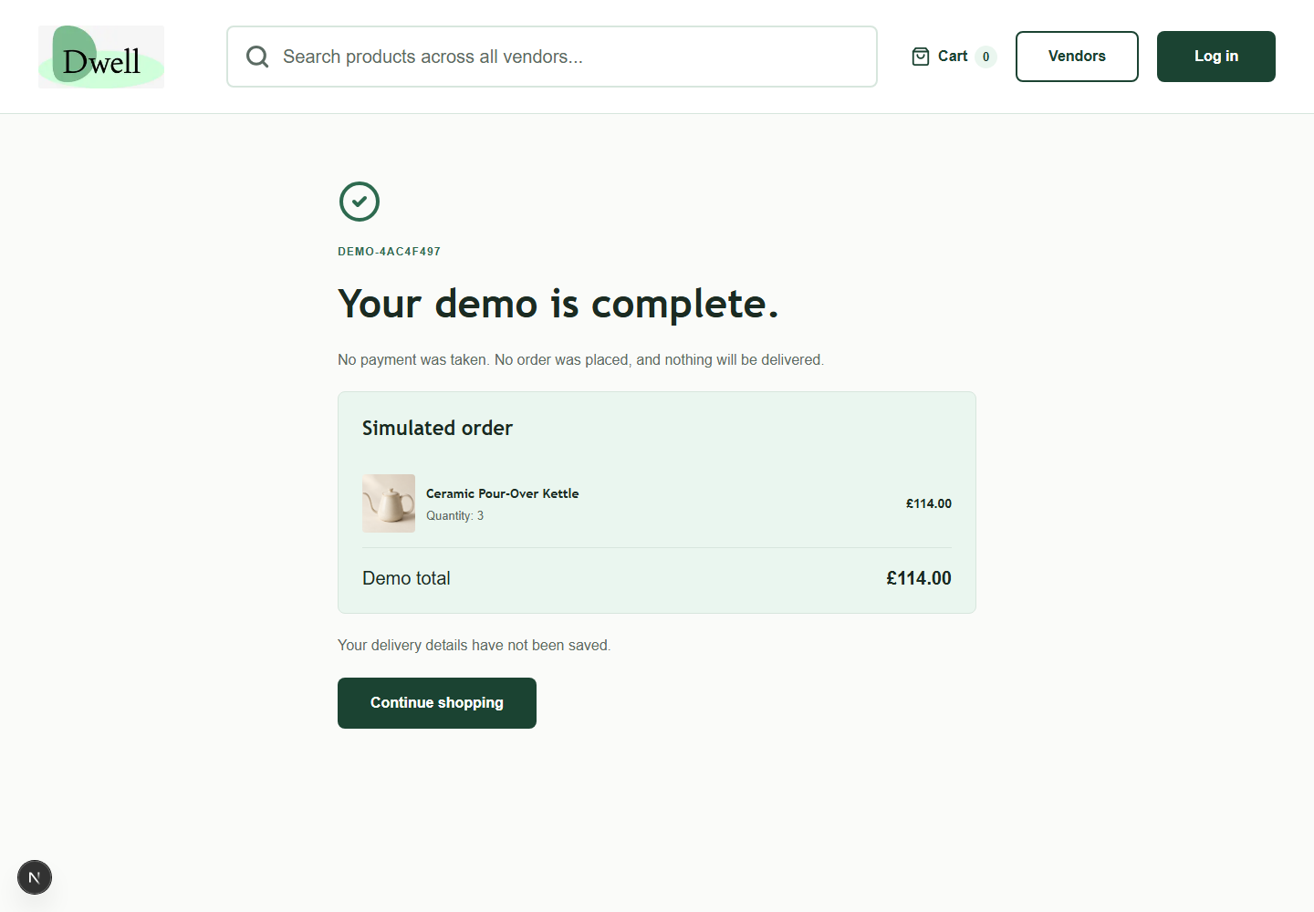
Figure F10. Simulated checkout receipt in the browser regression. No payment or order is created. Source: tmp/shopping-qa/receipt-desktop.png.

Appendix G — Evidence and asset register
G1. Current catalogue summary
Read-only API capture: 2026-09-11T10:22:19.246Z. Product total: 30; vendors: 5; categories: 4. The counts describe demonstration records, not survey respondents or commercial partners.
Category | Product count
Electronics | 6
Fashion | 5
Home & Garden | 13
Sports & Outdoors | 6

Vendor | Product count
Circuit Studio | 6
Fernway Supply | 5
North & Co. | 6
Trail & Tide | 6
Willowbrook | 7
The original seed classifies Recycled Wool Throw under Fashion. Counts reflect the data as implemented rather than an assumed reclassification.

G2. Reproduction and test boundaries
Command / file | Meaning
npm test (root) | 8 cart/asset tests; Node test runner.
npm test (api) | 39 HTTP checks; Vitest and Supertest.
npm run build (root); API typecheck/build | Compilation/type verification.
api/tests/verify-linux.mjs | Creates/removes a uniquely named temporary PostgreSQL database; never point integration tests at the production database.
npm run test:browser | Fixture-backed UI flows against a running frontend; generates screenshots.
docs/verification.md | Consolidated release evidence and reproduction instructions.
npm run docs:erd | Render schema-derived SVG and PNG.

G3. Source and evidence register
Evidence | Location / use in this report
Original brief | Root PDF; identical copy also supplied under report/. Requirements baseline.
Research inputs | competitor_analysis.docx and report/Persona 1–3.png; no survey answers supplied.
Design assets | report/wireframes/ and High-Fidelity Mockup/; appendices C/D.
Data/API implementation | api/prisma/, api/src/, api/README.md.
Frontend implementation | app/, components/, lib/ and next.config.ts.
Quality evidence | tests/, api/tests/, api/src/*.test.ts and docs/verification.md.
Historical plans | docs/superpowers/plans/ dated 25 August, 6 September and 10 September. Plans are not completion evidence on their own.
Image provenance | public/images/products/README.md and stock-sources.json.
Deployment release | 8fba4fd; source/database backup at /var/backups/dwell-images-fZwjWr.
Report captures | Embedded public captures collected on 11 September; screenshot provenance in Appendix F.
Source review excluded generated dependencies, build caches, private environment contents and unrelated server applications. Historical prototype data in lib/data.ts remains as a shopping-test fixture; the live pages use the API. Existing plans and documentation were checked against current code rather than treated as automatically current.

G4. Outstanding assessment evidence
Required evidence | Completion entry
Survey results and method | [INSERT original questionnaire, valid sample and analysis.]
At least ten interviews / approved substitute | [INSERT evidence or written approval.]
At least five task-test users | [INSERT actual session results; no data fabricated.]
Final demo video / presentation | [INSERT link and date.]
Approved timeline / team contribution | [INSERT targets, identities and sign-off.]
Accessibility test record | [INSERT manual findings and completed checklist.]

G5. Product-image provenance
Nineteen product images are generated illustrations (the original seven plus twelve additions); eleven are downloaded stock photographs. Generation prompts are preserved in public/images/products/README.md. The source URLs below reproduce the reviewed stock manifest; photos may differ from the fictional product’s specific materials or branding.
organic-cotton-tee — Pexels / Daniel & Hannah Snipes
Original photo — https://www.pexels.com/photo/minimalist-fashion-flat-lay-of-white-t-shirt-37704838/
knitted-beanie — Pexels
Original photo — https://www.pexels.com/photo/black-knit-hat-with-chopsticks-on-wooden-suface-14769575/
recycled-daypack — Pexels
Original photo — https://www.pexels.com/photo/a-black-backpack-on-white-surface-13869858/
insulated-water-bottle — Pexels
Original photo — https://www.pexels.com/photo/silver-bottle-on-gray-surface-2832062/
cork-yoga-mat — Pexels
Original photo — https://www.pexels.com/photo/close-up-photo-of-a-rolled-yoga-mat-4028197/
camping-lantern — Pexels
Original photo — https://www.pexels.com/photo/retro-paraffin-lamp-hanging-in-forest-in-sunlight-6271359/
picnic-blanket — Pexels / Darina Belonogova
Original photo — https://www.pexels.com/photo/food-and-camera-lying-on-a-picnic-blanket-8764275/
resistance-band-set — Unsplash / Russell Moore
Original photo — https://unsplash.com/photos/resistance-bands-with-rainbow-stripes-hang-4KX0FQqOGl4
linen-apron — Pexels / Ron Lach
Original photo — https://www.pexels.com/photo/person-with-hands-together-8180080/
wooden-wall-hooks — Pexels / Elina Nova
Original photo — https://www.pexels.com/photo/two-aprons-hanging-on-a-wall-13797005/
cotton-bath-towel — Pexels / Castorly Stock
Original photo — https://www.pexels.com/photo/a-folded-white-bath-towel-on-bathtub-rim-4404976/
License references: https://www.pexels.com/license/ and https://unsplash.com/license. Download URLs and any subject notes are retained in stock-sources.json. Product photos are local assets, not hotlinked. The team should confirm rights/provenance for the separately supplied persona and branding imagery before redistribution.

Appendix H — AI Usage Declaration
DRAFT DECLARATION — Review against your university’s AI policy, amend to reflect each member’s actual use, and sign before submission.
AI assistance was used during the Dwell project and in preparing this report. The declaration below distinguishes tool assistance from human research and responsibility. It is not a claim that all work was completed without assistance.
Use | Declared assistance / boundary
Software development and review | OpenAI Codex assisted with examining requirements, implementing and refining application/API behaviour, testing, documentation, seed safety and deployment tasks in the recorded workflow. Team members must verify their own contribution and understanding.
Product imagery | OpenAI image generation produced 19 illustrative catalogue assets in total. Prompts/provenance are recorded in public/images/products/README.md. Eleven other assets were sourced from Pexels/Unsplash as recorded in stock-sources.json.
ER diagram | The diagram was rendered programmatically from the actual Prisma schema into SVG/PNG; it was not inferred from an imagined database.
Report preparation | Codex assisted with reading project files, extracting PRD/design-document content, structuring and drafting this report, checking references, capturing public-page evidence and generating the .docx.
Research and evaluation | AI did not conduct the owner’s survey, supply respondents, invent interview quotations or manufacture five-user usability results. Those data remain to be inserted by the team.
Source verification | Implementation claims were checked against code, documents, tests and recorded deployment evidence. External guidance is cited separately. Remaining gaps and uncertainty are explicitly identified.
Human review declaration to complete: “We have reviewed the report and the AI-assisted project outputs, checked factual claims and references, confirmed permissions for included material, and can explain the design and implementation. We have added only genuine research and contribution evidence. We accept responsibility for the submitted work and have disclosed AI use in accordance with our institution’s requirements.”
Completion item | Entry
Tool/model details required by university | OpenAI Codex; image generation. [INSERT any additional tools/model details actually used.]
Member name and student ID | [INSERT for every contributing member]
Individual scope of AI use | [INSERT each member’s own declaration]
Review date / signatures | [INSERT]
Tutor/policy reference | [INSERT applicable module/university guidance]
No university logo or signature has been fabricated. The cover page and research placeholders remain deliberately incomplete for the project owner to finish.

