https://encycolorpedia.com/

The color **emerald** with hexadecimal color code **#50c878** is a shade of **green-cyan**. In the RGB color model #50c878 is comprised of 31.37% red, 78.43% green and 47.06% blue. In the HSL color space #50c878 has a hue of 140° (degrees), 52% saturation and 55% lightness. This color has an approximate wavelength of 537.77 nm.

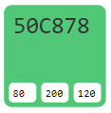

The color **imperial red** with hexadecimal color code **#ed2939** is a shade of **pink-red**. In the RGB color model #ed2939 is comprised of 92.94% red, 16.08% green and 22.35% blue. In the HSL color space #ed2939 has a hue of 355° (degrees), 84% saturation and 55% lightness. This color has an approximate wavelength of 616.22 nm.

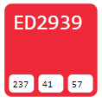

The color **emerald green** with hexadecimal color code **#046307** is a dark shade of **green**. In the RGB color model #046307 is comprised of 1.57% red, 38.82% green and 2.75% blue. In the HSL color space #046307 has a hue of 122° (degrees), 92% saturation and 20% lightness. This color has an approximate wavelength of 548.87 nm.

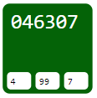

https://hexcolor.co

**Color spaces of #beffc2 Snowy Mint - RGB(190, 255, 194)**

Provide color information and color scheme for #beffc2. #beffc2 is the hex color code that is a variation of "Snowy Mint" because of their close resemblance. The hexadecimal triplet #beffc2 definition is: Red = 190, Green = 255, Blue = 194 or CMYK: Cyan = 0.25490196078431, Magenta = 0, Yellow = 0.23921568627451, Black = 0.

