Instrukcja ustawiania uprawnień bazy danych:
If you opt to use this method, you need to take into consideration that everytime you add a new database, you will need to go and configure the permissions for that database. It can become quite a tedious process if you need to configure permissions for databases on a weekly basis.
- Open SQL Server Management Studio (shortcut: Start -> Run -> ssms)
- Connect when prompted.
- Expand Security and then expand Logins.
- If you don't have the network service listed (should be NT AUTHORITY\NETWORK SERVICE):
  - Right-click on the Logins folder and select New Login.
  - At the top, in the 'Login Name' field, enter NETWORK SERVICE. If it refuses to accept that, try entering NT AUTHORITY\NETWORK SERVICE (Remember to set “windows authentication”, not SQL Server Authentication).
  - Now select the Server Roles tab on the left.
  - You can tick any role you like, but for me I will give it 'public' access.
  - Now select the User Mapping tab on the left.
  - Tick all the databases you want to allow this service account to access.
  - In the Schema column for each selected database, set the value to dbo (or whatever schema you are using in your database).
  - Then, select one database row at a time and set the following permissions for it:
    - db_datareader
    - db_datawriter
    - public
  - Now click OK.
- If you do have the network service account listed, edit that login entry and then follow steps (5 - 9) above.
That's it for the engine-level. You still need to add the service account to each and every database that you have selected initially as in step 6 above. So:
- Expand Databases on the left.
- Expand the Security folder and then expand Users.
- The service account should be listed there. Right-click and Properties on the service account (for us, NT AUTHORITY\NETWORK SERVICE).
- Select the Securables tab on the left.
- Click on the Search button.
  - Select 'Specific Objects' and click OK.
  - Now click the Object Types button.
  - Scroll down and tick Schemas. Click OK.
  - In the textbox below, enter the schema you are giving access for (the same as Step 7 above). In our case, it will be dbo. Click OK.
  - At the bottom, select all the permissions you want to give for that database. In my case, I need quite extensive access to my database so I will be selecting these permissions:
    - Alter
    - Control
    - Create Sequence
    - Delete
    - Execute
    - Insert
    - References
    - Select
    - Update
- Now click OK.
Repeat the above steps for each and every database that you have selected.

Problemy są jeszcze ze skonfigurowaniem połączenia pomiędzy IIS i bazą danych. Pokazuje się błąd, że nie ma dostępu na bazę, bo login failed for user: WORKGROUP\DESKTOP-STQ4I44$. Należy więc utworzyć użytkownika o nazwie DESKTOP-STQ4I44$ (pamiętaj, że ta nazwa wynika z twojej nazwy serwera – sprawdzasz ją we właściwościach serwera – na samej górze zakreślone na niebiesko – PPM → właściwości), nazwa serwera została zakreślona na żółto:
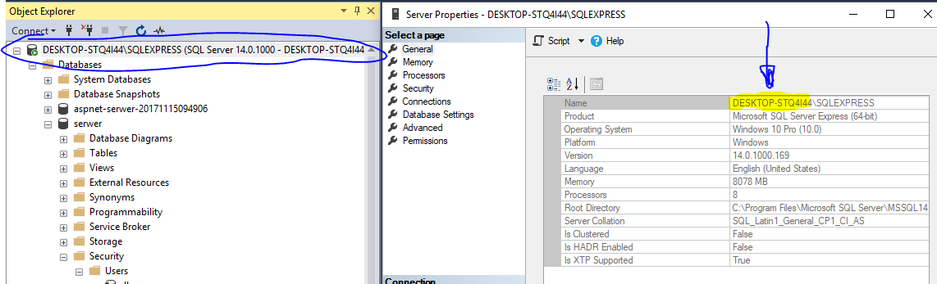

oraz nadać mu odpowiednie uprawnienia: Alter, Control, Create Sequence, Delete, Execute, Insert, References, Select, Update

Przy dodawaniu użytkownika należy pamiętać o tym, że należy go przypisać do loginu “NT AUTHORITY\SYSTEM”, domyślnym schemacie (najlepiej dbo):
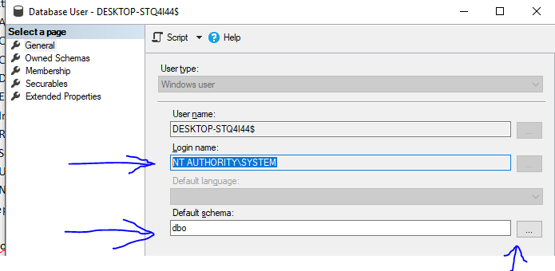
Dodatkowo sprawdź, czy w zakładce “Securables” masz odpowiednio ustawiony wpis “Securables” oraz uprawnienia (czyli wspomniane wcześniej: Alter, Control, Create Sequence, Delete, Execute, Insert, References, Select, Update zakreślone na niebiesko):

