Semester project 2

# introduction

In this report I will explain why I made the choices I did when creating the game. I will write about the interpretation of the task, design and sketches, illustration and icons and the visual choices I did. Later I will discuss and write about my work process, including the user testing I did. At last I will write about my reflections about the project and list all my references.

## Link to github repo AND THE GAME:

**GITHUB REPO:**

<https://github.com/adahab91/semesterproject2>

**LINK TO THE GAME:**

<http://geitermat.no/semesterproject2/index.html>

## interpretation of the task

What is your interpretation of the task? Define the main issue. Write short how you choose to solve the problem/task.

**My interpretation of the task** is that I shall build a boardgame with a Game of Thrones theme. I shall use a given API, and made the game using HTML, CSS and JavaScript. It shall have three main pages, a character select page, a board game page and the final page where it shall be declared a winner. I chose to add an extra page before the character selection page. This page is only an intro page, where you enter the game. The reason I chose to do this is because I added music on the required pages, and I know from experience music on the index page is annoing. I think the game is better with an index page where you can enter the game on you own terms. This creates a more “complete” feeling, and you do not “get thrown” right in the game .

**The main issue in this Semester Project** would be finding relevant images that is not licensed and creating JavaScript code that works well and does not have bugs. The game shall also be intuitive, and it would be inportant that the game have a “complete look”.

# DESIGN sketches

## Inspiration

What do you do to find inspiration for the task? Please show selected examples.

I got my inspiration from Game of Thrones. I am a GoT fan, so having ideas on how the game should look was not a problem. I have also played a lot of games, and this was a big advantage. At the beginning of the Semester Project I created a mood board (without color palettes), to get inspiration.

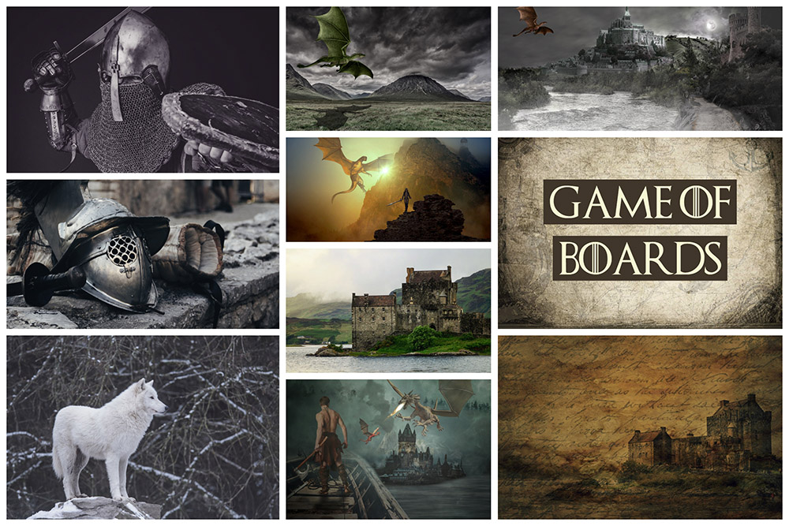

## Sketches

First, I created a prototype in Adobe XD. At that point I had not decided yet how the game play shall work and did not include a nice layout of it in my prototype. I often get the best ideas while I code and see thing “alive” on the screen.

**This is the link to my prototype:**

<https://xd.adobe.com/view/1450ef1f-8466-4368-6d82-2dbed85d56ba-6261/?hints=off>

Later when I started coding the board game page, I created some sketches/drawings on how things should look.

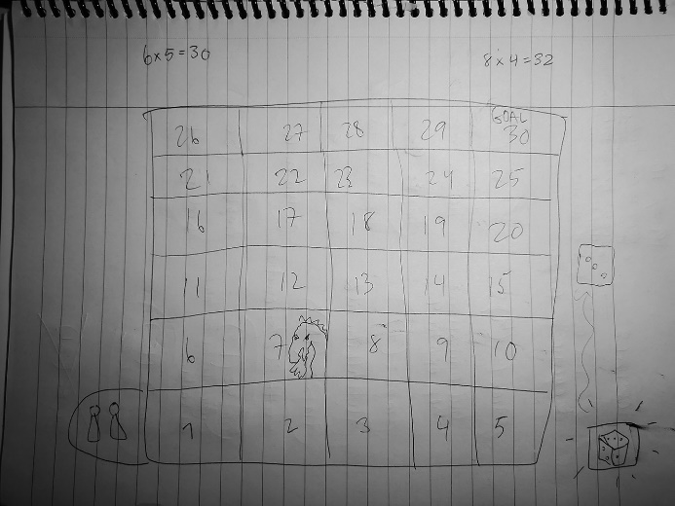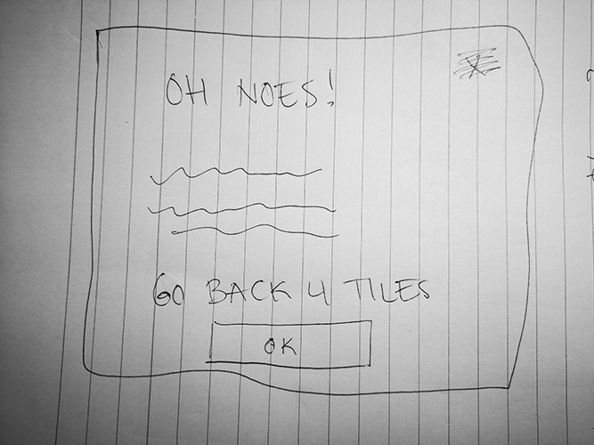

The first sketch is a sketch of the board game, the second sketch is of a popup message when tokens landed on a trap tile. I found out that a popup with an “ok button” on each trap tile would be too much, and I decided to make a message appear for a few seconds instead. It would be too much “clicking”.

# illustrations and icons

I had problems finding Game of Thrones images that was not licensed. I decided to create my own illustrations and icons in Adobe Illustrator. I chose ten well known characters that was funny to illustrate. I made four versions of each character, a full-size character, a token, a thumbnail image and an image of only the head. Underneath I show a full presentation of all the versions I made of each character.

All the illustrations is made in a flat style, and they can be presented in a good way in both extra small to extra large screens.

## Sansa

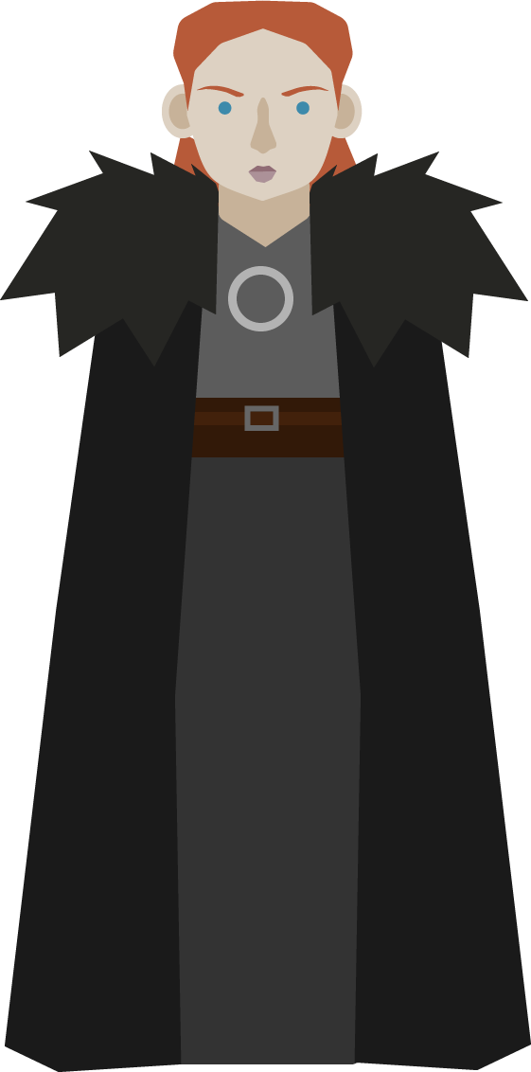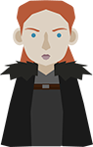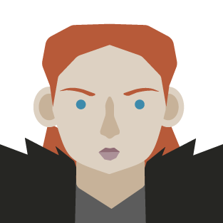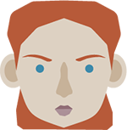

## tyrion

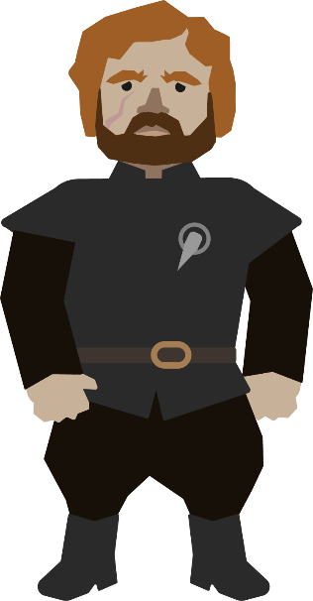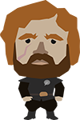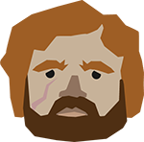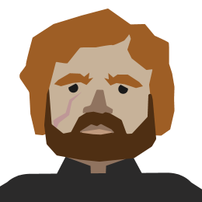

## melisandre

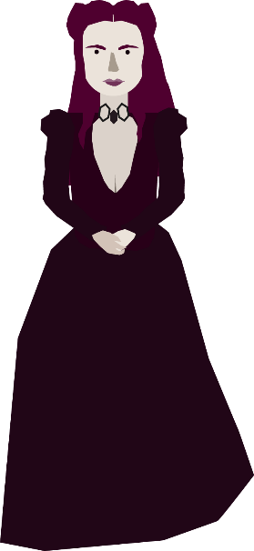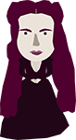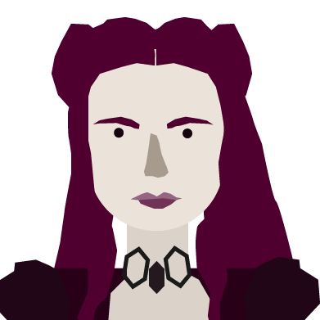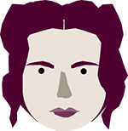

## samwell

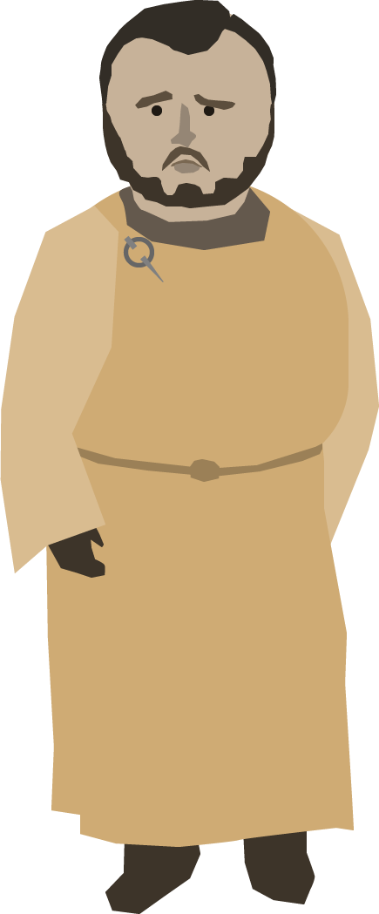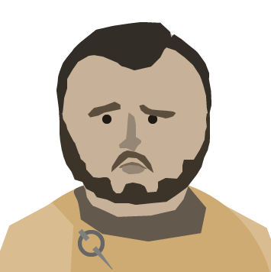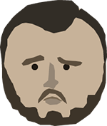

## jon

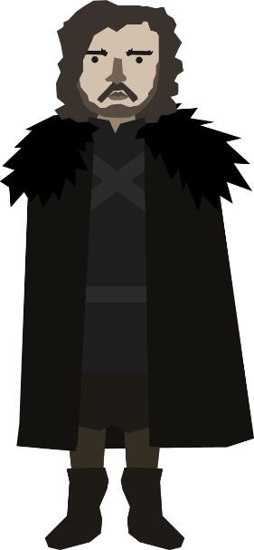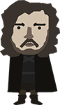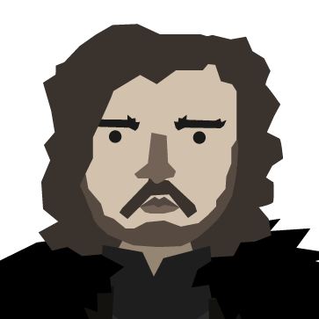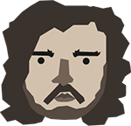

## sandor

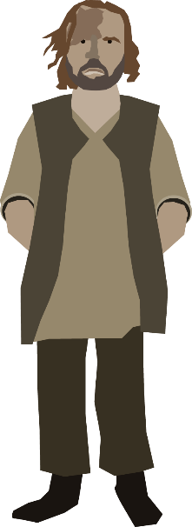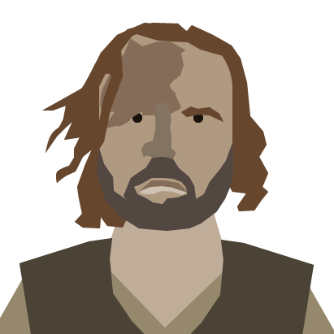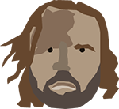

## cersei

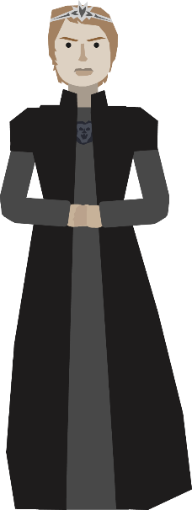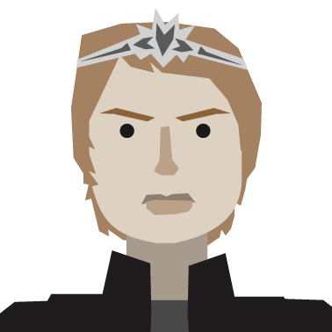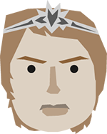

## varys

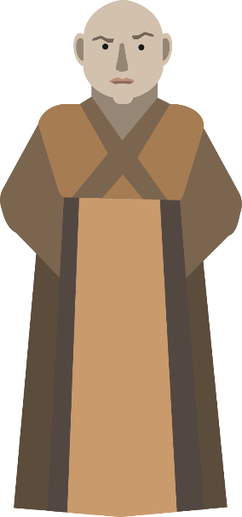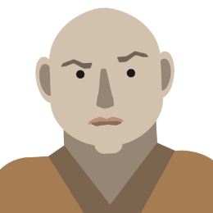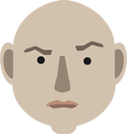

## arya

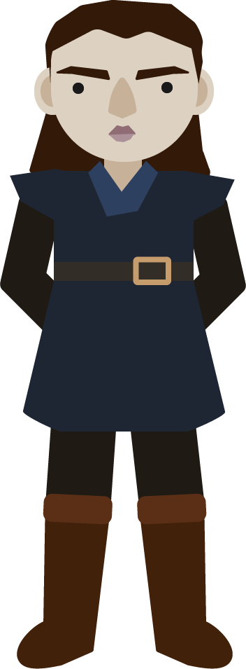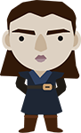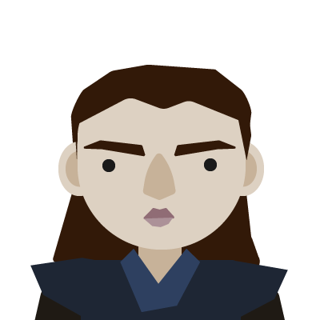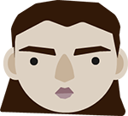

## daenerys

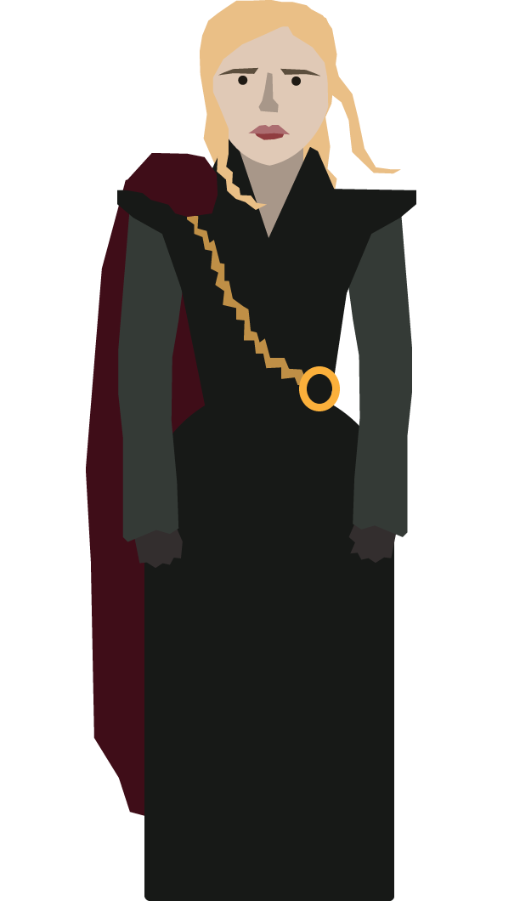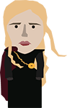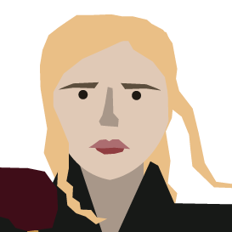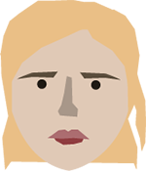

# visual choises

My game is minimalistic and have a flat design. It is simple, the different components have crisp edges and I do not use shadows. Instead I use inset and outset borders to create a dimensional effect on thigs I want to illustrate is clickable (buttons, thumbnails etc.) or other important areas I want the player to notice (character cards, trap tiles etc.).

## Logo

I used a Game of Thrones font that is free for personal use. The creator of the font is Charlie Samways. It is a serif “display font”. I chose to create a logo that looks a lot like the original GoT logo. This is because it strengthens the feeling that this is a GoT game. I created two versions of the logo, one in white and another in black. I only needed the white version in this game.

 

## Typography

I use Google fonts for my typography. I use two fonts in my game, “Philosopher” and “Open Sans”. The reason I chose “Philosopher” is because I think it fits the personality of the game. I found out that “Open Sans” is a good match together with “Philosopher” and chose that as my second font. “Open Sans” is a font that is easy to read even in small screen sizes.

### Philosopher

“Philosopher” is a Sans Serif font created by Jovanny Lemonad. I use this font as headings, popup messages, on buttons and as tile numbers.

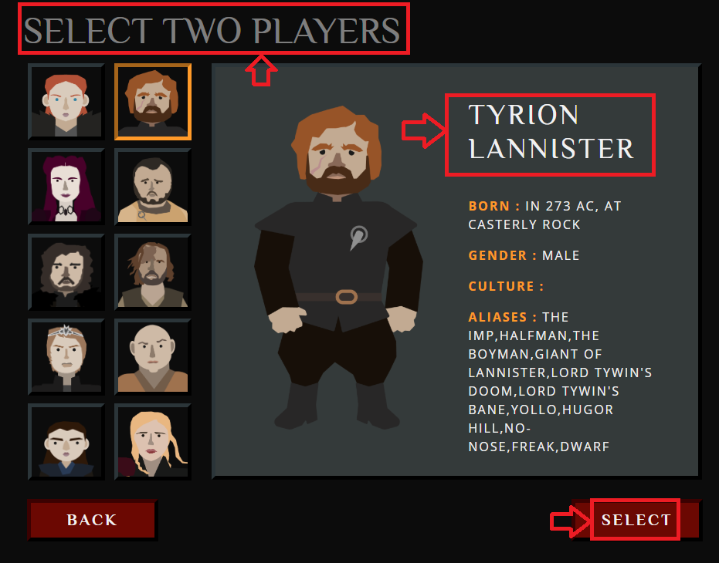

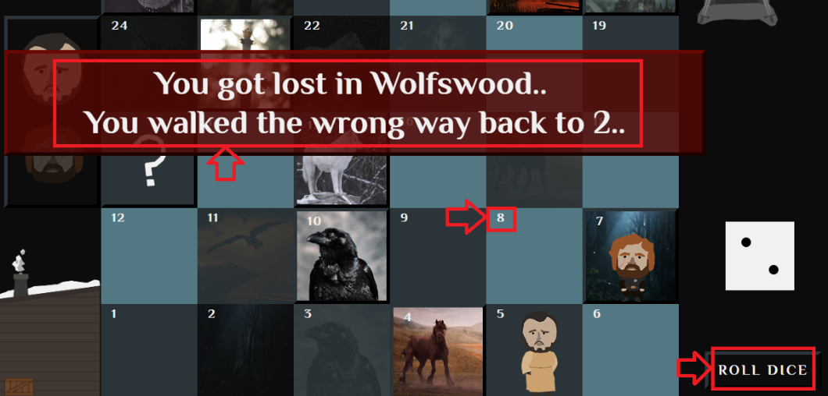

I was careful not to choose a font that is widely used by others on my headings.

### Open sans

“Open Sans” is a Sans Serif font created by Steve Matteson. I use this font as body text.

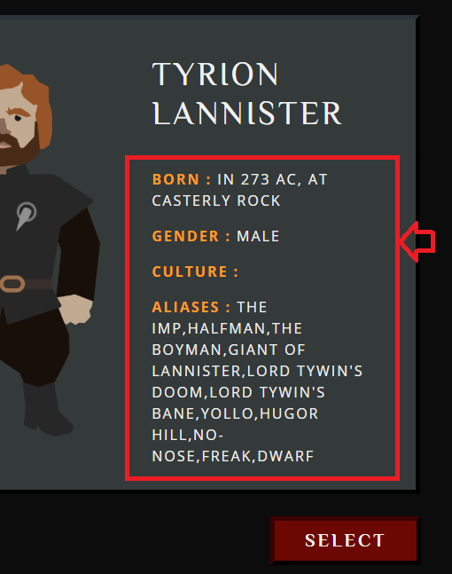

I chose a bolder version on the orange stats to make them more eye catching.

## the 7 principles of universal design

1. My game is equitable to use. It is appealing to any user and provide the same means of use for all users.
2. It fits everyone, even if you have special disabilities.
3. It is simple and intuitive.
4. I present content with a great contrast between information and its surroundings.
5. I provide warnings if the browser does not support content I present, like if the browser does not support Canvas, I present an alternative message.
6. The game only needs a small amount of physical effort to play. And only have a small amount of repetitive actions (rolling the dice).
7. Is responsive.

## Layout

I tried to display all the content of each page “above the fold”. I did not want my game to be scrollable, I think that doesn’t give a good “game vibe”. This was a bit hard on the smallest screens, but I think I managed it well on larger screen sizes. All content is centered on the middle of the screen.

### spacing

I used a lot of percentage margin and padding to make the site more responsive. This works great because the site is responsive, and percentige margin will adjust depending on the screen size. I use media screens to adjust margin and padding depending on screen size. I also use the media screens to adjust other content depending on the screen size (etc. images, container width).

In the game I use both uniform and individual spacing on my items.

### GRid system (index, character select and board game page)

The grid system I used was Bootstrap’s 12 grid system. It is built with flexbox and is fully responsive.

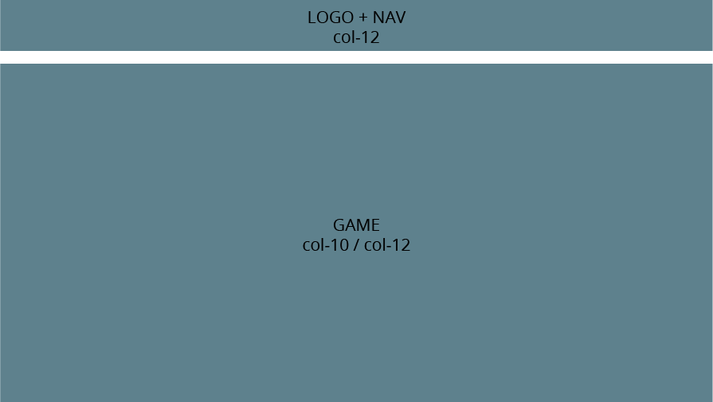

### grid system (final page)

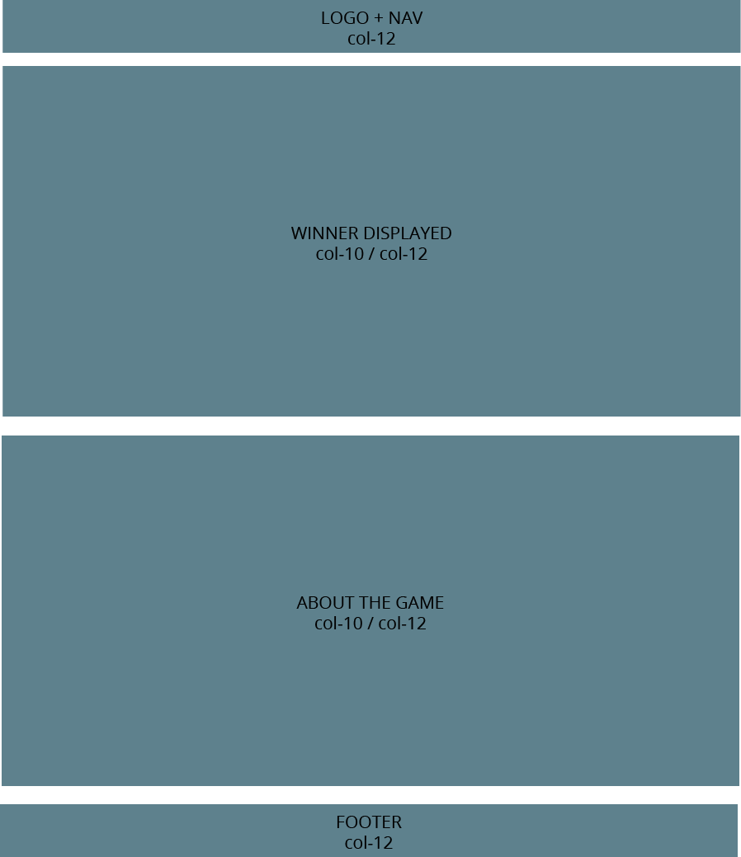

## Interactive features

### sizes

The sizes of the interactive features shall be big and intuitive. They shall also be big enough for the extra small screens. It shall be easy to click on etc. the buttons/nav when you have a small smartphone. All content on the page is made to fit both extra large and small screens.

### buttons

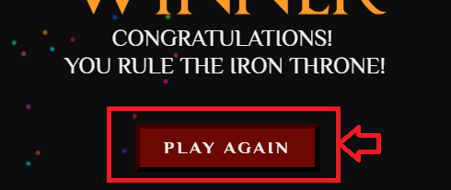 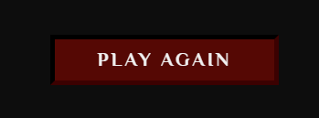 (hover)

The buttons in the game is red, with an outset border. I chose red because it is more “call to action” and eye catching.

### navigation

I have only a collapsed hamburger menu. It does not expand on large screens. This is because I did not want the menu items to take away the focus from the game. The menu is responsive. There is a hover state on the menu items. You can turn of and on sound, refresh the page and exit the game. The menu items are icons from Font Awesome. The logo appears on the left in the navigation, the hamburger menu with its items on the right. The navigation is responsive.

I added togglable background to the navigation (board game page) when displayed in laptop screen.

 (active state)  (passive state)

### character selection

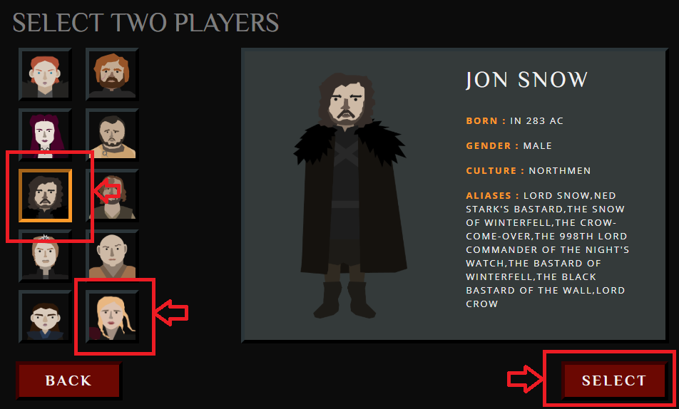

The character selection page has outset borders on the thumbnail images to make them pop out. There is an active state on the thumbnail (orange inset border) and a passive state(black outset border). I chose the color orange because then it is easy to see what character is selected. The card information appears as cards.

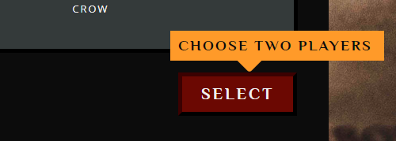

If the player chose anything else than two players, then there is a popup message that tells the user that they need to choose only two players.

### boardgame pagE

When you enter the board game page there is a hand that indicate that you shall click on the “Roll Dice” button.

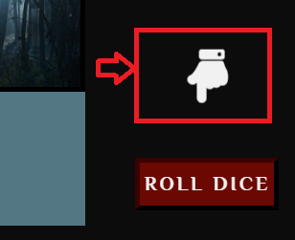

After you click the button a dice appears and its intuitional what to do next.

If you roll a six a popup message appears and you know that the same player can throw the dice one more time. When you land on a trap tile the “roll dice” button is not clickable and turns grey.

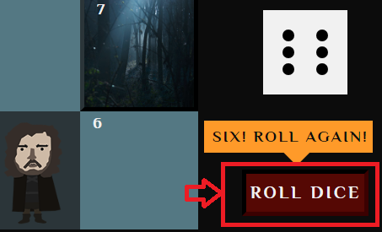

I also added a “whose turn is it” box where the head of the token that shall roll the next dice have the opacity of 100%, and the other inactive player have an opacity of 30%.

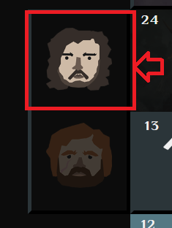

### Final page

On the final page there are a scroll up and down button. The arrows in the scroll up and down buttons indicate that there is more content “below the fold”. When an arrow turns grey it tells the user that there is not more content further up/down. There is a social sharing buttons like twitter and facebook.

I added an interactive feature where you can copy the link of the game and share with friends.

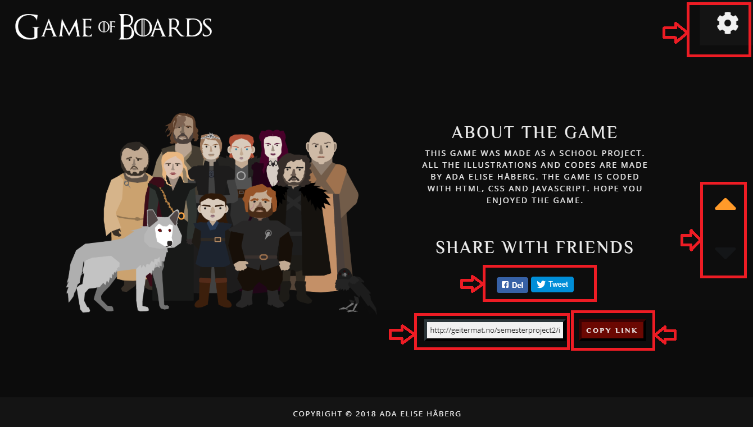

## Pop ups

I have used pop ups instead of modals. I think modals added a lot of extra clicks to the game, and it would be a bit annoying if a modal appeared each time someone landed on a trap tile.

There are three different kinds of pop ups in my game. They all deliver a message to the players and inform what’s going on in the game.

### Positive pop up

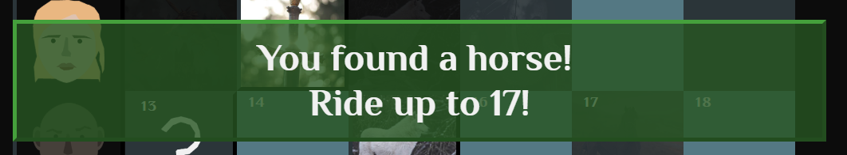

The positive pop up appears when someone lands on a positive trap tile. The color is green to indicate that something good is happening.

### Negative pop up

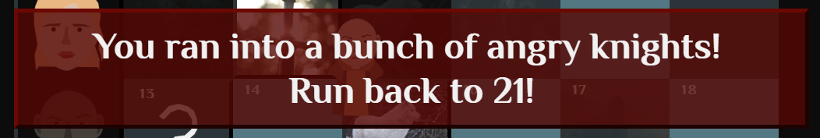

The negative pop up appears when someone lands on a negative trap tile. The color red indicates that something bad happened.

### Winner pop up

The winner pop up appears when someone win the race to the iron throne.

## colors

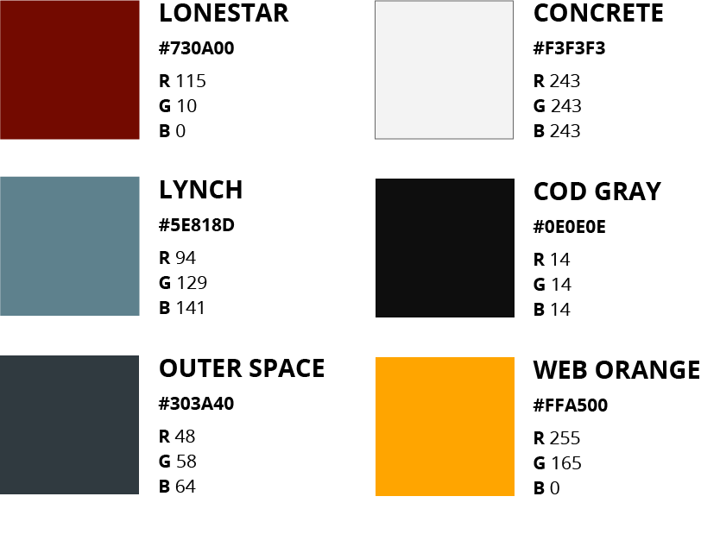

These are the colors that I use the most in the game.

There is used other colors than those mentioned above, but that is because it is a game and if I had only used those colors above the game would be a bit boring. I use a mix of warm (Lonestar, web orange and concrete) and cold colors (lynch and outer space).

### Examples of the usage of colors

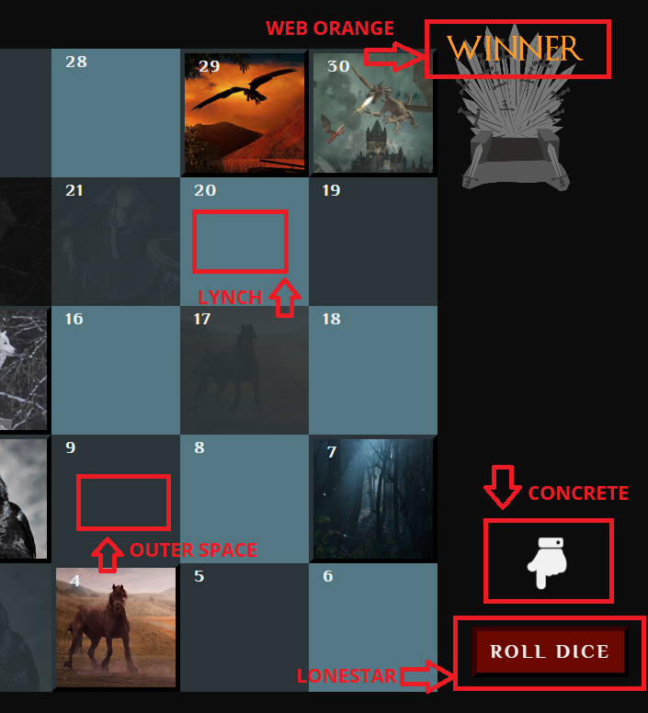

## graphics/images

I only used license free images on the “trap tiles” on the board game page. Choosing the right images on these trap tiles was important for my design on the page. They had to be relevant when it comes to the GoT theme, they must be unique and have a good quality. It was also important for me that the composition of the images was good, because the “trap tiles” was so small. Each “trap tile” has an ending point where the token lands. I added the same image on the landing point and added opacity on the “landing point images” in adobe photoshop. The reason I did this is because it shall illustrate where the “trap tile” starts and ends.

### Trap tiles (start and end)

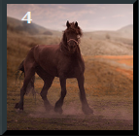 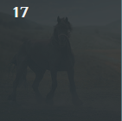

All the images/graphics are mobile friendly and have a small size to prevent long loading time. All the images I used are free and not licensed.

## Other content

### footer

I only have a footer on the winning page. This is the page with information, the rest of the pages are “game pages”. In the footer there is only copyright text.



## brand and target audience

**The brand personality** for Game of Boards is “Exitement”. This means that the associations is; Daring, spirited, imaginative and up-to-date. I think this brand personality fits great together with the style I have presented in this report and the overall look of the game.

**The target audience** of Game of Boards is everyone that loves GoT. The GoT fans are both men and women, and the colors I have chosen is not typically “women- or men colors”. The red color gives a warm touch and makes the user alert to the red buttons. The orange color gives the user a feeling of energy enthusiasm and creativity. The blue/grey colors calms the game down.

# work process

I will describe my work process and what I did, from the beginning of the project to the final result. I also add some discussion on some of the different choices I made.

### preperations

* Read assignment.
* Set up Git repository.
* Found inspiration from other games and GoT content.
* Made a mood board.
* Made Gantt Chart.

### sketching/ prototype

* Made sketches.
* Made a prototype in Adobe XD.
* Looked at the API we where given.
* Found the right name to the game, “Game of Boards”.

### illustrations

* Made 10 characters.
* Made token, thumbnail image and image of head for each character to use in the game.

### design

* Got inspiration from other color schemes on Adobe Color.
* Made my own color scheme. Changed the color scheme while I was working, not all the colors I found at the start did well in the game.
* Found the font I wanted to use in my logo. I chose a GoT font, to give the logo the right association.
* Made the logo in two different versions, only needed the white one.
* I did not choose the style of the different components like buttons and navigation early in the work process. I changed things a lot while I was working.

### creating the game

* Created the HTML structure of the index and character selection page.
* I used BEM blocks when writing the HTML. By using BEM blocks I prevent getting spaghetti CSS with no structure.
* I used both Bootstrap classes and my own BEM blocks. I separated my own classes from Bootstrap classes with bracket notation. Etc. [ navbar-nav ][ navigation__itemholder ]
* Created CSS for these pages. I used Sass in this project. I really like Sass, it makes writing CSS much simpler and faster. I often prefer to nest my CSS and make it inherit from each other and create a hierarchy. I find it easy to style my reusable BEM block this way.
* I then created the JS for character selection page. At first I was planning to create two character selection pages, where you chose player one first, click your way over to the next page and then select player two. I found out after a lot of work that I wanted to do this in only one page.
* Then I started working on the board game page. I found out that I wanted to create a board game inspired by the original “snakes and ladder” game. I researched a lot online and found a lot of different solutions on how to build this kind of board game. Some used only canvas and others didn’t. I spent a lot of time figuring out how to create a game only using Canvas. I found out that this was too complicated and did it more simple, by doing some DOM manipulating and using Bootstrap’s grid system. I decided I would use Canvas to display smaller content like the dice.
* After I built the board game page I started working on the final page. On this page the character that won was presented above the fold sitting in the iron throne. The “three eyed raven” and the wolf “Ghost” sits beside the winner. I added some animation on the wolf so it look like its breathing, and added animation on the raven so it sometimes jump on its pedestal.
* Below the fold on the final page I added some information about the game, an image of all the characters I made, some ways to share the site and a footer.

### bug testing and final adjustments

* I spend a lot of time on the small adjustments.
* I cleaned my code, removed stuff I had commented out and fixed bugs that appeared.
* I did a lot of bug testing while I was working and writing the code for the different pages.
* I also asked friends and family for feedback on my project the whole time.
* I found out there was too little bling on the winning page and added some firework to honor the winner of the game even more. The firework code I used is a public pen code from codepen.io. The creator is Eddie Lin (link in references).
* I also tried to shorten my code even more, and break the .js files into smaller more readable files. It was not always easy, because a lot of my functions share the same variables and objects.
* Made the SEO and WCAG of the page good.

### User testing

* After I had created the game, I asked people I knew to test my game. I watched them play and took notes while they played.
* I noticed that the game is intuitive and easy to play and understand.
* I also sent the link to my game to other friends and asked for feedback.
* I got constructive feedback on loading time, on my codes, and the animation of the characters.
* I considered this and made some changes to the game.
* I took a test to check if the game is mobile friendly, and it is (link in sources).

# SUMMARY AND EVALUATION

I think this was a fun semester project. I am a Game of Thrones fan, and creating a game of something I like makes the task more engaging to me. It also gave me a better picture in my head of how I wanted the game to look alike. I have also played a lot of games, and know that often “Less is more”. I think the overall style of my game is good, and the UI design is complete from index page to final page. It was a bit challenging for me to write the JS, but I think the final result fulfill the requirements from the semester project. I also notice that writing JS is easier for me now than before, I even found it useful to use etc. “objects” and “constructors”.

All my pages except the board game page is responsive. There was no requirement that the board game page should be responsive. I made the board game page to fit extra large screens (1920 x 1080). Even though it wasn’t required I added some media queries to make this page fit laptop screens (width 1367px), this is because I know that this is the most used screen size and there would be people playing this game on a laptop.

I also found it a bit hard to split up all my JS code. They are nested together, so some of the JS files are long even though I have shortened my functions a lot. There is a lot of different popups, messages, movement and animation. I think they all need to bee there make the game better.

I am pleased with the final result of this game. Even though I wish I had come up with an idea of how to make the board game page fit all screens.

# Sources and references

## Fonts

**Game of Thrones font:**

[**https://fontmeme.com/fonts/game-of-thrones-font/**](https://fontmeme.com/fonts/game-of-thrones-font/)

**Philosopher font:**

[**https://fonts.google.com/specimen/Philosopher**](https://fonts.google.com/specimen/Philosopher)

**Open sans font:**

[**https://fonts.google.com/specimen/Open+Sans**](https://fonts.google.com/specimen/Open+Sans)

## images

[**https://unsplash.com/**](https://unsplash.com/)

[**https://pixabay.com/**](https://pixabay.com/)

[**https://www.pexels.com/**](https://www.pexels.com/)

## license free code used in my projects

**Fireworks made by Eddie Lin:**

[**https://codepen.io/yshlin/**](https://codepen.io/yshlin/)

## CDN

**Font awesome:**

[**https://fontawesome.com/how-to-use/on-the-web/setup/getting-started?using=web-fonts-with-css**](https://fontawesome.com/how-to-use/on-the-web/setup/getting-started?using=web-fonts-with-css)

**Bootstrap:**

[**https://getbootstrap.com/**](https://getbootstrap.com/)

## validations

**Mobile friendly test from google:**

[**https://search.google.com/test/mobile-friendly?utm_source=mft&utm_medium=redirect&utm_campaign=mft-redirect**](https://search.google.com/test/mobile-friendly?utm_source=mft&utm_medium=redirect&utm_campaign=mft-redirect)

**Check if game fits people with color deficits:**

[**http://www.checkmycolours.com/**](http://www.checkmycolours.com/)

## Other recourses

**CSS-TRICKS**

[**https://css-tricks.com/**](https://css-tricks.com/)

**Drawing shapes in canvas:**

[**https://developer.mozilla.org/en-US/docs/Web/API/Canvas_API/Tutorial/Drawing_shapes**](https://developer.mozilla.org/en-US/docs/Web/API/Canvas_API/Tutorial/Drawing_shapes)

**SASS guide:**

[**https://sass-lang.com/guide**](https://sass-lang.com/guide)