Specifications and Design

# Requirement Specifications

## Functional requirements

## Non-functional requirements

## Interfaces

# Architecture of the system

# UML Design Documentation

## Class diagram

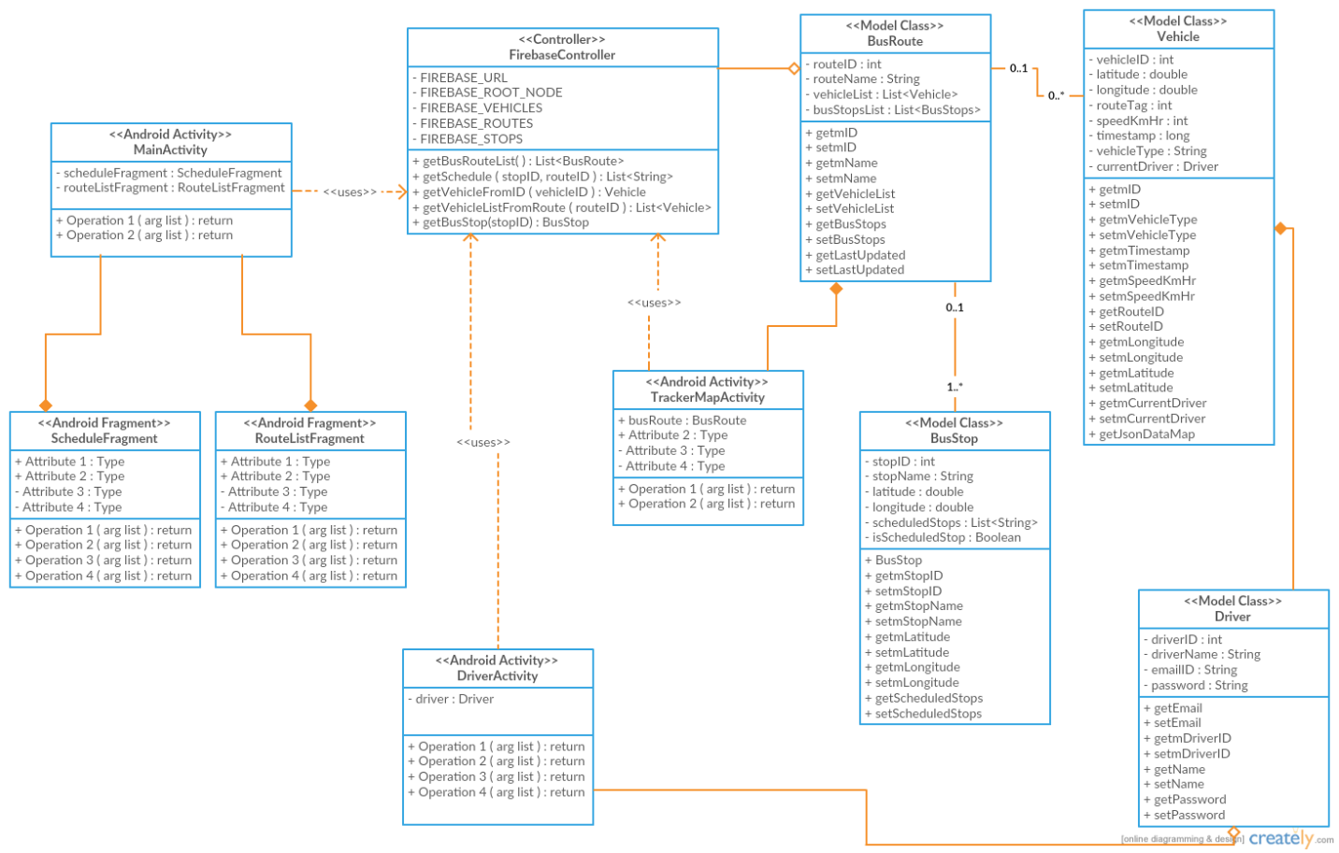

## Sequence diagram

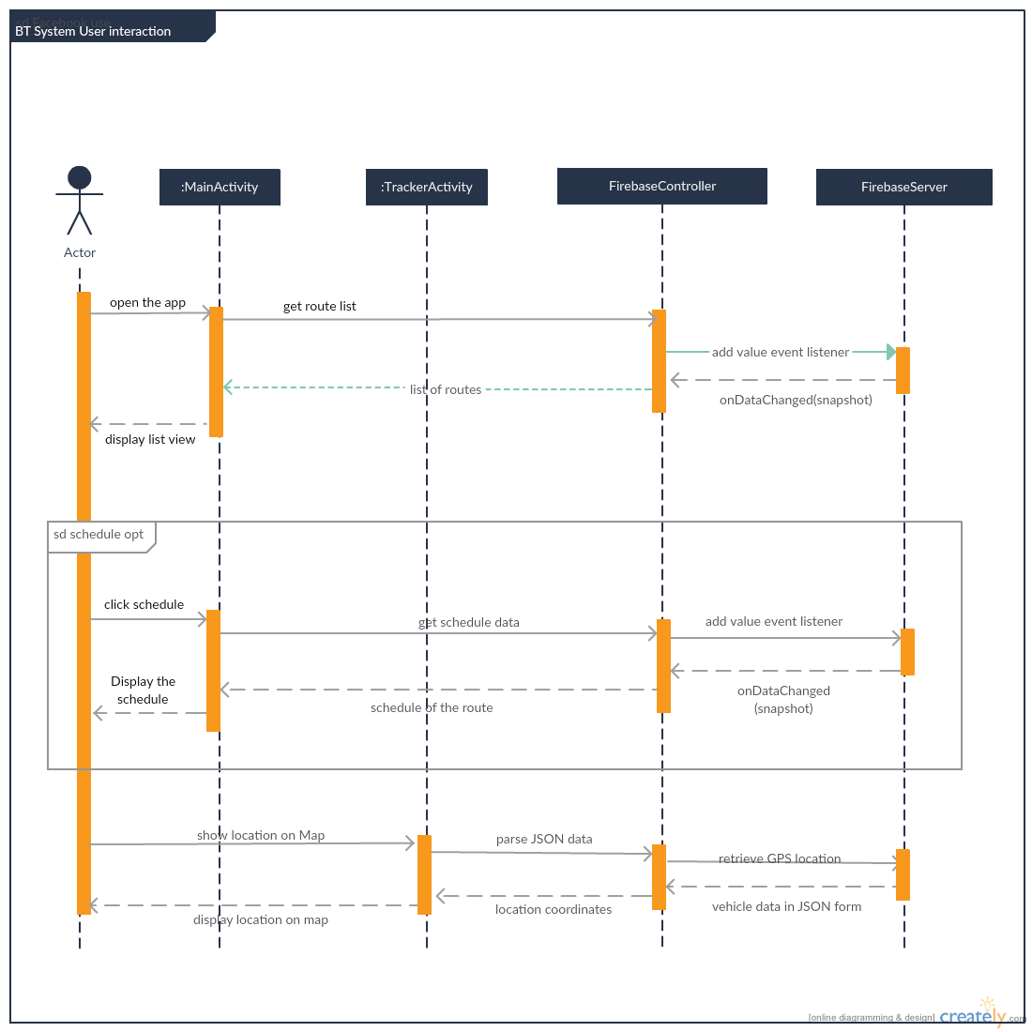

## Use case diagram

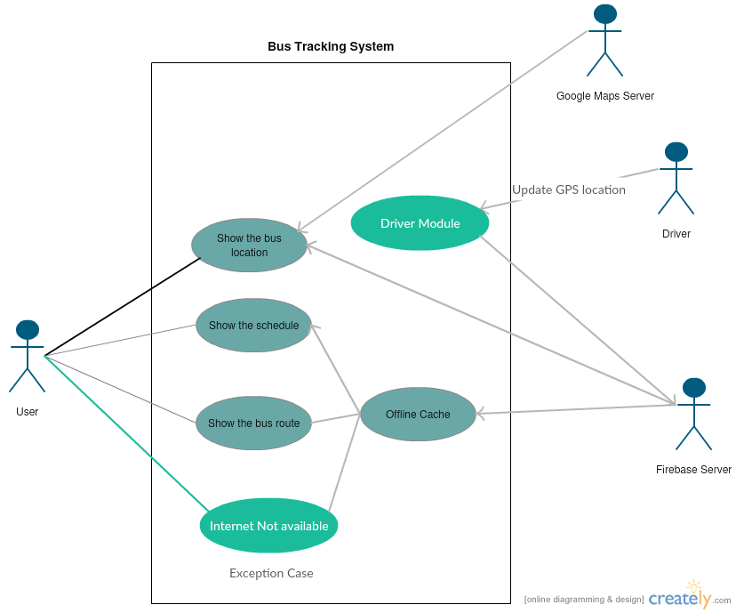

# Test Plan

# Updated risk management

# Updated project plan

# Meeting minutes

'Android Developers' meeting minutes

|  |  |
| --- | --- |
| Location: | Discovery Park NTDC B157 |
| Date: | 09/22/2016 |
| Time: | 10:00 a.m. |
| Author: | Gil Wasserman |
| Attendees: | Dr. Hyunsook Do, Anurag Chitnis, Nitesh Kumar Sharma, Satyanarayana Chivukula, Gil Wasserman |

### Agenda items

1. Requirement Elicitation
2. Project status and feasibility

### Discussion:

* Discussed with customers from other groups about the functionality of the project. Some parts of the project’s desired functionality were clarified for the customers i.e. how the user interface will be designed, what it is intended to do, etc. Received input from customers about desired functionality like showing multiple routes that go to one stop, having the ability to determine which route gets the user to their location fastest, and having static maps of each route easily accessible for the user.
* Discussed these desired requirements with group members, determined that static maps and showing multiple routes should be feasible. Designing an algorithm to determine which bus out of multiple routes will get to a location fastest was a feature that was agreed on would be a great future feature to add, but not realistic in the current timeline of the project.
* Started discussion on deliverable 2 requirements

| Sr. No. | Action items | Owner(s) | Deadline | Status |
| --- | --- | --- | --- | --- |
| 1 | Push the POC of the Firebase integration to the repository | Anurag | 09/22/2016 | Completed |
| 2 | Push the POC of the Google Maps integration to the repository | Gil | 09/22/2016 | Completed |
| 3 | Create UML design documents, requirement specification report, updated risk management and project plan, and test plan for deliverable document | Satyanarayana | 10/11/2016 | In Progress |
| 4 | Create UML design documents, requirement specification report, updated risk management and project plan, and test plan for deliverable document | Nitesh | 10/11/2016 | In Progress |
| 5 | Create UML design documents, requirement specification report, updated risk management and project plan, and test plan for deliverable document | Gil | 10/11/2016 | In Progress |
| 6 | Create UML design documents, requirement specification report, updated risk management and project plan, and test plan for deliverable document | Anurag | 10/11/2016 | In Progress |

'Android Developers' meeting minutes

|  |  |
| --- | --- |
| Location: | Discovery Park NTDC B157 |
| Date: | 10/06/2016 |
| Time: | 10:40 a.m. |
| Author: | Gil Wasserman |
| Attendees: | Dr. Hyunsook Do, Anurag Chitnis, Nitesh Kumar Sharma, Satyanarayana Chivukula, Gil Wasserman |

### Agenda items

1. Class Diagram
2. Assign code responsibilities
3. Deliverable 2 Progress

### Discussion:

* Went over the class diagram created by Anurag. Discussed the different major parts of the project in the diagram and the functionality each class would provide to the overall project.
* Discussed the Firebase database structure and how it relates to the class diagram, specifically the main root nodes needed in the database and how some data would be duplicated for easier access in the app
* Split up the work on the project, assigning Gil the ScheduleFragment and RouteListFragment, Anurag the TrackerMapActivity, Satyanarayana the DriverActivity, and Nitesh the FireBaseController.
* Continued discussion on deliverable 2 and finalizing responsibilities for the submission. Gil will do the updated risk management and will also work on the requirements specification report.

| Sr. No. | Action items | Owner(s) | Deadline | Status |
| --- | --- | --- | --- | --- |
| 1 | Create UML design documents, requirement specification report for deliverable document | Satyanarayana | 10/11/2016 | In Progress |
| 2 | Create requirement specification report, and test plan for deliverable document | Nitesh | 10/11/2016 | In Progress |
| 3 | Create requirement specification report, updated risk management for deliverable document | Gil | 10/11/2016 | In Progress |
| 4 | Create UML design documents and project plan for deliverable document | Anurag | 10/11/2016 | In Progress |
| 5 | Push draft of ScheduleFragment and RouteListFragment in preparation of Peer Review | Gil | 10/13/2016 | In Progress |
| 6 | Push draft of TrackerMapActivity in preparation of Peer Review | Anurag | 10/13/2016 | In Progress |
| 7 | Push draft of DriverActivity in preparation of Peer Review | Satya | 10/13/2016 | In Progress |
| 8 | Push draft of FireBaseController in preparation of Peer Review | Nitesh | 10/13/2016 | In Progress |



# Progress report

We have finished a basic proof of concept in which a user could checkout a particular location on google map and save it to the Firebase real-time database. If the same application is installed on more than one phone, multiple people will be able to fetch the checked out location at the same time. In this activity we performed the feasibility test of the overall project.

Second proof of concept we performed is to show the markers on the particular GPS co-ordinates. We learned how to show the markers on google map, which will further help in plotting the bus stops.

# Member contribution

|  |  |  |  |
| --- | --- | --- | --- |
| Member name | Contribution description | Overall Contribution (%) | Note  (if applicable) |
|  |  |  |  |
|  |  |  |  |
|  |  |  |  |
|  |  |  |  |