CSCI 3110 | ALGORITHMS AND DATA STRUCTURES | FALL 2026
Air Traffic Control Simulator
Sorted vector vs. heap with lazy deletion vs. indexed heap, on 109,781 real flights into Atlanta
Team: William Starks, Kyle Penton, Pau Mang, Heidtmann Oppong
Middle Tennessee State University
Presentation: December 1, 2026
Repository: https://github.com/adainstarks/atc-sim

1. The application and the data
Section author: William Starks.
An airport tower keeps a list of incoming flights and must always land the one due soonest. The list never stands still: flights join it, run early or late, and get cancelled or diverted. That is a priority queue where entries also change and disappear. We store the list three ways and measure which keeps up best as traffic grows.

The data
The data is the Bureau of Transportation Statistics Airline On-Time Performance data for May to August 2026: every domestic flight by the larger U.S. airlines scheduled to land at Atlanta Hartsfield-Jackson (ATL). It has 109,781 flights. Of these, 107,500 landed (66% early, 33% late, 1% on time), 1,781 were cancelled and 500 were diverted. Because two thirds of flights land early, “delay” in this project means any change to the arrival time, earlier or later.
Each flight’s id is its row number in the file. Its key is its scheduled arrival in minutes since May 1, 2026, 00:00 Atlanta time. Flights due the same minute land in id order, so every structure must produce exactly the same landing order. scripts/prepare_data.py builds the file and checks that, for all 107,500 landed flights, scheduled arrival plus delay equals the recorded arrival, so no flights were dropped.

The simulation
Every structure implements the same five-function interface (addFlight, delayFlight, removeFlight, landNext, size), so the simulator, the tests and the benchmark treat them identically. One run on the first N flights has four timed phases:
- Add: all N flight plans join the list in a shuffled order. The seed is fixed, so every structure sees the same order.
- Delay: every flight that landed early or late moves to its real arrival time (98.6% of landed flights).
- Remove: cancelled and diverted flights leave without landing.
- Land: the earliest flight lands, repeatedly, until the list is empty.
After the run, outside the timing, the landing order is compared with the order the planes really landed in. A structure that gets it wrong is flagged.

2. Structure A: the sorted vector
Section author: William Starks.
The list is a std::vector of (arrival, id) entries kept in descending order, so the earliest flight is at the back. Landing a flight is a pop_back. To add a flight, a binary search finds its place and insert shifts everything after it. To change a flight’s time, it is erased and inserted again. To remove a flight, a binary search finds it and erase shifts everything after it. An array indexed by flight id remembers each flight’s current arrival time so the entry can be found.
The strength is simplicity, and the cost of landing is as low as it gets. The weakness is that every add, change and remove moves O(n) entries.
At 100,000 flights, adding took 303.8 ms and changing times took 1,107.5 ms, while all 97,783 landings together took 0.59 ms. The structure is excellent at the one thing it does last, and slow at everything before it.

3. Structure B: a binary heap with lazy deletion
Section author: Kyle Penton.
A binary heap finds the earliest flight instantly but cannot find a flight in the middle. Lazy deletion works around that: never search for the old entry, just leave it behind and recognize it later.
The heap is a std::priority_queue of nodes, each holding an entry and a generation number. Three arrays indexed by flight id track each flight’s current arrival, its current generation and whether it is still waiting.
- Add: push a node with the flight’s generation. O(log n).
- Delay: bump the flight’s generation and push a new node. The old node is now stale. O(log n).
- Remove: mark the flight inactive and bump its generation. Nothing is pushed or popped. O(1).
- Land: pop the top node. If the flight is inactive or the generation does not match, the node is stale: discard it and pop again. The first valid node lands. Each stale node is popped once, so the cost is O(log n) amortized.
size() reports the number of flights waiting, not the number of nodes in the heap. The price is memory and wasted pops: at 100,000 flights the heap reaches about 196,000 nodes (100,000 adds plus 96,446 delays), nearly twice the number of live flights. That shows up in the measurements: of the lazy heap’s 29.3 ms total at 100,000 flights, 23.4 ms (80%) is the landing phase, where the stale nodes are thrown away.

4. Structure C: the indexed heap (independent research)
Section author: Pau Mang.
The indexed heap (also called an addressable priority queue) removes the need for stale copies. It keeps a binary min-heap in a vector, plus an array pos[id] giving each flight’s current position in the heap, or -1 if it is not waiting. Every swap inside the heap updates pos for both entries, so the heap can always answer “where is flight 7?” in O(1).
- Add: append at the end and sift up. O(log n).
- Delay: find the entry through pos, change its time, then sift up if it got smaller or down if it got larger. O(log n).
- Remove and land: move the last entry into the hole, shrink the vector, then sift up or down. Landing removes index 0. O(log n).
The heap holds exactly the flights that are waiting, so there is nothing to discard. Compared with lazy deletion, the indexed heap was faster in total at every size: 1.8 times at 1,000 flights, 1.9 times at 10,000 and 2.1 times at 100,000. At 100,000 flights it was 2.9 times faster at changing times and 2.1 times faster at landing, because its heap is about half the size and never pops dead entries. Lazy deletion won only at removal (0.011 ms against 0.047 ms), which is under 0.4% of the indexed heap’s total here. The indexed heap costs one extra array and extra work on every swap, and it is harder to write correctly. The full one-page write-up is in docs/research-indexed-heap.md.

5. Experiments
Section author: Heidtmann Oppong.

Procedure
We ran the first 1,000, 10,000 and 100,000 flights of the data set. The simulator builds the schedule, then times the four phases. Loading the data is excluded. Every structure receives the same schedule at each size. Each structure and size is run five times and the arithmetic mean is reported in milliseconds; results.csv keeps all 45 runs.
Verification. make test passed 10 tests for each structure (30 of 30). make check confirmed that each structure landed all 107,500 landed flights in the real order. The benchmark ran on Linux x86_64 with g++ 14.2.0, C++17, -O2.

Predictions
Before measuring, we predicted these costs, where n is the number of flights waiting:
Operation | A: sorted vector | B: lazy heap | C: indexed heap
Land next | O(1) | O(log n) amortized | O(log n)
Add | O(n) | O(log n) | O(log n)
Delay | O(n) | O(log n) | O(log n)
Remove | O(n) | O(1) | O(log n)
Whole run | O(n²) | O(n log n) | O(n log n)

Results
Average total time (ms) | 1,000 | 10,000 | 100,000
sorted-vector | 0.231 | 13.063 | 1426.500
lazy-heap | 0.106 | 1.765 | 29.345
indexed-heap | 0.059 | 0.910 | 14.036
Each value is the mean of five runs. Lower is better.
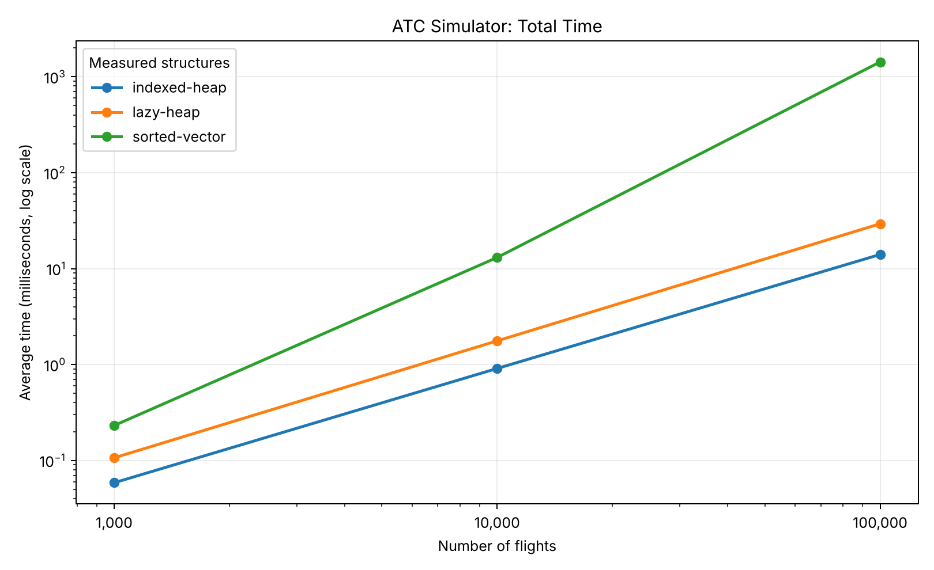
Figure 1. Average total time by number of flights (log-log scale).
At 100,000 flights (ms) | Add | Change | Remove | Land | Total
sorted-vector | 303.846 | 1107.514 | 14.548 | 0.594 | 1426.500
lazy-heap | 3.342 | 2.558 | 0.011 | 23.434 | 29.345
indexed-heap | 2.178 | 0.883 | 0.047 | 10.928 | 14.036

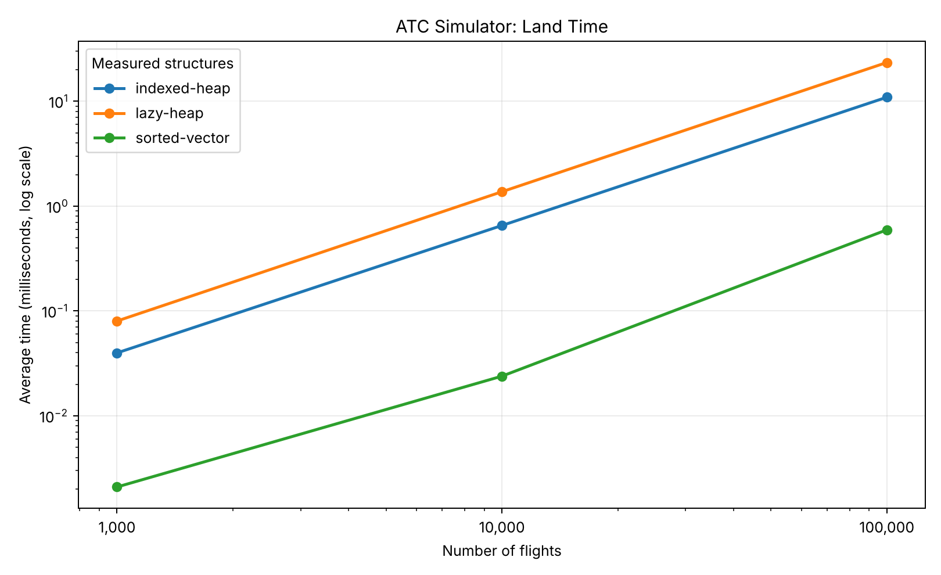
Figure 2. Average landing-phase time. The sorted vector is fastest here by a wide margin.

Interpretation
The indexed heap was fastest at all three sizes. At 100,000 flights its total was 14.036 ms, against 29.345 ms for the lazy heap and 1426.500 ms for the sorted vector, which took about 101.6 times as long. The sorted vector spent most of its time (1,107.5 of 1,426.5 ms) changing flight times, because keeping a sorted sequence means shifting elements. The lazy heap avoids repositioning old entries but pays to discard stale ones. The indexed heap updates positions directly and avoids stale copies.
Compared with the predictions. The landing prediction held: at 100,000 flights the vector landed every flight in 0.594 ms, against 10.928 ms for the indexed heap and 23.434 ms for the lazy heap. The prediction that the vector would stay competitive at small n did not hold: even at 1,000 flights its total (0.231 ms) was about 4 times the indexed heap’s (0.059 ms), because its add, change and remove phases were already slower. From 10,000 to 100,000 flights the vector’s total grew about 109 times, close to the 100 times expected from O(n²), while the lazy heap grew about 17 times and the indexed heap about 15 times, slightly above the 12.5 times expected from O(n log n). For both heaps, landing was the most expensive phase.

Limitations
These are single-machine measurements without confidence intervals. The input is the first N records, not random samples, and the same schedule is used in all five repeats. Memory use was not measured. Compiler, CPU, background load and data order may change the ranking or the magnitudes. All timings were taken in a Linux x86_64 environment, not on a team member’s own computer; rerun make bench on the target machine if required. The totals exclude data loading and chart generation.

Reproducing the experiment
From the repository folder: make clean && make && make test && make check && make bench, then python3 scripts/plot_results.py (needs matplotlib). Results are in results/results.csv and results/charts/benchmark_summary.csv.

6. Conclusions
Section author: the whole team.
- The indexed heap was the best structure in our tests. It was fastest at every size, about 100 times faster than the sorted vector and about twice as fast as the lazy heap at 100,000 flights.
- The sorted vector’s cost comes from updates, not landing. Landing is its strength (0.6 ms for 97,783 landings), but every add, change and remove shifts O(n) entries, and in this workload nearly every flight changes time.
- The lazy heap is a reasonable middle choice. It is simpler than the indexed heap and has the cheapest removal, but its heap fills with stale entries and landing pays for them.
- Big-O predicted the shape of the results well, but not everything. The growth rates matched, but the vector was not competitive even at 1,000 flights, so constant factors matter as well as growth rates.
- Scale matters for the recommendation. At 1,000 flights every structure finishes in under 0.3 ms. A real tower holds far fewer than 100,000 flights at once, so the differences we measured matter for very large lists, not for one airport’s next hour. If the list is large and most entries change, use the indexed heap. If it is small, or changes rarely, the simple sorted vector is enough.

7. AI use and sources
The project handout allows AI on this project. The log in docs/ai-use-log.md records each use. In summary: Claude (Anthropic) helped with the proposal, the data preparation script, loader, simulator, benchmark, unit tests, the sorted vector and the README. OpenAI ChatGPT helped complete the lazy heap and indexed heap, the plotting script and an early draft of the experiments report and slides. Claude also helped switch the charts to a log scale, write the comparison with the predictions, draft sections 1 to 4 and 6 of this combined report, the indexed-heap write-up, the combined slides, the balanced slides and speaker outline, and the final consistency fixes. Each member should review and be able to explain their own section.
Source. U.S. Department of Transportation, Bureau of Transportation Statistics. Airline On-Time Performance Data: Reporting Carrier On-Time Performance (1987 to present), monthly files for May to August 2026. https://www.transtats.bts.gov/. Downloaded November 4, 2026.

