ZERO-COST CONSTRUCTION PILOT
Try Pickleball Before Making Any Permanent Change
Use the existing tennis court, removable tape and portable nets to test demand first.
The immediate request
Approve a temporary pilot only. No resurfacing, no permanent paint, and no removal of the tennis court. If portable nets and tape are already available or can be borrowed, the pilot requires no construction spending.

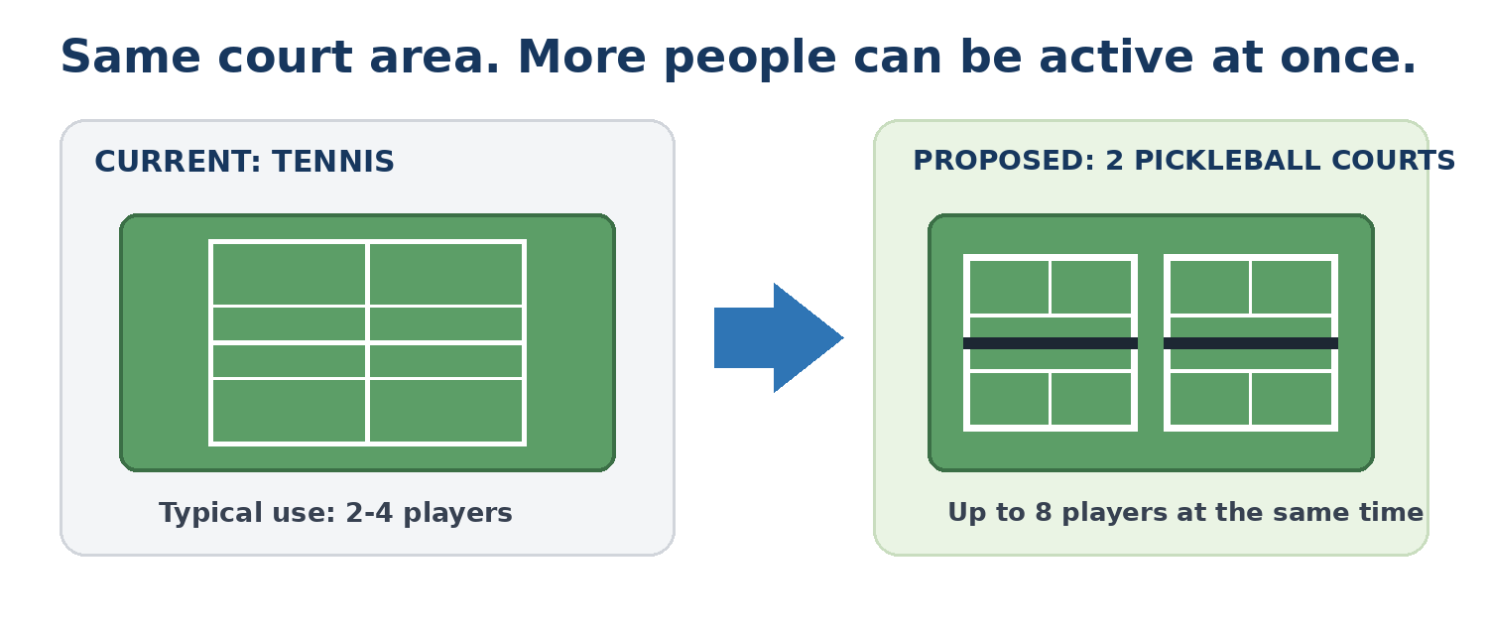
Why start this way
The school can see whether students, faculty, staff and alumni actually use pickleball before considering any permanent investment.

TRY IT | MEASURE IT | THEN DECIDE

1. Why This Pilot Could Matter to the Law School
The pilot is small, but the potential benefits are broader than recreation. Pickleball can support student wellness, professional relationships, inclusion, campus community and more active use of an existing court - without requiring a permanent change first.
WELLNESS + FOCUS | A short game can provide an active break from long periods of reading, sitting and case preparation. It gives students a practical way to step away, move, reset and return to study.
CAREER + NETWORKING | Doubles naturally mixes four people at a time. Open-play sessions can bring together students, faculty, alumni and visiting legal professionals in a relaxed setting that is easier to schedule than many traditional networking activities.
INCLUSIVE PARTICIPATION | The basic game is quick to learn and rewards placement, touch and strategy as well as athleticism. That can make recreational doubles approachable across different ages, experience levels and athletic backgrounds.
BETTER USE OF SPACE | Two pickleball courts can accommodate 8 active players at once. With open-play rotation, additional participants can wait, socialize and cycle into short games - allowing one court area to serve more people.
COMMUNITY + BELONGING | Students can arrive alone rather than needing an established group. Open play can create informal interaction among 1Ls, 2Ls, 3Ls, LL.M. students, faculty, staff and alumni who may not otherwise meet.
WHY THIS FITS A LAW SCHOOL
The same activity can serve several goals at once: a quick wellness break, a social activity, an alumni or recruiting event, and a low-pressure way for people across the law-school community to meet.

2. Open Play: What Makes the Pilot Different
Open play turns the court from a facility that requires a pre-arranged match into a shared community activity. During designated hours, a person can arrive alone or with friends, join the queue, play a short doubles game, rotate, and meet new people.
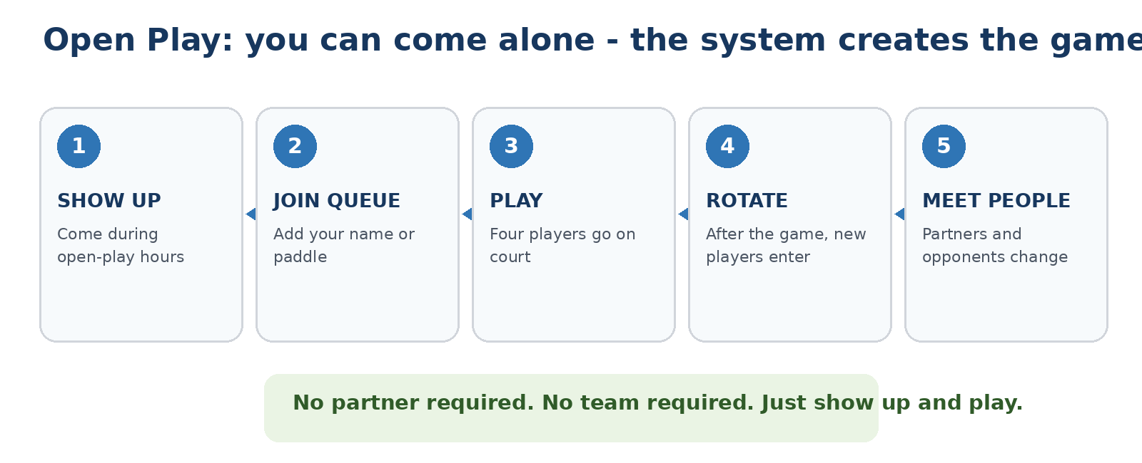

A simple example
5:30 PM after class
A student walks to the court alone. They add their name or paddle to the queue, join three other players for a short game, rotate out when the game finishes, talk with people who are waiting, and then play again with a different group.

This makes the court useful even for someone who does not already have a sports group. The open-play format can also create interaction across classes, ages and roles within the law-school community.

3. Start With the Pilot - Consider Permanent Courts Later
The proposal does not ask the school to approve a permanent conversion now. The pilot is the decision point. If participation is strong and sustained, the school can then study whether permanent lines or dedicated pickleball courts make sense.
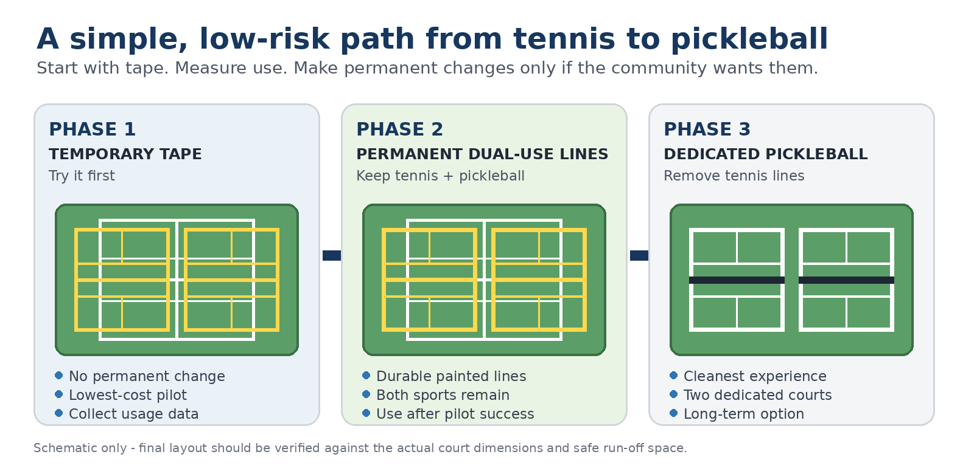
Step 1 - Now: temporary tape pilot
Use removable tape and portable nets. Keep the tennis court intact. Run scheduled open-play sessions and collect participation data.

Step 2 - Only after a successful pilot
If the school sees consistent demand, evaluate permanent dual-use lines while keeping tennis available.

Step 3 - Long-term option
Only if demand clearly supports it, investigate converting the area into two dedicated pickleball courts. Cost, design and contractor quotes can be evaluated at that time.

4. Proposed Pilot Program
The pilot should be simple, reversible and easy to evaluate. The surrounding area can remain unchanged during the trial.
- Confirm that two pickleball layouts can be marked safely within the existing court area.
- Use removable court-marking tape and portable nets; avoid permanent paint or resurfacing.
- Set designated open-play hours so people can arrive alone or in groups.
- Run the pilot for approximately 8-12 weeks.
- Track unique participants, repeat players, average attendance and basic feedback.
- Review the results and decide whether it is worth investigating a permanent court solution.
What is NOT being requested now
No budget approval for resurfacing. No permanent court construction. No removal of the tennis court. No landscaping or additional amenities.

Requested Decision
Approve the pilot
Authorize a temporary pickleball pilot on one existing tennis court using removable lines and portable nets. After the pilot, review actual participation before considering any permanent pickleball court project.

ZERO CONSTRUCTION COMMITMENT NOW. DATA FIRST. PERMANENT DECISION LATER.

